

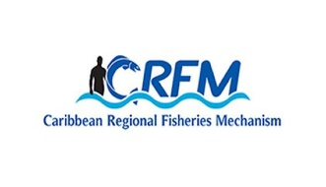
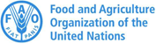

ISSN: 1995-1132

CRFM Technical & Advisory Document
No. 2025 / 05

BARBADOS
MARINE SPATIAL PLANNING PROFILE

CRFM Secretariat
Belize
CRFM Technical & Advisory Document -
Number 2025 / 05

Barbados Marine Spatial Planning Profile

Prepared by:

Claire Hedley, Principal Consultant, Howell Marine Consulting
Email: claire@howellmarine.co.uk

Joseph Onwona Ansong, Senior Consultant, Howell Marine Consulting
Email: kofi@howellmarine.co.uk

This publication has been made possible through funding by BE-CLME+ Project: Promoting National Blue Economy Priorities Through Marine Spatial Planning in the Caribbean Large Marine Ecosystem Plus - GEF Project ID 10211

CRFM Secretariat
Belize
2025
CRFM Technical & Advisory Document Number 2025 / 05

Barbados Marine Spatial Planning Profile

© CRFM 2025
All rights reserved.
Reproduction, dissemination and use of material in this publication for educational or non-commercial purposes are authorised without prior written permission of the CRFM, provided the source is fully acknowledged. No part of this publication may be reproduced, disseminated or used for any commercial purposes or resold without the prior written permission of the CRFM.

Correct Citation:
CRFM, 2025. Barbados Marine Spatial Planning Profile. CRFM Technical & Advisory Report No. 2025 / 05. 30p.

ISSN: 1995-1132
ISBN: 978-976-8293-92-3

Published by the Caribbean Regional Fisheries Mechanism Secretariat
Belize and St. Vincent and the Grenadines

EXECUTIVE SUMMARY
The Caribbean Large Marine Ecosystem Plus (BE-CLME+) Project aims to promote and further progress a blue economy in the Caribbean Region through MSP and Marine Protected Areas (MPAs) in Barbados, Belize, Guyana, Jamaica, Saint Lucia, and Panama. Under the BE-CLME+ Project, the Caribbean Regional Fisheries Mechanism (CRFM) Secretariat have developed a Caribbean Regional Marine Spatial Planning (MSP) Step-by-Step Guide and Protocol. This Barbados Marine Spatial Planning Profile was produced, following desk-based research and stakeholder feedback, to assess the current status, challenges and opportunities for marine spatial planning in Barbados, in order to inform the development of the Guide and Protocol.
Barbados is a Small Island Developing State (SIDS) with a land area of 430 km² and jurisdiction over an extensive Exclusive Economic Zone (EEZ) exceeding 185,000 km². This vast marine area is integral to the nation’s blue economy, supporting key industries such as fishing, tourism, and maritime transport, alongside exploration of marine renewable energy and oil and gas. The Barbados Marine Spatial Plan (BMSP) serves as a cornerstone for implementing Barbados’ Blue Economy Strategy, providing a structured approach to manage marine resources for sustainable economic growth and environmental protection.
The BMSP is actively being developed and is a long-term initiative with a final version expected to be presented in 2027, followed by a 15-year implementation period. A key goal of the BMSP is the legal designation of 30% of the ocean space as protected biodiversity zones by 2027, with sustainability practices applied to the remaining 70% using adaptive zoning methodologies.
Political commitment to the BMSP is strong, being both a domestic priority and an international obligation. The Coastal Zone Management Unit (CZMU), under the Ministry of Environment and National Beautification, Green and Blue Economy, is the lead authority for implementing the MSP process, supported by a dedicated Marine Spatial Planning Unit (MSPU). The BMSP is legally underpinned by existing and proposed national legislation, notably the planned repeal of the Coastal Zone Management Act (CZMA) 1998 and its replacement with the Integrated Coastal and Marine Management (ICMM) Act (currently a Bill), 2025, which mandates the use of MSP processes.
A highly inclusive and participatory process is central to the BMSP. This involves extensive stakeholder engagement, managed through a multi-tiered governance structure including the Project Steering Committee (PSC) and the Stakeholder Advisory Committee (SAC). Engagement methods have included public consultations (14 sessions as of May 2025), targeted focus groups (12 sessions), and nearly 4,000 submitted public surveys.
The BMSP is primarily funded through an innovative debt-for-nature swap (2022), which committed the country to enhanced marine protection and sustainable management, backed by the Inter-American Development Bank (IDB) and The Nature Conservancy (TNC). This transaction is projected to generate $50 million in savings over 15 years, directed toward conservation via the Barbados Environmental Sustainability Fund (BESF).
Despite these successes, significant challenges remain, particularly relating to data gaps and integration. Data on marine ecosystems, economic activities, and human uses is often scattered, outdated, or in non-spatial formats. Specific deficiencies exist regarding deep-sea habitats, the distribution of most commercially important fish species (including nursing/spawning grounds), and updated benthic habitat monitoring. Other major challenges include competition for limited marine space, fragmentation of governance (historically), and limited public awareness of the BMSP and blue economy initiatives.
Key recommendations for advancing the MSP include enacting the Integrated Coastal and Marine Management Bill, 2025, and investing in systematic data collection, digitisation, and georeferencing across the EEZ. It is also recommended to secure long-term contracts for the MSPU team to mitigate instability caused by personnel turnover and explore innovative financing, such as environmental levies, to reinforce public funding.

Table of Contents
EXECUTIVE SUMMARY 4
1 INTRODUCTION 2
1.1 Scope 2
1.2 Context 2
2 MSP OVERVIEW 4
3 MSP PROCESS REVIEW 7
3.1 MSP Vision and Objectives 8
3.2 Role of Institutions and Agencies 8
3.3 Stakeholder Engagement 10
3.4 Data and Evidence 12
3.5 Transboundary Cooperation 15
3.6 Funding MSP Processes 16
4 MSP CHALLENGES 17
5 MSP BEST PRACTICES AND SUCCESSES 19
6 RECOMMENDATIONS 21
REFERENCES 24

INTRODUCTION

Scope
The Caribbean Regional Fisheries Mechanism (CRFM) Secretariat is preparing a Caribbean Regional Marine Spatial Planning Step-by-Step Guide and Protocol under the BE-CLME+ Project, to be delivered by the end of 2025. The Guide and Protocol will align with international best practice for developing and implementing MSP but it will be tailored to the specific challenges and opportunities of the countries participating in BE-CLME+: Barbados, Belize, Guyana, Jamaica, Panama, Saint Lucia.
Consultations took place in each country through July and August 2025 to understand how the Guide and Protocol can best take account of their individual circumstances. The profile provides a detailed overview of the current status of Marine Spatial Planning (MSP), its underpinning drivers and political support, and challenges and recommendations specific to Barbados. This profile was originally prepared in July 2025 in advance of those consultations based on desk-based research using available documents relevant to MSP in Barbados to provide an initial baseline of information. The information was tested and refined through consultation with MSP stakeholders in Barbados, to identify the issues most relevant to the development of the Guide and Protocol.
The recommendations contained in Section 6 reflect recommendations contained in the various evidence sourced and reviewed for how Barbados can further progress its MSP. They indicate potential future direction of travel for Barbados, and will be used to understand how the Regional Guide and Protocol can support in addressing them.

Context
Barbados is a small island of 430 km², with a population of approximately 282,635, making it one of the world’s most densely populated countries. It is part of the Caribbean Large Marine Ecosystem (LME), a major global marine biodiversity hotspot, characterised by tropical ecosystems including coral reefs, mangrove and seagrass forests, sandy beaches and rocky shorelines. The island’s Exclusive Economic Zone (EEZ) is roughly wedge-shaped, with a total area over 185,000 km2, extending approximately 75 km offshore to the west and approximately 400 km offshore to the east into the Atlantic Ocean (Figure 1). To the east, the EEZ extends well past the insular shelf or the toe of the Barbados Ridge into depths exceeding 5,000 m. The eastern (Atlantic side) boundary of the EEZ is adjacent to international waters rather than the EEZ of another territory (IDB, 2020).
The area is defined by its large size, its critical role in the nation's blue economy and sustainable development, and its diverse marine environment that faces various natural and anthropogenic challenges. The coast of Barbados holds immense value and is considered integral to the lives of Barbadians. It provides essential goods and services, including food, places to live, work, and relax, and acts as a gateway to the world via the Bridgetown Port (CZMU, 2020a).
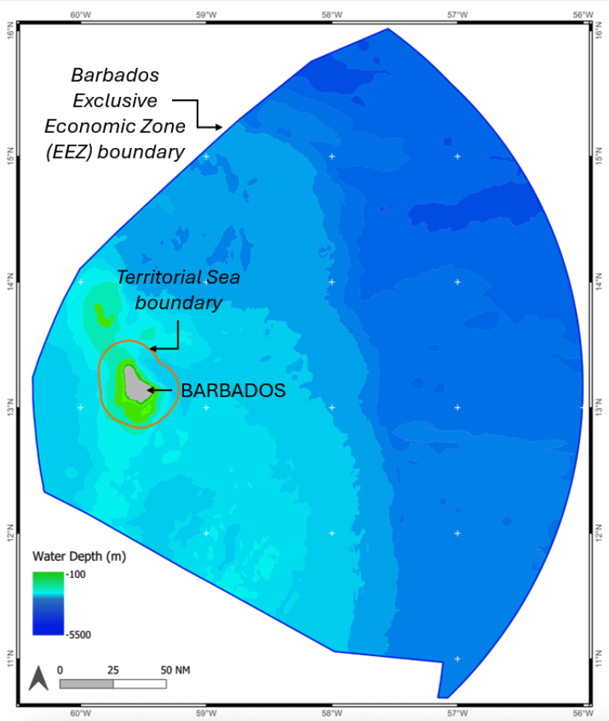

Figure 1. Map of Barbados territorial sea (12 nm) and Exclusive Economic Zone (200 nm) boundaries

Barbados also boasts a rich biodiversity of coastal habitats, including beaches, sand-dunes, sea cliffs, gullies, coastal wetlands (mangroves, seagrass beds), and coral reefs. Coral reefs are of significant ecological value, providing crucial ecosystem services including shelter, feeding grounds, and coastline protection (CZMU, 202a).
A goal of the Barbados Marine Spatial Plan (BMSP) (currently being developed), is to legally designate 30% of the EEZ as protected biodiversity zones by 2027, with varying levels of protection. Sustainable practices are intended to be applied to the remaining 70% of the ocean space (CZMU, 2025b).
Alongside ocean protection, the EEZ also supports key industries such as fishing, tourism, maritime transport and marine renewable energy. There is an exploration of offshore wind, wave, and thermal energy, alongside cautious oil and gas exploration within the EEZ (CZMU, 2020a). The BMSP seeks to promote sustainable and equitable national socio-cultural and economic development through adaptive and responsive use of the ocean space, fostering a profitable blue economy for all Barbadians.

MSP OVERVIEW
This section provides an overview of the status of the BMSP, including underpinning legislation and policy, lead authority, the status of BMSP, planning approach and scope.
Table 1. BMSP overview
Criteria | Overview
MSP Legislation and Policies | The legal basis for the BMSP is primarily rooted in existing and proposed national legislation, coupled with significant international commitments and a commitment to good governance.  The BMSP process is aligned with national and international commitments, including the goal to designate at least 30% of the ocean space as marine protected areas in line with the Global Biodiversity Framework (Kunming-Montreal Protocol).  While the MSP itself is not a piece of legislation, the process is expected to inform future legislation related to marine management. For example, the Barbados Parliament is currently developing a Seaport Industry (Management, Operations and Development) Act, 2025, which will relate to broader MSP efforts.  Other relevant legislation:  Coastal Zone Management Act (CZMA) 1998: The primary legal instrument for managing Barbados’ coastal and marine resources. There are plans to repeal and replace the Act with the Integrated Coastal and Marine Management (ICMM) Act (currently a Bill), 2025, with an expanded focus on disaster risk management, climate change adaptation, and holistic integrated coastal and marine management. The updated Act specifically mandates the use of MSP processes and the designation of marine managed areas as tools for sustainable management.  Integrated Coastal Zone Management Plan, 2020-30 (ICZM Plan): Mandated by the CZMA and implemented by the Coastal Zone Management Unit (CZMU), the ICZM Plan provides policy guidance for the sustainable use and protection of coastal resources. The ICZM Plan is a foundational policy document for MSP in Barbados.  Planning and Development Act 2019: A primary legislative instrument relevant to ICZM in Barbados. It underpins the approach to the ICZM Plan and the broader process of developmental planning in Barbados. It importantly expresses the requirement for public participation in achieving the Act's purposes, a feature absent from its predecessor. The CZMU advises the Town and Country Development Planning Office (TCDPO) on granting development permissions within the coastal zone, ensuring adherence to the ICZM Plan.  Fisheries Act (as amended 2000) – repealed 2025: Governed the management and conservation of fisheries and marine living resources. Before repeal, its schemes took precedence in cases of conflict with the CZMA regarding living marine resources outside designated management areas.  Sustainable Fisheries Management and Development Act 2025: Establishes the legal framework for all fisheries activities, from pre-harvest to harvest operations, including fishing, boat building, research, monitoring, and cross-sectoral coordination.  Sustainable Fisheries Management and Development (Seafood Markets and Businesses) Act: Establishes regulations for seafood markets, businesses, and supply chain management.  Marine Pollution Control Act (MPCA) 1998: Addresses marine pollution and supports the broader objectives of marine conservation and sustainable use.  Marine Areas (Preservation and Enhancement) Regulations 1981: These regulations, made under the CZMA, establish specific restrictions and enforcement mechanisms for marine protected areas.  Debt-for-Nature Swap (2022): The BMSP is a cornerstone of broader conservation efforts under a debt-for-nature swap finalised in 2022, which commits the country to enhanced marine protection and sustainable management, backed by international financial and technical support from the Inter-American Development Bank (IDB) and The Nature Conservancy (TNC).  Maritime and Underwater Heritage Act 2024: Provides for the management of coastal state activities specific to maritime and cultural heritage, to ensure a holistic legislative framework, underpinned by policy considerations, and of course, best practices embedded in UNCLOS and UNESCO heritage regimes.  Maritime Areas (Jurisdiction, Rights and Sustainable Marine Development) Act 1978: grants Barbados sovereign rights and jurisdiction over the Exclusive Economic Zone (EEZ).
Lead MSP Authority | The CZMU, under the Ministry of Environment and National Beautification, Green and Blue Economy is the lead agency for implementing the CZMA, the ICZM Plan, and the MSP process. A Marine Spatial Planning Unit (MSPU) has been established within the CZMU.
Stage of MSP | The BMSP is actively being developed through comprehensive public engagement and scientific data collection, with concrete deadlines set for its drafting and finalisation, and subsequent long-term implementation over the coming years.  - The first draft of the plan is due in September 2025  - This draft will then undergo public review  - The final version of the BMSP is expected to be presented in 2027  - Following adoption, there will be a 15-year implementation period  A significant aspirational goal of the BMSP is to legally designate 30% of the ocean space as protected biodiversity zones by 2027, with sustainability practices applied to the remaining 70%.
Plan Name/MSP Initiative(s) | Barbados Marine Spatial Plan (BMSP)  MSP is a cornerstone for implementing Barbados’ Blue Economy Strategy, providing a structured approach to managing the country’s marine resources for sustainable economic growth, environmental protection, and social inclusion.  The BMSP and the ICZM Plan are interdependent pillars of Barbados’ marine governance. The ICZM Plan manages the land-sea interface and immediate coastal resources, while BMSP governs the broader ocean space, together ensuring that development, conservation, and community needs are balanced from the shoreline to the edge of the EEZ.
Plan Scale | The scale is extensive, covering all maritime areas under Barbados’ jurisdiction, from the shoreline out to the limits of the country’s EEZ, which extends up to 200 nautical miles from the coast. This marine area is approximately 185,000 km², making it about 430 times the size of Barbados’ land mass.  The BMSP is a long-term initiative, with the first draft expected by September 2025 and the final version in 2027, followed by a 15-year implementation period. This long timeframe is consistent with the extensive area it seeks to manage.
Plan Scope | The BMSP is an integral element to implementing Barbados’ Blue Economy (BE) Action Plan (IDB, 2021). The overarching goal of the BE Action Plan is to create and implement governance that enables inclusive and distributive economic growth within the limits of healthy and resilient marine ecosystems. Similarly, the BMSP incorporates a holistic approach by considering ecological, economic, and social factors and integrating multiple uses for an inclusive decision-making that considers the needs and inputs of multiple parties. The BE Action Plan proposed pivotal sectors are fisheries, tourism, marine transportation, energy, marine technology, marine services, and maritime non-living resources (e.g., sand, minerals, etc.).  The BMSP is, therefore, an inter-sectoral and participatory process aiming to create balance between users, and uses of the marine space, giving due consideration to the importance of the ocean and its resources to our communities, to sustaining lives and livelihoods, to preserving our cultural heritage patrimony and to our way of life in Barbados.  The MSP process will also seek to designate at least 30% of the EEZ, alongside sustainability practices across the remaining 70% through adaptive zoning methodologies. These areas are identified based on current and potential ocean use, as well as scientific data on marine resources.  It explicitly integrates public consultation (including marginalised groups) in every phase to gather insights from Barbadians, combined with extensive scientific data collection, modelling, and Geographic Information Systems (GIS) to understand present and future ocean use. It aims to foster the responsible use of marine resources, facilitate the enjoyment of the marine space, and nurture a profitable blue economy to benefit all Barbadians. Like the land planning process already adopted in Barbados, the BMSP will outline the regulations to ensure the sustainable use of the island’s surrounding ocean space. It is intended as a long-term, adaptive guide for development, not a static document.
Planning Approach | The BMSP is based on a zoning approach to balance all uses and users of Barbados’ marine space, including but not limited to fisheries, tourism, shipping, conservation, renewable energy, and mariculture. It is developed through an inclusive, consultative process involving all sectors and groups that use or are impacted by the marine space, ensuring broad participation and local ownership. The approach is also intentional in ensuring that special consideration is given for groups that are disproportionately at risk of negative impacts. The BMSP is intended as a living document, subject to ongoing review, public feedback, and adjustment as new information and priorities emerge.
Political Commitment to MSP | Political commitment is strong, multi-layered, and internationally recognised. The BMSP is both a domestic political priority and an international obligation, with strong leadership, broad stakeholder involvement, and clear integration into the country’s long-term development and conservation goals.  The Government of Barbados has made MSP a central pillar of its sustainable development and blue economy strategies (MMABE, 2020, 2020a), with explicit support from the highest levels of government and key ministries.  The BMSP process is led by the Government of Barbados, specifically the CZMU, but it has strong cross-government support with direct involvement of ministries and agencies responsible for environment, fisheries, tourism, and economic development. The BMSP is also a formal commitment under the 2022 debt-for-nature swap (CZMU, 2025b).  Political leaders have emphasised the importance of inclusive, participatory processes, ensuring that all sectors and communities have a voice in shaping the BMSP (CZMU, 2025c).

MSP PROCESS REVIEW
The BMSP process (Figure 2) is designed to ensure a comprehensive, inclusive, and evidence-based approach to managing the country’s marine space and the steps reflect global best practices that are tailored to Barbados’ national priorities and commitments. The process is currently (July 2025) at stage 2-3.
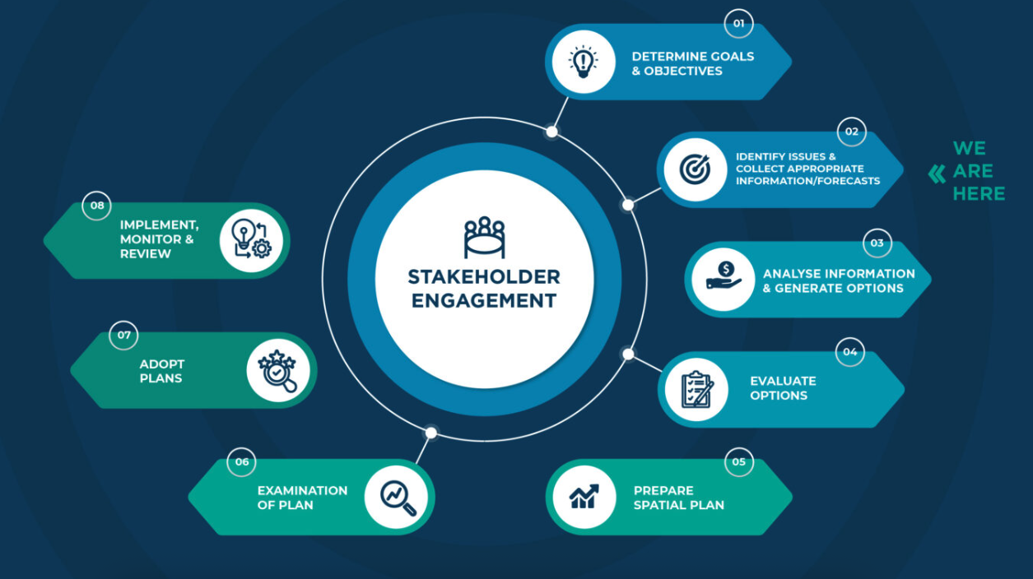
Figure 2. BMSP process (Source: https://barbadosmarinespatialplan.com)

MSP Vision and Objectives
Goal and objective setting is a formal stage in the development of the BMSP. They are informed by a combination of national priorities, stakeholder input, scientific data, international commitments, and ongoing blue economy initiatives.
Table 2. BMSP Goals and Objectives (CZMU, 2025b)
Goal 1: Sustainability principles and management practices are applied to reduce threats to marine natural capital and ecosystem services, ensuring the protection of the marine environment

Objectives:
- Complete the MSP by 2027
- Legally declare 30% of ocean space as protected biodiversity zones by 2027
- Apply sustainability practices to the remaining 70% of ocean space using adaptive zoning methodologies
- Support environmental stewardship engagement by 2028
Goal 2: Sustainable and equitable national socio-cultural and economic development is promoted through adaptive and responsive use of the ocean space

Short-term objectives:
- Develop curricula and courses to address 3-5 priority areas for short-term ocean uses
- Build a qualified cadre to manage these priorities within the first five years of implementation
Long-term objectives:
- Establish partnerships and internships for innovation, technology use, and entrepreneurship
- Engage diverse stakeholders to promote sociocultural and economic development
Goal 3: Ensure that the MSP process, and its outcomes, apply good governance principles, practices, and rights-based ethics

Objectives:
- Develop and implement the necessary mechanisms, processes, and procedures to ensure the MSP process is functional, effective, and in accordance with the MSP governance framework

Role of Institutions and Agencies
The BMSP process is governed by a comprehensive, multi-institutional framework involving key government agencies, advisory bodies, technical groups, and broad stakeholder participation. The structure (Figure 3) ensures oversight, technical rigor, legal integration, and stakeholder engagement at every stage.
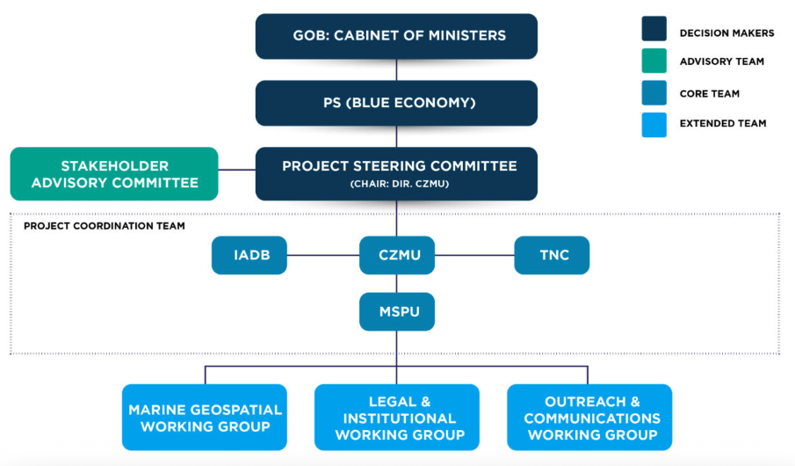

Figure 3. BMSP Governance Framework

Project Steering Committee (PSC) - strategic oversight, leadership, inter-agency coordination
- Cabinet-appointed body providing strategic oversight, leadership and inter-agency coordination for the MSP process.
- Chaired by the Director of the CZMU.
- Includes representatives from:
- Ministry of Environment and National Beautification, Green and Blue Economy (Fisheries Division)
- Planning and Development Department
- Ministry of Tourism and International Transport
- Ministry of Energy and Business Development
- Barbados Defence Force
- Barbados Coast Guard
- Barbados Chamber of Commerce and Industry
- The Nature Conservancy (TNC)
- University of the West Indies
Stakeholder Advisory Committee (SAC)
- Facilitates stakeholder participation and input, sectoral representation and information flow.
- Ensures that various sectors (tourism, fisheries, energy, conservation, research, vulnerable and marginalised groups, etc.) influence MSP outcomes and information is widely disseminated.
Coastal Zone Management Unit (CZMU)
- Lead authority for MSP, technical oversight, responsible for overall execution, coordination, and implementation of the plan on behalf of the Government of Barbados.
- Chairs the Project Steering Committee and manages the Marine Spatial Planning Unit (MSPU), which undertakes the technical and administrative work of MSP.
Inter-American Development Bank (‘IADB’ above) and The Nature Conservancy (TNC)
- International supporting partners.
- Provide technical and financial support, especially as part of the debt-for-nature swap and blue bond agreements.
Marine Spatial Planning Project Unit (MSPU)
- Dedicated unit within the CZMU responsible for day-to-day management, tasks and technical analyses, and coordination with specialists and consultants.
Technical Working Groups
- Data, legal, and communication support.
- Marine Geospatial and Science Working Group: Guides scientific data collection, interpretation, and application for MSP.
- Legal and Institutional Working Group: Reviews and recommends legal and policy reforms to ensure MSP recommendations are enforceable and integrated into national law.
- Outreach and Communications Working Group: Manages communication strategies and public engagement to ensure transparency and broad awareness.
Other key ministries and agencies listed also provide sectoral expertise, implementation, regulatory input:
- Ministry of Environment and National Beautification, Green and Blue Economy
- Ministry of Tourism and International Transport
- Ministry of Energy and Business Development
- Ministry of Housing and Lands
- Ministry of Public Works
- Ministry of Education
- Ministry of Foreign Affairs and Foreign Trade
- Planning and Development Department
- Barbados Coast Guard

Stakeholder Engagement
The Government of Barbados, through the CZMU (CZMU, 2025a), has emphasised that full stakeholder participation is essential for equitable and effective MSP. The BMSP is developed through an open, consultative process involving public engagement activities at each stage, including opportunities for feedback on draft plans. The
The process is for all Barbadians who are users of, and are impacted by the marine space, regardless of their background or the frequency of use. The process seeks to involve all sectors and groups in the society, who directly and indirectly benefit from, or use the ocean space. All feedback is reviewed by the Project Steering Committee, and the plan is designed as a living document, allowing for amendments based on stakeholder input and changing conditions.
A Grievance Redress Mechanism (CZMU, 2024) is in place and published online to allow stakeholder to submit grievances to the MSPU, which are then reviewed and addressed, ensuring transparency and accountability in the process.
Key stakeholder engagement activities include:
- Public consultations: structured public meetings are held to gather input and feedback, such as the Parish Listening Sessions (CZMU, 2025a). As of May 2025, there have been 14 public consultations with 405 participants, providing opportunities for direct dialogue and community input.
- Focus groups: targeted sessions with specific stakeholder groups (e.g., fishers, tourism operators, conservationists) allow for in-depth discussion of sector-specific issues. Twelve focus group sessions have been conducted with 71 participants (BMSP website – accessed July 2025).
- Surveys: broad-based surveys are used to collect opinions, concerns, and suggestions from a wide cross-section of the population, such as a beach user survey. Nearly 4,000 surveys have been submitted, enabling quantitative analysis of public sentiment and priorities (BMSP website – accessed July 2025).
- Education: outreach to schools and educators is a core component, with over 1,000 students and 58 educators engaged. This builds awareness and fosters stewardship among younger generations.
- Communications programme: a dedicated communications strategy uses digital media campaigns, traditional media such as the Blue Print newsletter launched in March 2025, public events, and outdoor messaging to raise awareness, promote open dialogue, and keep the public informed and engaged.
- Participatory mapping: participatory GIS and community mapping exercises are used to integrate local knowledge into the planning process, particularly for fisheries, habitat classification, and blue economy studies.
- Feedback at milestones: the MSP process is designed with clear milestones where public feedback is actively sought and incorporated, ensuring continuous engagement throughout the planning cycle, for example when the first draft of the plan is published.
- Creative engagement initiatives: activities such as logo competitions for the MSP brand encourage creative participation and help build a sense of ownership among the public, especially younger Barbadians. A video series called Seaside chats was produced in collaboration with the local television station. A jingle and a community music video has also been produced to encourage participation in the MSP process.
Governance arrangements to facilitate stakeholder engagement
The MSP process achieves coordination between government bodies and stakeholders through a structured, multi-tiered governance framework designed to ensure inclusive participation, technical rigor, and effective communication throughout the planning and implementation process. The following institutional arrangements further support and facilitate stakeholder input:
- Project Steering Committee (PSC): provides the link between high-level decision-makers and the technical, stakeholder, and implementation teams, and includes representatives from major government ministries and the University of the West Indies.
- Stakeholder Advisory Committee (SAC): ensures that stakeholders from all relevant sectors (tourism, fisheries, energy, conservation, research, etc.) have direct input into the MSP process. It works alongside the PSC to facilitate stakeholder participation, influence outcomes, and disseminate information within their networks. The SAC ensures the voices of those impacted by or benefiting from marine space are heard and considered.
- Technical Working Groups: provide guidance on scientific data (Marine Geospatial and Science Working Group), legal and policy frameworks (Legal and Institutional Working Group), and public communications (Outreach and Communications Working Group). These groups include representatives from relevant ministries, departments, academia, and non-governmental organisations, ensuring that technical and sectoral expertise informs the MSP.
- Marine Spatial Planning Project Unit (MSPU): dedicated unit within the CZMU manages day-to-day tasks, coordinates stakeholder engagement, and ensures that the technical and administrative aspects of the MSP are executed efficiently.

Data and Evidence
A wide range of spatial data is available to support the BMSP, with ongoing efforts to expand and refine these datasets. As of late 2024, data collection for the MSP was reported to have reached about 80% completion, covering 435 marine sites and incorporating extensive stakeholder input (Barbados Today, 2024).
Geospatial Programme
The Geospatial Programme is a central pillar of the Barbados MSP. It uses advanced mapping and spatial data analysis to support sustainable management of Barbados’ marine environment. The programme provides the technical foundation for understanding and visualising the complex interactions within the country’s ocean ecosystems, which is essential for informed decision-making and balancing ecological health with human activities. It uses remote sensing, in-situ surveys, spatial modelling and data integration.
Fisheries sector assessment
A comprehensive assessment (CRFM, 2025) was carried out in 2024 to identify data availability, gaps, needs, and challenges specifically for the fisheries sector to inform this MSP process. The assessment identified the following categories of spatial data available to support MSP:
- Fisheries distribution data: historical records include general fish landing sites, which indicate where fisherfolk launch but lack details on actual fishing locations or effort at sea. Some studies map fishing activities based on gear used (e.g., longline, seine, spear fishing) or specific target species like flying fish, queen conch, sea urchin, and Caribbean Spiny Lobster. More precise, higher-resolution spatial data on fishing distribution and effort over time was collected in 2022 through a pilot Digi-Fish project, which equipped 30 small-scale vessels with tracking devices across 12 landing sites.
- Participatory mapping data: through engagement sessions with fisherfolk, local knowledge has been used to map important areas. This includes 41 current fishing grounds, mainly nearshore in the south and east, but also within the EEZ, with species like snappers, amberfish, barracuda, and tuna frequently reported. Six historical fishing grounds were identified, mostly nearshore, where fishing no longer occurs. Seven fish nursing grounds, some linked to pipe structures, were mapped, with cavally, conch, lobsters, sharks, and snappers noted as key species. The locations of 14 government-owned Fish Aggregating Devices (FADs) were also recorded, primarily anchored structures within territorial waters on the eastern side. Additionally, seven locations of observed user conflicts were identified, primarily involving spear fishers and transiting vessels (recreational, commercial, transport). However, it is crucial to note that these participatory mapping results have limitations due to the small sample size (28 participants) compared to over a thousand licensed fisherfolk, meaning they are not fully representative of the target population.
- Marine habitats data: geospatial data for nearshore benthic habitats, such as coral reefs, seagrass, and mangroves, are available from recent studies. The CZMU also holds spatial information on deep-sea geomorphic features (e.g., sills, canyons, ridges), which can serve as surrogates for species distribution where specific data is scarce. Smaller-scale studies detail coral and seagrass distribution and past coral bleaching events.
- Species distribution data: this category includes opportunistic biodiversity sightings from platforms like GBIF and OBIS-SEAMAP for various species (birds, turtles, fish). Modelled biomass estimates for commercially important fish (e.g., snapper/groupers, parrotfish) are available, predominantly for nearshore waters. There is extensive data on sea turtle nesting beaches, nearshore movements, and international tracking. Documented sightings of marine mammals (e.g., humpback whales) and general locations of invasive species like lionfish and the seasonally monitored sargassum (via satellite data) are also available.
- Oceanographic data: the CZMU possesses spatial layers for bathymetry and water quality. International platforms like NOAA provide satellite-derived data on sea surface temperature, salinity, and currents. Local oceanographic monitoring stations and buoys also provide hydrometeorological, wave, and current data.
- Other relevant layers: this grouping encompasses administrative and jurisdictional boundaries (e.g., territorial sea, EEZ, parish boundaries), a recent wetland inventory, SCUBA diving site locations, and some land cover/use data (e.g., Consett Bay watershed). Commercial vessel traffic data, including real-time and historical Automatic Identification System (AIS) data, is accessible via platforms like Global Fishing Watch (GFW) and Marine Traffic. Lastly, hazard risk assessments for coastal erosion, inundation, land pollution, traffic, fire hazards, and sargassum inundation impacts on coastal ecosystems, tourism, and fisheries exist.
Despite this breadth of data, the assessment (CRFM, 2025) concluded that its utility for MSP is often constrained. Key challenges include data existing in varied formats (e.g., many in PDF, requiring digitisation), differing scales and resolutions, and a general lack of comprehensive metadata, which complicates integration and quality assessment. Much of the data is also outdated, representing a single "snapshot" in time, thus limiting its relevance for dynamic marine environments and future scenario modelling. Furthermore, data accessibility is hampered by scattered sources and, in some cases, an unwillingness among data holders to share information, often due to sensitivity or absence of established protocols. Addressing these limitations is critical for effective MSP, although outdated data still provides a baseline from which to identify priority gaps so it can be further developed and enhanced.
Cetacean Survey
Barbados’ Cetacean Survey – a study of whales and dolphins – undertaken as part of the Barbados Marine Spatial Plan and in partnership with the Caribbean Cetacean Society (CCS), was carried out for the collection of data on essential marine biodiversity from the 24th of February till the 8th of March 2025. This is an important component of designing a Marine Spatial Plan. As Barbados' Exclusive Economic Zone (EEZ) is more than 400 times its land space, it could be considered a large ocean state. While much is still unknown about this vast area, Barbados is making steps to learn more about the life that inhabits its waters.
Sea floor mapping
The Government of Barbados has partnered with the Marine Institute of Ireland to conduct the first-ever comprehensive bathymetric survey of Barbados’ ocean floor (CRFM, 2025). This will provide critical data for MSP and sustainable ocean management. The survey will be conducted in phases over the next seven years, with the first phase scheduled for August–September 2025. The data collected will provide valuable insights into Barbados’ underwater topography, supporting coastal resilience, climate adaptation, and sustainable economic activities within the island’s marine space.
Data viewing
An interactive map viewer is available on the BMSP website where conservation, fisheries and energy data layers can be viewed.
Data gaps
Despite available data, the data gaps assessment (CRFM, 2025) highlights the following data gaps which could challenge effective MSP:
- Fisheries sector: there is incomplete and outdated information on fisheries distribution (e.g., longline, seine), as well as a lack of detailed data on user conflicts between fishing activities and other sectors. The use and impact of fish aggregating devices (FADs) are not well-documented. Furthermore, information on fishing community vulnerability to climate change and the potential for aquaculture/mariculture development is missing.
- Biological data: there is a need for periodic updates and monitoring systems for benthic habitats like coral reefs, seagrass, and mangroves, and a complete lack of information on deep-sea habitats. Crucially, there's a gap in the distribution data for most commercially important fish species, including their nursing, spawning, and mating grounds. Information on invasive species' effects and the distribution of marine mammals and seabirds is also limited.
- Environmental data: inadequate data exist on pollution sources and levels (e.g., plastic debris, chemical contaminants, nutrient runoff) and their impacts. Further research on sargassum impacts and the effects of artificial light on marine life is also needed.
- Socioeconomic data: there is insufficient data on the economic value and distribution of the fisheries industry, profitability analyses for different fishing gears, and detailed information on how marine activities impact coastal communities and their livelihoods. There are also data deficiencies on vulnerable groups such as women youth etc and their current challenges. Further, socio-economic data is not always easily available from the Stats Department in the format required.

Transboundary Cooperation
The BMSP is underpinned by national efforts but strongly recognises and seeks to enhance regional and international cooperation for effective marine management, conservation, and sustainable development of its extensive marine space. The proposed ICMM Bill, 2025, explicitly empowers the Minister to enter regional MSP arrangements with Cabinet approval. This is intended to benefit Barbados, particularly where there are overlapping maritime claims with other states in the continental shelf area, or when it is necessary to promote marine conservation and preserve biodiversity in areas beyond national jurisdiction. Cooperation is also deemed necessary for cross-border maritime activities.
The Caribbean Sea is entirely divided into territorial waters or EEZs of adjacent countries, with no international waters within it. This geographical reality underscores the inherent need for regional management and cooperation. Barbados' sizeable EEZ, extending into the Atlantic adjacent to international waters, further emphasises the scope of this challenge and opportunity.
The marine space and EEZ of Barbados share boundaries with several neighbouring countries in the eastern Caribbean:
- Martinique (France) to the northwest
- Saint Lucia to the northwest
- Saint Vincent and the Grenadines to the west
- Trinidad and Tobago to the southwest
- Venezuela to the southwest
- Guyana to the southeast (boundary still to be finalised)
Barbados engages in transboundary cooperation for managing its marine space and EEZ through several mechanisms:
- Maritime boundary agreements: Barbados has signed maritime boundary agreements with France (Martinique, 2009), Saint Vincent and the Grenadines (2015), and Saint Lucia (2017) (Mosely, 2018). The boundary with Trinidad and Tobago was determined by international arbitration. These treaties not only clarify jurisdictional boundaries but also explicitly provide for cooperation in marine environmental protection, conservation, and management of living resources, as well as the effective management of oil and gas deposits. Where the distance between Barbados and another state is less than 200 nautical miles, boundaries are generally set by agreement or, in the absence of agreement, assumed to be the median line.
- Regional MSP: Barbados participates in regional initiatives under the Organisation of Eastern Caribbean States (OECS). The OECS is developing a Regional Marine Spatial Planning Framework to facilitate cooperation on transboundary issues among member states. Barbados is aligning its own MSP efforts with these regional approaches, drawing on lessons from OECS-led projects such as the Caribbean Regional Oceanscape Project (CROP). The Caribbean Regional Fisheries Mechanism and the Caribbean Community Common Fisheries Policy (2024) also provide regional frameworks linked to MSP.
- Environmental and resource management: Barbados also participates in broader regional frameworks, such as the Caribbean Large Marine Ecosystem/North Brazil Shelf Large Marine Ecosystems (CLME+) project, which addresses transboundary marine ecosystem issues and promotes cooperation across the Wider Caribbean Region.
- International and interregional research collaboration: Barbados is involved in EU-Caribbean cooperation on marine research (CZMU, 2025), including participation in workshops and research programs that foster dialogue, joint research, and strategic alliances with regional and international organisations. These efforts aim to address shared marine challenges and build capacity for transboundary management.
Barbados does not currently have any formal bilateral or multilateral transboundary marine protected area (MPA) agreements specifically designating joint MPAs with neighbouring countries. However, Barbados is actively engaged in the following regional and international cooperation frameworks that support the establishment and management of MPAs with transboundary relevance:
- Regional agreements: Barbados is a party to the Cartagena Convention and its Protocol Concerning Specially Protected Areas and Wildlife (SPAW), which facilitates cooperation among Caribbean states for the protection of marine biodiversity, including the establishment and management of MPAs with transboundary significance. This protocol provides a framework for collaborative action but does not establish specific transboundary MPAs between Barbados and its neighbours. Barbados is also a party to Protocol Concerning Pollution from Land-Based Sources and Activities (LBS Protocol) under the Cartagena Convention designed to prevent, reduce, and control land-based marine pollution in the Wider Caribbean Region.
- Commonwealth Blue Charter: Barbados co-champions the Commonwealth action group on marine protected areas, working with other countries (such as Seychelles) to promote best practices and knowledge exchange on MPA management, including issues related to transboundary conservation.
- National MPA initiatives: Barbados is finalising two nearshore Marine Managed Areas but these are within its own waters and not formally shared with other nations

Funding MSP Processes
The Barbados MSP is primarily funded through an innovative debt-for-nature transaction (CZMU, 2025e). This financial mechanism, completed in September 2022, allowed Barbados to restructure part of its national debt to free up funds for marine conservation and climate resilience projects. This innovative deal was backed by a US$150 million guarantee from the Inter-American Development Bank (IDB) and The Nature Conservancy (TNC). The structure allowed Barbados to buy back existing debt at a discount, reducing its borrowing costs and generating significant fiscal savings.
Key details regarding the funding include:
- Generated savings: this debt-for-nature transaction is projected to create $50 million in savings over 15 years.
- Allocation of funds: these savings are specifically directed towards conservation efforts, which include the MSP, through the Barbados Environmental Sustainability Fund (BESF) and a long-term endowment trust.
- Implementing bodies: the Inter-American Development Bank and The Nature Conservancy provide technical and financial support towards MSP.
This 2022 debt-for-nature swap set the stage for Barbados's subsequent and even larger debt-for-climate swap in 2024, which focuses on climate adaptation and water management, with the South Coast sewage plant upgrade as a flagship initiative (Barbados Today, 2025).
Beyond this core funding mechanism, the proposed Integrated Coastal and Marine Management Bill, 2025, outlines a broader scope for financing MSP activities. Potential revenue sources for MSP financing include:
- Government revenue allocations: Direct allocations from government budgets, as well as government bonds and taxes specifically earmarked for MSP.
- Grants and donations: From bilateral and multilateral donors, individuals, and corporations.
- Other sources: Funds from non-governmental organisation (NGO) members and supporters, investors, oil spill fines and funds, and voluntary contributions from the merchant shipping industry, seaports, and marinas.
The broader Blue Economy Action Plan (IDB, 2021) was developed prior to the conceptualisation of the MSP and has been placed on general hiatus since the disbandment of the Ministry of Maritime Affairs and the Blue Economy. Although the action plan is still to be implemented, the communication strategy for the Blue Economy, which includes aspects of the MSP, proposed estimated resource allocation of US$1,580,000 over a five-year period. This budget would cover various initiatives such as creating a strong brand image, developing a dedicated blue economy website, running TV campaigns with short videos, producing market reports on blue economy sectors, implementing visitor awareness campaigns at entry points, organising talks in schools and universities, and establishing platforms for dialogue among stakeholders.

MSP CHALLENGES
Barbados faces several interconnected challenges in developing a science-based, inclusive, and well-resourced approach to MSP that is supported by strong institutional frameworks and sustained stakeholder engagement (CRFM, 2025; CZMU, 2023; CZMU, 2025a; CZMU, 202d). The main challenges are:
- Competing ocean uses: multiple sectors compete for limited marine space leading to conflicts that complicate integrated management. As a Small Island Developing State (SIDS), Barbados faces extreme challenges such as resource scarcity and dense population, which intensify pressure to exploit marine resources. Economic challenges and difficulties in securing external concessional funding further amplified the pressure to sustainably exploit resources within the large EEZ.
- Data gaps and limited information: assessment (CRFM, 2025) highlights deficiencies in spatial and temporal data on marine ecosystems, economic activities, and human uses. Information is often scattered, outdated, or incomplete, making effective planning and decision-making difficult. Much of the existing data is in non-spatial formats (e.g., images in reports), which requires additional effort for digitising and georeferencing for use in analytical tools. Many datasets are outdated (more than 10 years old), limiting their relevance in a dynamic marine environment, and most current data does not cover the entire EEZ. Current data gaps include information on deep-sea habitats, the distribution of most commercially important fish species (including nursing, spawning, and mating grounds), the distribution of marine mammals and seabirds, especially migratory species, and the effects of artificial light on sea turtles and nearshore fish populations. Data on the economic value and distribution of the fisheries industry is also limited, including profitability analysis and the standard of living for small-scale fishing communities. Specific data challenges include:
  - Data integration and quality existing data comes in various formats (e.g., many in PDF), scales, and qualities, making integration into a unified geospatial platform difficult. The lack of metadata often limits understanding data quality and accuracy.
  - Data accessibility and sharing: finding relevant data is challenging due to scattered sources. There is an unwillingness among some data holders to share information, often due to sensitivity (e.g., proprietary fishing spots) or a lack of trust. Data sharing is currently often informal.
  - Technological resources: while hardware generally meets minimum requirements, internet connectivity needs improvement for cloud-based GIS services. A significant hurdle is the absence of a government-negotiated multi-agency ESRI license, forcing individual agencies to secure their own funding and licenses, which hinders unified software use for data management and sharing.
  - Human resources: there are discrepancies in GIS expertise between institutional teams involved in CZMU (intermediate to advanced) and the Barbados Fisheries Division (less advanced). A high personnel turnover rate due to reliance on yearly contracts creates instability within the MSP teams.
- Environmental pressures: overfishing, coastal development, sewage, and other forms of pollution are ongoing threats to marine ecosystems. These are compounded by climate change impacts such as more frequent and severe storms and rising sea levels which can hinder the objectives of protected zones.
- Governance, regulation and enforcement: historically, there has been a fragmented approach to managing the blue economy, though the Ministry of the Environment and National Beautification, Green and Blue Economy (previously the Ministry of Maritime Affairs and Blue Economy) and the proposed Integrated Coastal and Marine Management Bill, 2025, aim to consolidate this. The discontinuity of projects due to political transitions also poses a challenge to long-term implementation.
- Insufficient funding and resources: marine protection and MSP initiatives must compete with other national priorities like healthcare, education, and climate-resilient infrastructure, resulting in limited funding for ocean conservation and management.
- Public awareness: a significant portion of the population is unaware of existing communication initiatives for the blue economy, with a general lack of knowledge about its potential. Many participants in community listening sessions were initially unfamiliar with the Barbados MSP, highlighting a need for continued public outreach and communication. Calls for increased education on marine conservation and responsible waste management were consistent across community sessions. Limited engagement due to lack of awareness could potentially lead to social vulnerabilities faced by vulnerable groups.
- Perceived lack of public input in government decision-making: is a concern, and stakeholders expressed a strong desire for transparency and regular updates to build trust.
- Institutional coordination: effective MSP requires coordinated action among various government agencies and alignment with regional and international partners, which can be difficult to achieve, although the new CZMU and MSP will help.
- Capacity building: there is a need for ongoing training and capacity building within government and among stakeholders to support the science-based and participatory nature of MSP.
- Geographical and climate-related vulnerabilities: Barbados' windward, easterly position exposes it to high wind and wave energy, and a lack of naturally sheltered areas or harbours, which creates challenges for marine activities and infrastructure. The island is vulnerable to coastal hazards exacerbated by climate change, including coastal erosion, flooding, tidal variations, and tropical storms/hurricanes. Sea level rise is also a concern. Its unique hydrogeology leads to diffuse submarine discharge as a primary source of nearshore marine pollution, making it more challenging to identify and quantify compared to surface water point sources.

MSP BEST PRACTICES AND SUCCESSES
Barbados is taking a multi-faceted and progressive approach to developing its MSP, encompassing strong governance, extensive data collection, comprehensive public engagement, and innovative financial strategies.
Establishing robust governance and legal frameworks
- The Government of Barbados has shown a strong commitment by establishing the Ministry of Maritime Affairs and the Blue Economy (MMABE) in 2018, which transformed into the Ministry of Environment and National Beautification (MENB) in 2022, aiming to consolidate the Blue Economy agenda and move away from fragmented approaches.
- The Coastal Zone Management Unit (CZMU) serves as the national focal agency for Integrated Coastal Zone Management (ICZM) and coastal planning, working in partnership with other government agencies and advising on development within the Coastal Zone Management Area (CZMA).
- A Marine Spatial Planning Unit (MSPU) has been established within the CZMU as the competent authority for national MSP activities, responsible for preparing and reviewing the MSP, and undertaking public education.
- The proposed Integrated Coastal and Marine Management Bill, 2025, is set to replace previous legislation, providing a more effective framework for coastal resource management, conservation, and enhancement in light of climate change. This Act outlines the legal framework for the MSP process, including defining marine areas and the duties of the MSPU.
- A Marine Spatial Planning Steering Committee has been established to assist the MSPU on technical, scientific, and operational matters, and to make recommendations for continued management and sustainable development of Barbados's ocean space.
- A non-judicial Grievance Redress Mechanism (GRM) has been prepared for the BMSP, providing an accessible process for receiving grievances and concerns related to the MSP process.
Conducting comprehensive data collection and research
- Cetacean Survey: Barbados conducted a comprehensive cetacean survey in 2025 to support the design of their marine spatial plan, surveying waters up to 30 miles offshore to address data gaps and collect information on whale and dolphin populations, locations, and behaviours.
- Barbados is undertaking ground-breaking marine research, including the first deep-sea survey of its EEZ in collaboration with the Marine Institute of Ireland. This survey is critical for understanding underwater habitats, resource distribution, and environmental conditions, and will directly inform the MSP.
- Efforts are being made to improve spatial data collection and management, addressing challenges like outdated or non-spatial data. New marine biodiversity data will be collected in 2026.
Prioritising extensive public awareness and engagement
- The BMSP is designed as a people-centred and science-based process, ensuring that Barbadians' insights on marine use, combined with scientific data, inform the plan.
- Community listening sessions have been a critical component of the MSP baseline visioning process, designed to gather public feedback, identify concerns, discuss solutions, and foster engagement from all Barbadians. These sessions have been conducted across all 11 parishes, including diverse community members and those directly engaged in marine activities.
- The MSP process actively encourages community participation through workshops, feedback sessions, and collaborative projects, recognising the importance of local knowledge and the need to build trust and transparency. The Integrated Coastal and Marine Management Bill, 2025 also mandates public consultation for the coastal zone management plan and its amendments, as well as for the MSP.
- Barbados plans to implement comprehensive communication strategies, including creating a strong brand image for the Blue Economy, developing brochures and flyers, promoting the Blue Economy through social media (Facebook, Instagram, Twitter, LinkedIn), and launching a dedicated Blue Economy website with updated content.
- There is a focus on educational programmes and talks in schools and universities to raise awareness about marine conservation and the blue economy.
- The MSPU is also focused on public education and promotional activities to sensitise the public to restrictions and management measures imposed by the MSP.
Developing human resources and capacity
- The MSP process is supported by a dedicated, multidisciplinary team within the CZMU, with guidance from a multi-sectoral MSP Project Steering Committee.
- There's a commitment to providing continuous training opportunities in areas such as GIS, digital data collection, participatory mapping, and facilitation skills for the MSP team and key stakeholders like fisherfolk.
- Barbadian representatives are included in initiatives like the deep-sea survey to build local capacity in conducting such research.
- The Barbados Fisheries Policy 2023-2033 explicitly promotes capacity building for fishers and communities to enhance their effective participation in fisheries management and MSP processes.
Securing sustainable financing
- The Blue Bond for Ocean Conservation is a financial initiative directly supporting the MSP process, allowing Barbados to reduce international debt and channel approximately $50 million into marine protection efforts.
- The Prime Minister has referenced a second upcoming "debt swap" to upgrade the Southcoast Sewage Plant, highlighting innovative financial mechanisms linked to marine environmental health.
- The Integrated Coastal and Marine Management Bill, 2025, mandates the preparation of a financial plan that estimates the cost of MSP activities and identifies alternative means of financing.

RECOMMENDATIONS
The recommendations below primarily reflect recommendations set out in the evidence sources reviewed when developing this profile and include some suggestions based on challenges and limitations identified in the evidence sources. They indicate the potential direction of travel for Barbados MSP, and they will be tested and developed further through consultation with Barbados stakeholders to understand the feasibility and practicality of actioning them, which will inform the Guide and Protocol.
Key recommendations for Barbados to progress its MSP include building on the solid foundations and momentum already established, including:
Governance
- Enact the Integrated Coastal and Marine Management Bill, 2025, and invest in resources to implement it effectively.
- Implements provisions in Part 29 (Fisheries, Marine Spatial Planning and Management) of the Sustainable Fisheries Management and Development Act
Addressing data gaps and enhancing research
- Ensure delivery of the deep-sea habitat mapping in partnership with the Irish Marine Institute.
- Invest in systematic data collection, digitisation, and georeferencing for comprehensive spatial information across the entire EEZ to address gaps in spatial data.
- Secure funding to extend and increase the sample size of vessel tracking projects (like DigiFish) to provide more representative and accurate data on fishing grounds, effort, and target species.
- Collect and update data on deep-sea habitats, commercially important fish species (including nursing, spawning, and mating grounds), marine mammals, seabirds, and the effects of artificial light.
- Conduct further research on the impacts of invasive species and sargassum seaweed and gather information on sources and levels of pollution (plastic, chemical, nutrient runoff) and their effects on marine ecosystems.
- Ensure all relevant sectors and agencies use the same software for data collection, management, and sharing to facilitate integration into a unified MSP platform.
- Work through existing regional frameworks, and identify new opportunities, to work with neighbouring countries to standardise and share data.
- Make use of existing data platforms to upload data to improve transparency in decision-making.
- Action the recommendations set out in the data gaps and needs assessment for the fishing sector:
  - Participatory mapping to collect initial low-resolution data and engage stakeholders including vulnerable groups.
  - Expanding vessel tracking systems (like the Digi-Fish project) for high-resolution data on fishing grounds, effort, and species.
  - Implementing suitability studies for mariculture.
  - Developing and implementing reporting and monitoring systems for habitats and degraded areas, potentially involving citizen science.
  - Collaborating with research institutions and Non-Governmental Organisations (NGOs) to collect specific missing data.

Stakeholder participation and engagement
- Implement any outstanding recommendations from the Stakeholder Analysis Report (CZMU, 2023).
- Implement any outstanding recommendations from the Report on Community-Level Focus Groups (CZMU, 2025).
- Continue to build on the comprehensive programme of public engagement initiatives to raise public awareness of MSP.
- Continue to build a strong digital presence, using existing platforms such as the MSP website, social media, data portals, to promotion to disseminate information and engage the public.
Developing human resources and capacity
- Support the MSPU as a dedicated, knowledgeable, and multidisciplinary team through long-term contracts to mitigate gaps and instability caused by personnel turnover.
- Offer continuous training in GIS, digital data collection, participatory mapping, and facilitation skills for the MSP team and key stakeholders like fisherfolk.
- Continue to identify further partnership opportunities that can support capacity building and skills transfer, such as the partnership with the Irish Marine Institute; consider ‘train the trainer’ skills transfer so Barbadians can then train more people.
Funding and investment
Investment is needed in data provision and skills and capacity, and this will continue into the plan implementation and monitoring phase. Investment is also needed to enable effective enforcement.
- Consider ringfencing dedicated government funds for MSP activities.
- Explore innovative financing mechanisms to reinforce public funding, such as environmental levies for large coastal developments or cruise passengers to support marine conservation, or the proposed "debt for climate swap" to upgrade the Southcoast Sewage Plant.
- Barbados could review the potential to generate revenue by licensing its marine environmental datasets and providing API access to commercial users (consultancies, developers, tech companies, tourism operators) through tiered subscription or pay-per-use models, while maintaining free access for research and education.

REFERENCES
Barbados Today. (2024). Marine Spatial Plan 80 per cent complete. Newspaper article 16/11/2024. Internet - https://barbadostoday.bb/2024/11/16/marine-spatial-plan-80-per-cent-complete/

Barbados Today. (2025). High-tech sewage plant ‘coming’ with climate finance deal. Newspaper article 16/11/2024. Internet - https://barbadostoday.bb/2025/05/10/high-tech-sewage-plant-coming-with-climate-finance-deal/

MMABE. (2020). Barbados Blue Economy Scoping Study: Initial Action Plan. Ministry of Maritime Affairs and the Blue Economy (MMABE) Report. Prepared under the UWI-UNDP Blue Economists Programme.

MMABE. (2020a). Barbados Blue Economy Scoping Study: Synthesis Report. Ministry of Maritime Affairs and the Blue Economy (MMABE) Report. Prepared under the UWI-UNDP Blue Economists Programme.

CRFM. (2024). Caribbean Community Common Fisheries Policy. CRFM Special Publication, No. 26.ISSN-1995-4875.

CRFM. (2025). National Consultancy to Conduct Data Gap and Needs Assessments for the Fisheries Sector to Inform Marine Spatial Planning in Barbados. CRFM Fishery Report, GEF Project ID 10211.

CZMU. (2020). Integrated Coastal Zone Management Plan 2020-2030. Volume 1 - Policy Framework. Internet - https://coastal.gov.bb/iczm-policy-and-legislation/integrated-coastal-zone-management-plan/

CZMU. (2020a). Integrated Coastal Zone Management Plan 2020-2030. Volume 2 - The Barbados ICZM Plan. Internet - https://coastal.gov.bb/iczm-policy-and-legislation/integrated-coastal-zone-management-plan/

CZMU. (2023). Stakeholder Analysis Report. Internet - https://barbadosmarinespatialplan.com/wp-content/uploads/2025/04/Stakeholder-Analysis-Session-Report-Final.pdf

CZMU. (2024). Grievance Redress Mechanism. Internet – https://barbadosmarinespatialplan.com/wp-content/uploads/2025/04/Grievance-Redress-Mechanism-Website-Copy.pdf

CZMU. (2025). Barbados MSP Bathymetric Survey Factsheet. Internet - https://barbadosmarinespatialplan.com/wp-content/uploads/2025/06/Bathymetric_Survey_Fact_Sheet.pdf

CZMU. (2025a). Community Listening Sessions Report. Internet - https://barbadosmarinespatialplan.com/wp-content/uploads/2025/06/Community_Listening_Sessions_Report.pdf

CZMU. (2025b). Goals and Objectives of the Barbados Marine Spatial Planning Process Factsheet. Internet – https://barbadosmarinespatialplan.com/wp-content/uploads/2025/04/MSP-Goals-and-Objectives-.pdf

CZMU. (2025c). Our Ocean, Our Decision. Get in on de Plan! Factsheet. Internet - https://barbadosmarinespatialplan.com/wp-content/uploads/2025/04/Our-Ocean-Our-Decision-Fact-Sheet-4-page.pdf

CZMU. (2025d). Report on Community-Level Focus Groups with Parish Independence Committees. CZMU Report. Internet - https://barbadosmarinespatialplan.com/wp-content/uploads/2025/06/Report_on_PIC_Focus_Groups.pdf

CZMU. (2025e). Debt for Nature Transaction Factsheet. Internet – https://barbadosmarinespatialplan.com/wp-content/uploads/2025/03/Debt-for-Nature-Transaction.pdf

IDB. (2020). Stakeholder Sensitization and Communications Programme for the Blue Economy in Barbados. Communication Strategy Report. Inter-American Development Bank (IDB) Report. Internet - https://coastal.gov.bb/wp-content/uploads/2024/07/D2-01-BARBADOS-BLUE-ECONOMY-Comms-Strategy-Report.pdf

IDB. (2021). Implementation of an Integrated Blue Economy Policy Framework and Strategic Action Plan for Barbados. Inter-American Development Bank (IDB) Report. Project: ATN/CO-17589-BA. Internet - https://coastal.gov.bb/wp-content/uploads/2024/07/Barbados-BE-Roadmap-Final.pdf

Mosely, A. (2018) Oceans Governance in Barbados: Legal and Institutional Framework. Internet - https://unctad.org/system/files/non-official-document/ditc-ted-22022018-Oceans-Barbados-Moseley.pdf

The Barbados Parliament. (2025). Integrated Coastal and Marine Management Bill, 2025. Internet - https://www.barbadosparliament.com/bills/details/832

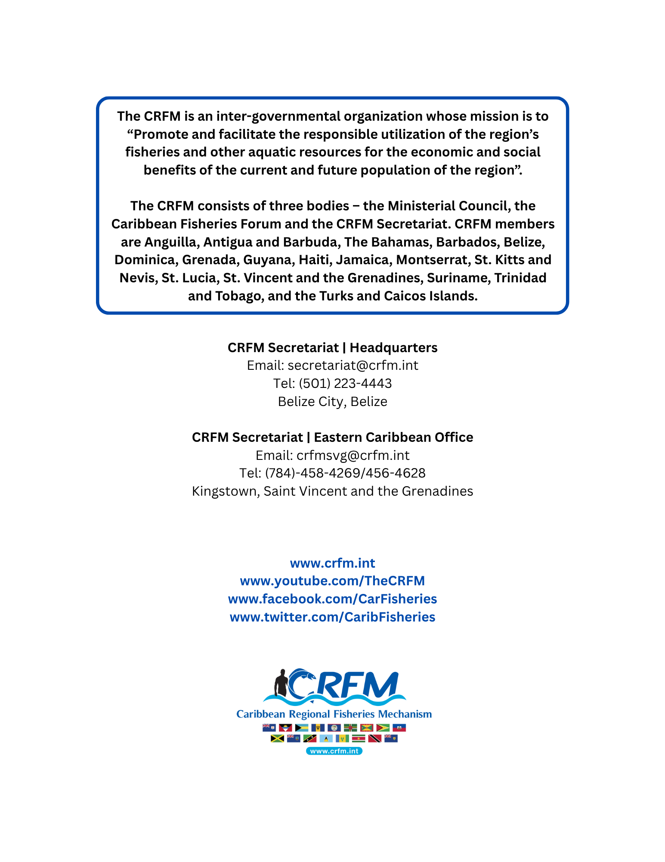

https://www.worldometers.info/world-population/barbados-population/

