
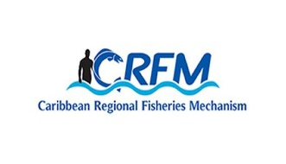



ISSN: 1995-1132

CRFM Technical & Advisory Document No. 2025 / 11

FINAL REPORT
DATA GAP AND NEEDS ASSESSMENT TO INFORM MARINE SPACIAL PLANNING IN BELIZE

CRFM Secretariat
Belize
CRFM Technical & Advisory Document -
Number 2025 / 11

Data Gap and Needs Assessment to Inform Marine Spatial Planning in Belize

Prepared for: Caribbean Regional Fisheries Mechanism

Submitted by: Science for Sustainability Ltd (SSL).
August 14, 2024

This publication has been made possible through funding by BE-CLME+ Project: Promoting National Blue Economy Priorities Through Marine Spatial Planning in the Caribbean Large Marine Ecosystem Plus - GEF Project ID 10211

CRFM Secretariat
Belize
2025

CRFM Technical & Advisory Document Number 2025 / 11

Data Gap and Needs Assessment to Inform Marine Spatial Planning in Belize

© CRFM 2025
All rights reserved.
Reproduction, dissemination and use of material in this publication for educational or non-commercial purposes are authorised without prior written permission of the CRFM, provided the source is fully acknowledged. No part of this publication may be reproduced, disseminated or used for any commercial purposes or resold without the prior written permission of the CRFM.

Correct Citation:
CRFM, 2025. Data Gap and Needs Assessment to Inform Marine Spatial Planning in Belize. CRFM Technical & Advisory Report No. 2025 / 11. 81p.

ISSN: 1995-1132
ISBN: 978-976-8293-93-0

Published by the Caribbean Regional Fisheries Mechanism Secretariat
Belize and St. Vincent and the Grenadines

Executive Summary

Background
The Belize Marine Spatial Planning Data Gaps and Needs Assessment provides a detailed evaluation of the information required to support Marine Spatial Planning (MSP) in Belize. The report emphasizes the significance of spatial data and its necessity for planning, mapping, and decision-making to balance environmental protection, social needs, and economic development in Belize’s marine space. The report also highlights the critical role of data in supporting the sustainable use and protection of marine resources and underscores that MSP requires a robust, comprehensive understanding of both ecological and human activities across marine environments. Data-driven planning ensures that the competing interests of economic development, environmental conservation, and social welfare are balanced and aligned with Belize’s international commitments, such as the Blue Loan Agreement (BLA).

The assessment reiterates that effective MSP is essential for achieving a sustainable blue economy. Belize’s Blue Economy Development Policy and Strategy (BEDPS) aims to increase economic growth through ocean-based sectors such as fisheries, tourism, and renewable energy while maintaining ecological balance. The MSP process will play a key role in managing competing ocean uses and preventing conflicts between industries while ensuring the protection of vital ecosystems. However, achieving this vision requires that the country addresses data gaps in sectors critical to the blue economy, such as mariculture, offshore energy, and marine tourism. In this context, MSP provides a strategic tool to align Belize’s economic and environmental objectives, helping the country meet its international commitments, such as the Global Biodiversity Framework and Sustainable Development Goals (SDG 14: Life Below Water).

MSP is a public process of analyzing the spatial and temporal distribution of human activities, habitats and natural resources in marine areas in order to designate specific use zones to achieve ecological, economic and social objectives that have been specified through a political process. MSP is a practical way to create and establish a more rational use of Belize’s marine space and the interactions among users, to balance demands for development with the need to protect the environment, and to deliver social and economic outcomes in an open and planned way. As part of its commitments under the BLA, Belize is obligated to produce a Marine Spatial Plan that brings together multiple users of the sea – including energy, industry, government, conservation and recreation – to make informed and coordinated decisions about how to use marine resources sustainably.

MSP generally uses spatial data to prepare maps that illustrate a more comprehensive picture of a marine area – identifying where and how an ocean area is being used and what natural resources and habitats exist. The data requirements for MSP must therefore be assessed against the available data so that gaps may be identified and filled in time to meet current and future planning needs.

MSP is crucial for Belize as it is part of its commitment under the BLA, requiring the development of a legally enforceable marine spatial plan by 2026. The Belize Sustainable Ocean Plan (BSOP), a central component of this strategy, aims to allocate 30% of Belize's marine territory to biodiversity protection and sustainable use. This plan will designate specific zones in the ocean for various activities such as conservation, fisheries, tourism, and shipping, while protecting marine biodiversity. The establishment of institutional structures, such as the MSP Authority under the Coastal Zone Management Authority and Institute (CZMAI), is essential for coordinating the MSP process. The BSOP’s governance framework ensures that stakeholders are involved, making the planning process inclusive and transparent. However, further legal frameworks may be necessary to ensure the enforcement and longevity of the MSP plan.

Methodological Approach
A systematic framework was used for identifying and organizing essential data needed for MSP. A review was conducted of relevant guidance material from the Intergovernmental Oceanographic Commission and other relevant MSP literature published by UNESCO, and local stakeholder input was obtained through online surveys , meetings and workshops. These activities provided information to develop the tabular listing of data needed to guide effective Marine Spatial Planning in Belize. The results of the online survey, discussions with key stakeholders and a national validation workshop provided stakeholder input which was used to assess the availability of datasets and collect other relevant metadata including, inter alia, spatial and temporal extent, data format, and sources. Data availability was also assessed by consulting national stakeholders and reviewing existing national databases.

A data catalog was constructed which lists each essential dataset as a row record and it was analyzed to identify data gaps and integrate stakeholder feedback on priority datasets. The data catalog aims to consolidate datasets from multiple sectors into a single, accessible framework. This includes sector-specific datasets for governance, infrastructure, living and non-living resources, and ocean uses, among others. The data catalog emphasizes that a standardized approach to categorizing and organizing data is essential for supporting MSP, which involves distinguishing datasets into baseline, derivative, and modeled data types. A data catalog structured according to international hierarchical standards and the Belize’s Sustainable Ocean Plan (BSOP) sector categories provides an efficient means to manage marine and coastal data, enabling better decision-making for MSP. The catalog's continued effectiveness beyond this report will rely on regular updates and stakeholder collaboration to address ongoing data needs.

Key Findings
Data Needs and Gaps: Belize has collected considerable spatial data on various marine ecosystems and human activities. A total of 229 spatial datasets were identified as relevant for Marine Spatial Planning (MSP) in Belize. These datasets span multiple categories, including governance, infrastructure, living resources, non-living resources, and ocean uses. Out of the 229 identified datasets, 137 datasets (about 60%) are already available in spatial format to some extent. These datasets cover areas such as fisheries, marine biodiversity, and habitat mapping. The remaining 92 datasets (40%) were identified as gaps, meaning that these datasets are currently unavailable or incomplete. These gaps are particularly prominent in emerging sectors like deep-sea minerals, offshore renewable energy, and biopharmaceuticals. Data availability by category was as follows:
  - Governance: 5 out of 7 datasets available.
  - Infrastructure: 10 out of 14 datasets available.
  - Living Resources: 47 out of 75 datasets available.
  - Non-living Resources: 12 out of 29 datasets available.
  - Ocean Uses: 63 out of 104 datasets available.
These numerical results highlight that while progress has been made in collecting spatial data for traditional sectors, significant gaps remain in newer and emerging sectors, which need to be filled to support comprehensive marine spatial planning in Belize.

Priority Data Gaps: The assessment makes it clear that while Belize has made notable progress in collecting data on marine ecosystems and human activities, priority gaps remain. These include essential datasets on biodiversity, land tenure, hydrography, and coastal geomorphology, as highlighted by stakeholders. The assessment also identified key gaps, especially in emerging sectors such as deep-sea minerals and offshore renewable energy. The report presents a matrix showing the availability of datasets across different sectors and highlights where data is insufficient. Traditional sectors like fisheries and marine species monitoring have more comprehensive data, while emerging sectors face significant shortages. For emerging sectors, there is an urgent need for baseline data to support future development, such as in marine renewable energy and biopharmaceutical exploration.

Significance of Data Gaps: These gaps could delay Belize's progress toward achieving its conservation and development goals, particularly the country’s commitment to protecting 30% of its marine territory as marine protected areas (MPAs) by 2026. Without a complete picture of marine biodiversity and the impact of human activities on habitats and species, Belize may struggle to create and effectively manage protection zones that fulfill its obligations under the BLA.

Under the BLA, Belize is required to expand its protection zones. However, limited data on marine biodiversity, including species of conservation concern and critical habitats, makes it challenging to fully understand biodiversity values and plan for effective protection zones. Though data on coral reefs and mangrove coverage exists, there are still substantial gaps in data on species such as fish, marine mammals, and critical habitats for conservation. One of the key challenges lies in Belize's limited technological capacity and human resources to collect , manage and analyze the data. Furthermore, the high cost of acquiring the remaining data represents a significant barrier to comprehensive planning.

Data Standardization and Accessibility: A key discussion point in the document is the need to systematize and standardize data across institutions. Belize has already collected large amounts of data, but these datasets are often fragmented, inconsistent, or inaccessible to decision-makers. The report highlights the need for a centralized data repository to ensure that relevant stakeholders can access up-to-date, high-quality data. Data standardization will also help avoid redundancies and ensure that future data collection efforts are targeted and efficient.
Belize’s MSP process will benefit from adopting standardized frameworks for data collection and analysis, as seen in successful MSP initiatives globally. The report mentions the use of tools like GIS, Seasketch, and MARXAN in data analysis, which could greatly enhance the ability to map and prioritize areas for conservation and development.

Data Limitations and Access Barriers: The document highlights limitations in temporal and spatial data coverage of key datasets. Many datasets are outdated, incomplete, or geographically limited, but may still serve a useful purpose dependent on the scope required for the analysis.
One of the key barriers discussed is the lack of effective data-sharing protocols among stakeholders. While many organizations hold valuable data, it is often inaccessible due to bureaucratic hurdles or lack of awareness. Additionally, there is no centralized repository for MSP-related data, making it difficult to know what data is available and where it is stored.

Human Capacity and Technological Gaps: Belize faces significant challenges due to the limited availability of technology, high acquisition costs for data, and gaps in human resources capable of managing and analyzing data. Addressing these shortcomings will require targeted investments in human capacity building, access to technology, and financial resources for data collection. Effective governance structures will also ensure that the MSP process is inclusive and transparent, allowing for meaningful participation from coastal communities, industry, and conservation organizations.

Resources and Strategies needed to Close Gaps: The Belize Marine Spatial Planning (MSP) Data Gaps and Needs Assessment provides key recommendations for addressing the data needs and gaps identified throughout the assessment. It offers strategic approaches in four main areas: (i) institutional arrangements, (ii) capacity building, (iii) data sources and collection methods and (iv) collaboration to ensure Belize can effectively implement MSP.

Institutional Arrangements: The report emphasizes the need for an Interagency Information Management System or Data Hub for MSP. This centralized system would organize, store, and provide access to all data required for MSP. The Coastal Zone Management Authority and Institute (CZMAI) is recommended as the lead agency to manage the MSP Data Hub, given its experience in data collection and collaboration with various stakeholders. However, institutional strengthening, especially in human and technical capacity, is necessary for the CZMAI to fully manage the system.
The Data Hub would ensure transparency and consistency in organizing and describing complex information on marine ecosystems, human activities, and ecosystem services. There is also the need for standardization of data categories, vocabulary, and definitions across all contributors to facilitate efficient data searches and analysis.

Capacity Building: The report stresses the importance of investing in human capacity for managing spatial data, especially in areas such as metadata standards, data integrity, and online data portals. There is also a need for technical expertise in data analysis, particularly for specialized subject areas such as species population dynamics and habitat coverage. CZMAI will require both general and subject-specific capacity-building efforts to support the long-term success of Belize’s MSP process.

Data Sources and Collection Methods: The report outlines recommendations for improving data collection and sharing methodologies and filling priority data gaps. These include developing inter-institutional data-sharing protocols to ensure that stakeholders can access the data they need, without bureaucratic hurdles, and creating a master list of definitions for all datasets relevant to MSP will also aid in the collection and assimilation of new data into the system
Collaboration: Collaboration between government agencies, non-governmental organizations, and international partners will be essential to gather missing data and share technical expertise. The report suggests that international cooperation will be critical in closing data gaps and improving technical capacity. Partnerships with regional and international organizations, such as The Nature Conservancy (TNC) and the Caribbean Regional Fisheries Mechanism (CRFM), have already provided valuable support in data collection and planning. Extending these collaborations could help Belize access additional resources and expertise for overcoming the technological and financial challenges it faces. This includes access to new technologies, such as satellite imagery and high-precision hydrographic surveys, as well as collaborations with regional and international partners to gain access to advanced data management tools and expertise.

Sustainable Financing: Securing long-term financial resources is another critical aspect discussed in the report. The BLA and other international funding mechanisms have already contributed to Belize’s MSP process, but sustaining this level of investment will be necessary for meeting the 2026 deadline. Ensuring that financial support is not only available for data collection but also for long-term capacity building and monitoring is vital for the success of Belize’s MSP efforts.

Conclusion
The MSP process is a vital tool for Belize to ensure sustainable ocean management while meeting its international commitments. The report makes it clear that Belize’s Marine Spatial Planning process is at a crucial juncture. While the country has made significant progress in data collection and stakeholder engagement, addressing data gaps, particularly in biodiversity and human impacts, remains a priority as does building capacity, and ensuring that institutional frameworks support the implementation of a legally binding MSP by 2026.

The report recommends several strategies to address the identified gaps. First, Belize must systematize and standardize the available data to fill the most pressing data needs. There is also a need for enhanced capacity building, particularly in spatial data management and analysis. Partnerships and collaborations with regional and international entities can help fill data gaps, share resources, and enhance technical skills.

Sustained investment in technology, human resources, and international partnerships will be crucial for successfully implementing the Belize Sustainable Ocean Plan. Belize’s success in MSP will not only fulfill its obligations under the BLA but also pave the way for a sustainable, resilient blue economy that benefits future generations.

List of Acronyms

BBIC | Belize Blue Investment Company
BEDPS | Blue Economy Development Policy and Strategy
BLA | Blue Loan Agreement
BPZ | Biodiversity Protection Zone
BSOP | Belize Sustainable Ocean Plan
CCCCC | Caribbean Community Climate Change Centre
CFA | Conservation Funding Agreement
CRFM | Caribbean Regional Fisheries Mechanism
CZMAI | Coastal Zone Management Authority and Institute
DG MARE | Directorate-General for Maritime Affairs and Fisheries
DoE | Department of the Environment
EAF | Ecosystem Approach to Fisheries
EDF | Environmental Defense Fund
FD | Forest Department
FiD | Fisheries Department
GBF | Global Biodiversity Framework
GDP | Gross Domestic Product
ICZMP | Integrated Coastal Zone Management Plan
IDB | Inter-American Development Bank
IOC | Intergovernmental Oceanographic Commission
MED-CFU | Ministry of Economic Development – Climate Finance Unit
MEP | Maritime Economy Plan
MPA | Marine Protected Area
MSP  NBiO | Marine Spatial Planning  National Biodiversity Office
NCCO | National Climate Change Office
OCPP | Ocean Country Partnership Programme
OECS | Organization of Eastern Caribbean States
SDG | Sustainable Development Goals
SIDS | Small Island Developing States
TNC | The Nature Conservancy
UB-ERI | University of Belize – Environmental Research Institute
UNESCO | United Nations Educational, Scientific and Cultural Organization
WCS | Wildlife Conservation Society
WWF | World Wildlife Fund

Table of Contents
Executive Summary i
1. Introduction 1
1.1 Marine Spatial Planning 1
1.2 Understanding Marine Spatial Planning (MSP) 2
2. Marine Spatial Planning Process 5
3. MSP Implementation Globally 7
4. Data Needs for MSP 10
5. Status of MSP in Belize 14
6. Data needed for Belize Sustainable Ocean Plan (BSOP) 17
6.1 Methodology 18
7. Data Availability and Existing Arrangements for MSP 21
7.1. Rationale for Data Catalog Common Vocabulary 21
7.2. Sources of information on data availability, gaps, needs and existing arrangements 23
7.3. Data Catalog 27
8. Data Gaps, Priorities and Resources Needed for MSP 41
8.1. Major Gaps and Priority Data Needed to Inform MSP 45
8.2. Data Limitations 49
8.3. Data Access Barriers 51
8.4. Gaps in Capacity to Generate, Manage and Analyze Data (Human and Technological [Software/Hardware]) 52
8.5. Resources Needed to Address Gaps (Data Sources, Collection Methods, Acquisition Costs) 55
9. Recommendations for Addressing Data Needs and Gaps for MSP 57
9.1 Institutional Arrangements 57
9.2 Capacity Building 59
9.3 Data Sources and Collection Methods 60
10. Summary and Conclusion 61
11. References 62
Annexes 63

Introduction

This report was prepared under the BE: CLME+ Project, as a national consultancy to conduct a data gap and needs assessment to inform marine spatial planning in Belize and support the development of Belize’s Marine Spatial Plan (MSP), known as the “Belize Sustainable Ocean Plan” (BSOP). The BE-CLME+ Project is a regional initiative aimed at promoting blue economy development in the Caribbean region through Marine Spatial Planning (MSP) and Marine Protected Areas (MPAs), Ecosystem Approach to Fisheries (EAF), development of climate-smart sustainable fisheries value chains, and knowledge management in Barbados, Belize, Guyana, Jamaica, Saint Lucia, and Panama.

1.1 Marine Spatial Planning

Marine Spatial Planning (MSP) as defined by the Intergovernmental Oceanographic Commission (IOC) of UNESCO is “A public process of analysing and allocating the spatial and temporal distribution of human activities in marine areas to achieve ecological, economic and social objectives that have been specified through a political process” (UNESCO-IOC/European Commission 2021). It is a tool that allows sector-based planning to address multiple uses across land-sea interfaces and ocean governance that goes beyond the reach of integrated coastal zone management, as its scope is broad across multiple spaces and integrates activities and uses from land to coastal areas, and beyond, into the exclusive economic zone. It is a comprehensive, integrated, ecosystem-based planning approach that is vastly different from the traditional sector based, single-purpose approach historically used in coastal and ocean governance. In the last two decades, the use of this planning approach has been advocated by an increasing number of scientists, policy makers and marine science experts as the most effective way to protect marine resources, address conflicts, improve coastal and ocean resources management and plan for future ocean use (McGann et al. 2014).

Recently, MSP efforts have been implemented in multiple countries around the world including Europe, Australia, New Zealand, China, the U.S., Canada with MSP studies and guidelines developed to guide other countries, with a primary focus on lessons learned from European countries (Collie et al., 2013; UNESCO, n.d.). Through the GEF funded Caribbean Regional Oceanscape Project, ocean governance frameworks and coastal and marine spatial plans have been developed for the Organization of Eastern Caribbean States (OECS): Dominica, Grenada, St Kitts and Nevis, Saint Lucia, St Vincent and the Grenadines (OECS 2021). Since 2017, IOC-UNESCO and the European Commission’s Directorate-General for Maritime Affairs and Fisheries (DG MARE) adopted a “Joint Roadmap to accelerate MSP processes worldwide (MSP roadmap)”, with the aim of tripling the maritime area globally that is benefitting from Marine Spatial Planning by 2030. This has led to accelerated efforts to implement MSP across the Caribbean and Latin America with IOC-UNESCO in partnership with the European Commission’s Directorate-General for Maritime Affairs and Fisheries placing many of the countries of the region on a surer footing towards effective management of their maritime resources. Marine Spatial Planning can also help to address cross border or transboundary ocean governance issues and help pave the way towards a sustainable blue economy through effective and participatory planning.

1.2 Understanding Marine Spatial Planning (MSP)
There are several key characteristics that define effective MSP. It is ecosystem-based, focused on balancing ecological, economic, and social goals and objectives toward sustainable development. It is integrated, and looks across sectors and agencies, and among levels of government. It involves place-based or area-based planning. It is adaptive, providing opportunities for learning and adjustments based on experience. It is strategic and anticipatory, focused on the long-term. Finally, the MSP process is participatory, ensuring stakeholders are actively involved in the process.

In the pursuit of the global sustainable development goals and development of a sustainable blue economy and effective ocean governance, MSP has become an important tool to help countries achieve their sustainable development and conservation targets. Due to its highly integrated nature, MSP offers an opportunity to help address all the Sustainable Development Goals (SDG) goals, while focusing on SDG 14 – Life Under Water (Figure 1) and the Global Biodiversity Framework (GBF). The vision articulated for the GBF is that of a world living in harmony with nature where “by 2050, biodiversity is valued, conserved, restored and wisely used, maintaining ecosystem services, sustaining a healthy planet and delivering benefits essential for all people.” The mission of the GBF up to 2030, towards the delivery of the 2050 vision, is “To take urgent action to halt and reverse biodiversity loss to put nature on a path to recovery for the benefit of people and planet by conserving and sustainably using biodiversity and by ensuring the fair and equitable sharing of benefits from the use of genetic resources, while providing the necessary means of implementation”. Most countries have already designated various marine spaces for transportation, oil and gas, aquaculture, renewable energy, etc. However, these designations have been historically sector-based or on a case-by-case basis. Furthermore, they do not adequately consider the spatial and temporal impacts on other human activities or on the environment, leading to conflict among human users and degradation of marine environment and resources. These conflicts may reduce the ability of the marine environment to optimally provide ecosystem services. Decision making is not as effective since it is reacting in response to these negative impacts rather than being proactive and planning for a more desirable future. MSP offers a future-oriented solution where present-day conflicts can be addressed as part of a larger planning effort for future uses and potential conflicts, with the aim of safeguarding the environment to ensure sustained ecosystem services from the ocean space and development of a sustainable blue economy.
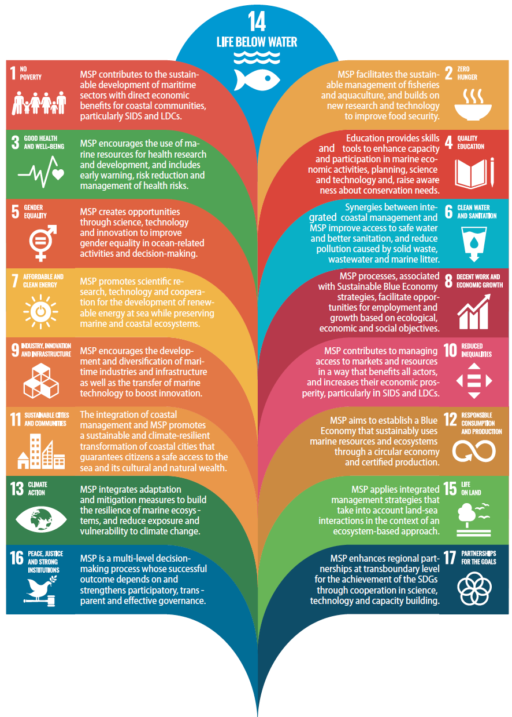
Figure 1: Relationship between MSP and the SDGs, Source: IOC-UNESCO, 2020

Marine resources vary with both space and time and understanding the trends in distribution of activities and ecosystem services are important for managers to have a good grasp to achieve effective marine management. Data plays an important role in understanding spatial and temporal distribution of activities and services and in informing the MSP process, both in the planning and implementation of MSP. Therefore, having the required data readily available and accessible for decision making is crucial. Understanding and mapping spatial and temporal distribution in the ocean space is an important part of MSP process, which helps countries to understand the spatial and temporal dynamics of their marine space; and maximize and sustain ecosystem goods and services. MSP therefore can provide a variety of economic, social and environmental benefits to countries, thereby improving access and increased benefits to a wide range of users while conserving and protecting valuable ecosystems and resources (Table 1).

Table 1 Benefits of Marine Spatial Planning
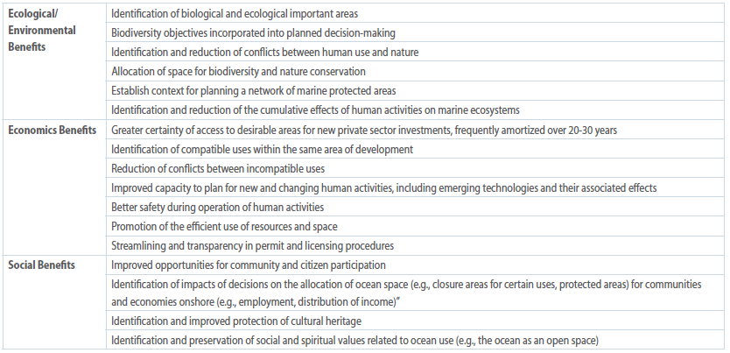
Source: IOC Manual and Guides No. 53, ICAM Dossier No. 6. Paris: UNESCO. 2009 (English).

The Marine Spatial Planning process culminates in a comprehensive MSP Plan that usually has a 10 to 20 year life span and lays out the vision of the future for a country’s marine and ocean resources. It includes a marine spatial plan along with other management measures, zoning maps and regulations necessary to implement that plan (Figure 2). All these outputs involve various data types crucial to the definition of the zoning maps and the plan.

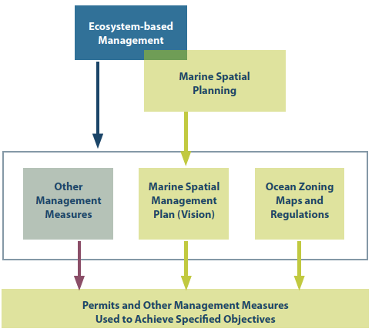
Figure 2: Major outputs of MSP (Source: Ehler and Douvere, 2009)

Marine Spatial Planning Process

The development and implementation of Marine Spatial Planning generally takes several years from pre-planning through to approval and implementation. Countries need to have a clearly identified timeline for completion and ensure that the necessary resources are identified and available for successful MSP completion. MSP involves a variety of steps (Ehler and Douvere 2009) which include:

- Identifying need and establishing authority – This first step involves clearly defining why MSP is needed. Having a clear objective for MSP will keep the process focused and on track as MSP rolls out. It will also help define the appropriate authority needed to develop and implement MSP. Key outputs from this step include a preliminary list of specific problems that need to be solved through marine spatial planning and a decision about the type of authority needed for developing marine spatial planning.
- Obtaining financial support - involves two major tasks: identifying possible alternative financing mechanisms for MSP and defining the feasibility of these alternative funding mechanisms. This is closely related to setting goals and objectives for MSP. Usually, the main output from this step is the development of a financial plan that estimates the costs of MSP activities and identifies alternative means to obtain financing for those activities.
- Organizing the process through pre-planning - involves an objective based approach to marine spatial planning centered around clearly defined goals, objectives, and indicators which evaluate the performance of management measures in achieving the goals and objectives. The main outputs of this pre-planning include establishment of a marine spatial planning team with the desired skills; a work plan; defined boundaries & time frames; a set of principles to guide development of the marine spatial plan; and the goals and objectives for MSP.
- Organizing stakeholder participation – It is important to involve key stakeholders in the development of MSP because the process has multiple objectives (social, economic and ecological) and should therefore reflect the varied expectations, opportunities or conflicts occurring in the MSP area. The most important output from this is a plan outlining who, when and how to involve stakeholders throughout the marine spatial planning process.
- Defining and analyzing existing conditions – This involves conducting an inventory on the current status of the coastal and marine environment and includes collecting a wide range of baseline information. It should also consider any obvious trends and developments to assess uses and pressures later in the planning process. Data should be up-to-date, objective, reliable, relevant and comparable with a major focus on the following spatial data categories: biological and ecological features, distribution of human activities and oceanographic and other physical environmental features. The general expected outputs of this step include inventory and maps of important biological and ecological areas and current human activities and pressures; and identification of possible conflicts and compatibilities among existing human uses and between existing human uses and the environment.
- Defining and analyzing future conditions – Equally important to defining and analyzing existing conditions is that of defining and analyzing future ones. This involves asking the question: where do we want to be? Key tasks here include projection of current trends in existing human uses, estimating spatial and temporal requirements for future, new demands of ocean space, identifying possible alternative future scenarios, and selecting the preferred use scenario.
- Preparing and approving the spatial management plan – This is the final phase of planning and answers the question: how do we get there? It should outline specific management measures that will produce the desired future and achieve the target goals and objectives, through clearly defined decisions about the location and timing of human activities. This step culminates in a comprehensive management plan, including if needed, a zoning plan.
- Implementing and enforcing the spatial management plan – After the end of the planning process begins the implementation. This is the action phase of MSP with the designated authorities starting implementation of the new management actions defined in the MSP.
- Monitoring and evaluating performance – This is an ongoing process that provides managers and stakeholders with indications on the extent of progress towards achieving the MSP goals and objectives, by assessing the status of the marine environment and measuring the performance of management measures.
- Adapting the marine spatial management process – This final step involves the use of adaptive management. Based on results of monitoring and evaluation, the marine spatial planning should be adapted as necessary so that actions have their intended effects. This will involve periodic review and updating of the marine spatial plan.

MSP is not a one-off process resulting in a one-time plan, rather it is an iterative process that involves adaptive management, learning and adapting to changing conditions and environment (Figure 3). The process of MSP is not a linear process but rather a dynamic and adaptive one. MSP should involve feedback loops that incorporate changes as needed, revisiting of goals and objectives due to changing conditions, change in management approaches based on new available data, or varying levels of stakeholder participation that inform the planning process over time.

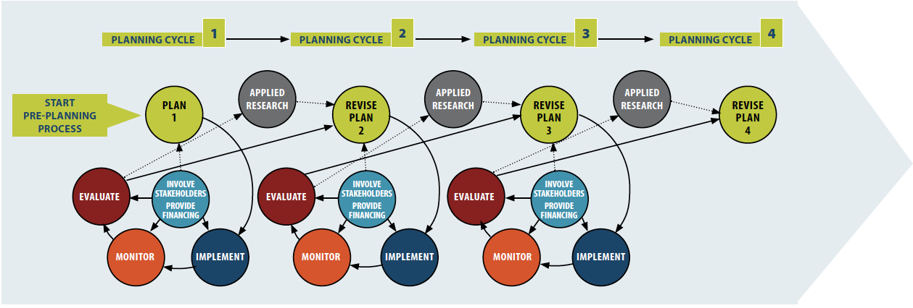
Figure 3: Marine Spatial Planning Process (Source: Ehler and Douvere, 2009).

MSP Implementation Globally

There is a global trend of increasing Marine Spatial Planning in countries across the world, which is closely tracked and supported by IOC-UNESCO. Since 2017, when IOC UNESCO and DG MARE initiated the MSP Roadmap Project, there has been substantial capacity built for MSP globally and initiation of the process across multiple countries. By 2021, the project had benefited 500 stakeholders from over 140 countries through a variety of trainings, workshops, forums, etc. and over 20 publications including an international guide on MSP. However, despite this wealth of capacity building among about 100 countries/territories that are engaged in MSP, most still do not yet have a marine spatial plan. Engagement in MSP is defined as the existence of at least a pilot project or an MSP working group established in the country to initiate discussions and scoping.

At the end of 2023, over 126 countries were determined to be engaged in MSP initiatives, representing a 20% increase from 2022 (Figure 4). This increase is largely from Africa and Oceana with the initiatives led or supported by international organizations (Figure 5). A similar trend exists for MSP initiatives in the Caribbean and Southeast Asia. North America and Europe remain as the regions with the most MSP plans completed and implemented. A total of 45 countries have approved MSP plans, which represent a 10% increase from last year. This number is considered low, quite likely since the process for the development of an approved MSP can take several years, since the necessary assessments, stakeholder engagement and approval require a significant investment of time. Furthermore, the transition from MSP discussions to an approved MSP cannot occur without a designated authority which is dependent on the establishment of a legal framework, which could also take several years to establish.

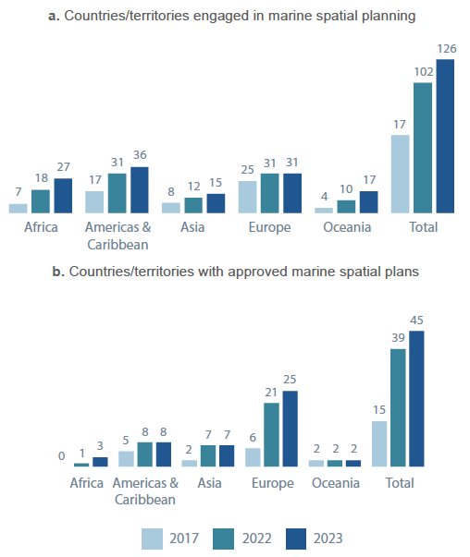

Figure 4: Marine spatial planning status around the world: a) number of countries/territories engaged in MSP; and b) number of countries/territories with approved marine spatial plans. Source IOC-UNESCO 2024.

Nevertheless, MSP is used as a platform for multi-sectoral engagement and negotiating diverse interests. Currently, many countries have linked MSP with the development of sustainable ocean-based economies, also referred to as the ‘blue economy’. The Ocean Panel 2023 documented more than 25% increase in the number of countries that have joined the High-Level Panel for a Sustainable Ocean Economy and commitment to develop sustainable ocean plans focused on blue economy approaches, which include MSP. At the same time the MSP approach is continually used to promote the achievement of global conservation goals, such as Target 1 (on participatory, integrated and biodiversity inclusive of spatial planning) and Target 3 (on at least 30% of coastal and marine areas effectively conserved and managed by 2030) under the Global Biodiversity Framework. It is expected that MSP adoption will be accelerated with continued support from international organizations, stakeholders, and national governments working together, especially in developing countries and SIDS, to help address the capacity gaps. In depth monitoring and evaluation should be done to help assess: (i) the MSP process, including degree of stakeholder engagement; (ii) marine spatial plans and their relevance; (iii) implementation of the plan; and (iv) the outcomes of the plans. This will provide a comprehensive picture of how plans are being implemented and improved.

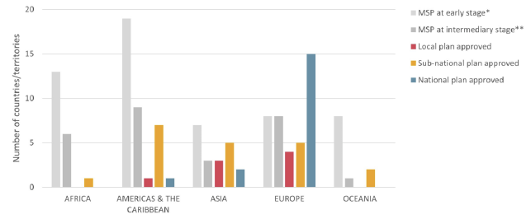
Figure 5: Status of MSP globally based on stage of the MSP process in April 2022. Note: *MSP Pilots were considered to be at early stage; **for at least part of the maritime area. Source IOC-UNESCO, 2022.

MSP in the Caribbean is in its early stage and progressing gradually, as ocean governance capacity is being strengthened in the region. Significant progress has been made across the Organisation of Eastern Caribbean States (OECS) with MSP initiated from as early as 2010 and in many of the countries, MSP related plans have been developed. This has placed the countries of the OECS ahead of the other islands of the Caribbean in implementing large scale MSP through an evolving response to increasing demands on space and resources, initially to reduce conflicts and protect the environment, but more recently to deliver a sustainable blue economy (Table 2). This has also enabled the countries to advance marine data collection, ocean literacy and ocean governance in the OECS. However, it is uncertain when these countries will achieve full implementation of MSP despite having plans, due largely to various capacity challenges, including inadequate human resources, data limitations, long-term funding constraints and the lack of MSP legislation. The further evolution of MSP in the OECS, and extending into the rest of the Caribbean will depend on how well national governments can address the capacity needs and gaps (Mahadeo 2022).

Table 2: Marine Spatial Plans from the OECS (Source: Mahadeo, 2022)

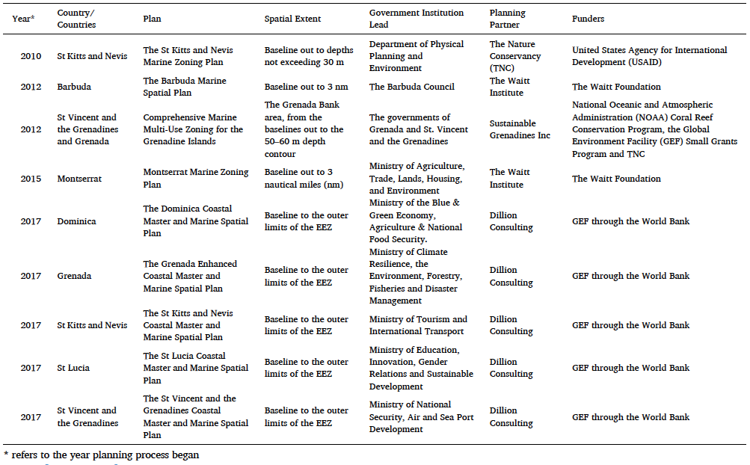

Data Needs for MSP

A critical part of the MSP process and implementation is evidence-based decision making. Therefore, a successful MSP requires the availability of reliable data and spatial information for effective planning and implementation and to realize a sustainable blue economy. This spatial information is a critical component of the data required for every stage of the marine spatial planning process and enables analysis to address a range of areas, including:
- an understanding of the current status and future uses of the marine environment;
- developing objectives for marine conservation;
- consideration of land-sea interactions;
- identification of conflicts and synergies among maritime sectors and coastal activities;
- understanding of the socio-economic and governance context

These types of data and information are categorized based on the main pillars of MSP: environmental data, economic data and social data. Data collection provides the basis for understanding the current conditions, current and future trends, relevant issues in the marine space and future needs for planning effective ocean governance. Fundamental to the data collection process is the adoption of an ecosystem-based approach that looks holistically at the marine and coastal environments. This will involve data on the marine environment, and activities in the marine and coastal space, including socioeconomic information and governance arrangements, as well as climate change. The data collection process should be structured, targeted and thematically focused to support and inform MSP objectives and ensure that the planning process meets the country’s needs and ensure an effective ocean governance framework is established. The collection and analysis of data requires various levels of capacities both human and technical capacity, particularly for the generation of spatial data. This often involves people skilled in spatial data collection and analysis and will require technical analytical resources such software, IT equipment, remote sensing tools and other relevant resources. To ensure that the most relevant and complete data is available, the necessary financial resources must be identified to acquire and support both the human and technical capacity necessary to address data needs for MSP. However, the data needed for MSP must be comprehensively identified first before the supporting resources and capacity needed can be acquired.

Identification of the types of data and information required can follow defined frameworks based on global MSP practices or newly developed frameworks adapted for the specific context and tailored to the MSP objectives for a particular country. Several examples of frameworks exist that outline data and information needs including the European Directive on Maritime Spatial Planning 2014/89/EU, and marine biodiversity defined by Good Environmental Status as is described in the Marine Strategy Framework Directive 2008/56/EC. The broad categories of data required for MSP are listed in the table below, but these can be further defined and tailored to the specific needs of individual/ national MSP processes.

Table 3: List of data types required for analyzing initial existing conditions

MSP Input Data required for analyzing existing conditions
• Oceanographic spatial information and physical processes (ocean temperature, waves, currents…)
• Data on marine environment and ecological patterns (eutrophication level, benthic habitat status, relative importance of areas…)
• Marine conservation (extension and objectives of Marine Protected Areas…)
- Ecosystem services – vulnerability and resilience
• Information on coastal and maritime activities (aquaculture, ocean energy facilities, coastal tourism, ports and harbours…)
• Socio-economic information (coastal population, economic activities, benefits and impacts, unemployment, income by sector…)
- Emerging ocean uses and future needs
• Governance information and existing management measures (administrative units, prospecting permits….)

For a clearer link between data needs and the MSP process, Ehler and Douvere (2009) provides useful guidance and breaks down the data needs in relation to the questions which need to be answered to inform MSP, as well as the analytical tasks underpinning those questions. The guidance goes even further to suggest how the information may be presented, like maps for example, to inform decision making about MSP. Such guidance is useful from a process-based perspective as it informs the nature and depth of data analyses which must be carried out to provide the necessary information needed for MSP. From this, the data needs can be clearly linked to each analytical task by determining whether quantitative or qualitative data on a particular subject is going to be inputted into the analysis. This logical process flow for assimilation of data into MSP helps to reduce cost and effort associated with unnecessary data collection and streamlines the identification of data needs and gaps. Figure 6 highlights the data-reliant steps in the MSP process, i.e. steps 5 and 6.

The informational outputs and associated analytical tasks resulting from step 5, according to Ehler and Douvere (2009) are as follows:

- information outputs that will be used to inform decision making:
- An inventory and maps of important biological and ecological areas
- An inventory and maps of current human activities and pressures
- A map of possible conflicts and compatibilities among existing human uses
- A map of possible conflicts and compatibilities between human uses and nature

- The analytical tasks involved in producing these outputs:
- Task 1 - Collecting and mapping information about important ecological, environmental, and oceanographic conditions
- Task 2 - Collecting and mapping information about existing human activities
- Task 3 - Identifying current pressures, threats, conflicts and compatibility

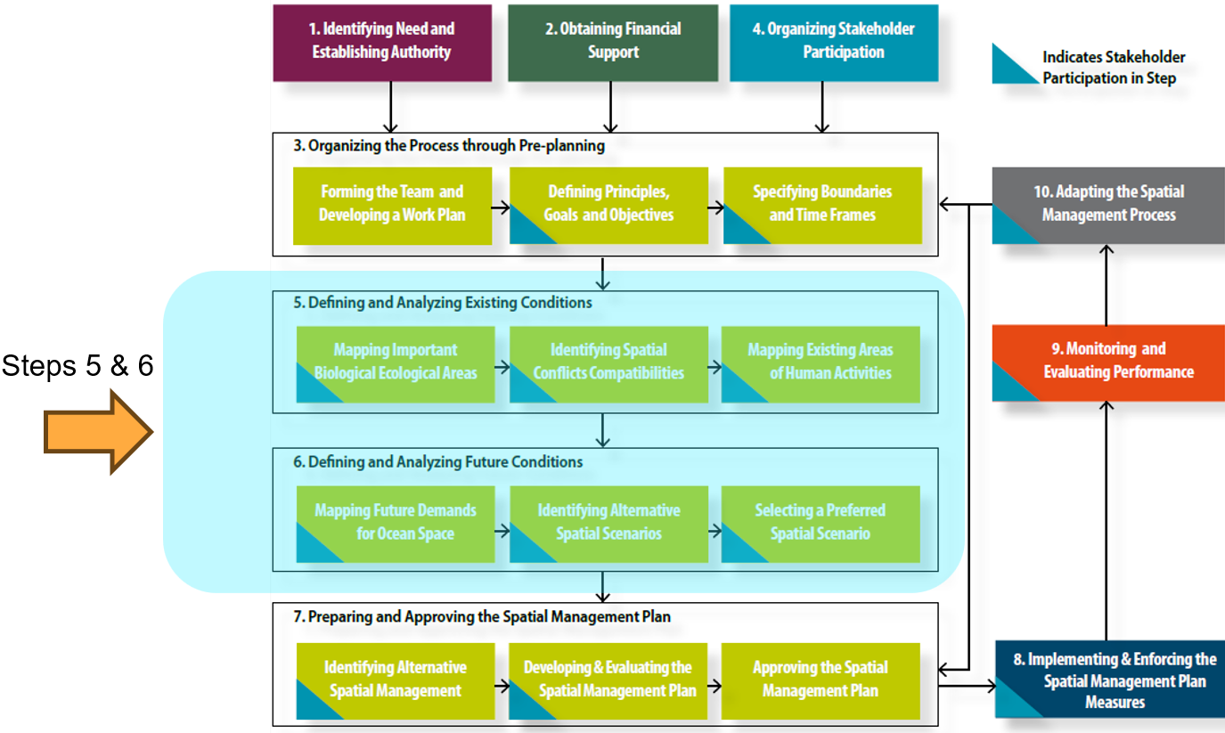

Figure 6: Steps in the MSP process, highlighting those that require spatial data (From Ehler and Douvere, 2009).

The logical process flow from analytical task to information outputs provides sufficient guidance to identify the data needed to conduct the analytical task. To assess existing conditions, three general categories of data are needed: data on biological and ecological spatial and temporal distribution; data on spatial and temporal distribution of human activities; and oceanographic and hydrographic features which may help to act as proxies for determining biological occurrence or suitability for human activities. Under these three broad categories of data, data on specific species, habitats, human activities, hydrographic features, etc. can then be earmarked as necessary inputs into the data analysis. Ehler and Douvere (2009) provide guidance on the necessary data required for step 5 of the MSP process, and these are shown in Figure 7.

Step 6 of the MSP process is about defining future conditions, and the preparation of a preferred future scenario for spatial arrangement of human uses, in relation to natural and physical features of the marine space. The data input needs for step 6 are also intuitive in the sense that projections require trends or rates of change about the same list of biological and ecological features and human activities. For example, to map where tourism use may expand in the future, the current rate of growth of visitation to marine protected areas or the rate of growth of new tourism establishments, for example, are needed. Rates can be determined from analysis of annual data on tourism visitation to martin protected areas, or analysis of annual changes to ocean use and human footprint in the marine space.

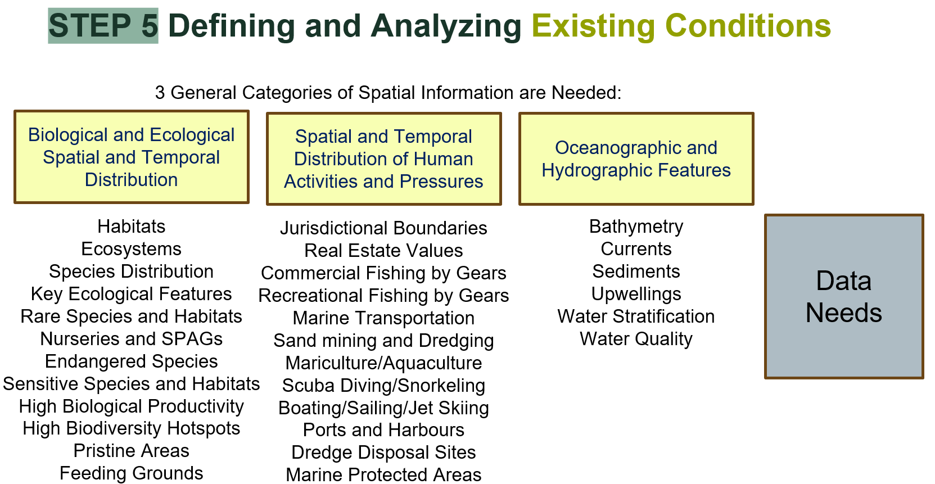

Figure 7: Data requirements for step 5 of the MSP process (Source: Ehler and Douvere, 2009).

Status of MSP in Belize

In November 2021 the Government of Belize, the Belize Blue Investment Company (BBIC) and The Nature Conservancy (TNC) signed the Blue Loan Agreement (BLA) and Conservation Funding Agreement (CFA). Under these agreements there are several conservation commitments that must be met, including the completion of a legally enforceable Marine Spatial Plan (MSP) by November 2026. The Coastal Zone Management Authority and Institute (CZMAI), under the Ministry of Blue Economy and Civil Aviation, has been designated as the lead agency for the Marine Spatial Planning process, which commenced in October of 2022.

The vision for Belize’s MSP is “a healthy, resilient, and equitably shared ocean that supports a thriving national economy and nurtures the culture and well-being of all Belizeans”. The BSOP aims to achieve a sustainable blue economy by implementing a spatial plan for Belize ocean space that balances environmental protection, social/traditional uses, and economic activities. This will include the protection of up to 30% of Belize’s ocean as marine protected areas. The planning process for the BSOP will be consistent with international best practices, based on cutting-edge science and the best available data. The BSOP will be guided by the principles of inclusivity, participation, transparency, and equity.
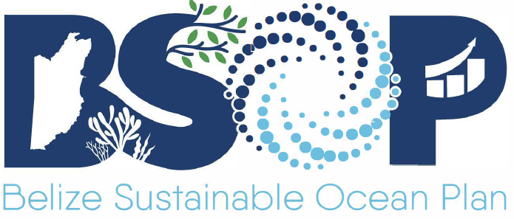

The Ministry of Blue Economy launched a Belize Blue Economy Development Policy and Strategy (BBEDPS) and a Belize Maritime Economy Plan (BMEP) in 2022 which include priority areas of focus for the sustainable development of Belize’s blue space that have significant bearing on the MSP process, including the identification of existing and emerging sectors and data needs especially for future uses.

The Maritime Economy Plan describes the existing maritime economy of Belize. It outlines the priorities and actions necessary to address national issues, international commitments and the challenges of a Small Island Developing State. These actions aim to support economic growth, livelihoods and jobs, and reduce losses from natural hazards, extreme weather events and climate change. The objective of the MEP is to help grow the national economy and includes good governance, sustainable development, and gender equality while recognizing the needs of small and vulnerable States. The MEP offers a strategic roadmap towards building a robust blue economy.

Marine Spatial Planning is one of the primary approaches that will directly enable the implementation of the Belize Blue Economy Development Policy and Strategy (BBEDPS) which has a mission “to increase Gross Domestic Product (GDP) through a thriving Blue Economy Development pathway that is wholistic, harmonized, innovative and socially just, supported by a robust, science-based management regime of our aquatic resources and space to improve the livelihood of all Belizeans”. This involves managing multiple sectors and uses in the blue space with active involvement of stakeholders backed by science-based decision making, all strategies encompassed within the MSP process. The BBEDPS should guide the development and roll out of the BSOP.

The main objectives of the MSP process are to develop a legally enforceable plan that allocates space in support of all activities that take place within Belize’s Ocean space, and to facilitate the expansion of marine biodiversity protection zones by 9.7% to meet the target of 30% of Belize’s marine territory protected. This marine spatial plan or the BSOP, along with a revised Integrated Coastal Zone Management Plan (ICZMP), guided primarily by the Blue Economy Policy and Strategy (BEPS), Maritime Economy Plan (MEP) and other sector-based plans, will be crucial for Belize to meet its international commitments for ocean protection. These plans and strategies serve to inform data needs for MSP. The BSOP is being developed through a science-based, stakeholder-driven process that aims for a balance between the protection of key ecosystems and sustainable development in alignment with Belize's economic, ecological, and social goals. A clearly established governance framework will provide opportunities for stakeholders to fully engage in and contribute to the development of the BSOP, guided by the principles of fairness and equity. The BSOP aims to improve ocean management and stakeholder participation in decision making, contribute to economic stability and maritime safety and provide protection of valuable marine ecosystems and adaptation to climate change (Figure 8a). The BSOP considers and plans for current and emerging uses of Belize’s ocean space ensuring they are aligned with the country’s marine conservation and development priorities (Figure 8b).
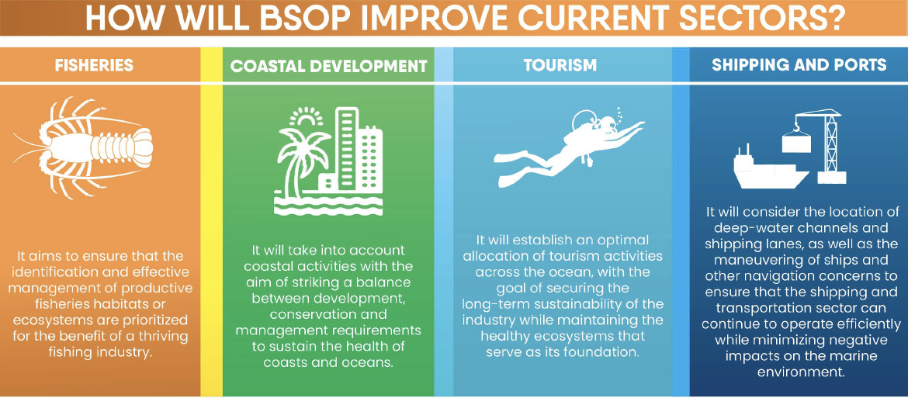
Figure 8a: Benefits of MSP to major ocean-based activities (Source: BSOP Fact Sheet 2023).

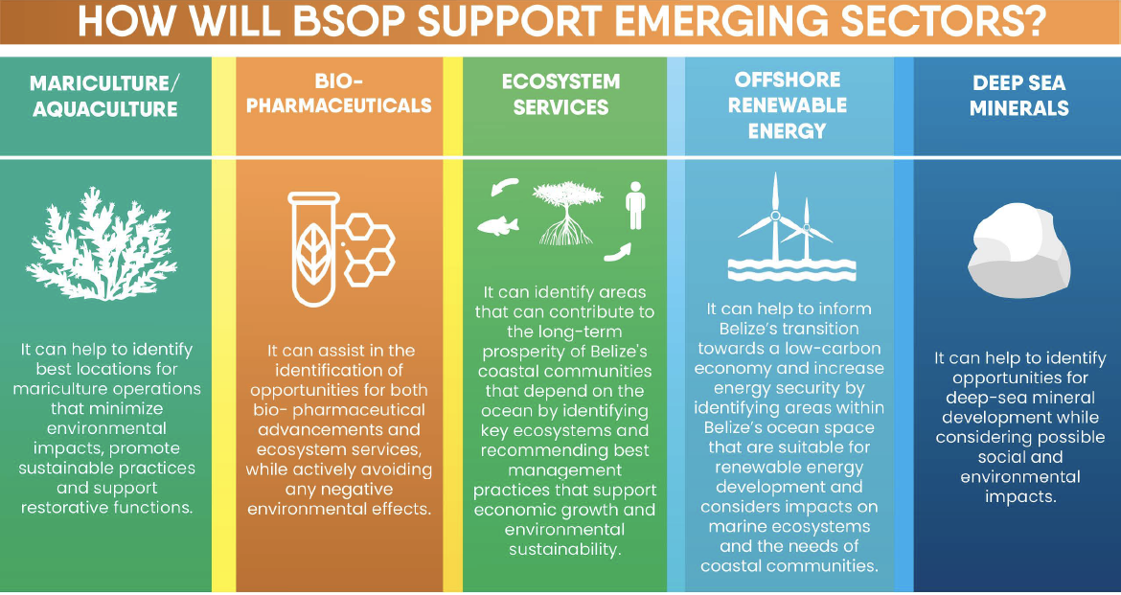
Figure 8b: MSP support for emerging marine sectors (Source: BSOP Fact Sheet 2023).

The BSOP is spearheaded by the Coastal Zone Management Authority and Institute (CZMAI). The entire process involves multiple steps over four years, which is an ambitious target that will require excellent project management, multi-agency coordination and support at the highest levels of government to achieve a legally adopted marine spatial plan by November 4th, 2026. The various steps involved in Belize’s MSP process are highlighted in Figure 9 below. To date the CZMAI has spearheaded the completion of steps 1-4, with the establishment of an MSP Authority, obtaining financial support for the MSP process, organizing the MSP process, and engaging stakeholders. Step 5 - analyzing existing conditions is currently in process with a draft report on Analysis of Existing Conditions undergoing technical review for completion by mid- to end of 2025.

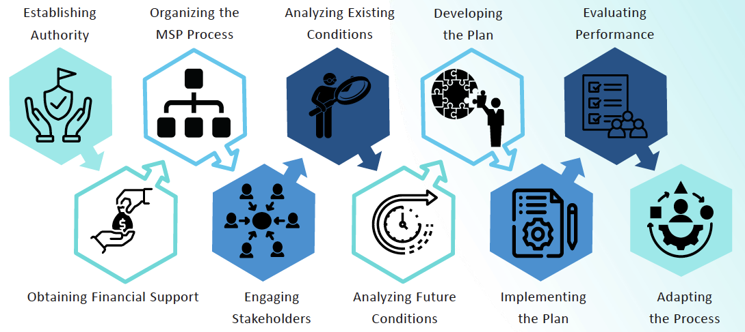
Figure 9: Overview of the MSP Process for Belize (Source CZMAI 2024)

Since the initiation of the MSP process in October 2022, Belize has established an MSP authority through a designated lead agency for MSP and establishment of a multisectoral steering committee, core team and technical working groups by sector, inclusive of the relevant stakeholders. Financial support for the MSP process is being provided by Belize Fund for A Sustainable Future and is accessed under the Government Strategic Allocation (GSA) through the Blue Bond and Finance Permanence Unit. The CZMAI has conducted stakeholder engagement through multiple public awareness and community outreach drives across the country and has recently completed participatory mapping in June 2024, using an ocean use survey of over 500 stakeholders/users of the marine area. The ocean use survey engaged 27 coastal communities and mapped the social, cultural and economic dependency of sectors and users on Belize coastal and marine resources. Current efforts are focused on analyzing existing conditions for MSP, such as establishing baselines and mapping human uses (pers. comm. CZMAI, 2024).

Based on the outputs from the ongoing BSOP development process, a proposal to expand the total ocean space currently under medium biodiversity protection to 25% by November 2024 is being reviewed for approval. Several proposed areas, including Lighthouse Reef Atoll, Glover’s Reef Atoll Marine Reserve and Bacalar Chico Marine Reserve – oceanic transboundary area, for medium biodiversity protection have been identified with initial consultations in coastal communities completed during May to June 2024. The participatory mapping and planning for protected areas are being done through the use of various spatial analysis tools, including GIS, Seasketch and MARXAN. Next steps for the BSOP include validation of data mapping, MARXAN analysis, existing conditions report and completion of milestone 4 – expansion of medium biodiversity zones (pers. comm. CZMAI, 2024).

Data needed for Belize Sustainable Ocean Plan (BSOP)

Given the list of current priority sectors (fisheries, coastal development, tourism, shipping and ports (Figure 8a)) and list of emerging sectors (mariculture/aquaculture, bio-pharmaceuticals, ecosystem services, offshore renewable energy, and deep sea minerals (Figure 8b)),the approach taken is to organize data needs considered the following national policies and plans;
- Belize’s Blue Economy Development Policy, Strategy and Implementation Plan (BEDPS)
- Maritime Economy Plan (MEP), recognizing that these categories in the abovementioned national documents differ slightly in nomenclature from the categories recommended in Lightsom et al. (2015) (see Table 4), the data needs for BSOP was organised in a manner which was consistent with both categorizations, using different levels or sub-categories to ensure compatibility.

The categories in Lightsom et al. (2015) consider and include non-living and living resources available in the ocean space; the various ocean uses, governance, and infrastructure. Non-living resources include energy resources such as oil, natural gas, wind, tides; material resources such as sand and other minerals; physical/chemical features such as geomorphology, bathymetry, substrate types, water-quality, among others. Living resources include information on habitats, ecological functions and services, biological occurrences or biological life. Ocean uses touch on a wide range of activities from recreational and cultural uses to harvesting of living resources to energy production, transportation, and other commercial/industrial uses. Governance data include information relevant to marine protected areas, leases, jurisdictional/sectoral boundaries, regulatory use restrictions, among others. The final data category of infrastructure requires information on existing and planned supporting infrastructure in the ocean space, including ports, pipelines, cables, buoys and navigational aids and other structures in the water.

6.1 Methodology

To provide a comprehensive assessment of where Belize is currently in terms of data availability and data gaps needed for MSP, the following analytical approach was taken.

- First, a list of relevant data needed for MSP was compiled based on the literature (particularly referring to Ehler and Douvere, 2009) by examining and reviewing the BSOP and other related documents, and by reviewing the data needs identification process used in other similar countries' MSP.
- A hierarchy of data categorization was formulated based on Lightsom et al (2015) and using the BSOP categories. This provided the necessary means to ensure all categories were examined for data availability and gaps. The list of data needed for MSP from step 1, was aligned to these categories.
- Information on data gaps, capacity gaps, and priority data and capacity needs in Belize, in relation to MSP, was collected with the help of key stakeholders using online surveys, one-on-one meetings, examination of local data centres, and focus group discussion as part of the validation workshop. This list was compared against the list from step 1.
- To facilitate the analysis of gaps and needs, a data catalog for marine and coastal data was developed in Microsoft Excel and analyzed to examine gaps and priorities for MSP according to the different categories of MSP data. This catalog presented each data needed for MSP as a row record in the Excel Spreadsheet, with qualitative metadata about the record indicating, inter alia, the category under which it falls, the data content type (baseline, derivative or modeled), whether it is in a spatial format such as raster or feature, the source of the data, a short description of how it was produced and what it contains, the timeframe when it was collected or produced, whether it was reported as available by a stakeholder, or whether it was deemed as not currently available but needed for MSP (i.e. a gap). This catalog forms the basis for the analysis of data needs and gaps and will aid MSP planners in identifying and filling data gaps. The data catalog in Excel spreadsheet format accompanies this report as a separate file available for download. A snapshot of the data catalog is presented in Figure 10 below.
- The data catalog was validated at a stakeholder workshop held on August 9, 2024 at CZMAI’s conference room, where participants provided clarification on instances of duplicate records, missing datasets, temporal and spatial extent and completeness, and other relevant metadata. The feedback was used to revise the data catalog, from which the final analysis of gaps and needs was performed. Information regarding completeness of datasets was sourced only from stakeholders, most of whom were not directly involved in the collection of the datasets; therefore, the information used in validation is considered second hand. A firsthand examination of the datasets was not conducted as this was not in the scope of work and indeed would require more time beyond what was allotted for this consultancy.

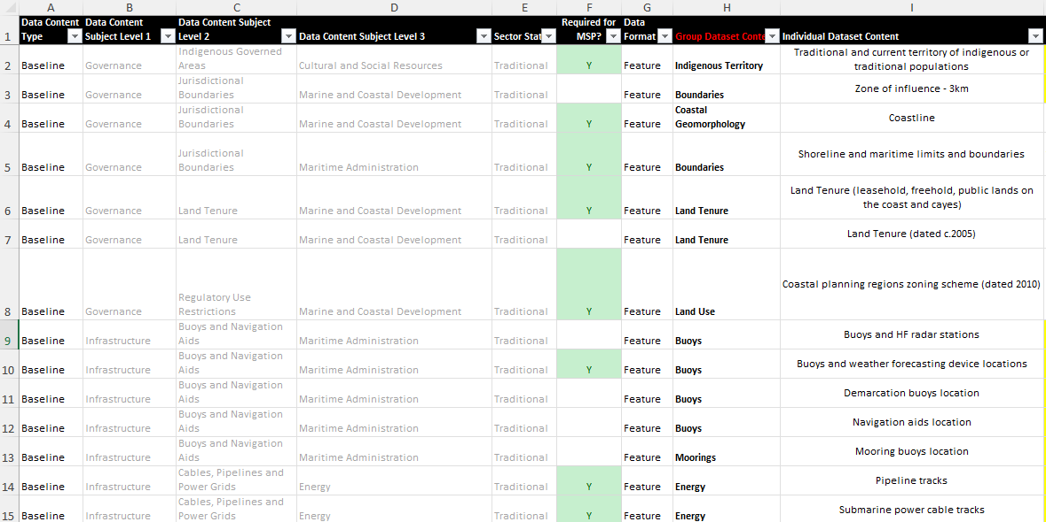

Figure 10: Snapshot of a portion the data catalog for MSP in Belize developed as part of this report, showing an example of the field headings and record contents

Data Availability and Existing Arrangements for MSP

Rationale for Data Catalog Common Vocabulary

Comprehensive Marine Spatial Planning (MSP) involves complex analyses of the status and potential uses of horizontal and vertical spaces of coastal and marine ecosystems (including the water column) and their potential changes over time. Relevant spatial data and derived analytical products inform all phases of the MSP process, including identification of national objectives for the long-term use and conservation of specific areas; assessment of the status and trends of ecosystems, resources, and human uses; and creation, long-term implementation, and adaptive management of comprehensive plans to sustainably match uses to appropriate areas.

Table 4 Data Categories (data content subjects) for Marine Planning (Source: Lightsom et al., 2015)

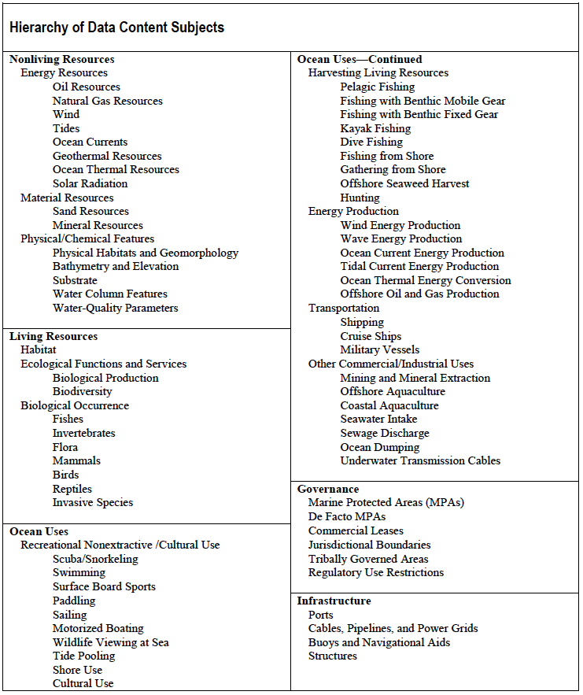

The Belize Sustainable Ocean Plan (BSOP) identified several traditional and emerging sectors in which key science and data needs exist to inform national decision-making about how and where human uses should occur in the blue economy (Figure 8). According to Lightsom et al. (2015), data can be categorized using different hierarchical concepts such as by ‘data content types’ which refers to how the data is generated and therefore how it can be used, or by ‘data content subject’ which are categories referring to, for example, data on living versus non-living resources, data by MSP sectors, or thematic areas. To effectively support the complex decision-making process involved in MSP, the data catalog proposed herein utilizes a hierarchical approach or ‘browse tree’ which categorizes data according to both data content type and data content subject. In both instances, categories of data content types and data content subjects are suggested which aligns with common terminology used internationally (as recommended in Lightsom et al., 2015) and used among local data practitioners, and which also fits within the sector definitions as decided within the Maritime Economy Plan and the Belize Sustainable Ocean Plan. To achieve this, different levels of data content subjects are utilized as described further below.

The first level of categorization is defined by ‘data content type’. There are three data content types: baseline data, derivative data or analytical or modeled data. Baseline data will include data on distribution, locations or patterns of a living or non-living feature of interest across space and/or at different points in time, produced by observation, measurement, interpolation or even modeling. For example, baseline data on ecosystems can pertain to ecosystem distribution at the start of a monitoring period and at every subsequent re-measurement, or it can pertain to abundance and distribution of conch. Derivative data will include the results of assessments that provide information about observed or measured changes, values, drivers, conflicts, overlaps, or functions of a living or non-living feature within its present distribution. Derivative data is produced from analysis of baseline data and may express, for example, changes in ecosystem distribution between two points in time as a result of certain drivers or conch distribution according to habitat. Analytical or modeled data will include predictions or projections of potential present or future state in relation to a living or non-living feature or the interactions between two or more living or non-living features across the coastal or marine space and may present distributions, values, impacts, changes, conflicts, functions or drivers of a living or non-living feature. For example, ecosystem importance as modeled against some set of values or interactions between different data sets such predicted impacts on ecosystems as a result of expanding human activities would represent modeled data.

The use of these three broad categories at the start of hierarchy is beneficial also in the sense that the derivative and analytical categories of data generally do not require logistical and acquisition costs, as these are produced from computations and analyses performed on various baseline datasets. For example, if mangrove cover is available for more than two years, this would be classified as baseline datasets. A mangrove deforestation dataset can then be produced rather easily between two points in time (a derivative dataset) and used to influence policy making to curb mangrove deforestation in identified hotspots. A dataset about human footprint within mangrove ecosystems can also be produced by further spatial analyses using human footprint baseline datasets, to produce an analytical output to influence decision making on where to best protect critical mangrove ecosystems. On the other hand, the mangrove cover dataset itself represents data that needs to be collected either remotely using satellite imagery, aerial photography, lidar, and/or land-based mapping, and in some cases even by modeling (but this would still represent a baseline scenario in terms of mangrove cover). Generally speaking, baseline datasets will have greater collection effort and costs but require lesser technical capacity than derivative and analytical datasets. However, derivative datasets generated through analysis of baseline data may also involve technological costs related to software and hardware. For example, the analysis of spatial data requires specialized license-based software such as Esri’s ArcGIS.

The second level of data categorization is defined by ‘data content subject’. This refers to data about a variety of aspects of the living and non-living components of the ecosystems as well as human uses in the coastal and marine space. The categorization of data content subjects recommended in Lightsom et al. (2015) is used as the first and second level of data content subjects (see Table 4), while a third level of data content subject is introduced which aligns with the data categories and definitions decided for marine spatial planning in the Belize Sustainable Ocean Plan. Specifically, the third level of data content subjects used in this data catalog refers to those used in the Belize Sustainable Ocean Plan and include fisheries and aquaculture, tourism, marine and coastal ecosystems, maritime administration, marine and coastal development, and energy.

Beyond the direct applications for categorizing and facilitating the search for MSP datasets, the organizational structure of the data catalog, which uses common vocabulary, facilitates the identification of data gaps and priorities. If the category names are used as keywords in the metadata description of the datasets, and in technical publications and research reports, they can assist in identifying new data that can fill knowledge gaps. Using a common data catalog framework and vocabulary to describe data availability and needs will help to support MSP through improved data access and sharing.

Sources of information on data availability, gaps, needs and existing arrangements

Several sources of information were used to generate the list of available data needed for MSP in order to develop the data catalog, as a first step in identifying availability, gaps and needs.

Firstly, a structured survey was designed to capture information regarding what data was currently available according to different data content subjects and data content types relating to MSP in Belize. This survey was administered using Google Forms and sent out to 67 stakeholders identified during the BSOP planning process in 15 different MSP sectors including Energy, Research and Education, Natural Resource Management, Ecosystem Services, Tourism and Recreation, National Security and Defense, Maritime Transport, Fisheries, Coastal Development, Mariculture/Aquaculture, Metocean, Boat Building and Marinas, Mining and Minerals, and Cultural and Social Resources. This survey also captured information relating to capacity gaps and needs. The survey is available at the following link (https://forms.gle/YGur9CkYVhRjdNit6). A total of thirteen responses were received (see Figure 11 for gender breakdown).

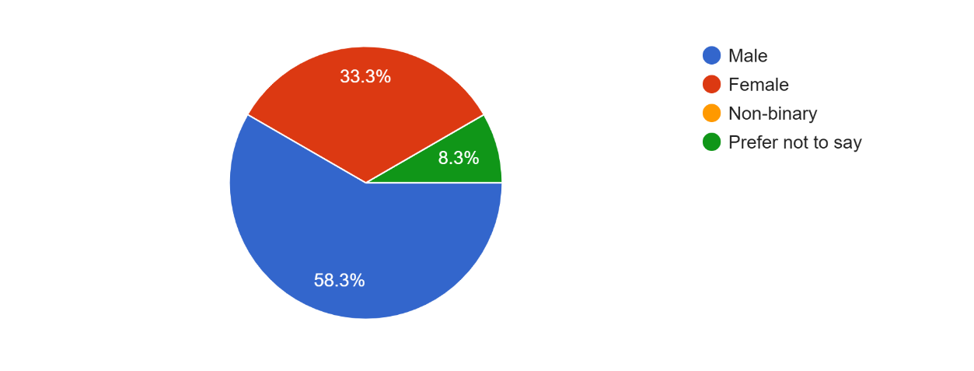
Figure 11. Gender of respondents

The survey respondents represented a considerable cross-section of coastal and marine organizations (Figure 12) and respondents said they worked in all the relevant sectors for marine spatial planning (Figure 13).

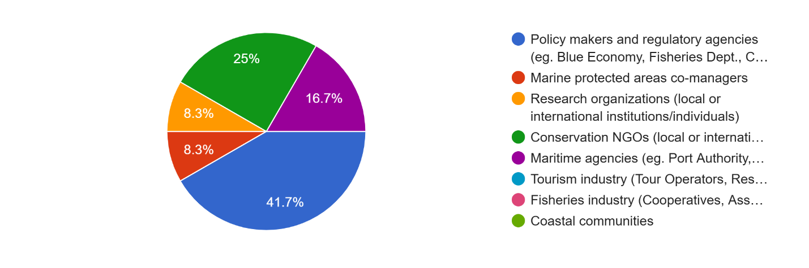
Figure 12. Cross-section of coastal and marine organizations represented in the survey

The complete graphical results of the survey are available in the Annex, while the complete set of survey responses in Excel spreadsheet accompanies this report as a separate file.

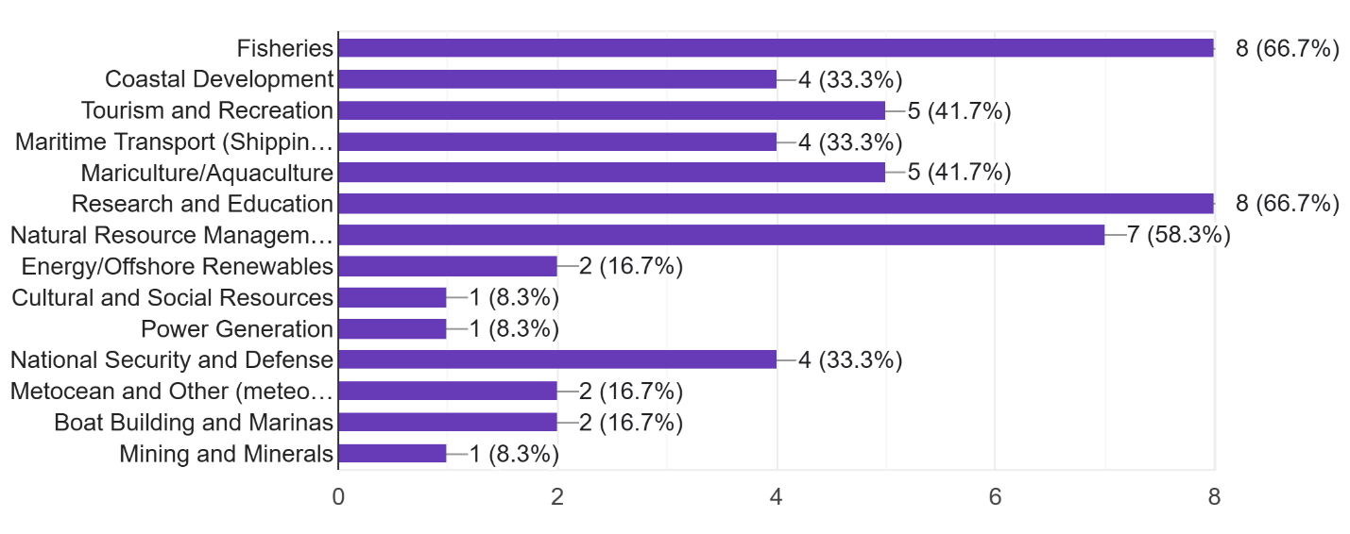
Figure 13. MSP sectors in which respondents stated they worked

Secondly, one-on-one discussions with representatives from some of the survey respondents were held to clarify responses regarding data availability, where ambiguities existed, as well as to explore other issues related to existing arrangements for data collection, sharing, and fulfilling future needs. These survey respondents included the Fisheries Department, Blue Economy Unit, Blue Bond and Finance Permanence Unit, The Nature Conservancy, Wildlife Conservation Society, and Coastal Zone Management Authority and Institute. The discussions provided further insight and clarity into the consistency of data collection as well as challenges with maintaining data collection efforts across the entire coastal and marine space.

Third, the Coastal Zone Management Authority and Institute (CZMAI) hosts a Coastal and Marine Data Centre, which contains a collection of spatial and non-spatial information collected by the CZMAI as well as its partners over the years. This data centre has been hosting data since 1995 and has aided in monitoring trends and informing decisions including the development of the Integrated Coastal Zone Management Plans. Throughout the years, several projects have collaboratively assisted with filling data gaps and needs in different data content subject areas and have been incorporated into the data centre. This information was assimilated into the data catalog for a complete, holistic picture of data availability across all sources. Access to data in the data centre can be obtained through a request submitted on CZMAI’s website or via e-mail. The complete list of data layers available in the data centre are presented in Table 5 below. CZMAI’s data centre is available at the following link (Coastal and Marine Data Centre - Belize Coastal Zone Management (coastalzonebelize.org). Information gathered from CZMAI’s website and also provided by CZMAI on its project's synopsis was also used in the development of the data catalog for MSP.

Table 5 Data layers available in the Coastal and Marine Data Centre maintained by the CZMAI

Human Use Layers
Agriculture & Runoff (2020)
Agriculture zoning scheme (2010)
Aquaculture (2020)
Aquaculture zoning scheme (2010)
Coastal Development (2020)
Coastal Development zoning scheme (2010)
Coastal Planning Regions Zoning Scheme (2010) (Downloadable)
Conservation zoning scheme (2010)
Dredging (2020)
Fishing (2020)
Fishing Zoning scheme (2010)
Land Use Footprint in Caye Caulker, Central Region and South Northern Region (2016) - under MCCAP
Marine Conservation (2020)
Marine Dredging zoning scheme(2010)
Marine Recreation (2020)
Marine Recreation zoning scheme (2010)
Marine Transportation zoning scheme (2010)
Oil Exploration
Water Quality linked to Marine Transport (2020) - NASA SDG
Zone of Influence- 3km
Marine Habitat
Bathymetry, Channels, Cable, Reef, Ridge, Ripple for Corozal Bay down to Belize City - UKHO Lidar
Bathymetry, Channels, Cable, Reef, Ridge, Ripple for Port of Belize, Commerce Bight and Big Creek - UKHO Multi Beam Echo Sounder
Coral (2010)
Coral (2020)
Mangrove Cover (2014) - MCCAP
Mangrove Cover (2016) - MCCAP
Mangrove Cover (2019) - MCCAP
Marine Habitat Cover -(coral, seagrass and mangrove) 2007-2010
National Marine Habitat Map (1997) - 19 benthic habitat types
Seagrass (2010)
Seagrass (2016)
Biodiversity/Species Distribution
Crocodiles -2010
Dolphin -2010
Manatee sightings -2012
Sea turtles -2010
Transportation
Marine Transportation (2020)
Shipping Lanes -2005 (Downloadable)
Shipping Ports -2005 (Downloadable)

Fourth, the feedback provided during the BSOP Marxan Workshop for MSP in April 2024 provided additional information relating to data availability and data types in relation to use in Marxan-based planning. During the workshop, participants from the MSP Technical Working Groups also provided verbal indication of the availability of certain datasets for MSP, which was compiled in a spreadsheet as a list of records describing the datasets, and is available at the following link (https://tnc.box.com/s/ahcohaq27m57w19n18awevul95tbrxhj).

Fifth, participants who attended the validation workshop for this consultancy, provided valuable feedback to further identify data availability, gaps, needs, and potential opportunities to address data gaps. A list of participants is provided in the Annex.

Sixth, a review of data collected by co-managers and partners working within Belize’s marine protected areas carried out under the Ocean Country Partnership Program (OCPP) project (Cowburn et al, 2024) contributed additional clarity in terms of specific dataset quality and spatial and temporal completeness for subject matters such as water quality, fisheries, habitats, and threatened species.

Lastly, a review of the Belize Maritime Economy Plan, Belize Sustainable Ocean Plan and other sector plans and strategies provided brief but helpful insight into available data needed for the development of plans as well as an indication of priority information and data needed for implementation of activities under those plans.

The sources of information which acknowledge or confirm the availability or need for certain datasets are included in the data catalog.

Data Catalog

As described in Lightsom et al. (2015), an information management system for marine spatial planning will require a strong backbone known as a data catalog, which is metadata about all the available spatial datasets categorized according to data content types and data content subjects. Within the information management system processing framework, this data catalog is searched by a user, using keywords that align to a common vocabulary represented by the data content types and data content subjects. Once the dataset record is located, the associated hyperlink directs the user to the data server for access and download. The maintenance and continuous update of the data catalog is critically important as time progresses, since new datasets will emerge of better quality and longer timeframe, and data gaps and needs will be filled by data from new collection efforts or by analysis of existing baseline datasets. Each time a dataset is generated it must be recorded in the catalog and deposited into the data server. The administrative process involved in managing the data catalog is best served by use of a Technical Committee of specialists from various MSP sectors or subject areas which can meet to validate and approve the inclusion of a dataset that meets certain standards.

The data catalog developed in the context of this consultancy was designed to aid the identification of gaps, needs and priorities, and is not based on an assessment of the datasets themselves, since data collection and compilation was not included within the scope of works. Therefore, inclusion of a record for any particular dataset within the catalog is not an indication of whether the dataset meets certain standards or criteria for accuracy, representativeness or completeness, which may be set by those who will analyze the data as part of the MSP process. Instead, the metadata in the catalog presents available information on dates and spatial extent, which may then be used to assess whether the datasets are temporally or spatially complete relative to analytical needs. As discussed in Lightsom et al (2015), the matter of data quality and suitability for use in MSP analyses is typically handled by a Technical Committee of MSP experts and spatial data analysts, who determine what analyses need to be performed and what information outputs are required for decision making.

While the full data catalog itself accompanies this report as an Excel spreadsheet, summary tables produced from the catalog are presented and discussed further below to highlight data availability, needs and gaps.

Table 6 below was produced by querying the data catalog according to what datasets exist for given data content subject categories recommended by Lightsom et al. (2015), which was further populated with data content subject categories unique to Belize’s national circumstances (e.g. Tourism). The table shows the modified hierarchy of data content subjects for the Belize MSP. Within each sub-category in the hierarchy, the datasets that are needed for MSP are listed individually, and whether they are already available or represent a gap is denoted by a “1” in the relevant column. For each category in the hierarchy, an initial assessment can be made of the gaps, as represented by the gap versus the total datasets needed for MSP. For example, in the Governance category, a total of 26 datasets are listed as needed to inform MSP. Of those, 20 datasets are already available, while five (6) are not. An example of a data gap is ‘permitted areas for mining and dredging’; this dataset is needed to inform where in the marine space is already designated for extraction of sand and other resources.

A total of 229 records of different datasets from all categories were identified as either available or needed to inform MSP. This number can be reduced if datasets are consolidated where data from different years are available in separate datasets, or where different datasets with similar content exist for different geographic extents. Of this total, 137 datasets are reported as available to some extent (meaning the data has been collected and or analyzed and have either been transformed into a spatial dataset or are in the process of being transformed). Since, the datasets were not actually collected and examined as part of the scope of this consultancy, data availability is assessed up to the point of determining that the dataset exists, and its spatial and temporal completeness, based on stakeholder input or through examination of data listings and reports. A total of 92 datasets from various categories are considered gaps that are needed for MSP and therefore must be produced either through collection or through analyses at some point in the near future. A course indication of progress toward data availability to inform MSP in Belize can be given as 60% (137/229 datasets).

Table 6 Availability of datasets by data content subject categories for Marine Spatial Planning in Belize (data content subjects from Lightsom et al. [2015] with nationally relevant sub-categories)

Data Content Subject Categories | Available | Gap | Grand Total
Governance | 5 | 2 | 7
Indigenous Governed Areas |  | 1 | 1
Traditional and current territory of indigenous or traditional populations |  | 1 | 1
Jurisdictional Boundaries | 3 |  | 3
Coastline | 1 |  | 1
Shoreline and maritime limits and boundaries | 1 |  | 1
Zone of influence - 3km | 1 |  | 1
Regulatory Use Restrictions | 1 |  | 1
Coastal planning regions zoning scheme (dated 2010) | 1 |  | 1
Land Tenure | 1 | 1 | 2
Land Tenure (leasehold, freehold, public lands on the coast and cayes) |  | 1 | 1
Land Tenure (dated c.2005) | 1 |  | 1
Infrastructure | 10 | 4 | 14
Buoys and Navigation Aids | 2 | 3 | 5
Buoys and HF radar stations | 1 |  | 1
Buoys and weather forecasting device locations |  | 1 | 1
Demarcation buoys location |  | 1 | 1
Mooring buoys location |  | 1 | 1
Navigation aids location | 1 |  | 1
Cables, Pipelines and Power Grids | 3 |  | 3
Pipeline tracks | 1 |  | 1
Submarine fibre optic cable tracks | 1 |  | 1
Submarine power cable tracks | 1 |  | 1
Ports | 3 | 1 | 4
Cruise port calls |  | 1 | 1
Cruise port location | 1 |  | 1
Ports and harbors location and calls | 1 |  | 1
Shipping ports (dated 2005) | 1 |  | 1
Structures | 2 |  | 2
Anchorage and berthing areas | 1 |  | 1
Location of marinas and dry docks | 1 |  | 1
Living Resources | 47 | 28 | 75
Biological Occurrence | 17 | 14 | 31
Acropora presence/absence locations |  | 1 | 1
Bird sightings (nesting grounds and roosting areas) | 1 |  | 1
Caribbean Sponge (Tethya crypta) Distribution |  | 1 | 1
Conch biomass | 1 |  | 1
Deep sea coral and sponge observations | 1 |  | 1
Deep sea migration of megafauna |  | 1 | 1
Deep slope fishery stock |  | 1 | 1
Distribution and abundance of other marine species (including invertebrates, microbes, and plankton) |  | 1 | 1
Finfish biomass | 1 |  | 1
Fisheries independent sampling (national conch surveys, LAMP surveys, AGRRA fish surveys, catch data from MPAs, SPAGs) | 1 |  | 1
Fleshy macroalgae cover | 1 |  | 1
Golden Seaweed (Eucheuma isiforme) Distribution |  | 1 | 1
Golden Seaweed (Eucheuma isiforme) Farms |  | 1 | 1
Herbivorous fish biomass | 1 |  | 1
Lobster biomass | 1 |  | 1
Manatee feeding areas and migration routes | 1 |  | 1
Marine mammals and protected species migratory tracks (turtles, sharks, manatees, rays, dolphins, whales) | 1 |  | 1
Sargassum Distribution and Hotspots |  | 1 | 1
Seaweed Locations |  | 1 | 1
Snapper and Grouper biomass | 1 |  | 1
SPAG sites in Cayman Crown |  | 1 | 1
Species of concern (critically endangered, endangered, vulnerable, protected, and invasive) |  | 1 | 1
Stony Coral Tissue Loss Disease Presence |  | 1 | 1
Stony Coral Tissue Loss Disease Spread |  | 1 | 1
Tunicate (Ecteinascidia turbinata) Distribution |  | 1 | 1
Crocodile distribution (dated 2010) | 1 |  | 1
Dolphin distribution (dated 2010) | 1 |  | 1
Manatee sightings (dated 2012) | 1 |  | 1
Sea Turtles (dated 2010) | 1 |  | 1
Targeted biomass g/100m2 (dated 2018-2023) | 1 |  | 1
SPAG data - grouper and snapper size, abundance, and species richness | 1 |  | 1
Ecological Function and Services | 4 | 6 | 10
Carbon Sequestration (Mangrove) |  | 1 | 1
Carbon Sequestration (Seagrass) |  | 1 | 1
Carbon Stocks (Mangrove) | 1 |  | 1
Carbon Stocks (Seagrass) | 1 |  | 1
Critical habitat: nurseries (commercial species and species of conservation concern) | 1 |  | 1
Deep slope biodiversity |  | 1 | 1
Fish spawning areas (commercial species) | 1 |  | 1
High biodiversity priority areas |  | 1 | 1
Population dynamics across space and time of commercial species (conch, lobster, finfish) |  | 1 | 1
Shoreline Protection Priority Areas |  | 1 | 1
Habitat | 26 | 8 | 34
Coral atolls | 1 |  | 1
Coral reef damage - coral bleaching, anchor strikes |  | 1 | 1
Coral reef health (coral cover) | 1 |  | 1
Coral reef loss |  | 1 | 1
Coral reef priority areas | 1 |  | 1
Critical habitat: corals (Elkhorn, Staghorn, Boulder Star, Lobed Star, Mountainous Star, Pillar, Rough Cactus) | 1 |  | 1
Critical habitat: sea birds nesting and roosting sites (Red-footed Booby and others) | 1 |  | 1
Critical habitat: sea turtles nesting sites (Green, Hawksbill, Leatherback) | 1 |  | 1
Deep sea sensitive habitats |  | 1 | 1
Essential Fish Habitat (EFH): Atlantic Highly Migratory Species |  | 1 | 1
Essential Fish Habitat (EFH): corals, reef fish, Spiny Lobster, Queen Conch | 1 |  | 1
Habitat areas of particular concern | 1 |  | 1
Habitat risk assessment | 1 |  | 1
Seagrass loss |  | 1 | 1
Seagrass meadows | 1 |  | 1
Shallow coral location | 1 |  | 1
Coral reef (dated 2010) | 1 |  | 1
Coral reef (dated 2020) | 1 |  | 1
Coral reef (dated 2021) | 1 |  | 1
Coral reef cover % (dated 2018-2023) | 1 |  | 1
Mangrove and littoral cover (dated 2019) | 1 |  | 1
Mangrove cover (dated 2014) | 1 |  | 1
Mangrove cover (dated 2016) | 1 |  | 1
Mangrove cover (dated 2020) | 1 |  | 1
Mangrove Deforestation (dated 2019) | 1 |  | 1
Mangrove priority areas (dated 2018) | 1 |  | 1
Marine habitat cover (coral, seagrass, mangrove) (dated 2007-2010) | 1 |  | 1
Marine habitats (19 benthic types) (dated 1997) | 1 |  | 1
Marine habitats (4 benthic types - seagrass, coral, bare sediment, algae) (dated 2021) | 1 |  | 1
Seagrass cover (dated 2016) | 1 |  | 1
Seagrass cover (dated 2021) | 1 |  | 1
Seagrass cover (dated 2024) |  | 1 | 1
Artificial Reef/Submerged Vessels |  | 1 | 1
Priority Seagrass Areas |  | 1 | 1
Non-living Resources | 12 | 17 | 29
Energy Resources |  | 1 | 1
Petroleum reserves |  | 1 | 1
Material Resources |  | 1 | 1
Deep sea mineral deposits |  | 1 | 1
Physical/Chemical Features | 11 | 15 | 26
Bathymetry using Lidar (Corozal Bay to Belize City, Port of Belize, Commerce Bight, Big Creek) | 1 |  | 1
Bathymetry using Multi-beam Echo Sounder (Corozal Bay to Belize City, Port of Belize, Commerce Bight, Big Creek) | 1 |  | 1
Bathymetry/Hydrography (deep water) |  | 1 | 1
Bathymetry/Hydrography (high precision) |  | 1 | 1
Beach and Coastal Erosion |  | 1 | 1
Beaches |  | 1 | 1
Coastal geomorphology |  | 1 | 1
Deep sea upwelling and currents |  | 1 | 1
Maintained channels | 1 |  | 1
Marine hydrography (Sills, Shelf Valley, Rise, Plateau, Escarpments, Canyons, Terrace) | 1 |  | 1
Ocean thermal energy dynamics |  | 1 | 1
Oceanographic and meteorological patterns at high resolution (temperature, wind, waves, salinity, tides, currents) |  | 1 | 1
Oceanographic and meteorological patterns at low resolution (temperature, wind, waves, salinity, tides, currents) | 1 |  | 1
Rivers leading to coast | 1 |  | 1
Salinity | 1 |  | 1
Sea level |  | 1 | 1
Sea surface temperature |  | 1 | 1
Sea surface temperature prediction |  | 1 | 1
Shoals | 1 |  | 1
Solar radiation |  | 1 | 1
Undersea caves |  | 1 | 1
Wave energy |  | 1 | 1
Wind dynamics |  | 1 | 1
Water quality for Glovers, Haulover Creek, St. Georges | 1 |  | 1
Water quality for EEZ and Territorial Sea | 1 |  | 1
Bathymetry (modeled) (dated 2021) | 1 |  | 1
Structures | 1 |  | 1
Wrecks and obstructions | 1 |  | 1
Ocean Uses | 63 | 41 | 104
Aquaculture | 2 |  | 2
Aquaculture - location of farms (dated 2020) | 1 |  | 1
Aquaculture (dated 2022) | 1 |  | 1
Biological Occurrence |  | 1 | 1
Algal Blooms |  | 1 | 1
Commercial Leases | 2 | 2 | 4
Leasing grids for non-renewables | 1 |  | 1
Permitted areas for mining and dredging |  | 1 | 1
Petroleum exploration sites | 1 |  | 1
Seabed use permit areas |  | 1 | 1
Demographics | 2 | 2 | 4
Coastal community populations | 1 |  | 1
Community social vulnerability data | 1 |  | 1
Socioeconomic data (income from ocean uses) |  | 1 | 1
Socioeconomic data (No. users per ocean use) |  | 1 | 1
Disaster Risk Management | 3 | 2 | 5
Climate Change refuge areas |  | 1 | 1
Flood prone areas | 1 |  | 1
Invest output: Coastal protection | 1 |  | 1
Invest output: Coastal vulnerability | 1 |  | 1
Sargassum influx coastal degradation |  | 1 | 1
Ecosystem Services | 1 | 1 | 2
Blue Carbon Priority Areas |  | 1 | 1
Priority areas for CC adaptation by habitats (mangroves, seagrass, coral reefs) | 1 |  | 1
Energy Production | 2 | 2 | 4
Potential areas in EEZ for renewable energy |  | 1 | 1
Powerplant locations | 1 |  | 1
Renewable energy plant locations | 1 |  | 1
Liquified Natural Gas Terminals |  | 1 | 1
Harvesting Living Resources | 5 | 5 | 10
Commercial fisheries (fisherfolk registration, fish landing sites, commercial landings, fisher logbook data) | 1 |  | 1
Deep slope commercial fishing catch |  | 1 | 1
Fish aggregating devices (FADs) |  | 1 | 1
Fisher's licenses per Managed Access Areas | 1 |  | 1
Fishing gear locations (stationary traps, shade and nets) |  | 1 | 1
Hot spots for commercial and recreational fisheries | 1 |  | 1
Sea mound location for fishing |  | 1 | 1
Seaweed Farms/Harvesting Locations |  | 1 | 1
Traditional subsistence fishing | 1 |  | 1
Fishing (dated 2020) | 1 |  | 1
Human Impacts | 5 | 5 | 10
Cumulative impact zones |  | 1 | 1
Dredging impacts on habitats |  | 1 | 1
Fishing and tourism human stressors | 1 |  | 1
Marine litter accumulation areas |  | 1 | 1
Pollution (solid waste, chemicals, effluent) |  | 1 | 1
Pollution point sources |  | 1 | 1
Future scenario: Fisheries | 1 |  | 1
Future scenario: Tourism | 1 |  | 1
Agriculture runoff (dated 2020) | 1 |  | 1
Water quality linked to marine transport (dated 2020) | 1 |  | 1
Land Use | 3 | 1 | 4
Coastal Development (dated 2020) | 1 |  | 1
Land Use Footprint in Caye Caulker, Central Region, and South Northern Region (dated 2016) | 1 |  | 1
Land Use Inventory in South Central and Southern Region (dated 2018-2023) | 1 |  | 1
Land Use Inventory of Entire Marine and Coastal Area |  | 1 | 1
Mariculture | 1 | 1 | 2
Mariculture (location of farms) | 1 |  | 1
Mariculture suitability (for Seaweed, Sea Cucumber, Common Snook, Cobia, and Octopus) |  | 1 | 1
Marine Protected Areas (MPAs) | 6 |  | 6
Proposed MPAs | 1 |  | 1
Conservation zoning scheme (dated 2010) | 1 |  | 1
Marine and coastal protected areas (dated 2005) | 1 |  | 1
Marine and coastal protected areas (dated 2023) | 1 |  | 1
Marine and coastal protected areas (dated 2024) | 1 |  | 1
Marine Conservation (dated 2020) | 1 |  | 1
Military | 1 | 1 | 2
Areas for live firing exercises |  | 1 | 1
Location of military areas (bases and practice areas) | 1 |  | 1
Mining, Dredging and Mineral Extraction | 2 | 2 | 4
Beach reclamation |  | 1 | 1
Burrow sites (Caye Caulker) | 1 |  | 1
Burrow sites (Central and Southern regions) |  | 1 | 1
Dredging sites (dated 2020) | 1 |  | 1
Ocean Dumping |  | 2 | 2
Ocean disposal sites |  | 1 | 1
Shipping discharge |  | 1 | 1
Recreational Non-extractive/Cultural Use | 7 | 4 | 11
Archaeological sites | 1 |  | 1
Beach and sand bar recreation sites | 1 |  | 1
Culturally and traditionally important areas |  | 1 | 1
Deep slope recreational fisheries catch (data from fishing tournaments, fish aggregating devices, sports fishing data) |  | 1 | 1
Dive and snorkel sites | 1 |  | 1
Historic lighthouse locations | 1 |  | 1
Recreational fisheries (data from fishing tournaments, fish aggregating devices, sports fishing data) |  | 1 | 1
Scenic and wildlife sightseeing areas | 1 |  | 1
Sports fishing and fly fishing sites | 1 |  | 1
Yachting areas |  | 1 | 1
Marine recreation (dated 2020) | 1 |  | 1
Regulatory Use Restrictions | 8 | 1 | 9
Danger zones |  | 1 | 1
Managed Access Zones | 1 |  | 1
Restricted zones | 1 |  | 1
Agriculture zoning scheme (dated 2010) | 1 |  | 1
Aquaculture zoning scheme (dated 2010) | 1 |  | 1
Coastal development zoning scheme (dated 2010) | 1 |  | 1
Dredging zoning scheme (dated 2010) | 1 |  | 1
Fishing Zoning Scheme (dated 2010) | 1 |  | 1
Marine recreation zoning scheme (dated 2010) | 1 |  | 1
Research and Education | 2 |  | 2
Long-term monitoring sites | 1 |  | 1
Research station locations | 1 |  | 1
Seawater Intake |  | 1 | 1
Desalination plants |  | 1 | 1
Settlements | 2 |  | 2
Coastal communities | 1 |  | 1
Coastal demographics data | 1 |  | 1
Sewage Discharge |  | 2 | 2
Effluent discharge areas |  | 1 | 1
Sewage discharge and contamination |  | 1 | 1
Tourism | 3 | 2 | 5
Resort type and location | 1 |  | 1
Tourism carrying capacity |  | 1 | 1
Visitation to MPAs (dated 2017) | 1 |  | 1
Visitation to MPAs (dated 2019) | 1 |  | 1
Visitation to all MPAs annually |  | 1 | 1
Transportation | 6 | 2 | 8
Boat building yards | 1 |  | 1
Nautical charts |  | 1 | 1
Pilot boarding areas | 1 |  | 1
Vessel Registration and Tracks | 1 |  | 1
Marine transportation routes (dated 2020) | 1 |  | 1
Marine transportation zoning scheme (dated 2010) | 1 |  | 1
Shipping lanes (dated 2005) | 1 |  | 1
Offshore Airport Locations |  | 1 | 1
Waste Management |  | 2 | 2
Solid Waste Disposal / Transfer Stations |  | 1 | 1
Solid Waste Transfer Routes |  | 1 | 1
Grand Total | 137 | 92 | 229

Besides the ability to quickly identify available data from among the list of all datasets needed to inform MSP, and therefore identify gaps and needs, the data catalog can also be queried to highlight the data content types associated with the available datasets under different data content subject headings. Table 7 shows that the majority of available datasets are considered baseline data or data about distribution of a particular variable. While this type of data content can certainly inform aspects of MSP, decision makers who are not subject matter experts may find it difficult to interpret baseline data. Derivative data expresses the results of computations or comparisons performed on baseline data, for example, the change in conch biomass across Belize’s sea space through time. This is easier for decision makers to understand in terms of where they may seek to implement protective safeguards to prevent overharvesting. Likewise, modeled data, which seek to fill data gaps using relationships between existing baseline data, can be very helpful in terms of decision-making. Table 7 shows that while there is a wealth of baseline data, analytical outputs expressing interpreted information that can be assimilated into decision-making processes are generally lacking.
Table 7 Matrix of availability of datasets by different data content subjects and data content types

Data Content Subject - (Categories According to BSOP) |  | Data Content Type
 |  | Baseline | Derivative | Modeled
 | Fisheries, Aquaculture and Mariculture | - Aquaculture (location of farms) |  | - Invest: Fisheries Scenario Projections
 | Fisheries, Aquaculture and Mariculture | - Aquaculture zoning scheme
 | Fisheries, Aquaculture and Mariculture | - Commercial fisheries (fisherfolk registration, fish landing sites, commercial landings, fisher logbook data)
 | Fisheries, Aquaculture and Mariculture | - Conch biomass
 | Fisheries, Aquaculture and Mariculture | - Finfish biomass
 | Fisheries, Aquaculture and Mariculture | - Fisheries independent sampling (national conch surveys, LAMP surveys, AGRRA fish surveys, catch data from MPAs, SPAGs)
 | Fisheries, Aquaculture and Mariculture | - Fisher's licenses per Managed Access Areas
 | Fisheries, Aquaculture and Mariculture | - Fishing Zones / Managed Access Areas
 | Fisheries, Aquaculture and Mariculture | - Herbivorous fish biomass
 | Fisheries, Aquaculture and Mariculture | - Hot spots for commercial and recreational fisheries
 | Fisheries, Aquaculture and Mariculture | - Lobster biomass
 | Fisheries, Aquaculture and Mariculture | - Mariculture (location of farms)
 | Fisheries, Aquaculture and Mariculture | - Recreational fisheries (data from fishing tournaments, fish aggregating devices, sports fishing data)
 | Fisheries, Aquaculture and Mariculture | - Snapper and Grouper biomass
 | Fisheries, Aquaculture and Mariculture | - Traditional subsistence fishing
 | Tourism | - Beach and sand bar recreation sites |  | - Invest: Tourism and recreation
 | Tourism | - Dive and snorkel sites
 | Tourism | - Resort locations
 | Tourism | - Scenic and wildlife sightseeing areas
 | Tourism | - Sports fishing and fly fishing areas
 | Tourism | - Tourism carrying capacity
 | Tourism | - Visitation data within MPAs
 | Marine and Coastal Ecosystems and Species | - Acropora presence/absence locations | - Algae loss | - Habitat risk assessment
 | Marine and Coastal Ecosystems and Species | - Benthic habitat maps (seagrass, coral, bare sediment, algae) | - Coral loss
 | Marine and Coastal Ecosystems and Species | - Coastal and marine protected areas | - Coral loss and degradation (bleaching, anchor strikes, dredging)
 | Marine and Coastal Ecosystems and Species | - Coral and atoll cover | - Coral priority areas
 | Marine and Coastal Ecosystems and Species | - Critical habitat: corals (Elkhorn, Staghorn, Boulder Star, Lobed Star, Mountainous Star, Pillar, Rough Cactus) | - Coral reef health
 | Marine and Coastal Ecosystems and Species | - Critical habitat: nurseries (commercial species and species of conservation concern) | - Mangrove deforestation
 | Marine and Coastal Ecosystems and Species | - Critical habitat: sea birds nesting and roosting sites (Red-footed Booby and others) | - Mangrove Priority Areas
 | Marine and Coastal Ecosystems and Species | - Critical habitat: sea turtles nesting (Green, Hawksbill, Leatherback) | - Proposed MPAs
 | Marine and Coastal Ecosystems and Species | - Crocodile distribution | - Seagrass loss
 | Marine and Coastal Ecosystems and Species | - Deep sea coral and sponge observations | - Stony Coral Tissue Disease Spread
 | Marine and Coastal Ecosystems and Species | - Dolphin distribution
 | Marine and Coastal Ecosystems and Species | - Essential Fish Habitat (EFH): Atlantic Highly Migratory Species (Big-eye Tuna, Yellowfin Tuna, Swordfish, Blue Marlin, Longbill Spearfish, Sailfish, White Marlin, Blacktip Shark, Caribbean Reef Shark, Lemon Shark, Nurse Shark, Oceanic Whitetip Shark, Tiger Shark)
 | Marine and Coastal Ecosystems and Species | - Essential Fish Habitat (EFH): corals, reef fish, Spiny Lobster, Queen Conch
 | Marine and Coastal Ecosystems and Species | - Fleshy macroalgae cover
 | Marine and Coastal Ecosystems and Species | - Habitat areas of particular concern
 | Marine and Coastal Ecosystems and Species | - Manatee sighting, feeding areas and migration routes
 | Marine and Coastal Ecosystems and Species | - Mangrove cover
 | Marine and Coastal Ecosystems and Species | - Marine mammals and protected species migratory tracks (turtles, sharks, manatees, rays, dolphins, whales)
 | Marine and Coastal Ecosystems and Species | - Marine hydrography (Sills, Canyons, Shelf, etc.)
 | Marine and Coastal Ecosystems and Species | - Rivers leading to coast
 | Marine and Coastal Ecosystems and Species | - Seagrass meadows
 | Marine and Coastal Ecosystems and Species | - Shallow corals location
 | Marine and Coastal Ecosystems and Species | - Stony Coral Tissue Loss Disease Presence
 | Marine and Coastal Development | - Agriculture runoff | - Coastal Erosion | - Invest: Coastal vulnerability
 | Marine and Coastal Development | - Agriculture zoning scheme | - Fishing and tourism stressors | - Invest: Coastal protection
 | Marine and Coastal Development | - Beach Erosion | - Water quality linked to marine transport | - Sargassum influx coastal degradation
 | Marine and Coastal Development | - Beach reclamation |  | - Smart coasts: priority areas for CC adaptation
 | Marine and Coastal Development | - Coastal Communities |  | - Smart coasts: flood prone areas
 | Marine and Coastal Development | - Coastal development zoning scheme
 | Marine and Coastal Development | - Coastal Planning Regions
 | Marine and Coastal Development | - Conservation zoning scheme
 | Marine and Coastal Development | - Dredging sites
 | Marine and Coastal Development | - Dredging zoning scheme
 | Marine and Coastal Development | - Land Tenure
 | Marine and Coastal Development | - Land Use (human footprint)
 | Marine and Coastal Development | - Marine recreation zoning scheme
 | Marine and Coastal Development | - Mining sites
 | Marine and Coastal Development | - Pollution (solid waste, chemicals, effluent)
 | Marine and Coastal Development | - Sewage discharge and contamination
 | Marine and Coastal Development | - Water quality
 | Marine and Coastal Development | - Zone of influence
 | Maritime Administration | - Anchorage and berthing areas |  | - Bathymetry – modeled under the GEO BON project
 | Maritime Administration | - Bathymetry (Corozal Bay to Belize City, Port of Belize, Commerce Bight, Big Creek)
 | Maritime Administration | - Boat building yards
 | Maritime Administration | - Buoys and HF radar stations
 | Maritime Administration | - Buoys and weather forecasting device locations
 | Maritime Administration | - Danger zones
 | Maritime Administration | - Fish aggregating devices (FADs)
 | Maritime Administration | - Location of marinas and dry docks
 | Maritime Administration | - Location of military areas (bases and practice areas)
 | Maritime Administration | - Maintained channels
 | Maritime Administration | - Marine transportation routes
 | Maritime Administration | - Meteorological and oceanographic pattern maps (temperature, wind, tides, currents, etc.)
 | Maritime Administration | - Navigation aids location
 | Maritime Administration | - Ocean disposal sites
 | Maritime Administration | - Pilot boarding areas
 | Maritime Administration | - Ports and harbors location and calls
 | Maritime Administration | - Restricted zones
 | Maritime Administration | - Shipping lanes
 | Maritime Administration | - Shoals
 | Maritime Administration | - Shoreline and maritime limits and boundaries
 | Maritime Administration | - Vessel Registration and Tracks
 | Energy | - Exploration sites
 | Energy | - Leasing grids for non-renewables
 | Energy | - Pipeline tracks
 | Energy | - Powerplant locations
 | Energy | - Renewable energy plant locations
 | Energy | - Submarine cable tracks
 | Research and Education | - Long-term monitoring sites
 | Research and Education | - Research station locations
 | Cultural and Social Resources | - Archaeological sites
 | Cultural and Social Resources | - Coastal demographics data
 | Cultural and Social Resources | - Community social vulnerability data
 | Cultural and Social Resources | - Historic lighthouse locations
 | Cultural and Social Resources | - Socioeconomic data
 | Cultural and Social Resources | - Traditional and current territory of indigenous or traditional populations
 | Cultural and Social Resources | - Wrecks and obstructions

Data Gaps, Priorities and Resources Needed for MSP

The data catalog is organized according to data categories needed to inform MSP, and for each required category of data, individual datasets are listed as records, along with an indication of whether Belize has already generated the data in a manner sufficient to inform the MSP process, or not, as validated by stakeholders. Exploration of the data catalog can help to identify data gaps needed to inform MSP. Some gaps have already been highlighted in plans and strategy documents such as the Belize Maritime Economy Plan and the Belize Sustainable Ocean Plan. These, and other, data needs are entered into the data catalog as individual records which are consequently labeled as “gap” along with an indication of the source which identified the gap, e.g. “MEP – Maritime Economy Plan”.

In contrast, those datasets that are available to some extent (spatial or temporal) are labelled as “available”. Analysis of databases such as the CZMAI’s Coastal and Marine Data Centre, provides a list of available datasets, which when compared to the list of recommended needed data for MSP from Lightsom et al. (2015), provides for the identification of further data gaps. A Marxan workshop held in May 2024 for MSP yielded a data catalog needed for Marxan analysis, which also contained a wish list of data that are labeled as ‘nice to have’ or required. The feedback provided by survey respondents also identified data that are still lacking but needed for MSP. From these gaps, respondents also listed datasets that they think are high priority to gather or produce in order to inform MSP. Stakeholders view priority datasets as those which the MSP process must take into account in decision making in order to achieve the expected outcomes.

Table 8 is produced from the data catalog and provides a numerical snapshot of the data gaps across BSOP categories as well as an indication of which BSOP sector contains high priority datasets for acquisition based on the feedback received from stakeholders. As expected, emerging sectors which are new and not fully realized are generally data deficient, with close to four times (see Table 8) as many gaps as there are available data, while data gaps in traditional sectors are a little over half that of current availability. The prioritization of data gaps received from the survey respondents indicates that many high priority data gaps still remain under traditional sectors, while there seems to be little or no gaps that are of high priority in the emerging sectors.

Table 8. Quantification of data availability, gaps and priorities by emerging vs. traditional sectors. Numbers refer to count of spatial datasets in reference to a category, not to sliding scale and numbers of datasets in the priority column are a subsets of the total. For example,a figure of 6 in the Available column for Emerging sectors indicates that there are 6 datasets that are currently available across all emerging sectors, of which 2 are considered by stakeholders as priority to use in MSP.

 | Available |  | Gap |  | Grand Total
BSOP Sector |  | Priority |  | Priority | Grand Total
Emerging | 6 | 2 | 22 | 2 | 28
Bio-pharmaceuticals |  |  | 4 |  | 4
Deep Sea Minerals |  |  | 1 |  | 1
Ecosystem Services | 2 | 1 | 3 |  | 5
Energy | 1 |  |  |  | 1
Fisheries, Aquaculture and Mariculture | 1 |  | 6 | 2 | 7
Marine and Coastal Development | 1 |  |  |  | 1
Marine and Coastal Ecosystems |  | 1 | 1 |  | 1
Offshore Renewable Energy |  |  | 5 |  | 5
Traditional | 131 | 6 | 70 | 25 | 201
Cultural and Social Resources | 5 |  | 5 | 2 | 10
Ecosystem Services |  |  | 1 | 1 | 1
Energy | 5 |  | 2 | 1 | 7
Fisheries, Aquaculture and Mariculture | 20 | 2 | 5 | 3 | 25
Marine and Coastal Development | 25 | 1 | 19 | 3 | 44
Marine and Coastal Ecosystems | 32 | 2 | 10 | 3 | 42
Marine and Coastal Species | 9 |  | 7 | 2 | 16
Maritime Administration | 24 |  | 17 | 9 | 41
Research and Education | 2 |  |  |  | 2
Tourism and Recreation | 9 | 1 | 4 | 1 | 13
Grand Total | 137 | 8 | 92 | 27 | 229

One limitation in the presentation of priority gaps by sectors is that there are some cases of overlaps due to nomenclature across emerging and traditional BSOP sectors, which help to explain why some high priority data gaps are accounted for under traditional sectors when they are in fact considered emerging. For example, datasets about deep-sea fishing and mariculture which are priority emerging sub-areas are accounted for under the traditional sector of Fisheries, Aquaculture and Mariculture. This information is, however, not lost in the data catalog as the metadata field defining which datasets are considered emerging or traditional captures the differentiation between sub-areas such as deep-sea fishing versus traditional nearshore fishing, even though they are categorized under the same category of Fisheries, Aquaculture and Mariculture.

A characteristic of data gaps worth elaborating further is that while a record in the data catalog may indicate the availability of some data needed for MSP, there may be temporal and spatial gaps represented by missing years in what may be ideally suited for an annual time series or by missing locations in what ideally should be a national dataset. In other words, a dataset needed for MSP may be both available and a gap, and the gap may refer to the past. For example, tourist visitation to marine protected areas is collected consistently and systematically for only a handful of sites within some protected areas and is available for only some years. While this data may still be useful for limited trend analysis, there are still gaps related to other sites visited by tourists for which no data is collected or for missing years at sites where data collection commonly occurs. Whether gaps of a spatio-temporal nature will constrain informational outputs needed for decision making remains to be seen, but what is certain is that if data from the past were not collected there is nothing that can be done to fill those gaps. The identification of these gaps are helpful nevertheless in terms of ensuring future consistency in data collection across space and time. Spatially and temporally incomplete datasets account for a large share of the gaps identified and are so indicated in the data catalog. In the data catalog, incomplete datasets are represented by records of single years or sub-national coverage, as specified in the appropriate metadata columns.

Another useful analytical output from the data catalog regarding gaps is the assessment of the ‘readiness’ for implementing MSP, in terms of what percentage of datasets needed for MSP are available already. This output can be represented in multiple ways but Table 9 presents ‘readiness’ using Lightsom et al. (2015) categories. Overall data availability or ‘readiness’ of data for Belize’s MSP is around 60%, while data on non-living resources is the most lacking out of all the Lightsom et al (2015) categories - 41% availability). Although this manner of presentation of the results does not inform about the temporal and spatial quality of the different datasets (discussed in section 8.2 further below), it does indicate quite usefully that Belize has sufficient data in most categories to commence MSP.

Table 9 Estimating data ‘readiness’ for MSP using Lightsom et al. (2015) categories.

Data Subject Categories | Available | Gap | Total | Readiness
Governance | 5 | 2 | 7 | 71%
Indigenous Governed Areas |  | 1 | 1 | 0%
Jurisdictional Boundaries | 3 |  | 3 | 100%
Land Tenure | 1 | 1 | 2 | 50%
Regulatory Use Restrictions | 1 |  | 1 | 100%
Infrastructure | 10 | 4 | 14 | 71%
Buoys and Navigation Aids | 2 | 3 | 5 | 40%
Cables, Pipelines and Power Grids | 3 |  | 3 | 100%
Ports | 3 | 1 | 4 | 75%
Structures | 2 |  | 2 | 100%
Living Resources | 47 | 28 | 75 | 63%
Biological Occurrence | 17 | 14 | 31 | 55%
Ecological Function and Services | 4 | 6 | 10 | 40%
Habitat | 26 | 8 | 34 | 76%
Non-living Resources | 12 | 17 | 29 | 41%
Energy Resources |  | 1 | 1 | 0%
Material Resources |  | 1 | 1 | 0%
Physical/Chemical Features | 11 | 15 | 26 | 42%
Structures | 1 |  | 1 | 100%
Ocean Uses | 63 | 41 | 104 | 61%
Aquaculture | 2 |  | 2 | 100%
Biological Occurrence |  | 1 | 1 | 0%
Commercial Leases | 2 | 2 | 4 | 50%
Demographics | 2 | 2 | 4 | 50%
Disaster Risk Management | 4 | 2 | 6 | 67%
Ecosystem Services |  | 1 | 1 | 0%
Energy Production | 2 | 2 | 4 | 50%
Harvesting Living Resources | 5 | 5 | 10 | 50%
Human Impacts | 5 | 5 | 10 | 50%
Land Use | 3 | 1 | 4 | 75%
Mariculture | 1 | 1 | 2 | 50%
Marine Protected Areas (MPAs) | 6 |  | 6 | 100%
Military | 1 | 1 | 2 | 50%
Mining, Dredging and Mineral Extraction | 2 | 2 | 4 | 50%
Ocean Dumping |  | 2 | 2 | 0%
Recreational Non-extractive/Cultural Use | 7 | 4 | 11 | 64%
Regulatory Use Restrictions | 8 | 1 | 9 | 89%
Research and Education | 2 |  | 2 | 100%
Seawater Intake |  | 1 | 1 | 0%
Settlements | 2 |  | 2 | 100%
Sewage Discharge |  | 2 | 2 | 0%
Tourism | 3 | 2 | 5 | 60%
Transportation | 6 | 2 | 8 | 75%
Waste Management |  | 2 | 2 | 0%
Grand Total | 137 | 92 | 229 | 60%

Major Gaps and Priority Data Needed to Inform MSP

In terms of data gaps that are considered of high priority, the feedback from survey respondents and the information gleaned from the literature review corroborate one another. The following dataset groupings, in which data are sparse in temporal or spatial extent, are considered by stakeholders as top priority to generate as part of a data gathering exercise to inform MSP in Belize. For each priority gap, an indication of human and technological capacity needed to support data acquisition is provided. For a more detailed discussion of human and technological capacity needs to support data acquisition and analysis to inform MSP please refer to Section 8.4.

Coastal Geomorphology

The landforms that develop and persist along the coastline of Belize as a result of a combination of processes involving erosion of rocks and the transport and deposition of sediment by wind, waves, currents and sea-level changes and their influence on the development and evolution of the coast, littoral zone, beaches, nearshore and offshore environments is still an area that is lacking in up-to-date data. Although the coastline has been mapped on now outdated topographic maps and transformed into a feature dataset, many changes to the coastline and cayes since the creation of these topographic map series have occurred through natural and anthropogenic processes. There is no consolidated dataset that shows the coastal geomorphological information (e.g. beach location, rocks, deltas, silty soil deposits) needed to inform marine spatial planning along the coastline. This is a persistent gap which over time has led to the collection of pockets of coastal geomorphological data by individuals or entities, for example environmental impact assessment developers, who require the information to assess the feasibility of construction of facilities such as ports, hotels and other critical coastal infrastructure required to support traditional and emerging sectors as well as inform hazard and risk mitigation.

There are a handful of trained coastal geomorphologists resident and working in Belize, but there is no agency responsible for producing this data and accompanying maps. Such an endeavor will have to be carried out through project-based activities or via contracted work, very likely relying on externally sourced expertise and equipment. High resolution aerial photographs from drones or airplanes would provide the most feasible option for collecting spatial data on formations such as coastline, rocks, beaches, dunes, and deltas. Geological mapping would be required to fill in data on substrate such as the location of silt, bedrock, and different soil types. Capacity to conduct geological mapping is resident in the Geology and Petroleum Department, but this activity is not part of their scope of recurrent responsibilities.

Hydrography

Bathymetric data for the entire extent of Belize’s seas and exclusive economic zone has long been an outstanding and priority need for planning and development of its maritime area. Attempts have been made to model hydrographic data for the extent of Belize’s internal waters, but while such datasets may be used to predict depth, this type of data is not up to standard for use in nautical charts where high accuracy and precision is required. Other attempts at collecting bathymetric data have focused on filling gaps in high priority areas such as around Ports using Lidar and multi-beam echo sounding equipment, but this represents a small part of the entire maritime space. This data gap has limited the development of another major information gap, which is the need for updated and accurate nautical charts covering all of Belize’s internal waters.

According to stakeholders, staff at the Belize Port Authority are in possession of multi-beam echo sounding equipment and are trained to collect data and produce bathymetric datasets but are lacking the funding and policy directive to do so. This data gap would likely be fairly straightforward to fill, given the necessary support from the government with permissions and funding from local or international donors.

Land Tenure

Similar to hydrography, an updated dataset of land tenure, including leasehold, freehold and public lands, has long been an outstanding data need which has hindered many efforts to effectively plan for the use of Belize’s coastal space. Land tenure data should also include tenureship of the seabed, which is one the most obscure classes of land tenure, in terms of government knowledge of and willingness to release this information. A major constraint with the development of an updated land tenure dataset is the fact that successive governments and agents of the government have issued tensureship over lands and seabed for which, in many cases, government records are neither kept nor updated. Any effort to develop a complete dataset of land tenure will require examination of the system that governs land tax payments as well as input from landholders themselves, through some kind of re-registration system across the coastal and island areas.

The cadastral expertise and institutional knowledge of the land folio system exists in the Lands Department and among a handful of land consultants in Belize, however getting access to this information will be a major barrier to filling this data gap. Locating old records of land titles and titles to the seabed which has expanded in many cases to include former areas of dry land where the coastline has retreated will likely be challenging. Lack of an updated coastal geomorphology dataset showing where the seabed has expanded due to coastal erosion will hinder this process.
Biodiversity Hotspots

Biodiversity hotspots are biogeographic regions with high levels of biodiversity that are threatened by human use and impacts. Globally coral reefs are considered as biodiversity hotpots, and in particular the Coral Triangle and the Mesoamerican Reef, which the Belize Barrier Reef comprises the majority. The Conservation Commitments (Clause 1) sets forth Belize’s obligations to complete a legally enforceable MSP and to designate up to 30 percent of its sea in biodiversity protection zones, with at least 15 percent in high protection and 15 percent in medium protection. High versus medium protection, in this case, is most likely expected to be correlated with biodiversity levels and/or spatial representation in existing protected areas. The MSP must also include marine conservation outcomes for biodiversity protection and clearly define the permissible activities that may be lawfully carried out in any part of Belize’s seas. To achieve this commitment under Clause 1 in a meaningful way, Belize must have a very good understanding of biodiversity resources (species richness and abundance) as well as biodiversity status (threatened or otherwise) across its entire sea space, within all habitat types and ecosystems but especially deep reef ecosystems and pelagic ecosystems of the EEZ, where current information is unavailable or very limited. Addressing the data gaps related to deep or mesophotic reefs and pelagic ecosystems will require obtaining necessary research vessels, technical expertise and other specialized research equipment and capacity needed.

Based on the data catalog, biodiversity related information has been opportunistically collected in space and time in certain areas spread over Belize’s maritime area, mostly in the shallower areas of the inner waters, meaning that biodiversity hotspots can be identified only in areas where data exist. Biodiversity related data is not of sufficient spatial extent to support the identification of yet unmapped biodiversity hotspots. On the other hand, as a proxy to biodiversity, habitats known to be rich in biodiversity, such as coral reefs, are mostly mapped and available. However, even coral reef extent and biodiversity may contain gaps, as demonstrated by the identification of the Cayman Crown reef, a previously undiscovered high biodiversity area near the Sapodilla Cayes, just a few years ago.

Extensive local technological and human capacity in conducting biodiversity surveys has been built over the years, but some gaps in expertise remain at the species level for species groups such as sponges, eels, and turtles. Institutions such as the Fisheries Department and many of its co-managers possess the necessary equipment, training and human resources to carry out biodiversity surveys. The design and execution of surveys and analysis of the data remain challenging areas for local institutions who have limited technical and human capacity; these activities have largely been supported by external experts.

Future Scenario Projections

Best practice guidance from the Inter-governmental Oceanographic Commission of UNESCO recommends that marine spatial planning look to best likelihood future scenarios in order to decide present day use of the ocean. The Natural Capital Project used the InVEST tool to develop future scenario projections for the fisheries and tourism sectors, but even with this commendable step, the inputs into the modeling process were constrained by the very data gaps it intended to model.

In the past there has been training on the InVEST tool delivered to government personnel and staff of agencies such as the CZMAI, one as recent as 2023. Some local capacity therefore exists in so far as familiarity with the tool and ability to use it under guidance from InVEST experts. However, without complete input maps required to run the models, the outputs will be constrained.

Long-term Research Data

MSP requires a long-term commitment to data collection, management and analysis. But long-term data are frequently not available when MSP is initiated (Ehler and Douvere, 2009). Often, a data set extending over many decades is needed to understand the significance of human impacts compared to the natural impacts and processes that underpin the functioning of an ecosystem. A persistent priority data gap in Belize has been long-term research data on ecosystems, species, physical and chemical parameters of the seas, and human use and impacts. These are crucial in helping to forecast unidentified user conflicts, environmental issues and management needs, which can be addressed in the future during implementation through feed-back loops.

Uncertainties also exist with respect to various aspects of developing MSP management measures for a spatial management area. T herefore, an integral component of MSP includes short- and long-run data collection and research so as to have sufficient data or information to confirm assumptions made based only on the available data and information in the initial round of planning. Other uncertainties, such as the impacts and/or interactions between human use and activity on different marine species and/or ecosystems and their productivity, will require data collection and longer-term research.

Technological and human capacity to carry out long-term research is locally resident among government agencies, co-managers and NGOs working in certain thematic areas such as coral reefs, fisheries, land cover, mangroves, and water quality. Expertise in designing and carrying out long-term research in other areas such as metocean, social development, and oceanography are, however, limited and there will be a need for continued reliance on international expertise.

Data Limitations

Feedback from stakeholders received from the online survey and during the validation session regarding the extent, completeness, quality and format of available datasets was compiled within metadata fields in the attached data catalog, in particular the ‘short description’ and the ‘spatial extent’ fields. Many datasets reported as available have limited spatial extent for reasons specific to the projects under which they were collected, due to budgetary constraints, or due to limited availability of primary datasets such as remotely sensed imagery. However, stakeholders report that gap filling exercises are underway for datasets such as land use and ocean use. The completeness (availability of all data parameters within the area of interest) and quality of datasets were also reportedly limited for some datasets, but generally acceptable according to stakeholders. Data format was mostly in spatial files such as shapefiles or raster datasets according to stakeholders, with a few datasets (particularly datasets in possession of the Fisheries Department) that may still be in Excel format with geotagged information allowing for digitization into spatial files. Table 10 provides a listing of available datasets needed for MSP that are currently subject to notable limitations as reported by stakeholders.

Table 10. Issues reported by stakeholders regarding limitations of available data to inform MSP.

Data Limitation | Ideal Parameters | Datasets with Limitation | Details of Limitations
Limited Spatial Extent | All inner waters | Water Quality | Available for:  - sites around Glovers Reef,  - coastal sites from Haulover Creek to the International Airport  - Belize River mouth out to St. George’s Caye
Limited Spatial Extent | All offshore and coastal areas | Land Use Footprint | Available for:  - Caye Caulker  - Central Offshore Region  - Southern part of the Northern Offshore Region
Limited Spatial Extent | All offshore and coastal areas | Land Use Inventory | Available for:  - South Central Offshore Region  - Southern Offshore Region
Limited Spatial Extent | All territorial waters | Bathymetry | Available in high quality resolution only for areas around major ports
Limited Spatial Extent | All territorial waters | Burrow Sites | Available for the Caye Caulker area only
Limited Temporal Extent | 5 to 10 most recent consecutive years | Water Quality | For 2019 and 2020 only
Limited Temporal Extent | 5 most recent consecutive years | Land Use Footprint | Dated 2016 only
Limited Temporal Extent | 5 most recent consecutive years | Land Use Inventory | For 2018 to 2023 only
Limited Temporal Extent | 5 most recent consecutive years | Visitation to Marine Protected Areas | Available in griddle shapefile for 2017 and 2019 only
Completeness | Contains all attributes of interest | Coastal Geomorphology | Polyline shapefile contains high-water mark for the entire coastline and islands, but is incomplete as it does not contain beaches, rocky outcrops and other coastal geomorphological features.
Completeness | Contains all attributes of interest | Benthic Habitats | The most recent update improved on accuracy (dated 2021) but included only 4 of 19 benthic types – seagrass, coral, bare sediment and algae.
Completeness | Contains all attributes of interest | Leasing Grids for Non-renewable Resources | Currently contains incomplete data
Quality | Accurately represents the attribute of interest with high spatial integrity | Land Tenure | The 2005 shapefile of land tenure does not accurately represent different classes of land tenure, and it is now outdated.
Quality | Accurately represents the attribute of interest with high spatial integrity | Oceanographic and meteorological patterns | Suffers from low resolution for temperature, wind, waves, salinity, tides and currents
Format | Spatial format such as shapefile or raster | Water Quality | Data for Glovers, Haulover Creek Area and Belize River to St. George’s Caye are in Excel format, with geographic coordinate reference
Format | Spatial format such as shapefile or raster | Commercial fisheries (fisherfolk registration, fish landing sites, commercial landings, fisher logbook data) | Available only in Excel or Database format, but process underway to transform into spatial data

Data Access Barriers

An observation made during the consultations and meetings on data availability is that some stakeholders who themselves are data producers are frequently unaware of the full extent of data that is available to inform MSP. This means that while one stakeholder may have the view that there is a need for a particular dataset, another stakeholder may actually be in possession of said data but may not have the authorization or rights to distribute, or has not yet made it publicly available. This suggests that effective data awareness and sharing protocols (and perhaps even data hoarding) are barriers which may hinder access to available data, which can further lead to effort and cost in unnecessary data acquisition. Without willingness and protocols to share data and effective coordination of a centralized repository for distributing all MSP related data, stakeholders will continue to report apparent gaps. The data catalog compiled under this consultancy will hopefully help to raise awareness of the scope of available data and gaps. The data catalog will have to be shared with and used by all relevant stakeholders and maintained by a centralized entity as intended. The data catalog can serve as the starting point and form part of the data management system of a centralized repository.

Data Sharing Protocols

Data sharing protocols across institutions within and across sectors are non-existent in Belize. One such attempt by the government in 2019, known as the Belize Spatial Data Infrastructure, led to the signing of Memoranda of Understanding between various government ministries, but whether this has been put into effect and is serving the government effectively is uncertain. Currently, due to instutional changes/lack of capacity within the government department managing the Belize Spatial Data Infrastructure combined with a lack of legal/policy framework to govern data sharing and public access, costs of accessing this data, onerous or heavily regulated process to access, and insufficient data management infrastructure, the process has been ineffective. There is a general consensus among data generators and users that access to data for research, resource management and for a public purpose should never carry a cost and should be readily available. There is a clear need for a more effective and efficient method of ensuring timely access to data across institutions both government and non-government. Some recommendations to address limitations are provided in the following section.

Storage

There is no common storage and archiving format, with metadata standards, for marine and coastal spatial data. Data held in the CMDC of the CZMAI originated from different data producers and carried different metadata standards, if any. Storage is on regular hard disks or solid-state drives or in some cases on backup hard drives. Some institutions have utilized cloud-based storage but there are costs associated with doing so, and bandwidth limitations create challenges for storing large datasets such as satellite imagery. It is reported that one proactive stakeholder, recognizing barriers to accessing available data, took it upon himself to collect and collate all marine and coastal data from many different sources onto one hard drive which has been shared with and used by other stakeholders. Investment is required in the development of a centralized repository complete with backup hard drives separate from the user interface drives, that is also disaster resilient and easily updated and maintained.

Size and Format

With improvements in computing power, file size is no longer a major limitation to accessing and utilizing spatial data. Indeed, cloud computing has helped to alleviate this once pervasive challenge. Bandwidth limitations still persist, however, although accessing large datasets from the cloud has now been made easier through fibre optic and 4G technology in Belize.

Some datasets are available only in formats such as Excel spreadsheets or databases and have not yet been transformed into spatial data usable in analyses or mapping. A good example of this is Fisheries data held by the Fisheries Department, which is reportedly kept in spreadsheets and used primarily for non-spatial analyses. While the data is there, the format creates an access barrier for this needing to map fish biomass, for example. Data format issues mostly persist in government agencies that do not have GIS capabilities as yet, for example the Fisheries Department, Department of the Environment and the Geology and Petroleum Department. In the case of the Department of the Environment, a recently started initiative aims to create a GIS System to better serve the operations of the Department.

Gaps in Capacity to Generate, Manage and Analyze Data (Human and Technological [Software/Hardware])

Factors such as human and technological capacity to generate, manage and analyze data and to produce information required for decision-making are just as important to consider as is the availability of data. Capacity to engage in collection, analysis and interpretation of data plays a fundamental role, since the individuals responsible for collecting data needed to inform MSP, and those engaged in analysis and interpretation of data to inform MSP, are probably not the same. It is therefore important to caution that addressing human and technological capacity gaps must ensure the correct application of the capacity building measures, bearing in mind that the MSP integrates data from different activities and sources that must be managed in an integrated manner, and as such interventions should encourage and build on coordination and integration among and within sectors.

The survey of MSP stakeholders suggests that major gaps exist in local human capacity in areas such as data analysis, interpretation and mapping, and specialized technology used to collect data over large spatial scales such as remote sensing. Support for data analysis, reporting and use of remote sensing is often provided through the support of international NGOs or research agencies under projects from time to time. Likewise, technological gaps related to the availability of hardware and software, for example Lidar and Marxan, are often addressed through international support under projects or research. These human and technological gaps are not readily filled, as they require long-term investment in education, training and equipment. Some of the hardware needs, eg Lidar, are prohibitively costly outside of institutions which can make regular use of it. Lightsom et al (2015) discusses the issue of investing in filling technological and human capacity gaps for the purpose of MSP and recommends that investments in these areas ought to occur in the long run but that the marine spatial plan itself is more urgently required and therefore optimal use of available capacity and resources should be the focus in the short-term.

The following key areas represent persistent gaps in human and technological resources needed to sustain data collection, analysis and interpretation to inform MSP.

Human and Institutional Capacity for Systematic Data Collection

Over time, capacity has been built in staff of various public agencies and NGOs for the collection of ecological and physical data particularly related to some species, ecosystems and water quality. Recently, capacity to conduct human-impact mapping using remote sensing has increased through capacity building efforts of international entities such as NASA-SERVIR and other research-oriented organizations. However, despite capacity building efforts, a persistent challenge has been keeping the capacity in house due to turnover of trained technicians within organizations that have a stake in MSP. For example, the CZMAI has had several instances of turnover of data technicians responsible for collating and managing its coastal and marine data centre. Budget constraints and short project lifespans are typically the reasons why trained technicians often leave for better paying and more secure jobs in other fields.

Capacities to manage, analyze, and synthesize outputs from data on ecological and physical processes are, in contrast, less developed than the capacity to collect the data. Institutions involved in MSP indicate that support for data analysis is often provided by partner institutions abroad, or with the help of international NGOs with a local branch in Belize, who employ persons with the requisite analytical skills and expertise in the subject matter. These international NGOs with local offices are intricately involved in the MSP process as members of technical committees, for example, the Wildlife Conservation Society (WCS) chairs the technical working group on marine and coastal ecosystems. The continued support of international NGOs and their subject matter experts will be critical in conducting the analyses involved in the assessment of existing and future conditions.

The capacity to store data in a systematic and dynamic manner within a centralized entity is also a requisite to effective data administration and evidence-based decision-making processes. A well designed and operated data centre for MSP is critical to ensuring continued updates of datasets needed for adaptative management and will support data availability and accessibility, but more importantly it can serve to coordinate efforts across multiple data producers to pinpoint and fill critical data gaps in a collaborative and cost-effective manner. The ability to source data from a centralized source, with standardized metadata indicating collection methods, temporal extent and other details, is a major gap in terms of institutional capacity. However, the coastal and marine data centre maintained by the CZMAI has been a commendable attempt at addressing this capacity gap. Some recommendations for enhancement of centralized data storage and distribution are provided in the following section.

Formal academic training initiatives in MSP subject areas for staff of institutions involved in the process is not a priority under current support programs, according to feedback from stakeholders. The fact that there is currently no identified priority to provide support for high-level training (MSc, PhD) in subject areas important for MSP, is likely due to the expectation that increased technical capacity will be more clearly defined after the MSP is completed and once implementation of the plan begins to roll out. Short training exercises in specific subject areas, however, are continuously ongoing and will provide much needed support to MSP organizations to enhance their capacity to effectively support planning and implementation. Resources and capacity needed to inform and sustain data analysis and interpretation to inform MSP are identified and briefly discussed in the following section.

Technological (Software/Hardware)

The major data gaps highlighted in Section 8.1 require investment in technology and resources that may be outside the scope of local MSP budget planning. But these technological needs may be filled through collaboration with regional entities in possession of the necessary technology. For example, lidar-based hydrography is possible with available technology down to depths of 16 meters, which may help to fill bathymetric data for a major part of the area within the inner waters. The Caribbean Community Climate Change Centre (CCCCC) acquired an airborne Lidar system which it has deployed in the Caribbean region to aid nations in need of high-resolution data.

Technology available for coastal geomorphology studies includes remotely sensed data from platforms such as Sentinel, and may also be filled by use of airborne lidar, as mentioned above. However, software and systems for processing high volume of remotely sensed data is still lacking in the country. Some efforts have been made through support of NASA-SERVIR to aid Belize in accessing cloud-based technologies such as Google Earth Engine, but this will soon require users to go fully cloud-based, with no opportunities to store data and outputs off the cloud. Investment in traditional software such as Erdas Imagine for image processing may be an alternative but will require capacity building and budgetary support for software license fees.

Resources Needed to Address Gaps (Data Sources, Collection Methods, Acquisition Costs)

Priority data gaps are those that may be of sufficient importance to MSP such that unavailability will hinder decision making in the short term. These priority gaps may warrant investment in acquisition during the implementation phase, upon which improvements to the marine spatial plan can be based. It is generally recommended in Ehler and Douvere (2009) that initial planning phases of MSP should rely on available data, and not invest resources and time in costly acquisition. This recommendation is reasonable given the human and technological capacity gaps that will first have to be overcome so that data acquisition and analysis of priority gaps can be achieved. Nevertheless, some priority data gaps may be filled relatively quickly with available technology and expertise currently in country. These are summarized in Table 11 below.

In terms of acquisition costs, exact dollar figures for acquiring datasets are not available, especially given the timeframe of this consultancy. Instead, an estimated range from low-medium-high was used to indicate the level of finances needed to conduct data acquisition to fill priority gaps, and this is based on stakeholder feedback during the validation session. Low corresponds to costs in the thousands (000’s), medium in the tens of thousands (0000’s), and high in the hundreds of thousands (00000’s).

Table 11 Data sources, collection methods, and acquisition costs to fill priority data gaps for MSP.

Priority Data Gaps | Data Sources | Collection Methods | Acquisition Costs
Coastal Geomorphology | Outdated data is available from the topographic map series for the country.  Primary data will be needed. | Analysis of high-resolution aerial photography is the ideal method for collecting surface feature data, eg. beaches, littoral forest, rocks formations. Sediment transport and deposition rates and flows and wave direction and speed will require the establishment of a systematic data collection system along the coast during various seasons in the year. Automated monitoring stations are available for most parameters, but significant investment will be needed in technology and human capacity to set up and monitor collection devices for sediment transport, wave action, wind patterns, subsurface deposits, upwellings and other geomorphological features. | High
Hydrography | Pockets of bathymetric data for ports and Corozal bay.  Primary data needed for national level coverage. | Multi-beam sonar. Information from the Port Authority representative at the validation workshop suggests that a multi-beam sonar instrument is available and operation at the Port Authority. If support is available to cover the cost of deployment and data acquisition and analysis, this data gap could potentially be filled relatively quickly for the shallower territorial waters. | Medium to High
Land Tenure | Lands Department, Municipalities, Landholders | Ideally, a government-led initiative to conduct a deep scan of the land records, dividing the marine space into zones. This may be augmented by information presented by landholders through a voluntary registration system. | High
Biodiversity Hotspots | Biodiversity surveys | Survey transects stratified by benthic habitats or some other useful stratification. Collection of species abundance and richness along transect lines. Alternatively, a resampling of available transect and point data for the marine space may help to conduct a virtual identification of biodiversity hotspots. Such analyses have been used in scientific studies and will require scientific support from institutions abroad. | Medium
Future Scenario Projections | Modeled projections | The Natural Capital project promotes the use of the INVEST tool to generate spatial projections of future scenario within blue economy sectors such as tourism, fishing, recreation, and shipping. This is typically carried out as a workshop with multiple stakeholder involvement. | Medium
Long-term Research Data | Long-term monitoring sites | Continued and expanded collection of data from SPAG sites, LAMP, etc. | Medium

Recommendations for Addressing Data Needs and Gaps for MSP

9.1 Institutional Arrangements

An Interagency Information Management System or Data Hub for Marine Spatial Planning (MSP), comprised of a data catalog and data portal to organize, store and provide access to all data required for MSP, is of high priority as a part of the institutional arrangements necessary to support and inform Belize’s MSP and its Blue Economy development agenda. Given its current role as the lead agency in the development of the marine spatial plan and its involvement in coordinating the MSP process, the CZMAI is the recommended organization to manage the MSP Data Hub. The CZMAI has many years of experience collecting and collating marine spatial data via their Coastal and Marine Data Centre, and are therefore familiar with the data gaps, priorities and needs relating to collecting, collating and storing data. The CZMAI also has collaborative working partnerships with various data collecting agencies and organizations and they partake in many national level working groups in which data collectors and analyzers also participate. However, current limitations will need to be addressed to boost the capacity of CZMAI to enhance its Coastal and Marine Data Centre to be able to effectively serve the MSP process.

Such a system would be intended for use by marine data providers, managers, and ocean users in order to provide a transparent and consistent framework for organizing and describing complex information about marine ecosystems and their connections to humans, through ecosystem services that support socioeconomic well-being and livelihoods. As the Data Manager, CZMAI would keep an organized list of data categories and definitions within a dynamic catalog that can be updated with metadata as new data types and sources become available. This is important to ensure standardization throughout the system and across contributors and users of the system such that standardized vocabulary and definitions allows data records to be labeled with terms that can be efficiently searched by users familiar with the concepts the vocabularies represent. The data categories and definitions contained in the data catalog would be linked to the data portal, from which the desired dataset can be viewed, accessed and downloaded. The next logical step will be to develop definitions for all the required datasets for MSP. Feedback from participants at the validation workshop suggest that a master list of definitions for MSP is already being compiled. This can be expanded to include data definitions so that data contributors are aware of whether the data they have collected or are collecting fits the requirements for assimilation into analyses that will inform MSP.

In terms of data access permissions, data access rights and privileges protocols, including data sharing protocols, will need to be developed to define the various types and levels of access to MSP data. This can be informed by the MSP working group designated for providing oversight to the process and be implemented through a common data access and sharing protocol developed by the CZMAI as the Data Hub manager with relevant input from the MSP working group.

In ensuring that the requisite capacity for MSP data management exists, the CZMAI has two main limitations that will need to be addressed as a part of institutional strengthening to create a fully functional Data Hub for MSP. First, human capacity will be needed in general aspects of spatial data cataloging such as metadata standards, data integrity and maintenance of online data portals, more specifically capacity for creating and managing data portals and catalog data continuously. Technical capacity in data analysis, including statistical analyses, geospatial analysis, and general computation, will be needed to support the generation of information from datasets that are more general in nature, such as resource use data, economic data, and ecosystem and habitat coverage. The generation of needed data outputs and information regarding specialized subject areas, e.g. species population dynamics, will require support from subject matter experts in collaboration with CZMAI’s data analyst.

Second, improvements in data management and storage capacity in terms of computing hardware and internet bandwidth will be needed to support continuous data access and analysis, and updating of records as new data becomes available. The necessary IT equipment, software, licenses and data storage will be required for the setup and management of the MSP Data Hub. Cloud-based platforms may achieve this without the need to invest in data servers, and this may be tried on a pilot basis prior to deciding whether locally based data storage is more feasible in the long-term.

For such a system to work effectively, each national government agency, statutory body, or non-governmental organization working as part of the marine spatial planning community to generate required data, must have a data specialist who has the responsibility for ensuring that the organization’s data are made available to support national marine spatial planning activities. The data specialist will be responsible for identifying datasets and improving metadata records prior to submitting these to the data catalog in the MSP Interagency Information Management System or Data Hub so that datasets can be included and properly classified within the national system. The data specialist should regularly search the organization’s data holdings or be continuously aware of new and relevant data being collected. When relevant datasets are identified, they are prioritized to reflect their value for marine spatial planning and to reflect the amount of work required to allow their release to the public. Each data specialist updates metadata records according to national standardized data categories for marine spatial planning, established by the MSP Data Hub manager and adds keywords according to the standardized vocabulary that flag the data for inclusion in the data catalog within the information management system.

9.2 Capacity Building

An interdisciplinary capacity building program should be established/ identified to support the development and implementation of the MSP process including spatial data analysis and GIS, stakeholder engagement, ecosystem-based approach, area-based management, participatory mapping, ocean governance, blue economy, among others. This should involve training at multiple levels. Training should target MSP coordination within the Steering Committees and Technical Working Groups on the process of MSP, MSP development and implementation within agencies responsible for data collection, data management and data analysis. MSP implementation targeting the users, inclusive of local communities and indigenous peoples that rely on the ocean space should also be considered. This capacity building program/initiative will require different modalities of delivery based on the target groups, capacity gaps and needs but should involve three levels of capacity building: 1) training workshops and online seminars, 2) short courses, 3) formal educational training such as undergraduate and graduate degrees.

Training workshops and seminars should be provided for the Steering Committee and various technical working groups, targeting MSP considerations and approaches to build knowledge and understanding of MSP to ensure that a robust plan is developed, and implementation is effective. Training workshops and short courses should be developed and offered for government agencies responsible for MSP implementation; and NGO partners involved in MSP implementation such as research entities and co-managers, on marine spatial planning and associated tools, including monitoring and evaluation for MSP, methods and approaches for collection of data needed for MSP, the management of these data sets and analysis of the data to create derivative data and modelled data sets. Finally, long term capacity at the national level should be built through the creation of university programs (undergraduate and graduate) that include MSP in the curriculum and that focus particularly on data collection techniques, including spatial data, and the analysis of this data collected for MSP or through scholarship programs for degree programs at universities abroad in fields that support MSP implementation. Locally, University of Belize and Galen University should be engaged for the enhancement of existing programs to include a MSP component or development of tailored degree programs to address these needs. These universities can also be engaged to develop short courses to build capacity for MSP in the short term to midterm (the next two years while the BSOP is being developed).

Additionally, capacity building needs in the short term can be addressed through various technical assistance opportunities through bilateral agreements such as with the UK and US governments or multilateral cooperation through institutions like the Inter-American Development Bank (IDB) or the Caribbean Regional Fisheries Mechanism (CRFM). The identification of these opportunities should be coordinated by the MSP Steering Committee and the CZMAI.

The identification of capacity building needs including skills and technical qualifications critical for supporting successful MSP implementation, both in the short term and in the long term, will require a comprehensive national capacity needs assessment. This will then clearly identify the specific needs that exist for addressing data collection, management and analysis in both the development and implementation phases of MSP but can also identify capacities needed for implementation such as enforcement and management.

9.3 Data Sources and Collection Methods

Based on the identified priority data gaps and needs, and given the short timeframe (two years) to complete and legally adopt the BSOP, considerations to acquire the data necessary for the MSP process should include bi-lateral and regional cooperation opportunities to access in particular spatial data tools, equipment and technologies, and technical expertise that is not currently in country, for example the current support being provided by TNC and IDB on various aspects of MSP and Blue Economy development. In relation to the coastal geomorphology, hydrography and future scenario projections these will require such bi-lateral or regional cooperation since the expertise to collect these data or develop future scenario projections are not currently in country.

As it relates to collecting data and data sources for land tenure and biodiversity hotspots, there is available capacity in country to address these in the short-term but will require targeted efforts to collect the data, especially for land tenure. This will require coordination between CZMAI and the MSP Steering Committee with the relevant units within the Ministry of Natural Resources, to access information on land tenure and create a catalog. For biodiversity hotspots, additional field research efforts may be needed to fill existing gaps in knowledge on biodiversity, but more importantly the analysis of this to provide spatial information on biodiversity hotspots. This will require coordinating with the various NGOs and research institutions (both local and international) that collect biodiversity data. Collaboration with international organizations, including research institutions will be necessary to analyze the information within the short-term target for completion of the BSOP.

Collection of long-term research data for MSP will require identification of specific data needs for ecosystems, species, physical and chemical parameters of the seas, and human use (existing and future) and their impacts on the marine environment. This should be incorporated into an MSP priority research needs assessment to guide the long-term collection of crucial research data for MSP. This is an opportunity for the University of Belize and Galen University to respond to national needs by development graduate or research programs to provide this data.

Summary and Conclusion

The Belize Marine Spatial Planning (MSP) Data Gaps and Needs Assessment has provided a comprehensive understanding of the critical data requirements and existing gaps necessary to implement effective Marine Spatial Planning in Belize. The assessment shows that while Belize is on its way to achieving 60% data readiness for MSP, significant efforts remain to collect and standardize missing priority data. This will require investments in human capacity, technology, and resources to overcome the existing limitations in data availability, particularly in areas such as land tenure, biodiversity, and hydrography.

Belize’s commitment to developing a legally enforceable MSP plan by 2026 as part of the Belize Sustainable Ocean Plan (BSOP) will demand addressing these gaps promptly. This will involve regional and international cooperation to fill data shortages, strengthen technical expertise, and access necessary tools. The focus on protecting marine biodiversity while balancing economic and social objectives, particularly under the Blue Loan Agreement (BLA), places significant importance on robust and accurate spatial data.

Furthermore, fostering local capacities in data management and analysis is a critical aspect. Collaboration between government, NGOs, and international partners will be essential to close these gaps effectively. Additionally, improving data sharing protocols and developing a centralized data repository are vital steps toward streamlined data management.

In conclusion, Belize has made commendable progress toward MSP but must continue to prioritize investments in data acquisition, human capacity, and international partnerships to meet its 2026 goal. Implementing these steps will ensure the country not only fulfills its international obligations but also achieves a balanced, sustainable use of its marine resources for future generations.

References

Belize Blue Economy Development Policy, Strategy and Implementation Plan. 2022.

Belize Maritime Economy Plan. 2022.

Cowburn, B., Hughes, D. and Painting, S. 2024. Data Review of Belize’s marine protected areas.

Caribbean Regional Oceanscape Project (CROP). (2024, April 25). Organisation of Eastern Caribbean States. https://oecs.int/en/crop.

Ehler, C., Douvere, F. 2009. Marine Spatial Planning: a step-by-step approach toward ecosystem-based management. Intergovernmental Oceanographic Commission and Man and the Biosphere Programme. IOC Manual and Guides No. 53, ICAM Dossier No. 6. Paris: UNESCO. 2009 (English).

IOC-UNESCO. 2024. State of the Ocean Report. Paris, IOC-UNESCO. (IOC Technical Series, 190).
https://doi.org/10.25607/4wbg-d349.

Lightsom, F.L., Cicchetti, G., Wahle, C.M. 2015. Data categories for marine planning: U.S. Geological Survey Open-File Report 2015–1046., 27 p., http://dx.doi.org/10.3133/ofr20151046.

Mahadeo, S. 2022. Marine spatial planning in the Eastern Caribbean: Trends and progress. Marine Policy 145: 105277. https://doi.org/10.1016/j.marpol.2022.105277

McCann, J., T. Smythe, G. Fugate, K. Mulvaney, and D. Turek. 2014. Identifying Marine Spatial Planning Gaps, Opportunities, and Partners: An Assessment. Coastal Resources Center and Rhode Island Sea Grant College Program. Narragansett, R.I. 60 pp.

Ocean Panel. 2023. What is the Ocean Panel? https://oceanpanel.org/about-ocean-panel/.

UNESCO/IOC. 2021. MSP global Policy Brief: Identifying Existing and Future Conditions in Marine Spatial Planning. Paris, UNESCO. (IOC Policy Brief no 1).

UNESCO-IOC/European Commission. 2021. MSPglobal International Guide on Marine/Maritime Spatial Planning. Paris, UNESCO. (IOC Manuals and Guides no 89).

Annexes

Annex 1

Meeting notes from one-on-one discussions

- Andria Rosado Grinage – Ministry of Blue Economy and Disaster Risk Management – 18 June 2024
Agenda items:
- Follow up on survey response
- Any new industries
- Gaps, Challenges and Needs
Discussion:
- Regarding datasets relevant for MSP, the GOAP Project (Global Oceans Account Partnership) has a pilot project in Belize for 1 year, focusing on Ambergris Caye and nearby reef, the objective of which is to generate datasets useful for resource/economic valuation.

Under a 7 million dollar loan from the IDB, new data on lobster, deep sea fisheries and fisheries stock will be captured and a new Blue Economy informational database will be created to store all data relevant for making blue economy policy. However, the timeline for this may be after 2026. This project will also develop an MRV framework to generate information on the progress of the implementation of the BSOP.

The Smart Coast project did some land tenure data set collection but was not comprehensive enough nor accurate.

Andria to send the Blue Economy Development Strategy and Plan

- The Maritime Economies Plan identifies Renewable Energy, Biopharma, Deep Sea Mining as emerging industries, but these are more like carry overs from a template of a maritime economies plan. No policies or plans for these industries are yet in place nor envisioned to be in place any time soon. Data needs for these industries are more relevant in the long run.

- Restructuring of the Blue Economy Unit is currently underway. Andria and another officer will focus on data gathering and collection. An M&E officer and 2 BE officers are also part of the unit. Part of the vision of the BE Unit is to be a clearinghouse for data relevant for the marine sector, and to have this data and information ready for policy making.

- Adriel Castaneda – Fisheries Department – 23 June 2024
Agenda items:
- New and Emerging Sectors and Industries
- Current and future plans for fishery data collection and storage
- Cost of fishery data collection
Discussion:
- Currently, a focal area is seaweed mariculture, for which the regulatory framework will soon be developed and may open new data collection needs.

Deep sea fishing is a new sector for which the main source of data on deep sea stocks is voluntary catch data. There was some talk of using video transects using ROVs to collect deep sea stock data but it was deemed too costly and it may not be sustainable given lack of local capacity to purchase and maintain ROVs. A Mexican research agency may be engaged collaboratively to provide support to collect deep sea data.

Biopharma is not an immediate opportunity.

The Biodiversity Beyond National Jurisdictions (BBNJ) convention covers mining and deep sea exploration, but Belize recently acceded to the convention.

JICA was asked to help with resource data collection in the EEZ about ecosystems, but this did not materialize.

- Fisheries Department currently uses an SQL database platform to store catch data. Other fishery data are stored in Excel.

Sports fishing data collection and storage is still outstanding, but CZMAI is still in charge of that and data collection by FiD may create disconnects.

Fishing gear data is needed, especially related to stationary traps and nets. FADs data are needed. Vessel tracking was supported by OSPESCA through deployment of tracking devices but connectively was costly.

WWF piloted the use of an android app to gather catch data from fishers only at Glovers. However, licensing costs and data hosting costs are not sustainable.
CRFM has been piloting the collection of monitoring data using a bespoke app at St Kitts, which may be more cost effective.

- Fisheries data collection cost is available in the CAP II budget. It currently costs FiD 40-50K for conch surveys. 1 lobster trap is $200 BZD, so it is estimated that lobster surveys will cost roughly twice that of conch (ie 80-100K).

- Jamani Balderamos – The Nature Conservancy (TNC) Belize Program – 28 June 2024
Agenda items:
- Follow up on survey response
- Capacity building

Discussion:
- TNC’s answers regarding data inventory are in relation to what data TNC knows exist, since it doesn’t directly collect data.
For example, TNC supports the use of Sea Sketch which has two components: the Ocean Use Survey and Marxan analysis for conservation planning. Ocean Use Survey is a tool often used for MSP, but it is a subjective user-based tool. Ocean Use Survey results will therefore be reviewed by technical working group and will be the basis for socio economic planning and to highlight special use areas as well as conflict areas. The Ocean Use Survey reached around 500 people.
The BSOP can be viewed at www.seasketch.org
- TNC primarily supports CZMAI as the MSP plan lead, but it interacts with other organizations
TNC has access to global ocean datasets but recognize that high resolution datasets are needed for MSP

TNC nor the Blue Bond is directly supporting capacity building through higher education qualification of local MSP experts. But there is support for conferences and short trainings.

- Nicole Auil – Wildlife Conservation Society (WCS) – 1st July 2024
Agenda items:
- Follow up on survey response
- Data sharing
Discussion:
- WCS’s role is to support NGOs and regulatory agencies with SMART database, specifically data reporting and technical support.

WCS also collects data directly. It collected water quality data from Haulover bride to the airport from 2019 to 2020, and from Belize river mouth to the reef at St. Georges Caye in May and November from 2019 to 2022.
It has been collecting various fisheries data at Glover’s Reef from 2004 to 2023. It plans to collect water quality data at Glovers frequently up to 2026 under a project.
It has in its possession commercial fisheries data nationally from landing sites from 2017 to 2020.
WCS also has the new replenishment zone shapefiles passed in 2022.
WCS has LAMP data from Glovers and South Water Caye.
A Hydromet automated station was set up by the MET service on Glovers but the data is held by the MET service.
WCS also has climate vulnerability datasets from global projections.
- WCS is of the opinion that it doesn’t matter who is in charge of collecting, organizing, storing or giving access to data, as long as streamlining of data access and needs accompanies any such arrangements.

- Beverly Wade – Blue Bond and Finance Permanence Unit (BBFPU), Office of the Prime Minister – 3rd July 2024
Agenda items:
- MSP implementation arrangements, data management and capacity building
Discussion:
- Coordination of implementation of the legally enforceable MSP will likely be under CZMAI, since it is lead for developing the MSP.
The Blue Bond will be supporting 7 technical positions in CZMAI, and this will help with capacity for implementation.
An institutional review of CZMAI will be done to look at capacity for MSP/BSOP implementation.
A steering committee approach would likely remain in place during implementation phase.
Arrangements are not yet in place for data management or a common data reporting and storage framework, but the key issue is accessibility of data and information and capacity to house a large online database of MSP data. It may be appropriate to handle data access using levels of accessibility assigned to different datasets in terms of publicly available, with authorization or restricted. Whether MSP data will be centralized or sectorally management is not yet decided.

Annex 2

List of stakeholders consulted via online survey of data gaps and needs, one-on-one discussions and validation workshop

Online Survey Respondents – using Google Forms (Survey available at: https://forms.gle/nAoFS91NTVZYZm8M7)

Name | Organization | Gender | Role/Position
Jake Snaddon | University of Belize Environmental Research Institute | Male | Leadership
Asad Magana | Asad Magana, TIDE | Male | Leadership
David Ayala | Belize Coast Guard | Male | Leadership
Michael Jenkins | Belize Port Authority | Male | Operations and Safety Manager
Johanna Pacheco | NCCO | Female | Technical
Delwin Guevara | Coastal Zone Management Authority and Institute | Male | Technical
Adriel Castaneda | Fisheries Department | Male | Management
Rubiceli Perrera | Ministry of Economic Development | Female | Development Partnership Coordination/PSIP Officer
Andria Grinage | Ministry of Blue Economy and Disaster Risk Management | Female | Senior Blue Economy Officer
Jamani Balderamos | TNC | Male | Technical
Nicole Auil | Wildlife Conservation Society | Female | Leadership
Jane Salazar | The Nature Conservancy | Prefer not to say | Technical
Ali Cansino | Fragments of Hope | Male | Technical

One-on-one Discussions

Name | Organization | Gender | Role/Position
Beverly Wade | Finance Permanence Unit | Female | Leadership
Andria Grinage | Ministry of Blue Economy and Disaster Risk Management | Female | Senior Blue Economy Officer
Jamani Balderamos | TNC | Male | Technical
Nicole Auil | Wildlife Conservation Society | Female | Leadership
Delwin Guevara | Coastal Zone Management Authority and Institute | Male | Technical
Adriel Castaneda | Fisheries Department | Male | Management

Validation Workshop

Name | Organization | Gender | Role/Position
Andria Grinage | Ministry of Blue Economy and Disaster Risk Management | Female | Senior Blue Economy Officer
Jamani Balderamos | TNC | Male | Technical
Delwin Guevara | Coastal Zone Management Authority and Institute | Male | Technical
Michael Jenkins | Belize Port Authority | Male | Operations and Safety Manager
Arlene Young | Coastal Zone Management Authority and Institute | Female | Director
Victor Sho | Coastal Zone Management Authority and Institute | Male | Sports Fishing Coordinator
Emilie Gomez | Hol Chan | Female | Technical Coordinator
Mercedes | Hol Chan | Female
Belizario Carballo | Blue Bonds Finance Permanence Unit | Male
Nadine Nemhard
Nidia Chacon | The Nature Conservancy | Female
Virgina Burns Perez | Turneffe Atoll Sustainability Association | Female
Adele Ramos | Caribbean Regional Fisheries Mechanism | Female

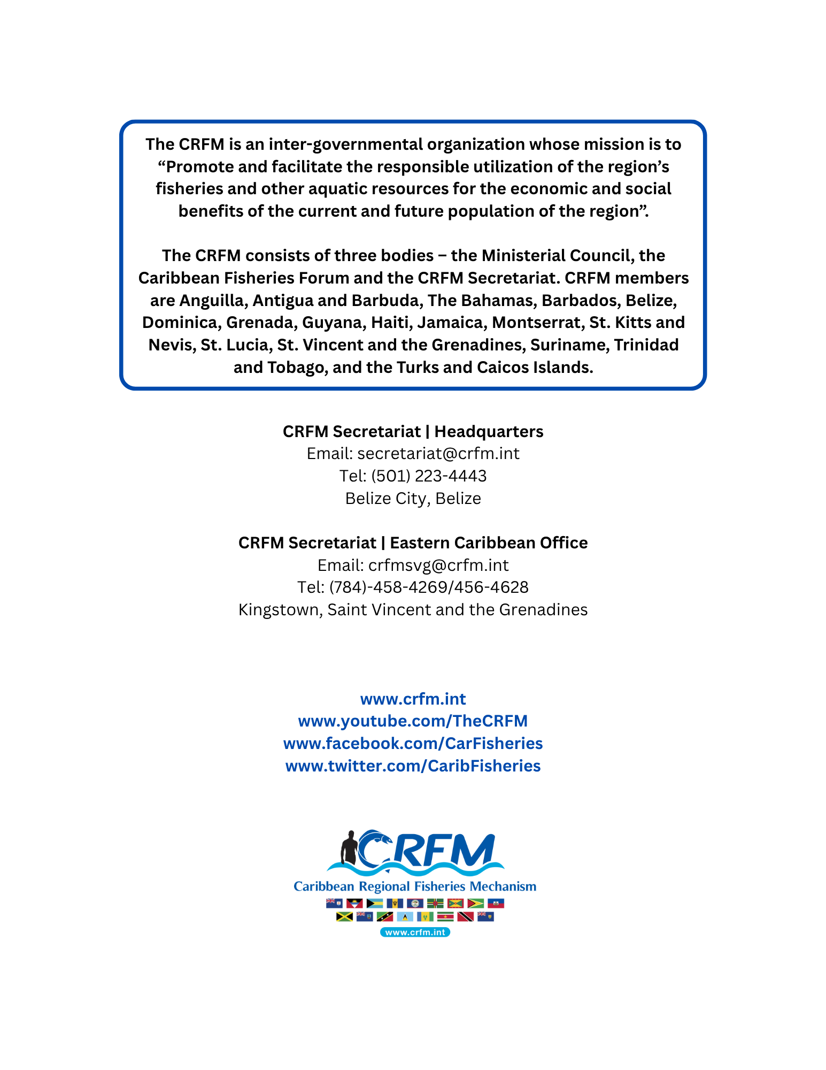

Data Content Type refers to how the data is generated and therefore how it may be used. Baseline data content type are empirical data collected in the field from observations or measurements. Derivative data content type are data produced from analysis of baseline data and give measures of change, trends or other calculated data outputs. Modeled data are data produced from baseline or derivative data that predict or model distribution, trends or status of features of interest which are not directly measured.
Integrated Valuation of Ecosystem Services and Tradeoffs (InVEST) tool developed by the University of Stanford. InVEST® is a suite of free, open-source software models used to map and value the goods and services from nature.
Light detection and ranging (Lidar) hardware technology uses a laser signal to estimate distances between the origin of the beam and some distant surface. It is used to map surfaces such as terrain, buildings, trees, and bathymetry to depths of around 16 metres.
Marxan is a suite of software tools designed to help decision makers find good solutions to conservation planning problems. Marxan is the most widely used decision-support software for conservation planning globally, and has been used to build marine and terrestrial conservation systems covering approximately 5% of the Earth's surface.
SERVIR is a joint initiative of the National Aeronautics and Space Administration (NASA) and United States Agency for International Development (USAID), and leading geospatial organizations, that helps countries in Asia, Africa, and Latin America use satellite data and geospatial tools for sustainable development.

