
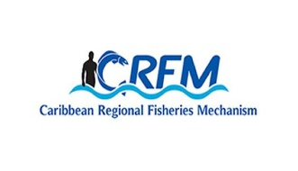
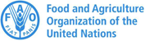


ISSN: 1995-1132

CRFM Technical & Advisory Document No. 2025 / 06

BELIZE
MARINE SPATIAL PLANNING PROFILE

CRFM Secretariat
Belize
CRFM Technical & Advisory Document -
Number 2025 / 06

Belize Marine Spatial Planning Profile

Prepared by:

Joseph Onwona Ansong, Senior Consultant, Howell Marine Consulting
Email: kofi@howellmarine.co.uk

Claire Hedley, Principal Consultant, Howell Marine Consulting
Email: claire@howellmarine.co.uk

This publication has been made possible through funding by BE-CLME+ Project: Promoting National Blue Economy Priorities Through Marine Spatial Planning in the Caribbean Large Marine Ecosystem Plus - GEF Project ID 10211

CRFM Secretariat
Belize
2025
CRFM Technical & Advisory Document Number 2025 / 06

Belize Marine Spatial Planning Profile

© CRFM 2025
All rights reserved.
Reproduction, dissemination and use of material in this publication for educational or non-commercial purposes are authorised without prior written permission of the CRFM, provided the source is fully acknowledged. No part of this publication may be reproduced, disseminated or used for any commercial purposes or resold without the prior written permission of the CRFM.

Correct Citation:
CRFM, 2025. Belize Marine Spatial Planning Profile. CRFM Technical & Advisory Report No. 2025 / 06. 24p.

ISSN: 1995-1132
ISBN: 978-976-8293-95-4

Published by the Caribbean Regional Fisheries Mechanism Secretariat
Belize and St. Vincent and the Grenadines

EXECUTIVE SUMMARY
The Caribbean Large Marine Ecosystem Plus (BE-CLME+) Project aims to promote and further progress a blue economy in the Caribbean Region through MSP and Marine Protected Areas (MPAs) in Barbados, Belize, Guyana, Jamaica, Saint Lucia, and Panama. Under the BE-CLME+ Project, the Caribbean Regional Fisheries Mechanism (CRFM) Secretariat have developed a Caribbean Regional Marine Spatial Planning (MSP) Step-by-Step Guide and Protocol. This Belize Marine Spatial Planning Profile was produced, following desk-based research and stakeholder feedback, to assess the current status, challenges and opportunities for marine spatial planning in Belize, in order to inform the development of the Guide and Protocol.
Belize is….
Table of Contents
EXECUTIVE SUMMARY i
1 INTRODUCTION 1
1.1 Scope 1
1.2 Context 1
2 MSP OVERVIEW 2
3 MSP PROCESS REVIEW 4
3.1 MSP Vision and Objectives 4
3.2 Role of Institutions and Agencies 7
3.3 Stakeholder Engagement 9
3.4 Data and Evidence 10
3.5 Transboundary Cooperation 13
3.6 Funding MSP processes 14
4 MSP CHALLENGES 15
5 MSP BEST PRACTICES AND SUCCESSES 16
6 RECOMMENDATIONS 18
REFERENCES 19

INTRODUCTION

1.1 Scope
The Caribbean Regional Fisheries Mechanism (CRFM) Secretariate is preparing a Caribbean Regional Marine Spatial Planning Step-by-Step Guide and Protocol under the BE-CLME+ Project, to be delivered by the end of 2025. The Guide and Protocol will align with international best practice for developing and implementing MSP but it will be tailored to the specific challenges and opportunities of the countries participating in BE-CLME+: Barbados, Belize, Guyana, Jamaica, Panama, Saint Lucia.
Consultations took place in each country through July and August 2025 to understand how the Guide and Protocol can best take account of their individual circumstances. The profile provides a detailed overview of the current status of Marine Spatial Planning (MSP), its underpinning drivers and political support, and challenges and recommendations specific to Belize. This profile was originally prepared in July 2025 in advance of those consultations based on desk-based research using available documents relevant to MSP in Belize to provide an initial baseline of information. The information was tested and refined through consultation with MSP stakeholders in Belize, to identify the issues most relevant to the development of the Guide and Protocol.
The recommendations contained in Section 6 reflect recommendations contained in the various evidence sourced reviewed for how Belize can further progress MSP. They indicate potential future direction of travel for Belize, and will be used to understand how the Regional Guide and Protocol can support addressing them.

1.2 Context
The Belizean territorial sea (12NM) covers an area of 18 951.44 km² and the Exclusive Economic Zone (EEZ) covers an area of 14 755.55 km². Belize has the second-longest unbroken reef system in the world and is renowned for its marine tourism. The tourism sector drives the construction of new coastal developments, airports, urban areas, and cruise ship ports. The coastal ecosystems also support a number of commercial, recreational, and subsistence fisheries. Belize intends to address the impacts of these coastal and marine developments by identifying Biodiversity Protection Zones through an inclusive, transparent, equitable, science-based participatory and interactive process. The goal of designating up to 30% of Belize’s Ocean in Biodiversity Protection Zones is part of the overall MSP design.
Belize MSP and the Belize Sustainable Ocean Planning (BSOP) are integrally related, with the MSP process forming the core mechanism for achieving sustainable ocean management within the country. The BSOP is the overarching framework designed to balance ecological protection, economic development, and social well-being across Belize’s ocean space. MSP is the practical, science-based process used to develop and implement BSOP. In Belize, MSP is the formal mechanism for achieving sustainable use and resilience in the country’s marine environment. It involves mapping ocean uses, consulting stakeholders, identifying zones for different activities (e.g., conservation, fisheries, industry), and enacting legally binding plans to guide how ocean spaces are used.
From this point, to avoid confusion, ‘MSP’ will be used to refer to the marine spatial planning ‘process’ and ‘BSOP’ will be used when referring to the marine spatial ‘plan’ itself.

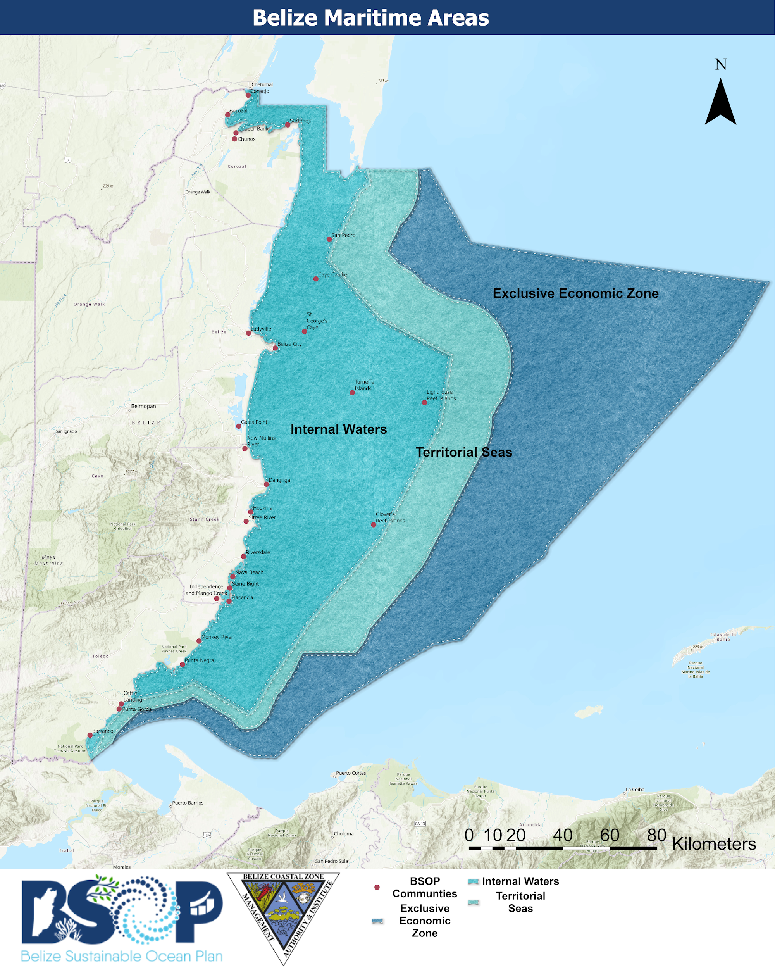
Figure 1. Belize Maritime Areas and Communities within the BSOP area

MSP OVERVIEW
This section provides an overview of the status of MSP in Belize including relevant policies, lead MSP authority, the status of the BSOP, planning approach and scope.

Table 1. Belize MSP overview
Criteria | Overview
MSP Legislation and Policies | MSP legislation is currently in development; however, the Fisheries Resources (Glover’s Reef Marine Reserve) Order, 2024, Fisheries Resources (Lighthouse Reef Atoll Marine Reserve) Order, 2024 and the Fisheries (Turneffe Atoll Marine Reserve) (Amendment) Order, 2022 are statutory instruments that have been used to establish use zones and conservation measures including seasonal closures.  The Belize Medium Term Development Strategy (2022-2026) is in line with MSP principles, as it promotes a balance between economic development and natural  resource protection, while addressing climate change adaptation and good governance.  The Belize Blue Economy Development Policy, Strategy and Implementation Plan (2022-2027) promotes an integrated, multisectoral approach to ocean management,  emphasising MSP, ecosystem-based management, climate adaptation, and financial  tools like blue bonds.  The Blue Maritime Economy Plan (Ministry of and Blue Economy and Civil Aviation, 2022) supports economic growth, job creation, and climate resilience across traditional sectors like fisheries and tourism, as well as emerging industries such as offshore renewable energy and marine biotechnology.
Lead MSP Authority | The Coastal Zone Management Authority & Institute (CZMAI), Marine Spatial Planning Unit under the Ministry of Blue Economy & Marine Conservation is the lead MSP authority in Belize.
Stage of MSP | The MSP stages include stakeholder engagement, public consultation, existing conditions, looking at future conditions and drafting outline of document.  As of October 2024, informed by the MSP process, up to 25% of Belize’s ocean space has been designated as medium Biodiversity Protection Zones. The BSOP outlines the goal of designating up to 30% of Belize’s ocean area as Biodiversity Protection Zones, and the delimitation of the ocean space where permissible activities can be lawfully carried out, by 2026.  The MSP process is currently at the stage of analysing existing conditions and preparing a draft Zoning Framework to guide zoning of uses.
Plan Name/MSP Initiative(s) | The output of MSP process in Belize will be the Belize Sustainable Ocean Plan (BSOP).  The Belize National Integrated Coastal Zone Management Plan (ICZMP) provides the framework to manage the coastal zone (3km inland out to 12nm offshore).
Plan Scale | The BSOP is being developed to cover the entire marine area under Belizean jurisdiction, including the coastal zone, the offshore EEZ and all marine ecosystems and uses.  The ICZMP covers Belize's entire coastal zone, broadly defined as the mainland coastline, cayes, mangroves, estuaries, lagoons, adjacent marine environments, and extends seaward up to the outer boundary of the territorial sea (12 nautical miles), and inland to 3 km.  As a result, the area managed under the ICZM Plan forms a critical subset of the broader marine area encompassed by the BSOP. Any spatial planning or management zone in the ICZMP will also fall within the jurisdiction of the BSOP.
Plan Scope | Both the BSOP and the ICZMP seek to balance sustainable development while conserving Belize’s coastal and marine resources, guided by science-based, cross-sectoral, and participatory decision-making, and both aim for long-term benefits to people, economy, and biodiversity.  The ICZMP provides specific, actionable, regionally tailored guidance for coastal and nearshore management, while the BSOP sets national-level, integrated policy and legal frameworks for the entire marine space, including the coastal zone.
Planning Approach | The planning approach mainly takes a zoning approach for spatial allocation of uses and management actions.
Political Commitment to MSP | The MSP process to develop the BSOP, and its documents are legally binding and an implementation plan is expected to be developed as part of the process.

3 MSP PROCESS REVIEW
The BSOP development process, and therefore MSP, follows the UNESCO-IOC MSP step by step guide and the 10 MSP steps. Belize is currently at the analysing existing conditions stage. The review below focuses on the BSOP process while the ICZM is considered as part of the best practices and challenges.
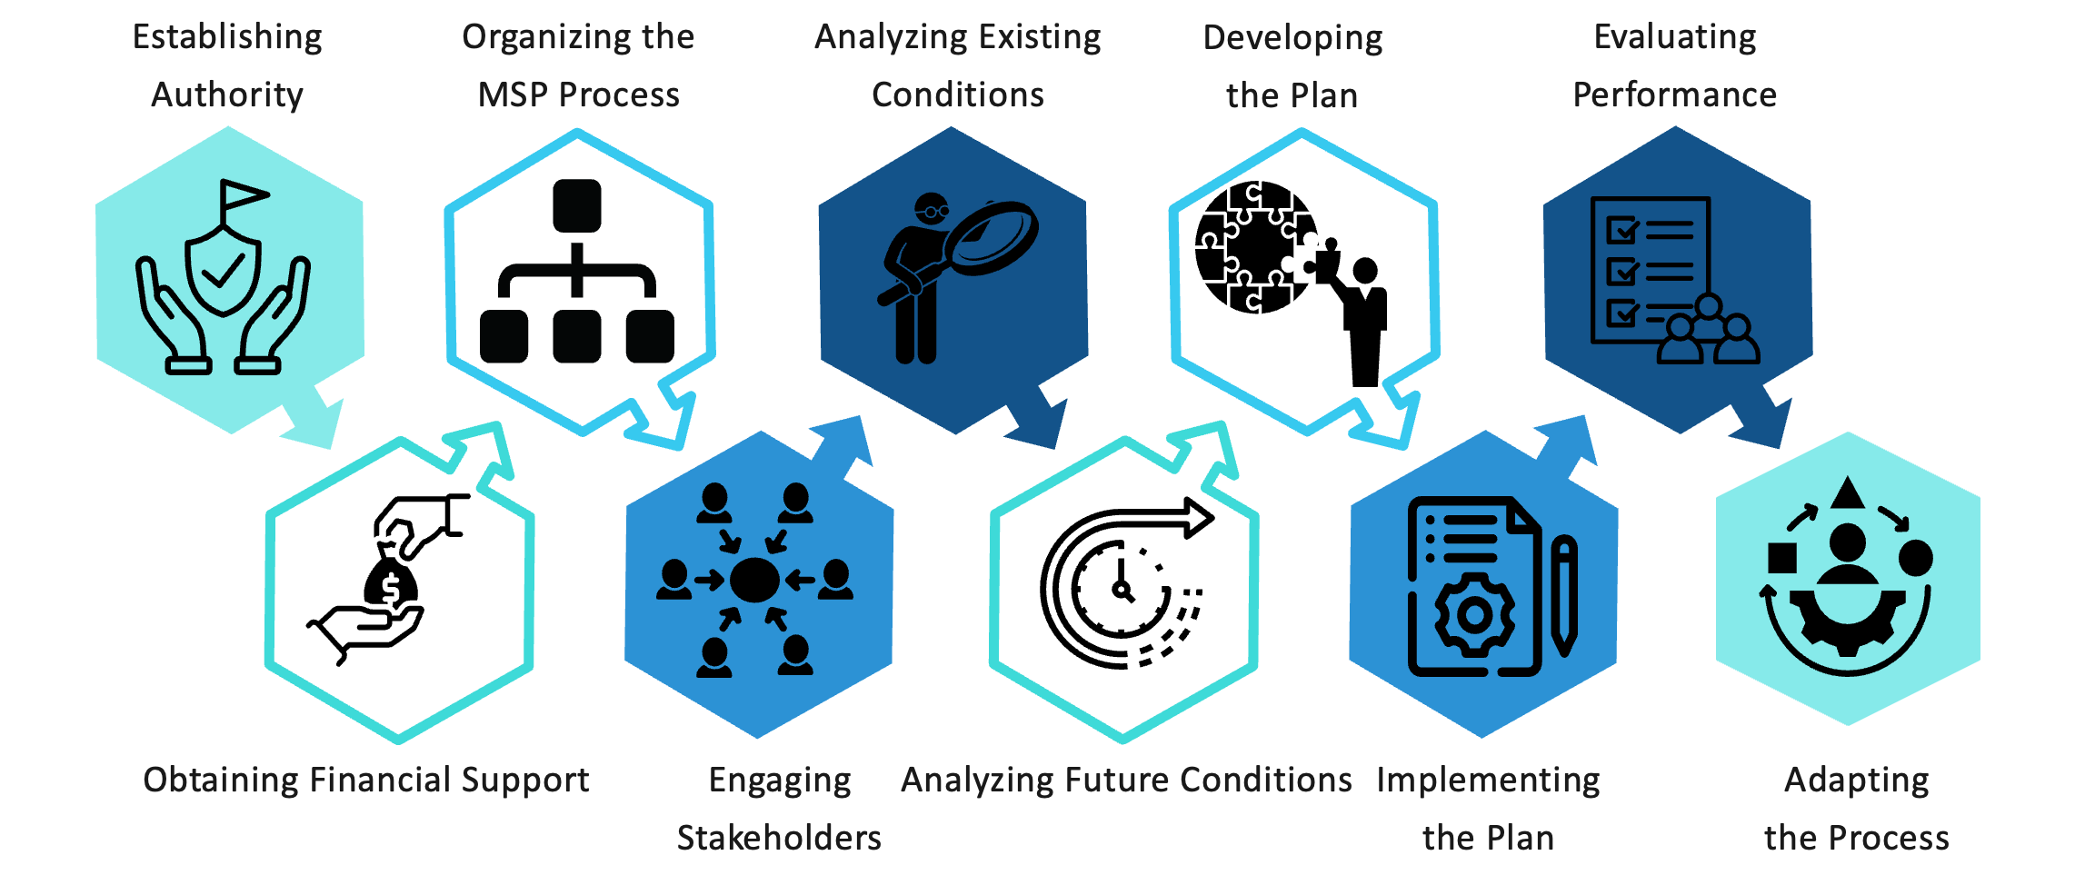
Figure 2. Belize MSP process

3.1 MSP Vision and Objectives
The vision of the BSOP is to ensure “a healthy, resilient, and equitably shared ocean that supports a thriving national economy and nurtures the culture and well-being of all Belizeans”. The overarching MSP goal is to enact and publish legislation required to legally enforce the BSOP so it can guide sustainable development and designate up to 30% of Belize’s ocean as Biodiversity Protection Zones.
Table 2. BSOP Goals and Specific Objectives
Goal 1: Process Governance Goal: To design and implement a science-based, data-driven, participatory, equitable, and inclusive MSP process which delivers on Belize’s MSP-related commitments under the Blue Loan Agreement and Conservation Funding Agreement, in conformance with the guiding principles for decision making.
- Specific Objective 1- Design and execute the process of developing a legally enforceable Marine Spatial Plan for Belize’s Ocean by November 2026.
- Specific Objective 2- Develop and implement the necessary mechanisms, processes, and procedures to ensure that the MSP process is functional, effective, and in accordance with the governance framework.
- Specific Objective 3- Develop and implement a communication strategy and plan to foster public understanding and support throughout the MSP process.
Goal 2: Marine Conservation Goal: To legally protect up to 30% of Belize’s Oceans as Biodiversity Protection Zones.
- Specific Objective 1- Design Biodiversity Protection Zones to protect priority habitats, areas, and species identified through the MSP process, integrating climate resilient safeguards.
- Specific Objective 2 - Strengthen the Marine Protected Area (MPA) network in conformance with national governance frameworks and ecological, economic, social, and cultural criteria set forth by the IUCN.
- Specific Objective 3 – By November 3rd, 2026, sign into law and g azette Biodiversity Protection Zones covering up to 30% of Belize’s Ocean space using a phased approach.
- Specific Objective 4- By November 3rd, 2026, complete, enact and publish legislation(s) to legally enforce the Marine Spatial Plan.
- Specific Objective 5- By November 3rd, 2029, develop legally enforceable Management Plans for Belize’s Biodiversity Protection Zones as described in the MSP.
- Specific Objective 6- Within one year of Cabinet’s endorsement, commence implementation of legally enforceable management plans for Belize’s Biodiversity Protection Zones.
Goal 3: Blue Economy Goal: To support the sustainable growth and development of Belize’s blue economy in alignment with legislation, policy, and planning frameworks
- Specific Objective 1- Identify and evaluate ocean spaces for their functional suitability to support projected sustainable expansion and management of traditional, existing, and emerging economic uses.
- Specific Objective 2- Map, measure, and monitor blue carbon ecosystems to meet conservation targets and leverage conservation financing opportunities.
Goal 4: Equity Goal: To ensure fair and equitable access for all Belizeans to benefits derived from ocean resources and spaces, with respect for traditional social, environmental, cultural and economic uses.
- Specific Objective 1- Between August 2022 and November 2026, implement a stakeholder engagement plan ensuring that 75% of quarterly targets for engaging with key multi-sectoral interest groups are met.
- Specific Objective 2- Identify cultural, indigenous, social, and economic uses, through stakeholder engagement, to determine the allocation of ocean spaces to safeguard community traditions, livelihoods, and participation in emerging sustainable economic activities.

The MSP process and resulting BSOP considers and plans for current and emerging uses of Belize’s ocean space ensuring they are aligned with the country’s marine conservation and blue economy priorities. The BSOP will consider how to improve current and emerging blue economy sectors in Belize (Figure 3 and 4)
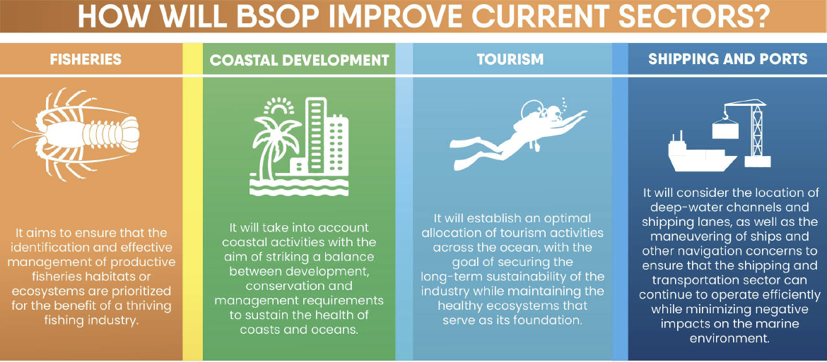
Figure 3 Benefits of BSOP to major ocean-based activities (Source: BSOP Fact Sheet 2023)

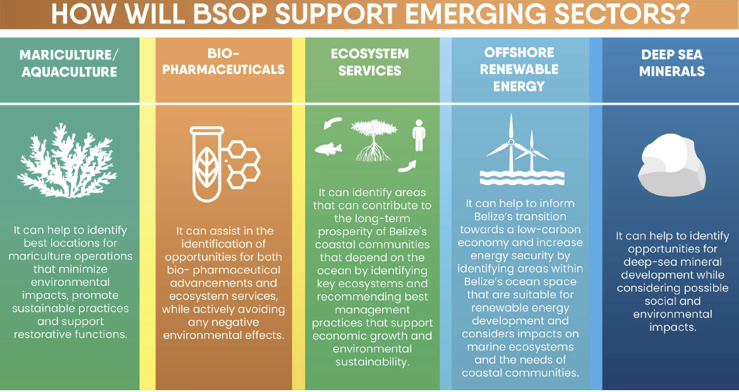
Figure 4 BSOP support for emerging marine sectors (Source: BSOP Fact Sheet 2023)

3.2 Role of Institutions and Agencies
The institutional framework to develop the BSOP includes a composition of the Executive Committee, the Steering Committee, the Core Team, and Technical Working Groups (Figure 5). The institutional framework is designed to facilitate a two-way flow of information between the Steering Committee and industry and resource management sectors as well as the public. The Steering Committee is responsible for providing oversight and guidance for the development and implementation of the MSP process as well as making recommendations via the Blue Bonds and Finance Permanence (BBFP) Unit to the Executive Committee for final endorsement.

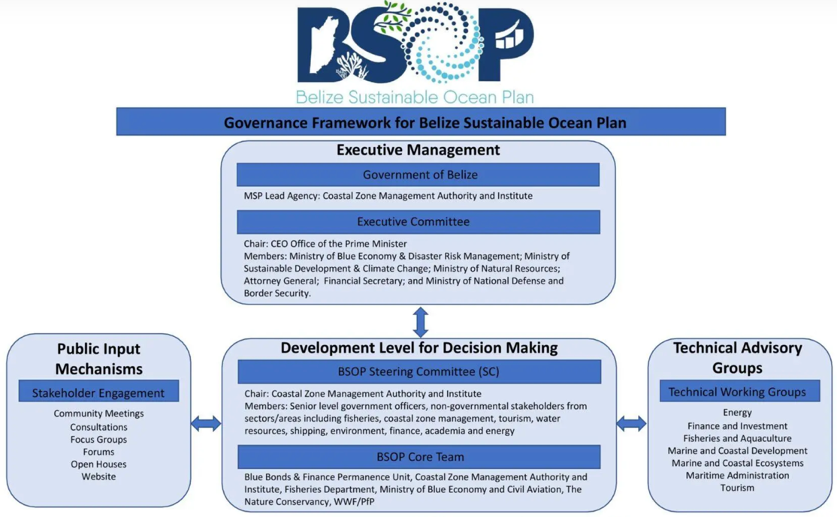
Figure 5. BSOP Governance Framework (revision anticipated by MSP Team)

The Steering Committee includes representatives from:
- Ministry of Blue Economy and Marine Conservation
- Ministry of Sustainable Development and Climate Change
- Ministry of Tourism and Diaspora Relations
- Ministry of Finance, Economic Development and Investment
- Ministry of Natural Resources, Petroleum and Mining,
- Coastal Zone Management Authority and Institute
- Blue Bonds/Finance Permanence Unit, Office of the Prime Minister
- The Nature Conservancy
- Belize Network of Non-Governmental Organizations (BNN)
- Belize Port Authority
- Energy Unit, Ministry of Public Utilities, Energy and Logistics
- University of Belize (UB)
- Belize National Coast Guard
- Belize Fisheries Department
- Belize Forest Department
- Department of Environment
- Representation from relevant fisher organisations – e.g. Northern fishermen Co-operative Society Ltd.
- Chairs of 4 TWGs: (1.) Finance and Investment; (2.) Fisheries (inclusive of Aquaculture); (3.) Marine and Coastal Ecosystems; (4.) Tourism

The Technical Working Groups were established under the guidance of the Steering Committee. The groups engage community representatives, civil society organisations, women’s groups, and Indigenous stakeholders to contribute local knowledge and to help identify social impacts and equity issues associated with marine space use. The working groups includes the following thematic areas and Chairs who work with detailed TORs:
- Energy (Recommended Chair Chair-Belize Electricity Limited)
- Finance and Investment (Recommended Chair-Belize Chamber of Commerce and Industry)
- Fisheries inclusive of Aquaculture (Recommended Chair-Northern Fishermen Co-operative Society Ltd.)
- Marine and Coastal Development (Recommended Chair-TBD)
- Marine and Coastal Ecosystems (Chair-Wildlife Conservation Society)
- Maritime Administration (Recommended Chair- TBD)
- Tourism (Chair- Belize Tourism Industry Association-BTIA)

3.3 Stakeholder Engagement
The MSP process to develop the BSOP is delivered through a participatory process that ensures regular engagement between the Core Team, Steering Committee and Technical Working Groups through meetings, multi-stakeholder workshops, community meetings, focus groups, consultations, forums, open house and BSOP website. The process has so far carried out 159 engagements with 27 communities in Belize.
In developing the BSOP, vulnerable and marginalised groups, including women and Indigenous peoples, were engaged through a series of participatory activities designed to ensure their meaningful involvement.
The BSOP process featured multiple stakeholder engagement sessions such as public consultations, workshops, and community outreach events, involving representatives from indigenous communities like the Garifuna, women’s groups, fishers, local organisations, and civil society. These activities took place in urban, coastal, and rural settings to capture diverse voices and perspectives.
Participatory tools like focus groups, interviews, and participatory mapping exercises facilitated expression of local knowledge and concerns regarding marine use, environmental impacts, and social equity. Recognising barriers such as limited access to information and communication gaps, the Coastal Zone Management Authority and Institute (CZMAI) implemented tailored approaches including the use of local languages, gender-sensitive facilitation, and targeted outreach through media and community leaders.
The process also integrated social safeguard principles and complied with standards like WWF’s Stakeholder Engagement Standard, which emphasises transparent communication, grievance mechanisms, and continuous stakeholder involvement throughout the planning phases.
Capacity-building efforts targeted marginalised groups to empower them with knowledge and skills for active participation and decision-making. The project framework ensured equitable access to meetings, and special sessions were organised to focus on the priorities and needs of Indigenous groups and women.
These engagement efforts were supported by regional and international projects including the BE-CLME+ Project.

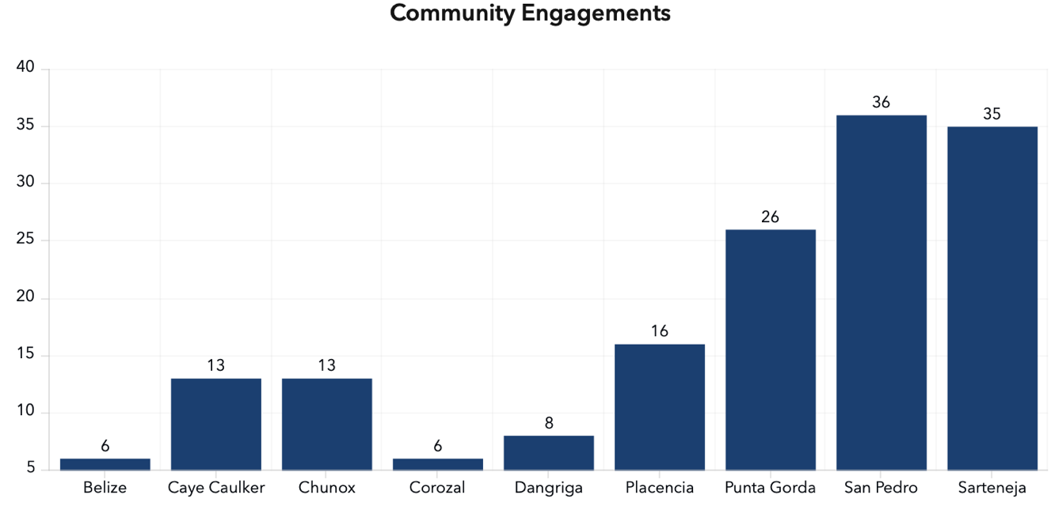

Figure 6 BSOP Community engagements within Belize

3.4 Data and Evidence
Considerable spatial data has been collected on various marine ecosystems and human activities to inform BSOP development. A recent data gaps and needs assessment (CRFM, 2004) identified a total of 229 spatial datasets as relevant. These datasets span multiple categories, including governance, infrastructure, living resources, non-living resources, and ocean uses. Out of the 229 identified datasets, 137 datasets (about 60%) are already available in spatial format to some extent. These datasets cover areas such as fisheries, marine biodiversity, and habitat mapping. The remaining 92 datasets (40%) were identified as gaps, meaning that these datasets are currently unavailable or incomplete (CRFM, 2004). These gaps are particularly prominent in emerging sectors like deep-sea minerals, offshore renewable energy, and biopharmaceuticals. Data availability by category was as follows:
- Governance: 5 out of 7 datasets available.
- Infrastructure: 10 out of 14 datasets available.
- Living Resources: 47 out of 75 datasets available.
- Non-living Resources: 12 out of 29 datasets available.
- Ocean Uses: 63 out of 104 datasets available.
These numerical results highlight that while progress has been made in collecting spatial data for traditional sectors, significant gaps remain in newer and emerging sectors, which needs to be filled to support a comprehensive MSP process in Belize.
The MSP Team, under the CZMAI, collects information on current human use areas through the Ocean Use Survey (OUS) to understand how users use the ocean and its resources, identify areas where ocean uses complement each other, provide decision makers with data to guide the planning process and support the BSOP development. The OUS is a participatory mapping activity that actively engages diverse stakeholders, including indigenous groups, licensed fisherfolk, tour guides, landowners, and port operators, across 27 coastal communities. The survey uses a user-friendly platform called SeaSketch to enable broad participation and to gather spatial data on how various groups use and value ocean spaces. This approach helps to ensure that marginalised communities can contribute their insights and needs for more inclusive ocean management and planning. The survey emphasises public participation to balance ecological, economic, and social goals while recognising and addressing the distinct challenges faced by vulnerable groups in coastal areas.
Dedicated science and mapping experts support data collection, and the process incorporates wide stakeholder participation through digital tools and in-person consultations. The data from the survey is used to develop an inventory of spatial data layers containing best available data/information on all uses of Belize’s Ocean Space. Data is gathered in targeted, time-bound phases associated with the development of the BSOP, rather than to a fixed periodic schedule. For example, the most recent Ocean Use Survey was launched in November 2023, unfolding over three phases of consultations and mapping exercises in 27 coastal communities. These phases are designed to capture comprehensive input during specific project planning periods, rather than through continuous or annual cycles. The first round of surveys ran from January to March 2024, with the most recent conducted from January to March 2025.

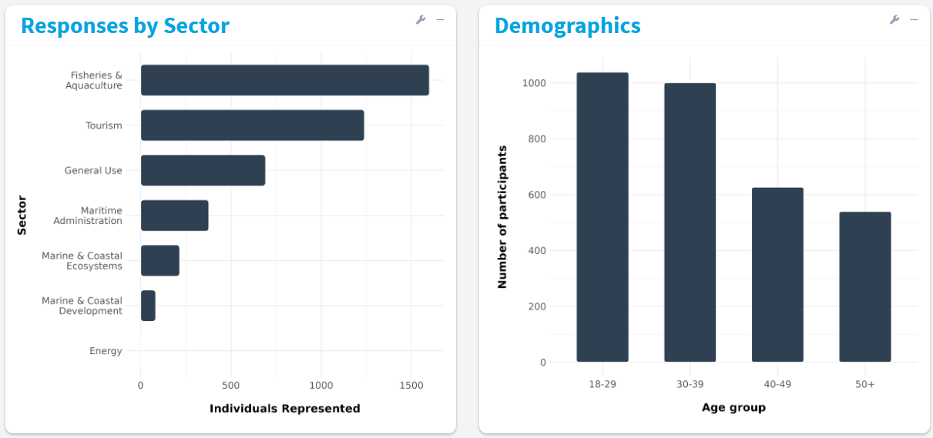
Figure 7. BSOP Ocean Use Survey Responses by Sector and Demographics
The BSOP data viewer has a series of interactive maps that show the public different uses of the Belize ocean spaces and interactive story maps. The data viewer includes data layers for aquaculture, coastal development, marine ecosystems, marine transportation, fisheries, energy and maritime administration. A Compatibility Matrix for uses of Belize’s Ocean Space which forms part of the “Analysis of Existing Conditions” Report has been developed and validated with stakeholders. The report will inform a draft Zoning Framework to guide zoning of uses within Belize’s Ocean Space (Figure 8). The zoning process will utilise decision support tools such as SeaSketch Ocean Planning to inform and guide decision-making for use of the ocean space.
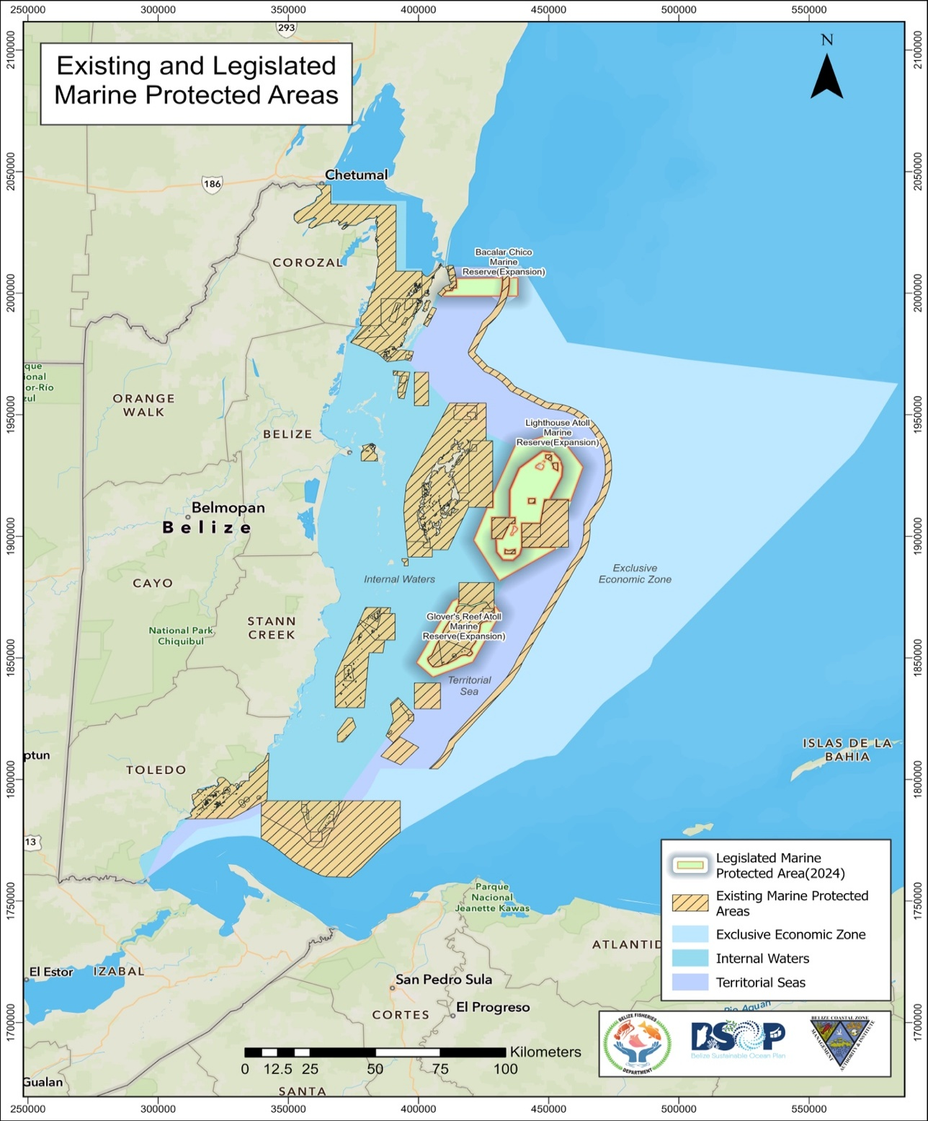
Figure 8. Existing and Propose Marine Protected Areas

3.5 Transboundary Cooperation
Transboundary cooperation on MSP between Belize and neighbouring countries is mainly focused on marine protected areas and coordination to strengthen institutional arrangements for conservation. One of the key transboundary conservation projects is the Mesoamerican Barrier Reef System (MBRS) project which extends from Isla Contoy on the north of the Yucatan Peninsula to the Bay Islands of Honduras, including the Belize barrier reef system. The MBRS Project is a large, transboundary initiative involving the four countries that share the reef: Mexico, Belize, Guatemala, and Honduras. It is led by a coalition of the national governments, with major coordination, funding, and leadership roles provided by the Mesoamerican Reef Fund (MAR Fund) and its Executive Director. It also involves a broad network of partners, including NGOs, international organisations, and national conservation agencies. The project seeks to enhance protection of the unique and vulnerable marine ecosystems comprising the MBRS, and to assist the participating countries to strengthen and coordinate national policies, regulations, and institutional arrangements for the conservation and sustainable use of this global public good. The transboundary area in the Bay of Chetumal (Belize-Mexico) is one of the selected areas for this project as well as the transboundary area in the Gulf of Honduras (Belize-Guatemala-Honduras) and the Sarstoon-Temash (Belize).
Belize and Mexico
The Directors, Deputy Directors and technical staff from the relevant border natural protected areas and agencies of Belize and Mexico engage at a transboundary level through Action Plan and Operational Plans for transboundary protected areas from 2016. This has been followed by projects such as National Commissions of Natural Protected Areas (CONAP) to establish transboundary protected areas.
The CONAP project’s intervention area includes 33 Prioritized Protected Areas (PPAs) in Mexico, Belize, and Guatemala. This initiative integrates the efforts of the governing institutions from each country: the Forest Department of the Ministry of Sustainable Development and Climate Change of Belize; Guatemala’s National Council of Protected Areas (CONAP); and Mexico’s National Commission of Natural Protected Areas (CONANP), which, together with the Central American Commission on Environment and Development (CCAD), form the Selva Maya Strategic Coordination Group (GEC).
The development of transboundary marine protected areas has been proposed between Belize and Mexico to improve the joint management of shared resources. The Bacalar Chico National Park and Marine Reserve, situated in northern Amber gris Caye, was designated on June 14, 1996 (Lock, 1997). It is bounded on the north by the Bacalar Chico channel, from which the park takes its name; this channel forms the border between Mexico and Belize. The Bacalar Chico forms an important component of the planned regional ecotourism developments. The governments of Belize and the Mexican state of Quintana Roo, have a strong interest in the economic development of this region, thus reinforcing the link between environmental and political security (Schrijver, 1993).
Belize and Guatemala
Transboundary cooperation on MPAs between Belize and Guatemala was formalised through the statutory instrument that was signed on July 31, 2020, by the then Minister of Agriculture, Fisheries, Forestry, the Environment and Sustainable Development for the expansion of the Sapodilla Cayes Marine Reserve, now approximately 321,623.5 acres. This expansion includes but is not limited to the protection of a portion of an important coral reef ecosystem known as the Corona Reef or Cayman Crown, which straddles the maritime boundary between southern Belize and Guatemala.
The Cayman Crown is described as the most underrepresented habitat in the MPA system of Belize and Guatemala and is a biologically important hotspot, a fish spawning aggregation site (FSA) for numerous fin fish species and habitat for deep-slope snapper and bottom-dwelling species. The statutory instrument ensures that the Cayman Crown was declared protected in both Belize and Guatemala.
After obtaining a valid research permit from the Belize Fisheries Department, the Toledo Institute for Development and Environment (TIDE) commenced research for FSAs at the Cayman Crown in February of 2020. Scientific information will inform the effective management of the Cayman Crown zone within the Sapodilla Cayes Marine Reserve. The TIDE’s research team was accompanied by a research team from FUNDAECO, Guatemala, that is responsible for the management of the Guatemalan portion of the Cayman Crown site. The FUNDAECO team obtained a valid research permit from the Belize Fisheries Department to participate in the research trips within Belize’s territorial waters and TIDE intends to access research permits from Guatemala when conducting research in the Guatemalan marine protected area. TIDE, FUNDAECO and Healthy Reefs for Healthy People Initiative have pledged through a cooperation agreement to work jointly on research, protection, and management of the newly formed transboundary marine protected area.

3.6 Funding MSP processes
The Government of Belize (GoB) and The Nature Conservancy (TNC) signed a “blue bond” debt conversion agreement in 2021 enabling the country to reduce its debt burden and increase its investment in marine conservation. The Belize Fund for a Sustainable Future was established to manage the $USD 553 M funds that will be invested in marine conservation with key milestones including the development, approval, and implementation of a ‘marine spatial plan’ as outlined in the Conservation Funding Agreement (CFA).
MSP and the resulting BSOP is intended to be complementary to the existing management structures, and in Belize’s case, will add new elements to sectoral management measures to aid the country in achieving its environmental, economic, and social objectives. One of the main outputs of the planning process is the allocation of space, or zones, designated for a particular use. The ‘marine spatial plan’, as defined in Clause 7 of the CFA is “a plan analysing and allocating parts of three-dimensional marine spaces (or ecosystems) to specific uses or objectives in order to achieve ecological, economic, and social objectives that are specified through a political process”. Table 3 defines the milestones, timelines and allocation for biodiversity protection under the “blue bond” debt conversion agreement.
Table 3 Blue bond and debt conversation for MSP timelines and milestones
Milestone number | Milestone summary description | Time after signing the Agreement | % of Ocean in High Protection | % of Ocean in Medium Protection | Total % of Ocean in Biodiversity Protection
1 | Expand Biodiversity Protection to 11.5% of the Ocean | 6 months | Increased to 5.7% | Remains at the current 8.96% | 20.53%
2 | Designate Public Lands within the BBRRS as Mangrove Reserve | 6 months
3 | Belize initiates MSP process | 1 year
4 | Expand Biodiversity Protection Zones to 25% of the Ocean | 3 years | Add 4.5% more in total across either Medium and/or High zones* |  | 25%*
5 | Implementation of ICZMP | 4 years
6 | Complete Biodiversity Protection Zones, MSP signed into law and implemented | 5 years | Add 5% more in total across either Medium and/or High zones* |  | 30%*
7 | At least 3 IUCN Green List Application submitted | 6 years
8 | Approved Management Plans | 8 years
*In all cases, is the lower of the % or the amount specified in the MSP
Other sources for funding MSP in Belize include Grant Strategic Allocation program for government projects and funding from TNC, the conservation funds, BE-CLME+ and PROCARIBE+ project (Table 4).

Table 4 Other MSP funding sources in Belize
Funding source | Description
RESILIENT BOLD BELIZE (PfP) | Funding from the Blue and Green Islands and the GEF Project Grant for US $4,742,964. The Implementing Agency is WWF-US
Conservation Funds | $USD4.2 M per year
BE-CLME+ | Resources for Technical Support for MSP and Opportunities for exchange
PROCARIBE+ | Resources for Technical Support for MSP and opportunities for Capacity Building

4 MSP CHALLENGES
The following are key challenges of MSP in Belize identified based on this review:
- Representation in MSP engagement and surveys: There appears to be a gap in official statistics about the gender breakdown of ocean use across sectors, with women often undercounted due to greater involvement in informal activities (Meyer et al., 2025). The high male to female ratio was noticeable after gendered analysis was conducted for MSP engagements.
- Data gaps: The Belize MSP Data Gaps and Needs Assessment highlights that while Belize has made notable progress in collecting data on marine ecosystems and human activities, priority gaps remain. These include data gaps regarding biodiversity, land tenure, hydrography, and coastal geomorphology, as highlighted by stakeholders. Other identified key data gaps were noticed especially in emerging sectors such as deep-sea minerals and offshore renewable energy.
- Logistics and equipment: Belize has already collected large amounts of data, but these datasets are often fragmented, inconsistent, or inaccessible to decision-makers. There is the need for a centralised data repository to ensure that relevant stakeholders can access up-to-date, high-quality data.
- Human capacity and technological gaps: Belize faces significant challenges due to the limited availability of technology, high acquisition costs for data, and gaps in human resources capable of managing and analysing data.

5 MSP BEST PRACTICES AND SUCCESSES
The following areas of work are MSP best practices identified from the review of the BSOP and the Belize ICZM.
Developing integrated plan objectives and indicators: Belize ICZM Vision, Objectives, and Indicators
The Belize ICZM integrates multiple marine sectors, including fisheries, aquaculture, tourism, and marine traffic, into four visions:
- Encouraging sustainable coastal resource use.
- Supporting integrated development planning.
- Building alliances to benefit Belizeans.
- Adapting to climate change.

One of these four visions includes a marine sector through a set of “Actions” (objectives). The plan’s Monitoring Protocol for Periodic Evaluation of Implementation and Coordination Plan (ICP) reflects the visions and objectives. These are clear, providing at least one measurable indicator for each objective. Table 5 shows an example of how the plan vision and objectives are developed to inform indicators and targets for ICZM.

Table 5 Marine Traffic Objectives of Belize’s Coastal Zone Management Plan and Indicators
Actions Required (Objective) | Indicator/Target(s) | Metric(s)
- Develop a national policy on marine transportation in support of the Informed Management zoning scheme to minimise user-conflicts | - National Policy developed by June 2018  - Prepare and submit Cabinet Paper by September 2018 | - Number of consultations held  - Number of stakeholders consulted  - Number of recommendations and suggestions to develop policy  - Date by when Cabinet Paper is submitted
- Develop and implement a national policy and supporting standards for the safe transport of hazardous chemicals in the sea | - National Policy developed by June 2018  - Prepare and submit Cabinet Paper by September 2018 | - Number of consultations held  - Number of stakeholders consulted  - Number of recommendations and suggestions to develop policy  - Date by when Cabinet Paper is submitted
- Update navigational charts for Belize to improve boating safety. | - At least three (3) new navigational charts produced by March 2019 | - Number of new charts produced

Ecosystem-based approach to planning
The Belize ICZMP process used Integrated Valuation of Environmental Services and Tradeoffs (InVEST) to formulate a management plan that was scientifically and economically sound (Figure 9). Ecosystem service modelling and mapping were employed to identify the location, extent, and intensity of human activities that could be adjusted to improve ecosystem service outcomes. Ecosystem service modelling typically begins by quantifying the risks of human activities to the structure and function of natural habitats (Arkema et al., 2014), followed by modelling the benefits provided by natural habitats for people’s livelihoods and well-being through ecological production functions. By pairing multiple ecosystem services and metrics with spatially explicit scenarios that compare alternative management options, it is possible to highlight how proposed marine spatial plans create synergies and trade-offs among activities in space.
During the planning process, teams of researchers, practitioners, and stakeholders evaluated how human impacts on coral, mangrove, and seagrass habitats would change the potential for ecosystems to provide coastal protection, tourism and lobster fishery benefits under three alternative management scenarios that promoted either habitat conservation, coastal development or “informed management” (Arkema et al., 2015). As a result, the plan explicitly considers how coastal management can provide benefits to multiple sectors and stakeholders, given their local visions and values.

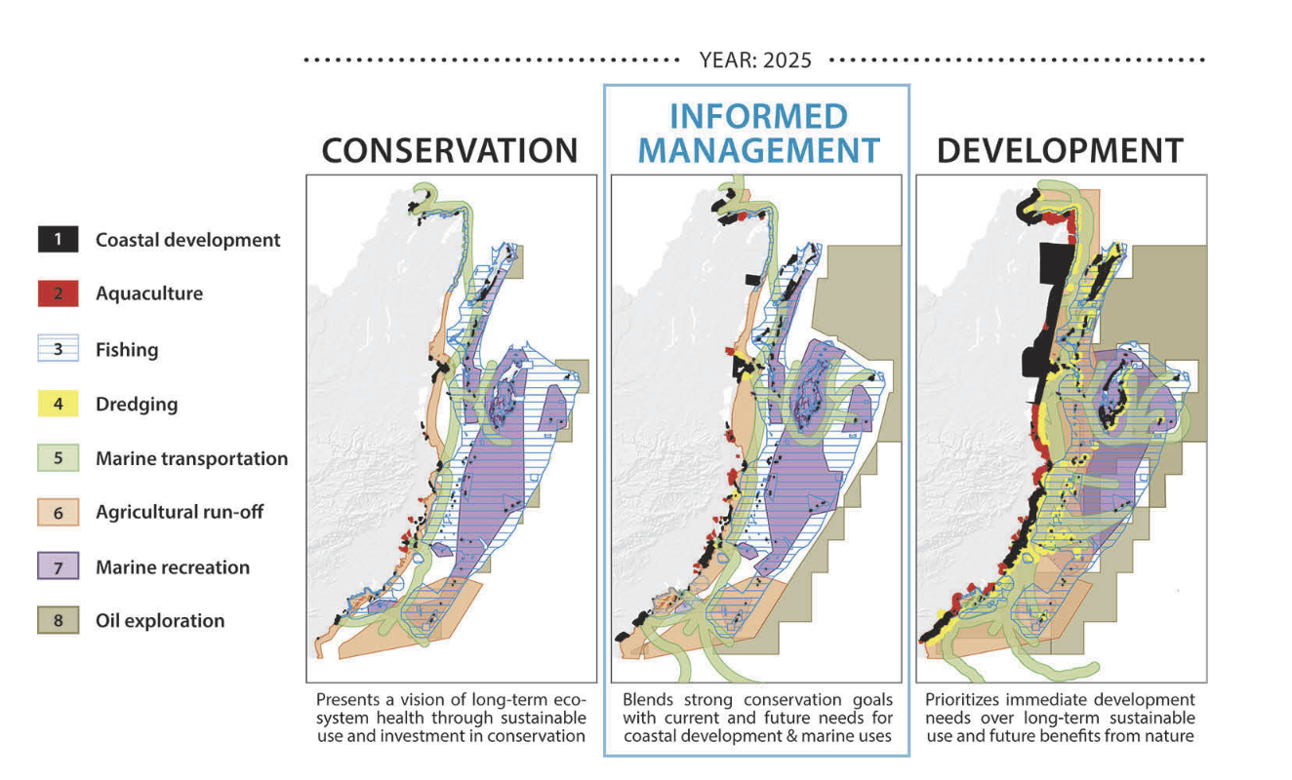
Figure 9 Zones of human use for three alternative future management scenarios in the year 2025.

The scenario storylines in Figure 9 are based on a 15-year vision of the future using 2010 state-of-play as the baseline. As described in Arkema et al. (2015), the final iteration of the Informed Management scenario was ultimately chosen as the preferred scenario for the integrated coastal zone management plan (CZMAI 2016).
The simple models allow for an iterative science and policy process—in which scientists, stakeholders, and decision-makers repeatedly re-evaluate proposed scenarios, predicted outcomes, and model assumptions throughout the planning process—and that can result in more robust marine plans. This iterative approach to co-creating scenarios, science and knowledge can produce more credible, transparent and effective tools that resonate with governments and stakeholders.

6 RECOMMENDATIONS
The recommendations below primarily reflect recommendations set out in the evidence sources reviewed when developing this profile and include some suggestions by HMC based on challenges and limitations identified in the evidence sources. They indicate the potential direction of travel for Belize MSP, and they will be tested and developed further through consultation with Belize stakeholders to understand the feasibility and practicality of actioning them, which will inform the Guide and Protocol.
The following are recommendations to advance MSP in Belize:
- Data management and standardisation: Data standardisation will help avoid redundancies and ensure that future data collection efforts are targeted and efficient. Belize’s MSP process will benefit from adopting standardised frameworks for data collection and analysis, as seen in successful MSP initiatives globally. The report mentions the use of tools like GIS, Seasketch, and MARXAN in data analysis, which could greatly enhance the ability to map and prioritise areas for conservation and development. The report emphasises the need for an Interagency Information Management System or Data Hub for MSP.
- Increased participation in MSP by women and women’s groups: A second round of the Belize OUS is proposed to increase female participation, with strategies to survey more female ocean users including targeting women in the fishery value chain and women’s groups in their communities. A grievance redress mechanism will further support the involvement of marginalised and marginalised groups
- Funding and investment in human capacity building: targeted investments in human capacity building, access to technology, and financial resources for data collection are needed to advance the MSP process.

REFERENCES
Arkema, K. K., Verutes, G., Bernhardt, J. R., Clarke, C., Rosado, S., Canto, M., et al. (2014). Assessing habitat risk from human activities to inform coastal and marine spatial planning: a demonstration in Belize. Environ. Res. Lett. 9:114016. doi: 10.1088/1748-9326/9/11/114016

Arkema, K. K., Verutes, G. M., Wood, S. A., Clarke-Samuels, C., Rosado, S., Canto, M., et al. (2015). Embedding ecosystem services in coastal planning leads to better outcomes for people and nature. PNAS 112, 7390–7395. doi: 10.1073/pnas.1406483112

CRFM. (2024). Data Gap and Needs Assessment to Inform NMSP in Belize. CRFM Fishery Report, GEF Project ID 10211.

CZMAI (Coastal Zone Management Authority and Institute). (2016). Belize Integrated Coastal Zone Management Plan. Belize City: CZMAI. https://www.coastalzonebelize.org/wpcontent/uploads/2019/11/BELIZE-Integrated-Coastal-Zone- Management-Plan.pdf.

Lock, N. (1997). Transboundary protected areas between Mexico and Belize, , 25:4, 445-454, DOI: 10.1080/08920759709362336

Meyer, A., Scherer, M., Balderamos, J., Nidia Chacon, Brooke Dixon, Andrew Estep, Shaistha Mohamed, Peter Menzies, Fathimath Nistharan, Matthew Paufve, Adriano Quintela, William J. McClintock. (2025). Gender-based Ocean uses and values: Implications for marine spatial planning, Marine Policy, Volume 178, 106691,

Schrijver, N. J. (1993). Sovereignty and the sharing of natural resources. In Transfrontier reserves for peace and nature: A contribution to human security, ed. A. H. Westing, 21-33. Nairobi: United Nations Environment Program

Verutes, G. M., Arkema, K. K., Clarke-Samuels, C., Wood, S. A., Rosenthal, A., Rosado, S., … Ruckelshaus, M. (2017). Integrated planning that safeguards ecosystems and balances multiple objectives in coastal Belize. International Journal of Biodiversity Science, Ecosystem Services & Management, 13(3), 1–17. https://doi.org/10.1080/21513732.2017.1345979

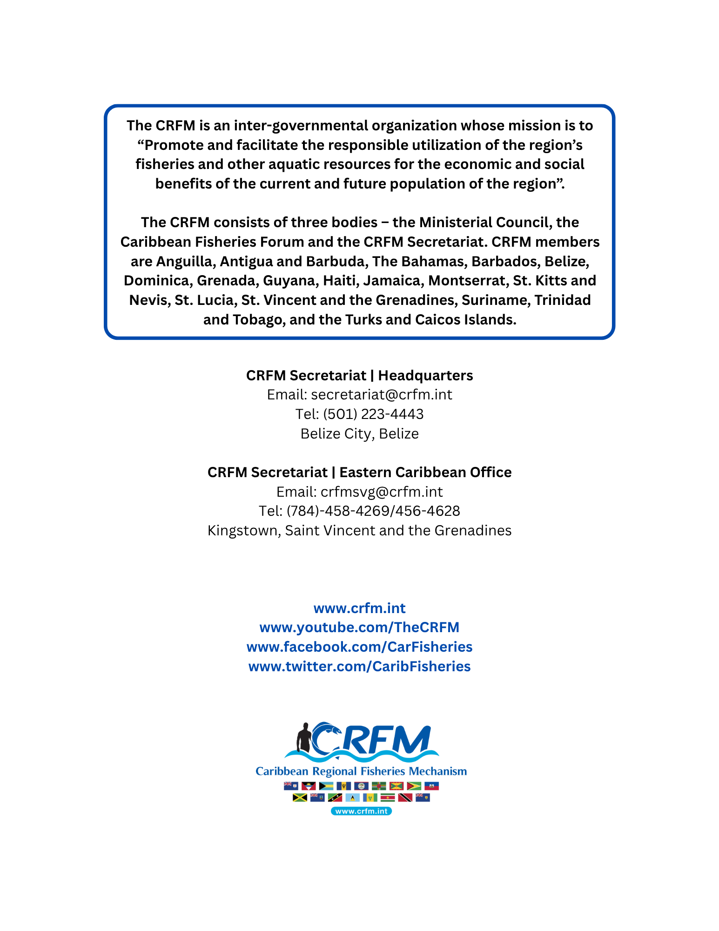

InVEST is open-source software that maps and values ecosystem services by modeling how environmental changes affect benefits to people.

