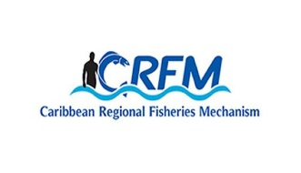

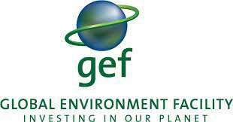


ISSN: 1995-1132

CRFM Technical & Advisory Document
No. 2025 / 12

FINAL REPORT

Data Gap and Needs Assessments to Inform MSP Implementation in Saint Lucia

CRFM Secretariat
Belize

CRFM Technical & Advisory Document -
Number 2025 / 12

Data Gap and Needs Assessments to Inform MSP Implementation in Saint Lucia

This publication has been made possible through funding by BE-CLME+ Project: Promoting National Blue Economy Priorities Through Marine Spatial Planning in the Caribbean Large Marine Ecosystem Plus - GEF Project ID 10211

CRFM Secretariat
Belize
2025

CRFM Technical & Advisory Document Number 2025/ 12

Data Gap and Needs Assessments to Inform MSP Implementation in Saint Lucia

© CRFM 2025
All rights reserved.
Reproduction, dissemination and use of material in this publication for educational or non-commercial purposes are authorised without prior written permission of the CRFM, provided the source is fully acknowledged. No part of this publication may be reproduced, disseminated or used for any commercial purposes or resold without the prior written permission of the CRFM.

Correct Citation:
CRFM, 2025. Data Gap and Needs Assessments to Inform MSP Implementation in Saint Lucia. CRFM Technical & Advisory Report No. 2025 / 12. 145p.

ISSN: 1995-1132
ISBN:

Published by the Caribbean Regional Fisheries Mechanism Secretariat
Belize and St. Vincent and the Grenadines
Executive Summary
The Blue Economy-Caribbean Large Marine Ecosystem Plus (BE-CLME+) Project is a regional initiative aimed at fostering blue economy development in the Caribbean through strategic activities including marine spatial planning (MSP), the establishment of marine protected areas (MPAs), the adoption of an ecosystem approach to fisheries (EAF), and the development of climate-smart sustainable fisheries value chains. Implemented by the Caribbean Regional Fisheries Mechanism (CRFM), this wider project includes Barbados, Belize, Guyana, Jamaica, Saint Lucia, and Panama and is being delivered in the collaboration of the Development Bank of Latin America and the Caribbean (CAF), the Food and Agriculture Organization (FAO) and the Global Environment Facility (GEF) as co-implementing agencies.
Saint Lucia’s involvement in this BE-CLME+ Project is underpinned by its National Ocean Policy and Strategic Plan (2020-2035) and Coastal Master and Marine Spatial Plan (2020-2035). These plans align closely with the objectives of the BE-CLME+ Project, supporting the island's transition to a sustainable blue economy. The National Ocean Governance Committee (NOGC), which includes various national departments and agencies and coordinates and evaluates the implementation of these ocean policies, serves as the focal point for the BE-CLME+ Project.

Objective of the consultancy
The objective of the consultancy was to conduct a comprehensive assessment of data gaps, data availability, and needs to support the implementation of Marine Spatial Planning (MSP) in Saint Lucia. This assessment aimed to build upon and complement ongoing Blue Economy (BE) processes in Saint Lucia.

Methodology and Approach
This final report centres on one component of the delivery of the BE-CLME+ Project in Saint Lucia, focusing on assessing data availability, identifying gaps, and evaluating needs to support the implementation of MSP while also complementing ongoing blue economy initiatives. The approach to implementing this assessment involved developing a stakeholder matrix to identify primary and secondary stakeholders followed by a comprehensive desk review of relevant data through the compilation of general/common data sources that support MSP in the Caribbean and around the world. The stakeholders Identified were directly engaged through, and invited to complete, an MSP-specific questionnaire following email introductions. This questionnaire focused on better understanding what data related to MSP currently exists in Saint Lucia, how the data was collected, and the format of the data and where and how they are currently stored.

Data set

What format is this data?

Which agency holds this data?

Who collected the data?

How was the data collected?

How is the data stored?

Has the data been analysed?

Do data sharing protocols exist?
Diagram 1. Questions related to datasets identified as being relevant to the Marine Spatial Planning process in Saint Lucia.
Key stakeholders were also engaged through virtual meetings during which data availability and needs were discussed (Table 1). A hybrid national workshop held in Saint Lucia was facilitated on 22 August 2024 to validate the findings of the assessment and the recommendations.
Table 1. Questions asked related to data availability and sharing as well as capacity needs
- What barriers/challenges does your agency experience as it relates to accessing and/or sharing data?
- What other datasets would support your work but are currently missing?
- What barriers/challenges exist to collecting data, storing, and analysing data?
- What skills/capacity (including capital) does your agency require for MSP data collection, storage, and analysis
- Does your agency have these skills/capacity (including capital) for MSP data collection, storage, and analysis?
- What costs are associated with securing/procuring/maintaining this skills/capacity for MSP data collection, storage, and analysis?

Findings
Key findings of this assessment indicate that Saint Lucia has already conducted a significant amount of work to create and implement a National Ocean Policy (NOP) and its accompanying action plan. This NOP establishes a comprehensive framework for integrated planning and management of Saint Lucia’s marine space and associated activities occurring within it over a fifteen-year period (2020-2035). The policy aims to balance environmental conservation with economic development, ensuring that ocean-based activities support long-term sustainability. This Policy prioritises the collection and collation of data and research to inform evidence-based decision-making, improving the understanding of marine environments and their economic potential, hence the need for the undertaking of a data gap assessment under this project to inform future implementation. The National Ocean Policy identifies eight priority sectors and associated activities which promotes, inter alia, an ecosystem-based management, public and private sector participation and, the use of best available evidence, sound science and best practice. These priority sectors focus on (1) marine fisheries, (2) marine aquaculture, (3) marine environment and biodiversity protection, (4) surface water management, (5) marine transport, (6) tourism and recreation, (7) coastal development and (8) sub-marine cables.
The Government of Saint Lucia, MSP partners and stakeholders have already generated a substantial amount of MSP data through their on-going work programmes as well as externally-funded projects. One of the most significant projects was the OECS’ Caribbean Regional Oceanscape Project (CROP) through which various MSP scenarios for Saint Lucia’s exclusive economic zone were explored and through which the Master Coastal and Marine Spatial Plan was developed. This Master Plan was formally endorsed and approved by the Government of Saint Lucia in June 2024, with the aim of enabling local agencies to better pursue a sustainable and emerging blue economy.

Existing data and data gaps
Existing and potential marine spatial planning information and evidence was categorised based on eight broad (and sometimes overlapping) data types. Each category represents a critical aspect of marine spatial planning that contributes to effective management and sustainable use of marine resources:
- Protected area and international designations: This category encompasses critical conservation areas that are recognized both nationally and internationally such as marine parks and Ramsar sites. Understanding these areas helps ensure that marine spatial planning aligns with biodiversity protection goals and complies with international agreements, facilitating effective conservation measures.
- Coastal and marine habitat: Identifying habitats is essential for assessing ecosystem health and function. This category allows planners to evaluate the spatial distribution and health of marine habitats, ensuring that critical ecosystems are protected and adequately managed to maintain their ecological integrity. This category could include habitat maps, and data on pollution and water quality.
- Socioeconomic: This category reflects the human dimensions of marine spatial planning, including the economic activities and social structures that depend on marine resources, focusing on understanding economic dependencies, social values and demographic trends. Datasets related to this category include the distribution and intensity of fisheries and local community demographics.
- Maritime zonation: including exclusive economic zones and territorial waters
- Tourism: As a significant economic driver in many coastal areas, understanding tourism dynamics is crucial for balancing development with conservation. This data category emphasises recreational marine use and could include datasets such as dive and snorkel sites, recreational beach use and sports fishing areas.
- Cultural: Marine areas often hold cultural and historical significance for local communities. Including cultural data in marine spatial planning recognizes the importance of preserving cultural heritage and ensures that traditional practices and values are maintained. This category could include datasets such as the location of shipwrecks and coastal landmarks that hold cultural significance, and the location of important marine-related community events.
- Coastal and marine infrastructure: This category addresses the physical structures and facilities that support marine activities, including but not limited to ports, marinas and coastal defences.
- Shipping: Given the importance of maritime trade and transport, this category focuses on the logistics of transport and trade routes, and could include datasets related to regulatory and jurisdictional boundaries, navigational aids and vessel tracking data
A total of 83 datasets, falling within these seven broad data type categories were identified through a review of documents sourced on-line as well as those shared by national stakeholders and through direct engagement with those stakeholders. Datasets are technically available to (or stored by) at least the agencies that either collected the data or commissioned the work that enabled the collection of data. Formats of data, however, may not necessarily be geospatial and additional work and effort may be required to transform this information into a standardised format that can be applied to the MSP development and implementation process.
Twenty agencies, including government, non-government, private sector and international non-government organisation stakeholders were consulted, with nine providing additional information to supplement the desk-top review findings. The results of this assessment indicate that there are currently 34 datasets associated with the coastal and marine habitat data type in addition to 32 socio-economic datasets and 11 datasets related to protected area and international designations. Despite this vast amount of information and evidence, several key datasets were identified as either missing or requiring updating but being necessary to support MSP implementation (Table 2).
Table 2. Data gaps related to marine spatial planning process identified by stakeholders during consultations.
Data gaps identified during stakeholder consultations
Connectivity between landfill sites and the marine environment (pollution)

Locations of future renewable energy project/s

Spatial data on the boundaries of ponds, mariculture areas and fisheries facilities

Fishing grounds

Beach and marine use and carrying capacity

Deepwater benthic contours and habitats

Desalination plants and brine discharge outflow pipes

Water quality in coastal areas including within marinas

Microplastics dispersal and content

(Demarcation of) marine management areas, including Laborie, Micoud and other sites identified within the marine protected area and marine management area systems plan
Stakeholders’ perceptions and ecological knowledge

Datasets previously collected but in need of updating
Biodiversity- and environmental-related datasets (including expanding on priority species distributions and benthic habitat mapping)

Navigational charts to be updated regularly with any additional MSP-related datasets

Capacity needs related to data collection, availability and storage
Consultations with MSP stakeholders identified data storage and management as a cross-cutting concern; the issue was raised by every agency consulted. Although a centralized system to store and manage spatial data has been created in various iterations, the latest of which being the GEOServices platform, the system remains underused and underpopulated. The lack of a well-used centralized data repository creates challenges with data sharing which is further exacerbated by lack of legislation requiring the access and sharing of certain datasets and the lack of an established/standard data-sharing protocol especially between national agencies, but also international organizations/agencies and research institutions contracted to conduct projects that generate (spatial) data.
To support effective MSP implementation and the pursuit of blue economy initiatives, stakeholders recognised the need for increased institutional capacity in the form of human capacity and training, technology-based infrastructure (cloud storage, modern data collection tools) and (Table 3).
Table 3: Summary of the priority training needs identified by stakeholders related to the collection of data to support marine spatial planning in Saint Lucia.
Priority areas for training identified by stakeholders

Qualitative data collection (social and social-economic, e.g., local ecological knowledge)

Remote data collection (including drones, satellite imagery)

Data management software application (Excel, GIS)

Spatial data analysis (GIS software)

Statistical data analysis and modelling (e.g., fish stocks, vessel monitoring systems)

Capital, technology-forward equipment to allow for the application of training and support MSP implementation were also identified as was the need for specialized software and subscriptions will also be required (Table 4).
Table 4. Summary of the capital equipment required to support the collection of data to inform Marine Spatial Planning in Saint Lucia.
Technology and capital equipment required
Aerial drones
Underwater drones

In-field data collection tools including tablets, GPS units, passive acoustic stations, baited remote underwater video stations, water quality monitoring equipment, beach profiling equipment

Laptops (with adequate processing speed and storage capacity)

Vessel Monitoring System (to expand recently initiated programme)

Mooring/Boundary markers for marine protected areas and marine management areas

Specialized software and subscriptions required
GIS software (or expansion of Government licenses to other agencies)

Fisheries data collection software

Graphic design software

Cloud storage/platforms

Sustainable financing mechanisms were also identified as being essential to meeting these needs and moving MSP forward in Saint Lucia. Although all government and statutory agencies have budgets to support daily operations, funds to specifically support the work required for MSP and blue economy development-related activities have primarily been sourced from external funding mechanisms and agencies. Blue economy initiatives offer opportunities for reinvestment into blue economic growth and MSP implementation, including on-going monitoring and management of the marine space which supports this emerging economy. The development of a sustainable financing strategy has been identified as a necessary and supportive instrument to be generated through the BE-CLME+ Project. Potential mechanisms that could be explored and integrated into this strategy may include, but may not be limited to, private-public partnerships, blue and green carbon credits, biodiversity credits, and conservation trust funds. It should be noted that debt for nature swaps/investment in conservation is currently being explored by the Government of Saint Lucia in collaboration with The Nature Conservancy and with funding from the US International Development Finance Corporation.
To enable a successful, sustainable blue economy, a comprehensive, evidence-based marine spatial plan is essential. This plan will thoughtfully and effectively consider existing and potential marine resources and activities and will consider how Saint Lucia’s marine area can be developed. The MSP should enable better access to data, either by collating and maximising use of existing data and identifying and collecting data that is required to make informed decisions. It will identify potential areas of conflict and take a progressive approach to minimise that conflict potential within the planning phases. Marine spatial planning and implementation is also embedded in inclusivity, where government, non-government, private sector agencies and industries and local communities can come together to identify management priorities and to advance and implement management decisions, regulations and policies.
For effective engagement, however, stakeholders and beneficiaries must also be aware of and understand what MSP means and the process involved, and how the blue economy can tangibly benefit the people of Saint Lucia. As part of this consultancy, communications materials on MSP have been developed to enhance public understanding and support for the project. These materials have been designed for social media platforms and cover three major themes: Saint Lucia’s MSP and blue economy priorities, the common values supporting the pursuit of the blue economy, and key aspects of what comprises the blue economy.

Abbreviations

BE | Blue Economy
CANARI | Caribbean Natural Resources Institute
CLME | Caribbean Large Marine Ecosystem
CMMSP | Coastal Master and Marine Spatial Plan
CROP | Caribbean Regional Oceanscape Project
CReW | Caribbean Regional Fund for Wastewater Management
CRFM | Caribbean Regional Fisheries Mechanism
ECDSS | Eastern Caribbean Decision Support System
ECMMAN | Eastern Caribbean Marine Managed Areas Network
EEZ | Exclusive Economic Zone
FAIR | Findable, accessible, interoperable and re-usable
GDP | Gross Domestic Product
GIS | Geographic Information System
IBA | Important Bird Area
ICZM | Integrated coastal zone management
IUU | Illegal, Unreported and Unregulated
IWCAM | Integrating Watershed and Coastal Area Management in the Small Island Developing States of the Caribbean
KBA | Key Biodiversity Area
MBES | Multibeam echo sounders
MSP | Marine spatial planning
NCA | National Conservation Authority
NGO | Non-governmental organization
NOP | National Ocean Policy
NSDI | National Spatial Data Infrastructure
OECS | Organization of Eastern Caribbean States
PDF | Portable document format
SAP | Strategic Action Plan
UBEC | Unleashing the Blue Economy of the Caribbean
VMS | Vessel Monitoring System
WECAFC | Western Central Atlantic Fishery Commission
XCD | Eastern Caribbean Dollar

Table of Contents
Abbreviations 11
Background 14
Saint Lucia’s Blue Economy 15
Key Components of Saint Lucia’s Blue Economy 15
1. Tourism 15
2. Artisanal, commercial fisheries and aquaculture 15
3. Marine conservation and ecosystem services 16
4. Maritime transport and infrastructure 16
Challenges Facing Saint Lucia’s Blue Economy 17
Strategic Initiatives Related to the Blue Economy 17
Relevance of Marine Spatial Planning to the Blue Economy 21
Gap Analysis and Needs Assessment 23
Methodology and Approach 23
Findings 23
1. Data gaps 23
2. Data governance: storage and management 41
3. Capacity building, training and technology needs 46
4. Financial needs 64
Conclusion 65
References 67
Appendix 1. Stakeholder Assessment Matrix 69
Appendix 2. Excel Worksheet used to conduct the data gaps and needs assessment 76
Appendix 3. Stakeholder attendance at national verification workshop held on Thursday, 22 August 2024 83
Appendix 4. Supporting marine spatial planning documents: the results of the desk-top literature review 84
Appendix 5. Marine spatial projects in Saint Lucia. 87
Appendix 6. Details of the marine spatial data available in St Lucia determined through literature review and stakeholder consultations 101
Appendix 7. Maps of the marine spatial data available in Saint Lucia. 111
Appendix 8: Copies of Google Team Jamboard discussions generated during the National Workshop 140

Background
Saint Lucia is an island nation located in the Eastern Caribbean Sea, part of the Lesser Antilles (Figure 1), with a total area of c.617 square kilometres (238 square miles), and an Economic Exclusive Zone (EEZ) of 15,474 km².

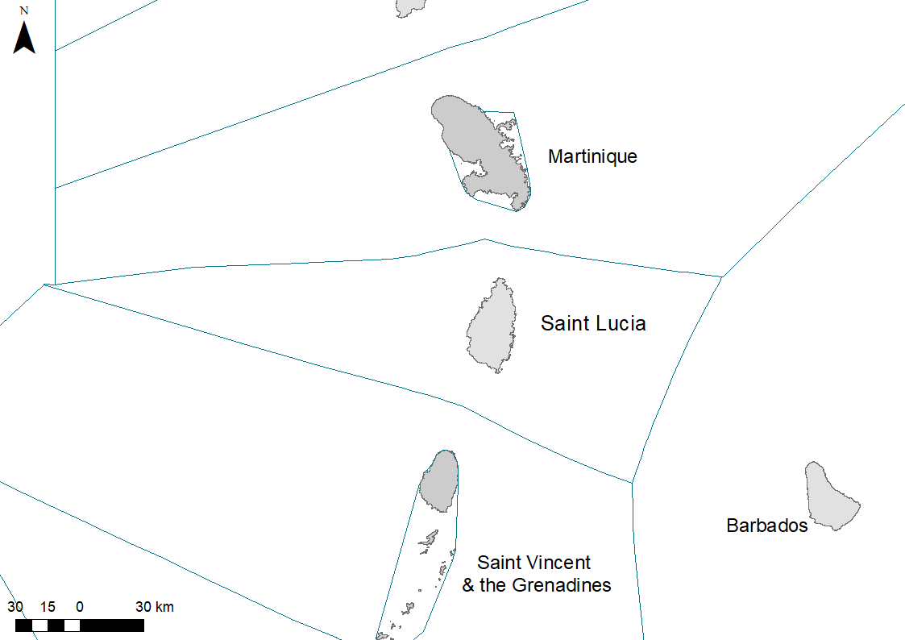
Figure 1. Saint Lucia and its Exclusive Economic Zone and neighbouring islands.
Saint Lucia has a population of approximately 180,000 people. With a primarily service-based economy, tourism is the most significant sector, accounting for approximately 65% of the island’s Gross Domestic Product (GDP) and almost 70% of employment. The island’s natural beauty, including its beaches, volcanic mountains, and marine attractions, draws visitors worldwide. Although the island’s natural resources and large EEZ could be a significant economic driver, currently only 1.4% of Saint Lucia’s GDP comes from agriculture, forestry and fisheries (World Bank 2022). Saint Lucia's heavy reliance on tourism presents significant challenges, particularly due to the devastating impact of major storms, hurricanes and the recent global COVID-19 pandemic, which severely impacted the island’s economy. These natural disasters and global phenomena can cripple the tourism industry for extended periods. Furthermore, the ongoing threat of climate change exacerbates these challenges, introducing additional uncertainties and vulnerabilities.
Recognizing these realities, national agencies have acknowledged the need for Saint Lucia to diversify and expand its blue economy. By doing so, the island can build resilience against economic disruptions caused by extreme weather events, climate change and global crises. Diversification into sustainable marine and coastal activities will not only provide alternative sources of income but also promote environmental stewardship and social equity. This strategic shift in economic focus will help to ensure a more stable future for Saint Lucia's economy and its people.

Saint Lucia’s Blue Economy
The blue economy refers to the sustainable use of ocean and marine resources for economic growth, improved livelihoods and jobs, while preserving the health of ocean ecosystems. As a small island developing state with a disproportionately high water to land ratio, Saint Lucia has significant potential to leverage its maritime resources to support its economy and sustainable development goals.

Key Components of Saint Lucia’s Blue Economy

Tourism
Diving and snorkelling. Saint Lucia's coral reefs and underwater biodiversity attracts almost 60,000 divers and snorkelers annually, with diving and snorkelling activities on coral reefs generating an estimated US$77 million in tourism expenditures annually (CROP 2021; Longley-Wood et al 2021).

Recreational fishing. Charter fishing tours are popular with tourists and draw almost US$3 million in direct tourist expenditures annually. With 46 operators, most of which depart from either Soufriere, Marigot Bay, Castries or Rodney Bay, more than 211,000 visitors engage in sportfishing tours annually. Saint Lucia also hosts regional and international fishing tournaments including the International Billfish Tournament which attracts more than 130 visitors from the UK, USA and neighbouring islands (Saint Lucia Tourism Authority 2023).

Yachting and sailing. The island hosts various yachting events, including the Atlantic Rally for Cruisers (ARC), which is a significant draw for international sailors. Organized by World Cruising Club, ARC is the largest trans-ocean sailing event in the world and regularly attracts upwards of 200 boats. The island is also popular for charter boat hire and tours with seven charter yacht agencies endorsed by Saint Lucia’s tourism authority.

Cruise ships. Saint Lucia is a favoured destination for cruise ships, with its ports welcoming numerous visitors who contribute to the local economy. During the 2023/2024 season, the Saint Lucia Tourism Authority has projected 400 cruise calls and approximately 600,000 cruise passengers for the island (Saint Lucia Tourism Authority 2023).

Artisanal, commercial fisheries and aquaculture
Artisanal fishing. Saint Lucia’s marine environment and fisheries shape the country’s lifestyle and cultural heritage, with small-scale traditional fishing forming a large part of the social fabric and economy of many coastal communities (Government of St Lucia 2018). Small-scale fishing is a traditional livelihood for many Saint Lucians with the Department of Fisheries reporting 482 vessels operating in 2021 (St Lucia Fisheries Department).

Offshore fishing. Although seasonal migratory pelagic fish species have historically comprised the majority of annual fish landings, there is still opportunity for expansion (FAO 2007) especially for large pelagics and flying fish (for sport fishing, local consumption and export) and within the industry’s longlining fleet which focuses on the harvesting of large tuna for the export market.

Aquaculture and mariculture development. Saint Lucia has been active in exploring opportunities in aquaculture and mariculture to reduce pressure on wild fish stocks and enhance food security. Sea moss (Eucheuma spp.) production occurs in the country, with 213 persons involved in sea-moss production in 2019 (St Lucia Fisheries Department).

Marine conservation and ecosystem services
Healthy marine and coastal ecosystems. Marine and coastal ecosystems, including coral reefs, seagrass beds and mangroves are critical for coastal resilience as well as robust and healthy biodiversity and thriving fisheries and tourism industries. Saint Lucia’s coastline and shallow coastal marine areas are particularly biodiverse, with two sites, the Mankôté mangrove system and Savannes Bay Marine Reserve, being internationally recognised as Ramsar sites.

Marine protected areas (MPAs). The establishment and management of MPAs help preserve marine biodiversity and support sustainable tourism and fishing practices. Saint Lucia currently has several legally defined designations related to marine protected areas including marine management areas, marine reserves and environmental protection areas.

Maritime transport and infrastructure
Similar to most other Caribbean Island nations, Saint Lucia’s economy is dependent on shipping. Approximately 90% of all goods imported into the country arrive by sea while most agriculture products are exported by sea, making shipping and the supporting infrastructure such as ports and harbours especially important to the economic growth of the country. Saint Lucia has multiple seaports, the two largest being Vieux Fort, which is the only full container port, and Port Castries. Port Vieux Fort operates 24 hours a day and is serviced by a specialised Ports Police Force for security. Port Castries has six berths for cargo ships with berths for passenger ships also available.

Challenges Facing Saint Lucia’s Blue Economy
St. Lucia’s blue economy faces significant challenges related to climate change, overfishing, tourism, and pollution. Climate change impacts marine ecosystems through rising sea temperatures and more frequent storms, while overfishing depletes fish stocks and disrupts marine biodiversity. Tourism, though economically beneficial, strains coastal resources and contributes to environmental degradation. Pollution from various sources further contaminates marine habitats, exacerbating the strain on the country’s marine resources and complicating sustainable management efforts (Figure 2).

Climate Change |  | Overfishing |  | Unsustainable Tourism |  | Pollution
Rising sea levels, ocean acidification, and increased storm frequency pose significant threats to Saint Lucia’s marine and coastal ecosystems |  | Unsustainable fishing practices can deplete fish stocks and damage marine habitats, affecting both biodiversity and the livelihoods of fishing communities |  | Without appropriate management, the influx of visitors can lead to environmental degradation overuse of natural resources and loss of biodiversity, ultimately compromising the very attractions that draw tourists in the first place |  | Marine pollution from land-based activities, such as plastic waste and agricultural runoff, poses threats to marine life and ecosystems  Implementing effective wastewater management, stormwater control and catchment management strategies are vital for preserving the health of marine environments
Figure 2. Summary of the challenges facing Saint Lucia’s blue economy

Strategic Initiatives Related to the Blue Economy
Coastal and marine development and management is overseen by government, statutory and non-governmental agencies, with defined legal mandates, including the Department of Sustainable Development, Department of Fisheries, Department of Physical Planning, Saint Lucia Air and Sea Ports Authority, the National Conservation Authority, and the Soufriere Marine Management Association Inc.
The structural framework governing these agencies and guiding coastal and marine development and management encompasses various existing laws and regulations (Table 5).
Table 5: Existing legislation on Saint Lucia that supports Marine Spatial Planning
Legislation | Relevance to MSP
Physical Planning and Development Act (2001) | Enabling planning and regulation of development on land as well as Saint Lucia’s territorial seas as well as the designation of Environmental Protection Areas
National Conservation Authority Act (1999) | Enabling the designation of protected areas on land or water, including Marine Protected Areas
Beach Protection Act (1967) | Providing for the protection and control of activities on beaches and the seashore
Fisheries Act (1984) | Enabling the management of fisheries and the establishment and protection of Marine Reserves
Maritime Areas Act (1984) | Enabling some national authority over the protection, planning and control of development across the EEZ
Minerals Vesting Act (1989) | Enabling control by the Crown of all minerals within Saint Lucia’s jurisdiction

Recognising that Saint Lucia's blue economy holds significant potential for promoting sustainable development and economic diversification, the Government of Saint Lucia, within this legislative structure and further supported by an Integrated Coastal Zone Management Policy, has been actively working to develop its blue economy through the development of a National Ocean Policy (NOP) and Strategic Action Plan (SAP) (2020-2035). The NOP-SAP establishes a framework for integrated planning and management of marine spaces and associated activities occurring within it for the period from 2020 to 2035. Implementation of the NOP is guided by eight principles (Table 6).
Table 6. Principles of Saint Lucia’s National Ocean Policy
Principle | Description
Island systems management | A multidisciplinary, integrated approach developed by the OECS to manage the socio-ecological systems of islands, promoting sustainable development, resource use and resilience through adaptive management and coordinated decision-making.
Ecosystem based management | An integrated resource planning approach that considers the connections between land, sea, air and living organisms, aiming to balance conservation, sustainable use and equitable resource-sharing
Environmental stewardship | The action taken by individuals, groups or institutions to protect, care  for and responsibly use the natural environment.
Sustainable development | The responsible use and management of ocean resources to support economic growth, environmental health and social well-being, ensuring long-term benefits without depleting or harming marine ecosystems
Public and private participation | Full public, private sector and non-governmental organization (NGO) participation is essential for creating credible and accountable rules, fostering co-management and ensuring stakeholders are empowered to actively engage in ocean governance and decision-making.
Use of best available evidence, sound science and best practice | Ocean planning and management decisions should be based on the best available information, integrating natural, social, economic, scientific and traditional knowledge, to support the sustainable use of ocean and coastal resources
Precautionary approach | When there is risk to human health or the environment and scientific uncertainty, risk-based management with precautionary measures should be applied
Environmental liability | Access to ocean resources for private profit should be priced fairly to ensure national and local benefits, with governance reflecting the broader economic, environmental, social and cultural interests
Transboundary Cooperation | Marine spatial plans and activities should consider the impact on neighbouring islands and nations, with consultation to ensure cooperative management of any shared effects
Good governance | Good governance requires public bodies to exercise prudence, responsibility and accountability, ensuring decisions are proportionate, consistent and targeted to the specific activity under consideration
Gender equality and inclusivity | Gender equality and inclusivity will be promoted to ensure equal access to resources, opportunities and decision-making for all, including marginalized and disadvantaged groups

The NOP further identifies eight priority sectors to focus the development of Saint Lucia’s blue economy (Table 7).
Table 7: Priority Sectors of the National Ocean Policy and their associated data-driven activities
Priority sectors | Related activities
Marine fisheries | - Regulate fish harvesting  - Implement plans to maintain and restore fish stocks for sustainable yield  - Support small-scale fishers  - Assess impacts on fishing  - Collaborate with neighbouring states on shared fish movement and ecosystems  - Adhere to regional and international fisheries management mechanisms  - Identify important fishing areas  - Explore underexploited stocks  - Assess marine infrastructure  - Ensure consistent and integrated management practices.
Marine aquaculture | - Identify aquaculture areas.  - Manage aquaculture impacts  - Assess alien species risk
Marine environment and biodiversity protection | - Protect 20% of coastal and marine areas by 2020.  - Sustainably manage ecosystems:  - Assess human impacts on sensitive habitats and species.  - Improve adherence to international and national environmental Laws, including UNCLOS.  - Integrate conservation areas and biodiversity in marine policy development.  - Follow obligations for biodiversity conservation.  - Assess effects on critical habitats and species, including carrying capacity.
Surface water management and wastewater treatment and disposal | - Reduce marine pollution  - Manage water resources and flood risks  - Support local involvement in water and sanitation management.  - Consider effects of land-based pollution on health and livelihoods.  - Address pollution control issues in the nearshore zone.
Maritime transport | - Evaluate social and environmental effects of increased freight and passenger volumes.  - Address marine space demand from increased shipping traffic.  - Include new shipping routes and port infrastructure in development.  - Adapt existing and future port facilities for climate resilience.  - Prioritize safety, security, and environmental protection
Tourism and recreation | - Ensure tourism planning considers a healthy marine environment.  - Use coastal planning for sustainable tourism policies and activity diversification.  - Evaluate environmental limits for existing and new tourism activities.  - Meet regional or international recreational water quality guidelines.  - Provide adequate marina facilities and support services.  - Create moorings avoiding environmentally sensitive areas  - Generate revenue from cruise ship tourism
Coastal development | - Consider existing ICZM policies in spatial planning.  - Ensure climate resilience in activities and developments.  - Include ecosystem considerations in development proposals.  - Align ICZM policies with the National Ocean Policy (NOP).
Submarine cables and pipelines | - Install cables deep in the seabed to promote marine safety.  - Integrate submarine cable and pipeline routing in the MSP process.  - Implement national obligations under international law regarding cables and pipelines.  - Conduct updated surveys before laying cables in territorial seas.
Expanding on these focal sectors, the following national priorities have been defined:
- Expanded fisheries. Saint Lucia’s fisheries sector is currently artisanal in nature and there is desire to expand the capacity of the sector to harness the opportunities presented from ridge to EEZ, as well as aquaculture and mariculture.
- Self-sufficiency. Saint Lucia is highly reliant on imported fuel, food and other products and there are opportunities to increase the self-sufficiency of the island to be more resilient to the impacts of climate change and global market fluctuations.
- Healthy ecosystems. The availability and health of the island’s ecosystems and natural resources are critical to the livelihoods of Saint Lucians. The ability to protect ecosystem health on land and in the ocean is dependent on a unified regulatory framework and effective collaboration between departments.
- Diverse economy. The economy is highly dependent on the tourism sector and there is a need to diversify the employment base with sustainable blue growth livelihood opportunities and support for local entrepreneurship to reduce unemployment and poverty.
- Responsible tourism. The tourism industry will continue to be an important economic sector for Saint Lucia and the expansion of this industry should focus on harnessing blue economy benefits sustainably, as the degradation of coastal/marine resources and the potential impacts of that degradation can also be far-reaching and affect other economic sectors.

Relevance of Marine Spatial Planning to the Blue Economy
Marine spatial planning (MSP) is highly relevant to the blue economy, serving as a critical tool for balancing the often-competing demands of marine resource use and conservation. MSP provides a strategic, integrated and sustainable approach to managing ocean resources by promoting the balanced use of marine spaces, protecting the environment, fostering economic growth and engaging stakeholders while managing user-user and user-environment conflict. MSP relies on scientific data and geospatial information to make informed decisions about the use and management of marine spaces. This data-driven approach ensures that decisions are based on best available knowledge, which enhances effectiveness of planning and ensures appropriateness of use of space.
Many countries in the Wider Caribbean are already utilizing aspects of MSP through area-based management tools, such as designating shipping lanes, allocating fishing areas, and establishing locally-managed marine areas or marine protected areas. Such integrated planning fosters a balanced approach and is vital for maximizing sustainable growth within a blue economy. For example, Saint Lucia has already initiated MSP components by zoning areas within its marine management areas and, in 2021, under the OECS’ Caribbean Regional Oceanscape Project (CROP), Saint Lucia began exploring various MSP scenarios across its EEZ with the development of a Coastal Master and Marine Spatial Plan (CMMSP) (OECS 2021). The 2021 CMMSP is considered to be the framework to enable the country to achieve “sustained and equitable growth by pursuing a Blue Economy strategy that respects and protects the shared ocean space” (OECS 2021). As an integrated plan, it encompasses the offshore, nearshore and landward coastal areas while also recognising that a coordinated approach among a range of Government Ministries, departments and agencies will be required for successful implementation and a thriving Blue Economy.
Comprised of two principal components (a Coastal Master Plan and a Marine Spatial Plan), the CMMSP presents potential nearshore and offshore zoning frameworks and options – the marine spatial plan, based on available data, stakeholder consultations and best practice. It considered existing zoning plans, assessed nearshore compatibility of existing and potential activities, potential pollution impacts, and potential climate change impacts for both the nearshore and the offshore. Offering various zoning scenarios, the marine spatial plan is meant to be a living document that is updated as additional data becomes available, and as conditions, situations, and stakeholder needs evolve.
The Coastal Master Plan, meanwhile, presents a range of priority interventions and investments that may be undertaken within coastal and marine spaces, framed within the context of the zoning plan, to support Saint Lucia’s transition towards a Blue Economy. Fifteen priority projects were identified from an initial list of 60, and included:
- Three that focus on enhancing climate resilience: solar farm enhancement, climate resilient sanitation systems, resilient fisheries facilities
- Four that focus on the protection of coastal and marine environments: marine pollution strategy, beach management strategy, integrating integrated coastal zone management (ICZM), the National Adaptation Plan, and National Ocean Policy, waste water management projects)
- Three that focus on the generation of economic growth: village tourism, business accommodation, sustainable financing for marine ecosystem services
- Three that focus on effective governance systems: integrated ecosystem management and restoration of forests, establishment of an ICZM Unit, new system of protected areas
- Two that focus on equitable distribution of wealth resulting from economic growth: strengthening aquaculture and mariculture, blue economy incubator and accelerator programmes
To support the implementation of the CMMSP and to achieve Saint Lucia’s vision of a Blue Economy, an implementation roadmap and schedule was developed, outlining actions required to ensure adequate institutional, inter-agency and public sector capacity, including capacity to enforce legal, policy and planning frameworks and social safeguards.
With the Government of Saint Lucia ready and positioned to move the CMMSP forward, the MSP scenario that will ultimately be pursued will need to be identified, strengthened and finalised, while still recognising that future changes may be required. Moving forward, to build on the proposed scenario/s and to fully develop an effective MSP, it is crucial to recognise, collate and analyze all relevant data currently available to inform the plan, as well as identify data gaps and challenges. This comprehensive understanding is essential for the successful implementation of MSP in Saint Lucia and is the purpose of this report. Here we present a comprehensive review of data available, including information on how it was collected, who currently holds the data and in what format, in addition to identifying the major data gaps and capacity needs of local organizations related to data collection, storage and analysis.

Gap Analysis and Needs Assessment

Methodology and Approach
In May 2024, a broad range of stakeholders involved in the collection or use of marine spatial data in Saint Lucia were identified through a rapid stakeholder assessment (Appendix 1) to facilitate the engagement of all identified stakeholders. To assist with data collection and stakeholder engagements, a worksheet was developed to outline the most commonly utilized types of marine spatial data in marine spatial planning processes (Appendix 2). The worksheet was distributed to stakeholders via email, requesting their input. Follow-up emails and phone calls were made to key agencies to ensure thorough participation. In total, nine stakeholders, including government agencies (Department of Fisheries, Department of Forestry, Department of Physical Planning, Department of Tourism, Energy and Public Utilities Division, Integrated Planning Programme, National Conservancy Agency), statutory bodies (Saint Lucia Solid Waste Management Authority), and international environmental nongovernmental organisations (Fauna & Flora) provided input through this process. On 22 August 2024, a National Marine Spatial Planning validation workshop was held, during which 12 agencies participated in a hybrid format, contributing valuable insights to this gap analysis and needs assessment (Appendix 3). Additionally, a thorough literature review was conducted to identify any additional marine spatial data available for Saint Lucia (Appendix 4).

Findings

Data gaps
Data is essential for MSP success. Data provide the foundation for informed, evidence-based decision making, allowing decision-makers and natural resources managers to better understand the complex interactions between human activities and the marine environment and for the sustainable management of resources. As outlined by Flynn et al. (2023), data can be described as facts, information as captured data, and knowledge as understanding. While information and data needs for MSP can differ depending on the specific planning objectives of a maritime jurisdiction, scale of the planning effort, level of detail required and specific objectives of the plan, core data categories tend to be consistent across MSPs and can be categorised within four broad areas (European MSP Platform 2024):
- Administrative boundaries
- Description of the geophysical environment and biological/ecological features
- Data relating to relevant human activities and sectors
- Socio-economic and policy-related data. Depending on the MSP’s context and focal area, additional data on specific issues may also be required, including renewable energy development and climate change adaptation.
For the purpose of this study and Saint Lucia, and based on the priorities and datasets identified within the CMMSP, the key categories of data required to support a national MSP were both spatial and temporal, ecological/biological, oceanographic, and socio-economic, and included:
- Protected area and international designations
- Coastal and marine habitats
- Maritime zonation
- Socio-economic data
- Tourism
- Cultural data
- Coastal and marine infrastructure
- Shipping

Existing data
A significant amount of spatial data related to the marine environment exists for St. Lucia, encompassing both regionally collected data – such as that gathered through OECS-led projects in collaboration with local agencies as well as locally collected data, including the mapping of seagrass beds and sea moss farms.
Although the CMMSP was drafted in 2021, MSP-related project-based data has been collected and compiled through nationally-, regionally-, and internationally-led projects since at least 1995, beginning with the cross-country OECS-led Ship-Generated Waste Management Project & Solid Waste Management Project which ran from 1995 to 2003. Since then, there have been at least an additional 14 projects that support Saint Lucia’s CMMSP (Table 8, Appendix 5), while recognising that temporal gaps in data still exist as these projects and associated activities were time-bound and that a comprehensive and iterative MSP would be benefit from additional (and sometimes on-going) data collection and analysis to.
From these project deliverables as well as other national studies and initiatives and through stakeholder consultation, 83 spatial datasets were identified that relate to the marine environment (Table 9, Appendix 6 and Appendix 7). This data is primarily stored in shapefile format and is often presented as maps in portable document format (PDF) project reports with maps which presents a challenge in translating this information into spatial analysis for MSP. At the same time, despite the substantial volume of data and the considerable financial, logistical and time investments made in its collection, there is also a lack of consensus among different agencies regarding the data’s origins, current custodianship and even existence. This disconnect has led to confusion and inefficiencies in accessing and utilizing the available resources. In addition, data-driven approaches to marine management are reportedly not very prevalent thus highlighting the need not simply for data collection and analysis but also, as a preliminary step, to develop the guiding methodologies in collecting data.

Table 8. Summary of projects undertaken in Saint Lucia with deliverables that support national marine spatial planning key marine spatial projects undertaken in Saint Lucia
Project | Project deliverables that support marine spatial planning and management
Ship-Generated Waste Management Project & Solid Waste Management Project (1995-2003) | - Solid waste and ship-generated solid waste disposal locations, with datasets held by Saint Lucia Solid Waste Management Authority
Integrating Watershed and Coastal Area Management in the Small Island Developing States of the Caribbean (IWCAM) (2006-2011) | - Geology datasets  - Management Area locations (including those within watersheds)  - Watershed boundaries  - Land use within watersheds datasets, with datasets held by Ministry of Agriculture, Forestry and Fisheries  - Areas of banana cultivation, with datasets held by Ministry of Agriculture, Forestry and Fisheries  - Degrees of soil erosion, with datasets held by Ministry of Agriculture, Forestry and Fisheries  - Settlements within various watersheds, with datasets held by Ministry of Agriculture, Forestry and Fisheries  - Mangrove wetlands (diversity, size, ownership) datasets, with most datasets held by the Ministry of Planning  - Port (depths, berthing capacity, etc.) datasets, with datasets held by the St. Lucia Air and Sea Ports Authority  - Beach profile data, fish census, catch and effort data, fishing vessels, beach profiles, beach inventory data, with datasets held by the Department of Fisheries  - Soufriere reef status, white sea urchin data, charcoal production within the Mankote Mangrove data, with datasets held by the Caribbean Natural Resources Institute (CANARI)  - Water flow rates and volumes, beaches, river water quality, river sediments, bay water, bay sediments for Rodney and Choc coastal watersheds  - Reef status, sedimentation rates, migration of fish in and out of the Soufriere Marine Management Area, with datasets held by the Soufriere Marine Management Association  - Physical infrastructure datasets, natural resources datasets, with datasets held by the Ministry of Planning
Sustainable Management of the Shared Living Marine Resources of the Caribbean Large Marine Ecosystem (CLME) and Adjacent Regions (2008-2013) | - Agreement on and understanding of transboundary problems of the CLME as they relate to management of living marine resources  - Regional and sub-regional governance framework  - Decision support framework for key transboundary fisheries  - Regional Planning Framework (Strategic Action Programme)
Testing a Prototype Caribbean Regional Fund for Wastewater Management (CReW) (2010-2014) | - Location of wastewater management facilities
Eastern Caribbean Marine Managed Areas Network (ECMMAN) Project (2013-2017) | - Eastern Caribbean Decision Support System (ECDSS)  - Capacity of fishers/coastal communities and support for marine conservation increased  - ECDSS capacity building and long-term maintenance implemented  - ECMMAN Steering Committee established
Implementing Integrated Land, Water & Wastewater Management in the Caribbean SIDS (2015-2022) | - Soufriere watershed datasets  - Samples of sediment deposits on offshore reefs  - Reforestation datasets
Iyanola – Natural Resource Management of the NE Coast (2015-2025) | - Grand Anse and Louvet Marine Reserves boundary datasets  - Degraded forest area datasets  - Restored/Rehabilitated areas datasets
Developing Organizational Capacity for Ecosystem Stewardship and Livelihoods in Caribbean Small-Scale Fisheries (StewardFish) Project (2017-2019) | - Enhanced leadership capacity of national fisherfolk organisations enhanced  - Increased engagement in stewardship activities by fisherfolk organisations
Caribbean Regional Oceanscape Project (CROP) | - Draft MSP, including datasets related to Saint Lucia’s marine boundaries, marine areas, coastal zone, risks in the nearshore coastal area, risk hot spots, potential areas for blue economy investment, Soufriere Marine Management Area boundaries and zones, nearshore coastal area zoning scenario, priority project locations  - Marine Ocean Wealth Report, including MSP datasets related to coral reef tourism, nature-dependent beaches, recreational fishing, wildlife, coral reef fisheries  - MSP data gap analysis
Catalyzing Implementation of the Strategic Action Program for the Sustainable Management of Shared Living Marine Resources in the Caribbean and North Brazil Shelf Large Marine Ecosystems (CLME+) (2018-2021) | - Agreement to coordinate knowledge management, facilitate data and information sharing, and support monitoring  - Proposal for Sustainable Financing Plan for Ocean Governance in the Wider Caribbean region  - Regional Plan of Action to Prevent, Deter and Eliminate Illegal, Unreported and Unregulated (IUU) Fishing in the Western Central Atlantic Fishery Commission (WECAFC) Member Countries  - Regional Strategy and Action Plan for the Valuation, Protection and/or Restoration of Key Marine Habitats for the Wider Caribbean  - Fisheries assessments
Integrated Ecosystem Management and Restoration of Forests on the South East Coast of Saint Lucia (2019-2024) | - Development of Global Information System (GIS) database  - High-value species, ecosystem, and habitat datasets  - Protected area boundaries and connecting corridor datasets,  - Zoning plans for new protected areas  - Reforested land datasets  - Rehabilitated seagrass beds, reefs, mangroves, and productive coastal systems datasets  - Marine buffer area datasets  - Agricultural landscape datasets, including erosion-prone areas
An Integrated Approach to Water and Wastewater Management Using Innovative Solutions and Promoting Financing Mechanisms in the Wider Caribbean Region (CREW+) (2020-2022) | - Establishment of national data and information management system to support data collection, analysis, interpretation, sharing and data maintenance  - Location of on-site and small-scale wastewater facilities
Unleashing the Blue Economy of the Caribbean (2021-2031) | - Coastal infrastructure
Developing Sustainable Sea Moss Farming Methods in Saint Lucia (2023-2026) | - Locations of sea moss farms  - Benthic habitats (coral reefs, seagrass beds)
Modelling and Assessment of Coastal Climate Change Impacts in Saint Lucia (2024-2025) | - Sea level rise models/maps  - Coastal inundation models/maps  - Coastal erosion models/maps  - Shoreline retreat models/maps  - Vulnerability maps/maps

Table 9. Summary of the most common data categories and data types used to inform marine spatial planning processes categorised as being present (highlighted green), requiring improvement (orange), non-existent (red) or not applicable (gray) in St Lucia.
Data Type | Dataset | Does this dataset exist in St Lucia? | Data Type | Dataset | Does this dataset exist in St Lucia?
Protected area & international designations | Marine Park boundaries |  | Maritime zonation | Exclusive Economic Zone
Protected area & international designations | Protected area boundaries (coastal) |  | Maritime zonation | Territorial waters
Protected area & international designations | Location of any Important Birds Areas (IBAs) (coastal / marine) |  | Maritime zonation | Shoreline boundary
Protected area & international designations | Location of Key Biodiversity Areas (KBAs) (coastal / marine) |  | Socio-economic | Location of key fishing sites (fishing effort, including FADS)
Protected area & international designations | Location of any Ramsar Sites (coastal / marine) |  | Socio-economic | Sand / aggregate extraction areas
Protected area & international designations | Location of any World Heritage Sites (coastal / marine) |  | Socio-economic | Fisheries closed areas (including nursery grounds, spawning areas)
Protected area & international designations | Protected beaches (e.g., protected from sand mining) |  | Socio-economic | Mariculture/aquaculture sites
Coastal & marine habitat | Distribution of nearshore marine habitats |  | Tourism | Location of coastal tourism developments (e.g. resorts / hotels)
Coastal & marine habitat | Coastal wetland sites |  | Tourism | Location of public beaches / swimming zones
Coastal & marine habitat | Bathymetry data / seabed mapping |  | Tourism | Dive / snorkel sites
Coastal & marine habitat | Location of coral reefs |  | Tourism | Mooring / anchoring areas (pleasure craft)
Coastal & marine habitat | Location of seagrass beds |  | Tourism | Mooring / anchoring areas (commercial vessels)
Coastal & marine habitat | Location of mangroves |  | Tourism | Location of ‘no anchoring zones’
Coastal & marine habitat | Distribution of key marine species |  | Tourism | Shipwrecks
Coastal & marine habitat | Dist. of protected marine species (please ID species) |  | Cultural | Cultural sites (coastal / marine)
Coastal & marine habitat | Dist. of spawning sites of key fisheries species |  | Coastal & marine infrastructure | Port / harbour areas
Coastal & marine habitat | Dist. of spawning/ breeding sites of protected marine species |  | Coastal & marine infrastructure | Marinas
Coastal & marine habitat | Dist. of nursery grounds of key fisheries species |  | Coastal & marine infrastructure | Reverse osmosis plant/s (coastal)
Coastal & marine habitat | Dist. of nursery grounds of protected marine species |  | Coastal & marine infrastructure | Waste-water treatment plant/s (coastal)
Coastal & marine habitat | Seabird nesting areas / sites |  | Coastal & marine infrastructure | Point source of pollution (including landfills)
Coastal & marine habitat | Seabird foraging areas / sites |  | Coastal & marine infrastructure | Subsea cables
Coastal & marine habitat | Sea turtle nesting areas / sites |  | Coastal & marine infrastructure | Pipelines (including energy / gas pipeline)
Coastal & marine habitat | Sea turtle foraging areas / sites |  | Shipping | Navigation areas
Coastal & marine habitat | Risk maps of erosion, sedimentation, inland flooding and storm surge |  | Shipping | Shipping lanes / important shipping routes
Coastal & marine habitat | Risk map of sea level rise models |  | Shipping | Shipping lanes / important shipping routes

1.2 Identified gaps
The identified data gaps related to MSP are detailed in Table 10 (and Appendix 8) along with a description of the relevance of this data to supporting the enhancement and implementation of the national marine spatial plan. Overall, these gaps underline the importance of integrated data collection and sharing among stakeholders to support effective marine spatial planning in Saint Lucia.

Table 10. Data gaps identified by Saint Lucia’s marine spatial planning stakeholders and recommendations on how to address them.
Data gap(s) identified | Relevance of this data for MSP | Recommendations on how data can be collected | Resources required to address data gap | Key agencies/ supporting projects  & additional notes | Estimated cost of addressing data gap (XCD)
Spatial data on the boundaries of coastal wetlands, mariculture areas and fisheries facilities. | This type of spatial data should be fed into marine zoning plans | Boundaries of existing aquaculture/mariculture sites do exist but have not yet been shared widely; it is also important to consider expansion of these activities into the future  Geospatial analysis:  Use of GIS to overlay various criteria such as depth, proximity to shore, water quality and existing marine users and distance to shore and infrastructure and climate impact projections to identify suitable areas for mariculture expansion  Remote sensing:  Use of satellite imagery to assess coastal conditions such as water turbidity, algal blooms and coastal erosion which can impact site suitability | GIS software (ArcPro subscription or free to use QGIS)  Training in GIS software of choice and application of satellite imagery | Department of Fisheries  Department of Physical Planning  This work can potentially be linked to World Bank funded “Unleashing the Blue Economy of the Caribbean (UBEC)” project. | Costs associated with staffing, and field data collection as well as those associated with data storage, training and subscriptions (see Table 16, Table 17, Table 18)
Spatial data related to fishing grounds, including monitoring data from their recently initiated Vessel Monitoring System (VMS). | VMS data can be used to determine fishing hotspots and levels of activity as well as for management and enforcement of MSP regulations. | Route mapping and visualization:  Using GIS to track trajectories over time, visualizing paths, speeds, fishing patterns and behaviour  Spatial clustering:  Applying spatial clustering algorithms or hot spot mapping methods to identify density of fishing vessels in different areas  Pattern recognition and behavioural analysis;  Identifying behaviours such as loitering, zigzagging, sudden changes in speed or direction which could indicate illegal activities or behaviour that attempts to avoid detection.  Temporal Analysis:  Conducting time-series analysis to identify seasonal patterns, trends or anomalies  Integrate with other data sources:  Combine with Automatic Identification System (a short-range tracking system that provides information about a ship to other ships and coastal authorities) to get a comprehensive view of vessel activities; integrate environmental data such as sea surface temperature, bathymetry and benthic habitats to analyse how environmental factors influence fishing behaviour/activity | Training in using one of the Vessel Monitoring System (VMS) analysis software (e.g., VesselFinder, MarineTraffic, Spire Maritime)  Purchase of the VMS analysis software (annual subscription) | Fisheries Department  Saint Lucia Air and Sea Ports Authority | Costs associated with staffing, as well as those associated with the purchase of additional vessel monitoring systems, data storage, training and subscriptions (see Table 16, Table 17, Table 18)
Data related to beach and marine use and capacity.  (particularly hotspots including Soufriere Marine Management Area and popular tourist beaches) | Important for managing coastal areas effectively | Visitor surveys & observational studies  Assess peak and average use (manual surveys or automated counters)  Behavioural observations  Observe and map how and where visitors are using different parts of the beach/marine areas for different activities to understand spatial distribution and identify high-use areas  Carrying capacity assessment: Physical carrying capacity:  Determining available space on beach/within marine area and the average area required by the visitor  Environmental carrying capacity:  Conducting assessment to determine the impact of beach/marine areas use on local ecosystems such as dune erosion, habitat damage, wildlife disturbance to inform sustainable use limits  Social carrying capacity:  Crowding perception analysis – using visitor surveys to determine the level of crowding that affects visitor satisfaction  Visitor spending analysis:  Collecting data on visitor spending in and around the beach and marine areas to assess the economic benefits of beach use | Field staff time and travel to sites  Training in qualitative data collection methods | Department of Fisheries  National Conservation Authority (for beaches)  Department of Sustainable Development,  Department of Tourism | Costs associated with staffing, as well as those associated with data storage, training and subscriptions (see Table 16, Table 17, Table 18)
LiDAR surveys to establish updated benthic contours and identify benthic habitats | Remote sensing data sets such as Light Detection and Ranging (LiDAR) data are important for small islands because it can help identify and monitor potential hazards, and plan for climate change and sea level rise. LiDAR data can help monitor even the smallest changes in land elevation and sea depth. This can help identify potential hazards early and implement mitigation measures | While LiDAR data has recently been collected There appears to be a need to expand the coverage of LiDAR data collection and analysis including:  Using the data to Create Digital Elevation Models (DEM) to visualise and analyse underwater topography and coastal features  Compare LiDAR datasets from different time periods to assess changes in coastal and marine environmental such as erosion and habitat degradation  Use LiDAR data to model and predict flood risks and sea-level rise impacts | LiDAR data is collected using a laser scanner mounted on an aircraft. The laser scanner sends out pulses of light to the ground, and the time it takes for the pulses to reflect back is used to calculate the distance to the ground  Training in the use of remote imagery and LiDAR data including methods for data acquisition, data processing and analysis (including the creation of DEM models), geospatial integration, interpretation and application of data and software training | Department of Fisheries  Soufrière Marine Management Association (SMMA)  LiDAR data was last collected between 2020-2023 as part of the World Bank’s Disaster Vulnerability Reduction Project (DVRP). The United States Geological Survey (USGS) recommend updating every 8 years- but more frequently at a site-specific level if specific infrastructure or MSP processes are planned in any area | Typically $500-$1000 per hectare for LiDAR flights  Consultants time to collate, format and analyse data
Expansion of benthic studies to map habitats into deeper offshore areas. | Benthic habitats are crucial in marine spatial planning because they support biodiversity, provide essential ecosystem services, and influence the distribution of marine resources. Mapping these habitats helps protect sensitive areas, guide sustainable resource use, and ensure balanced development while minimizing environmental impacts | Multibeam echo sounders (MBES), surveys can cover large areas of the seabed quickly and efficiently compared to traditional single-beam sonar or direct sampling methods like grabs and dives; this efficiency allows for more cost-effective mapping of extensive regions, supporting large-scale MSP initiatives  Underwater drones are robotic vehicles equipped with cameras, sonar, and other sensors; they can be remotely operated vehicles (ROVs), which are controlled by a human operator, or autonomous underwater vehicles (AUVs), which navigate on pre-programmed routes; they physically explore underwater environments and can capture detailed images, videos, and close-up sensor data | Hire a team of Consultants with MBES and/or drone equipment to conduct surveys at key areas around Saint Lucia  Possibly combine/collaborate with neighbouring islands to share costs, can be coordinated by regional agency (e.g., OECS, CRFM) | Department of Fisheries | $530,000+  Costs associated with boat trips to deploy MBES and/ or underwater drones and staff time, supported by MBES/drone experts, depending on area to be surveyed (e.g.,  Additional costs associated with staffing, as well as those associated with data storage and subscriptions (see Table 16, Table 17, Table 18)
Update existing biodiversity and environmental datasets | Helps identify and protect ecologically important areas and supports sustainable use of marine resources by guiding the placement of activities to minimize impacts on biodiversity | Review which ecological datasets should be updated, define methodologies and identify equipment/resources required | Training in novel methods for marine data collection (aerial drones, underwater drones, acoustic monitoring, along with building capacity for field (dive) surveys | Department of Fisheries  Soufrière Marine Management Association (SMMA)  Fauna and Flora  Saint Lucia National Trust | Costs associated with staffing, as well as those associated with data storage, training and subscriptions (see Table 16, Table 18, Table 18)
Further update navigational charts with marine spatial planning data | Updated navigational charts are essential for marine spatial planning as they ensure safe navigations, inform decision making and help balance various activities by providing critical information on water depths, hazards and environmental sensitivities | Recognizing that while navigation charts for St Lucia were updated in 2024, there may still be a need to request further updates during the MSP process, for example when considering new management zones, expansion of sea moss farms etc. These updates can be requested to the UK Hydrographic Office | No present need to do this, but charts should be reviewed annually to see if any important additions need to be made | Saint Lucia Air and Sea Ports Authority  Physical Planning Department  Department of Fisheries | Cost will depend on the updates required
Connectivity between landfill sites and other land-based sources of pollution (e.g., desalination plants) and the marine environment | Critical for MSP to prevent environmental harm, and avoid conflicts with fishing, tourism, and infrastructure and manage the cumulative impacts on marine and coastal ecosystems | Geospatial analysis Use of GIS to map the locations of landfill and relate to the marine environment (overlay watersheds, water channels & coastal zones)  Use satellite imagery or aerial photography to identify potential pathways of contamination overtime  Environmental monitoring  Conduct field measurements to measure changes in water quality such as salinity, turbidity and chlorophyll levels at outflow sites  Hydrological and hydrogeographic assessments  Would involve evaluating both surface and groundwater resources, including mapping water sources and analyzing aquifers, It includes studying the water balance This comprehensive understanding is essential for sustainable water management, flood risk mitigation, and ecosystem protection on the island (e.g desalination plants | GIS software (ArcPro subscription or free to use QGIS)  Training in GIS software of choice and application of satellite imagery | Saint Lucia Solid Waste Authority  The National Water & Sewerage Commission  Water Resource Management Unit  This work can potentially be linked to World Bank funded “Unleashing the Blue Economy of the Caribbean (UBEC)” project. | $130,000+  Additional costs associated with data storage, training and subscriptions (see Table 16, Table 17, Table 18)  For more detailed hydrological surveys: consultant with associated equipment $1300000+
Water quality at marinas as it relates to yachts and holding tanks (and discharge of those tanks) | Ensures environmental health of coastal areas, supports sustainable marine operations and protected marine life and human health | Data already being collected by CARHA on Western Coast of St Lucia but needs to be expanded to all coastlines | Water quality test kits/ laboratory for analysing samples and trained staff to conduct the monitoring | Saint Lucia Solid Waste Authority  The National Water & Sewerage Commission  Water Resource Management Unit  CARHA | Costs associated with staffing, as well as those associated with data storage, training and subscriptions (see Table 16, Table 17, Table 18)
Microplastic pollution in marine space | Knowledge on microplastics is important for MSP because it helps to identify areas where microplastic pollution is concentrated, and this information can be used to assess the risk to marine ecosystems and human health and to inform strategies to mitigate potential impacts | Collect water and sediment sampling collected from a range of areas and habitats to quantify and characterize the microplastics  Conduct biota sampling (e.g., fish and shellfish) to study the ingestion and accumulation of microplastics within the food web  Samples need to be analysed in a specialised laboratory | Field surveys to collect samples from a range of locations and habitats.  Trained field staff  Laboratory testing of samples  NB: it may be more cost effective to partner with a research organisation for this type of data collection. | Department of Fisheries  Ministry with Responsibility for Sustainable Development | $1670-$6700  Basic microplastic laboratory testing can cost between $270-$1400 per sample, with more advanced spectroscopic analysis that is used to quantity and characterise microplastics ranging for $1400-$5300 per sample
Demarcation of both new and existing marine management locations including Laborie, Micoud and other sites identified within the systems plan | Important for management and enforcement. Often the demarcation of site boundaries appears on maps only but physical demarcations are non-existent – buffer areas around these demarcations should also be considered-+ | Conduct GIS mapping  Use GIS to map and visualise boundaries.  Integrate managed area boundaries into AIS tracking systems as geographical overlays – this allows real-time monitoring of vessel positions relative to Park Boundaries, supporting management and enforcement activities | Initial set up for integrating marine park boundaries into AIS tracking systems | Department of Fisheries  Soufrière Marine Management Association (SMMA)  Fauna and Flora  Saint Lucia National Trust  Work is already being undertaken on this under CANARI’s GEF funded “Valuing Nature and Nature-based Solutions for Sustainable Blue and Green Pathways for the Tourism, Food and Urban Sectors in Saint Lucia” (2023-2029) and GEF funded “Upgrading of the Solar Powered SMART FAD for the Sustainable Development of Fisheries in the South of Saint Lucia (Micoud to Choiseul). | $53000-$270000  Costs for establishing the AI tracking systems can range from $53000 -$270000 including data preparation and mapping, software customization, hardware and infrastructure (e.g., base stations or data servers), licensing and data management and training  Additional costs associated with staffing, as well as those associated with data storage, training and subscriptions (see Table 16, Table 17, Table 18)
Records from the local community detailing their views and perception of the marine environment, describing their local ecological knowledge and socio-economic and personal connection with the marine environment | Much of what we know of Saint Lucia’s Marine environment comes from the real-life experiences of the people who interact with the ocean on a regular basis – This detailed knowledge of local ecology is an important resource and can easily be lost as we lose older members of the community  Understanding of social-economic relationships with the marine environment ensures that planning balances conservation efforts with the socio-economic needs of communities and industries reliant on the marine environments. | Qualitative data collection will involve undertaking formal or informal face-to face interviews, focal point meetings or more structured surveys with local community members.  Sharing the information collected with a wider audience through different communication channels including videos, and social media  Socio-economic data collection involves gathering information on coastal demographics, economic activities (such as fishing and tourism), and stakeholder perspectives to understand human interactions with marine resources. It includes analyzing employment and income data, cultural values, and existing policies that influence resource use | Training for field staff in qualitative data collection.  Design and creation of videos and recordings of the interviews | Department of Fisheries  Some socio-economic and community data collection and analysis has already been undertaken to inform Saint Lucia’s Coastal Master and Marine Spatial Plan Caribbean Regional Oceanscape Project (CROP) project this can be built upon | Costs associated with staffing, as well as those associated with data storage, training and subscriptions (see Table 16, Table 17, Table 18)
Locations of future renewable energy project | While the energy and Public Utilities Division has not historically engaged with MSP data, they identify a future need for it. As renewable energy projects, such as offshore wind farms, intersect with marine spaces, there will be a need to interconnect these with submarine power cables which requires relevant MSP data | Wind resource mapping:  Utilising wind speed and directional data obtained from meteorological stations, weather buoys and satellite observation to map areas with high wind energy potential  Wave and tidal energy assessment:  Incorporating wave height, frequency, tidal currents using oceanographic data from buoys and remote sensing data to identify suitable potential locations for wave and tidal assessment  Solar resource mapping:  Using satellite data and models to assess solar irradiance over marine areas to inform feasibility of floating photovoltaic systems | Hire experienced renewable energy expert to undertake a Renewable Energy Resource Assessment including the identification of potential sites for renewable energy generation | Department of Sustainable Development | $100000+  Consultant to conduct a feasibility study: $100000+ depending on which renewables are of interest

1.3 Recommendations
Data gaps identified by stakeholders can be filled by undertaking additional data collection initiatives which can be facilitated locally or in partnership with research institutions. Regional collaboration and high-level coordination of collaborative initiatives by regional agencies such as the OECS, CRFM or CANARI, offer cost-saving/-sharing opportunities, scaling up impact, and providing opportunity for shared learning. Table 11 above also suggests opportunities and actions to address these gaps.

Data governance: storage and management
Data and information collected to support the MSP process and to inform decision-making must be well managed, complete, accurate and accessible. Data governance, therefore, is the “process of classifying and securing [data and] information making it accessible and shared for reuse by all marine stakeholders and decision makers” (Flynn et al. 2023). One of the main challenges, however – and not only in Saint Lucia but more widely around the world, is the inaccessibility of data and information to marine spatial planning teams as well as limited awareness of what data and information exists, which agencies or individuals hold that data and information, inconsistent data and information storage, and incompatibility of data formats. Enhanced data management therefore is key to improving knowledge, promoting innovation, supporting decision-making, and reducing the cost of data collection duplication. FAIR Data Principles, endorsed and promoted by the European Commission, seek to facilitate knowledge discovery and exchange by making data findable, accessible, interoperable and re-usable (FAIR) and these principles can be applied within the context of Saint Lucia’s MSP process.

2.1 Current systems
A centralized system has been established for storing marine spatial data in Saint Lucia through the GEOServices platform as part of a Saint Lucia’s National Spatial Data Infrastructure (NSDI), established though the Disaster Vulnerability Reduction Project, a collaborative initiative between the Government of Saint Lucia and the World Bank. The NSDI, managed within the Ministry of Physical Development, was established following the recognition that geospatial data being collected across Government of Saint Lucia agencies needed to be standardized, used and shared. The platform is also meant to function as the mechanism to coordinate and promote data sharing through public and private sectors, academia, and nongovernmental organisations. The NSDI reflects the FAIR Data principles and, through robust data infrastructure and data management plan, seeks to build and support a strong data sharing culture among NSDI stakeholders. Despite the creation of the NSDI, however, individual agencies also manage their own data independently in electronic formats.
While some data is made available online by international organizations, such as The Nature Conservancy through their Caribbean Atlas web pages and the OECS via their GIS hub, these resources have limitations including data not being open access, data portals sometimes being down/inaccessible, and data stored sometimes being static and not updated regularly (if at all). For instance, when one of the international agency online repositories is down (as the OECS’ GIS hub was at the time of writing), accessing this data becomes challenging without directly contacting the data holder, who may or may not still be linked to a project or the agency and therefore may or not be accessible. Although external agencies and consultants are required to provide collected data to local partners (agency leading on the implementation/commission of data collection activities), it appears that the data and information is not often uploaded to the NSDI/GEOServices Platform. This is further compounded by the relative high staff turnover and no formal data sharing agreements, which often results in the loss of data due to gaps in institutional knowledge. In addition, while MSP-relevant data has also been published as articles, reports, and project findings, there is no central repository for these knowledge-based publications that are not always open-access, requiring interested individuals to identify authors and/or associated agencies or to sift through websites in search of those documents. The NSDI, however, would likely offer scope for their inclusion and centralized management.

2.2 Issues and limitations
Stakeholders identified several critical issues related to data storage and management for marine spatial planning in Saint Lucia. The following summary prioritizes these concerns, with the most frequently mentioned issues listed first.

Underused Centralized Data Repository: Based on stakeholder consultations, it appears that there is a general lack of awareness, except among a limited few who were involved in its establishment and received training in the use of the GEOServices which was established as a the central repository for storing and accessing marine spatial data. The system therefore remains underused and underpopulated, leading to inefficiencies in data management and, leaving data scattered across various agencies. Although this platform exists, not all MSP stakeholders are aware of it, suggesting the need for additional outreach, awareness, and promotion of the tool. A nationally-supported centralized repository would facilitate the storage and sharing of all types of datasets, including shapefiles, and help in identifying available datasets.

Quotes from stakeholders related to data storage and the management of MSP data in St Lucia:

“No central repository where data is stored; there were moves to establish a national database system (but was not completed).”

“There is no single repository of the information. One has to search for information from various possible sources.”

“Not always aware of datasets that are available or that have been developed - how is this communicated and shared (the national repository could assist with this).”

“Not knowing what data or information is available in other agencies. There is no communal database that would allow every agency to see what the other is working on to avoid duplication of effort.”

Challenges with Data Sharing: Challenges with data sharing appear to be rooted in issues related to data governance, despite the existence of the NSDI and the GEOServices platform. Without wider stakeholder buy-in into this system, data sharing challenges related to data security, maintaining data privacy, data interoperability, managing data volume, ensuring data accuracy and integrity, working within but needing to overcome organizational silos, and potential cost implications of data sharing (including infrastructure expenses, data preparation efforts, and security and privacy measures) impact the ability for MSP to move forward effectively and efficiently.

Again, despite the GEOServices platform, there is no established data-sharing protocol between national agencies, resulting in hesitation and difficulty in accessing data from other organizations. To address these issues, there is a clear need for a structured approach to data exchange, including the development and wide endorsement of a data sharing protocol and supporting policies and legislation that integrate data/resource management, support inclusive governance and stakeholder engagement, enable efficient resource allocation and conflict resolution, promote research and analysis, enable compliance with legal and ethical standards, and support capacity building and knowledge exchange. The FAIR Data Principles offer a potential framework for a national data sharing protocol as does the OECS’ Code of Conduct for Responsible Marine Research (OECS 2016) which not only outlines conduct as it relates to collecting marine data, but also how data should be accessed, shared and published.

Quotes from stakeholders related to data sharing of MSP data in St Lucia:

“Currently do not have a data sharing protocol - there is a need for an agency-based data sharing protocol, but there is also the challenge of accessing data from other agencies.”

“Data is usually not in a form that it can be easily shared. There is usually not a dedicated platform where data can be kept or sourced for sharing.”

Data Management and System Maintenance: Data management, as per the UK’s Intra-governmental Group on Geographic Information (2005), is “a group of activities relating to the planning, development, implementation and administration of systems for the acquisition, storage, security, retrieval, dissemination, archiving and disposal of data”. Drivers of data management maybe legislative, for example the Freedom of Information Act (2009) which “promotes the maximum disclosure of information in the public interest”, as well as non-legislative, including recognizing that data is sometimes collected at public expense and production and maintenance costs may need to be justified, the need to ensure that data of known and maintained quality is interoperable, the need to improve efficiency and add value, and the need to ensure that intellectual property rights and confidentiality of sensitive data are safeguarded. Benefits of good data management and system maintenance extend to data suppliers, intermediaries, as well as users, the benefits to these stakeholders include but are not limited to the following (IGGI, 2005):
  - Data suppliers:
    - Increasing confidence and trust that data will be used as agreed and intended
    - Providing clear understanding of the use of data, as formally documented within a Memorandum of Agreement and outline within data sharing protocols
  - Data intermediaries:
    - Better quality, harmonized and coherent data from use of common definitions, formats, validation processes and standardized procedures
    - Improved knowledge and understanding of data holdings, their availability, interpretation and use, with reduction of risk of duplication or loss, enhanced cataloguing, metadata and better access to data
  - Users:
    - Improved awareness and understanding of what data are available for current and future use
    - Improved access to data
    - Better quality and more timely information (access to the right information at the right time)

Principles of good data management include avoiding the re-collection of data, careful management of the whole life cycle of datasets, a defined data policy that establishes the framework within which data management can operate, clear identification of the owner of the data, compilation of metadata for all datasets, ensuring that datasets meet minimum quality standards. These principles are supported by a data management plan which considers the long-term management (and potential reuse) of all datasets and ensures that all datasets are fit for purpose. The management plan also considers dataset collection and analysis, procedures for data access and dissemination, and data audit to ascertain level of compliance with data policies, plans and procedures (IGGI 2005).

The systems that hold these data must similarly be as robust and well-maintained, including (but not limited to) ensuring that data can be effectively and efficiently stored and updated, that systems can be backed up and data can be recovered in case of emergency, that archival, search and analytics tools are enabled and relevant.

In Saint Lucia, individual agencies may have (formal or informal) data management plans and procedures and data systems, but they do not appear to be centralized or coordinated, with the same datasets and information being shared multiple times with the same (or multiple) agency/ies because systems are inadequately managed, shared datasets are not saved on agency-wide/accessible platforms or drives, and perhaps from lack of internal communication about data needs and sources. Enhancing internal management systems would streamline the process, reducing duplication and inefficiency, while improving accountability and transparency – as would the adoption and wide-scale use of the NSDI which has the management and system maintenance frameworks already in place.

Quotes from stakeholders related to data management and system maintenance:

“One of the major issues related to data is data management and maintaining data management/information systems – we often share the same data with the same and different agencies multiple times. A better management system is needed.”

2.3 Recommendations
There is a need for a more cohesive and well-supported approach to data management, including establishing a central repository, developing data-sharing protocols, and enhancing technical and human capacities following the principles of FAIR that aims to improve the Findability, Accessibility, Interoperability and Reuse of digital assets (Wilkinson et al 2016). Table 11 (and Appendix 8 – data storage and management needs) suggests opportunities and actions to address these limitations.

Table 12. Data needs related to the FAIR principle of findability, accessibility, interoperability and reuse of digital data identified by Saint Lucia’s marine spatial planning stakeholders and recommendations on how to address them.
Data needs | Recommendations on how to address limitations | Resources required to address limitations | Estimated cost of addressing limitations (XCD)
Findability and accessibility | Holistically consider existing legal instruments requiring data sharing and also identifying data that are prohibited from wider dissemination due to issues/requirements related to confidentiality  Strengthen existing legislation and develop new legislation requiring the sharing of all possible data, with supporting inter-agency data sharing protocols  Standardize and require data sharing between the Government of Saint Lucia and all external consultants, requiring the sharing of all data collected in all formats created | Legal consultant to review and update existing legal frameworks, establish data sharing and access protocols  Data management personnel to convert existing spatial data into standardized formats  In recognition of the substantial efforts invested in the development of the GEOServices platform as part of Saint Lucia's National Spatial Data Infrastructure (NSDI), a comprehensive review of the platform's current functionality is proposed; this review should focus on evaluating its applicability and identifying enhancements that could make it more user-friendly and appealing; by improving accessibility and encouraging the effective use and storage of data, we can significantly support the marine spatial planning process  This work can be lead/facilitated by the National Ocean Governance Committee or a taskforce established under/through this Committee | $580-$2700+  Cloud storage platforms options include Dropbox ($2700/year for 9TB of storage with 5 accounts) Box ($2700/year for unlimited storage with 3 accounts), Google Drive ($580/year for 5TB with 1 account)  Costs associated with legal consultant, software developer and data portal manager (based on Government of Saint Lucia pay scale)
interoperability and reuse | Convert all existing datasets into spatially compatible standardized formats and standardize protocols for data collection, storage and access to enable more effective and efficient data sharing  For every agency that collects spatial data, develop and maintain an agency-based database of all spatial datasets, including name of dataset/s, date of creation, associated project/s

Capacity building, training and technology needs
Capacity building as it relates to MSP is the process “through which the abilities of individuals, institutions and their networks are developed and enhanced to make effective and sustainable decisions about the temporal and spatial ordering of human activities in the marine spaces” (Ansong et al. 2021). Capacity development should strengthen a country’s ability to effectively plan, implement, monitor and evaluate marine spatial plans, based on the country’s specific and particular needs. While capacity development is often associated with staff development through formal education and training, capacity development is a much broader term and should be considered within a much wider context especially as it relates to MSP. Capacity is “the combination of people, institutions, and practices that permits countries to achieve their development goals” (World Bank in UNESCO-IOC 2021).
Individual capacity development in MSP involves equipping individuals with the necessary knowledge and skills to effectively participate in and contribute to marine spatial planning processes. This typically includes training, hands-on/experiential learning experiences and active involvement in planning activities. At the individual level, capacity development often focuses on:
- Understanding MSP: deepening knowledge of what MSP, its objectives and potential impacts on existing policies, regulations, institutions, coastal- and marine-based activities and local communities
- Planning competencies: developing skills in planning and decision-making related to marine spatial issues.
Key stakeholders who may benefit from individual capacity development in MSP include policymakers, researchers, managers, planners and other professionals within planning teams, government agencies, civil society organizations and sectoral representatives. Skills and competencies to consider in the marine spatial planning and implementation team are outlined in Table 12.
Table 12. Core skills/competencies in designing a marine planning and implementation function or body (from UNESCO-IOC 2021)
Skills and Competencies | Expertise and Backgrounds
Thinking strategically | Marine scientist and technical experts
Communicating effectively | Economists, geographers, political scientists
Analysis and judgement | GIS, data and IT specialists
Objective decision-making | Legal and policy expertise
Project management and process/change management | Terrestrial and marine planning
Stakeholder management and engagement | Sectoral interests (e.g., fisheries and marine industries)
Policy and decision-making | Environmental interests
Analytical/research and problem-solving skills | Heritage and cultural interests
Facilitation | Growth strategies, regeneration and economics
Negotiation and mediation | Sustainability appraisal

Capacity development at the institutional level usually involves strengthening the capabilities of organizations involved through policies, mandates, tools, collaborative mechanisms and information systems. As MSP is an ongoing process, requiring continuous planning and adaptation, building capacity to sustain planning (and implementation) over time is imperative.
Key areas for institutional capacity development include:
- Strengthening structures: enhancing organizational structures, processes and resources to support MSP activities
- Human capital: investing in a trained and competent workforce
- Financial resources: ensuring adequate funding for MSP initiatives
- Technology: utilizing appropriate technology for planning, monitoring, and evaluation
- Data and knowledge: accessing and managing relevant data and information
- Coordination: establishing mechanisms for effective collaboration and coordination among different institutions involved in MSP
Institutions directly involved in MSP may include government ministries and agencies, research institutes, universities and regional bodies. Each of these institutions should conduct capacity assessments to identify gaps and develop targeted capacity development actions. At the same time, capacity development should be mainstreamed into existing policies, action plans and research strategies that support MSP, helping to ensure that capacity development is a continuous and integrated part of the overall MSP process.
Capacity development for MSP is often also required at the wider community level as well as within general education systems and curricula. MSP messages and communications materials and information should be clear, concise and easy to understand, engaging and use innovative tools, visuals, and game elements to capture attention, and relevant, focusing on the underlying reasons, divers, and potential benefits of MSP. Increased community and stakeholder awareness and understanding would enable more authentic and active engagement of communities and stakeholders within MSP as well as enhanced monitoring and evaluation of and accountability within the MSP process as they would be in a better position to define for themselves the role/s they can play, recognise MSP achievements and identify gaps and opportunities for improvement.

3.1. Institutional capacity
The institutional capacity of Saint Lucia's national agencies related to MSP is characterized by several strengths and challenges.

The strengths include:

- Dedicated agencies: Saint Lucia has several agencies directly involved in and/or with a mandate to support some aspect(s) of marine spatial planning, including: the Department of Fisheries, Department of Sustainable Development, Department of Tourism, Ministry and Department of Physical Development, National Conservation Authority (NCA), National Integrated Planning Programme Unit, the Royal Saint Lucia Police Force, and Saint Lucia Air and Sea Ports Authority. These agencies have specific mandates to manage and/or protect the coastal and marine environments or to plan for and manage activities within these spaces, demonstrating a clear institutional focus on MSP.

Existing data and knowledge: Various agencies have accumulated significant amounts of marine spatial data, such as mapping of seagrass beds, sea moss farms, and other coastal and marine habitats. This existing data provides a strong foundation for MSP activities.

Engagement with international and regional bodies: Saint Lucia’s agencies collaborate with regional and international organizations including the Caribbean Regional Fisheries Mechanism, Fauna & Flora, the Organisation of Eastern Caribbean States, The Nature Conservancy and the University of the West Indies, benefiting from regional initiatives and projects that bring in external expertise, data and resources while also assisting with capacity building, facilitating regional/international networking, and supporting lobbying efforts by national agencies.

While the weaknesses (some of which have been discussed previously) include:

Limited human capacity: The agencies often face shortages in trained personnel, particularly in data analysis, GIS, and advanced data management. This limits their ability to fully collect and utilize existing data and hampers comprehensive MSP implementation. Staff turn-over in most agencies is relatively high as such there may be a need to restructure existing positions for better remuneration to keep people interested.

Inadequate infrastructure: Insufficient infrastructure, such a lack of cloud storage and modern data collection tools, further constrains agencies’ capabilities. For example, essential equipment for data collection and analysis, such as drones and specialized software are either limited or lacking.

Capacity building needs: There is a significant need for training and capacity building across multiple areas, including GIS, data management, remote data collection, and the development of marine spatial plans. Without these skills, agencies struggle to effectively engage in MSP processes.
Based on these findings, it could be argued that Saint Lucia’s institutional capacity for effective marine spatial planning is hampered by fragmented data management, limited resources, and a need for enhanced training and infrastructure. Addressing these gaps is crucial for strengthening the country's MSP framework and ensuring sustainable management of its marine resources. Table 13 below outlines the mandates of Saint Lucia’s leading MSP agencies along with the MSP-related activities in which they are engaged and the capacity needs they identified to support their ability to meet those mandates.
Table 14. Leading MSP agencies in Saint Lucia, their mandates, Marine Spatial Plan-related activities and capacity needs, with additional data provided in Appendix 1 and Appendix 5.
Agency | Mandate | Key MSP-related activities (current & potential) | Identified/ Required capacity
Department of Fisheries | To provide effective and efficient services in promoting sustainable development of Saint Lucia’s fisheries sector through participatory management and sustainable use of the fishery resources | Data collection/storage related to:  - Marine habitats  - Fisheries management | Datasets collected/held:  - Fishing grounds  - Fishing landings, effort including gear type  - Boundaries of aquaculture (fresh water and marine) holdings  - Key species distribution  - Vessel monitoring systems (VMS)  Training needs identified:  - Data analysis  - Data formatting and storage  - GIS platforms (QGIS/ ArcView)  - LIDAR analysis  Capacity needs  - Departmental data storage system  - Data sharing protocols  - Staff to support data collection and analysis, fisheries management
Department of Sustainable Development | To support national sustainable development through the facilitation of an integrated and participatory approach to governance, promoting environmental management and innovative technologies and building capacity to adapt and mitigate the impacts of climate change while demonstrating the value of building a green economy | Data collection/maintenance related to:  - Impacts of climate change on coastal habitats/areas | Datasets collected/held:  - Potential Climate change impacts (e.g., sea level rise, storm surge, temperature rise)  Training needs identified:  - Stakeholder engagement  - Ocean governance  Capacity needs  - Departmental data storage system  - Data sharing protocols
Department of Tourism | To support the delivery of quality, authentic and distinctive destination experiences and creative products and services, with a clear focus on the needs of residents, visitors and the environment, which will contribute to year-on-year growth | Data collection/maintenance related to:  - Coastal tourism developments  - Public beaches, swimming zones  - Diving, snorkelling sites  - No anchoring zones  - Shipwrecks | Datasets collected/held:  - Maritime vessels in Saint Lucia’s waters (cruise vessels, ferries, yachts)  Training needs identified:  - Maritime tourism matters  - Marine spatial planning process  - Communications and outreach
Ministry/ Department of Physical Development | To support sustainable improvement in the quality of life of all St. Lucians, through effective integrated planning, coordination, implementation and monitoring of physical/ spatial, technological, economic, environmental and social development activities | Data collection/maintenance related to:  - Bathymetry  - Coastal development | Training needs identified:  - Remote data collection tools (e.g., drones)  - Data analysis  Capacity needs  - Standardised data collection and storage protocols  - Data sharing protocols  - Public awareness regarding MSP and the Blue Economy
National Conservation Authority | To identify, manage, conserve and generally provide stewardship over natural assets including beaches, coastal, protected and other declared or designated areas, in a sustainable manner and to provide ancillary amenities thereby contributing to the social and economic development of Saint Lucia | Data collection/maintenance related to:  - Beach use  - Beach maintenance  - Sea turtle nesting activity  - Protected area boundaries  - Seabird and sea turtle foraging areas | Datasets:  - Beach use  - Beach capacity data  Training needs:  - Data collection – protocols  - Data analysis  - Data formatting and storage  Equipment needs:  - Laptop  - Drone  - Camera  - Clinometer, ranging poles  Research Officer
National Integrated Planning Programme | To network with all departments to provide strong evidence-based assessments necessary for the justification and alignment of infrastructure plans and strategies to the country’s national infrastructure priorities | Data collection/maintenance related to:  - Coastal infrastructure | Training needs:  - Understanding role in and contribution to MSP process
Royal Saint Lucia Police Force | To provide a professional policing service and in partnership with all communities to create a safer environment for all people in St. Lucia | Enforcement of MSP-relevant laws and regulations | Training needs:  - Understanding role in and contribution to MSP process
Saint Lucia Air and Sea Ports Authority | To facilitate trade and travel through value creation in a safe, secure and customer-centric environment for sustained social and economic development | Data collection/maintenance related to:  - Bathymetry  - Navigational areas, shipping lanes  - Port locations | Training needs:  - Understanding role in and contribution to MSP process

3.2 Gaps and needs
Capacity gaps and needs within the MSP process and among MSP stakeholders include those that have been identified by stakeholders as well as those that are generally required by best practice but are currently missing. Best practice calls for capacity development (and maintenance) throughout the MSP cycle, from pre-planning through to implementation, evaluation and revision. Table 14 compares best practice to what currently exists within agencies responsible for MSP in Saint Lucia.
Table 14. Capacity for effective marine spatial planning: best practice vs the Saint Lucia context (based on UNESCO-ICO 2021).
Marine spatial planning cycle | Key capacity development activities | Saint Lucia stakeholder capacity gaps and needs (where known/identified)
Pre-planning/ inception stage | Developing expertise for drafting MSP into legislation and operationalising the authority for planning | - Draft MSP (within CMMSP) developed by external consultants, supported by stakeholder consultations  - National Ocean Governance Committee established to move CMMSP forward
Pre-planning/ inception stage | Professional development of planning personnel (training courses and formal education) | -
Pre-planning/ inception stage | Awareness raising regarding intent, scope, potential benefit of MSP, targeting all stakeholders | - Limited awareness regarding MSP and blue economy
Pre-planning/ inception stage | Joint vision development, to build commitment and ownership for plan implementation | - Framed within the context of the National Ocean Policy
Planning stage | Data for MSP, including Identification and collection of scientific data as well as local and traditional knowledge, and including through citizen science approaches | - Additional datasets related to:  - Land-based and point sources of pollution, including desalination plants  - Potential locations of renewable energy sites  - Wetland boundaries  - Aquaculture/Mariculture locations  - Fisheries facilities  - Fishing grounds  - Beach use and capacity  - Offshore benthic contours  - Marine biodiversity data (regularly monitored and spatial data updated)  - Navigational charts regularly updated to recognise any changes in use of the marine environment  - Water quality (especially at marinas)  - Microplastic pollution levels  - Boundaries of marine management areas  - Local/Traditional ecological knowledge  - Training in data collection:  - Qualitative data collection  - Remote data collection  - Data management  - iNaturalist  - Local ecological knowledge and traditional ecological knowledge data collection
Planning stage | Development and use of Decision Support Tools (software including spatial mapping, scenario definition, data analysis, transfer and storage | - Training in:  - QGIS/ArcGIS  - Maxent  - Microsoft Excel  - Spatial data analysis  - Statistical analysis and modelling
Planning stage | Knowledge and application of key concepts, including land-sea interaction, integrating ecosystem-based approach (EbA) into planning, conducting strategic environmental impact assessments (SEAs) | - Funds to support (already-developed) EbA project  - Existing capacity within the Department of Physical Development in conducting and reviewing environmental impact assessments; additional training required to support SEAS across MSP sectors
Planning stage | Enhancing institutional capacity, to support coordination and data sharing among different sectors, agencies and governance levels | - Development of data sharing protocols  - Sharing/Uploading of data to GEOServices platform  - Establishment of a cross-agency task force to support cross-sectoral data sharing
Implementation, evaluation and revision phases | Developing expertise for drafting legislation and sectoral regulatory frameworks | - Expertise within Attorney General’s Chambers
Implementation, evaluation and revision phases | Facilitating collaboration across institutions for building understanding of legal implications of MSP, requirements of permitting and other regulatory processes | - Can be facilitated by the National Ocean Governance Committee
Implementation, evaluation and revision phases | Developing practices related to monitoring, evaluation and adaptation, including data gathering and analysis, indicator development for plan review and assessment | - Can be developed/facilitated through the National Ocean Governance Committee  - Increasing staff complements (e.g., National Conservation Authority Research Officer)
Implementation, evaluation and revision phases | Raising awareness about MSP implementation for building plan owernship and adoption | - Multi-media, cross-sectoral communications plan, identifying key messages, audiences, and communications platforms  - Can be developed/facilitated through the National Ocean Governance Committee

Additional details regarding priority training areas are outlined in Table 16 while Table 17 outlines specialised capital equipment and Table 18 (and Appendix 8) outlines specialised software.

3.3 Recommendations
With the marine spatial plan being a living document that is expected to change as additional data is collected, supporting activities are developed and implemented, additional actions are identified, and priorities are reassessed, capacity development actions need to be initially assessed and tailored to the existing context and then regularly reviewed – ideally annually. The initial assessment should inform a capacity development strategy, with clear objectives, timelines and budgets and should speak directly to filling identifying capacity gaps. Recognizing that there are constraints and that all needs may not also be filled or addressed, capacity development will need to be prioritized, with focus placed on developing the capacity of those who facilitate planning (planners, technical staff), support planning (key sector stakeholders), and implement the plans (government ministries and departments, including Ministers). Capacity development activities should also be tailored or adapted to suit the stakeholder needs and should run throughout the MSP cycle and process.
Capacity development does not need to start from scratch. Rather, it can build on existing skills, information and knowledge bases, infrastructure and data management systems, while also using existing staffing or amplifying existing networks to pursue MSP. At the same time, it is critical for implementing agencies to consider whether current staff complements will meet growing demands and assess additional staffing requirements.
MSP is also meant to be an iterative process which means that capacity must be maintained over time, with a focus on building institutional capacity to reduce reliance on experts that will only fill capacity gaps in the short-term. Emphasis should be placed on facilitating knowledge and skill transfer and on integrating MSP into education systems and school curricula.
Annual surveys that are conducted to assess capacity needs can also be used to assess development and capacity retention/maintenance levels as part of a monitoring and evaluation system. While, at the same time, considering additional training, equipment, and supporting resource needs emerging through the implementation of Saint Lucia’s marine spatial plan and blue economy initiatives. Table 15 below outlines priority training areas for Saint Lucia’s key MSP stakeholders and potential national, regional, and international agencies that can provide the necessary training support.
Table 15. Training requirements identified by marine spatial planning stakeholders in Saint Lucia.
Some online free to use resources do exist such as those on the Caribbean Geoportal (although these do require a ARCGIS subscription), other more bespoke training workshops/courses will likely require the hiring of an external consultant, which with travel, accommodation and workshop costs is estimated to cost in the region of $50000-60000 XCD per workshop/course.
Training required | Justification | Suggested training bodies/agencies | Focal stakeholder groups
Qualitative data collection (including beach use data and capacity, local ecological knowledge and traditional ecological knowledge) | To enhance data quality, ensure ethical practices, and allow for the integration of local knowledge into management processes effectively, ultimately contributing to better-informed decision-making in marine spatial planning and related fields | The following regional agencies have expertise in undertaking qualitative surveys and providing training on this subject:  - The Nature Conservancy  - University of the West Indies  - CANARI | All agencies that collect marine spatial data
Remote data collection (aerial drones), underwater drones for biodiversity and environmental monitoring) | Investing in training for remote data collection with aerial and underwater drones is necessary to enhance the capabilities of local agencies and to improve data quality, ensure compliance and contribute to effective biodiversity and environmental monitoring practices, ultimately leading to better conservation outcomes | The following regional agencies have expertise in undertaking remote data collection and providing training on this subject:  - Caribbean Regional Fisheries Mechanism (using online data collection platforms)  - The Caribbean Geoportal (Free training but requires ARCGIS subscription)  - University of West Indies- Mona Geoinformatics Institute  - Marine Management Organisation (using remote data collection equipment)  - Marine Spatial Solutions Ltd. (using remote data collection equipment)  - United Kingdom’s Centre for Ecology and Hydrology (creating bespoke online/offline applications to support in-field data collection) | Department of Fisheries  Forestry Department  National Conservation Agency  Saint Lucia National Trust
Data management | Training in data management is necessary for local agencies to efficiently organize, analyze and visualize marine data  It facilitates the integration of diverse ecological, economic, and social data sources while minimizing errors that could compromise trust in the planning process  Training also establishes data-sharing protocols, ensuring that relevant information is accessible to all stakeholders  Effective data management also supports compliance with legal requirements governing marine spatial planning | The following regional agencies have expertise in undertaking remote data collection and providing training on this subject:  - The Caribbean Geoportal (Free training but requires ARCGIS subscription)  - Centre for Environment, Fisheries and Aquaculture Science  - Marine Management Organisation  - United Kingdom’s Centre for Ecology and Hydrology (creating bespoke online/offline applications to support in-field data collection) | Department of Fisheries  Department of Physical Development  Forestry Department  National Conservation Agency  Saint Lucia National Trust
Data management software (including Microsoft Excel) | Necessary for enhancing local agency’s ability to organize, analyze and visualize marine data effectively  Proficiency in these tools will enable them to handle complex datasets, perform advanced analyses and generate insightful reports, leading to better decision-making  The use of data management software also improves data accuracy | As well as drawing on the expertise of other agencies/departments in Lucia (e.g., Central Statistical Office) for more formal training the following regional agencies have expertise in this subject:  - The Caribbean Geoportal (Free training but requires ARCGIS subscription)  - University of West Indies- Mona Geoinformatics Institute | Department of Fisheries  Department of Tourism  Forestry Department  National Conservation Agency  Saint Lucia National Trust
GIS training (basic/introductory and advanced) | A working knowledge of GIS software GIS supports marine spatial planning by enabling staff to analyze and visualize complex spatial data related to marine ecosystems  Proficiency in GIS tools allow for the integration of diverse data sources, enhancing decision-making regarding resource allocation and environmental management  A competence in using GIS software will enable local agencies to effectively map and assess spatial relationships that will facilitating collaboration with stakeholders and compliance with regulatory requirements in marine planning processes | As well as drawing on the expertise of other agencies/departments in Lucia (e.g., Ministry of Physical Planning). The following regional agencies have expertise in both undertaking remote data collection and providing training on this subject:  - The Caribbean Geoportal (Free training but requires ARCGIS subscription)  - University of West Indies- Mona Geoinformatics Institute | Department of Fisheries  Forestry Department  Saint Lucia National Trust
Spatial data analysis | Necessary to equip local staff with the skills to interpret and analyze geographic information critical to managing marine resources effectively  Proficiency in spatial analysis allows for the identification of patterns, spatial relationships and to evaluate the impacts of human activities on marine ecosystems | As well as drawing on the expertise of other agencies/departments in Lucia (e.g., Ministry of Physical Planning). The following regional agencies have expertise in both undertaking remote data collection and providing training on this subject:  The Caribbean Geoportal (Free training but requires ARCGIS subscription)  University of West Indies- Mona Geoinformatics Institute  Marine Management Organization | Department of Fisheries  Forestry Department  National Conservation Agency  Saint Lucia National Trust
Statistical analysis and modelling | Essential for building internal expertise and reducing reliance on external consultants  Proficiency in this area allows local staff to conduct robust analyses, derive meaningful insights from data and make informed decisions based on statistical evidence | The following regional agencies have expertise in both undertaking remote data collection and providing training on this subject:  - The Caribbean Geoportal (Free training but requires ARCGIS subscription)  - University of West Indies- Mona Geoinformatics Institute  - Centre for Environment, Fisheries and Aquaculture Science | Department of Fisheries  Department of Tourism  Forestry Department  National Conservation Agency  Saint Lucia National Trust

Table 16. Capital equipment requirements identified by marine spatial planning stakeholders in Saint Lucia
Capital equipment |  |  | Justification | Requesting agency | Estimated cost of capital equipment (XCD)
DJI Mavik 3 Multispectral (with insurance) (aerial drone) |  |  | To support remote monitoring and data collection |  | $19000
Underwater remote operated vehicle |  | FIFISH V6 Expert ROV | To support remote monitoring and data collection | Fauna & Flora | $17000
 |  | Blueye Robotics X3 | To support remote monitoring and data collection | Fauna & Flora | $73400
Ruggex RhinoTAB Tough Rugged Industrial Tablet |  |  | To support in-field data collection (cost per tablet) |  | $2000
Garmin GPSMAP 65 |  |  | To support in-field data collection (cost per unit) |  | $1000
Laptop (with fast processing speed) | MSI Stealth 15 |  | To support data upload, processing and analysis | Department of Physical Development (for other agencies) | $3803
Laptop (with fast processing speed) | Lenova Legion Pro 7i Gen |  | To support data upload, processing and analysis | Department of Physical Development (for other agencies) | $10900
Laptop (with fast processing speed) | MSI Titan HX |  | To support data upload, processing and analysis | Department of Physical Development (for other agencies) | $13600
Passive acoustic stations | Loggerhead Instruments Inc: LSI |  | To support in-water data collection (cost per unit) |  | $15250
Passive acoustic stations | Ocean Instruments: SoundTrap ST600 STD |  | To support in-water data collection (cost per unit) |  | $12250
Passive acoustic stations | RS Aqua: Porpoise Acoustic Recorder - 500m |  | To support in-water data collection (cost per unit) |  | $36650
Baited Remote Underwater Video Stations | Self-constructed BRUVS |  | To support in-water data collection (cost per unit) |  | $5300
Baited Remote Underwater Video Stations | Blue Abacus Carbon Fibre BRUVS |  | To support in-water data collection (cost per unit) |  | $22200/unit
Vessel Monitoring System | NEMO VMS (CLS Fisheries) |  | To support vessel monitoring within Saint Lucia’s EEZ (cost per unit) |  | $1600
Vessel Monitoring System | iFleetONE VMS Fishery Complete Kit - Vessel Monitoring System (NOAA) |  |  |  | $8450
Coastal and marine water quality equipment | Hanna HI9829-00101 (ITM Instruments Inc.) |  | To support in-water data collection |  | $22000
Coastal and marine water quality equipment | Xylem Analytics ProDSS Handheld with calibration solutions |  | To support in-water data collection |  | $27450
Mooring/ Boundary markers | 24”-diameter mooring buoy with PVC center tube (white, yellow, red) (Sailboat Stuff) |  | To delineate nearshore water zones (cost per unit) |  | $750
Mooring/ Boundary markers | 24”-diameter mooring buoy with PVC center tube (white, yellow) (Miami Cordage) |  | To delineate nearshore water zones (cost per unit) |  | $850
Collection of local ecological knowledge and traditional ecological knowledge | Video camera |  | To collect views, perspectives, positions, and knowledge of local stakeholders (cost per unit) | Department of Tourism | $5800
 | Camera |  |  | Department of Tourism | $4618
 | Microphone |  |  | Department of Tourism | $270
 | Headphone |  |  | Department of Tourism | $600
 | Solid State Drives |  |  | Department of Tourism | $270
 | SD cards |  |  | Department of Tourism | $55

Table 17. Specialized software requirements identified by marine spatial planning stakeholders in Saint Lucia
Software |  | Justification | Requesting agency | Estimated cost of capital equipment (XCD)
GIS software | QGIS | To improve spatial data handling and analysis |  | $0 (with some limited functionality)
GIS software | ArcGIS | To improve spatial data handling and analysis |  | Creator level per annual subscription: $3500; professional level per annual subscription, annual: $11500 professional plus level per annual subscription, $21500
Fisheries data collection software | FishBio – online/ offline electronic catch reporting system, compatible with any tablet, mobile phone, computer (standard application) | To support fisheries-related surveying, monitoring, analysis and management, including enforcement | Department of Fisheries | $0
Fisheries data collection software | Kobo Toolbox - online/ offline data collection, management, and visualization platform compatible with any tablets, mobile phones (standard application) |  | Department of Fisheries | $0
Fisheries data collection software | SMART - standardized and streamline data collection, analysis, and reporting platform (standard application) |  | Department of Fisheries | $0
Fisheries data collection software | UKCEH iRecord data portal and app - bespoke online/offline data collection, management and visualization platform compatible with any tablets, mobile phones, including training in data maintenance and development of survey forms, including migrating existing data into newly established portal |  | Department of Fisheries | $79000 (not including travel and subsistence for on-island training by consultants)
Fisheries data collection software | Saint Lucia data portal and app - bespoke online/offline data collection, management and visualization platform compatible with any tablets, mobile phones, including training in data maintenance and development of survey forms |  | Department of Fisheries | $71000 (not including travel and subsistence for on-island training by consultants)  $3300 (annual cloud and maintenance subscription)
Graphic design and communications software | Adobe Creative Suites - supports graphic design, web design, film production | To support communications and awareness raising | Department of Physical Development | $1800 (annual subscription)

Financial needs

Current funding
Although all government and statutory agencies have budgets to support their day-to-day operations, funds to specifically support MSP and blue economy development-related activities have primarily been sourced from external funding mechanisms and agencies, including the Global Environmental Facility and the World Bank. While this external funding has been essential to collecting baseline data, filling data gaps, establishing frameworks, and identifying next steps (Appendix 7), additional funding will be necessary for the implementation, monitoring, and evaluation of the marine spatial plan and blue economy initiatives. The Government of Saint Lucia, in collaboration with The Nature Conservancy, is currently engaged in a project (“Blue Bond Project”) aimed at restructuring Government of Saint Lucia debt and redirecting portions of loan payments to fund and support marine and coastal conservation interventions.

Recommendations
Sustainable financing mechanisms will be essential to ensure on-going and long-term MSP implementation. Revenue generated from blue economy initiatives can be reinvested into blue economic growth, coastal and marine monitoring, and marine biodiversity and habitat conservation and protection. Sustainable financing mechanisms for the sustainable use and protection of marine biodiversity and habitats, including private-public partnerships, debt-for-nature swaps, blue and green carbon credits, biodiversity credits, and conservation trust funds, are being explored around the world, led by agencies such as (but not limited to) the European Commission, The Nature Conservancy, World Wildlife Fund, Finance Earth and Blue Finance. Saint Lucia’s Blue Bond initiative marks a progressive step towards sustainable financing and will provide lessons learned from the region.

Conclusion
Marine Spatial Planning is a critical tool for sustainable ocean management, especially within the context of the blue economy. Although Saint Lucia has an existing Coastal Master and Marine Spatial Plan, moving this Plan forward, collaboratively and comprehensively, will require additional data and capacity. Through this consultancy, data and capacity gaps amongst lead MSP agencies and supporting partners was assessed to identify existing strengths as well as areas where additional support would be beneficial.
Twenty agencies, including government, non-government, private sector and international non-government stakeholders were consulted to better understand the existing context and supporting environment for marine spatial planning in Saint Lucia. Results of this consultation and assessment indicate that Saint Lucia already benefits from a wealth of existing marine spatial data with over 80 relevant spatial and temporal datasets across eight data types already available for use. In addition, some level of MSP expertise already lies within various government, non-government and private sector agencies. This foundation can be leveraged to improve MSP processes, making the most of the available knowledge and resources. At the same time, there are still key gaps related to MSP, either with datasets either missing or requiring updating, including those related to coastal and marine biodiversity and habitats, mariculture areas and fishing grounds, demarcation of marine management areas, coastal and marine infrastructure including future/planned renewable energy projects and desalination plants, point and non-point sources of marine pollution including the landfill and reverse osmosis brine discharge pipes, beach and marine use and carrying capacity and deepwater benthic contours and navigation lanes.
Collection and analysis of data can be conducted in-agency, however, most MSP stakeholders recognise that additional capacity is required to effectively and efficiently undertake this work. Priority areas for training include qualitative data collection, remote data collection, data management software application, spatial data analysis, and statistical data analysis and modelling. Tools required to support the collection of MSP data were also identified and include remote vehicles (e.g., aerial and underwater drones), in-field data collection tools (e.g., tables, GPS units, acoustic stations, water quality monitoring equipment), vessel monitoring systems, and mooring/boundary markets for marine management areas. Beyond these capital equipment and tools, stakeholders also identified specialised software and subscriptions to support on-going MSP efforts, including GIS software, fisheries data collection software, graphic design software for communications and outreach, and cloud storage/platforms to hold collected data. With established relationships with international organizations such as the CRFM, OECS and The Nature Conservancy, there are significant opportunities for gaining external expertise, accessing additional data and training, and participating in collaborative projects which will only further bolster local capabilities and resource availability, contributing to more robust MSP efforts.
MSP stakeholders widely agree that data storage and management is a cross-cutting concern despite the existence of a centralized system to store data. With the centralized data repository being underused and underpopulated, understanding what data already exists as well as its ownership and accessibility amongst and within relevant agencies have impeded its wider application. Establishing a new centralized system is unnecessary. Rather, agencies should be encouraged and supported through policies, regulations and training to use the existing GeoServices platform, reducing redundancy and enhance the efficiency of marine spatial planning.
As Saint Lucia transitions towards a productive and sustainable blue economy, having the necessary structural frameworks in place, including a robust, data-driven, climate-informed marine spatial plan that prioritizes sustainable use of marine resources, protects marine and coastal ecosystems, and involves and considers the diverse needs and priorities of stakeholders, including the communities that rely on these marine spaces for their livelihoods and well-being, is essential. The draft CMMSP provides that necessary framework but the MSP scenario that will ultimately be pursued still needs to be identified, strengthened and finalised. This will require a multi-pronged approach involving collecting, collating, storing, analyzing, and sharing priority datasets, procuring necessary equipment to support on-the-ground/in-the-water data collection and data storage, enhancing skills and knowledge-bases through training, securing additional financing to support data and training needs as well as long-term MSP implementation, while also – and at the same time – raising awareness amongst MSP stakeholders and the wider community regarding the importance of data and data sharing and the value of the blue economy to livelihoods, the national economy, and the marine and coastal environment.

References
Angsong, J., Calado, H., Gilliland, P.M. (2021) A multifaceted approach to building capacity for marine/maritime spatial planning based on European experience. Marine Policy. 132. DOI: 10.1016.j.marpol.2019.01.011
Anthoney, D. & Dornelly, A. (2009) St Lucia. Pp 333 – 338 in C. Devenish, D. F. Díaz Fernández, R. P. Clay, I. Davidson & I. Yépez Zabala Eds. Important Bird Areas Americas - Priority sites for biodiversity conservation. Quito, Ecuador: BirdLife International (BirdLife Conservation Series No. 16).
Commonwealth Marine Economies Programme. (2018) Commonwealth Marine Economies Programme - St Lucia Country Plan (publishing.service.gov.uk)
European MSP Platform. (2024) MSP and Assessment Tools. Accessed 05-10-2024.
FAO. (2007) Fishery Country Profile: Saint Lucia. Accessed 01-08-2024.
Flynn, S., Tray, E., Woolley, T., Leadbetter, A., Heney, K., O’Driscoll, D., Aonhgusa, C.N., Conway, A. (2023) Management of spatial data integrity including stakeholder feedback in Maritime Spatial Planning. Marine Policy. 156: 7. DOI: 10.1016/j.marpol.2023105799
Government of Saint Lucia. (2018) Saint Lucia’s Sectoral Adaptation Strategy and Action Plan for the Fisheries Sector (Fisheries SASAP) 2018- 2028, under the National Adaptation Planning Process. Department of Sustainable Development, Ministry of Education, Innovation, Gender Relations and Sustainable Development and Department of Agriculture, Fisheries, Natural Resources and Cooperatives, Ministry of Agriculture, Fisheries, Physical Planning, Natural Resources and Cooperatives.
Government of Saint Lucia. (2020) Saint Lucia National Ocean Policy. Prepared by Howell Marine Consulting and Sustainable Seas Ltd as part of the Caribbean Regional Oceanscape Project (CROP) implemented by the Organisation of Eastern Caribbean States, and the International Bank for Reconstruction and Development acting as an Implementing Agency of the Global Environment Facility. 49 pp.
Intra-governmental Group on Geographic Information. (2005) The Principles of Good Data Management, 2nd Edition. The Office of the Deputy Prime Minister, London, United Kingdom. 35 pp.
Longley-Wood, K., McNulty, V., Constantine, S., Harborne, A., and Zuercher, R., Spalding M. (2021)
Mapping Ocean Wealth in Dominica, Grenada, St. Kitts and Nevis, Saint Lucia, and St. Vincent and
the Grenadines. Final Synthesis Report under the Caribbean Regional Oceanscape Project.
Organisation of Eastern Caribbean States. (2020) Integrated Ocean Management and Marine Spatial Planning in the OECS (E-Book 5 of 5) OECS Commission, Morne Fortune, Castries, Saint Lucia.
Organisation of Eastern Caribbean States. (2021) Mapping Ocean Wealth In Saint Lucia. 4 pp.
Organisation of Eastern Caribbean States. (2021) Saint Lucia Coastal Master and Marine Spatial Plan – Draft, under the Caribbean Regional Oceanscape Project (CROP). 850 pp.
Organisation of Eastern Caribbean States Commission. (2016) OECS Code of Conduct for Responsible Marine Research. OECS Commission, Castries, Saint Lucia. 21 pp.
UNESCO-IOC. (2021) MSPglobal Policy Brief: Capacity Development in Marine Spatial Planning. Paris, UNESCO (IOC Policy Brief no 4). 16 pp.
Wilkinson, M., Dumontier, M., Aalbersberg, I. et al. (2016) The FAIR Guiding Principles for scientific data management and stewardship. Sci Data 3, 160018. https://doi.org/10.1038/sdata.2016.18
World Bank. (2022) "St Lucia Country Profile." World Development Indicators, The World Bank Group, Accessed 11-08-2024.

Appendix 1. Stakeholder Assessment Matrix
Potential stakeholders and experts that are relevant to Saint Lucia’s blue economy. Each person/organisation is assigned to one of the following roles: (1) Primary stakeholders (authorities and institutes who govern and manage the manage aspects of the marine/coastal environment or activities occurring within the marine/coastal environment); (2) Secondary stakeholders (individuals or agencies who hold datasets but are not directly involved in marine/coastal governance).
Stakeholder Name/ Organisation | Mandate | Potential Contribution (Datasets) to the Project | Role/s with Project | Mode of Engagement
Caribbean Regional Fisheries Mechanism | To promote and facilitate the responsible utilization of the region's fisheries and other aquatic resources for the economic and social benefits of the current and future population of the region.  Supporting the blue economy development through marine spatial planning, an ecosystem approach to fisheries, development of climate-smart sustainable value chains, and knowledge management | Project oversight | Project Manager  Executing agency of the project  Oversee day-to-day management of the project through the Project Management Unit  Review and approve project reports | Remote meetings  Email
National Ocean Governance Committee | To coordinate, monitor, and evaluate the implementation of the National Ocean Policy; to advise the Government of St. Lucia on the management of the marine space under the jurisdiction of St. Lucia | Project oversight | Project Team Member  Project focal point  Facilitate information acquisition, acquisition costs, and other logistical areas (e.g., organising meetings with critical stakeholders  Participate in verification meeting  Review and approve project reports | Emailed survey
Department of Fisheries | To provide effective and efficient services in promoting sustainable development of Saint Lucia’s fisheries sector through participatory management and sustainable use of the fishery resources | Datasets related to: marine park boundaries; distribution of nearshore marine habitats; bathymetry data/seabed mapping; location of coral reefs, seagrass beds, mangroves; distribution of key marine species, protected marine species, key fisheries species; distribution of spawning and breeding sites of key fisheries species, protected marine species; distribution of nursery grounds of key fisheries species, protected marine species; sea turtle nesting and foraging areas; risk maps of erosion, sedimentation, inland flooding, storm surge, sea level rise models; EEZ boundary; territorial waters; shoreline boundary; location of key fishing sites, fisheries closed areas; location of public beaches/swimming zone, diving and snorkelling sites; location of shipwrecks | Project Team Member & Project Stakeholder  Serve as counterpart to support project implementation  Provide relevant background documents  Assist with/Facilitate stakeholder engagement  Respond to questionnaire regarding datasets  Participate in verification meeting  Review project documents | Virtual meetings  Emailed survey (completed)  Attended National Workshop
Department of Sustainable Development and Environment | To support national sustainable development through the facilitation of an integrated and participatory approach to governance, promoting environmental management and innovative technologies and building capacity to adapt and mitigate the impacts of climate change while demonstrating the value of building a green economy. | Datasets related to: location of IBAs, KBAs, Ramsar Sites, World Heritage Sites; distribution of nearshore marine habitats; coastal wetland sites; seabird nesting areas, seabird foraging areas; risk maps of erosion, sedimentation, inland flooding, storm surge, sea level rise models; shoreline boundary; location of public beaches/swimming zones; sand/aggregate extraction areas | Project Team Member & Project Contributor  Respond to questionnaire regarding datasets  Participate in verification meeting | Emailed survey (completed)  Attended National Workshop
St. Lucia National Trust | To protect, conserve, and promote St. Lucia’s natural, cultural, and built heritage | Datasets related to: (coastal) protected area boundaries; location of IBAs, KBAs, Ramsar Sites, World Heritage Sites; seabird nesting and foraging sites; (marine and coastal) cultural sites | Project Contributor  Respond to questionnaire regarding datasets  Participate in verification meeting | Emailed survey (completed)  Conducted telephone interview  Attended National Workshop
Department of Physical Development and Urban Renewal | To support sustainable improvement in the quality of life of all St. Lucians, through effective integrated planning, coordination, implementation and monitoring of physical/ spatial, technological, economic, environmental and social development activities | Datasets related to: risk maps of erosion, sedimentation, inland flooding, storm surge, sea level rise models; shoreline boundary; location of coastal tourism developments; location of public beaches/swimming zones; protected beaches; marinas; sand/aggregate extraction areas | Project Contributor  Respond to questionnaire regarding datasets  Participate in verification meeting | Emailed survey (completed)  Conducted telephone interview  Attended National Workshop
Public Utilities Department | To support the creation of an environment that fosters sustainable, social, and economic growth through the development of road and transportation networks, advanced global communication services, and public utility services and meteorological services | Datasets related to: subsea cables; pipelines (including energy/gas) | Project Contributor  Respond to questionnaire regarding datasets  Participate in verification meeting | Emailed survey (completed)
St. Lucia Air and Sea Ports Authority | To facilitate trade and travel through value creation in a safe, secure and customer-centric environment for sustained social and economic development | Datasets related to:port/harbour areas | Project Team Member & Project Contributor  Respond to questionnaire regarding datasets  Participate in verification meeting | Emailed survey  Attended National Workshop
Division of Maritime Affairs | To support the operations of local vessels and ensures the nation's maritime activities are conducted in accordance with national and international maritime safety and pollution prevention standards | Datasets related to: bathymetry data/seabed mapping; mooring/anchoring areas (pleasure, commercial vessels); navigational areas; shipping lanes/important shipping routes; pipelines (including energy/gas) | Project Contributor  Respond to questionnaire regarding datasets  Participate in verification meeting | Emailed survey  Attended National Workshop
Ministry of Tourism | To support the delivery of quality, authentic and distinctive destination experiences and creative products and services, with a clear focus on the needs of residents, visitors and the environment, which will contribute to year-on-year growth | Datasets related to: location of coastal tourism developments; diving and snorkelling sites | Project Team Member & Project Contributor  Respond to questionnaire regarding datasets  Participate in verification meeting | Emailed survey (completed)  Attended National Workshop
St. Lucia Tourism Authority | To promote St. Lucia as a premier tourism destination | Datasets related to: location of coastal tourism developments; diving and snorkelling sites; location of shipwrecks | Project Contributor  Respond to questionnaire regarding datasets  Participate in verification meeting | Emailed survey
Ministry/ Department responsible for Culture | To support the delivery of quality, authentic and distinctive destination experiences and creative products and services, with a clear focus on the needs of residents, visitors and the environment, which will contribute to year-on-year growth | Datasets related to: (marine and coastal) cultural sites | Project Contributor  Respond to questionnaire regarding datasets  Participate in verification meeting | Emailed survey
National Conservation Authority | To identify, manage, conserve and generally provide stewardship over natural assets including beaches, coastal, protected and other declared or designated areas, in a sustainable manner and to provide ancillary amenities thereby contributing to the social and economic development of Saint Lucia | Datasets related to: (coastal) protected area boundaries; location of IBAs, KBAs, Ramsar Sites, World Heritage Sites | Project Contributor  Respond to questionnaire regarding datasets  Participate in verification meeting | Emailed survey
Department of Environmental Health | To preserve St. Lucia’s natural resources and maintaining the island’s natural beauty | Datasets related to: (coastal) landfills; reverse osmosis plants; (coastal) wastewater treatment plants; point sources of pollution (coastal) | Project Contributor  Respond to questionnaire regarding datasets  Participate in verification meeting | Emailed survey  Attended National Workshop
Saint Lucia Solid Waste Management Authority | Manage, regulate, control and treat waste in Saint Lucia. Establish, maintain, improve and regulate the use sanitary landfills and facilities, in accordance with established scientific principles and practices. | Datasets related to: (coastal) landfills; point sources of pollution (coastal) | Project Contributor  Respond to questionnaire regarding datasets  Participate in verification meeting | Emailed survey  Attended National Workshop
Fauna and Flora | An international nonprofit that aims to conserve threatened species and ecosystems worldwide. (Fauna and Flora have an office-based in Saint Lucia) | Datasets related to: benthic habitat; sea moss farms, biodiversity data | Project Contributor  Respond to questionnaire regarding datasets  Participate in verification meeting | Telephone interview  Attended National Workshop
The Nature Conservancy | A global environmental nonprofit working to create a world where people and nature can thrive. | Datasets related to: Nature-based tourism; marine spatial zoning plans; habitat maps; elevation; bathymetry | Project Contributor  Respond to questionnaire regarding datasets  Participate in verification meeting | Email
Organization of Eastern Caribbean States | An inter-governmental organisation dedicated to economic harmonisation and integration, protection of human and legal rights, and the encouragement of good governance between countries and territories in the Eastern Caribbean | Datasets related to: nature-based tourism; marine spatial zoning plans; | Project Contributor  Respond to questionnaire regarding datasets  Participate in verification meeting | Email

Secondary Stakeholders
Stakeholder Name/ Organisation | Mandate | Potential Contribution (Datasets) to the Project | Role/s with Project | Mode of Engagement
Integrated Planning Programme Unit | To coordinate national physical planning projects | Datasets related to: national land use | Project Contributor  Respond to questionnaire regarding datasets  Participate in verification meeting | Emailed survey  Telephone interview
Pitons Management Area Office | To increase community and national awareness of the Pitons Management Area and to build support for its effective management, facilitating compliance with the World Heritage Convention (1972), the Physical Planning Act (2001) and the LAC (2013) for the PMA by monitoring development activities and supporting conservation measures | Datasets related to: location of World Heritage Site (Pitons Management Area) | Project Contributor  Respond to questionnaire regarding datasets  Participate in verification meeting | Emailed survey
Soufriere Marine Management Association | To sustainably manage the St. Lucia Marine Management Area | Datasets related to: marine park boundaries | Project Contributor (potentially through Fisheries Department)  Respond to questionnaire regarding datasets  Participate in verification meeting | Emailed survey  Attended National Workshop
Digicel | To provide mobile phone and home entertainment services | Datasets related to:  subsea cables | Project Contributor (potentially through Public Utilities Department)  Respond to questionnaire regarding datasets  Participate in verification meeting | Emailed survey
Deep Blue Cable | To provide connectivity across the Caribbean islands and to the Americas through a state-of-the-art subsea fibre-optic system | Datasets related to:  subsea cables | Project Contributor (potentially through Public Utilities Department)  Respond to questionnaire regarding datasets  Participate in verification meeting | Email survey

Appendix 2. Excel Worksheet used to conduct the data gaps and needs assessment
This survey form was either sent to stakeholders by email or the worksheet was completed during telephone interviews
Respondent Profile
Profile Information | Details
Name
Agency
Position
Email
Gender

Data Gaps
Data Type | Dataset | Does this dataset exist | In what format is this data? (e.g. Excel, shapefile, .jpg, text file) | In what format should this data ideally be? Who/ Which agency holds this dataset? | Who/ Which agency holds this dataset? |  | Who/ Which agency collects this dataset? | How is this data collected? | How/ Where is this data stored? | Is this data analysed? | If analysed, how is this data analysed? | Do data sharing protocols exist? | Can this dataset be shared with the CLME+ Project (Y/N)
Protect-ed area and inter-national designa-tions | Marine park boundaries
Protect-ed area and inter-national designa-tions | Protected area boundaries (coastal)
Protect-ed area and inter-national designa-tions | Location of any IBAs (coastal / marine)
Protect-ed area and inter-national designa-tions | Location of KBAs (coastal / marine)
Protect-ed area and inter-national designa-tions | Location of any Ramsar Sites (coastal / marine)
Protect-ed area and inter-national designa-tions | Location of any World Heritage Sites (coastal / marine)
Protect-ed area and inter-national designa-tions | Protected beached (e.g. protected from sand mining)
Coastal and marine habitat | Dist. of nearshore marine habitats
Coastal and marine habitat | Coastal wetland sites
Coastal and marine habitat | Bathy-metry data / seabed mapping
Coastal and marine habitat | Location of coral reefs
Coastal and marine habitat | Location of seagrass beds
Coastal and marine habitat | Location of mangroves
Coastal and marine habitat | Dist. of key marine species (please ID species)
Coastal and marine habitat | Dist. of protected marine species (please ID species)
Coastal and marine habitat | Dist. of spawning sites of key fisheries species
Coastal and marine habitat | Dist. of spawning/ breeding sites of protected marine species
Coastal and marine habitat | Dist. of nursery grounds of key fisheries species
Coastal and marine habitat | Dist. of nursery grounds of protected marine species
Coastal and marine habitat | Seabird nesting areas / sites
Coastal and marine habitat | Seabird foraging areas / sites
Coastal and marine habitat | Sea turtle nesting areas / sites
Coastal and marine habitat | Sea turtle foraging areas / sites
Coastal and marine habitat | Risk maps of erosion, sedimenta-tion, inland flooding and storm surge
Coastal and marine habitat | Risk map of sea level rise models
Maritime Zonation | Exclusive Economic Zone
Maritime Zonation | Territorial waters
Maritime Zonation | Shoreline boundary
Socio-econom-ic | Location of key fishing sites (fishing effort, including FADS)
 | Sand / aggregate extraction areas
 | Fisheries closed areas
Tourism | Location of coastal tourism develop-ments (e.g. resorts / hotels)
Tourism | Location of public beaches / swimming zones
Tourism | Dive / snorkel sites
Tourism | Mooring / anchoring areas (pleasure craft)
Tourism | Mooring / anchoring areas (commer-cial vessels)
Tourism | Location of ‘no anchoring zones’
Tourism | Shipwrecks
Cultural | Cultural sites (coastal / marine)
Coastal and marine infra-struc-ture | Port / harbour areas
Coastal and marine infra-struc-ture | Marinas
Coastal and marine infra-struc-ture | Reverse osmosis plant/s (coastal)
Coastal and marine infra-struc-ture | Waste-water treatment plant/s (coastal)
Coastal and marine infra-struc-ture | Point source of pollution (including landfills)
Coastal and marine infra-struc-ture | Subsea cables
Coastal and marine infra-struc-ture | Pipelines (including energy / gas pipeline)
Shipping | Navigation areas
Shipping | Shipping lanes / important shipping routes
Questions |  |  |  |  |  | Response
What barriers/challenges does your agency experience as it relates to accessing and/or sharing data?
What other datasets would support your work but are currently missing?
What barriers/challenges exist to collecting data, storing, and analysing data?
What skills/capacity (including capital) does your agency require for MSP data collection, storage, and analysis
Does your agency have these skills/capacity (including capital) for MSP data collection, storage, and analysis?
What costs are associated with securing/procuring/ maintaining these skills/capacity for MSP data collection, storage, and analysis?
Additional comments

Appendix 3. Stakeholder attendance at national verification workshop held on Thursday, 22 August 2024

Name | Agency | Gender
Lavina Alexander | Department of Sustainable Development | female
Marcathian Alexander | Department of Physical Development and Urban Renewal | female
Samantha Charles | Ministry of Tourism | female
Harold Dalson | Soufriere Marine Management Association Inc (SMMA) | male
Augustine Dominique | Saint Lucia National Trust | male
Wilbur Etienne | Maritime Affairs | male
Shannon Evans | Department of Physical Development and Urban Renewal | female
Donald Fabien | Saint Lucia Air and Seaports Authority | male
Makeba Felix | Department of Fisheries | female
Yaemi Fevrier | Saint Lucia Air and Seaports Authority | male
Emlyn Jean | Saint Lucia Solid Waste Management Authority | female
Calvin Lee | Ministry of Tourism, Investment, Creative Industries, Culture and Information | male
Javan Lewis | Ministry of Tourism | male
Ernie Pierre | Ministry of Health | male
Rebecca Rock | Forestry | female
Maier Sifflet | Department of Sustainable Development | female
Adams Toussaint | Fauna and Flora | male
Dayne Buddo | CRFM | male
Allena Joseph | CRFM | female
Adele Ramos | CRFM | female
Farah Mukhida | Independent consultant | female
Louise Soanes | Independent consultant | female

Appendix 4. Supporting marine spatial planning documents: the results of the desk-top literature review

Anthoney, D. & Dornelly, A. (2009) St Lucia. Pp 333 – 338 in C. Devenish, D. F. Díaz Fernández, R. P. Clay, I. Davidson & I. Yépez Zabala Eds. Important Bird Areas Americas - Priority sites for biodiversity conservation. Quito, Ecuador: BirdLife International (BirdLife Conservation Series No. 16).
Commonwealth Marine Economies Programme. (2018) Commonwealth Marine Economies Programme - St Lucia Country Plan (publishing.service.gov.uk)
d’Auvergne, C., Eckert, K.L. (1993) WIDECAST Sea Turtle Recovery Action Plan for St. Lucia. Eckert, K.L (ed.) CEP Technical Report No.26 UNEP Caribbean Environment Programme. Kingston, Jamaica. xiv+70 pp.
FAO. (2007) Fishery Country Profile: Saint Lucia. Food and Agriculture Organization of the United Nations. 13pp.
FAO. (2018) Project Document: Developing Organizational Capacity for Ecosystem Stewardship and Livelihoods in Caribbean Small-Scale Fisheries (StewardFish) project. 125 pp.
Global Environmental Facility. 2017. Project Identification Form - CReW+: An integrated approach to water and wastewater management using innovative solutions and promoting financing mechanisms in the Wider Caribbean Region. 47 pp.
Government of Saint Lucia. Action Plan for Implementing the Convention on Biological Diversity’s Programme of Work on Protected Areas. 36 pp.
Government of Saint Lucia. Marine Protected Areas in Saint Lucia.
Government of Saint Lucia. (2001) National Report on Integrating Management of Watersheds and Coastal Areas in St. Lucia. 122 pp.
Government of Saint Lucia. (2018) Revised Second National Biodiversity Strategy and Action Plan (2018-2025). A Publication of the Department of Sustainable Development. 238 pp.
Government of Saint Lucia. (2018) Saint Lucia’s Sectoral Adaptation Strategy and Action Plan for the Fisheries Sector (Fisheries SASAP) 2018-2028, under the National Adaptation Planning Process. Department of Sustainable Development, Ministry of Education, Innovation, Gender Relations and Sustainable Development and Department of Agriculture, Fisheries, Natural Resources and Cooperatives, Ministry of Agriculture, Fisheries, Physical Planning, Natural Resources and Cooperatives. 66 pp.
Government of Saint Lucia. (2020) Saint Lucia National Ocean Policy. Prepared by Howell Marine Consulting and Sustainable Seas Ltd as part of the Caribbean Regional Oceanscape Project (CROP) implemented by the Organisation of Eastern Caribbean States, and the International Bank for Reconstruction and Development acting as an Implementing Agency of the Global Environment Facility. 49 pp.
Haffey, D. (2009) A Systems Plan for Protected Areas in Saint Lucia. OECS Protected Areas and Associated Livelihoods Project. 105 pp.
Heilemann, S. (2011) Consultancy to deliver the CLME Project Causal Chain Analysis (CCA) revision, CCA gap analysis and the update of the Reef and Pelagic Ecosystems Transboundary Diagnostic Analysis (TDA). Prepared for The Caribbean Large Marine Ecosystem and Adjacent Areas (CLME) Project. 244 pp.
Longley-Wood, K., McNulty, V., Constantine, S., Harborne, A., and Zuercher, R., Spalding M. (2021) Mapping Ocean Wealth in Dominica, Grenada, St. Kitts and Nevis, Saint Lucia, and St. Vincent and the Grenadines. Final Synthesis Report under the Caribbean Regional Oceanscape Project.
Mahadeo. S. (2022) Marine spatial planning in the Eastern Caribbean: Trends and progress. Marine Policy. 145: 9 pp.
Mahon, R., Fanning, L., McConney, P. (2011) CLME TDA Update for Fisheries Ecosystems: Governance Issues. Prepared for The Caribbean Large Marine Ecosystem and Adjacent Areas (CLME) Project. 123 pp.
Organisation of Eastern Caribbean States. (2003) Implementation Completion Report for the OECS Ship-Generated Waste Management Project and the Solid Waste Management Project. 104 pp.
Organisation of Eastern Caribbean States. (2016) Project Information Document/Integrated Safeguards Data Sheet (PID/ISDS): Concept Stage. 18 pp.
Organisation of Eastern Caribbean States. (2019) Caribbean Regional Oceanscape Project Subcomponenet 2.1: Expanding Marine Data Aggregation and Analytic Tools – Mapping Ocean Wealth Project Overview. 1 p.
Organisation of Eastern Caribbean States. (2020) Integrated Ocean Management and Marine Spatial Planning in the OECS (E-Book 5 of 5). OECS Commission, Morne Fortune, Castries, Saint Lucia. 15 pp.
Organisation of Eastern Caribbean States. (2021) Mapping Ocean Wealth In Saint Lucia. 4 pp.
Organisation of Eastern Caribbean States. (2021) Mapping Ocean Wealth in Dominica, Grenada, St. Kitts and Nevis, Saint Lucia, and St. Vincent and the Grenadines – First Synthesis Report, Caribbean Regional Oceanscape Project (CROP). 65 pp.
Organisation of Eastern Caribbean States. (2021) Saint Lucia Coastal Master and Marine Spatial Plan – Draft, under the Caribbean Regional Oceanscape Project (CROP). 850 pp.
The Nature Conservancy. (2013) Eastern Caribbean Marine Managed Areas Network (ECMMAN) Project. 2 pp.
The Nature Conservancy. (2016) Summary Report of Satellite Mapping of Benthic Habitats and Bathymetry for Antigua, Dominica and Saint Lucia, Caribbean. 25 pp.
World Bank. (2022) "St Lucia Country Profile." World Development Indicators, The World Bank Group, Accessed 11-08-2024: https://databank.worldbank.org/views/reports/reportwidget.aspx?Report_Name=CountryProfile&Id=b450fd57&tbar=y&dd=y&inf=n&zm=n&country=LCA&_gl=1*18yknvi*_gcl_au*MTk1MjE2OTI1Ny4xNzIzNDAzMDA3
UK Government. (2018) Commonwealth Marine Economies Programme: Enabling safe and sustainable marine economies across Commonwealth Small Island Developing States – Saint Lucia Country review. 7 pp.
United Nations Development Programme. (2008) GEF Project Identification Form – Testing a Prototype: Caribbean Regional Fund for Wastewater Management (CReW). 26 pp.
United Nations Development Programme. (2013) GEF Project Identification Form – CLME: Catalysing Implementation of the Strategic Action Programme for the Sustainable Management of shared Living Marine Resources in the Caribbean and North Brazil Shelf Large Marine Ecosystem. 35 pp.
United Nations Environment Programme. (2012) GEF Project Identification Form – Implementing Integrated Land, Water & Wastewater Management in Caribbean SIDS. 49 pp.
United Nations Environment Programme. (2012) GEF Project Identification Form – Iyanola: Natural Resources Management of the NE Coast. 21 pp.
United Nations Environment Programme. (2016) GEF-6 Project Identification Form – Integrated Ecosystem Management and Restoration of Forests on the South East Coast of Saint Lucia. 27 pp.
United Nations Environment Programme. (2016) Project Document – Integrated Ecosystem Management and Restoration of Forests on the South East Coast of Saint Lucia. 118 pp.
UNDP/GEF CLME Project. (2011) Caribbean Large Marine Ecosystem Regional Transboundary Diagnostic Analysis. 151 pp.
(2013) The Strategic Action Programme for the Sustainable Management of the Shared Living Marine Resources of the Caribbean and North Brazil Shelf Large Marine Ecosystems (CLME+ SAP). 135 pp.

Appendix 5. Marine spatial projects in Saint Lucia
At least 15 projects related to marine spatial planning and/or generating marine spatial datasets have been undertaken in Saint Lucia since 1995. These projects, led by both national and international agencies, have achieved project-intended and-specific results while also supporting Saint Lucia’s larger overarching goal of developing a sustainable blue economy based on thoughtful and logical marine spatial planning design.

Ship-Generated Waste Management Project & Sold Waste Management Project

Project Period
1995-2003

Project Objectives
- Reduce terrestrial and marine pollution in the Caribbean Sea and in OECS countries through avoiding and discouraging indiscriminate disposal of solid waste both on and off shore
- Improve the coverage and effectiveness of domestic solid waste collection and disposal facilities
- Reduce pollution of international and territorial waters caused by ship-generated solid waste
- Improve the collection, treatment and disposal of ship-generated solid wastes
- Assist beneficiary countries in the establishment of appropriate legal and institutional frameworks to enable effective management and disposal of shore and ship-generated waste
- Assist in the preparation of plans and programs to address the problems of collection, treatment and disposal of liquid waste
- Identify Regional opportunities for reduction, recovery and recycling of solid waste

Main Project Outputs
- Procurement of collection, storage, disposal, and monitoring equipment
- Development of new sanitary landfills or managed disposal sites
- Closure, redemption, and reclamation of unsuitable or inappropriate existing dump sites
- Construction of transfer stations in Grenada and Dominica
- Procurement of equipment for bio-medical/hospital waste treatment (Antigua and Barbuda, Saint Lucia, St Kitts and Nevis)
- Procurement of equipment to promote waste recovery and recycling
- Procurement of solid waste collection, storage facilities and transport equipment for large ports, small craft harbours, and anchorages
- National Solid Waste Management Entities
- Ship-generated waste bills
- Enhanced protection of Grenada dove

Key MSP Deliverables for Saint Lucia
- Solid waste and ship-generated solid waste disposal locations, with datasets held by Saint Lucia Solid Waste Management Authority

Project Partners
Implementing partners: OECS, Antigua and Barbuda, Dominica, Grenada, St Kitts and Nevis, Saint Lucia, St Vincent and the Grenadines

Funding Agency
Global Environment Fund

Integrating Watershed and Coastal Area Management in the Small Island Developing States of the Caribbean (IWCAM)

Project Period
2006-2011

Project Objectives
- Strengthen the capacity of the participating countries to implement an integrated approach to the management of watersheds and coastal areas

Main Project Outputs
- New policies incorporating Integrated Water Resources Management for Antigua and Barbuda, the Bahamas, Barbados, Cuba, Dominica, Grenada, Jamaica, Saint Lucia, St Vincent and the Grenadines, and St Kitts and Nevis
- Official designation of the sensitive well-field area (approximately 500 acres of land encompassing 7 of 10 wells that withdraw water from the Basseterre Valley Aquifer) in the Basseterre Valley, St Kitts and Nevis, as a National Park under the National Conservation and Environmental Protection Act
- Projects building on successes from others, e.g., Grenada and Tobago regarding wetland filtration
- Mainstreaming at national level, e.g., Jamaica’s Watershed Area Management Mechanism and rainwater harvesting in St. Lucia
- Baseline levels determined at eight of the nine demonstration project sites
- Measures initiated to mitigate pollution of water resources
- Innovative technologies such as lombriculture and vermiculture, and a range of soil conservation measures to increase agricultural yield while reducing organic waste successfully piloted

Key MSP Deliverables for Saint Lucia
- Geology datasets
- (Protected) Management Areas boundaries
- Watershed boundaries
- Land use within watersheds datasets, with datasets held by Ministry of Agriculture, Forestry and Fisheries
- Areas of banana cultivation, with datasets held by Ministry of Agriculture, Forestry and Fisheries
- Degrees of soil erosion, with datasets held by Ministry of Agriculture, Forestry and Fisheries
- Settlements within various watersheds, with datasets held by Ministry of Agriculture, Forestry and Fisheries
- Mangrove wetlands (diversity, size, ownership) datasets, with most datasets held by the Ministry of Planning
- Port (depths, berthing capacity, etc.) datasets, with datasets held by the St. Lucia Air and Sea Ports Authority
- Beach profile data, fish census, catch and effort data, fishing vessels, beach profiles, beach inventory data, with datasets held by the Department of Fisheries
- Soufriere reef status, white sea urchin data, charcoal production within the Mankote Mangrove data, with datasets held by CANARI
- Water flow rates and volumes, beaches, river water quality, river sediments, bay water, bay sediments for Rodney and Choc coastal watersheds
- Reef status, sedimentation rates, migration of fish in and out of the Soufriere Marine Management Area, with datasets held by the Soufriere Marine Management Association
- Physical infrastructure datasets, natural resources datasets, with datasets held by the Ministry of Planning

Project Partners
Implementing partners: Caribbean Environmental Health Institute, UN Environment Caribbean Regional Coordinating Unit, Caribbean Environment Programme, Antigua and Barbuda, Bahamas, Barbados, Cuba, Dominican Republic, Grenada, Haiti, Jamaica, St Kitts and Nevis, Saint Lucia, St Vincent and the Grenadines, Trinidad and Tobago

Funding Agency
Global Environment Fund

Sustainable Management of the Shared Living Marine Resources of the Caribbean Large Marine Ecosystem (CLME) and Adjacent Regions

Project Period
2008-2013

Project Objectives
- Contribute to the sustainable management of the shared living marine resources of the Caribbean LME and adjacent areas through an ecosystem-based management approach that will meet the WSSD target for sustainable fisheries

Main Project Outputs
- Agreement on and understanding of transboundary problems of the CLME as they relate to management of living marine resources
- Regional and sub-regional governance framework
- Decision support framework for key transboundary fisheries
- Regional Planning Framework (Strategic Action Programme)

Key MSP Deliverables for Saint Lucia
- Agreement on and understanding of transboundary problems of the CLME as they relate to management of living marine resources
- Regional and sub-regional governance framework
- Decision support framework for key transboundary fisheries
- Regional Planning Framework (Strategic Action Programme)

Project Partners
Implementing partners: United Nations Development Programme, United Nations Office for Project Services, Antigua and Barbuda, Bahamas, Barbados, Belize, Brazil, Colombia, Costa Rica, Cuba, Dominica, Dominican Republic, France (French Guiana, Guadeloupe, Martinique, St Barthelemy, St Martin), Grenada, Guatemala, Guyana, Haiti, Honduras, Jamaica, Mexico, Nicaragua, Panama, St Kitts and Nevis, Saint Lucia, St Vincent and the Grenadines, Suriname, The Netherlands (Aruba, Bonaire, Curaçao, Saba, St Eustatius, Sint Maarten), Trinidad and Tobago, United Kingdom (Anguilla, Bermuda, British Virgin Islands, Cayman Islands, Montserrat, Turks and Caicos Islands), United States of America (Puerto Rico, US Virgin Islands), Venezuela

Funding Agency
Global Environment Fund

Testing a Prototype Caribbean Regional Fund for Wastewater Management (CReW)

Project Period
2010-2014

Project Objectives
- Pilot revolving financial mechanisms and their related wastewater management policy reforms that can subsequently be established as feasible instruments to provide sustainable financing for the implementation of environmentally sound and cost-effective wastewater management measures

Main Project Outputs
- Innovative financial mechanisms
- Policy, legal, and institutional reform
- Cleaning house mechanism to support sharing of information on wastewater management

Key MSP Deliverables for Saint Lucia
- Location of wastewater management facilities

Project Partners
Implementing partners: Antigua and Barbuda, Barbados, Costa Rica, Guatemala, Guyana, Honduras, Panama, Saint Lucia, Suriname

Funding Agency
Global Environment Fund

Eastern Caribbean Marine Managed Areas Network (ECMMAN) Project

Project period
2013-2017

Project Objectives
- Declare new marine management areas (MMAs) and strengthen existing MMAs
- Build strong constituencies for sustainable livelihoods and ocean use
- Improve and update an Eastern Caribbean Decision Support System (ECDSS) that provides accessible decision-making tools and incorporates current ecological, socio-economic, and climate change data
- Institute sustainability mechanisms to support the MMA network, including regional political commitments and actions, collaboration mechanisms on marine and coastal resources, and sustainable financing

Main Project Outputs
- 6-10 new MMAs established
- At least 10 existing MMAs strengthened
- Capacity of fishers/coastal communities and support for marine conservation increased
- At least 3 alternative livelihood projects under implementation
- Existing accessible and user-friendly, spatial information for Decision Support updated
- Practical information and decision-making products developed
- ECDSS capacity building and long-term maintenance implemented
- ECMMAN Steering Committee established
- €2-4 million of additional financial resources mobilised

Key MSP Deliverables for Saint Lucia
- Eastern Caribbean Decision Support System
- Capacity of fishers/coastal communities and support for marine conservation increased
- ECDSS capacity building and long-term maintenance implemented
- ECMMAN Steering Committee established

Project Partners
Implementing partners: The Nature Conservancy; OECS, Social and Sustainable Development Division; UNEP/SPAW-RAC, CRFM
Beneficiaries: St. Kitts and Nevis; Antigua and Barbuda; Dominica; Saint Lucia; St. Vincent and the Grenadines; Grenada

Funding Agency
The German Federal Ministry for the Environment, Nature Conservation, Building and Nuclear Safety

Implementing Integrated Land, Water & Wastewater Management in Caribbean SIDS

Project Period
2015-2022

Project Objectives
- Contribute to the preservation of Caribbean ecosystems that are of global significance and the sustainability of livelihoods through the application of existing proven technologies and approaches that are appropriate for small island developing states through improved fresh and coastal water resources management, sustainable land management and sustainable forest management that also seek to enhance resilience of socio-ecological systems to the impacts of climate change

Main Project Outputs
- Rapid water and land-related diagnostic analysis
- National local policy/legal institutional reform
- Integrated land management plans, incorporating biodiversity and ecosystem services valuation
- 2 rainwater harvesting systems
- Upland watershed protected and restoration
- 4 watershed basin master plans for 4 of the participating countries
- Monitoring protocol for periodic assessment of relevant environmental indicators (especially ground and surface water quality)
- Integrative appropriate decision support tools (water information systems, spatial databases)
- National Integrated Water Resource Management/Water Use Efficiency strategies/plans for at least 2 participating countries

Key MSP Deliverables for Saint Lucia
- Soufriere watershed datasets
- Samples of sediment deposits on offshore reefs
- Reforestation datasets

Project Partners
Implementing partners: Antigua and Barbuda, Barbados, Cuba, Dominican Republic, Grenada, Jamaica, St Kitts and Nevis, Saint Lucia, St Vincent and the Grenadines

Funding Agency
Global Environment Fund

Iyanola – Natural Resource Management of the NE Coast

Project Period
2015-2025

Project Objectives
- Increase management effectiveness and sustainable use of the North East Coast’s natural resource base to generate multiple global environmental benefits
- Enhance land use planning and regulatory framework
- Enhance sustainable land management and carbon benefits in deciduous seasonal and low montane rainforest zones
- Enhance capacity for the production of biodiversity-friendly goods and services within forest and coastal communities

Main Project Outputs
- Land use plan for NE Coast
- Zoning plan for restoration of degraded forest areas
- Restoration of degraded priority forest areas
- Rehabilitation of 200 ha riparian, ravine, beach and migratory corridors of NE Coast forest areas
- Research and monitoring programme established for indicator species
- Enhanced management effectiveness of 4 key NE Dry Forest Reserves
- Boundaries delineated for Grande Anse and Louvet Marine Reserves
- National management system for sustainable production and sale of biodiversity-friendly goods and services

Key MSP Deliverables for Saint Lucia
- Grand Anse and Louvet Marine Reserves boundary datasets
- Degraded forest area datasets
- Restored/Rehabilitated areas datasets

Project Partners
Implementing partner: Ministry of Sustainable Development, Energy, Science and Technology – Sustainable Development and Environment Division

Funding Agency
Global Environment Fund

Developing Organizational Capacity for Ecosystem Stewardship and Livelihoods in Caribbean Small-Scale Fisheries (StewardFish) Project

Project Period
2017-2019

Project Objectives
- Develop organizational capacity for fisheries governance
- Enhance ecosystem stewardship for fisheries sustainability
- Secure sustainable livelihoods for food and nutrition security
- Promote participatory management and evaluation

Main Project Outputs
- Enhanced leadership capacity of national fisherfolk organisations enhanced
- Increased engagement in stewardship activities by fisherfolk organisations
- Increased livelihood enhancement opportunities
- Formalised project management and evaluation arrangements with national fisherfolk organisations

Key MSP Deliverables for Saint Lucia
- Enhanced leadership capacity of national fisherfolk organisations enhanced
- Increased engagement in stewardship activities by fisherfolk organisations

Project Partners
Implementing Partners: CRFM; Caribbean Network of Fisherfolk Organisations; CANARI; University of the West Indies Centre for Resource Management and Environmental Studies; Western Central Atlantic Fishery Commission
National partners: Fisheries Division of the Ministry of Agriculture, Lands, Fisheries and Barbuda Affairs, Antigua and Barbuda; Fisheries Division of the Ministry of Agriculture, Food, Fisheries, Water Resource Management, Barbados; Fisheries Department of the Ministry of Agriculture and Fisheries, Belize; Fisheries Department of the Ministry of Agriculture, Guyana; Fisheries Division of the Ministry of Industry, Commerce, Agriculture and Fisheries, Jamaica; Department of Fisheries of the Ministry of Agriculture, Food Production, Fisheries, Co-operatives and Rural Development, Saint Lucia; Fisheries Division of the Ministry of Agriculture, Forestry, Fisheries and Rural Transformation, St Vincent and the Grenadines

Funding Agency
Fish and Agriculture Organization; Global Environment Facility

Caribbean Regional Oceanscape Project (CROP)

Project Period
2017-2021

Project Objectives
- Develop marine spatial plans in a participatory manner, endorsed by participating member states and the OECS Commission
- Develop coastal master plans in a participatory manner, endorsed by participating member states
- Improve OECS ocean data coverage and access to ocean education on existing platforms

Main Project Outputs
- Coastal Master Plans developed for Dominica, St Kitts and Nevis, Saint Lucia, St Vincent and the Grenadines, enhanced Coastal Master Plan for Grenada
- Data Gap Analysis report
- MSPs developed for Dominica, Grenada, St Kitts and Nevis, Saint Lucia, St. Vincent and the Grenadines, incorporated into a single document
- Regional MSP Framework, including 8 transboundary MSP priority themes
- Data Management and Data Infrastructure Report
- OECS Blue Economy Strategy
- Blue Economy Promotional and Marketing Strategy/Plan
- Assessment Report on Sustainable Financing Options
- GIS Strategic Plan
- First Baseline Report, Developing National Ocean Policies and Strategies
- National Ocean Policy and Strategic Action Plan for Dominica, Grenada, Saint Lucia, National Ocean Policy for St Kitts and Nevis
- Discussion Paper on OECS Regional Cooperation for Ocean Governance
- Mapping Ocean Wealth Report
- Capacity building in MSP planning, mapping ocean wealth

Key MSP Deliverables for Saint Lucia
- Draft MSP, including datasets related to Saint Lucia’s marine boundaries, marine areas, coastal zone, risks in the nearshore coastal area, risk hot spots, potential areas for blue economy investment, Soufriere Marine Management Area boundaries and zones, nearshore coastal area zoning scenario, priority project locations
- Marine Ocean Wealth Report, including MSP datasets related to coral reef tourism, nature-dependent beaches, recreational fishing, wildlife, coral reef fisheries
- MSP data gap analysis

Project Partners
Implementing partners: The World Bank; The OECS Commission
Beneficiaries: Dominica; Grenada; St Kitts and Nevis; Saint Lucia; St Vincent and the Grenadines

Funding Agency
Global Environment Facility

Catalyzing Implementation of the Strategic Action Program for the Sustainable Management of Shared Living Marine Resources in the Caribbean and North Brazil Shelf Large Marine Ecosystems (CLME+)

Project Period
2018-2021

Project Objectives
- Facilitate ecosystem-based management (EBM)/ecosystem approach to fisheries (EAF) in the CLME+ for the sustainable and climate resilient provision of goods and services from shared living marine resources, in line with the endorsed CLME+SAP
- Integrate governance arrangements for sustainable fisheries and for the protection of the marine environment Enhance capacity of key institutions and stakeholders to effectively implement knowledge-based EBM/EAF for sustainable shared living marine resources use in the CLME+
- Reduce environmental stresses
- Identify major high-priority investment needs and opportunities within the CLME+ region
- Maximise regional socio-economic benefits and Global Environmental Benefits from Strategic Action Program (SAP) implementation

Main Project Outputs
- Region-wide permanent arrangement for sustainable ecosystem-based fisheries management
- SAP implementation coordination mechanism
- Permanent policy coordination mechanism
- Strategy for mainstreaming EBM-EAF
- Agreement to coordinate knowledge management, facilitate data and information sharing, and support monitoring
- Proposal for Sustainable Financing Plan for Ocean Governance in the Wider Caribbean region
- Regional Plan of Action to Prevent, Deter and Eliminate Illegal, Unreported and Unregulated (IUU) Fishing in the WECAFC Member Countries
- Regional Strategy and Action Plan for the Valuation, Protection and/or Restoration of Key Marine Habitats for the Wider Caribbean
- Regional Nutrients Reduction Strategy and Action Plan
- Inventory of best practices for data and information management, communication and awareness building, and decision-making processes
- Five demonstration sub-projects related to the Caribbean spiny lobster, shrimp and groundfish, Caribbean flyingfish, ecosystem-based management, stakeholder capacity building
- Sustainable fisheries investment reports and plans for Guyana’s artisanal finfish sector, Grenada’s yellowfin tuna, pollution mitigation and habitat restoration for the Bahamas, Colombia, and Honduras

Key MSP Deliverables for Saint Lucia
- Agreement to coordinate knowledge management, facilitate data and information sharing, and support monitoring
- Proposal for Sustainable Financing Plan for Ocean Governance in the Wider Caribbean region
- Regional Plan of Action to Prevent, Deter and Eliminate Illegal, Unreported and Unregulated (IUU) Fishing in the WECAFC Member Countries
- Regional Strategy and Action Plan for the Valuation, Protection and/or Restoration of Key Marine Habitats for the Wider Caribbean
- Fisheries assessments

Project Partners
Implementing partners: Antigua and Barbuda, Barbados, Belize, Brazil, Colombia, Costa Rica, Dominica, Dominican Republic, Guatemala, Grenada, Guyana, Haiti, Honduras, Jamaica, Mexico, Panama, St Kitts and Nevis, Saint Lucia, St Vincent and the Grenadines, Suriname, Trinidad and Tobago, United States of America

Funding Agency
Global Environment Fund

Integrated Ecosystem Management and Restoration of Forests on the South East Coast of Saint Lucia

Project Period
2019-2024

Project Objectives
- Enable sustainable economic development of the South East Coast by maintaining healthy ecosystems, sustainable livelihoods, and securing global environmental benefits
- Establish effective ecosystem management mechanism
- Rehabilitate and protect degraded landscapes
- Work with communities to support sustainable natural resource-based livelihoods
- Support communities to access resources

Main Project Outputs
- Monitoring and information systems to support sustainable ecosystem management
- 2 new protected areas within the Micoud and Laborie communities
- At least 1000 hectares of land reforested
- At least 200 hectares of mangroves and other coastal vegetation rehabilitated
- Carbon benefits of mangrove restoration estimated
- 10 sustainable livelihood projects

Key MSP Deliverables for Saint Lucia
- Development of GIS database
- High-value species, ecosystem, and habitat datasets, with datasets held by AGENCY and the Department of Sustainable Development
- Protected area boundaries and connecting corridor datasets,
- Zoning plans for new protected areas
- Reforested land datasets
- Rehabilitated seagrass beds, reefs, mangroves, and productive coastal systems datasets
- Marine buffer area datasets
- Agricultural landscape datasets, including erosion-prone areas

Project Partners
Implementing partner: Ministry of Sustainable Development, Energy, Science, and Technology

Funding Agency
Global Environment Fund

An Integrated Approach to Water and Wastewater Management Using Innovative Solutions and Promoting Financing Mechanisms in the Wider Caribbean Region (CReW+)

Project period
2020-2022

Project Objectives
- Implement innovative technical and small-scale solutions in the Wider Caribbean Region using an integrated water and wastewater management approach building on sustainable financing mechanisms piloted through the Caribbean Regional Fund for Wastewater Management

Main Project Outputs
- Diagnostic analysis of existing policy frameworks, legislations, guidelines, and standards in support of Integrated Water and Wastewater Management (IWWM)
- Recommendations for reforming institution policies, legislations, and regulations in support of IWWM
- 9 national development strategies and plans incorporating multi-sectoral approaches to IWWM
- Report on the development of a new protocol for managing freshwater resources
- New or updated national platforms/databases
- Recommendations on sustainable financing options
- Recommendations on innovative policies, technologies, and good practice for investment strategies/plans for water use, pollution prevention, and conservation of critical watersheds/hotspots
- Identification of parameters required to improve water source protection and use efficiency

Key MSP Deliverables for Saint Lucia
- Establishment of national data and information management system to support data collection, analysis, interpretation, sharing and data maintenance
- Location of on-site and small-scale wastewater facilities

Project Partners
Implementing partners: Barbados; Belize; Colombia; Costa Rica; Cuba; Dominican Republic; Grenada; Guatemala; Guyana; Honduras; Jamaica; Mexico; Panama; St Kitts and Nevis; Saint Lucia; St Vincent and the Grenadines; Suriname; Trinidad and Tobago

Funding Agency
Global Environment Fund

Unleashing the Blue Economy of the Caribbean

Project Period
2021-2031

Project Objectives
- Stimulate economic recovery in Saint Lucia and other participating countries (Dominica, Grenada, and St. Vincent and the Grenadines), strengthening marine and coastal resilience and improving the competitiveness of their economies in three critical and interconnected sectors/areas: tourism, fisheries and aquaculture and waste management

Main Project Outputs
- Robust policy and institutional framework implemented at regional and national levels to ensure that marine and coastal development contribute to the expansion of economic output and bolter job creation with the long-term goal of improving competitiveness and reducing poverty levels
- Innovative finance mechanisms to direct investments into economic activities that enhance ocean health and resilience identified and implemented, leading to an increase in employment and greater GDP contribution from ocean assets
- Capacity of project partners to respond to emergencies supported

Key MSP Deliverables for Saint Lucia
- Coastal infrastructure

Project Partners
Implementing partners: OECS Commission, Government of Dominica – Ministry of Finance, Government of Grenada – Ministry of Finance, Planning Economic Development and Physical Development, Government of St. Vincent and the Grenadines – Ministry of Finance and Economic Planning, Government of Saint Lucia – Ministry of Finance, Economic Growth, Job Creation, External Affairs and the Public Sector

Funding Agency
World Bank

Developing Sustainable Sea Moss Farming Methods in Saint Lucia

Project Period
2023-2026

Project Objectives
- Develop, implement and showcase sustainable sea moss farming frameworks in Saint Lucia, providing livelihood options that are compatible with the conservation of coastal/marine environments

Main Project Outputs
- Inventory of drivers of biodiversity loss through a desk-top review, community meetings, participatory threat analysis, and interview with sea moss farmers
- Monitoring plan
- Baseline data to measure sea moss farming’s impacts on forests, seagrass beds and sea turtles in the Point Sable Environmental Protection Area and Praslin
- Potential negative impacts identified and stakeholders’ values, needs and interests into integrated a sea moss management plan
- Local capacity strengthened through training in sustainable growing techniques, alternative materials, and best environmental and sanitation practices
- National sea moss strategy and plan developed, including a manual on sea moss farming best practices

Key MSP Deliverables for Saint Lucia
- Locations of sea moss farms
- Benthic habitats (coral reefs, seagrass beds)

Project Partners
Implementing partners: Fauna & Flora, Department of Fisheries, Department of Environmental Health, Saint Lucia National Trust

Funding Agency
Darwin Initiative

Modelling and Assessment of Coastal Climate Change Impacts in Saint Lucia

Project Period
2024-2025

Project Objectives
- Increase resilience of coastal ecosystem, critical infrastructure and facilities, economic sectors, and coastal communities in Saint Lucia to the combined effects of sea level rise, stronger tropical cyclones and other extreme weather events
- Produce more refined modelling of the exposure to sea level rise hazards and tropical cyclone coastal hazards enhanced by sea level rise with accompanying vulnerability, risk, and economic impact assessments

Main Project Outputs
- Baseline data on coastal risks collected and analysed
- Models of extent of permanent coastal inundation, erosion and shore line retreat under various sea level rise scenarios and extent of these sea level rise hazards, combined with tropical cyclone and extreme weather hazards, including temporary coastal flooding and erosion and fluvial flooding
- Climate vulnerability and risk assessment developed for exposed natural and human-made assets
- Economic impact assessment for Saint Lucia's coastline, focusing on the combined effect of sea level rise, tropical cyclones and other extreme weather events

Key MSP Deliverables for Saint Lucia
- Sea level rise models/maps
- Coastal inundation models/maps
- Coastal erosion models/maps
- Shoreline retreat models/maps
- Vulnerability maps/maps

Project Partners
Implementing partners: International Institute for Sustainable Development, Government of Saint Lucia – Ministry of Finance

Funding Agency
Green Climate Fund (Readiness and Preparatory Support Programme)

Saint Lucia Blue Bond Initiatives

Project Period
2024-

Project Objectives
- Restructuring Government of Saint Lucia sovereign debt and redirecting of a portion of the loan payments to fund grants and to capitalize an endowment fund for long-term funding of conservation activities with the goals of conserving and enhancing marine and coastal ecosystems, strengthening the governance and management of such ecosystem, and creating resilient ecological and human communities

Main Project Outputs
- $14.5 million of debt savings

Key MSP Deliverables for Saint Lucia
- Not applicable

Project Partners
Government of Saint Lucia, The Nature Conservancy

Funding Agency
US International Development Finance Corporation

Appendix 6. Details of the marine spatial data available in St Lucia determined through literature review and stakeholder consultations

Map No. | Data type | Dataset | Lead organization | Year data collection | Format of data | Contact/ Location of data | Is this data open access/ easily accessible?
1 | Protected area and internation-al designation | Protected area boundaries | Saint Lucia National Trust  National Conservation Authority  Forestry Department | 2009 | Shapefile | Forestry Department | Yes
2 | Protected area and internation-al designation | Protected area boundaries | Organization of Eastern Caribbean States (CROP Project) | 2021 | Shapefile | Ministry of Sustainable Development  Organisation of Eastern Caribbean States  Susanna Discott | Yes
3 | Protected area and internation-al designation | Designated and proposed protected areas | Organisation of Eastern Caribbean States Protected Areas Livelihoods Project | 2009 | Shapefile | David Haffey | Yes
4 | Protected area and internation-al designation | Soufriere Marine Management Area zoning plan | OECS Protected Areas Livelihoods Project | 2009 | unknown
5 | Protected area and internation-al designation | Soufriere Marine Management Areas zoning plan options | Organization of Eastern Caribbean States (CROP Project) | 2021 | Shapefile | Ministry of Sustainable Development  Organisation of Eastern Caribbean States  Susanna Discott | Yes
- | Protected area and internation-al designation | Pointe Sables Environmental Protection Area | Saint Lucia National Trust |  | unknown | Saint Lucia National Trust
6 | Protected area and internation-al designation | Piton Management Areas zoning plan | Government of Saint Lucia (National Biodiversity Strategy and Action Plan) |  | unknown
7 | Protected area and internation-al designation | Priority sites for species conservation within protected areas | National Biodiversity Strategy and Action Plan (NBSAP) – Saint Lucia | 2018 | Shapefile | Department of Fisheries
8 | Protected area and internation-al designation | Important Bird and Biodiversity Areas and Key Biodiversity Areas | BirdLife International |  | Shapefile | Department of Sustainable Development  National Conservation Authority  Saint Lucia National Trust
9 | Protected area and internation-al designation | Ramsar boundaries | Forestry Department |  | Shapefile  JPEG | Department of Sustainable Development  Forestry Department  National Conservation Authority  Saint Lucia National Trust
- | Protected area and internation-al designation | World Heritage sites | Pitons Management Area Office  Department of Sustainable Development  National Conservation Authority |  | unknown
10 | Coastal and marine habitat | Digital Elevation Model (bathymetry) | The Nature Conservancy | 2016 | Shapefile | Department of Fisheries  Saint Lucia Air and Port Authority  The Nature Conservancy: Denise Perez | Yes
11 | Coastal and marine habitat | Contours | Ministry of Sustainable Development (CReW+: An integrated approach to water and wastewater management using innovative solutions and promoting financing mechanisms in the Wider Caribbean Region | 2017 | unknown | Ministry of Sustainable Development
12 | Coastal and marine habitat | Geology | Ministry of Sustainable Development (CReW+: An integrated approach to water and wastewater management using innovative solutions and promoting financing mechanisms in the Wider Caribbean Region | 2017 | unknown | Ministry of Sustainable Development
- | Coastal and marine habitat | LIDAR data for DTM and habitat mapping |  | 2020  2022  *requires analysis | Not yet analysed | Department of Physical Development
13 | Coastal and marine habitat | Watersheds | Ministry of Sustainable Development (CReW+: An integrated approach to water and wastewater management using innovative solutions and promoting financing mechanisms in the Wider Caribbean Region | 2017 | unknown | Ministry of Sustainable Development
14 | Coastal and marine habitat | Watersheds, primary streams and riparian areas | Government of Saint Lucia (National Biodiversity Strategy and Action Plan) |  | unknown | No local agency has confirmed that they hold this data
15 | Coastal and marine habitat | Benthic habitat | The Nature Conservancy | 2016 | Shapefile – stored on TNC’ | Department of Fisheries  The Nature Conservancy: Denise Perez | Yes through TNC’s online portal
16 | Coastal and marine habitat | Areas of cold upwelling | Government of Saint Lucia (National Biodiversity Strategy and Action Plan) |  | unknown | No local agency has confirmed that they hold this data
17 | Coastal and marine habitat | Shallow off-shore bank | Government of Saint Lucia (National Biodiversity Strategy and Action Plan) |  | unknown | No local agency has confirmed that they hold this data
18 | Coastal and marine habitat | Coral reefs | Government of Saint Lucia (National Biodiversity Strategy and Action Plan) |  | unknown | No local agency has confirmed that they hold this data
- | Coastal and marine habitat | Coral reef distribution |  |  | Shapefile | Department of Fisheries  Department of Sustainable Development  Fauna & Flora  Saint Lucia National Trust
- | Coastal and marine habitat | Seagrass distribution |  |  | Shapefile | Department of Fisheries  Department of Sustainable Development  Fauna & Flora  Saint Lucia National Trust
19 | Coastal and marine habitat | Seagrass | Government of Saint Lucia (National Biodiversity Strategy and Action Plan) |  | unknown | No local agency has confirmed that they hold this data
20 | Coastal and marine habitat | Mangrove habitat | The Nature Conservancy | 2016 | Shapefile | The Nature Conservancy: Denise Perez | Yes
21 | Coastal and marine habitat | Mangroves | Government of Saint Lucia (National Biodiversity Strategy and Action Plan) |  | unknown | No local agency has confirmed that they hold this data
22 | Coastal and marine habitat | Lagoons | Government of Saint Lucia (National Biodiversity Strategy and Action Plan) |  | unknown | No local agency has confirmed that they hold this data
23 | Coastal and marine habitat | Beaches | Government of Saint Lucia (National Biodiversity Strategy and Action Plan) |  | unknown | No local agency has confirmed that they hold this data
24 | Coastal and marine habitat | Rocky Shores | Government of Saint Lucia (National Biodiversity Strategy and Action Plan) |  | unknown | No local agency has confirmed that they hold this data
25 | Coastal and marine habitat | Terrestrial habitats | Ministry of Sustainable Development (CReW+: An integrated approach to water and wastewater management using innovative solutions and promoting financing mechanisms in the Wider Caribbean Region | 2017 | unknown | Ministry of Sustainable Development
26 | Coastal and marine habitat | Important wildlife habitats | Government of Saint Lucia (National Biodiversity Strategy and Action Plan) | 1992 | unknown | Forestry Department
27 | Coastal and marine habitat | Blue carbon habitats (including mangroves and seagrass beds) | The Nature Conservancy |  | Shapefile | The Nature Conservancy: Denise Perez | Yes
28 | Coastal and marine habitat | Current biomass of grouper | Organization of Eastern Caribbean States (CROP Project) | 2021 | Shapefile | Ministry of Sustainable Development  Organisation of Eastern Caribbean States  Susanna Discott | Yes
29 | Coastal and marine habitat | Potential biomass of snapper without fishing activity | Organization of Eastern Caribbean States (CROP Project) | 2021 | Shapefile | Ministry of Sustainable Development  Organisation of Eastern Caribbean States  Susanna Discott | Yes
- | Coastal and marine habitat | Lobster breeding grounds | Department of Fisheries |  |  | Department of Fisheries
- | Coastal and marine habitat | Sea urchin breeding grounds | Department of Fisheries |  |  | Department of Fisheries
- | Coastal and marine habitat | Conch breeding grounds | Department of Fisheries |  |  | Department of Fisheries
- | Coastal and marine habitat | Lionfish distribution | Department of Fisheries |  |  | Department of Fisheries
30 | Coastal and marine habitat | Important areas for birds | Organization of Eastern Caribbean States (CROP Project) | 2021 | Shapefile | Ministry of Sustainable Development  Organisation of Eastern Caribbean States  Susanna Discott | Yes
31 | Coastal and marine habitat | Shoreline protection offered by coral reefs | Government of Saint Lucia (National Biodiversity Strategy and Action Plan | 2007 | unknown | World Resources Institute
32 | Coastal and marine habitat | Drought susceptibility and landslide risk | Government of Saint Lucia (National Biodiversity Strategy and Action Plan | 2012 | unknown | CaribSave Partnership
33 | Coastal and marine habitat | Erosion/Sedimentation risk assessment | Organization of Eastern Caribbean States (CROP Project) | 2021 | Shapefile | Ministry of Sustainable Development  Organisation of Eastern Caribbean States  Susanna Discott | Yes
34 | Coastal and marine habitat | Erosion map | Ministry of Sustainable Development (CReW+: An integrated approach to water and wastewater management using innovative solutions and promoting financing mechanisms in the Wider Caribbean Region | 2017 | unknown | Ministry of Sustainable Development
- | Coastal and marine habitat | Erosion, sedimentation, storm surge risk maps | Department of Sustainable Development | 2024 - ongoing | unknown | Department of Sustainable Development
- | Coastal and marine habitat | Sea level rise risk maps | Department of Sustainable Development | 2024 - ongoing | unknown | Department of Sustainable Development
35 | Maritime zonation | Exclusive Economic Zone boundary | Department of Fisheries |  | Shapefile | Department of Fisheries
- | Maritime zonation | Territorial waters | Department of Fisheries |  | Shapefile | Department of Fisheries
36 | Maritime zonation | Shoreline boundary | Department of Fisheries |  | Shapefile | Department of Fisheries
- | Socio-economic | Key fishing sites (fishing effort, including FADS) | Department of Fisheries |  | Shapefile | Department of Fisheries
37 | Socio-economic | Fishing landing sites | Fisheries and Agriculture Organization | 2017 | unknown | Department of Fisheries
38 | Socio-economic | Areas of overfishing | Government of Saint Lucia (National Biodiversity Strategy and Action Plan) | 2012 | unknown | CaribSave Partnership
- | Socio-economic | Fishing closed areas | Department of Fisheries |  | Shapefile | Department of Fisheries
- | Socio-economic | Mariculture areas / sea moss farms | Fauna & Flora |  | Shapefile | Department of Fisheries  Department of Sustainable Development  Fauna & Flora  Saint Lucia National Trust
39 | Socio-economic | Estimated cumulative fishing impact | Organization of Eastern Caribbean States (CROP Project) | 2021 | Shapefile | Ministry of Sustainable Development  Organisation of Eastern Caribbean States  Susanna Discott | Yes
40 | Socio-economic | Recreational fishing intensity | Organization of Eastern Caribbean States (CROP Project) | 2021 | Shapefile | Ministry of Sustainable Development  Organisation of Eastern Caribbean States  Susanna Discott | Yes
- | Socio-economic | Vessel monitoring (VMS) | Department of Fisheries |  | Shapefile | Department of Fisheries
41 | Socio-economic | Dredging and sand mining risk assessment | Organization of Eastern Caribbean States (CROP Project) | 2021 | Shapefile | Ministry of Sustainable Development  Organisation of Eastern Caribbean States  Susanna Discott | Yes
- | Socio-economic | Permission to use seabed for economic gain | Department of Physical Development |  | unknown | Department of Physical Development
42 | Socio-economic | Risk hotspots (areas where human-based activity most greatly interacts with marine ecosystems) | Organization of Eastern Caribbean States (CROP Project) | 2021 | Shapefile | Ministry of Sustainable Development  Organisation of Eastern Caribbean States  Susanna Discott | Yes
43 | Socio-economic | People/Communities risk assessment | Organization of Eastern Caribbean States (CROP Project) | 2021 | Shapefile | Ministry of Sustainable Development  Organisation of Eastern Caribbean States  Susanna Discott | Yes
 | Socio-economic | Natural capital mapping of marine environment | Department of Economic Development (Blue Bond Project) | 2024 - ongoing |  | Department of Economic Development
44 | Socio-economic | Trends in land use | Government of Saint Lucia | 2000  2015 | unknown | GOSL  Caribbean Community Climate Change Center
45 | Socio-economic | Potential areas for blue economy investment | Organization of Eastern Caribbean States (CROP Project) | 2021 | Shapefile | Ministry of Sustainable Development  Organisation of Eastern Caribbean States  Susanna Discott | Yes
46 | Socio-economic | Priority blue economy projects | Organization of Eastern Caribbean States (CROP Project) | 2021 | Shapefile | Ministry of Sustainable Development  Organisation of Eastern Caribbean States  Susanna Discott | Yes
47 | Socio-economic | Blue economy proposed zoning plan | Organization of Eastern Caribbean States (CROP Project) | 2021 | Shapefile | Ministry of Sustainable Development  Organisation of Eastern Caribbean States  Susanna Discott | Yes
- | Tourism | Coastal tourism development | Department of Tourism |  | Excel file  Department of Tourism website | Department of Tourism
48 | Tourism | Hotels risk assessment | Organization of Eastern Caribbean States (CROP Project) | 2021 | Shapefile | Ministry of Sustainable Development  Organisation of Eastern Caribbean States  Susanna Discott | Yes
- | Tourism | Public beaches / swimming zones | Department of Physical Development |  | Text file | Department of Physical Development
49 | Tourism | SCUBA diving risk assessment | Organization of Eastern Caribbean States (CROP Project) | 2021 | Shapefile | Ministry of Sustainable Development  Organisation of Eastern Caribbean States  Susanna Discott | Yes
- | Tourism | Mooring/anchoring sites | Maritime Affairs |  | Excel database | Maritime Affairs
- | Tourism | No anchoring zones | Maritime Affairs |  | Excel database | Maritime Affairs
- | Tourism | Shipwrecks | Maritime Affairs  Saint Lucia Dive Association |  | unknown | Maritime Affairs
50 | Tourism | Nature tourism in Saint Lucia | The Nature Conservancy | 2019 | Shapefile | The Nature Conservancy: Denise Perez  Mark Spalding | No
51 | Tourism | Nature-based tourism (areas of high use) | The Nature Conservancy | 2019 | Shapefile | The Nature Conservancy: Denise Perez  Mark Spalding | No
52 | Tourism | Nature-dependent beaches | Organization of Eastern Caribbean States (CROP Project) | 2021 | Shapefile | Ministry of Sustainable Development  Organisation of Eastern Caribbean States  Susanna Discott | Yes
53 | Tourism | Coral reef tourism | Organization of Eastern Caribbean States (CROP Project) | 2021 | Shapefile | Ministry of Sustainable Development  Organisation of Eastern Caribbean States  Susanna Discott | Yes
54 | Tourism | Intensity of whale and dolphin watching | Organization of Eastern Caribbean States (CROP Project) | 2021 | Shapefile | Ministry of Sustainable Development  Organisation of Eastern Caribbean States  Susanna Discott | Yes
55 | Tourism | Density of seafood restaurants | Organization of Eastern Caribbean States (CROP Project) | 2021 | Shapefile | Ministry of Sustainable Development  Organisation of Eastern Caribbean States  Susanna Discott | Yes
- | Cultural | Cultural sites | Saint Lucia National Trust |  | Shapefile | Saint Lucia National Trust
- | Cultural | Underwater sculpture site |  |  | unknown
56 | Coastal and marine infrastruc-ture | Sub-sea cables risk assessment | Organization of Eastern Caribbean States (CROP Project) | 2021 | Shapefile | Ministry of Sustainable Development  Organisation of Eastern Caribbean States  Susanna Discott | Yes
- | Coastal and marine infrastruc-ture | Coastal infrastructure (state-based) | Integrated Planning Program |  | Shapefile
- | Shipping | Navigational charts (including habitats, currents, navigational channels, FADS) | Maritime Affairs | 2024 | Shapefile | Maritime Affairs
57 | Shipping | Shipping risk assessment | Organization of Eastern Caribbean States (CROP Project) | 2021 | Shapefile | Ministry of Sustainable Development  Organisation of Eastern Caribbean States  Susanna Discott | Yes

Appendix 7. Maps of the marine spatial data available in Saint Lucia.
Map number refers to metadata and references detailed in Appendix 6.
1. Protected Area Boundaries  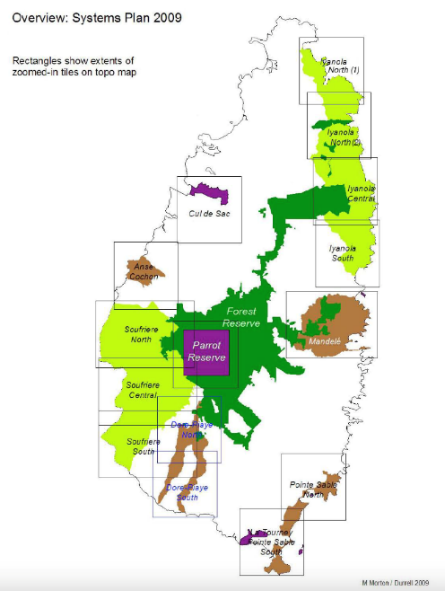 |  | 2. Protected Area Boundaries  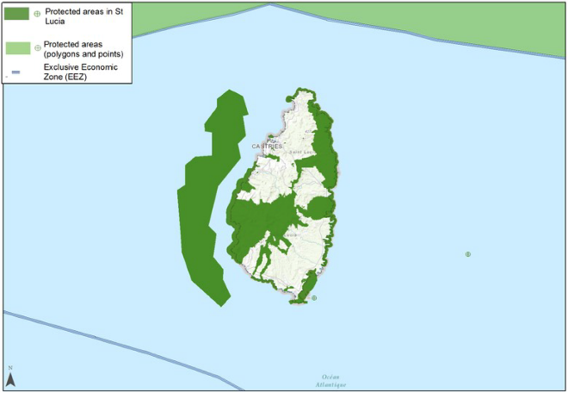

3. Designated and proposed protected areas  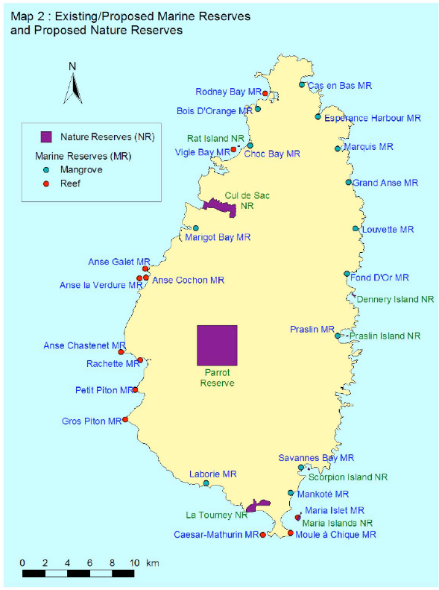 | 4. Soufriere Marine Management Area zoning plan  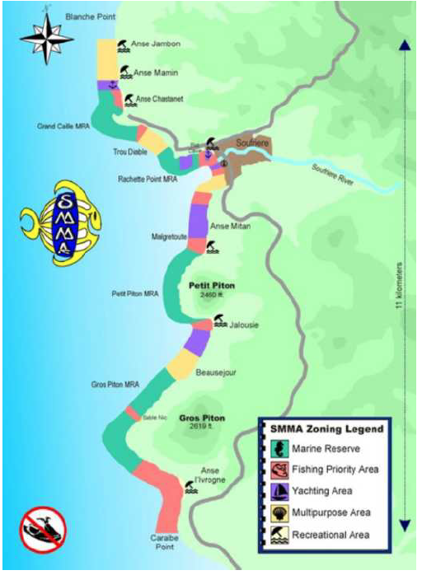

5. Soufriere Marine Management Area zoning plan options  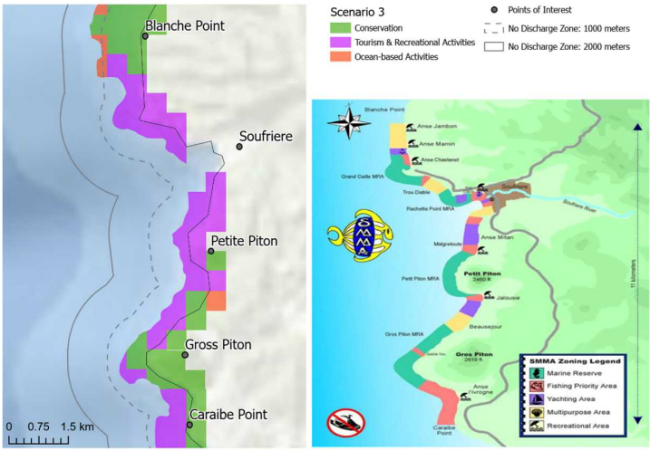 | 6. Pitons Management Area zoning plan  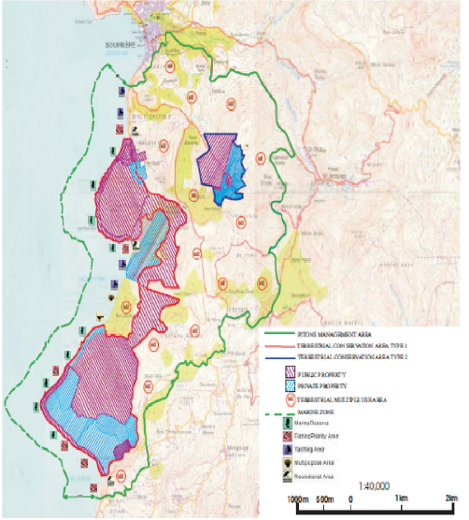

7. Priority sites for species conservation with protected areas  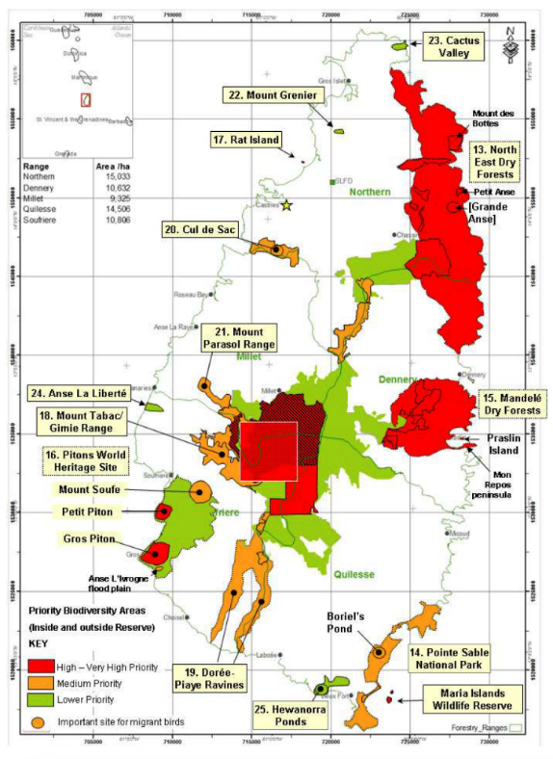 | 8. Important Bird and Biodiversity Areas  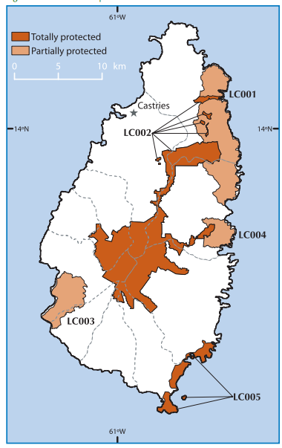

9. Ramsar Boundaries  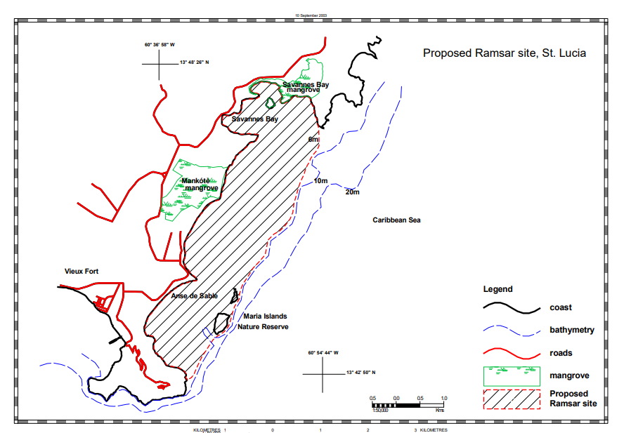 | 10. Digital elevation (bathymetry)  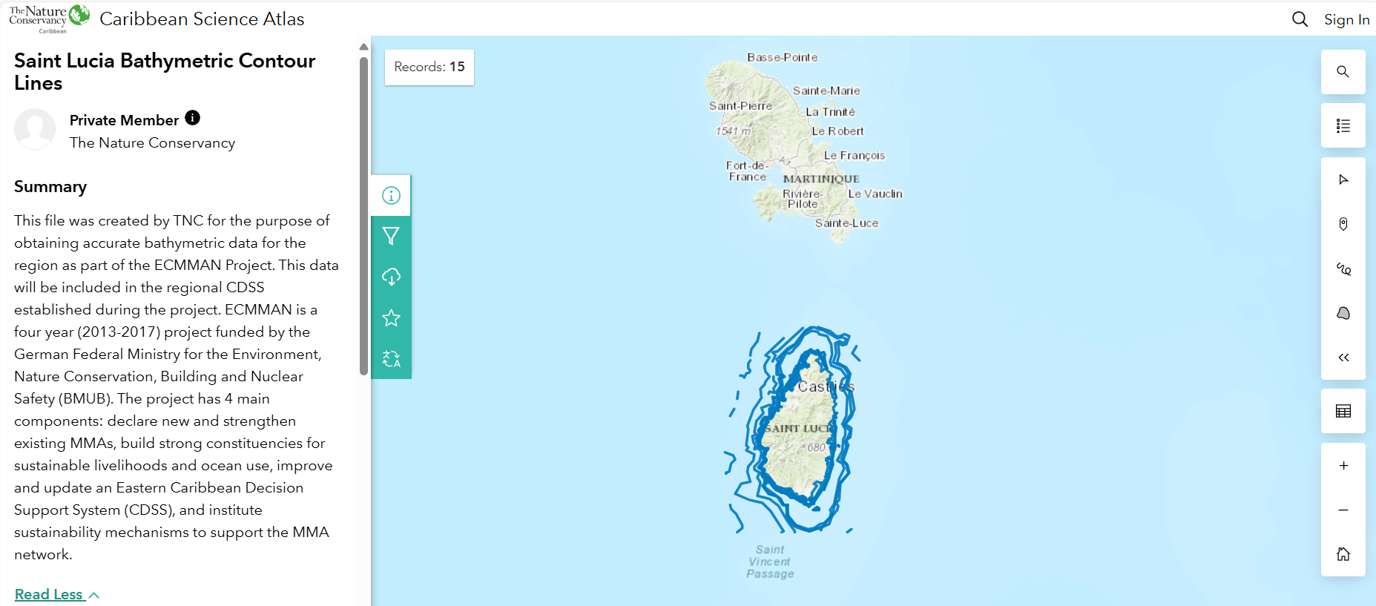

11. Contours  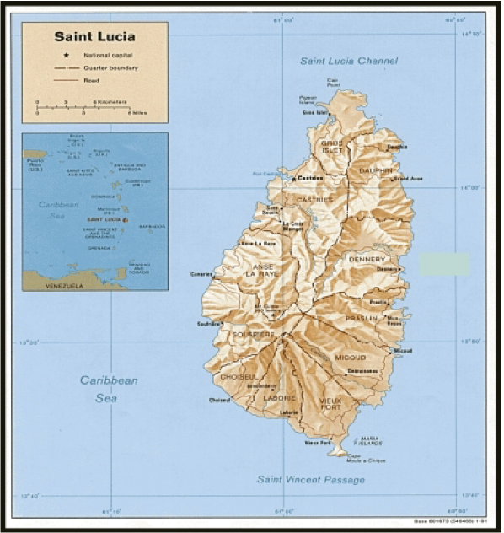 | 12. Geology  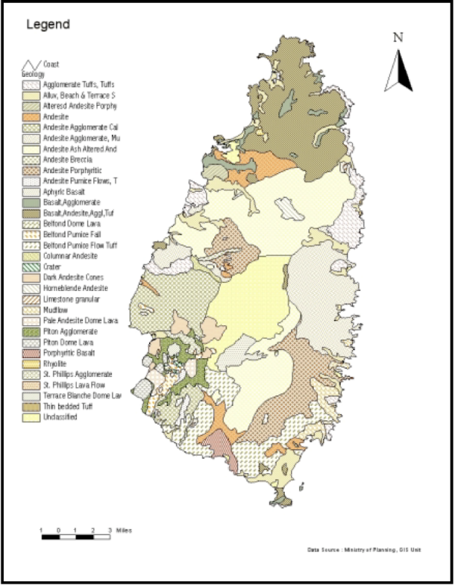

13. Watersheds  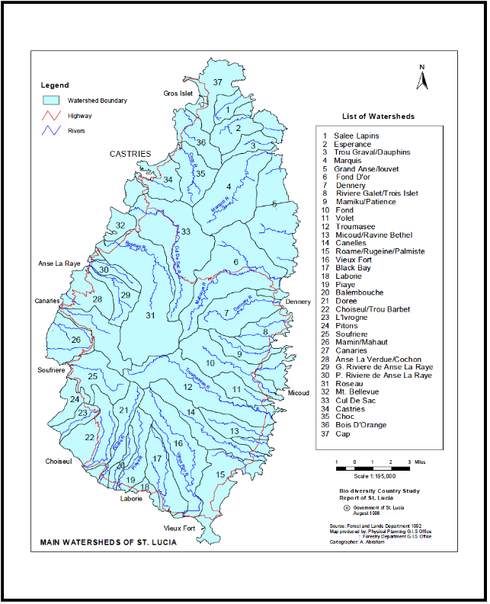 | 14. Watersheds and channels  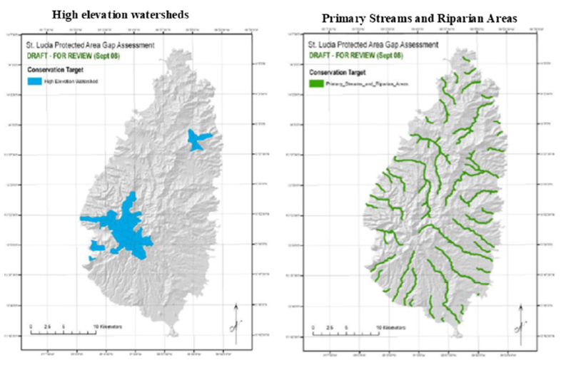

15. Benthic habitat  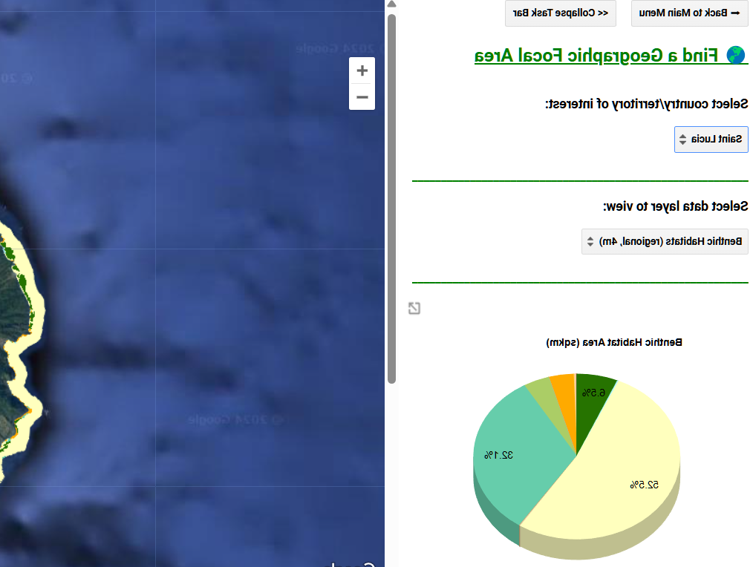 | 16. Areas of cold upwelling  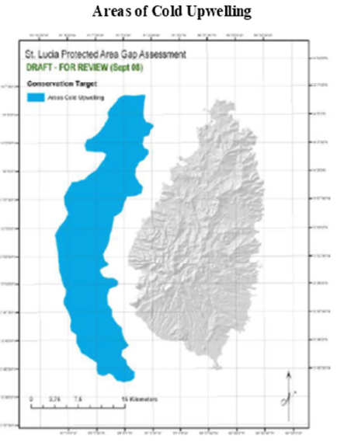

17. Areas of cold upwelling  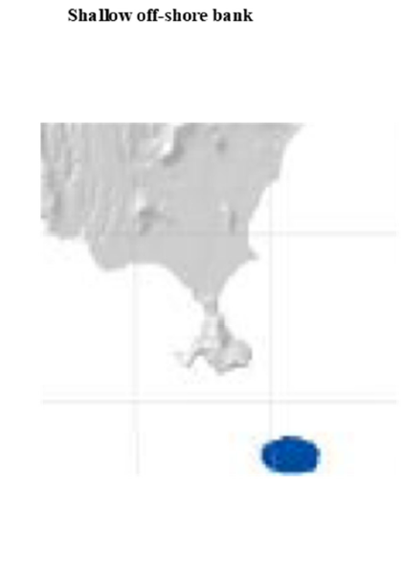 | 18. Coral reefs  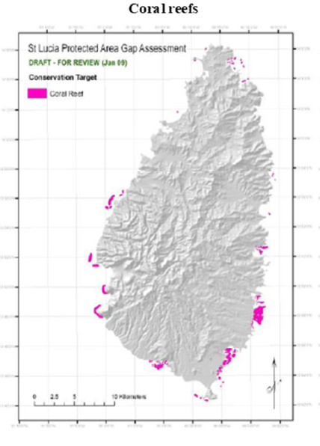

19. Seagrass beds  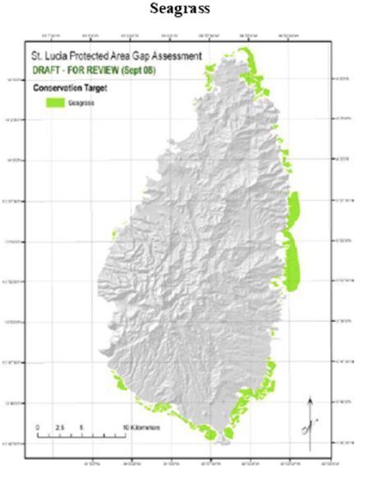 | Mangrove habitat  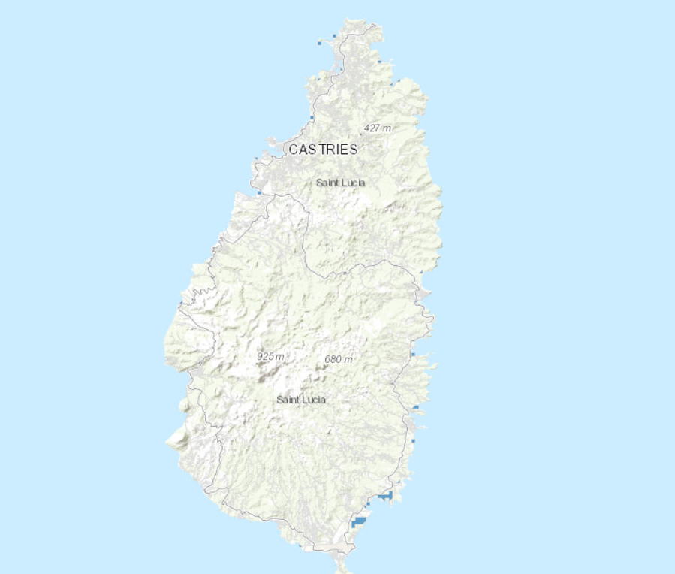

21. Mangroves  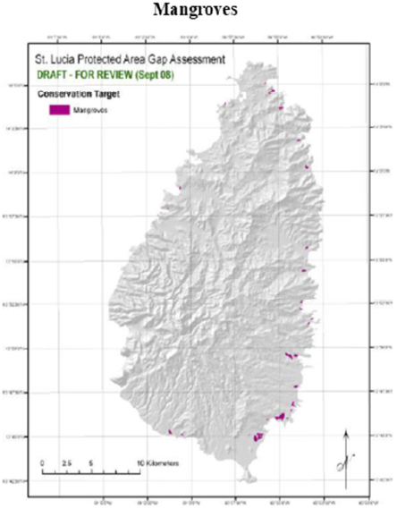 | 22. Lagoons  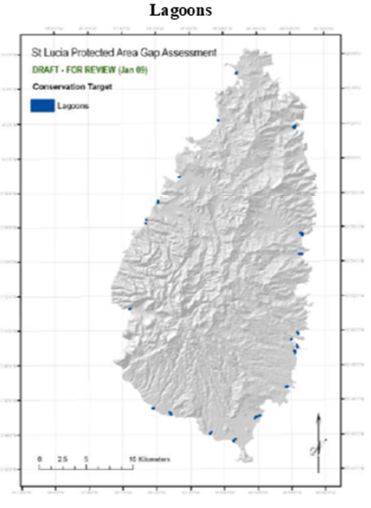

23. Beaches  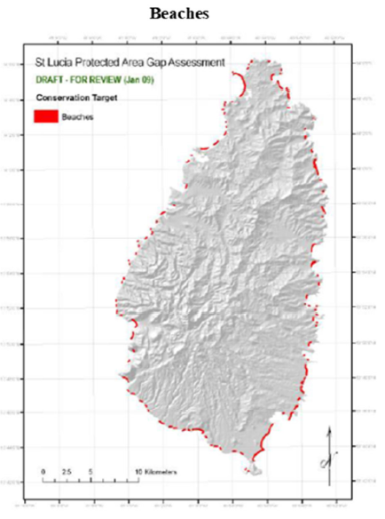 | 24. Rocky shores  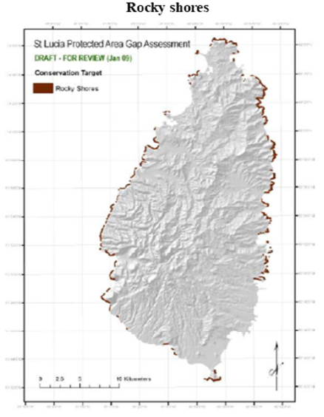
25. Terrestrial habitats  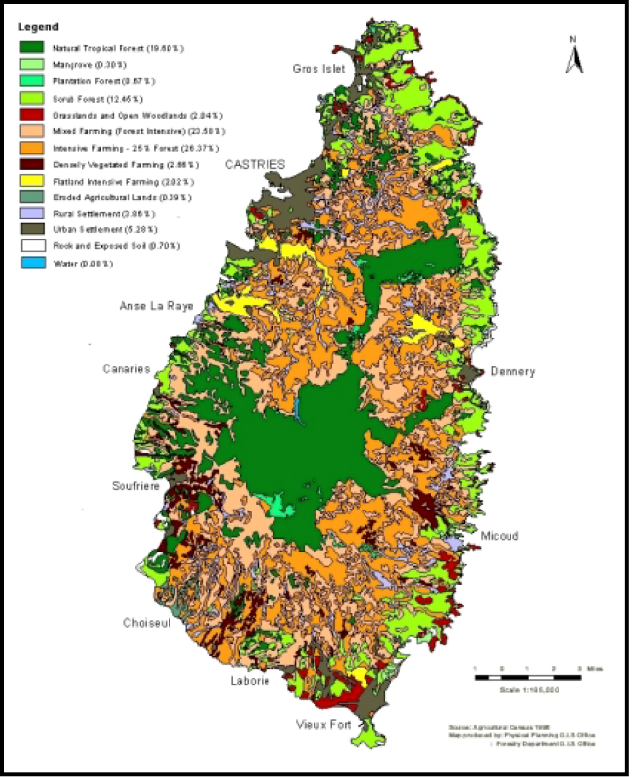 | 26. Important wildlife habitats  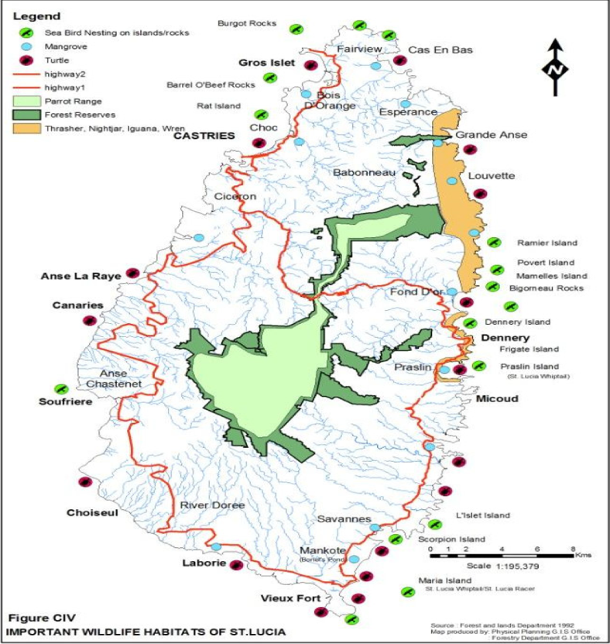

27. Blue carbon habitats  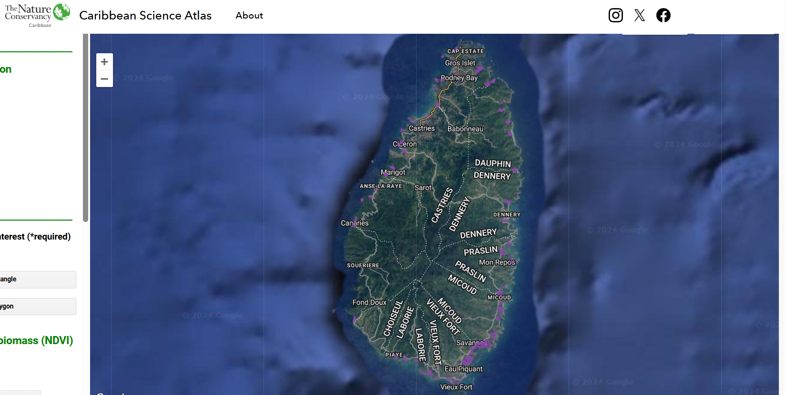 | 28. Current biomass of grouper  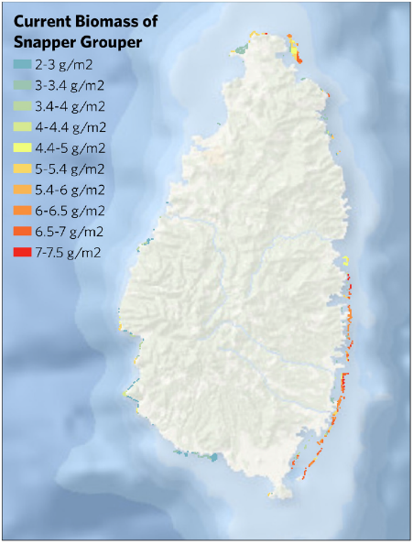

29. Potential biomass of snapper without fishing activity  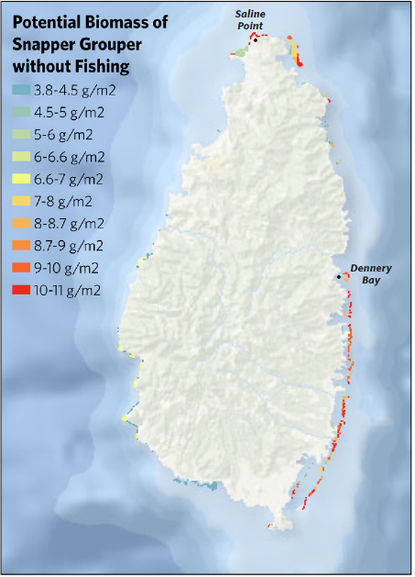 | 30. Important Areas for Birds  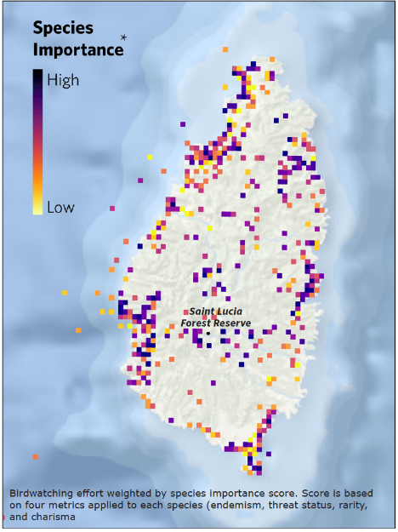

31. Shoreline protection offered by coral reefs  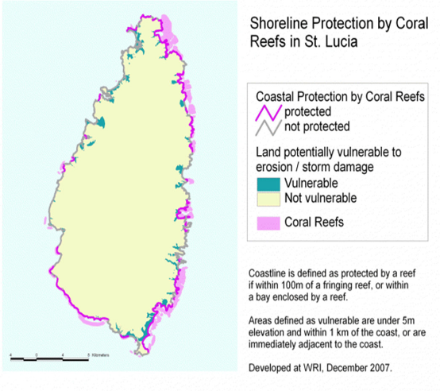 | 32. Drought susceptibility and landslide risk  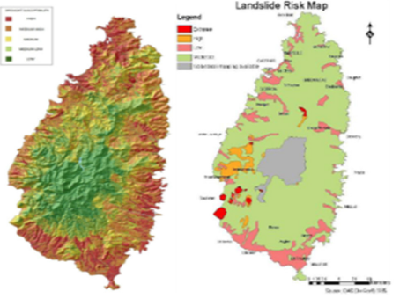
33. Erosion/sedimentation risk assessment  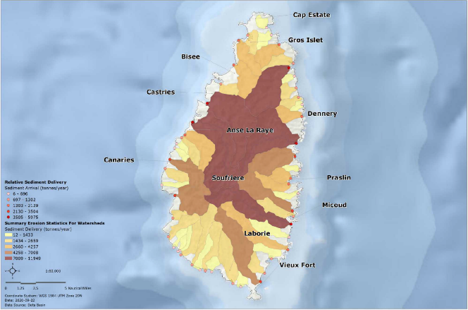 | 34. Erosion map  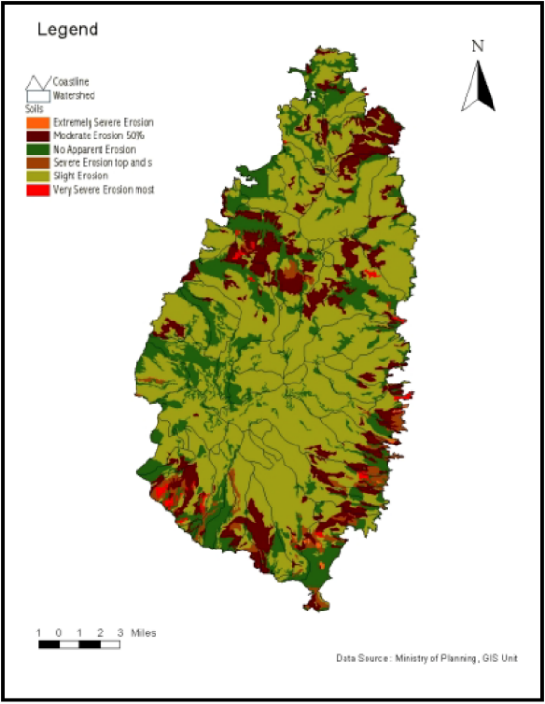

35. Exclusive Economic Zone boundaries  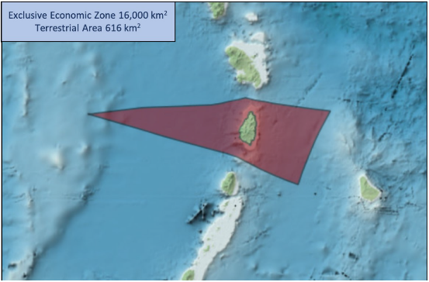 | 36. Shoreline boundary  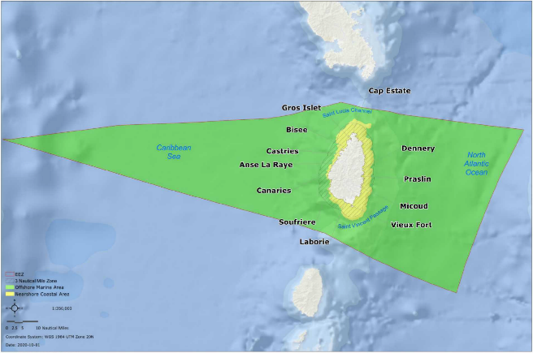

37. Fishing landing sites  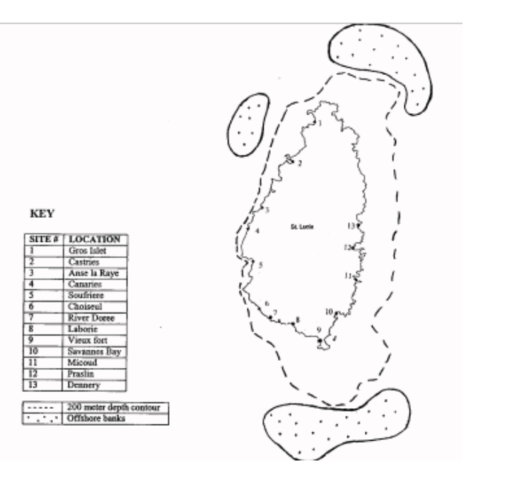 | - Areas of overfishing  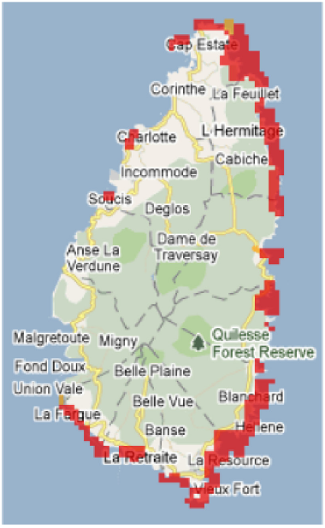

39. Estimated cumulative fishing impact  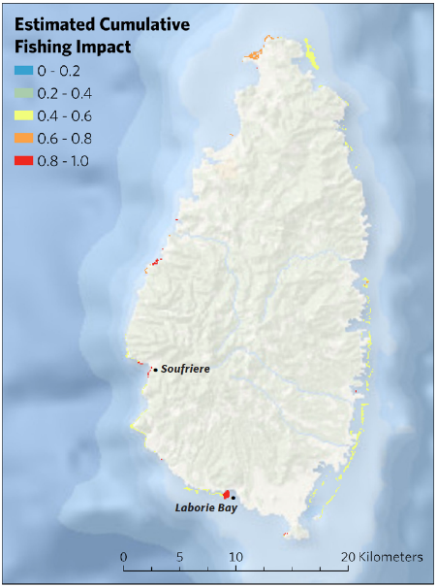 | 40. Recreational fishing intensity  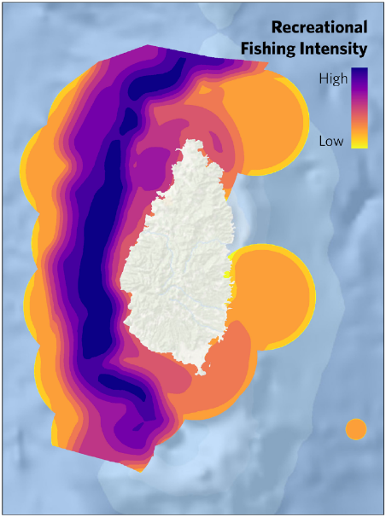

41. Dredging and sand mining risk assessment  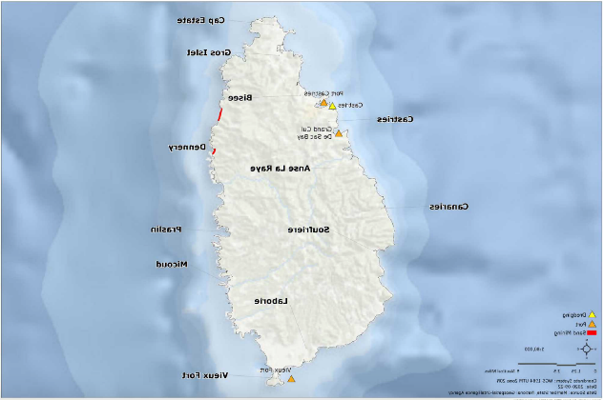 | 42. Risk hotspots (areas where human-based activities most greatly interacts with marine ecosystems  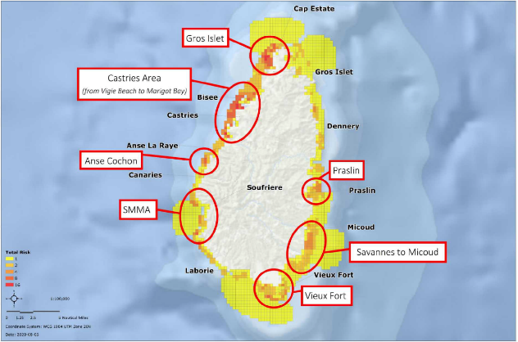

43. People/Communities risk assessment  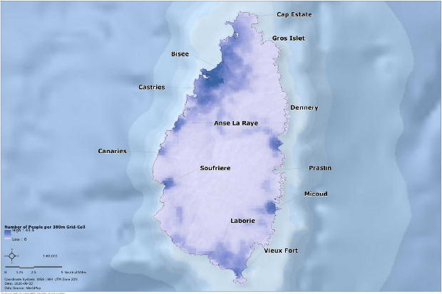 | 44. Trends in land use  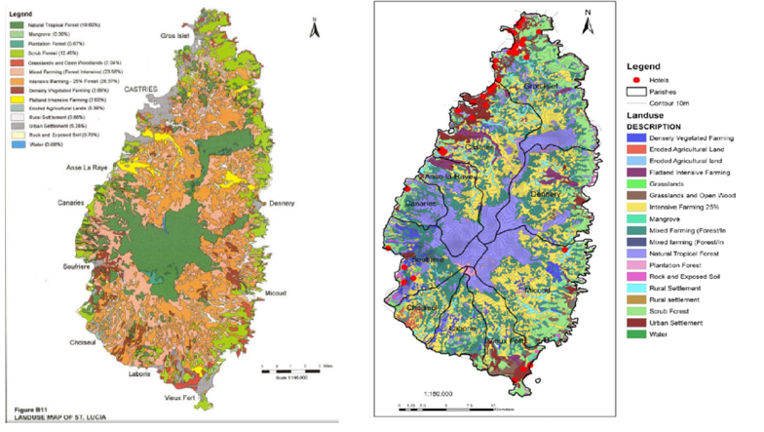

45. Potential areas for blue economy investment  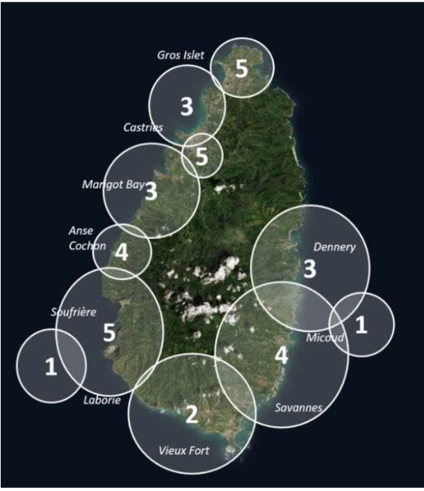 | 46. Priority blue economy projects  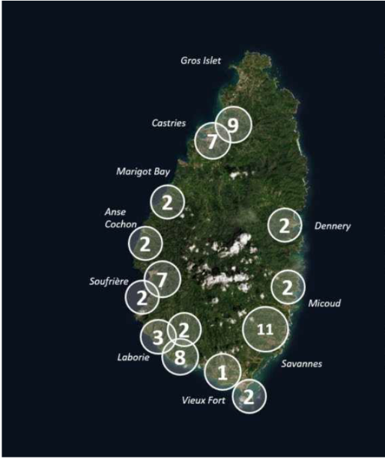

47. Blue economy proposed zoning plan  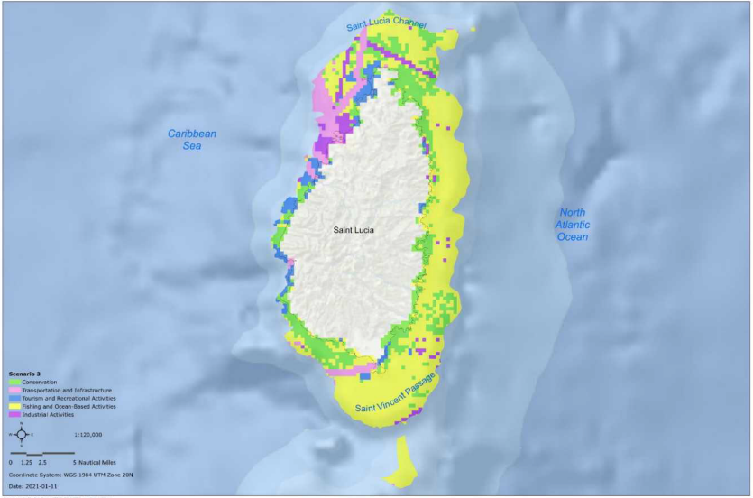 | 48. Hotel risk assessment  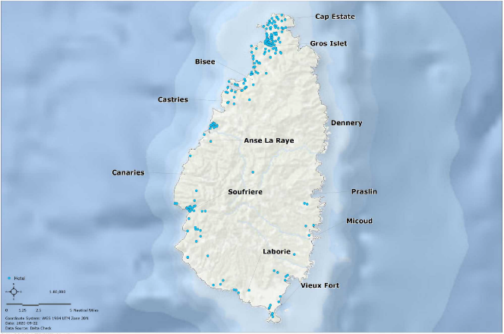

49. SCUBA diving risk assessment  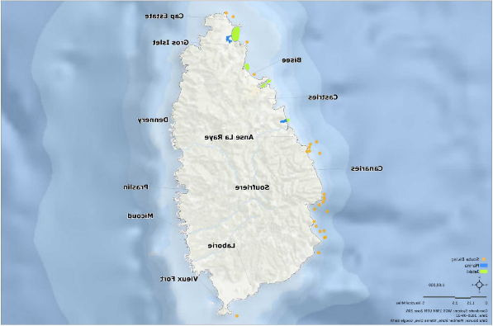 | 50. Nature tourism in Saint Lucia  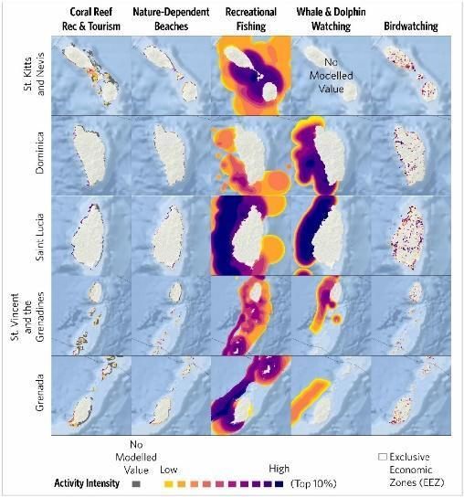

51. Nature-based tourism in Saint Lucia (areas of high use)  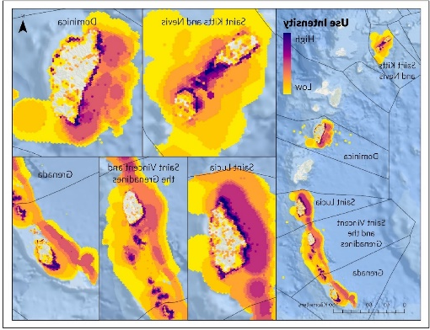 | 52. Nature dependent beaches  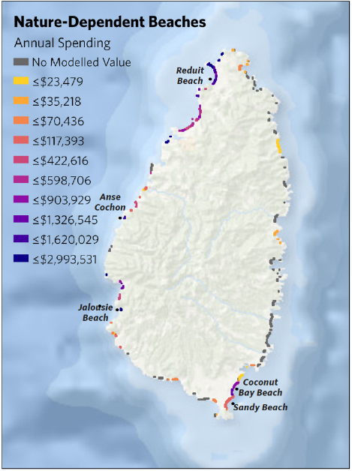

53. Coral reef tourism  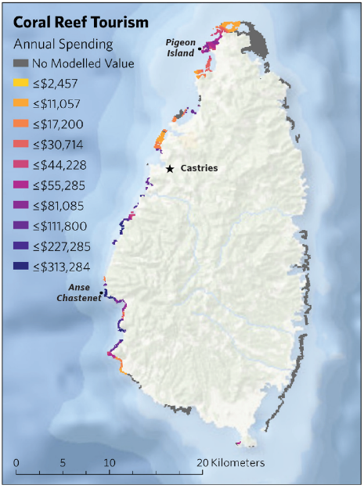 | 54. Intensity of whale and dolphin watching  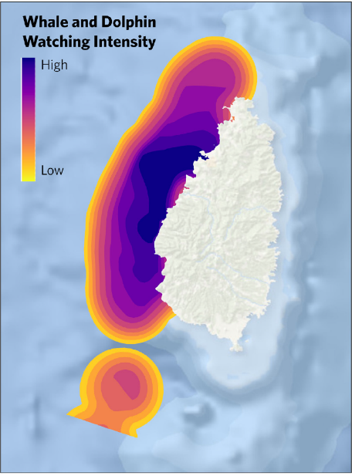

55. Density of seafood restaurants  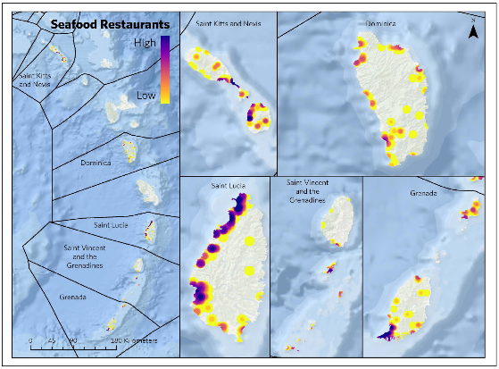 | 56. Sub-sea cables risk assessment  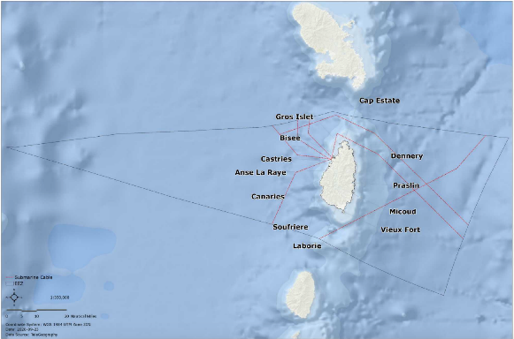

57. Shipping risk assessment
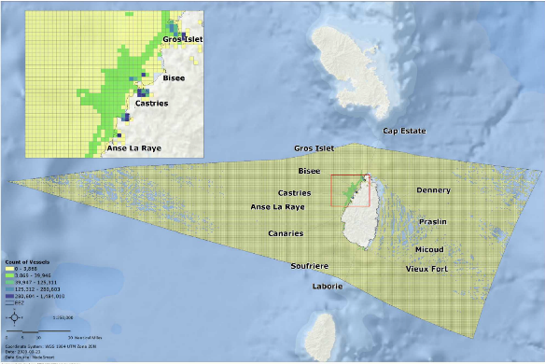

Appendix 8: Copies of Google Team Jamboard discussions generated during the National Workshop

