

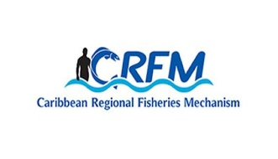


ISSN: 1995-1132

CRFM Technical & Advisory Document
No. 2025 / 08

JAMAICA
MARINE SPATIAL PLANNING PROFILE

CRFM Secretariat
Belize

CRFM Technical & Advisory Document -
Number 2025 / 08

Jamaica Marine Spatial Planning Profile

Prepared by:
Joseph Onwona Ansong, Senior Consultant, Howell Marine Consulting
Email: kofi@howellmarine.co.uk

Claire Hedley, Principal Consultant, Howell Marine Consulting
Email: claire@howellmarine.co.uk

This publication has been made possible through funding by BE-CLME+ Project: Promoting National Blue Economy Priorities Through Marine Spatial Planning in the Caribbean Large Marine Ecosystem Plus - GEF Project ID 10211

CRFM Secretariat
Belize

CRFM Technical & Advisory Document Number 2025/ 08

Jamaica Marine Spatial Planning Profile

© CRFM 2025
All rights reserved.
Reproduction, dissemination and use of material in this publication for educational or non-commercial purposes are authorised without prior written permission of the CRFM, provided the source is fully acknowledged. No part of this publication may be reproduced, disseminated or used for any commercial purposes or resold without the prior written permission of the CRFM.

Correct Citation:
CRFM, 2025. Jamaica Marine Spatial Planning Profile. CRFM Technical & Advisory Report No. 2025 / 08. 20p.

ISSN: 1995-1132
ISBN: 978-976-829396-1

Published by the Caribbean Regional Fisheries Mechanism Secretariat
Belize and St. Vincent and the Grenadines

EXECUTIVE SUMMARY
The Caribbean Large Marine Ecosystem Plus (BE-CLME+) Project aims to promote and further progress a blue economy in the Caribbean Region through MSP and Marine Protected Areas (MPAs) in Barbados, Belize, Guyana, Jamaica, Saint Lucia, and Panama. Under the BE-CLME+ Project, the Caribbean Regional Fisheries Mechanism (CRFM) Secretariat has developed a Caribbean Regional Marine Spatial Planning (MSP) Step-by-Step Guide and Protocol. This Jamaica Marine Spatial Planning Profile was produced, following desk-based research and stakeholder feedback, to assess the current status, challenges and opportunities for marine spatial planning in Jamaica, in order to inform the development of the Guide and Protocol.
Jamaica is a Small Island Developing State with a significant marine jurisdiction; its Exclusive Economic Zone (EEZ) is approximately 235,000 km², which is 24 times the size of its land area. Nationally, MSP is currently in the development stage. Overall coordination of the blue economy is managed by the Ministry of Economic Growth and Job Creation (MEGJC), the Planning Institute of Jamaica (PIOJ), and the National Council on Ocean and Coastal Zone Management (NCOCZM). The NCOCZM, chaired by the Minister of Foreign Affairs and Foreign Trade (MFAFT), acts as the lead MSP authority. Political commitment to MSP development is demonstrated by government discussions and a grant agreement with the Caribbean Development Bank (CDB).
A key success in Jamaica’s MSP journey is the localized MSP pilot implemented at the Pedro Bank between 2014 and 2015, spearheaded by the National Environmental and Planning Agency (NEPA) and The Nature Conservancy (TNC). Pedro Bank is an expansive area covering 8,040 km$^2$, critical to Jamaica as its primary commercial and artisanal fishing grounds and the main harvesting area for queen conch. The Pedro Bank MSP followed international best practice, using the UNESCO-IOC step-by-step guide. Its core vision was achieving effective and collaborative management of the bank’s biodiversity and ecosystem health to support sustainable livelihoods. This approach led to the creation of a draft multi-use zoning design to guide management and sustainable resource use. Engagement was facilitated through a multi-sectoral Pedro Bank Working Group (PBWG) and utilized a collaborative and Participatory Geographic Information System (PGIS) approach to integrate local knowledge with scientific data.
Jamaica also engages in important transboundary efforts, specifically within the Seaflower Biosphere Reserve (SFBR), designated by UNESCO in 2000, which encompasses Colombian, Jamaican, and Nicaraguan jurisdictions. The Sanin-Robertson treaty (1993) regulates the Joint Regime Area (JRA) between Jamaica and Colombia, enabling both countries to jointly manage, control, and exploit natural resources, conduct marine scientific research, and protect the marine environment within that area.
However, the implementation of MSP faces significant challenges. These include the advisory nature of the PBWG, which limits its role in the actual implementation of the Pedro Bank plan. Moreover, the existing Ocean and Coastal Zone Management (OCZM) Policy has failed to achieve its intended impact due to policy implementation barriers such as inadequate resourcing and a lack of legal standing, underscoring the need for enhanced enabling arrangements. Data acquisition remains difficult; although basic spatial information exists, crucial datasets (e.g., location of industrial fishing effort) were not granted to the Pedro Bank project team. Human resources are also a limitation, as qualified staff are often stretched across multiple agency projects, suggesting the need for a dedicated MSP team.
Key recommendations to advance MSP include: establishing new legislation to support MSP and marine zoning; securing long-term government mandate for the adoption of the Pedro Bank MSP; and revisiting and updating the OCZM Policy to align with new paradigms like MSP. Furthermore, investment in specialized training, communication specialists, and advanced GIS capabilities is necessary to ensure effective data collection and stakeholder engagement, particularly with remote groups like the Pedro Cay fishers.

Table of Contents
EXECUTIVE SUMMARY 1
1 INTRODUCTION 3
1.1 Scope 3
1.2 Context 3
2 MSP OVERVIEW 4
3 MSP PROCESS REVIEW 6
3.1 MSP Vision and Objectives 7
3.2 Role of Institutions and Agencies 8
3.3 Stakeholders Engagement 9
3.4 Data and Evidence Gaps 9
3.5 Transboundary Cooperation 10
3.6 Funding MSP Processes 13
4 MSP CHALLENGES 13
5 MSP BEST PRACTICES AND SUCCESSES 14
6 RECOMMENDATIONS 14
REFERENCES 16

INTRODUCTION

Scope
The Caribbean Regional Fisheries Mechanism (CRFM) Secretariat is preparing a Caribbean Regional Marine Spatial Planning Step-by-Step Guide and Protocol under the BE-CLME+ Project, to be delivered by the end of 2025. The Guide and Protocol will align with international best practice for developing and implementing MSP but it will be tailored to the specific challenges and opportunities of the countries participating in BE-CLME+: Barbados, Belize, Guyana, Jamaica, Panama and Saint Lucia.
Consultations took place in each country through July and August 2025 to understand how the Guide and Protocol can best take account of their individual circumstances. The profile provides a detailed overview of the current status of Marine Spatial Planning (MSP), its underpinning drivers and political support, and challenges and recommendations specific to Jamaica. This profile was originally prepared in July 2025 in advance of those consultations based on desk-based research using available documents relevant to MSP in Jamaica to provide an initial baseline of information. The information was tested and refined through consultation with MSP stakeholders in Jamaica, to identify the issues most relevant to the development of the Guide and Protocol.
The recommendations contained in Section 6 reflect recommendations contained in the various evidence sourced reviewed for how Jamaica can further progress MSP. They indicate potential future direction of travel for Jamaica, and will be used to understand how the Regional Guide and Protocol can support addressing them.

Context
Jamaica has a significant marine area, with an Exclusive Economic Zone (EEZ) of approximately 235,000 km², which is 24 times the island's land area. An MSP process was implemented at Pedro Bank by the National Environmental and Planning Agency (NEPA) of Jamaica and The Nature Conservancy (TNC). Located approximately 50 miles (80 km) southwest of Jamaica, Pedro Bank is a biologically and economically-significant area. Its three sandy islands (cays) are composed of coral reefs, sand, and sea grass beds. It makes up Jamaica’s main commercial and artisanal fishing grounds, serves as the primary harvesting area for queen conch, and is also an important nesting area for both seabirds and sea turtles.
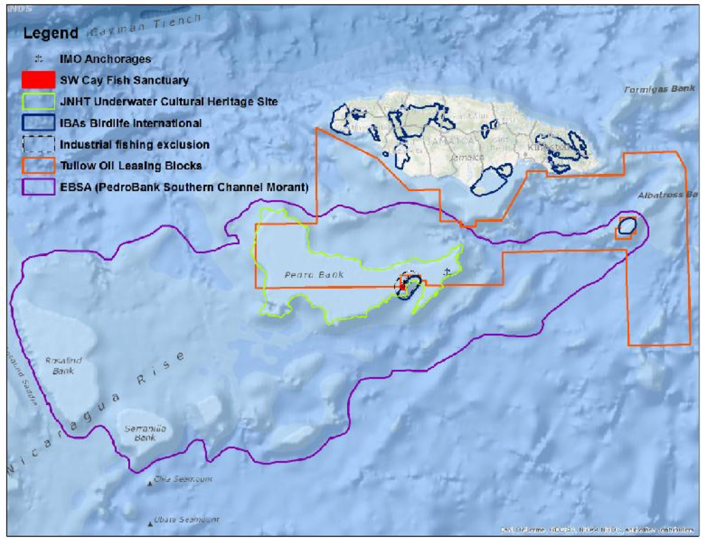
Figure 1. Geographic location of the Pedro Bank and a representation of existing spatially-based management measures. (Note: the image does not include the more recently designated Pedro Cays Protected Area.

MSP OVERVIEW
This section provides an overview of the status of MSP in Jamaica including relevant policies, lead MSP authority, that status of MSP, planning approach and scope.
Table 1. Jamaica MSP overview and status
Criteria | Overview
MSP Legislation and Policies | Towards Ocean and Coastal Zone Management in Jamaica includes a National Action Plan on ocean and coastal zone management as a product of national policy to elevate concern for coastal management to the level of planning and action. It recognises coastal resources as important assets that offer the country manifold economic options. The Action Plan is intended to be consistent with the general direction of the policy on ocean and coastal zone management so that both documents will harmonise in respect of matters relating to the use of coastal resources. The plan is made up of projects that are clustered under programme areas and spread over a period of one five-year cycle in two phases. Phase I spreads over the years zero to two and comprises of eight programme areas, whereas Phase II spreads over years three to five and comprises four programme areas. The overall responsibility for coordinating the implementation of the plan will rest with the National Council on Ocean and Coastal Zone Management.  The Portland Bight Protected Area (PBPA) was designated on 22 April 1999 under section 5 (1) (b) of the Natural Resources Conservation Authority (NRCA) Act, 1991. es regionally important examples of dry limestone forest, and nationally important areas of coral reef, mangrove wetland and seagrass.  The Negril Marine Park (NMP) was first declared under the Natural Resources Conservation Authority Act 1991 and was legally established under the Natural Resources Conservation Act Order (Negril Marine Park Declaration) by the Government of Jamaica on 4 March 1998.  The Ocho Rios Marine Park Protected Area (ORMPPA) was designated on 16 August 1999 under section 5 (1) (b) of the Natural Resources Conservation Authority (NRCA) Act, 1991.  The Natural Resources (Marine Parks) (Amendment) Regulations, 2015, are a set of regulations in Jamaica that govern activities within marine parks. They prohibit activities like destroying or harming marine life (e.g., corals, shells, seaweed), removing natural resources, and attaching structures to coral or rock formations without permission. The regulations also address fishing and other activities within these protected areas
Lead MSP Authority | The National Council on Oceans and Coastal Zone Management (NCOCZM) and chaired by the Minister of Foreign Affairs and Foreign Trade (MFAFT).  Jamaica’s blue economy coordinating structure is led by the Ministry of Economic Growth and Job Creation (MEGJC), the National Council on Ocean and Coastal Zone Management (NCOCZM), and the Planning Institute of Jamaica (PIOJ)
Stage of MSP | Development stage. In April 2018 the Ministry of Economic Growth and Job Creation launched a process for the development of the national spatial plan for Jamaica, including issues related to climate change; the project was established through a grant agreement between the Caribbean Development Bank and the government of Jamaica. The Planning Institute of Jamaica (PIOJ) and the Ministry have included work on the National Spatial Plan in its Adaptation Programme and Financing Mechanism for a Pilot Programme for Climate Resilience.  A localised MSP has been piloted at the Pedro Bank
Plan Name/MSP Initiative(s) | The Pedro Bank MSP was developed by the NEPA of Jamaica and TNC between 2014 and 2015.  The process to develop a National Marine Spatial Plan is currently being developed.  The Jamaica Ecoregional Planning (JERP) project. Have previously outlined conservation areas and strategies for the sustainable use of freshwater, marine and terrestrial biodiversity  In 2023, with funding from the World Bank, recommendations for a Blue Economy Roadmap for Jamaica were developed in coordination with the Planning Institute of Jamaica (PIOJ) and a multi-agency Technical Review Committee. The Government of Jamaica is currently developing its Blue Economy (BE) plan to promote the sustainable use of ocean resources for economic growth, improved livelihoods, and jobs while preserving the health of ocean ecosystem.
Plan Scale | The Pedro Bank MSP covers the full extent of Pedro Bank - an expansive, submerged bank located approximately 80 km (50 miles) southwest of mainland Jamaica. The plan covers approximately 8,040 km² and includes the main plateau of the bank and associated shallow marine habitats, the Pedro Cays, which are key ecological and human-use sites, plus minor cays, shoals, rocks, and important benthic habitats  While a national MSP is currently being discussed, the spatial scale has not yet been announced.
Plan Scope | The Jamaican Government is yet to define the national MSP scope.  The Pedro Bank MSP focussed on create a draft multi-use zoning design for sustainable resource use, building capacity for integrated marine management in Jamaica, and supporting awareness, decision-making, and long-term sustainability for Pedro Bank’s marine ecosystem.
Planning Approach | Multi-use zoning design is expected to guide sustainable use and inform decisions about protected area.
Political commitment to MSP | There are discussions for MSP at the government level and the grant agreement between the Caribbean Development Bank and the Government of Jamaica shows some level of commitment for MSP development.

MSP PROCESS REVIEW
The Pedro Bank MSP process followed the UNESCO-IOC MSP step by step guide and the 10 MSP steps. The planning process included the following steps:
- Instituting stakeholder participation
- Establishing clear objectives and goals
- Preliminary assessment
- Defining existing and future conditions
  - Mapping marine habitats
  - Mapping marine resources and space-uses
  - Building a multi-objective database
- Providing decision-support products
  - Identifying priority conservation areas
  - Visualising fishing patterns
  - Multi-objective DST analyses
- Allocating marine resource and space-use management
  - Recommending area-specific marine management measures
  - Generating a marine multi-use zoning design
- Implications of MSP for Pedro Bank

MSP Vision and Objectives
The MSP vision for the Pedro Bank is “A future where effective and collaborative management of the Pedro Bank and Cays biodiversity and ecosystem health support sustainable livelihoods”. The following guiding principles were developed for the Pedro Bank MSP process:
- Healthy resources and human well-being
  - Ensure pristine marine life and productive resources
  - Promote sustainable livelihoods
  - Provide resilience to climate change
  - Support educated communities
  - Encourage honesty and respect by all
  - Develop an eco-community on the Pedro Cays
- Access to comprehensive information
  - Generate baseline of conditions and monitor changes
  - Improve accountability of decision-making
  - Increase education and awareness of the importance of Pedro Bank
- Effective integrated management
  - Establish an integrated governance structure for MSP implementation
  - Regulate access and ensure sustainable use of resources
  - Create efficient administration, monitoring and evaluation programmes
  - Institute effective regulatory and enforcement mechanisms
  - Facilitate responsive and adaptive management
The following goals and objectives were developed for the Pedro Bank MSP:
Pedro Bank MSP Goals and Objectives
Conservation of biodiversity
- Ensure healthy, productive and resilient environment
- Safeguard ecological diversity and integrity of species and habitats
- Protect natural resources and cultural heritage
- Develop effective long-term monitoring of resources and ecosystem services
Abundant and healthy fisheries
- Enhance size and diversity of fish stocks
- Ensure safety for fishers and sustainable fishing practices
- Optimise sustainable yield (e.g. spend less time at sea to earn living)
- Improve fisheries management using a collaborative approach
- Generate incentives for compliance, value-added markets & livelihood diversification
- Create effective regulations supported by severe penalties & functional enforcement
- Strengthen monitoring, control and surveillance using technology
Safe transportation
- Prevent marine pollution and improve maritime safety and management through international, regional and local frameworks
- Establish transportation corridors, install navigational makers and moorings
- Enhance education of navigation and safety at sea for fishers
- Facilitate safer vessels and equipment to reduce accidents
- Institute vessel monitoring and safety systems for all vessels
Sustainable future development
- Establish rigorous permitting and environmental auditing procedures to monitor new development
- Adopt best practices (innovative clean technologies) for oil and natural gas development
- Assure compensation for potential impacts to marine resources and livelihoods
- Encourage potential for renewable energy production (i.e. wind, tides) opportunities
Research for awareness
- Generate a baseline of conditions using a collaborative monitoring and evaluation framework
- Strengthen scientific research capacity and ensure access to information
- Increase knowledge and awareness of the importance of Pedro Bank
- Educate communities to achieve behavioural change (voluntary compliance)
- Facilitate an interpretative experience (representative ecosystem components) and promote potential for alternative livelihood (research tourism)

Role of Institutions and Agencies
The following are key stakeholder that have remit for MSP in Jamaica:
- Ministry of Foreign Affairs and Foreign Trade
- Ministry of Agriculture, Fisheries, and Mining
- Ministry of Culture, Gender, Entertainment and Sport
- Ministry of Economic Growth and Job Creation
- Ministry of Education, Skills, Youth and Information
- Ministry of Finance and the Public Service
- Ministry of Industry, Investment and Commerce
- Ministry of Labour and Social Security
- Ministry of Local Government and Community Development
- Ministry of Science, Energy, Telecommunications and Transport
- Ministry of Tourism
- National Council Oceans & Coastal Zone Management (NCOCZM)
- National Environment & Planning Agency (NEPA)
- The National Fisheries Authority (NFA)
- National Solid Waste Management Authority (NSWMA)
- Petroleum Cooperation of Jamaica (PCJ)
- Protected Areas Committee (PAC) and the Cays Committee
- Shipping Association of Jamaica
- Urban Development Commission (UDC)
- Veterinary Services Division - Ministry of Agriculture and Fisheries (MOAF)
- The Jamaica Promotions Corporation (JAMPRO)
- The Port Authority of Jamaica (PAJ)
- The Maritime Authority of Jamaica (MAJ)
- The Water Resources Authority (WRA)
- The Ministry of Education and Youth (MOEY)
- The Ministry of Labour and Social Security (MLSS), and
- Planning Institute of Jamaica (PIOJ)
- Jamaica Defence Force Coast Guard (JDF-CG)
- Industrial fishing companies
- Jamaica Fish Sanctuary Network (JFSN)
- Jamaica Fishermen's Cooperative Union (JFCU)
- Jamaica National Heritage Trust (JNHT)
- Jamaica Yachting Association
- Marine Police (JCF-MP)
- Maritime Authority of Jamaica (MAJ)
- The Nature Conservancy (TNC)
- University of the West Indies (UWI)

Stakeholders Engagement
A multi-sectoral stakeholder group, the Pedro Bank Working Group (PBWG), was formed based in part on the pre-existing (2005) Pedro Bank Management Project (PBMP) members to guide the MSP process. The PBWG comprises 35 persons from 26 marine-related public sector agencies, NGOs, academics, artisanal and industrial fishing representatives, and various national marine committee members. The role of the PBWG was to guide stakeholder engagement, provide direction for the project and methods applied, review data and analyses, and work together to make final recommendations for the Pedro Bank.

Data and Evidence Gaps
The government of Jamaica has already invested US$50 million to develop the National Spatial Planning Information Technology (NSPIT) Platform whose objective is to function as Jamaica's spatial data infrastructure to improve decision making in planning and national development, providing government agencies, educational institutions, the private sector, and citizens access to Jamaica's spatial data. Currently the development of the NSPIT platform is not yet completed and there is an opportunity to work collaboratively with the NSPIT team to design and implement specific MSP tools within the platform and to promote its use for a national MSP initiative
The data and capacity needs assessment found that there is some basic spatial information exists for use during the baseline assessment for MSP process in Jamaica. Thanks to the efforts of multiple governmental agencies (e.g., NEPA, WRA, etc.) and NGOs (e.g., TNC, Global Fish Watch, etc.) several data is already in a geospatial format (e.g., shapefile, geotiff, etc.). However, data found in reports and publications will have to be requested and in some cases digitised, so that it can be included in a GIS project for further analysis.
For the Pedro Bank MSP initiative, a marine habitat map of the Pedro Bank was created in two parts. In 2012 the Living Oceans Foundation (LOF) conducted a number of marine surveys on the Pedro Bank (i.e. AGGRA surveys, benthic habitat videos and side-scan sonar measurements). In 2014 Landsat 8 and WorldView-2 satellite imagery were acquired and the LOF data (Bruckner 2012) were classified using digital image processing techniques to develop two benthic habitat mapping products.
Participatory research methods (e.g. socio-economic surveys, questionnaires and mapping exercises, marine field surveys) were employed to solicit and incorporate spatially-based local knowledge within the geodatabase and fill information gaps on human use.
The geodatabase was created using ArcInfo version 10.1 software. All data were imported and standardised using ArcMap, ArcCatalog and Arc Toolbox along with the Spatial Analyst extension. All data collected and created were organised and grouped into feature datasets or similar ‘themes’ of the resource use values, each of which contain a number of corresponding feature classes or ‘layers’ categorised by name, methods, source, geoprocessing performed and identified priority goals
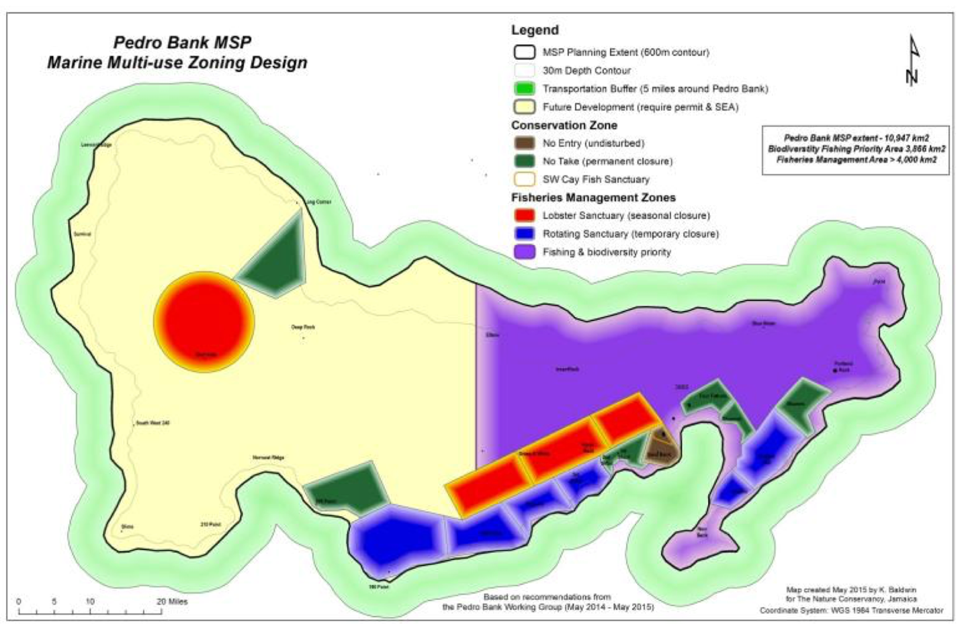
Figure 2. Pedro Bank MSP Zoning Design
The boundaries of the various zones represented on the multi-use zoning map in many cases are ‘fuzzy’ and used to draw reference to the type or manner of spatially-explicit management measure to be applied. Therefore the depicted zoning boundaries are not to be seen as ‘final’ as further work with key stakeholders must be undertaken to identify the most feasible arrangements for the Pedro Bank.

Transboundary Cooperation
Transboundary cooperation for MSP in Jamica is mainly focused on transboundary marine conservation initiatives between Jamaica, Colombia and Nicaragua. The Seaflower Biosphere Reserve (SFBR) located on the southwestern side of the Caribbean Sea system was designated as a Biosphere Reserve by UNESCO in 2000 under Colombian, Jamaican, and Nicaraguan jurisdiction (Figure 3). It covers approximately 180,000 km2, and comprises of three main oceanic islands (San Andres, Providencia, and Santa Catalina), a set of cays, and atolls (Serrana, Serranilla, Alburquerque, Roncador, Quitasueño, and Bajo Nuevo). The SFBR hosts representative marine and coastal tropical ecosystems such as seagrasses, mangroves, wetlands, reef lagoons, beaches, open sea, dry forests, and coral reefs.

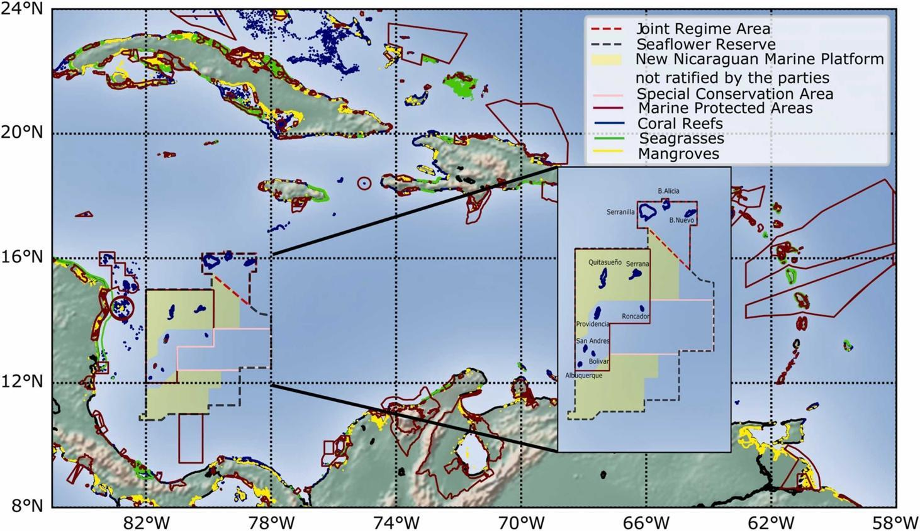
Figure 3. Geopolitical division of the Seaflower Biosphere Reserve. The coastal/marine strategic ecosystems (yellow, green and blue polygons), and MPA (red brown polygons) location in the Caribbean area
The Seaflower Marine Protected Area (SMPA) was created in 2005 as part of the SBR, covering 65,000 km² and including coastal and marine ecosystems with different levels of management and conservational status. Figure 4 below shows the location of the SMPA within the Joint Regime Area.
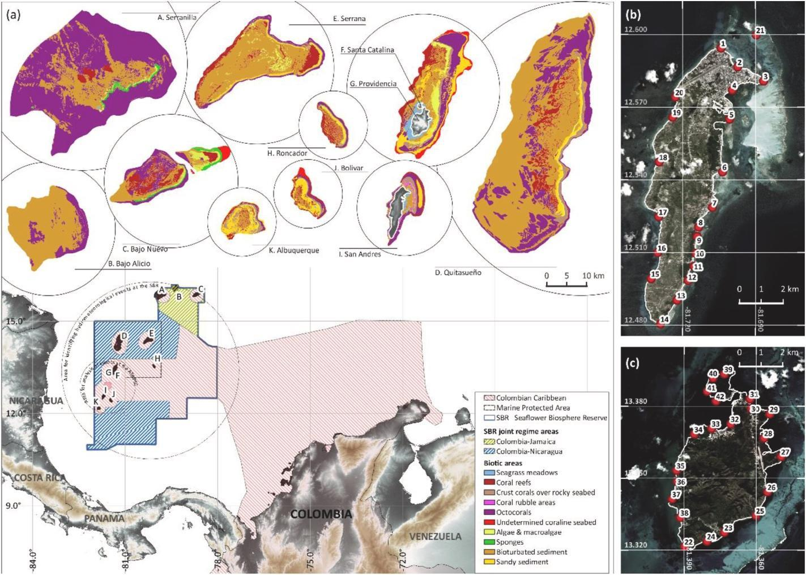
Figure 4. Location of the Marine Protected Area of the Seaflower Biosphere Reserve within the Colombian Caribbean and binational joint regime areas. (a) Biotic units for the different banks, cays, and islands of the SBR. (Source: Osorio-Cano et al., 2024)

Until 2012, the SFBR was under Colombian jurisdiction, with the northernmost zone, a Joint Regimen Area (JRA), being shared with Jamaica. However, after La Haya ruling in 2012 Colombia had to yield around 40% of the protected waters to Nicaragua following years of dispute. Colombia continues to exercise sovereignty over cays and islands but vast areas of water that surround Quitasueño and Serrana are now under Nicaraguan jurisdiction.
The JRA between Jamaica and Colombia has been regulated by the Sanin-Robertson treaty since 1993. The zone is illustrated by the dashed red lines in Figure 3; however, it excludes the maritime area around the cays of Serranilla and Bajo Nuevo which are under Colombian jurisdiction. In the JRA both countries jointly manage, control, explore, and exploit the resources. The Parties may carry out the following activities:
- Exploration and exploitation of natural living or non-living resources on the seabed and its subsoil, and other activities for the economic exploitation and exploration.
- The establishment and use of artificial islands, installations, and structures.
- Marine scientific research.
- The protection and preservation of the marine environment.
- The conservation of living resources.
- Neither Colombia nor Jamaica can authorise other countries, organisations, or foreign vessels to carry out any activities there
All countries have ecosystems (mainly corals, seagrass, and mangroves) subject to protection and have developed different governance instruments to protect them.

Funding MSP Processes
TNC played a role assisting with establishing an endowment for the Pedro Bank MSP. The Caribbean Challenge Initiative and the Caribbean Biodiversity Fund. provided financial support for the project. TNC has made an initial pledge of $8 million USD into the fund. The National Environment and Planning Agency contracted TNC to conduct participatory GIS (PGIS) leading to the development of the MSP and zoning design.

MSP CHALLENGES
The following are key challenges of MSP in Jamaica based on this review:
- Stakeholder engagement efforts: Future efforts should consider investing additional resources (including hiring a professional facilitator) to assist with planning mechanisms for engagement and the use of facilitation tools. Furthermore, while our data collection and mapping efforts at landing sites were instrumental in building understanding and working relationships with the Pedro Bank fishers, the remote location of the Cays made the participation of Pedro Cay fishers at the PBWG workshops challenging. Additional thought on how best to engage these critical stakeholders should be a priority for future initiatives.
- Advancing the implementation of previous MSP initiatives: Likewise, clearly establishing the role for implementation of a MSP should be clarified from the outset. In the Pedro Bank case, the PBWG’s role was advisory and implementation of such a broad scope of work is not ultimately seen as a responsibility of NEPA. Now, additional resources are required to share the MSP and its benefits to upper-level decision-makers and obtain buy-in. Notwithstanding this, over the course of the project numerous presentations were made at national marine committee meetings to share the MSP with relevant decision-makers and in the future adequate resources should be allocated to include these types of activities. Lastly, access to essential datasets (i.e. location of industrial fishing effort, oil priority areas) was not granted to the MSP project despite extensive effort and the use of official channels for acquiring information (i.e. letters of request from CEO of NEPA, the Chief Fisheries Officer and an ATI request). As a result, the MSP project and decision-making had to proceed without crucial existing information.
- Impact of existing marine and coastal policies: Jamaica's Ocean and Coastal Zone Management (OCZM) Policy has not had the intended impact due to policy implementation barriers created by inadequate resourcing, lack of legal standing, and weak institutional arrangements. The need for enhanced enabling arrangements for the implementation of the policy are evident.
- Human resources: In terms of human resources, although qualified personnel exist at the different governmental agencies in Jamaica, they are already exercising duties related to the work of their specific agencies. For example, there is only one GIS technician at the NFA, and his effort is already divided among different projects and activities. Therefore, due to the amount of effort necessary to support the different aspects of a MSP initiative, consideration should be given to hired a MSP team force that could them coordinate with personnel at the different agencies and other related stakeholders (e.g., TNC, University of West Indies, etc.).
- Training and capacity building: The NEPA and the NFA have access to the ESRI software and products and technical capabilities to implement MSP analysis utilising geospatial data. Current GIS technicians might require intermediate to advanced training in specific topics and software (table 8). In contrast, other relevant actors (e.g., data collectors, sanctuary biologists, etc.) might require more basic GIS training to allow them to understand and feel comfortable in collecting and analysing data, supporting the MSP process.
- Logistics and equipment: internet resources could be improved because some of the tools for data collection, managing information and interactive sharing of data and results rely on a stable internet connection. The government of Jamaica is facilitating access to the ESRI license, and several governmental agencies are already using several of its products. It is recommended that a national MSP process continue with the adoption of ESRI products to create, collect, manage, analyse, report, and share the results. ArcGIS Pro has several tools that can be used to analyse different aspects of the MSP process based on defined objectives (e.g., suitability analysis, hot spot analysis, data modelling, etc.).

MSP BEST PRACTICES AND SUCCESSES
The following are MSP best practices identified from the review of the existing MSP initiatives in Jamaica:
A collaborative and Participatory Geographic Information System (PGIS) approach for MSP
The collaborative PGIS was found useful for collecting, integrating and understanding multi-knowledge interdisciplinary information and planning for the future of marine resource management of the Pedro Bank (Baldwin, 2015). The PGIS approach, including the collaborative development of the Pedro Bank GIS database, engaged a wide range of stakeholders in the development of the MSP from the outset. Information exchange and access mechanisms provided strengthened capacity for broad participation in governance and informed decision-making. The continued participation of the PBWG, including maintaining communication and access to information across such a wide range of marine stakeholders, should be ensured and will be required for the successful implementation of MSP and the multi-use zoning design, particularly in a complex SIDS coastal and marine environment such as the Pedro Bank.

RECOMMENDATIONS
The recommendations below primarily reflect recommendations set out in the evidence sources reviewed when developing this profile and include some suggestions by HMC based on challenges and limitations identified in the evidence sources. They indicate the potential direction of travel for Jamaica MSP, and they will be tested and developed further through consultation with Jamaican stakeholders to understand the feasibility and practicality of actioning them, which will inform the Guide and Protocol.
The following are recommendations to advance MSP in Jamaica:
- Work with NCOCZM to reaffirm high-level government mandate for the Pedro Bank MSP and at the national level. These efforts should ensure the official adoption of the MSP and the marine multi-use zoning design (Baldwin, 2015).
- Establish a framework for national marine governance identifying clear roles for cooperation.
- Establish a new legislation to support MSP and marine zoning (including the Fisheries Policy and Act).
- The Jamaica data gaps and needs assessment to inform MSP Report noted that stakeholder engagement is crucial for the MSP process. Therefore, it is important that the team leading the initiative has access to a communications specialist to support the development of outreach and communication materials tailored to the different stakeholders (e.g., fisherfolk, policy makers, researchers, and public). Furthermore, training in facilitation and communication skills can enhance the team capabilities.
- Develop capacity building programs to consider multiple training strategies to account for personnel turnover. For example, in-person training could be complemented with online, at the learners’ pace, training modules.
- The UN Department of Economic and Social Affairs review shows that there was broad agreement that the national OCZM policy must be revisited and updated. A considerable amount of time has elapsed since the policy was promulgated in 2022. In this time, new policies, development perspectives, and paradigms such as MSP have come to the fore. The updating and revision of the OCZM Policy must take these developments into account while ensuring coherence among policies and sectoral interests that impact the coastal zone. Ensuring that policy coherence is achieved in the revision of the OCZM policy required the introduction and employment of systems thinking (UNDESA, 2024).
- Transboundary MPAs: the successful implementation of the MPAs will also depend on public acceptance and stakeholder engagement. Sometimes, this is difficult to achieve, since what is recommended by the scientific community for the implementation, for instance, the scale and the size of the area to protect, is not accepted by the users given the potential negative socioeconomic impacts. An important investment between the countries would be essential to develop strong strategies and activities to guarantee acceptance and build stakeholder support that would contribute not just to conservation goals but also to the successful sustainable management of the shared resources.

REFERENCES
Baldwin, K (2015). Marine spatial planning for the Pedro Bank, Jamaica. Final Report. For the Nature Conservancy, Kingston, Jamaica. 39 pp.

L. Lopera, P.A. Zapata-Ramírez, Y. Cardona. (2023). Overview and potential implementation of a marine protected area network between Colombia, Nicaragua, and Jamaica Mar. Pol., 150 Article 105411, 10.1016/j.marpol.2022.105411

Osorio-Cano, J.,D., Alcérreca-Huerta, J., C., Navarro, B., A., Álvarez-Silva, O., (2024). The Seaflower Biosphere Reserve: Research advances on ocean and coastal processes and related hazards for the regional management,Ocean & Coastal Management,258,107414, doi.org/10.1016/j.ocecoaman.2024.107414.

UN Department of Economic and Social Affairs. (2024) Development of a Roadmap and Institutional Arrangements for the Review and Updating of Jamaica’s Integrated Coastal Zone Management Policy and its Enabling Framework. Available at: https://publicadministration.desa.un.org/development-roadmap-and-institutional-arrangements-review-and-updating-jamaicas-integrated-coastal

