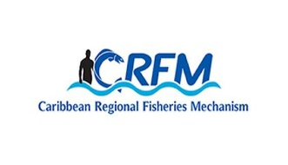




ISSN: 1995-1132

CRFM Technical & Advisory Document
No. 2025 / 15

FINAL REPORT

Data Gap and Needs Assessments to Inform MSP Implementation in the Republic of Panama

CRFM Secretariat
Belize

CRFM Technical & Advisory Document -
Number 2025 / 15

Data Gap and Needs Assessments to Inform MSP Implementation in the Republic of Panama

Prepared by
Nancy Montes
Consultant Geographic Information System and Human Dimensions Specialist.

Edited by
Allena A. Joseph
Marine Spatial Planning Specialist, GEF/CAF/FAO/CRFM BE-CLME+ Project, Caribbean Regional Fisheries Mechanism Secretariat, allena.joseph@crfm.int

Jorge Elías Jaén Bonilla
Dirección de Costas y Mares, Departamento de Ordenamiento de Espacios de Costas y Mares, Ministerio de Ambiente, Panamá

This publication has been made possible through funding by BE-CLME+ Project: Promoting National Blue Economy Priorities Through Marine Spatial Planning in the Caribbean Large Marine Ecosystem Plus - GEF Project ID 10211

CRFM Secretariat
Belize
2025
CRFM Technical & Advisory Document Number 2025/ 15

Data Gap and Needs Assessments to Inform MSP Implementation in the Republic of Panama

© CRFM 2025
All rights reserved.
Reproduction, dissemination and use of material in this publication for educational or non-commercial purposes are authorised without prior written permission of the CRFM, provided the source is fully acknowledged. No part of this publication may be reproduced, disseminated or used for any commercial purposes or resold without the prior written permission of the CRFM.

Correct Citation:
CRFM, 2025. Data Gap and Needs Assessments to Inform MSP Implementation in the Republic of Panama. CRFM Technical & Advisory Report No. 2025 / 15. 61p.

ISSN: 1995-1132
ISBN: 978-976-8368-02-7

Published by the Caribbean Regional Fisheries Mechanism Secretariat
Belize and St. Vincent and the Grenadines

EXECUTIVE SUMMARY
The government of Panama published in May 2022 its National Ocean Policy based on the vision "To be a Blue Panama". This guiding document describes and calls for promoting and developing the country’s Blue Economy (BE) through different tools and frameworks including the development and implementation of the marine spatial planning (MSP) process.
The Ministry of the Environment, through the Directorate of Coasts and Seas in coordination with national and regional partners, will continue to conduct subsequent projects throughout the national territory to advance planned and ongoing MSP activities in support of its National Ocean Policy. Since 2018, Panama has participated in regional initiatives and projects such as the Great Coastal Marine Ecosystem of the Central American Pacific (PACA) with the objective of strengthening regional governance in the Pacific coast. A pilot project in the Gulf of Chiriquí which supported local leaders and promoted governance led to the achievement of a fisheries co-management agreement and the subsequent declaration of a “Reserve Area for Sustainable Fishing” in the archipelago of Islas Secas, Gulf of Chiriquí.
Regional initiatives are also contributing to the implementation of the National Ocean Policy. This consultancy is supported by the BE-CLME+ Project: Promoting National Blue Economy Priorities Through Marine Spatial Planning in the Caribbean Large Marine Ecosystem Plus (GEF Project ID 10211).
The general objective of this consultancy is to develop a comprehensive assessment of data gap and needs to inform the MSP in the Republic of Panama, with a focus on the Bocas del Toro region. The assessment will include (1) the status of the MSP processes in Panama and the types and sources of data used to inform MSP; (2) the availability and needs (human and technological) of relevant spatial and temporal data. The findings of the assessment will guide recommendations on the data sources and collection methods to address identified data needs.
In the Caribbean region, the government of Panama is promoting development in the province of Bocas del Toro (located in the far northwest of Panama, bordering Costa Rica and the Caribbean Sea coast). This region is thought to be more similar to the Caribbean Antilles in terms of its socio-economic development. The Bocas del Toro archipelago is made up of a system of 9 main islands, 52 cays and thousands of islets, with diverse ecosystems, from a dense tropical cloud forest to extensive areas of mangroves and coral reefs. Panama's first national marine park is located in Bocas del Toro and is a top ecotourism destination and one of the planet's most biologically diverse areas, making it a conservation priority. The province also boasts high diversity of indigenous people, with 64% Chibcha ancestry, 26% mestizos, and 10% Afro-Panamanians. The main ethnic groups are the Ngöbe-Buglé and the Naso Tjër Di.
A successful MSP initiative took place in the Pacific area of Panama. The Gulf of Chiriquí hosted a pilot project under the Great Coastal Marine Ecosystem of the Central American Pacific (PACA) to improve governance and conservation by engaging local leaders in planning "Fisheries Spatial Zoning" and achieving a fisheries co-management agreement. In 2023, the Ministry of Agricultural Development established the Reserve Area for Sustainable Fishing in Islas Secas via Executive Decree. This experience underscored the necessity of collaborating with local stakeholders and governmental agencies.
In 2008, the National Council for Sustainable Development (CONADES) led a consultancy to develop the Bocas del Toro Integrated Coastal Marine Management Plan, resulting in an atlas, profile documents, and a monitoring plan for coastal resources. In 2024, the government introduced the "Local Zoning Plan for the District of Bocas del Toro" to guide municipal land use for the next ten years, with an emphasis on soil classification and land use management.
The MSP process collects spatial data on various issues and processes, forming the backbone of planning and decision-making. MSP data shows human activities, marine ecosystems, hotspots, conflicts, shared opportunities, and future economic and climate scenarios. This consultancy aims to assess data availability, gaps, and needs for MSP in the Archipelago of Bocas del Toro, using literature reviews and interviews with key stakeholders.
In terms of available data, the MSP can utilize information compiled in two spatial atlases: The Environmental Atlas of the Republic of Panama (2010) and the Atlas of the marine-coastal resources of Bocas del Toro (2008). Both atlases are available in printed form and some of the data is available in electronic form through the National Environmental Information System —SINIA. Additionally, there are several studies, reports, and monitoring efforts developed by relevant stakeholders and agencies (e.g., Smithsonian Tropical Research Institute (STRI), government agencies, NGO’s, etc.). The data currently available include:
- administrative boundaries
- topography and land features (including soil, watersheds, etc.)
- land cover/land use
- some species distribution such as sea turtles, manatees, mangroves, dolphins, coral reefs, etc.)
- marine transportation routes
- small scale fisheries distribution
- marine tourist sites
Current available data represents a diverse collection of information on the region and its resources. However, integrating this data into an MSP process may be challenging due to varying temporal and spatial scales, resolutions, formats, etc. Some of this data could be used to guide participatory mapping exercises to produce missing relevant and up-to-date data for the MSP process. Furthermore, interviews with local stakeholders revealed detailed spatial knowledge (Figure 1), such as maritime routes, fishing grounds, tourism sites, and marine species distribution (e.g., lobsters, dolphins, lionfish), among others. Such valuable knowledge would need to be captured through stakeholder interviews, participatory mapping exercises, etc. and it will have to be digitized for integration into the MSP analysis.
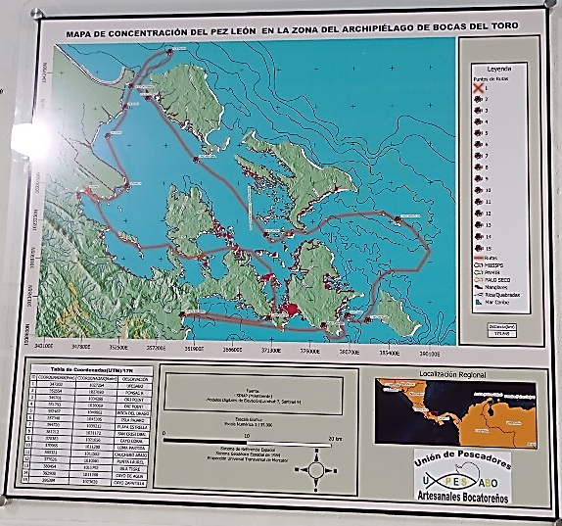

Figure Members of the Artisanal Union of Fishers of Bocas del Toro (UPESABO) documented the distribution of lionfish in the Bocas del Toro Archipelago. A framed poster version of the map is placed in their center.
Developing and maintaining processes for continuously enriching information through reliable data collection and stakeholder input is necessary and can be achieved through human capacity building and technology improvement. The use of products from the Environmental Systems Research Institute, Inc. (ESRI) in the region is prevalent, and there is substantial GIS expertise among governmental and NGO partners in Panama. Capacity building should be directed towards advanced training opportunities focusing on MSP tools, facilitation skills, and communication strategies. Also, due to the archipelago's cultural richness, it's important to follow best practices for engaging with Panama's indigenous people.
An MSP initiative for the Bocas del Toro region should also use the National Environmental Information System (SINIA) to provide stakeholders with reliable spatial data, improving collaboration, decision-making, efficiency, and transparency. SINIA is a platform developed by the Ministry of Environment (MiAmbiente) of Panama with the purpose of managing, centralizing, and disseminating environmental information relevant to the country. This platform enables the development of MSP tools like spatial data visualizations, dashboards, interactive maps, and management scenarios to enhance stakeholder engagement and consensus building, benefiting the Bocas del Toro MSP process and future initiatives in Panama.

TABLE OF CONTENT
EXECUTIVE SUMMARY i
INTRODUCTION 1
OBJECTIVE 4
METHODOLOGY 4
Systematic literature review 4
Structured interviews 4
Validation workshop 5
RESULTS AND DISCUSSION 5
Current available data 6
Previous experiences with MSP in Panama 6
Atlases and portals 7
Project-specific literature 15
Data gaps 22
MSP data needs 25
Data accessibility 29
Technological resources 30
MSP software 30
Training and capacity building 32
RECOMMENDATIONS 33
CONCLUSIONS 35
REFERENCES 35
APPENDIX 42
Appendix 1. Terms of Reference (TOR) 42
Appendix 2. Inception Meeting 43
Appendix 3. Organizations that participated in the interviews and validation workshop 44
Appendix 4. Questionnaire used to guide interviews 48
Appendix 5. Communication and Outreach material 49

Figures

Figure 1 Members of the Artisanal Union of Fishers of Bocas del Toro (UPESABO) documented the distribution of lionfish in the Bocas del Toro Archipelago. A framed poster version of the map is placed in their center………………………………………………………………… 2
Figure 2 A) Panama’s Caribbean Exclusive Economic Zone (EEZ). B) Bocas del Toro Province. 3
Figure 3 Geovisor PEM.……………………………………………………………………….. 6
Figure 4 Example of one of the maps developed for the Local Zoning Plan for Bocas del Toro District…………………………………………………………………………………. 7
Figure 5 SINIA Geoportal (left) and Geospatial Analysis (right) tools…………………………..8
Figure 6 Example of layers on the Panama Maritime Authority Portal………………………… 8
Figure 7 Example of data available in the STRI GIS Data Portal……………………………… 8
Figure 8 Example of a map from the Environmental Atlas Republic of Panama………………. 9
Figure 9 Maps from the Atlas marine-coastal resources of Bocas del Toro……………………. 9
Figure 10 Mapping Ocean Wealth. As an example, the figure shows the modelled total dollar value of reef tourism (per km2) for Panama………………………………………….. 12
Figure 11 Resource Watch Portal. As an example, the left figure shows the 2011 integrated local threat level for coral reefs while the right figure shows estimates for the 2014 coral reef fisheries relative catch………………………………………………………………… 12
Figure 12 Examples of some of the spatial layers available in ESRI from the Land Use Plan Office (POT in Spanish)………………………………………………………………. 13
Figure 13 Global Biodiversity Information Facility. The figure shows an example of a general search of data on this platform. The green rectangle represents the Bocas del toro area, while the yellow-to-red dots represent sightings of animal/plant species. The size of the dots represents the number of sightings reported in that specific location (latitude/longitude)……………………………………………………………………. 13
Figure 14 Skylight platform. The figure shows an example of how vessels are tracked by this platform……………………………………………………………………………….. 14
Figure 15 Marine Traffic Platform. The figure shows the live location (dots) and direction (arrow heads) of vessels in the area. As an example, the image highlights the position of a tanker in the Bocas del Toro region…………………………………………………… 14
Figure 16 Examples of maps made by locals…………………………………………………….. 22
Figure 17 MSP adaptive approach……………………………………………………………….. 26
Figure 18 Data accessibility……………………………………………………………………… 29

Tables

Table 1 Panama’s National Ocean Policy goals and priorities related to MSP…………………… 2
Table 2 Key organizations leading Panama’s Blue Economy and MSP initiatives……………….. 5
Table 3 Available data with its source and potential application in MSP……………………….. 16
Table 4 Suggested data to inform MSP………………………………………………………….. 26
Table 5 Suggested trainings for technicians supporting Panama’s MSP process………………... 32
Table 6 Interviewed stakeholders during the site visit in the Boca del Toro region…………….. 46
Table 7 Validation workshop participants……………………………………………………….. 47

List of Acronyms and Abbreviations

AMP | Autoridad Marítima de Panamá (Panama Maritime Authority)
ARAP | Autoridad de los Recursos Acuáticos de Panamá (Panama Aquatic Resources Authority)
ATP | Autoridad de Turismo de Panamá (Panama Tourism Authority)
BE | Blue Economy
CLME+ | Caribbean Large Marine Ecosystem Plus
FPIC | Free, Prior, and Informed Consent
GIS | Geographic Information Systems
MSP | Marine Spatial Planning
NGO | Nongovernmental organizations
PACA | Great Coastal Marine Ecosystem of the Central American Pacific
POC | Point of Contact
POT | Plan de Ordenamiento Territorial (Land Use Plan Office)
SINIA | Sistema Nacional de Información Ambiental (National Environmental Information System)
STRI | Smithsonian Tropical Research Institute
TOR | Terms of Reference

INTRODUCTION
The Archipelago of Bocas del Toro is marked by its rich biodiversity and vibrant maritime sectors. The current conditions pertaining to marine resource use in this area are shaped by multiple factors, including the diverse use patterns by local communities and industries. Fisheries, tourism, transportation, and aquaculture are prominent, each contributing uniquely to the region’s economy and ecological footprint.
Panama has implemented several policies and plans that emphasize the importance of sustainable marine resource use. The National Policy for the Ocean prioritizes the conservation and sustainable use of marine resources, advocating for integrated management approaches. Additionally, the Blue Economy (BE) strategy is pivotal in fostering sustainable development, aiming to balance economic growth with the preservation of ocean health. This strategy includes the promotion of sustainable fisheries, responsible tourism, and the protection of marine biodiversity.
The government also supports several international agreements, such as the United Nations Convention on the Law of the Sea (UNCLOS) and the Convention on Biological Diversity (CBD), which underline the country’s commitment to international standards in marine conservation. Furthermore, Panama’s Marine Protected Areas (MPAs) are critical in safeguarding vital ecosystems and species from overexploitation and environmental degradation.
Despite these efforts, the Bocas del Toro region faces numerous challenges in managing its marine resources. Overfishing, unregulated tourism, habitat destruction, and pollution are pressing issues that compromise the health of marine ecosystems. The enforcement of sustainable practices is often hindered by limited resources and technological capabilities. Additionally, climate change poses a significant threat, exacerbating the vulnerability of marine environments.
However, there are also several opportunities for improving marine resource management. The region's tourism industry presents potential for eco-friendly development that can support conservation initiatives. Moreover, advancements in technology provide innovative solutions for monitoring and managing marine resources more effectively. Engaging local communities and stakeholders in conservation efforts is essential for fostering a sense of stewardship and compliance with best practices.
The Marine Spatial Planning (MSP) process offers a promising approach to address these challenges. By integrating data, human resources, and technological advancements, MSP can help align policy goals with actionable strategies. Enhanced data collection and analysis, coupled with community engagement and technological innovation, are pivotal in achieving sustainable marine resource management. This process not only supports the conservation of marine ecosystems but also fosters economic opportunities and resilience within local communities.
MSP facilitates the efficient allocation of marine space, ensuring that various activities such as fishing, tourism, and conservation are conducted in harmony. By involving stakeholders and utilizing comprehensive data, MSP can help mitigate conflicts, enhance resource use efficiency, and promote sustainable practices. Ultimately, MSP provides a holistic framework that supports the achievement of Panama’s policy goals and objectives, ensuring the long-term health and prosperity of Bocas del Toro’s marine resources.
The MSP process begins with preparation and planning by setting goals, identifying stakeholders, and gathering data on marine and socio-economic factors. This leads to a baseline assessment and spatial analysis. Stakeholder input shapes management options, which are detailed in a draft plan covering zoning, governance, and communication. After validation and approval, implementation follows an action plan with clear roles and timelines. Ongoing monitoring and evaluation allow for adjustments as needed.
Data collection is vital in MSP as it informs planners' decisions, monitors marine ecosystem health, identifies conflicts among marine uses, and promotes transparency and engagement when shared with the public and stakeholders.
In Panama, through regional initiatives and projects such as the Great Coastal Marine Ecosystem of the Central American Pacific (PACA), a pilot project on MSP was carried out in the Gulf of Chiriquí. The main objective of this project was to strengthen the governance framework and effective conservation of the Gulf of Chiriquí (in the Pacific coast of Panama), through the development of a scalable approach — to support local leaders and their participation in the planning process of a “Fisheries Spatial Zoning” initiative, and the achievement of a fisheries co-management agreement to aid in its implementation. Furthermore, in 2023 the Ministry of Agricultural Development created the Reserve Area for Sustainable Fishing in the archipelago of Islas Secas, Gulf of Chiriquí, through Executive Decree No. 2 published in Official Gazette 29723-B.
The Ministry of the Environment, through the Directorate of Coasts and Seas in coordination with national and international partners, will conduct subsequent projects throughout the national territory based on the goals and priorities of Panama’s National Ocean Policy (Table 1):

Table 1 Panama’s National Ocean Policy goals and priorities related to MSP.
Aspect | Description
Conservation of marine ecosystems and biodiversity | A primary focus is on the conservation of marine biodiversity, which involves the protection of diverse marine species and their habitats. This includes the establishment and management of Marine Protected Areas (MPAs) to safeguard critical ecosystems from overexploitation and degradation.
Sustainable fisheries | Promoting sustainable fisheries is another key priority. This entails implementing practices that prevent overfishing, support the recovery of fish populations, and ensure the long-term health of marine environments. The policy aims to balance the needs of local communities with conservation goals.
Pollution prevention and control | Addressing marine pollution is vital for maintaining healthy ocean ecosystems. The policy includes measures to reduce pollution from land-based sources, such as agricultural runoff and plastic waste, as well as from maritime activities.
Climate change adaptation | Climate change poses a significant threat to marine ecosystems, and the policy prioritizes strategies for adaptation and resilience. This includes monitoring climate impacts, protecting coastal areas, and developing adaptive management practices to mitigate the effects of rising sea levels and ocean acidification.
Integrating coastal and marine management | The policy emphasizes the need for integrated management approaches that consider the land-sea interface. This involves coordinating activities across different sectors and regions to ensure that coastal and marine resources are managed sustainably and holistically.
Community engagement and stakeholder participation | Engaging local communities and stakeholders is crucial for the success of MSP initiatives. The policy promotes participatory approaches that involve fishers, tourism operators, conservation groups, and other stakeholders in decision-making processes.
Data collection and technological innovation | Enhanced data collection and the use of technological innovations are pivotal for informed decision-making. The policy supports the development and utilization of advanced monitoring tools, such as remote sensing and geographic information systems (GIS), to improve the understanding and management of marine resources.

This consultancy is supported by the BE-CLME+ Project, which is a regional initiative aimed at promoting the development of the blue economy in the Caribbean region through MSP and marine protected areas, the ecosystem approach to fisheries, the development of climate-smart sustainable fisheries value chains and knowledge management in six Caribbean countries, including the Republic of Panama. The objective of this consultancy is to comprehensively assess data availability; data gaps and needs assessment to inform the MSP in Panama with a focus on the Bocas del Toro regional.
In the Caribbean region, the government of Panama through the National Ocean Policy and the Sustainable Tourism Master Plan is promoting the development of the province of Bocas del Toro. Panama’s Caribbean coast is diverse and complex. The Bocas del Toro region presents greater similarities with the Caribbean region than the rest of Panama’s Caribbean coast (Figure 2).
In 2008, the National Council for Sustainable Development (CONADES) commissioned a consultancy to formulate the Bocas del Toro Integrated Coastal Marine Management Plan, which produced an atlas, profile documents, and a coastal resource monitoring plan. In 2024, the government launched the "Local Zoning Plan for the District of Bocas del Toro" to guide municipal land use over the next decade, emphasizing soil classification and land use management. Although there have been concerted efforts to plan for the sustainable development of the Blue Economy and marine resource conservation in the Bocas del Toro region, it remains crucial to update the data for the coastal marine zone, much of which dates back to 2008.
The Bocas del Toro archipelago was the first national marine park in Panama. It is considered one of the places with the greatest biological diversity on the planet. The archipelago is made up of a system of 9 main islands, 52 cayes and thousands of islets. It contains diverse ecosystems, from a dense tropical cloud forest to extensive areas of mangroves and coral reefs. The province also has a high cultural diversity. About 64% of the population has Chibcha ancestry, 26% mestizos and 10% Afro-Panamanians. The largest ethnic groups are the Ngöbe-Buglé and the Naso Tjër Di.
In the archipelago region, institutions and organizations have independently developed activities in fishing, tourism, maritime transportation, industry, and research. The recently published National Ocean Policy is intended to provide guidelines for integrating and coordinating spatial use among marine users to prevent and manage conflicts and mitigate negative impacts on natural resources. The MSP process leverages spatial data to support planning and decision-making by mapping human activities within marine ecosystems, prioritizing zones for various uses, and identifying areas for environmental protection or shared usage. Additionally, it aids in assessing future economic and climate scenarios.

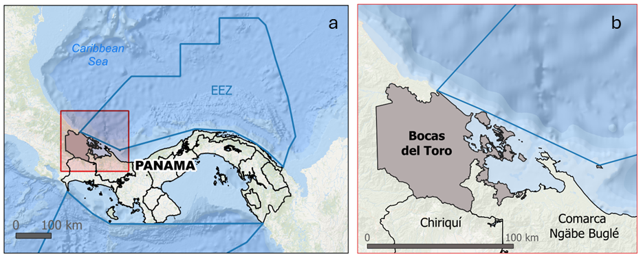
Figure 2 A) Panama’s Caribbean Exclusive Economic Zone (EEZ). B) Bocas del Toro Province.

OBJECTIVE
The MSP process requires the collection of spatial data and information related to a variety of issues and processes. This data also forms the backbone of any planning and decision-making process. Data for MSP provides an overview of the spatial distribution of human activities, marine ecosystems and hotspots, identifies conflicts and shared spatial opportunities, and enables spatial exploration of future economic and climate scenarios.
The objective of this consultancy is to comprehensively assess data availability; data gaps and needs assessment to inform/support the MSP in Panama in the Bocas del Toro region.

METHODOLOGY
The main methods used in this consultancy were:

Systematic literature review
The review of information was carried out on documents, images and maps on the study area (Bocas del Toro), related to territorial limits, flora, fauna, spatial distribution of human activities, shipping, energy, infrastructure, climate change, oceanic characteristics, vulnerability assessments, socioeconomics, ocean conflicts report, among others.
In 2022, the government of Panama released the National Ocean Policy. However, there are no publicly available plans, at national or regional level, which provide guidance on relevant information needed for its MSP process. However, using general information on the MSP process and guidance from the Directorate of Coast and Seas and the Panama Aquatic Resources Authority, this consultancy identified publicly available information relevant to the objective and activities of this consultancy, such as official, popular, and scholarly documents and spatial layers. This included relevant national and international reports, government and NGO’s websites and documents, GIS portals, and open-source scholarly work.
The main web search engine used was Google Scholar. In terms “Bocas del Toro”, “GIS” were used in the principal search (893 results). Furthermore, potential information was located through details in reviewed documents. Also, reliable and well-established spatial atlases and databases were searched using the terms “Panama” and “Bocas del Toro”. Other relevant data for Panama in terms of MSP initiatives was searched using “Panama”, “MSP”, “Participatory mapping”.

Structured interviews
In-person, virtual and phone meetings/ interviews were conducted with key stakeholders. The target population included individuals familiar with spatial data in the region of Bocas del Toro, such as government officials, GIS specialists, members of NGOs, representatives from academic institutions, maritime authorities, local authorities, community leaders, and others involved in related fields. The Directorate of Coasts and Seas and the Aquatic Resources Authority of Panama proactively reached out to leaders of the indigenous communities to ensure their meaningful participation in the process. Free, prior, and informed consent (FPIC) was applied through a series of consultations that respected the communities' timelines, cultural protocols, and decision-making structures. These engagements were designed to ensure that indigenous voices were not only heard but integrated into this assessment. Furthermore, all data collection efforts were conducted with full respect for customary land and marine rights, incorporating traditional knowledge and practices to ensure that the process aligned with the values and stewardship principles of the indigenous communities involved.
The objective of these interviews were to gather information related to their knowledge/perception about spatial information in the area (e.g., distribution of human activities, natural resources, and/or conflicting areas between different ocean users); to provide leads that allow for the access to relevant documents, to understand their level of expertise in GIS and spatial analysis as well as other technical areas relevant to the MSP process (e.g., facilitation skills, programing, etc.); and to give them the opportunity to provide feedback regarding information needs to inform MSP in the study area.
A list of stakeholders to be invited to participate in these meetings/interviews was developed in coordination with Panama’s point of contact (POC), including the Panama Aquatic Resources Authority (ARAP), the National Environmental Information System (SINIA), Artisanal Fishers’ Union of Bocas del Toro, Association of Boat Operators of Bocas del Toro, Smithsonian Tropical Institute, among others. The consulting team visited Panama on Feb 11 to 15, 2025 to conduct in-person interviews and stakeholder consultation as appropriate. To ensure that the relevant information was discussed during the interviews, a questionnaire was designed in coordination with the POC and the CRFM/PMU.

Validation workshop
A validation workshop was held in a hybrid format on May 2nd, 2025, to present the findings and recommendations from the assessment and to solicit feedback from a broad range of stakeholders. This activity was organized with support from the POC and CRFM/PMU. The invitation to participate in this activity was sent to all the actors identified by the Directorate of Coasts and Seas and the Aquatic Resources Authority of Panama. The same institutions and individuals who participated in the assessment were invited to ensure continuity and consistency in the review process. In addition, other relevant institutions that had not previously participated were also invited to contribute, although some chose not to attend. The workshop aimed to ensure that the assessment of information for the Marine Spatial Planning (MSP) process was inclusive, transparent, and reflective of the diverse needs and concerns of all parties involved. This approach reinforced the commitment to participatory governance and helped validate that the process was grounded in shared understanding and accountability.
All the meetings, interviews, presentations, etc. were conducted in Spanish (Panama’s official language). All the participants did not have any problem communicating in Spanish.

RESULTS AND DISCUSSION
Panama is advancing its blue economy which is guided by the National Ocean Policy aiming to become a "Blue Panama". Several key organizations are leading the efforts related to the blue economy and MSP (Table 2).

Table 2 Key organizations leading Panama’s Blue Economy and MSP initiatives.
Entity | Responsibilities
Ministry of Environment (MiAmbiente) | Formulation and execution of policies related to the management of marine and coastal spaces
Panama Maritime Authority (AMP) | Regulating maritime activities in national waters, such as freight transport, vessel traffic, fishing, and maritime tourism
Aquatic Resources Authority (ARAP) | Management of living resources, regulation of fisheries and aquaculture, conservation of marine biodiversity, and sustainable use of marine space
Panama Tourism Authority (ATP) | Sustainable management of tourism in marine and coastal areas, ensuring tourism activities contribute to economic development and respect conservation
Ministry of Security | Maritime security, surveillance of illegal activities, and protection of marine and coastal resources
Ministry of Commerce and Industries | Promotes sustainable commercial and industrial activities within the marine and coastal space
Academia and research centers | Provide scientific knowledge, methodological tools, and critical analysis for informed decisions about the management and use of marine space
Non-governmental organizations | Influence through research, lobbying, education, awareness-raising, and collaboration with government and international organizations
The Panama National Ocean Policy was published in 2022. Although it highlights priority areas for MSP (Table 1), there is a need to develop a MSP process plan that will include the country’s vision, objectives, roles, and timelines for implementing this process nationally and regionally.

Current available data
Current data originates from multiple sources (mostly project-specific collections) and employs diverse spatial formats. Spatial data is often limited, varies in resolution and scale, and it is not updated routinely, providing mainly a static overview of observed distributions. This section provides details about previous experiences with MSP in Panama, supplemented by data from two primary sources: Atlases and portals (national and regional/international), as well as current available data from project-specific literature.

Previous experiences with MSP in Panama
Marine spatial planning is an established concept with several guiding documents and examples of its implementation globally. In Panama, MarViva has been adopting and implementing projects in the Pacific Ocean under the MSP framework. Examples of their work in Panama includes:
- Manual for the inter-institutional coordination of marine spaces with emphasis on the Coiba National Park and the Gulf of Chiriqui
- National Marine Park Gulf of Chiriqui National Marine Park Zoning
- Voluntary agreements reached with fishermen in the central portion of the Gulf of Chiriqui
- Guide to Sustainable Fishing in the Central Portion of the Gulf of Chiriqui, Panama
As part of the MSP process, MarViva created the "Geovisor PEM" geo portal, featuring a database of 190 entities in the Costa Rican, Panamanian, and Colombian Pacific regions with features such as protected areas, fisheries, navigation and countries boundaries (Figure 3).

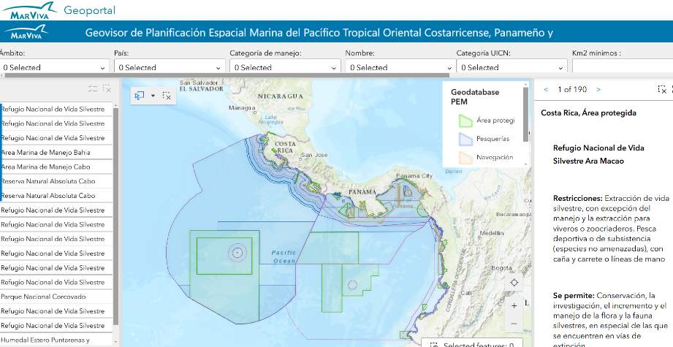
Figure 3 Geovisor PEM.
Territorial planning in Panama is managed through plans and policies. In 2024, the government published the "Local Zoning Plan for the District of Bocas del Toro," which organizes the use and occupation of municipal territory, including urban centers, 10 years ahead (Figure 4). However, this plan targeted mainly land features (e.g., soil classification, land use, etc.) and its objective was not applied to the marine environment (maritime transportation, fishing distribution, species and marine habitats distribution, etc.). This created a significant gap in managing and sustainably using marine and coastal resources in Bocas del Toro.

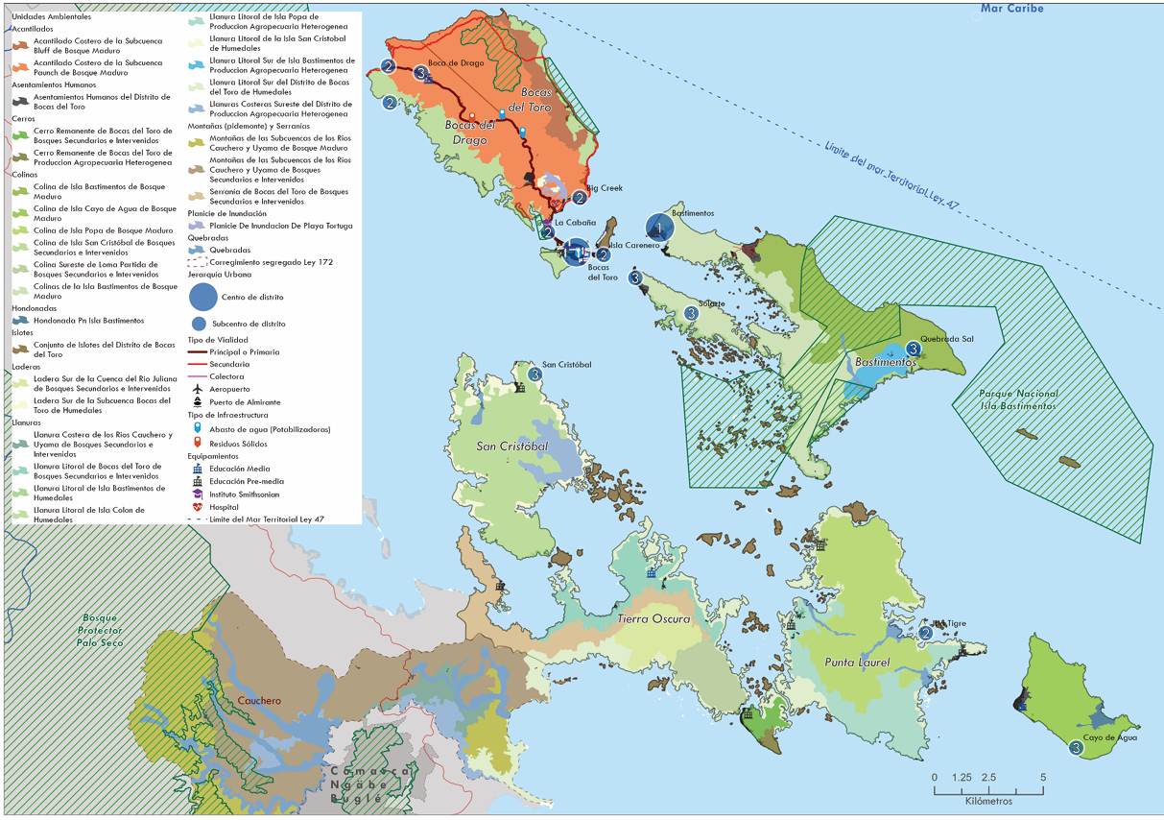
Figure 4 Example of one of the maps developed for the Local Zoning Plan for Bocas del Toro District.

Atlases and portals
Atlases and portals are essential for MSP (especially in early stages of the process). They offer cost-free spatial layers, non-spatial data, and interactive tools that help visualize data and provide quick statistics summaries for customizable areas. Despite some limitations, such as coarse spatial and/or temporal resolution or model-generated data, these platforms provide easy access to metadata and tools for downloading relevant layers.
The information available and accessible through various portals and atlases (especially online platforms) can play a critical role in informing and supporting the MSP process. These tools typically provide geospatial data, scientific research, environmental assessments, and socio-economic data that are crucial for making informed, sustainable, and equitable decisions in managing marine and coastal areas.
A description of the most important atlases and portals with information for the Bocas del Toro region is presented below. Identified layers are listed in Table 3.
National Atlases and Portals
This subsection summarizes Panamanian atlas and portals containing relevant information for the MSP process in Bocas del Toro.
National Environmental Information System —SINIA
SINIA is a platform managed by MiAmbiente that collects, manages and disseminates environmental information for Panama. It covers various areas such as biodiversity, climate change, water resources, air quality, protected areas, among others (Figure 5). Data had varying restrictions and sometimes required a request. Controlling access to certain layers is vital due to the sensitive information they contain.
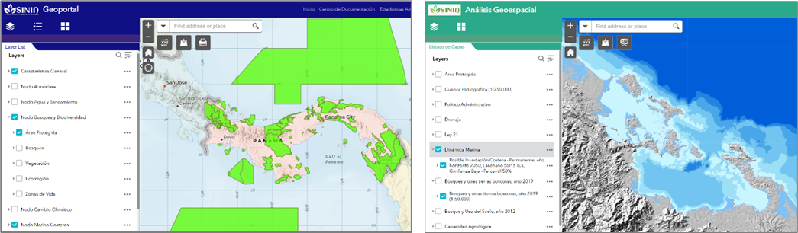
Figure 5 SINIA Geoportal (left) and Geospatial Analysis (right) tools.
Maritime Geoportal
This is a website that offers access to a series of interactive maps and information of the Panamanian maritime sector, both nationally and internationally. However, the information must be requested. Some of the available layers include (Figure 6):
- Investment projects (state investment in public infrastructure port works)
- State and concession ports
- Passenger movements
- Maritime navigation aid
- Cargo and container movements in the national port system

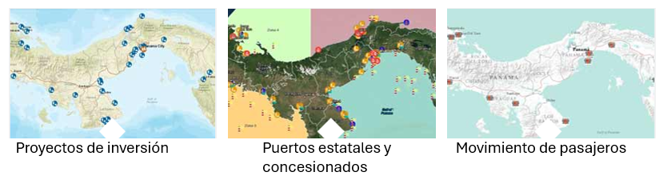
Investment projects | Ports | Passenger movements
Figure 6 Example of layers on the Panama Maritime Authority Portal.
Smithsonian Tropical Research Institute GIS Data Portal
Allows users to search, view and download resources from Smithsonian in Panama. Examples of data currently available in this portal are meteorological, hydrological and oceanographic (from their physical monitoring program), stream Network 2022, Panama jurisdiction boundaries 2016, Protected National Parks boundaries, and bird and fish layers, among others (Figure 7).
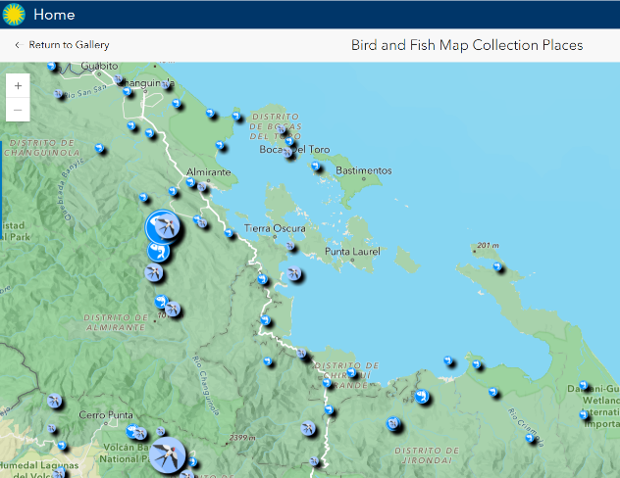

Figure 7 Example of data available in the STRI GIS Data Portal.

Environmental Atlas Republic of Panama (2010)
Figure . Example of data available in the STRI GIS Data Portal.
This atlas serves as a comprehensive resource aimed at enhancing the understanding and management of Panama's diverse and rich natural environments. This initiative was developed to provide detailed insights into the country's ecological landscapes, identifying key regions, ecosystems, and biodiversity hotspots essential for conservation efforts. The information contained in the atlas is displayed at a national level. Some of this information is available in a spatial format through SINIA. However, most layers remain outdated, and only a map in PDF format is available. The scale on which the information is presented does not allow for greater details for Bocas del Toro. Its main content comprises of boundaries, population distribution, weather features, soils, water, biodiversity and ecosystem restoration, vegetation, forest cover and reforestation, environmental, Panama’s canal hydrology, human activities, industry, investments, public spending (Figure 8).

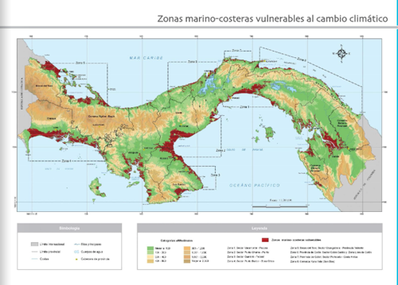 | 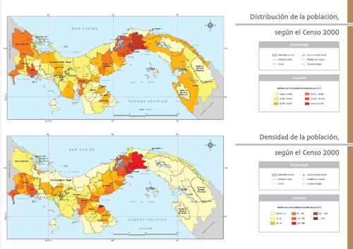
Figure 8 Example of a map from the Environmental Atlas Republic of Panama.
Atlas of the marine-coastal resources of Bocas del Toro (2008)
This atlas was developed as a consultancy for the development of the integrated marine-coastal management plan of Bocas del Toro within the framework of the Multiphase Program for Sustainable Development of Bocas del Toro. The main content of the atlas includes: information on natural environment, ecoregions, vegetation cover and land use, coastal marine ecosystems, coral reefs, seagrasses, mangroves, sea turtles, marine mammals, political administrative environment, limits of marine zones, political division, population and road network, population changes, indigenous population, protected areas, social indicators, fishing zones, lobsters, tourism, ports and navigation routes, agricultural activities, anthropogenic threats (Figure 9).

Fishing grounds | Tourism | Touristic sites
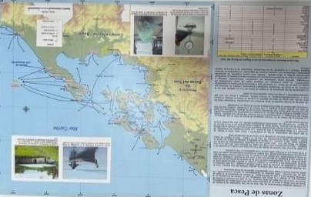 | 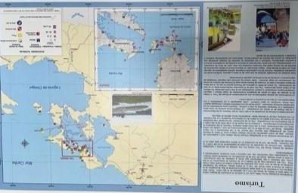 | 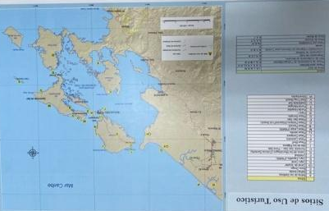
Ports and navigation routes | Type of coastline | Bathymetry
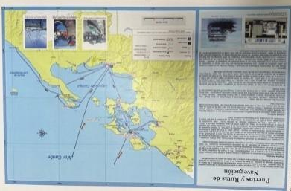 | 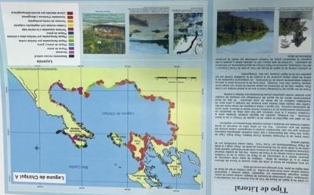 | 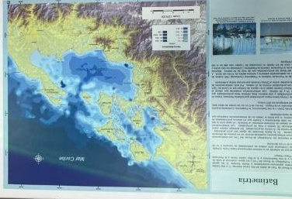
Annual precipitation | Coastal-marine ecosystems | Coral reefs
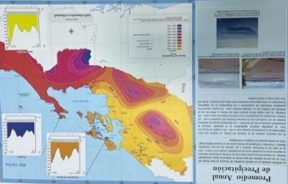 | 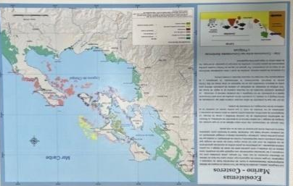 | 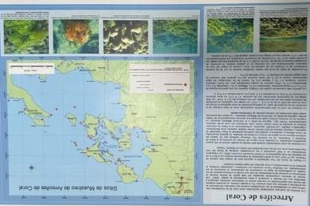
Seagrass | Sea turtles | Mangroves
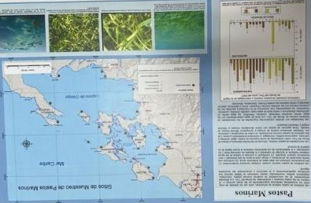 | 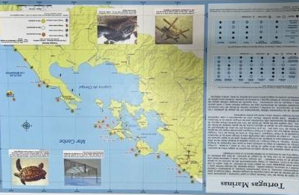 | 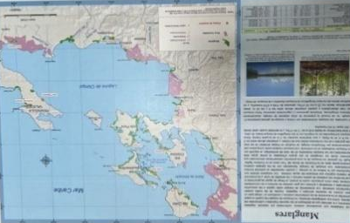
Marine mammals | Panama maritime limits | Administrative boundaries
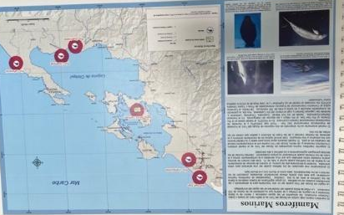 | 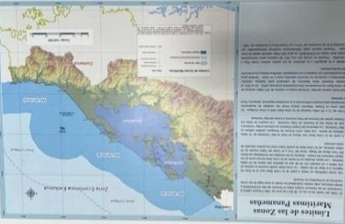 | 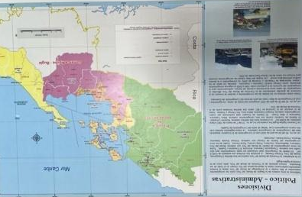
Populated areas and roads | Change in population 1999-2000 | Indigenous population
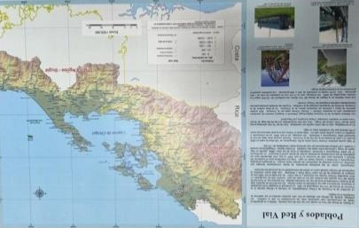 | 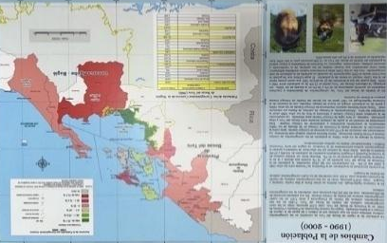 | 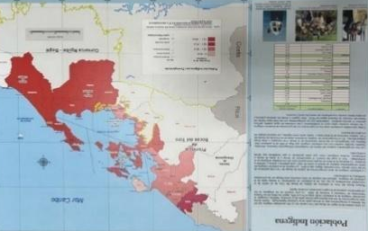
Land cover/land use | Protected areas | Threats and conflicts
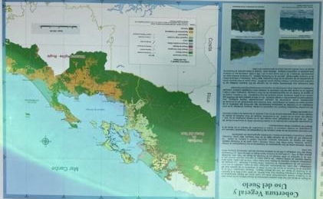 | 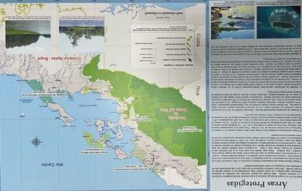 | 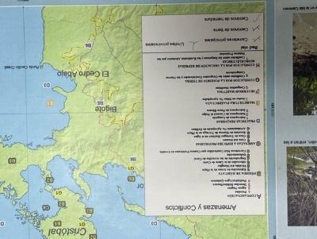
Drinking water | Sanitary services | Electrical services
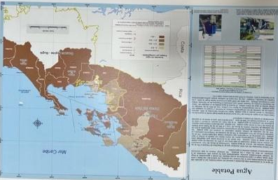 | 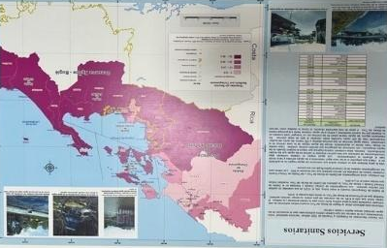 | 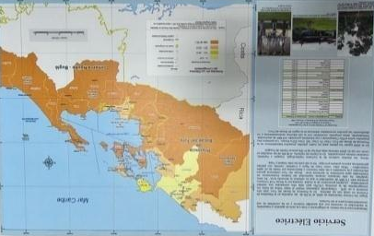
Relief | Drains and basins | Tourist sites
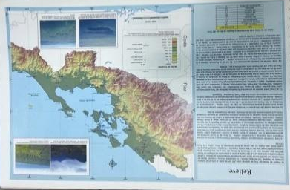 | 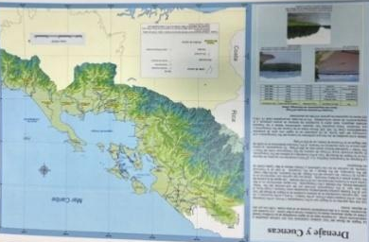
Touristic activities | Cacao and banana | Anthropogenic threats
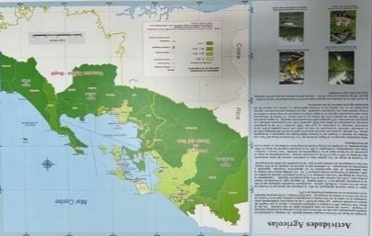 | 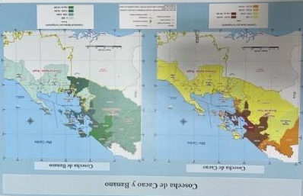 | 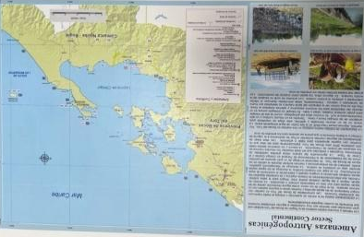
Figure 9 Maps from the Atlas marine-coastal resources of Bocas del Toro.

The data in this atlas is relevant for MSP in the Bocas del Toro region but should be used mainly as a reference in participatory data exercises due to its limitations. Some challenges in accessing and using this data include:
- The information is not digital. Only one physical copy of this atlas was found at the ARAP station in Isla Colon, Bocas del Toro during the consultancy.
- The atlas lacks details about the data collection method and its spatial and temporal scale.
- Published in 2008, the atlas has limited current use due to changing marine conditions.
Regional/International Atlases and Portals
These digital platforms are created and maintained by regional or international organizations. They integrate geospatial and environmental information from marine and coastal areas at a regional or global level. These tools are designed to provide accessible and up-to-date data that can be used in the MSP process, sustainable ocean management, and marine ecosystem conservation. Depending on the platform, these typically include data on ecosystems, human activities, changes in the environment, climate change impacts, protected areas, and other aspects relevant to the management of marine resources. In this assessment we only included platforms that have relevant information for the region of Bocas del Toro, Panama.

Mapping Ocean Wealth
This portal provides spatial information about the economic, social, and cultural values of coastal and marine habitats worldwide. The portal is led by The Nature Conservancy (TNC) with support from other organizations such as the World Bank. For Panama, only some topics/layers are available (mainly global layers). Relevant layers include estimates of flood damage to people and the economy, protection of marine habitats, tourism value of coral reefs, and modeled fish catches.
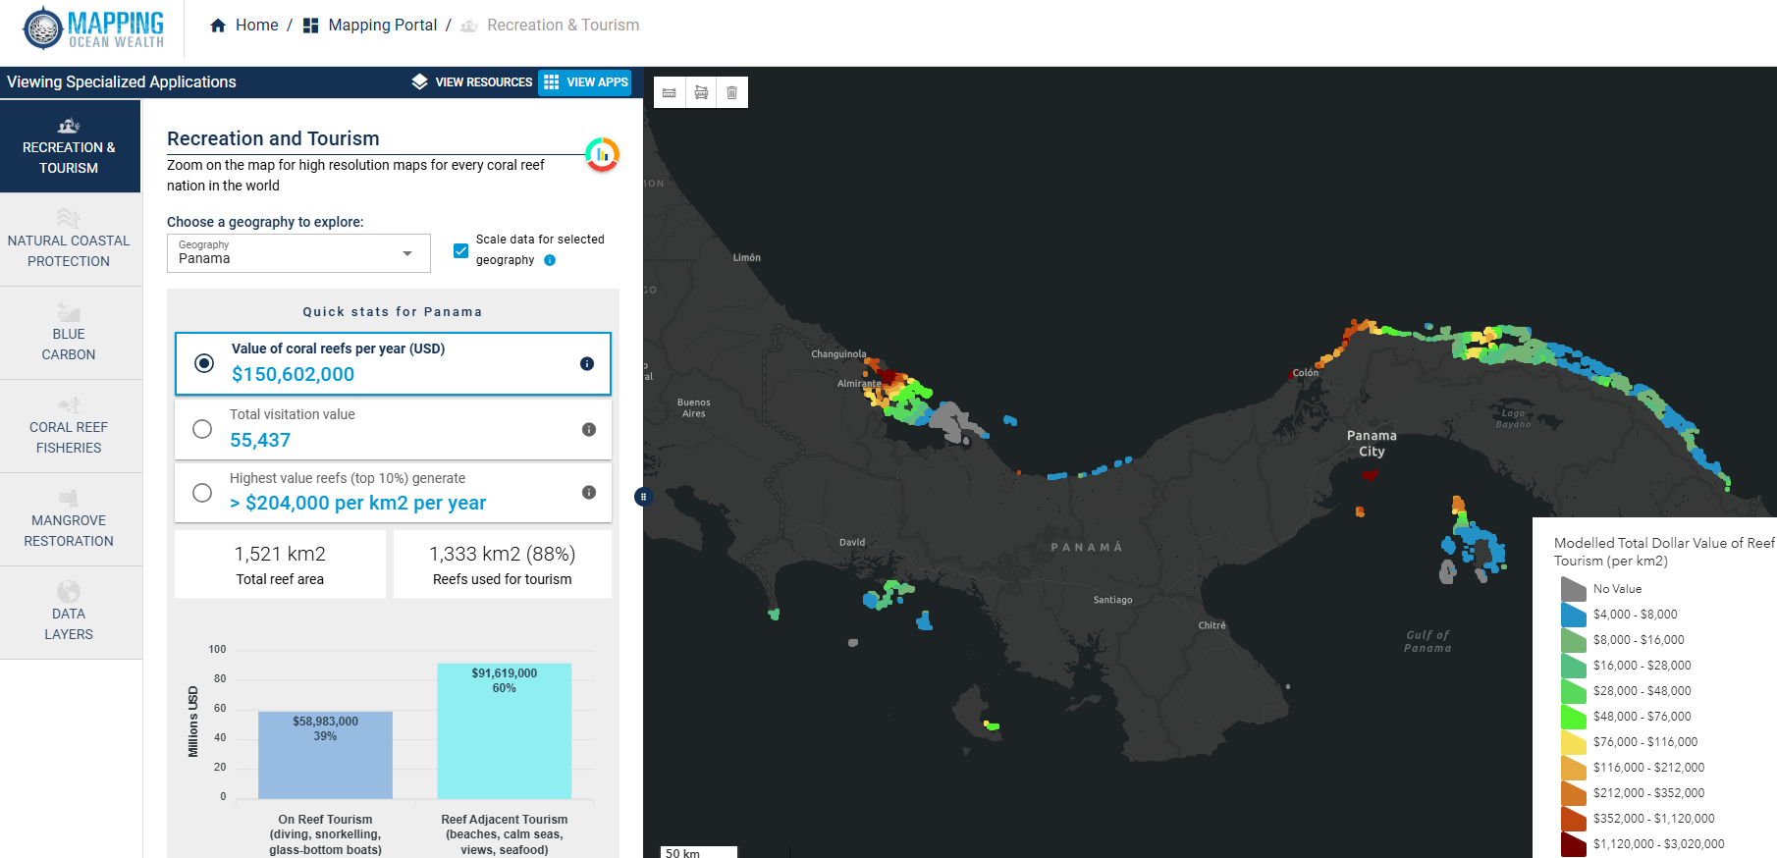
Figure 10 Mapping Ocean Wealth. As an example, the figure shows the modelled total dollar value of reef tourism (per km2) for Panama.
Resource Watch (World Resource Institute —WRI)
For Panama, this portal provides global data on pollution, local threats to coral reefs, shipping traffic density, major ports, total suspended matter, water temperature and salinity, and coral reef locations, among others. The data can be visualized on their map platform or easily downloaded. Information for Bocas del Toro includes coral reef fisheries relative catch.
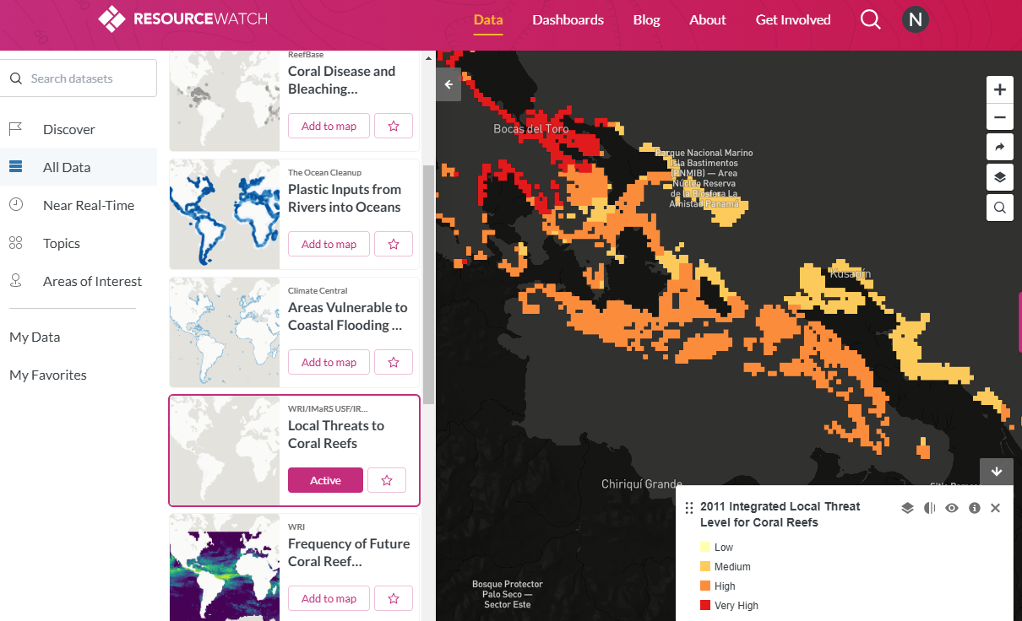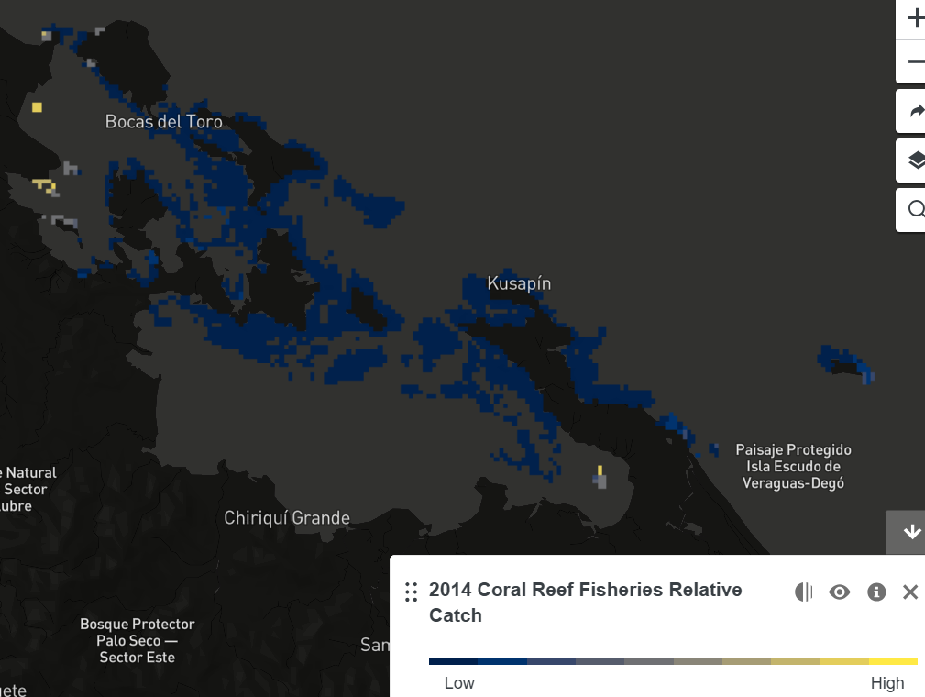

Figure 11 Resource Watch Portal. As an example, the left figure shows the 2011 integrated local threat level for coral reefs while the right figure shows estimates for the 2014 coral reef fisheries relative catch.

Environmental Systems Research Institute (ESRI)
ESRI GIS mapping products are the most powerful mapping and spatial analytics technology currently commercially available. It has several platforms for creating and sharing spatial data maps (e.g., ArcGIS Online, Living Atlas, etc.). However, it should be noted that this is a licensed resource.
Several organizations in Panama are utilizing this platform for their GIS work and data sharing with varying accessing levels (e.g., SINIA, land use plan office (POT in Spanish), Panama Maritime Authority Portal, STRI portal, etc.). The benefit of utilizing information from this platform for the MSP process lies in its spatial format, originating from a reliable, curated source. Additionally, the data is readily accessible, prepared, and can be seamlessly integrated into various spatial analyses, such as impact assessments and hotspot analysis. The specific spatial layers currently available are mentioned in Table 3 below.
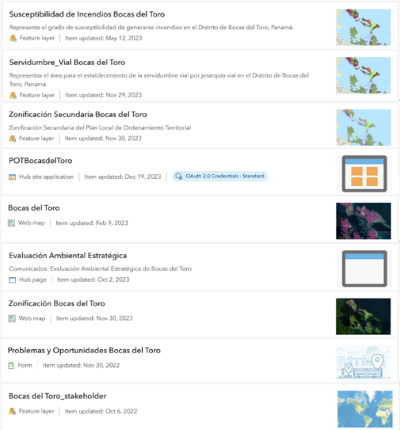
Figure 12 Examples of some of the spatial layers available in ESRI from the Land Use Plan Office (POT in Spanish).
Global Biodiversity Information Facility—GBIF
This is an international network aimed at providing open access biodiversity data. The platform contains occurrence data (sightings) with location details (latitude, longitude) for several taxa (e.g., birds, fish, mammals, etc.). Although over one million records were retrieved for the Bocas del Toro area, data needs further filtering to match data with specific marine species based on determined MSP objectives. The platform's sightings are mostly opportunistic, limiting their use. However, this information can serve as a reference for participatory mapping exercises in early MSP stages.
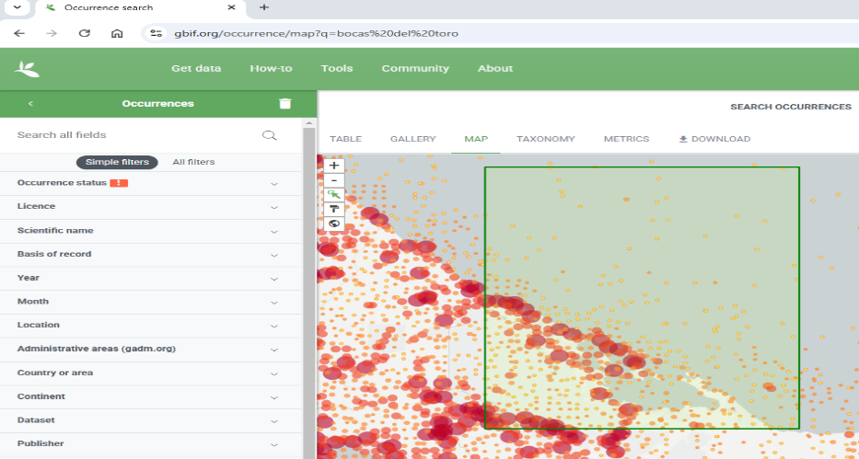
Figure Global Biodiversity Information Facility. The figure shows an example of a general search of data on this platform. The green rectangle represents the Bocas del toro area, while the yellow-to-red dots represent sightings of animal/plant species. The size of the dots represents the number of sightings reported in that specific location (latitude/longitude).

Skylight
This artificial intelligence driven program combats illegal fishing by visualizing and analyzing vessel behaviors. It offers free licensing to government, regional, and nongovernmental organizations. Key features include vessel heatmap visualization, vessel detection through satellite radar, optical imagery, and night lights, identification of suspicious or inactive Automated Identification Systems (AIS) vessels, potential transshipments and bunkering alerts, detailed vessel information, among others. Although Panama’s government has not yet adopted this platform, it holds potential for documenting illegal and conflicting areas as vessel detection technology advances and Panamanian technicians gain proficiency in its use.
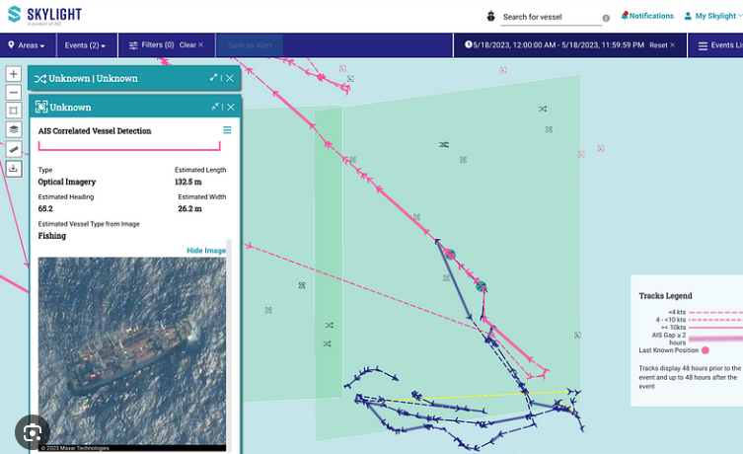
Figure 14 Skylight platform. The figure shows an example of how vessels are tracked by this platform.
Marine Traffic
Marine Traffic is one of several commercial platforms for visualizing AIS vessel data. For instance, in this platform ship details, tracking and maritime analytics are licensed and can only be accessed through one of their plans (monthly standard plan starts at $19 USD).
Although in the Bocas del Toro Archipelago maritime traffic by cargo ships and tankers is minimal (mainly from the oil industry and for transportation of bananas), subscribing to a platform such as this could provide spatial and temporal data regarding this kind of vessel in the area.
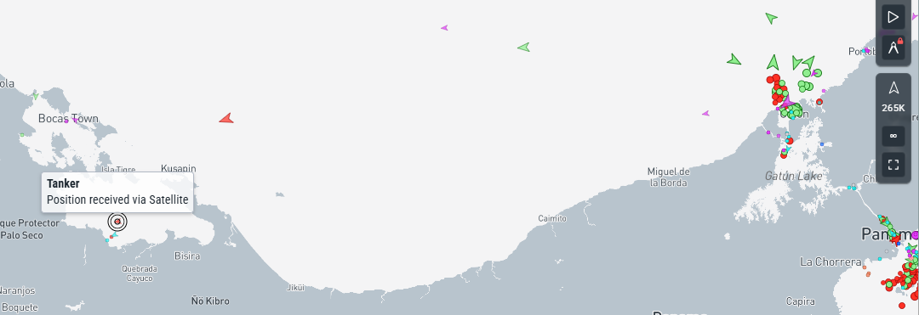
Figure 15 Marine Traffic Platform. The figure shows the live location (dots) and direction (arrow heads) of vessels in the area. As an example, the image highlights the position of a tanker in the Bocas del Toro region.

Project-specific literature
A review of relevant literature revealed several spatial layers useful for Panama's MSP process. However, most of this information is available only as images in reports and articles and it will have to be requested and/or digitized to be able to incorporate it into the MSP process.
The sections that follow delve into key aspects such as the marine environment, human activities, and climate and hazard risks and other data layers. By integrating information on administrative boundaries, physiography, oceanography, marine ecosystems, and biodiversity, alongside socioeconomic and cultural insights, this compilation aims to support decision-making processes and foster sustainable development. Additionally, the climate adaptation and hazard sections offer valuable data on present and future risks, aiding in the identification of vulnerable areas and the development of robust strategies for resilience. An outline of the data encompassed within each category of Table 3 is provided below:
1. Information about the marine environment:
- Administrative boundaries (e.g., study area limits, exclusive economic zone, protected areas, etc.) This data is used to delimitate the working area of the MSP process.
- Physiography and oceanography can be described using topography (e.g., bathymetry) and oceanographic variables (e.g., temperature, salinity, etc.). Topographic layers show sea floor and coastal line features, while oceanographic variables detail physical, chemical, and biological characteristics of the ocean. These variables often correlate with habitats and marine species distribution and abundance. For example, nutrient concentrations (nitrates and phosphates) and dissolved oxygen can identify areas of high primary productivity essential for biodiversity and fisheries. Such information could be used as a surrogate variable for describing key areas for fishes in a MSP process.
- Data on marine ecosystems and biodiversity includes the distribution, abundance, and condition of habitats and marine species. Some layers in Table 3 can map sea turtle nesting beaches (e.g., Parejo et.al., 2025), while others estimate sea turtle occurrence using tracking data and predictive variables (e.g., Meylan, et.al., 2013; Evans, 2019; Guzman and Estevez, 2024). Other layers in Table 3 can be used to map areas for coral reefs (e.g., Allen Coral Atlas) while others could describe their condition (e.g., Tiffany, 2015). Another example, Table 3 show sources describing the distribution of dolphins in the Bocas del Toro archipelago (e.g., Lotzkat, et.al., 2010), but there are also layers during a MSP to describe areas of conflict between dolphins and the tourism industry (e.g., May-Collado, et. al., 2015; Barragan-Barrera, et.al., 2017).
2. Human activities encompass significant areas for various ocean users, along with socioeconomic and cultural information. Resources such as the Atlas de Boca del Toro, Resource Watch, and Mapping Ocean Wealth provide spatial layers that can be utilized in participatory mapping to create maps that highlight fishing zones for key commercial marine species. Additionally, ARAP, Mapping Ocean Wealth, and the Panama Tourism Authority offer data on tourist sites, including locations and statistics. This information, when integrated with participatory mapping, can also be leveraged to generate updated maps of vital locations and regions for the tourism industry. Socioeconomic and cultural information is very useful for understanding the potential impact of different activities (scenarios), among other analyses (generate weighted variables based on defined socioeconomic and/or cultural data). Socioeconomic disaggregated data (e.g., gender, vulnerable groups, age, etc.) for the study area is limited. In addition, there are limited examples of tourism disaggregated data (age and gender) for Bocas del Toro (Camara de Turismo de Bocas del Toto, 2020).
3. Climate adaptation/hazards integrating present/future risks and variability due to climate and hazards help reduce vulnerability and support long-term decision-making. This section includes factors such as sea level rise, coastal erosion, flooding (e.g., Ciniglio et al., 2021; Climate Change Directorate of the Ministry of the Environment), oil spills, marine pollution (e.g., Resource Watch), coral bleaching, and hypoxia zones (e.g., Mapping Ocean Wealth). In MSP, this data can help identify hotspots of vulnerability, vulnerability indices, hazard models, scenario models, etc.
4. Other data layers: an MSP process should be guided by specific objectives. Since these objectives have not yet been defined, Table 3 also includes an "other" category with layers that might be useful once an MSP plan has been developed.
Table 3 presents the relevant information, including its source and potential application in MSP.
Table 3 Available data with its source and potential application in MSP.
DATA | Main Sources | Potential application in MSP
MARINE ENVIRONMENT
Boundaries
Country | SINIA; ESRI; STRI GIS Data Portal, Atlas Ambiental de Panamá; Atlas Bocas del Toro | This data primarily outlines the MSP process's operational area and additional management areas.
Administrative divisions
Territorial Sea
Exclusive economic zone
Protected areas
Watershed Units
Oceanographic conditions
Bathymetry | STRI website; STRI field station; Atlas de Bocas del Toro; ESRI; Resource Watch; Mapping Ocean Wealth; Atlas Ambiental de Panamá; Atlas Bocas del Toro; Aviso+; Evaluación Ecorregiones Marinas Mesoamérica TNC-08; Bocas bathymetry map package | These variables are often associated with the habitats, distribution, and abundance of marine species. When direct spatial or temporal information is limited, they can be used as surrogate layers due to their relationship with habitats or species of interest.
Sea surface temperature
Salinity
Currents
Nutrients
Global tidal range
Marine Habitats
Coral reefs extent | SINIA; ESRI; STRI GIS Data Portal; Atlas de Bocas del Toro; Allen Coral Atlas; Resource Watch; Mapping Ocean Wealth; Global Mangrove Watch, Atlas Ambiental de Panamá; Atlas Bocas del Toro; Inventario Nacional de Humedales; Stewart et.al. 2022; Tiffany 2015; Guzman et.al., 1998; Guzman et.al., 2001; Guzman et.al., 2005; Kayes 2005; Thompson 2016; Shen 2016; Rodas, et.al., 2020; Seemann, et.al. 2014; Aronson et.al., 2014 | These layers offer precise spatial and temporal details regarding specific features. When combined with participatory mapping, this information can be utilized to produce updated maps of critical locations and regions.
Coral reef condition
Seagrass
Mangrove extent
Salt marshes
Swamps
Peatland (2018)
Wetlands
Marine species
Chlorophyll a | Neo Nasa; Resource Watch; STRI field station; Cathalac | This data identifies productive habitats that support abundant marine life, including fish relying on plankton for food.
Fish species | Atlas de Bocas del Toro; Arocha et al., 2024; Gonzales Rodriguez, 2017; Liu 2018; Dominici and Wolff, 2005; Seemann, et.al. 2018 | One of the essential components in MSP is understanding the distribution of marine species such as fish, manatees, sea turtles, and other relevant marine life. It helps identify areas that are ecologically significant, such as regions with high biodiversity, which are crucial for conservation efforts; supports sustainable fisheries by mapping the distribution of commercial fish species, enabling marine planners to designate fishing zones that optimize yields while ensuring the long-term health of fish populations; addresses human-wildlife conflicts by understanding the habitats of dolphins in tourism areas, aiding in developing strategies that minimize disturbances and promote coexistence between marine life and industry; tracks the impacts of climate change on marine ecosystems, as changes in distribution patterns can indicate shifts in environmental conditions; enhances conservation efforts by prioritizing actions on critical habitats and migration routes, ensuring the survival of endangered species; and informs policy and decision-making by providing a scientific basis for stakeholders to make informed choices about marine resource use, balancing ecological, economic, and social interests.
Sharks | Atlas de Bocas del Toro; Arocha et al., 2024; Gonzalez et.al., 2019; Collin 2005
Dolphins’ distribution | Atlas de Bocas del Toro; MiAmbiente; Lotzkat, et.al., 2010
Dolphin watching industry | Barragán-Barrera, et.al., 2017  May-Collado, et. al., 2015  Lotzkat, et. al., 2010
Manatees | Atlas de Bocas del Toro; STRI; Reed 2017
Sea turtles nesting areas | Atlas de Bocas del Toro; MiAmbiente; STRI, INaturalist  Parejo, et.al., 2025.
Sea turtles feeding grounds/migratory movements | Meylan, et.al., 2013; Evans 2019; Guzman and Estevez, 2024; Pabon-Aldana, et.al., 2012
Sea cucumber distribution/abundance | Atlas de Bocas del Toro; Merchan et.al., 2019
Star fish distribution/abundance | Atlas de Bocas del Toro; Guzman and Guevarra, 2002
Sponges’ distribution | Diaz 2005; Easson, et.al. 2015
Sea slugs’ distribution/identification | Goodheart, et.al., 2016; Neill, et.al., 2024
Spiny lobster distribution | Atlas de Bocas del Toro; Arocha et al., 2024; Guzman and Tewfik, 2004
Sea lion (invasive) | Unión de Pescadores Artesanales Bocatoreños (Almirante); ARAP
Sargassum | Atlantic Ocean Watch
Coral diseases/issues | Mapping Ocean Wealth; Resource Watch; Li and Reidenback, 2014; Altieri, et.al., 2017; Berry, et.al., 2013
HUMAN ACTIVITIES
Maritime routes | Atlas de Bocas del Toro; Global Fishing Watch; Skylight; Marine traffic; local maps at tourism operators | One essential aspect of MSP is the incorporation of spatial information regarding human activities, which include navigation, fishing, tourism, and recreational practices, among others. Human activities in marine environments provide vital insights into how these ecosystems are utilized and impacted. Spatial information related to human activities includes data on fishing grounds, navigation routes, tourism spots, and areas used for recreational activities, among others. This information helps MSP practitioners to identify conflict areas by understanding where different activities overlap, thereby revealing potential conflicts or synergies between sectors; enhance decision-making through accurate data that allows for better-informed decisions regarding the allocation of marine resources and space; and promote inclusivity by recognizing all user groups and their spatial needs, leading to more equitable ocean governance.
Commercial shipping lanes | Resource Watch
Fishing areas | ARAP; Atlas de Bocas del Toro
Vessels distribution (based on AIS, SAR) | Skylight
Diving sites | Atlas de Bocas del Toro; Local maps at diving operators
Aids to navigation | AMP; Atlas de Bocas del Toro
Buoys | AMP; Atlas de Bocas del Toro
Landing sites/marinas/ports | ARAP; AMP; Atlas de Bocas del Toro
Coral reef fisheries relative catch (2014) | Resource Watch; Atlas de Bocas del Toro
Modeled Fish Catch from the World's Coral Reefs | Mapping Ocean Wealth
Mariculture sites | ARAP; Bocas Mariculture; Dyer Aqua
Vessel and fishing statistics | ARAP; AMP
Captain licenses | AMP
Fishing licenses | ARAP
Water tourism sites | Atlas de Bocas del Toro; Local maps at tourism operators
Value of coral reef tourism (2013) | Resource Watch
Coral Reef Tourism Value and visitation | Mapping Ocean Wealth
Tourism statistics | Autoridad de Turismo de Panamá
Alternative tourism | Arosemena, et.al., 2025
Underwater archaeological sites | PANAMAR, 2021
Vessel detections —based on AIS, SAR (identification of fishing fleets and/or vessels potentially conducting abnormal or suspicious activity) | Skylight
Inspection reports | AMP
CLIMATE ADAPTATION/HAZARDS
Susceptibility to Coastal Flooding in Bocas del Toro | Dirección de Cambio Climático del Ministerio del Ambiente; SINIA Atlas de Bocas del Toro; Atlas Ambiental de Panamá; Instituto de Meteorología e Hidrología de Panamá | These layers provide critical insights into the environmental vulnerabilities and risks that impact coastal and marine ecosystems. By combining scientific data with local knowledge, MSP can identify areas most at risk, predict future changes, and implement adaptive measures to mitigate the impacts of climate change.  This is a holistic approach to ensure that ocean planning is not only inclusive but also proactive in addressing ecological and human security concerns, ultimately fostering a more robust and adaptive marine environment.
Rainfall deficit
Precipitation
Analysis of sea level rise in Isla Colon, Bocas del Toro | Ciniglio et. al. 2021; Grajales, et.al. 2022
Relative value of coral reef shoreline protection (2014) | Resource Watch Atlas de Bocas del Toro, Atlas Ambiental de Panamá
Landslide susceptibility
Predicted soil erosion prevalence (2020)
Cumulative climate impacts on marine ecosystems (2017)
Number of people avoiding damage from flooding per decade | Mapping Ocean Wealth; Atlas de Bocas del Toro; Atlas Ambiental de Panamá
Economic values (gross domestic product - purchasing power parity) protected from flooding per decade | Mapping Ocean Wealth
Infrastructure/night-time lights (NTL) protected from flooding per decade | Mapping Ocean Wealth
Fringing reefs providing protection to people | Mapping Ocean Wealth
Fringing reefs providing protection to economic values | Mapping Ocean Wealth
Fringing reefs providing protection to infrastructure/NTL | Mapping Ocean Wealth
InVEST Hazards – Wind and Wave Index | Mapping Ocean Wealth
Seasonal hypoxia and temperature inversions | Adelson, et.al., 2022
Climate and hydrological factors affecting variation in Chlorophyll concentration and water clarity | Collin, et.al. 2009
Impact of water runoff on marine environment | D’Croz, et.al., 2005; Pedersen, et.al. 2024;
Fire Susceptibility in Bocas del Toro | POT Atlas de Bocas del Toro, Atlas Ambiental de Panamá
Global estimate of river plastic discharge into the world’s oceans for 2010 | Resource Watch; Barragan-Barrera, et.al. 2024; Rhodes 2018
Mercury assessment on sharks | Resource Watch; Barragan-Barrera, et.al. 2024; Rhodes 2018
Total suspended matter | Resource Watch; Barragan-Barrera, et.al. 2024; Rhodes 2018
Water treatment plants in operation | ESRI
OTHER
Land use | POT | The inclusion of these layers depends on the specific objectives of the MSP process. Incorporating diverse layers such as geology, deforestation, and census data (among others) into a MSP process can enhance the accuracy and inclusivity of the planning. For instance, geology maps provide critical insights into the physical structure of the marine and coastal environments, influencing habitat distribution and resource management. Deforestation data is essential for understanding land-use changes and their impact on coastal ecosystems and biodiversity. Census data, on the other hand, offers valuable information on human demographics and socio-economic activities, which are vital for assessing community needs and potential conflicts.
High resolution images for the southeast portion of Isla Colon | ESRI
Global power plants database | Resource Watch
Wind farm | Prado, et.al, 2016
Panama detail stream network (2022) | STRI GIS Data Portal, Atlas de Bocas del Toro, Atlas Ambiente República de Panamá; Instituto Nacional de Estadística y Censo (https://www.inec.gob.pa/), Instituto Geográfico Nacional Tommy Guardia: IGNTG; MiAmbiente (mapa de cobertura boscosa y uso del suelo 2021); Coates, et.al., 2005
Neighborhood census 2020
Panama Districts boundaries 2024
Meteorological stations
Geology map 250K mosaic
Topography1:50K y 1:25K
Vegetation cover 1990 and 2000
Deforestation by activity

Local knowledge
Stakeholders should be included and consulted in a MSP process to ensure its comprehensiveness and accuracy. Their involvement helps integrate valuable local knowledge with scientific data, capturing detailed spatial insights and culturally significant information.
Many approaches—like intellectual property rights, specialized laws, community-made protocols, and international agreements—can help protect traditional knowledge. But real protection happens when communities themselves decide how their heritage and knowledge is used. By truly respecting collective rights, creating strong legal support, and inviting those who hold the knowledge to lead, ensures the information is preserved, valued, and honored.
This people-centered method honors the deep connection communities have with their marine environment and builds genuine collaboration. Local voices add essential insights about how people live, the nature of the sea, navigation, and what these places mean culturally — making ocean planning more practical and meaningful. Areas where local knowledge can be captured and applied include:
Participatory Mapping: this involves engaging local stakeholders in the process of mapping marine features, fishing grounds, routes, tourism activities, conflict areas, and culturally significant fishing spots. This approach allows for the collection of detailed spatial knowledge that is often only accessible to those who have lived and worked in the area for extended periods. By including local stakeholders in mapping activities, the MSP process can integrate traditional and local knowledge with scientific data, creating a more comprehensive and accurate representation of the region.
Crucially, the ethical application of Free, Prior, and Informed Consent (FPIC) is central to this process. FPIC ensures that community members are not only consulted but are true partners — fully informed about the mapping’s purpose, empowered to participate freely, and able to consent or withhold consent before any data is collected or shared. By honoring FPIC, participatory mapping becomes a collaborative endeavor in which local voices shape how their knowledge is represented and used, reinforcing trust and upholding the rights of knowledge holders.
Through participatory mapping, the valuable insights and expertise of local residents are captured, ensuring that ocean planning respects and reflects the cultural and practical aspects of the community's relationship with their marine environment. This process begins with organizing community meetings and workshops to explain the objectives and benefits of participatory mapping. Residents, fishers, boat and tour operators, resource managers, and other relevant parties are invited to share their insights and expertise. Tools such as maps, GPS devices, and digital platforms are utilized to document the information provided by participants. The collected data is then integrated with scientific and technical data to create a comprehensive and accurate representation of the region. Regular feedback sessions ensure that the map reflects the community's perspectives and experiences, fostering a sense of ownership and collaboration. Through participatory mapping, valuable local knowledge is captured, enhancing the cultural relevance and practical applicability of the MSP process.
Data Collection: Local stakeholders possess valuable information on human distribution and marine features that are essential for baseline assessments. Their input can complement scientific studies and existing platforms, providing a more accurate and inclusive data set (Figure 16A).
Navigation Methods: Boat operators and fishers have diverse knowledge of navigation methods, including the use of compasses, land features, and cellphones. Their experiences can inform safe and effective navigation strategies within the MSP framework. Additionally, almost all boating organizations possess maps that display tourist locations and occasionally delineate water routes (Figure 16B).
Cultural Knowledge: Understanding the cultural significance of certain marine areas and activities is essential for culturally relevant ocean planning. Stakeholders can provide insights into community fishing spots and other culturally important locations (Figure 16C).
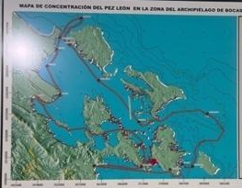 | 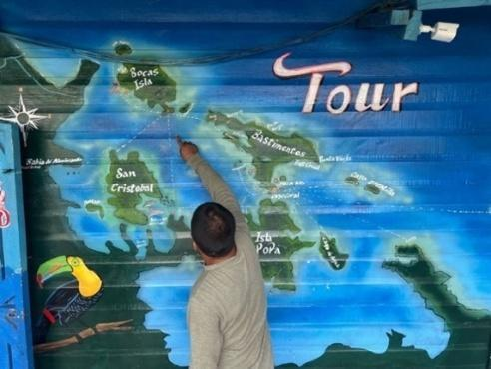 | 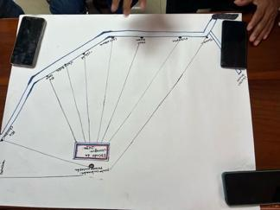
A. This map was created by the fishing association UPESABO. It shows the distribution of lionfish in the Bocas del Toro region. | B. Map used by the Torres maritime tourism transportation to show customers touristic sites. | C. This map was created by the fishing cooperative leaders, and it was presented in the Chiriqui Grande meeting (14/2/2025). The map represents fishing communities in the Bocas del Toro region.
Figure 16 Examples of maps made by locals.

Data gaps
Despite covering key topics for a baseline assessment, this assessment reveals that data lacks information on human distribution in the region, necessitating complementing the information with platforms and scientific studies specific for the Bocas del Toro region. While local stakeholders have valuable knowledge of marine features, the MSP analysis requires digitized layers of this information for a comprehensive overview. No conflicts between ocean users were reported in interviews, but literature review highlighted fatal injuries to dolphins caused by vessels, indicating spatial conflicts. Marine traffic data includes commercial vessel lanes marked by buoys, and collaboration with AMP is essential for integrating this important spatial information. Existing data on marine habitats is outdated and generalized, requiring updates for detailed analysis. Meteorological monitoring is insufficient and requires an increase in the number of monitoring sites for effective monitoring of climate change impacts. Lastly, data on marine species distribution and abundance is incomplete and needs enhancement. A summary of data gaps by topics is presented below.

Conflict reports among ocean users
In the interviews local stakeholders did not report any conflicts with other users or activities. However, the literature review identified dolphins as being fatally injured by vessels which exemplify spatial conflicts between the vessels and marine wildlife.
To effectively increase reports on user conflicts within the MSP process, a multi-faceted approach can be adopted. Firstly, by enhancing stakeholder engagement through regular consultations, workshops, and forums that can foster open communication between various marine users, including fishers, commercial operators, and managers or scientists. Also, by establishing clear, accessible reporting mechanisms such as digital platforms and hotlines where stakeholders can easily document and share their concerns. Furthermore, raising awareness through education campaigns about the importance of reporting conflicts can empower stakeholders to contribute actively. Integrating conflict reporting into routine monitoring and assessments ensures that data is consistently updated and reviewed. Collaborating closely with local authorities and using participatory mapping techniques can also help identify and visualize conflict hotspots, aiding in proactive conflict resolution and informed decision-making within the MSP framework.
Considering this, it is essential that the development of specific dispute resolution guidelines is undertaken by the MSP team in close coordination with its steering committee. The underlying principles of empowerment, participation, collective rights, and ethical consent provide a strong foundation. Online mechanisms for MSP data sharing must be built upon these principles, with dispute resolution processes co-designed and overseen by a diverse steering committee in which indigenous stakeholders play an integral role. This approach will not only address conflicts fairly and transparently but also reinforce trust, respect, and collaboration among all participants.
Marine traffic/shipping lanes
There are some buoys marking a "commercial vessel lane" utilized by companies such as Chiquita (a banana company). These large vessels require this channel for navigation, and locals are aware of these routes. It is necessary to collaborate with the Maritime Authority of Panama (AMP) to include this information in the MSP process because this is important spatial information regarding the use as well as identification and mitigation of potential marine traffic conflict with other users of the marine space must be considered in the spatial analyses. The AMP is the government entity in charge of regulating and supervising Panama's maritime and port sector, and has information related to inspections and licenses of vessels and captains, and maritime infrastructure in the region. Accurate and up-to-date data on vessel inspections that include details regarding the location, time of inspection, type of vessel involved, etc. could ensure that vessels operating within the marine space adhere to safety and environmental regulations, which is vital for mitigating risks associated with maritime traffic. Licenses of vessels and captains provide insights into the number of operating vessels in the area, the legal compliance and qualifications of those navigating these waters, additional data (e.g., years of experience, training taken, livelihood information, etc.) which could foster a safer and more regulated maritime environment. Additionally, detailed knowledge of maritime infrastructure, such as ports, docks, navigational aids, aids in strategic planning for marine traffic management, resource allocation, and conflict resolution among different marine users.
Marine habitats
Although data on the distribution and types of marine habitats exist, much of it is outdated and lacks detail, for example, some of the currently available layers are generalized (no information about the type of marine environment and/or its condition). Also, some of the current data were created at a coarse scale. Further analysis will require updating and refining the current marine habitat layers. This includes conducting detailed field surveys to gather high-resolution data on the types and conditions of marine environments. Collaboration with local stakeholders, researchers, and institutions such as the Smithsonian Tropical Research Institute (STRI) can facilitate the integration of valuable local knowledge with scientific methodologies. Utilizing advanced technologies such as remote sensing, GIS mapping, and participatory mapping techniques can produce precise, digitized layers that reflect the current state of marine habitats.
Meteorological monitoring/climate change
The region requires additional marine meteorological monitoring sites. At present, STRI operates the only marine station on Isla Colon. This data is relevant to the MSP process and monitoring efforts of other activities such as climate change and sea level rise. The Institute of Meteorology and Hydrology of Panama manages twelve land-based meteorological stations in the region of Bocas del Toro. Given the significance of marine meteorological data for the MSP process and the region's vulnerability to climate change and sea level rise, it is essential to establish additional monitoring sites beyond the sole marine station on Isla Colon. Stakeholder input suggests that new sites should include key areas such as Dolphin Bay, known for marine mammal activity; Almirante Bay, an important commercial and ecological zone; and the coastal waters surrounding the Zapatillas Cays, which are critical for coral reef health. Furthermore, stakeholder input is essential to determine new locations for additional marine meteorological monitoring sites. By considering the suggestions and recommendations from local stakeholders, comprehensive coverage can be achieved. These locations, complemented by offshore monitoring near commercial shipping lanes, would provide comprehensive coverage, enabling better prediction, and management of climatic and oceanographic changes impacting Bocas del Toro region.
Marine species distribution and abundance
While some data exists on the location and abundance of certain marine species, it is often fragmented, outdated, site-specific, or produced at a large scale, and with limited temporal context (snapshot). Local stakeholders and researchers could use participatory mapping to update/generate distribution, and abundance estimates for key species (commercially important fishes, lobsters, sea turtles, manatees, dolphins, sea cucumbers, starfish, among others).
Other data collection methods include detailed field surveys, remote sensing, GIS mapping for high-resolution data, regular monitoring with underwater cameras and drones. Collaborations with institutions like the STRI and national universities will help improve scientific rigor. Citizen science initiatives involving local communities will also expand monitoring to accurately document key species such as commercially important fishes, sea turtles, and dolphins.

The limited data that does exist concerning the distribution of seabirds and marine mammals, particularly for migratory species, is available only at the Directorate of Coasts and Seas, MiAmbiente. Bocas del Toro is being promoted as an ecotourism destination; therefore, it is important to identify opportunities to develop ecotourism activities to ensure that activities such as bird and/or marine mammal watching activities are done responsibly and sustainably.
Invasive species distribution and abundance
Information about invasive species (distribution/occurrence/abundance) and their impact on the marine environment is unknown and it is often overlooked. It is important to include this data because these species can disrupt ecosystems, threaten biodiversity, harm economies, and undermine the goals of MSP itself.
Maritime security
Maritime security ensures the protection of coastal defense infrastructures and the enforcement of maritime laws. This includes the internal communication of agencies regarding military operations and the deployment of maritime law enforcement resources. Inspection and incident reports should incorporate spatial data to map security zones and monitor areas at risk of activities such as smuggling, unauthorized fishing, accidents on the water, and other maritime violations. Additionally, incident reports help identify conflicts between security operations and other marine activities/uses, allowing for better coordination and sustainable management. Due to its national security sensitivity, this information should be coordinated within governmental agencies with varying access levels for the different MSP stakeholders.
Pollution
The available information on sources and levels of pollution, including plastic debris, chemical contaminants, and nutrient runoff, is inadequate or missing. This lack of data also extends to their effects on other species and the economy of the region. It is important to include these layers because pollution is one of the main drivers of marine ecosystem degradation.
Common methods for data collection of pollution data include detailed field surveys which can provide localized data on pollution sources and levels, including plastic debris, chemical contaminants, and nutrient runoff. Remote sensing technologies, such as satellite imagery and GIS mapping, can offer high-resolution data on broader pollution patterns. Regular monitoring using underwater cameras and drones can track pollution changes over time and across different regions. Additionally, integrating citizen science initiatives can expand monitoring efforts and engage local communities in documenting pollution impacts on marine ecosystems. However, to ensure rigorous and reliable data collection, these methods should be developed with scientific institutions and universities, which involves time and cost.
Socio-economic value
The socio-economic value of fisheries, tourism industry, and other maritime economic activity encompasses comprehensive data on the distribution and economic contributions of these sectors, including employment rates, revenue generation, their impact on local economies, and gender disaggregated data. It also involves understanding the interaction between marine activities and coastal communities, assessing how these industries support livelihoods, how men and women differently access and use marine resources and identifying potential conflicts or dependencies as well as opportunities. By integrating detailed disaggregated socio-economic data, MSP can balance ecological health with economic prosperity for all marine resource users (men and women). Historical and current socio-economic data can be accessed through governmental agencies (i.e., ARAP, AMP, Panama Tourism Authority).
Depending on the objectives of the MSP and if more detailed socio-economic data are needed, common methods for collecting this data may include field surveys, interviews, workshops, and GIS mapping. Some examples of the type of data that can be collected to assess the socio-economic situation for MSP includes catch volumes and species types (commercial/recreational), economic value of landings (by species, port, gear type), employment data (number of jobs by fishery type or aquaculture facility), fishing effort (number of vessels, trip frequency, fishing zones), visitor numbers to coastal/marine sites (e.g., beaches, diving spots), tourism-related revenue (hotels, tours, charters), port activity data (cargo volumes, vessel types, revenue), economic value of ecosystem services (e.g., carbon sequestration, coastal protection by mangroves/seagrasses), traditional and indigenous marine use areas, and cultural practices linked to marine resources, among others.

MSP data needs
Marine ecosystems are dynamic and complex, influenced by natural variability, human activities, and climate change. The MSP process should be adaptable to managing marine resources flexibly and responsively (Figure 17). Clear objectives should guide the MSP process to determine necessary data needs.
The World Bank's MSP Blue Economy Data and Tools report (2022) identifies four main categories of MSP data required for the process: boundaries, physical/chemical/biological, activities and uses, and socio-economic and cultural data.

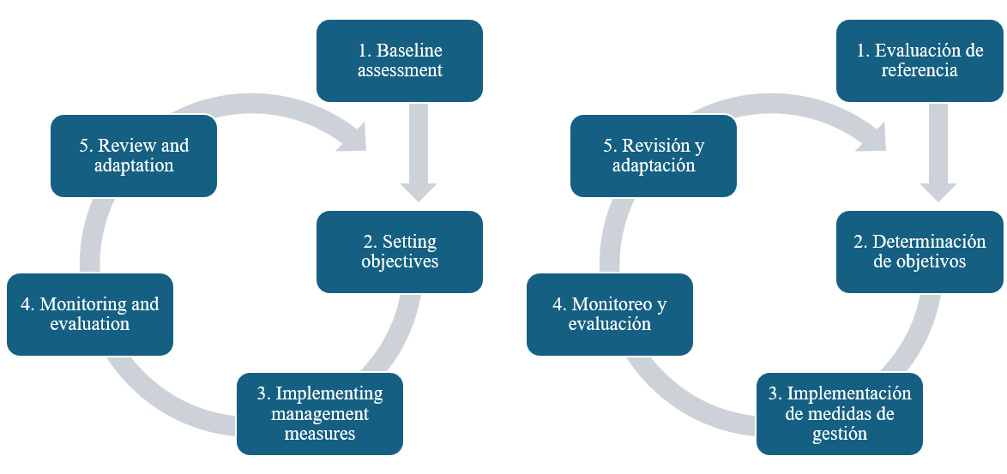
Figure 17 MSP adaptive approach.
MSP can serve as a tool to manage marine environments by considering the interactions (conflicts and opportunities) between ecological systems and human activities through an integrated approach. Based on this consultancy assessment, Table 4 lists useful data for guiding the MSP process and suggests methodologies to improve existing data. Data should be objective, reliable, and relevant spatially and temporally, with any limitations clearly disclosed for stakeholder consideration.

Table 4 Suggested data to inform MSP.
Different font colors indicate the priority of data collection: High priority is red, medium priority is green, and low priority is purple
Fisheries Data  Distribution/location data:  Small-scale fishery  Recreational fishery  Commercial fishery  User conflict areas  Diving sites for commercial species (e.g., lobster)  Landing site’s locations  Anchorages/mooring areas/locations  Marina’s location  Location of law enforcement reports  Mariculture (current)  Mariculture (potential areas)  Statistical data:  Fishing vessel characteristics (# of registered vessels by year/captain licenses)  Estimated marine fish production for artisanal finfish, and spiny lobster (weight and value)  Fisheries socio-economic data (fishers age and gender) | Current/existing data situation:  Data is available only for certain layers, such as diving sites and small-scale fishery, but must be updated and developed using a consistent spatial scale.  Data collection methods:  A participatory mapping methodology could be employed during the baseline assessment for collecting data on distributions. As the MSP progresses, other methods with higher spatial resolution could be used (e.g., distribution models and vessel tracking system).  Satellite data could be used to estimate the location of medium/large size features. However, events should be ground truthing. Fisheries statistics must rely on official reports and/or from reliable sources.  Partners for data collection:  MiAmbiente  ARAP  SINIA  Universities  Cooperatives /Associations
Habitat/Biological Data  Distribution data:  Coral reefs  Seagrass  Mangrove  Salt marshes  Swamps  Peat bogs  Degraded habitats extent (e.g., coral bleach, seagrass loss, etc.)  Fish species  Areas of high biodiversity  Nursing areas  Lobster  Sea turtle (nesting, feeding/resting areas)  Dolphin  Manatees  Sea cucumber  Starfish  Invasive species (e.g., lionfish, sargassum, starfish) | Current/existing data situation:  Generalized habitat layers (coral reef and mangrove) information is available at different temporal and spatial scales. Data on the distribution and abundance of most of the marine species is scares, aged, and site specific.  Data collection methods:  Current information could be used for the baseline assessment. Further analyses would require higher resolution data from monitoring systems.  A participatory mapping methodology could also be employed during the baseline assessment. This could be followed by the implementation of specific studies.  Partners for data collection:  MiAmbiente  SINIA  Universities  Cooperatives /Associations
Oceanographic Data  Distribution data:  Bathymetry  Chlorophyll a concentration  Nutrients  Ocean currents  Prevailing winds  Salinity  Sea surface temperature  pH  Dissolve oxygen  Ocean acidification  Changes in sea surface temperature  Changes in tides and waves | Current/existing data situation:  Satellite imagery provides much of this data, though the scale is often coarse.  Data collection methods:  Continue using global digital elevation models (DEM) (e.g., GEBCO, Seabed 2030). Based on specific objectives of MSP, obtain higher resolution data such as lidar data.  Initiate analysis with current satellite derived data. Increase the number of oceanographic buoys to increase the resolution of the data throughout the entire archipelago.  Partners for data collection:  MiAmbiente  SINIA  Climate Change Directorate  Universities  Cooperatives /Associations
Tourism Data  Distribution data:  Distribution of tourist  Watersports areas  Diving and snorkeling areas  Destination sites (on the water)  Tourism statistics (passengers by airport, purpose of trip, expenditure, etc.)  Visitor by resort and accommodation type  Number of tour operators by activities (e.g., sightseeing, snorkeling, diving, etc.) | Current/existing data situation:  Tourism and water transportation businesses generally display destination or diving site maps in their facilities on walls or banners. However, digitized layers need to be updated for use in a MSP process. The country gathers tourism statistics. There is an opportunity to suggest/gather additional local statistical information for the MSP process.  Data collection methods:  A participatory mapping methodology could be employed during the baseline assessment for collecting data on distributions. As the MSP progresses, other methods with higher spatial resolution could be used (e.g., distribution models and vessel tracking system).  National yearly tourism and recreation statistics.  Partners for data collection:  MiAmbiente  SINIA  Panama Tourism Authority  Universities
Transportation Data  Distribution/location data:  Large ships distribution (AIS)  Port locations  Aids to navigation  Buoys  Obstacles and wrecks | Current/existing data situation:  The AIS of large vessels provides some information. Current data (e.g., aids to navigation, buoys, etc.) needs updating and verification.  Data collection methods:  Vessel tracking system (AIS).  This information is already available. However, it is important to verify and keep up to date by ground truthing it.  Partners for data collection:  MiAmbiente  SINIA  AMP
Other Data  Distribution data:  Seafloor infrastructure (cables, pipes, etc.)/ Infrastructure marina (cables, pipas, etc.)  Pollution (agricultural discharge, plastic and solid waste, etc.)  Hazard risk coastal areas (vulnerability assessments) | Current/existing data situation:  Outdated site-specific data is available.  Data collection methods:  Implementation of specific studies.  Improve agencies internally communication and data sharing mechanisms related to military operations and infrastructure related to coastal defense and maritime law enforcement, as allowed by national security policies.  Partners for data collection:  MiAmbiente  SINIA  AMP  Climate Change Directorate

Data accessibility
Data accessibility refers to how easily users can locate, retrieve, understand, and use data. MSP needs diverse data types and sources for decision-making but in many instances face challenges with organizational data sharing privileges and the data itself (Figure 18).
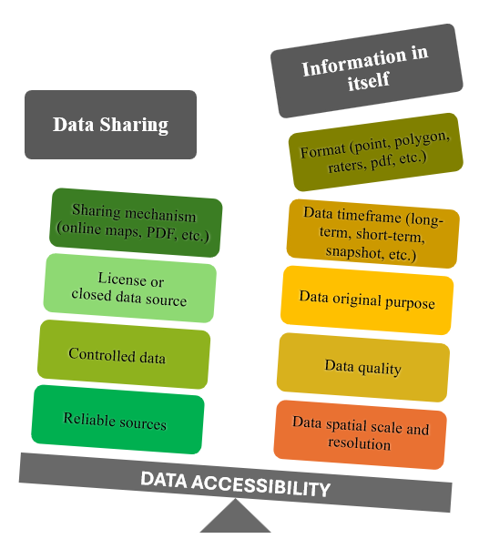
Figure 18 Data accessibility.
The MSP process should go through a series of steps to be able to use and integrate the data currently available. This process involves getting and managing the data, integrating the information, and developing platforms or mechanisms to share the data with MSP stakeholders at different phases of the process.
- Getting and managing the data: this will require coordinating with the different governmental and non-governmental organizations and universities to ensure mechanisms and terms for data sharing. Furthermore, there is a need to develop a data management system to handle all this information in an efficient manner. In 2022, the government of Panama passed the Law on Access to Public Information (Law No. 6) that seeks to facilitate free access to the information. However, most information must be requested as it has controlled access (e.g., the POT layers in ArcGIS online, the interactive map offered on the Panama Tourism Authority website, etc.). Currently, inter-agency data sharing utilizes formal request channels through a formal letter addressed to the owner/holder of the data of interest. Other organizations such as STRI offer their data more freely through a GIS portal or a data repository. However, some peer-reviewed articles do request a fee for accessing the information.
- Integrating the data: data must be integrated into a GIS project to allow its incorporation and usage in analytical tools. This could be challenging as existing data from different sources have varying formats (e.g., shapefile, geotiff, geoJSON, KML, jpg, PDF, etc.), temporal and spatial scales, and quality (related to purpose of data collection and the methodologies and equipment employed). To overcome this challenge, current data can serve as reference points, but further data collection is necessary to update the information spatially and temporally.
- MSP data sharing platform. This tool could be created within the structure of the SINIA platform, as the country is already investing in its development and maintenance. The proposed site will specifically facilitate data sharing among stakeholder groups and agencies that collect data to support the MSP process in Bocas del Toro. SINIA and several agencies are currently using ESRI products to share their data (e.g., ArcGIS Online, Hub, Survey123, Field Maps).

Technological resources
MSP relies heavily on technological resources to collect, manage, analyze, and visualize spatial data, especially when dealing with large, dynamic ocean environments.
Based on this assessment, relevant government (i.e., MiAmbiente, ARAP, AMP, Panama Tourism Authority, POT, among others) and non-government and academic institutions (i.e., TNC, STRI, etc.) in Panama use ESRI ArcGIS for GIS data. ESRI, the global leader in GIS, is expected to support the MSP process in Panama with its various products such as:
- ArcGIS Pro and Online for spatial layers
- Field Maps and Survey123 for data collection
- Dashboards, Story Maps, and Hub for data sharing
In general, ESRI software and products are reliable, user-friendly, with advanced spatial analysis tools and easy integration with other features for data sharing and visualization (e.g., interactive maps, story maps, dashboard, etc.).
Furthermore, in Panama there is also some expertise in the use of other GIS software such as QGIS which is an open-source and free to use software. QGIS has a steeper learning curve for beginners, offers a broad range of GIS functionalities spatial analysis, map design, geoprocessing, and plugins for additional capabilities.

MSP software
MSP relevant software is essential in MSP for organizing, analyzing, visualizing, and understanding complex marine data. Numerous software packages with tools, extensions, and plugins are available to facilitate MSP. Some of the most common ones include:

Marxan
Marzan provides a powerful decision-support tool widely used in MSP and systematic conservation planning. Marxan can assist with the evaluation of existing reserve systems to identify gaps in biodiversity protection, identify areas to include in new reserve systems, and provide decision support by producing several different options that meet both socio-economic and conservation objectives —Users can set multiple objectives and assess various conservation strategies using scenarios.
Marxan can be utilized in MSP for:
- Designing marine protected areas identifies configurations that meet conservation targets (e.g., 20% of each habitat type), minimizing socioeconomic costs.
- Scenario which allows for testing planning scenarios and trade-off analysis (e.g., comparing biodiversity conservation against fisheries value).
- Incorporating stakeholder values includes socioeconomic data (e.g., fishing intensity, tourism zones) to reduce conflicts with human uses.
- Prioritizing areas for management identifies critical and flexible areas for conservation strategies.
- Supporting ecosystem-based management integrates habitat, species distributions, connectivity, and threats.
- Climate adaptation planning considers future climate scenarios (e.g., ocean warming, acidification impacts) for resilient marine protected areas.
Running MSP analysis with Marxan requires data on planning units like grid cells, biodiversity features such as coral reefs and fish distributions, targets for each feature (e.g., 20% coral reef protection), cost data (e.g., fishing economic value), and constraints/exclusions (e.g., development areas).

Marxan’s key tools and extensions for MSP include the following: 1) Marxan (core), used to optimize the placement of areas that meet conservation targets at minimum cost; 2) Marxan with Zones, allowing allocation of areas into multiple zones (e.g., no-take, limited use), supporting multi-use MSP; and 3) Marxan with Connectivity, which integrates ecological connectivity like larval dispersal and species movement. Marxan outputs include selection frequency maps (how often each planning unit is selected across multiple runs), best solution map (least-cost solution that meets all targets), and gap analysis (how well conservation targets are being met).

SeaSketch
Developed by the McClintock Lab at the University of California, SeaSketch is built to help planners collaboratively develop zoning plans using spatial data, tools, and participatory processes. SeaSketch is used to design, evaluate, and manage marine spatial plans. It supports the entire MSP process, especially in areas where transparency, stakeholder engagement, and data accessibility are critical. Basic features are free, while advanced options cost $3K for baseline, $20K for group projects, and $80K for large projects.
Its core features include an interactive web GIS platform to upload and view spatial data and users can draw and edit zones directly on the map. A scenario design and comparison in which stakeholders can create zoning scenarios (e.g., marine protected areas, fisheries zones). SeaSketch allows for real-time collaboration in which multiple users can work together remotely. It also includes tools for commenting, voting, and discussion to foster participatory planning.
SeaSketch could also integrate tools like Marxan to evaluate solutions based on optimization, survey and consultation Tools for collecting local knowledge, preferences, or feedback. And to account for sensitive information, it has customizable permissions to allow planners to manage who can view or edit data and scenarios.
GIS software like ArcGIS and QGIS
Basic tools in ArcGIS or QGIS can help manage and integrate various data formats into one GIS project for spatial analysis and map-based decision-making (e.g., suitability analysis, habitat analysis, risk assessment). While SeaSketch and Marxan are designed for specific MSP tasks like scenario planning and solutions, ArcGIS (proprietary, by Esri) and QGIS (free and open-source) offer flexible, customizable platforms for managing and analyzing spatial data — essential throughout the MSP process.
GIS software can be utilized in MSP for:
- Data creation by spatial paper or digital data collection surveys, allowing users to digitize features directly onto maps, convert raw field data (e.g., GPS coordinates) into spatial layers, and generate new datasets through analysis tools.
- Data integration is facilitated by GIS software for combining diverse datasets (e.g., benthic habitats, fisheries catch and effort, marine traffic) and managing metadata, symbology, projections, and visualization.
- Baseline mapping and characterization includes creating marine resources inventories and ecosystem baseline maps (e.g., species distribution, bathymetry and oceanography, jurisdictional boundaries, etc.)
- Spatial analysis involves suitability and conflict analysis to provide information about areas suitable for specific uses (e.g., tourism, fisheries, conservation, etc.) or areas of high use conflict or cumulative pressure.
- Scenario planning and visualization entails creating and comparing alternative zoning maps, using symbology, transparency, and custom layouts to visualize plans, and integrate outputs from Marxan, SeaSketch, or other models for further analysis or presentation.
- Cumulative impact and risk assessment overlay multiple human activities and environmental pressures to assess cumulative impacts on habitats or species or apply tools like InVEST to explore how changes in ecosystems might affect the flow of benefits to people.
- Stakeholder communication and reporting involves creating custom maps, story maps, dashboards, atlases, and reports as outreach and communication products.

Though GIS software needs training, Panama's government GIS technicians might only need specific MSP training.

Training and capacity building
Training and capacity building to develop and implement MSP involve developing knowledge, skills, and tools for effective MSP process design, management, and participation.
Effective MSP data handling requires technical skills, particularly in GIS. Technicians should at least have basic to intermediate expertise in acquiring relevant data, managing layers, and integrating diverse datasets for analysis.
MSP tools like Marxan and ArcGIS rely on models to address key questions. Technicians need basic skills in mathematical and statistical modeling to effectively use these tools. As MSP advances, technical skills should also grow to develop custom models for long-term goals, such as predicting impacts of various planning scenarios.
Current Panamanian GIS technicians from leading MSP agencies (MiAmbiente, ARAP, POT, etc.) may need intermediate to advanced training in specific topics and software (Table 5). Other relevant actors (e.g., data collectors, local stakeholders) may require basic GIS training to understand and comfortably collect and interpret results, supporting the MSP process.
Capacity building should use various training methods to address personnel turnover. In-person training can be supplemented with self-paced online modules. Table 5 lists recommended trainings to enhance technical capacity for the MSP process in Panama.
Effective stakeholder engagement is also crucial for the MSP process. Serious consideration should be given to the expertise who understands social and cultural dynamics and can create a plan for engaging stakeholders, including effective communication methods.

Table 5 Suggested trainings for technicians supporting Panama’s MSP process.
Trainings | Main topics
Introductory training in GIS | Acquiring, managing, and reporting spatial data  Basic analysis based on already established tools (e.g., analyst tools)
Digital data collection | Methodology for conducting, analyzing, and reporting participatory mapping exercises.  Designing and implementing:  - digital forms for data collection  - protocols with tracking data  - monitoring systems (e.g., acoustic monitoring, drones and remotely operated vehicles)
Facilitation skills | Methods for participatory planning and stakeholder engagement under the social and environmental safeguards and gender guidelines.  Negotiation, conflict resolution.
Communication skills | Technical writing to produce clear and precise documents and reports.  Public speaking to enhance confidence and improve delivery at forums, workshops, and meetings.  Delivering effective presentations that convey information in a compelling and engaging manner across various formats.
Remote sensing | Acquiring, creating and working with derived data (new data created by combining and processing existing raw data)
Modeling and simulations (basic) | MSP software and tools (in deep exploration of current leading platforms to understand their strengths and limitations)
Models and simulations (intermediate) | Understanding of ecological and environmental modeling concepts  Creating and modifying models  Modeling software (e.g., MATLAB, Python, R software, etc.)  Spatial statistics (e.g., cluster analysis, hot spot analysis, etc.)  Advance simulations
Economic analysis | Cost-benefit analysis of different scenarios  Trade-off evaluation among competitive uses  Assessment of economic development opportunities
Legal and policy | Introduction to national and international laws, regulations, and policy framework related to MSP  National and international data sharing protocols
Cloud-based platforms for sharing data | Exploration of current platforms (strength and weakness based on national need)  Design and implementation of online platforms and tools (e.g., website, interactive maps, dashboards, mapping surveys, discussion forums, etc.) for sharing data and results to support stakeholder engagement  Mobile apps (design and implementation for data and results sharing)

RECOMMENDATIONS
Panama's government aims to develop its blue economy through a National Ocean Policy involving multiple sectors. The MSP process in Bocas del Toro is currently under development with the support of regional organizations (such as the GEF/CAF/FAO/CRFM BE-CLME+ Project).

This assessment outlines the availability of secondary data such as scientific reports, atlases, and local knowledge for the early stages of the MSP process. It highlights the necessity of collecting primary information on ocean user distribution, including fisheries, tourism, and transportation. Significant local spatial knowledge must be digitized through participatory mapping and other methodologies. However, there are notable gaps in temporal and spatial data, particularly regarding habitat distribution and biological data, which are often site-specific and not periodically collected. Methods like surveys and participatory mapping can gather baseline data, but participatory mapping has limitations due to reliance on recollection. Further exploration should include field surveys, remote sensing, GIS mapping, and regular monitoring with underwater cameras and drones, in collaboration with academic institutions to enhance scientific rigor.

Recommendations are grouped based on general topics such as data collection, MSP analysis, capacity building, and information sharing mechanism:

Data collection
Secondary data, such as scientific reports, national, regional and international atlases, and local knowledge, can be utilized during the early stages of the MSP process. However, it is necessary to collect crucial primary information on special distribution of ocean users, including fisheries (updating current information), tourism, and transportation. There is significant local spatial knowledge that will have to be digitized through participatory mapping processes and/or other appropriate methods (based on time and budget).

There are gaps in temporal and spatial coverage information for most data categories, especially the distribution and status of habitat and biological data, which is often site-specific and not collected periodically. Methods like surveys and participatory mapping with scientists, researchers, managers, technicians, and resource users such as fisherfolk can gather baseline data through this method.

Participatory mapping methods are also efficient and resource-light but have limitations due to their reliance on recollection rather than direct observation. Spatial layers derived include fishing grounds, conflict areas, tourist spots, species distribution, livelihood, and gender data. Participatory mapping also helps engage stakeholders early in the MSP process.

Stakeholders are willing to participate in all phases of MSP. However, the MSP process should follow/consider general guidelines on social and environmental safeguards and gender participation:
a) Recognize that fishers and communities are equal partners in marine resource management; and their views should be respected.
b) Community expectations should be managed realistically, and biodiversity interests communicated clearly.
c) Recognize that fishers are diverse with varying patterns and roles.
d) Indigenous people's traditional knowledge should be respected.
e) Engagement of local communities require persistence and consistency.

Collaborating with academic institutions and non-governmental organizations to collect specific data can enhance the baseline assessment. During the progression of the MSP process, it is important to transition from existing data to information gathered through established protocols. Resources should be allocated to high-resolution techniques, such as tracking devices, to obtain precise locations of fishing areas and key species.

MSP Analysis
The government of Panama should negotiate access to the ESRI license for its leading MSP agencies (e.g., MiAmbiente, ARAP, etc.). Many agencies already use its products. The Bocas del Toro MSP process should adopt ESRI products for data management and analysis. ArcGIS Pro offers tools for objectives like suitability analysis and data modeling, integrates with real-time data collection tools, and provides interactive sharing platforms such as ArcGIS Online and dashboards.

Additionally, using specialized software like Marxan is recommended. Marxan, which is used globally, handles complex planning solutions and evaluates the impact of customize scenarios define by the objectives of the MSP process, complemented by spatial analysis in GIS software like ArcGIS Pro and QGIS.

Capacity building
Panama has expertise in developing land-based projects and government agencies have skilled technicians and necessary resources like computer equipment and software. However, the MSP process involves a dedicated multidisciplinary team, with each member providing essential knowledge and skills to ensure that spatial plans are scientifically valid, legally compliant, inclusive and socially equitable. Personnel in most agencies are limited and manage multiple projects. Ideally, an MSP team would include a project manager, GIS specialist, marine ecologist, stakeholder engagement and communication specialist, policy and legal expert, information technology specialist, economist, and field technicians or data collectors. Experts from different government agencies can support this unit with planning, data collection, stakeholder engagement, marine ecology, fisheries, renewable energy, transportation, tourism, and recreation, among other areas. Additionally, the MSP process should be designed and implemented with the assistance of a multi-sectoral technical advisory committee. Other countries, including Kenya and Seychelles, have developed governance frameworks and established MSP authorities. These authorities consist of an executive committee, a multi-agency steering committee, a secretariat, legal and policy advisors, scientific advisory groups, stakeholder safeguards, and technical working groups to guide and coordinate the MSP process.
Information sharing
The MSP process requires an efficient mechanism for sharing both spatial and non-spatial data with varying access levels, including sensitive data. It also needs to share preliminary results for feedback from stakeholders. Panama has developed the National Environmental Information System (SINIA) to facilitate data sharing. Collaborating with the SINIA team presents an opportunity to improve the site to incorporate MSP tools within this existing platform (e.g., stakeholder sharing tools, discussion forums, specific interactive maps, etc.), starting with Bocas del Toro and potentially extending to other MSP initiatives in the country.

CONCLUSIONS
The MSP needs and data gaps assessment conducted aims to characterize existing data, technology, and human capacities, and identify any needs and gaps pertinent to the MSP process. This assessment emphasizes the interrelationships among governmental entities that will play a critical role in monitoring and collecting relevant data to support the MSP process in Panama. Key activities include stakeholder engagement and the development of a spatial modeling framework to map zoning options for human uses and marine ecological/habitat conservation, aiming to mitigate conflict. These initiatives are intended to align with and aid government decision-making in establishing policies, promulgating regulations, and enforcing actions.
The consultancy found that some basic spatial information is available for use during the baseline assessment for the MSP process in Panama. Thanks to the efforts of various governmental agencies (e.g., MiAmbiente, ARAP, among others) and NGOs (e.g., Global Fish Watch, STRI, etc.), several datasets are already in geospatial formats (e.g., shapefile, geotiff). However, data found in reports and publications will need to be requested and, in some cases, digitized for inclusion in a GIS project for further analysis. It is important to carefully consider the inclusion of potentially outdated data, as the marine environment is highly dynamic, and conditions are continually changing. Consequently, while information may exist on a specific topic, it may no longer be relevant. Analysis, interpretation, and reporting should consider the limitations of using currently available data.
Efforts should be made to collect missing data. The participatory mapping methodology could facilitate timely collection of important information (e.g., fishing grounds, user conflict areas, species distribution, etc.). Additionally, this method encourages the participation and engagement of stakeholders (e.g., scientists, experts, managers, local actors, indigenous people) from the early phases of the MSP. This approach is consistent with other literature and global MSP initiatives.
In the future, to carry out the MSP process, it would support the establishment of a national platform that compiles the planning process by integrating, managing, and sharing data, and providing tools for results interpretation and discussion forums to promote stakeholder engagement. The government of Panama has already invested in creating the National Environmental Information System (SINIA), and efforts should be made to utilize and build on this platform for the MSP in Bocas del Toro and eventually other MSP initiatives in Panama.

REFERENCES
Adelson, A. E., Altieri, A. H., Boza, X., Collin, R., Davis, K. A., Gaul, A., ... & Pawlak, G. (2022). Seasonal hypoxia and temperature inversions in a tropical bay. Limnology and Oceanography, 67(10), 2174-2189.

Al Berda, A. (2021). PANAMAR: una herramienta para la gestión del patrimonio cultural subacuático de Panamá. Cátedra, (18), 150-170.

Albert, Y. P., & Andreu, M. N. L. (2012). La planificación y gestión del turismo en las áreas protegidas de Panamá. El caso del Parque Nacional Marino Golfo de Chiriqui (Panamá). Boletín de la Asociación de Geógrafos Españoles.

Altieri, A. H., Harrison, S. B., Seemann, J., Collin, R., Diaz, R. J., & Knowlton, N. (2017). Tropical dead zones and mass mortalities on coral reefs. Proceedings of the National Academy of Sciences, 114(14), 3660-3665.

Arden & Price Consulting (2008). Consultoría para la Elaboración del Plan de Manejo Marino Costero Integrado de Bocas del Toro, en el Marco del Programa Multifases de Desarrollo Sostenible de Bocas del Toro. Informe de Avances N°2. Recursos Marino-Costeros de Bocas del Toro. Autoridad de los Recursos Acuáticos de Panamá Panamá. https://aquadocs.org/items/dac9702c-917d-45d8-8157-91ffe2eb318f/full

Arden & Price Consulting (2008). Atlas de los recursos marino: costeros de Bocas del Toro. Autoridad de los Recursos Acuáticos de Panamá. https://www.si.edu/object/siris_sil_955832

Arosemena, O., Falconett, MP, Smith, A. y Batista, X. (2025). Cartografía digital y segmentación del turismo alternativo en panamá. Cartografía digital y segmentación del turismo alternativo en Panamá. Centros: Revista Científica Universitaria, 14(1), 146-165.

Autoridad Nacional del Ambiente (ANAM). (2010). Atlas Ambiental de la República de Panamá. https://aquadocs.org/items/e5ae39d8-3ca0-4a47-8d1c-42dfc5d871f2

Barragán-Barrera, D. C., May-Collado, L. J., Tezanos-Pinto, G., Islas-Villanueva, V., Correa-Cárdenas, C. A., & Caballero, S. (2017). High genetic structure and low mitochondrial diversity in bottlenose dolphins of the Archipelago of Bocas del Toro, Panama: A population at risk?. PloS one, 12(12), e0189370.

Barragán-Barrera, D. C., Polo-Silva, C. J., González, C., Rodríguez, M., Baldrich, L., Bermúdez-Rivas, C., ... & Luna-Acosta, A. (2024). First stable isotope and mercury assessment of bonnethead and Caribbean sharpnose sharks from a potential nursery ground in the Archipelago of Bocas del Toro, Panamanian Caribbean. Frontiers in Marine Science, 11, 1235876.

Basu, I. (2016). Small-scale fishing in Central American indigenous people: Governance, tenure and sustainable management of marine resources.

Berry, K. L., Seemann, J., Dellwig, O., Struck, U., Wild, C., & Leinfelder, R. R. (2013). Sources and spatial distribution of heavy metals in scleractinian coral tissues and sediments from the Bocas del Toro Archipelago, Panama. Environmental monitoring and assessment, 185, 9089-9099.

Briand JK, Guzmán HM and Sunday JM (2023). Spatio-temporal patterns in coral reef composition and function across an altered environmental gradient: A 15-year study in the Caribbean. Front. Mar. Sci. 9:977551. doi: 10.3389/fmars.2022.977551

Cabrera Arias M. (1997). Manejo Costero Integral para Bocas del Toro. Tesis. Universidad de Panamá.

Camargo Velandia, M. (2016). Percepción de la comunidad de Panamá, Bocas del Toro sobre el impacto de la industria turística.

Castro M. Delgado P, Dias J, Duran D., Jimenez J., Scheel M. Carrilo M. (2021). Planificación espacial marina: conceptos, principios y guía metodológica.

Chevis M, Graham R. Insights into elasmobranch composition, abundance, and distribution in the Bocas del Toro Archipelago, Panama using fisheries-independent monitoring. Lat. Am. J. Aquat. Res.. 2022;50(3): 492-506. Available from: doi:10.3856/vol50-issue3-fulltext-2890 [Accessed 3 Mar. 2025].

Clark KE, Bravo VD, Giddings SN, Davis KA, Pawlak G, Torres MA, Adelson AE, César-Ávila CI, Boza X and Collin R (2022). Land Use and Land Cover Shape River Water Quality at a Continental Caribbean Land-Ocean Interface. Front. Water 4:737920. doi: 10.3389/frwa.2022.737920

Coates, A. G., McNeill, D. F., Aubry, M. P., Berggren, W. A., & Collins, L. S. (2005). An introduction to the geology of the Bocas del Toro Archipelago, Panama. Caribbean Journal of Science.

Collin, R. (2005). Ecological monitoring and biodiversity surveys at the Smithsonian Tropical Research Institute Bocas Del Toro research station. Caribbean Journal of Science.

Collin, R., Adelson, A. E., Altieri, A. H., Clark, K. E., Davis, K., Giddings, S. N., ... & Scott, C. P. (2024). Using forty years of research to view Bahía Almirante on the Caribbean coast of Panama as an integrated social-ecological system. Estuarine, Coastal and Shelf Science, 108878.

Collin, R., D'Croz, L., Gondola, P., & Del Rosario, J. B. (2009). Climate and hydrological factors affecting variation in chlorophyll concentration and water clarity in the Bahia Almirante, Panama. In Proceedings of the Smithsonian Marine Science Symposium. Smithsonian Institution Scholarly Press.

Cyronak, Tyler; Takeshita, Yui; Courtney, Travis A. et al. (2019). Diel temperature and pH variability scale with depth across diverse coral reef habitats [Dataset]. Dryad. https://doi.org/10.5061/dryad.tj1nf5f

D'Croz, L., Rosario, J. B. D., & Gondola, P. (2005). The effect of freshwater runoff on the distribution of dissolved inorganic nutrients and plankton in the Bocas del Toro Archipelago, Caribbean Panama. Caribbean Journal of Science.

de Ycaza, R. A., Spalding, A. K., & Cisneros-Montemayor, A. M. (2024). Assessing policy coherence for developing a blue economy: a case study in the Republic of Panama. Frontiers in Marine Science, 11, 1336030.

Díaz Merlano, J.M. y Jiménez Ramón, J.A., Eds. (2021). Planificación Espacial Marina: conceptos, principios y guía metodológica. Fundación MarViva, Bogotá, Colombia.

Diaz, M. C. (2005). Common sponges from shallow marine habitats from Bocas del Toro region, Panama. Caribbean Journal of Science.

Dominici Arosemena, A., & Wolff, M. (2005). Estructura de la comunidad de peces arrecifales en Bocas del Toro (Caribe, Panamá): gradientes en la complejidad del hábitat y exposición. Revista científica del Caribe.

Doucette, V. E., Rodriguez Bravo, L. M., Altieri, A. H., & Johnson, M. D. (2022). Negative effects of a zoanthid competitor limit coral calcification more than ocean acidification. Royal Society Open Science, 9(11), 220760.

Easson, C. G., Matterson, K. O., Freeman, C. J., Archer, S. K., & Thacker, R. W. (2015). Variation in species diversity and functional traits of sponge communities near human populations in Bocas del Toro, Panama. PeerJ, 3, e1385.

Ehler, C., Douvere, F., & Intergovernmental Oceanographic Commission. (2013). Planificación espacial marina: una guía paso a paso hacia la gestión ecosistémica.

Evans, D. R. (2019). Sea turtle conservancy’s Caribbean leatherback tracking and conservation project, Bocas del Toro Region, Panama. Testudo, 9, 47-51

Garbero, R. P. (2013). El sistema nacional de áreas protegidas de Uruguay avances y perspectivas (Doctoral dissertation, UNIVERSIDAD DE LA REPÚBLICA).

Gedan, K. B., Altieri, A. H., Feller, I., Burrell, R., & Breitburg, D. (2017). Community composition in mangrove ponds with pulsed hypoxic and acidified conditions. Ecosphere, 8(12), e02053.

Gehara, M., Summers, K. & Brown, J.L. Population expansion, isolation and selection: novel insights on the evolution of color diversity in the strawberry poison frog. Evol Ecol 27, 797–824 (2013). https://doi.org/10.1007/s10682-013-9652-0

Global Mangrove Watch (GMW) es una plataforma en línea que proporciona datos de teledetección y herramientas de monitoreo para los manglares del mundo. Proporciona acceso universal a información sobre dónde y qué cambios están experimentando los manglares en todo el mundo. Fuente: https://www.globalmangrovewatch.org/Mangrove extent

Gobierno de Panamá. (2013). Decreto ejecutivo No 431. Comisión para la formulación, desarrollo y monitorio de la política Nacional de Océanos.

Gobierno de Panamá, A. D. T. (2021). Plan Maestro de Turismo Sostenible de Panamá, 2020-2025. Recuperado de: https://www. atp. gob. pa/Plan_Maestro_de_Turismo_Sostenible_2020-2025.

Gobierno de Panamá. (2022). Política Nacional de Océanos. Estrategia y Plan de Acción Nacional. HIDRIA Ciencia, Ambiente y Desarrollo SL. https://www.undp.org/sites/g/files/zskgke326/files/2023-03/UNDP-PA-Politica-Oceanos-Documento.pdf

Golfo de Chiriqui PEM por MarViva https://storymaps.arcgis.com/stories/a652f5d88a2b497ca8c5474e57718c9c

González Rodríguez, C. T. (2017). Genética de conservación del tiburón cabeza de sombrero Sphyrna tiburo en Bocas del Toro, Panamá: evidencia preliminar de una población única; Genética de poblaciones de los tiburones martillo en peligro de extinción Sphyrna mokarran y Sphyrna lewini del sur de Florida, EE. UU.

Gonzalez, C., Gallagher, A. J., & Caballero, S. (2019). Conservation genetics of the bonnethead shark Sphyrna tiburo in Bocas del Toro, Panama: Preliminary evidence of a unique stock. PLoS One, 14(8), e0220737.

Goodheart, J. A., Ellingson, R. A., Vital, X. G., Galvão Filho, H. C., McCarthy, J. B., Medrano, S. M., ... & Valdés, Á. (2016). Identification guide to the heterobranch sea slugs (Mollusca: Gastropoda) from Bocas del Toro, Panama. Marine Biodiversity Records, 9, 1-31.

Grajales Saavedra, F., Ciniglio, S., Machado, V., & Vallarino, R. (2022). Sea level rise analysis in Colon Island, Bocas del Toro.

Guzman HM, Estévez RM (2024) Movement behavior of satellite-tagged leatherback turtles from Panama in response to chlorophyll, primary productivity, temperature, and eddy kinetic energy. Endang Species Res 55:93-107. https://doi.org/10.3354/esr01362

Guzman, H. M., & Estévez, R. M. (2024). Movement behavior of satellite-tagged leatherback turtles from Panama in response to chlorophyll, primary productivity, temperature, and eddy kinetic energy. Endangered Species Research, 55, 93-107.

Guzmán, H. M., & Guevara, C. A. (1998). Arrecifes coralinos de Bocas del Toro, Panamá: II. Distribución, estructura y estado de conservación de los arrecifes de las Islas Bastimentos, Solarte, Carenero y Colón. Revista de Biología Tropical, 46(4), 889-912.

Guzmán, H. M., & Guevara, C. A. (1999). Arrecifes coralinos de Bocas del Toro, Panamá: III. Distribución, estructura, diversidad y estado de conservación de los arrecifes de las islas Pastores, Cristóbal, Popa y Cayo Agua. Revista de Biología Tropical, 47(4), 659-676.

Guzmán, H. M., & Guevara, C. A. (2001). Arrecifes coralinos de Bocas del Toro, Panamá: IV. Distribución, estructura y estado de conservación de los arrecifes continentales de Península Valiente. Revista de Biología Tropical, 49(1), 53-66.

Guzman, H. M., & Guevara, C. A. (2001). Arrecifes coralinos de Bocas del Toro, Panama: IV. Distribucion, estructura y estado de conservacion de los arrecifes continentales de Peninsula Valiente. Revista de Biología Tropical, 49(1), 53-67.

Guzmán, H. M., & Guevara, C. A. (2001). Arrecifes coralinos de Bocas del Toro, Panamá: I. Distribución, estructura y estado de conservación de Ios arrecifes continentales de la Laguna de Chiriquí y la Bahía Almirante.

Guzman, H. M., & Tewfik, A. (2004). Population Characteristics and Co-occurrence of three exploited decapods (Panulirus argus, P. guttatus, Mithrax spinosissimus) in Bocas del Toro, Panama. Journal of Shellfish Research.

Guzman, H. M., Barnes, P. A., Lovelock, C. E., & Feller, I. C. (2005). A site description of the CARICOMP mangrove, seagrass and coral reef sites in Bocas del Toro, Panama. Caribbean Journal of Science.

Guzmán, H., & Guevara, C. (2002). Annual reproductive cycle, spatial distribution, abundance, and size structure of Oreaster reticulatus (Echinodermata: Asteroidea) in Bocas del Toro, Panama. Marine Biology, 141, 1077-1084.
https://storymaps.arcgis.com/stories/36b666de8f5f44438b657e1d48c70a19

I Naturalisthttps://www.arcgis.com/home/item.html?id=2fd4f275f0ed4442b4836a63e01eaa1d

Kassamali-Fox, A., Christiansen, F., May-Collado, L. J., Ramos, E. A., & Kaplin, B. A. (2020). Tour boats affect the activity patterns of bottlenose dolphins (Tursiops truncatus) in Bocas del Toro, Panama. PeerJ, 8, e8804.

Kayes, R. (2005). Turismo y conservación de arrecifes de coral en Bocas del Toro: Un análisis del ecoturismo y sus componentes guiados por guías turísticos.

Kim, A., Scott, C. P., & Swartz, W. (2024). Local perspectives on marine ecotourism development in a water-insecure island region: the case of Bocas del Toro, Panama. Frontiers in Marine Science, 11, 1377053.

Li, A., & Reidenbach, M. A. (2014). Forecasting decadal changes in sea surface temperatures and coral bleaching within a Caribbean coral reef. Coral reefs, 33, 847-861.

Liu, K. (2018). Diversidad y distribución de peces en el continuo arrecife de coral y pastos marinos en dos sitios frente a la costa occidental de Isla Bastimentos, Bocas del Toro, Panamá.

Lotzkat, S., Stadler, L., Carrizo, A., Hertz, A., & Kohler, G. (2010). Notes on the easternmost population of Diploglossus bilobatus (Squamata: Anguidae) in Veraguas, Panama. Salamandra, 46(1), 59-62.

MarViva. (2024). Proyecto regional “Hacia una gestión conjunta, integrada y basada en los ecosistemas del Gran Ecosistema Marino Costero del Pacífico Centroamericano (PACA)” 2024-2026. MarViva TOR para contratar a un Especialista en Planificación Espacial Marina https://marviva.net/wp-content/uploads/2024/11/TdR-Consultoria-A1-3.0.pdf

Martinez Darysbeth. 2024. Informe Ambiental Estrategico para el plan de ordenamiento territorial (POT) del Distrito de Bocas del Toro. Autoridad de turismo de Panama. 90 pag.

May-Collado, L. J., Quinones-Lebron, S., Barragán-Barrera, D. C., Palacios, J. D., Gamboa-Poveda, M., & Kassamali-Fox, A. (2015). La industria de observación de delfines en Bocas del Toro depende de una pequeña comunidad de delfines nariz de botella: implicaciones para la gestión. Int Whal Comm.

Merchan, F., Echevers, G., Poveda, H., Sanchez-Galan, J. E., & Guzman, H. M. (2019). Detection and identification of manatee individual vocalizations in Panamanian wetlands using spectrogram clustering. The Journal of the Acoustical Society of America, 146(3), 1745-1757.

Meylan, A. B., Meylan, P. A., & Espinosa, C. O. (2013). Sea turtles of Bocas del Toro province and the comarca Ngöbe-Buglé, Republic of Panamá. Chelonian Conservation and Biology, 12(1), 17-33.

Ministerio de Vivienda. Distrito de Bocas del Toro. Plan Local de Ordenamiento Territorial. Gobierno de Panamá.

Neill, J. L., Dillon, M. M., Bilecki, C., Bollinger, S., Dansereau, S. C., Flores, A., ... & Valdés, Á. (2024). New contributions to the heterobranch sea slug biodiversity of Bocas del Toro, Panama. NAUTILUS, 138(3-4), 75-81.

Neoesri. (2024). Bocas del Toro Baselayer high resolution images for the southeast portion of Isla Colon.https://www.arcgis.com/apps/mapviewer/index.html?layers=17d29bd0bffe4464a73c0f75ea0a128c)

Olivare, B. O. (2020). Caractezación socieconomica de Bocas del Toro en Panamá, una aplicación técnica multivaridas. Revista Brasileira de Gestão e Desenvolvimento Regional, 16(3).

Pabón-Aldana, K., Noriega-Hoyos, C. L., & Jaúregui, G. A. (2012). First satellite track of a head-started juvenile Hawksbill in the Colombian Caribbean. Marine Turtle Newsletter, 133(4), 4-7.

Pagenkopp Lohan, K. M., Hill-Spanik, K. M., Torchin, M. E., Strong, E. E., Fleischer, R. C., & Ruiz, G. M. (2015). Molecular phylogenetics reveals first record and invasion of Saccostrea species in the Caribbean. Marine Biology, 162, 957-968.

Panama en rutas de ecoturismo en Bocas del Toro. https://storymaps.arcgis.com/stories/72758865d5b64fdb8636e0fb7159d2b0
Panamá, P. N. U. D. (2018). Tercera Comunicación Nacional sobre Cambio Climático Panamá.

Parejo, S. G., Piacenza, S. E., García, R., Ordóñez, C., & Valverde, R. A. (2025). Nesting population trend of the leatherback sea turtle in Bocas del Toro province and Comarca Ngäbe-Buglé, Panama for the period 2002–2022. Global Ecology and Conservation, 57, e03415.

Pedersen, K., Cyronak, T., Goodrich, M., Kline, D. I., Linsmayer, L. B., Torres, R., ... & Andersson, A. J. (2024). Short-Term Spatiotemporal Variability in Seawater Carbonate Chemistry at Two Contrasting Reef Locations in Bocas del Toro, Panama. Aquatic Geochemistry, 30(1), 1-29.

PESCA DEPORTIVA EN PANAMA https://issuu.com/jorgeisaac57/docs/pesca_deportiva-_rp
Portal Geoespacial de Panamá https://aig-hg-portal.innovacion.gob.pa/aigportal/home/
POT. Panama. Multiple layers in the Bocas del Toro Region https://www.arcgis.com/home/user.html?user=POT_Panama

Prado, A., Cedeño, A., de Boutaud, E., Mójica, Y., & González, G. (2016). Estudio preliminar sobre la ubicación de un parque eólico marino en Panamá. Revista de Iniciación Científica, 2(2), 76-85.

Reed, V. (2017). Implications of hydropower and land use change for Antillean manatees in the lower Changuinola River, Panama: an integrative modelling analysis. McGill University (Canada)
Renegar, D. A., Schuler, P. A., Knap, A. H., & Dodge, R. E. (2022). TRopical Oil Pollution Investigations in Coastal Systems [TROPICS]: A synopsis of impacts and recovery. Marine Pollution Bulletin, 181, 113880.

Reyes-Arias, J.D., Brady, B., Ramos, E.A. et al. (2023). Vocalizations of wild West Indian manatee vary across subspecies and geographic location. Sci Rep 13, 11028. https://doi.org/10.1038/s41598-023-37882-8.

Rhodes, A. (2018). Abundancia, densidad e indicadores influyentes en la acumulación de residuos sólidos y soluciones de mitigación a lo largo de las costas de la Isla Colón en la provincia de Bocas del Toro, Panamá.
Rodas, A. M., Wright, R. M., Buie, L. K., Aichelman, H. E., Castillo, K. D., & Davies, S. W. (2020). Eukaryotic plankton communities across reef environments in Bocas del Toro Archipelago, Panamá. Coral Reefs, 39, 1453-1467.

Seemann, J., González, C. T., Carballo-Bolaños, R., Berry, K., Heiss, G. A., Struck, U., & Leinfelder, R. R. (2014). Assessing the ecological effects of human impacts on coral reefs in Bocas del Toro, Panama. Environmental monitoring and assessment, 186, 1747-1763.

Seemann, J., Yingst, A., Stuart-Smith, R. D., Edgar, G. J., & Altieri, A. H. (2018). The importance of sponges and mangroves in supporting fish communities on degraded coral reefs in Caribbean Panama. PeerJ, 6, e4455.
Segundo Coello. Towards joint integrated, ecosystem-based management of the Pacific Central American Coastal Large Marine Ecosystem (PACA).

SENACYT. (2018). Visión 2050. Diagnostico Bocas del Toro. Gobierno de Panamá.

Shen, E. (2016). Ensambles de peces de arrecife y corales en Punta Hospital y cerca de la Isla Bastimentos, Panamá.

SINIA. (2025). Sistema Nacional de Información Ambiental Panamá. https://sinia.gob.pa/.

Sitar, A., LJ, M. C., Wright, A. J., Peters-Burton, E., Rockwood, L., & Parsons, E. C. M. (2016). Los operadores de embarcaciones en Bocas del Toro, Panamá, muestran bajos niveles de cumplimiento con las regulaciones nacionales de observación de ballenas. Marine Policy, 68, 221-228.

Smith, D. A., Ibáñez, A., & Herrera, F. (2017). The importance of context: Assessing the benefits and limitations of participatory mapping for empowering indigenous communities in the Comarca Ngäbe-Buglé, Panama. Cartographica: The International Journal for Geographic Information and Geovisualization, 52(1), 49-62.

STRI. (2025). Smithsonian. Barhymetry https://www.arcgis.com/home/item.html?id=4239c3bf7d534e758f66e155d0e64c5c

Stewart, H. A., Wright, J. L., Carrigan, M., Altieri, A. H., Kline, D. I., y Araújo, R. J. (2022). Nuevos hábitats coexistentes de manglares y corales: extensas comunidades de coral ubicadas en las profundidades de los manglares de Panamá, un sistema de clasificación global y distribuciones previstas. PLoS One, 17(6), e0269181.
Stri Gis porta. https://stridata-si.opendata.arcgis.com/

Thompson, P. (2016). Cobertura de coral vivo y muerto en tres arrecifes y percepciones públicas sobre la degradación alrededor de la Bahía Almirante, Bocas del Toro.

Tiffany, B. (2015). Diversidad de organismos marinos y condición de los arrecifes en dos sitios arrecifales en Big Creek Beach y Boca del Drago, Bocas del Toro, Panamá.
TNC. 2008. Evaluación de ecorregiones marinas en Mesoamérica. Sitios prioritarios para la conservación en las ecorregiones Bahía de Panamá, Isla del Coco y Nicoya del Pacifico Tropical Oriental, y en el Caribe de Costa Rica y Panamá. Programa de Ciencias Regional, Región de Mesoamérica y el Caribe. The Nature Conservacy, San José, Costa Rica.

Trombulak S. (2006). Ley y Desorden la participación, la política, y la planificación en el Archipiélago de Bocas del Toro. Wesieyan University.

Valdés, S. L. (2020). Diagnóstico de la información de las áreas protegidas de Panamá en las bases de datos “Protected Planet”, SINAP y STRI. Escuela Agrícola Panamericana, Zamorano, Honduras.

Wade, E., & Biedenweg, K. (2019). Using Cognitive Mapping as a Method to Systematically Assess Perspectives in Fisheries Management. Gulf and Caribbean Research, 30(1), GCFI1-GCFI7.

WAKE, T. A. Complejidad e interacción a lo largo del oeste de Panamá y la costa caribeña de Costa Rica: la arqueología del Gran Bocas del Toro.

Willams E. y Lopez A. Inventario diagnóstico, análisis hidrológico y Ambiental de las fuentes de agua en changuinola Bocas del Toro y Chiriqui Grande. USAID, 63

Windevoxhel, N., & ter Heegde, M. (2008). Bocas del Toro archipiélago, Panamá. The ecosystem approach: learning from experience, 132.

Womersley, F.C., Sousa, L.L., Humphries, N.E. et al. Climate-driven global redistribution of an ocean giant predicts increased threat from shipping. Nat. Clim. Chang. 14, 1282–1291 (2024). https://doi.org/10.1038/s41558-024-02129-5

APPENDIX

Appendix 1. Terms of Reference (TOR)
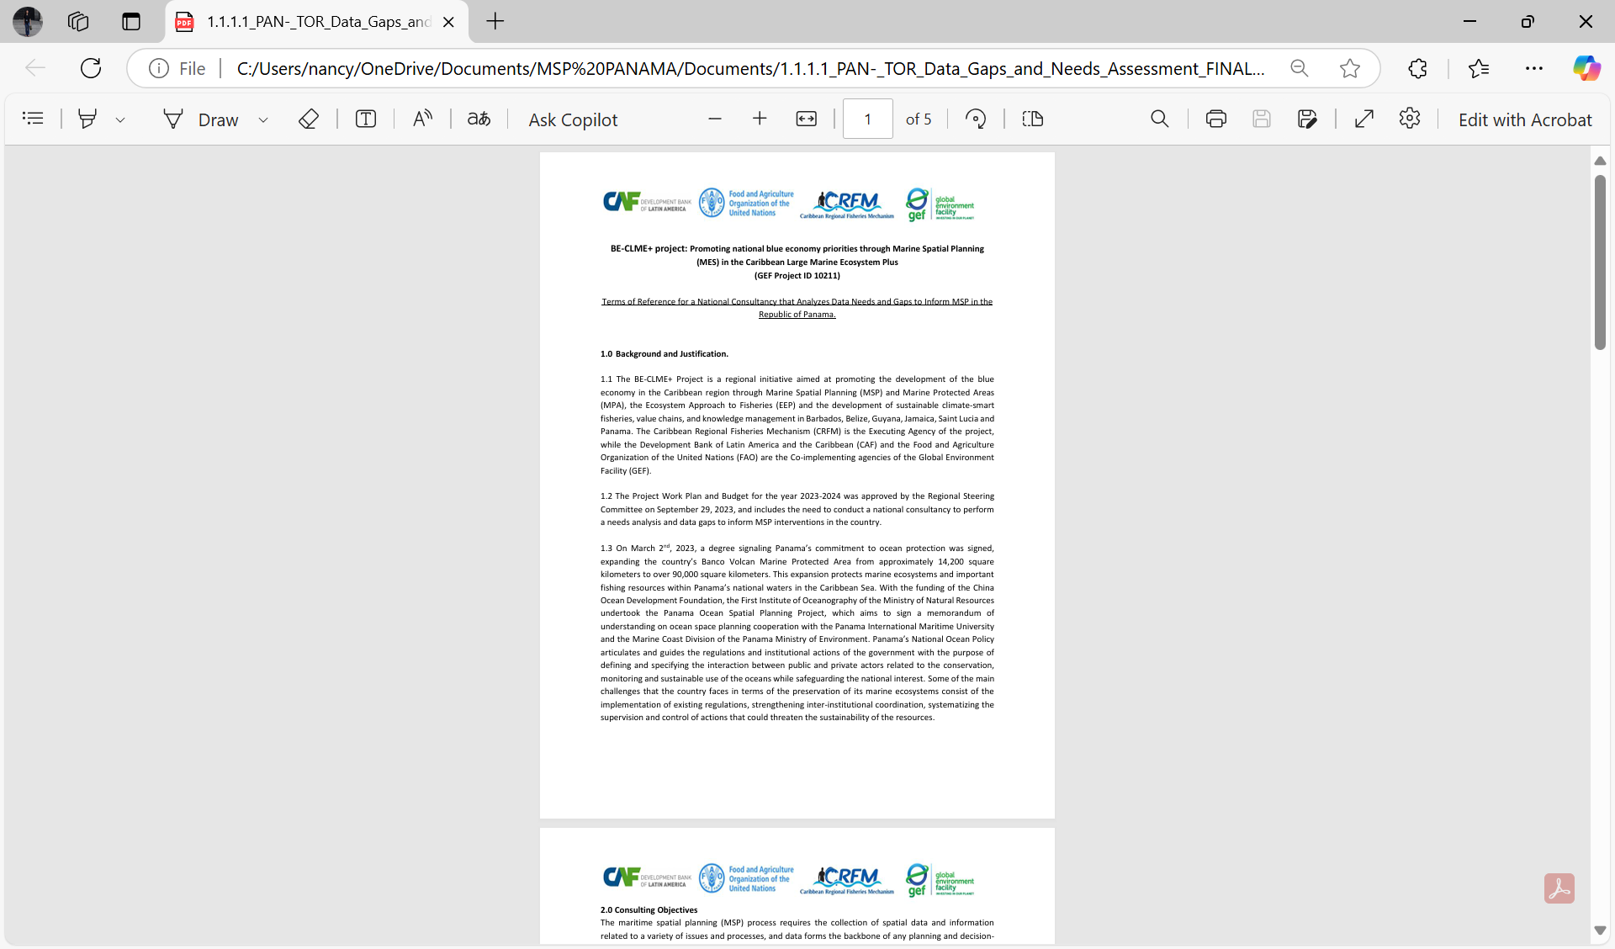 | 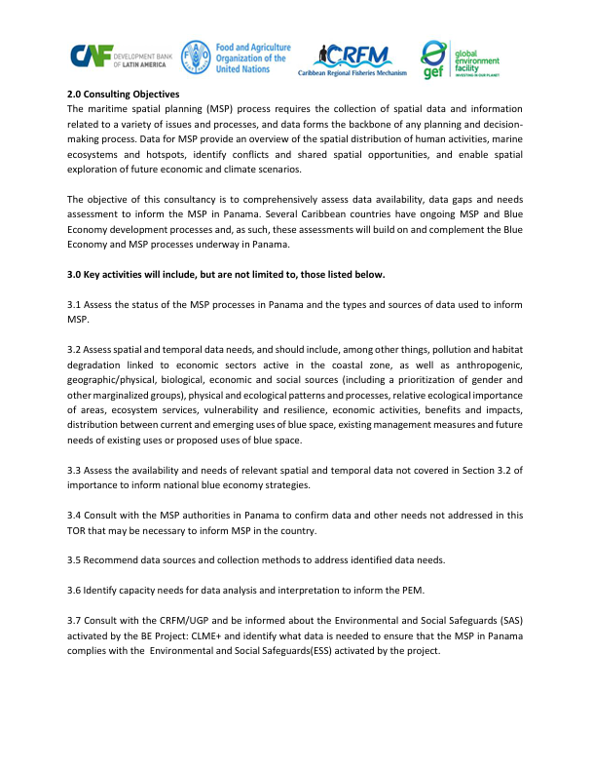
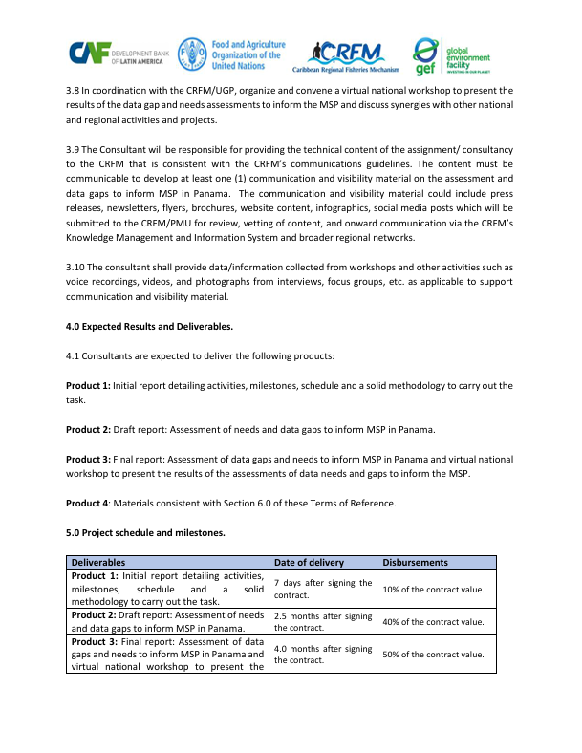 | 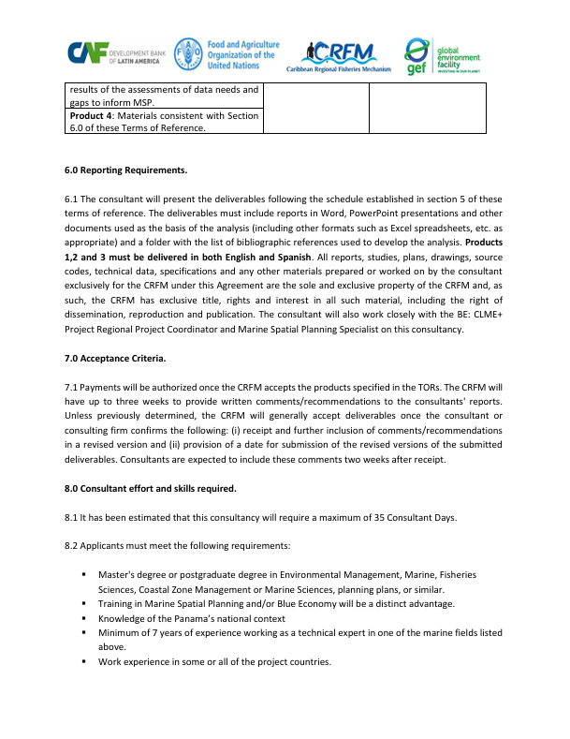
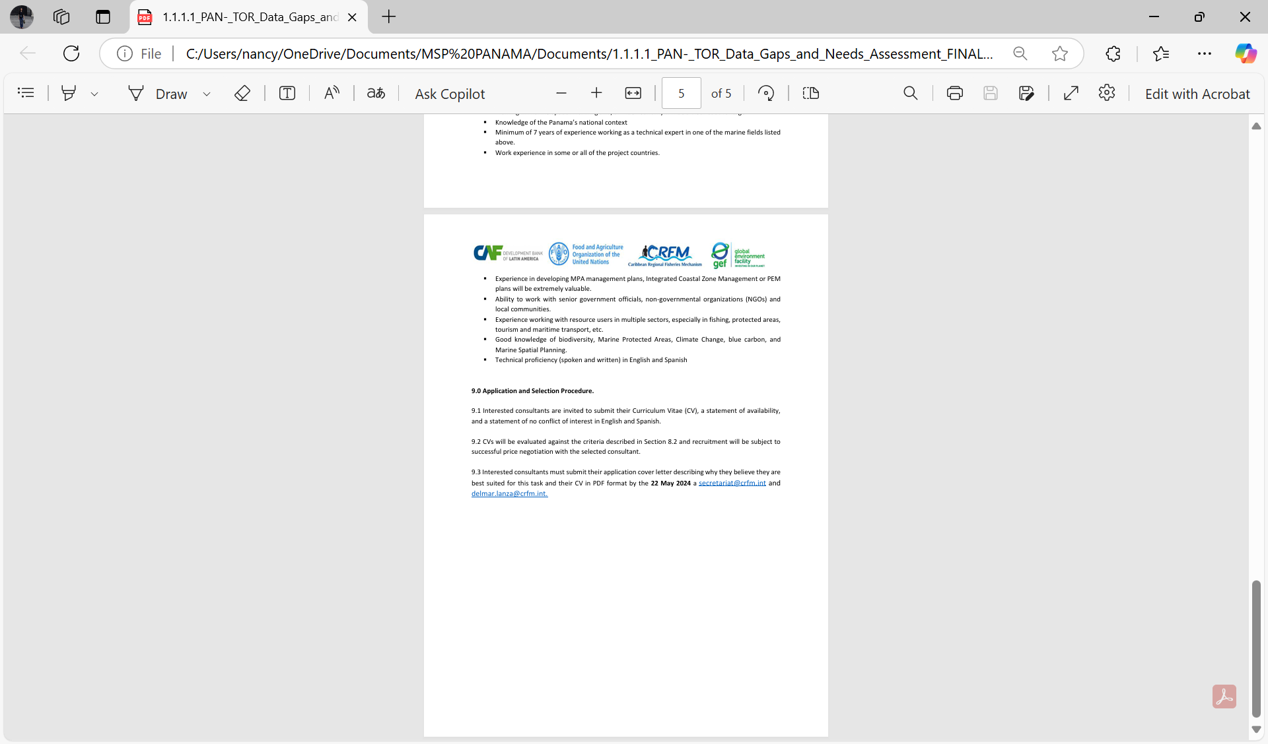

Appendix 2. Inception Meeting

Inception Meeting Agenda 12/03/2024 12-00—13:00pm EST.
- Welcome and introductions.
- Overview of BE: CLME+ Project
- Objective of the assignment
- Understanding of and approach to the assignment (methodology/ workplan)
- Resource needs and support from national agencies and project partners
- Roles, responsibilities and reporting requirements.
- Next steps
Participants:
Allena Joseph — CRFM-BE: CLME+ Project
Dayne Buddo — CRFM-BE: CLME+ Project
Jorge Elias Jaen Bonilla — PANAMA POC
Nancy Montes — Consultant

Appendix 3. Organizations that participated in the interviews and validation workshop
1. Panamá City, ARAP. Feb 11, 2025. ARAP Meeting Room.

Participant | Organization | Email | Gender
Juan Camilo Hurtado | Ministry of Environment | churtado@miambiente.gob.pa | Male
Jorge Jaen | Ministry of Environment | jejaen@miambiente.gob.pa | Male
Genesis Mendez | ARAP | gmendez@arap.gob.pa | Female
Manuel Castillo | National Aeronaval Service | manuelgomezoroa@gmail.com | Male
Alvin Chavez | Ministry of Environment | adchavez@miambiente.gob.pa | Male
Leyka Martines | ARAP | lmartinez@conap.gob | Female
Juan M. Posada | MarViva Foundation | juan.posada@marviva.net | Male
Jazmin Villarreal | ARAP-OSPESCA | yvillarreal@arap.gob.pa | Female

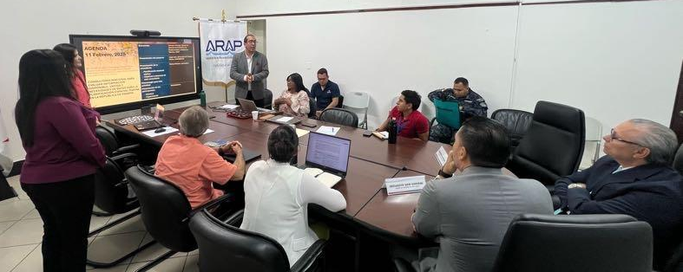

2. Isla Colon, Municipality building. Feb 13, 2025:

Participant | Organization | Email | Gender
Alex Hansen | Panama Maritime Authority | alexhansen@amp.gob.pa | Male
Angel Gonzalez | Bocas Alliance | angelbocas@yahoo.com | Male
Deynis Gonzalez | Ministry of Environment |  | Male
Alberto Saa | ARAP | alberto_saa@yahoo.com | Male
Alvin Chavez | Ministry of Environment | adchavez@miambiente.gob.pa | Male
Nancy Montes | Consultor | nancymontes@gmail.com | Female

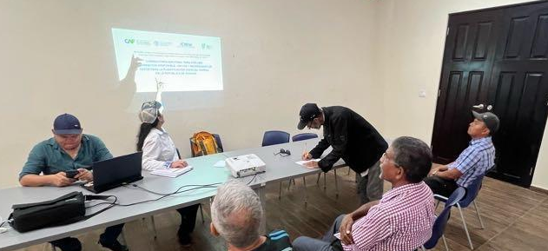

3. Chiriquí Grande, Municipality building. Feb 14, 2025:
Participant | Organization | Email | Gender
Alvin Chavez | Ministry of Environment | adchavez@miambiente.gob.pa | Male
Jesus Pineda | ARAP | pineda@arap.gob.pa | Male
Alfonso Simon | Sitramar | alfonsosimon@gmail.com | Male
Saul Jagao | Fisherman |  | Male
Alonso Trottman | Meren Kr. |  | Male
Oriel Quintana | Sitramar | oaquinta@gmail.com | Male
Leopoldo Santiago | OBC Paloma Key |  | Male
Obando Batres | Local authority, justice of the peace |  | Male
Nancy Montes | Consultor | nancymontes@gmail.com | Female

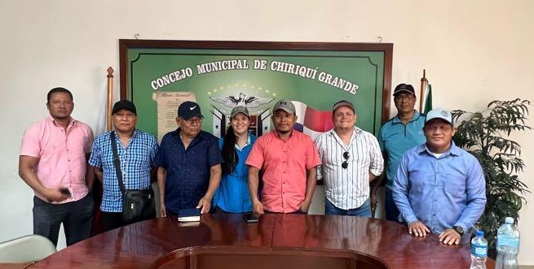

Table 6 Interviewed stakeholders during the site visit in the Boca del Toro region.
Organization | Contact Information | # of participants | Gender | Age group  Years
Almirante
Valencia Maritime Transportation Valencia | 67445943 | 1 | Male | 41-60
Federation of Maritime Transportation of Bocas del Toro | Eustaquio Valencia, president 67046530  Atencio Napoleón Pante 63434488 | 1 | Male | >60
Marine Transportation from Bocas del Toro (bocatoreños)  Almirante-Bocas | 67849268  67111843 | 1 | Male | 41-60
Torre Maritime Tourism Transportation | 64380807 | 2 | Males | 41-60
Bocas del Toro Amaranth | Two boat operators were interviewed 63342465 | 2 | Males | 19-40  41-60
Union of Artisanal Fishers from Bocas del Toro | Martha Machazeck, president  7583622 | 3 | Male  2 Females | 41-60
Colon Island
Boat operators from Bastimento and the archipelago Private tours and water taxi | Carl Powell, vice-president 67392307  Enrique Forbes, president 66922342 | 1 | Male | 41-60
United Association of Bocas del Toro Boat Operators | Office 7579760. www.boterosunidos.bocas.com | 1 interview  6 other present | Male | 41-60
Copeguitour | Fabio Rojas, secretary 67857968  Eduardo Batista, president 60358206 | 1 | Male | 19-40
Bocas dive center | info@bocasdivecenter.com | 1 | Female | 19-40
Bocas mariculture | Till Deuss | 2 | 1 Male  1 Female | 19-40
Smithsonian Tropical Institute | Plinio Gondola, scientific coordinator | 1 | Male | 41-60
Dyre Aqua | Alcibiades Araúz | 1 | Male | 41-60

4. Virtual validation workshop. May 2, 2025 10:00am – 12:15pm (Panama time).
The validation workshop was held in a hybrid format, with in-person attendees at the Municipality building in Isla Colon, Bocas del Toro.

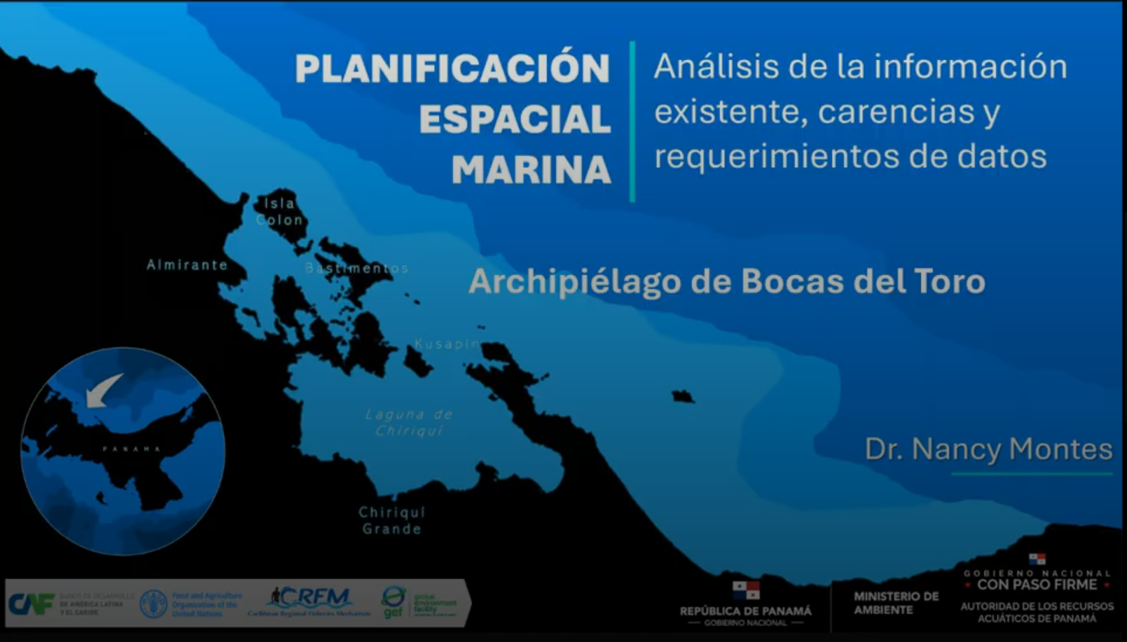 | 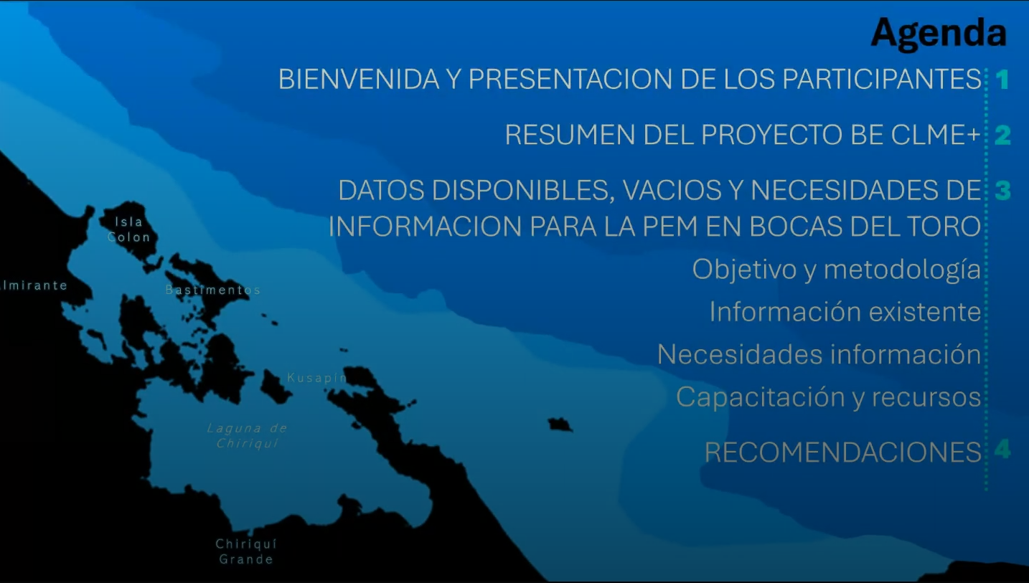

Table 7 Validation workshop participants.
Participants | Organization | Gender
Ernesto Albares | President Fisherfolks of San Cristóbal | Male
Alberto SAA | ARAP- oceanographer | Male
Andres Gonzalez | Bocas Alliance | Male
Sabedra Smith | Community of San Cristóbal | Male
Samuel Jimenez | Community of San Cristóbal | Male
Fernabe | Community of San Cristóbal | Male
Alex Sancer | AMP on Colon Island | Male
Alvaro Smith | Fisherfolk Organization of San Cristóbal | Male
Ignacio Quintero | Community of San Cristóbal | Male
Till Deuss | Mariculture Bocas SA | Male
Alcibiades Araúz | Dyer Aqua Panama | Male
Javier Machazeck | Regional Director ARAP | Male
Anastacio Boe | Ministry of Environment | Male
Jorge Jaenz | Ministry of Environment | Male
Alvin Chavez | Ministry of Environment | Male
Genesis Mendez | ARAP | Female
Jazmin Villareal | ARAP-OSPESCA | Female
Alfonso Simon | Bocas district | Male
Feliz |  | Male

Appendix 4. Questionnaire used to guide interviews
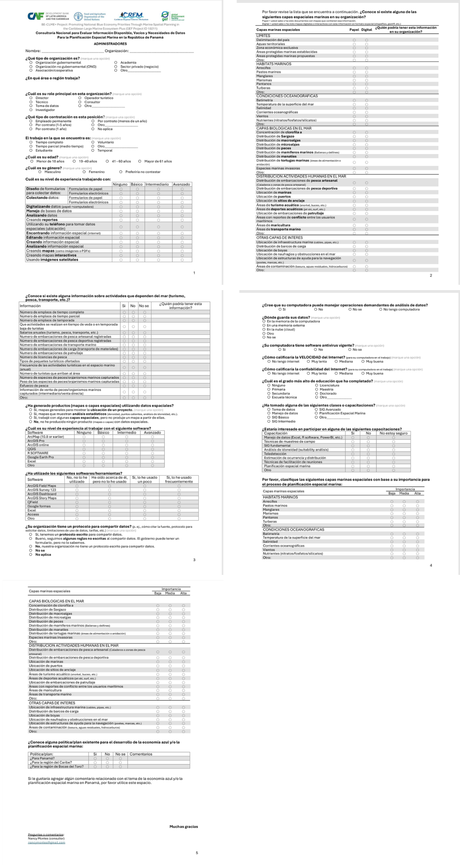

Appendix 5. Communication and Outreach material
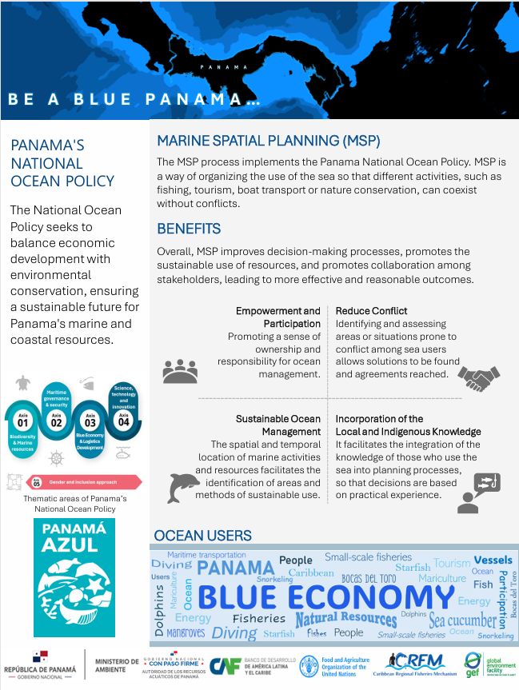

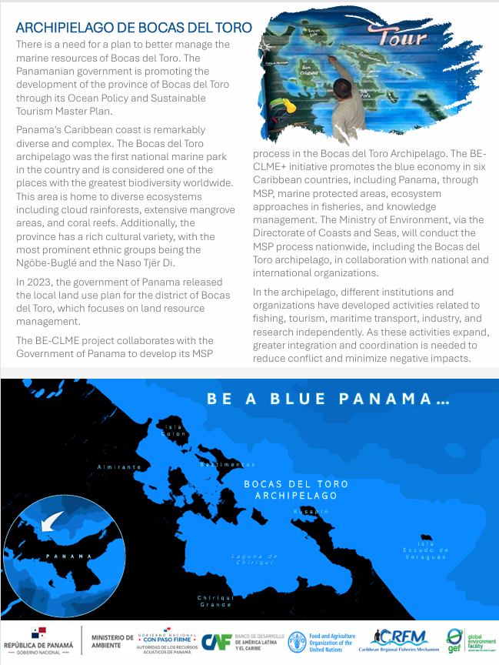

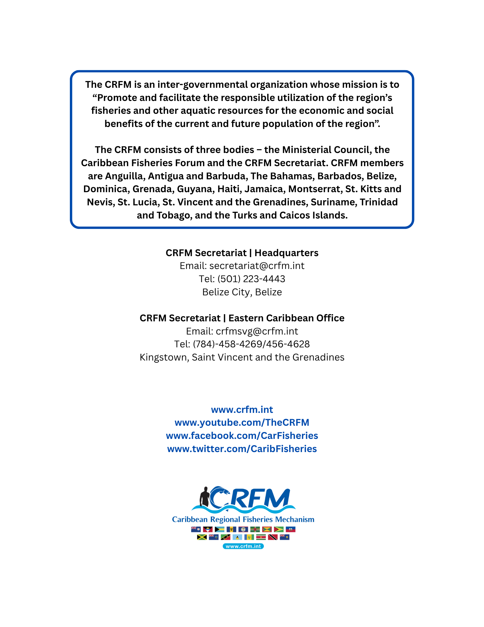

This information is used as a proxy for infrastructure value.

