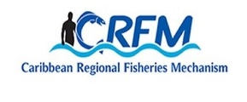




ISSN: 1995-1132

CRFM Technical & Advisory Document
No. 2025 / 13

FINAL REPORT
DATA GAP AND NEEDS ASSESSMENT TO INFORM MARINE SPACIAL PLANNING IN BARBADOS

CRFM Secretariat
Belize

CRFM Technical & Advisory Document -
Number 2025 / 13

Data Gap and Needs Assessment to Inform Marine Spatial Planning in Barbados

Prepared by: Nancy Montes
Consultant
Geographic Information System and Human Dimensions Specialist.

This publication has been made possible through funding by BE-CLME+ Project: Promoting National Blue Economy Priorities Through Marine Spatial Planning in the Caribbean Large Marine Ecosystem Plus - GEF Project ID 10211

CRFM Secretariat
Belize
2025
CRFM Technical & Advisory Document Number 2025/ 13

Data Gap and Needs Assessment to Inform Marine Spatial Planning in Barbados

© CRFM 2025
All rights reserved.
Reproduction, dissemination and use of material in this publication for educational or non-commercial purposes are authorised without prior written permission of the CRFM, provided the source is fully acknowledged. No part of this publication may be reproduced, disseminated or used for any commercial purposes or resold without the prior written permission of the CRFM.

Correct Citation:
CRFM, 2025. Data Gap and Needs Assessment to Inform Marine Spatial Planning in Barbados. CRFM Technical & Advisory Report No. 2025 /13 124pp.

ISSN: 1995-1132
ISBN: 978-976-8293-99-2

Published by the Caribbean Regional Fisheries Mechanism Secretariat
Belize and St. Vincent and the Grenadines

Executive Summary
Since 2018, with the creation of the Ministry of Maritime Affairs and the Blue Economy (BE) the government of Barbados has been promoting the sustainable use of ocean resources for economic growth, improved livelihoods, and jobs while preserving the health of ocean ecosystems (on the entire exclusive economic zone —EEZ). These efforts are supported by a financial initiative called “Blue Bond for Ocean Conservation” and made possible with the support from TNC and the Inter-American Development Bank. This initiative allows the country to reduce its international debt and will direct an estimated $50 million into a comprehensive marine protection effort.
In 2021, with funding from the Inter-American Bank, the government adopted the Blue Economy Policy Framework and Strategic Action Plan (IADB, 2021) to guide development of that country’s blue economy. While the BE focuses on leveraging ocean resources sustainably, Marine Spatial Planning (MSP) provides the tools and processes to manage marine environments effectively through the optimization of the use of marine space, user conflict remediation and enhancing the health of the marine ecosystem.
Because of the integration between the BE and the MSP process, the government is currently developing the “Barbados Marine Spatial Planning Design Guide”. This document will be used as an internal document to guide the process of developing the MSP, providing information on elements related to strategic direction, project management processes, and communications for use by the MSP planning team (GOB, 2023). A MSP Project Unit (within the Barbados Coastal Zone Management Unit) is undertaking the tasks and activities for the MSP process with the support of other government agencies (including the Barbados Fisheries Division), non-governmental organization (such as The Nature Conservancy), and academic institutions (such as Centre for Resource Management and Environmental Studies), among others.
Regional initiatives are also aiding this process, including key partners such as TNC. Furthermore, this consultancy to conduct a data gap and needs assessment is being supported by the BE-CLME+ Project: Promoting National Blue Economy Priorities Through Marine Spatial Planning in the Caribbean Large Marine Ecosystem Plus (GEF Project ID 10211).
The objective of this consultancy is to develop a comprehensive assessment of data gaps and needs (focused on the fisheries sector) to inform MSP in Barbados. To this end, three interconnected activities were implemented:
- a systematic literature and web review which included scholarly works and gray literature developed by governments, international agencies, and NGO’s. At least 240 documents were reviewed.
- a participatory mapping exercise involving fisherfolks. The objectives of this activity were to map important areas related to the fisheries sector, and to facilitate the engagement of fisherfolks in the marine spatial planning process. Two mapping sessions were conducted with the support of the Barbados Fisheries Division (BFD). This activity jump-started data collection on desired fishing themes and the participation of fisherfolk in the MSP process. The BFD will organize and implement further mapping sessions to increase sample size and the representativeness of this information.
- structured interviews with key stakeholders representing the fisheries sector. Interviews were conducted via email, face to face, and via phone (WhatsApp). Solicited information included awareness of spatial layers related to the fisheries sector, data sharing protocols, and perception of needed spatial data to inform MSP.
The overarching goal of the BE Roadmap is “to create and implement governance that enables inclusive and distributive economic growth within the limits of healthy and resilient marine ecosystems” (IADB, 2021; Singh-Renton, 2024). Similarly, the MSP incorporates a holistic approach by considering ecological, economic, and social factors and integrating multiple uses for an inclusive decision-making that considers the needs and inputs of multiple parties. The BE Policy Framework and Strategic Action Plan proposed pivotal sectors are fisheries, tourism, marine transportation, energy, marine technology, marine services, and maritime non-living resources (e.g., sand, minerals, etc.) (IADB, 2021).
This assessment focused on the fisheries sector that might operate on the entire EEZ of Barbados. The BE Roadmap proposed goal for the fisheries sector is “a sustainable fisheries sector, that enables inclusive and distributive economic growth within the limits of healthy and resilient marine ecosystems, through enabling policies for equitable participation, environmental and social protection, industry growth and diversification, clean technologies, circular material flows, and outcome-based management (Singh-Renton, 2024).”
The MSP process in Barbados is still in the early stages of development (step 3 and 5) and zones have yet to be determined. The MSP process is typically divided into the following steps:
- Identifying need and establishing authority  - Obtaining financial support  - Organizing the process through pre-planning  - Organizing stakeholder participation  - Defining and analyzing existing conditions | - Defining and analyzing future conditions  - Preparing and approving the spatial management plan  - Implementing & enforcing the spatial management plan measures  - Monitoring and evaluating performance  - Adapting the spatial management process
In terms of available data to inform MSP, this assessment found that although some data, related to the fisheries sector, is available (e.g., distribution of seine, longline, fishery, sea urchin, queen conch fishing grounds, etc.), its use for MSP may be limited because it requires effort and time to bring all the current data into one geospatial platform. For instance, when describing the distribution of the fishery sector, some layers show the distribution of fishing areas by gear while others describe the distribution by target species. Furthermore, in some cases the distribution of the fishery in question is symbolized using dots, while in other cases it is displayed using polygons or grid cells. Additionally, much of the current data is outdated and it represents a single or limited snapshot of the distribution of the feature of interest. During the MSP step 5 (defining and analyzing existing conditions) the use of the current data types from the existing literature is going to be challenging. Further analysis (e.g., scenario modeling) and systems to collect and analyze longitudinal data will be required to better support the MSP process in Barbados.
Like data pertaining to the fisheries sector, other associated data (e.g., marine habitats, species distribution, risk assessments, etc.) present some challenges. The limitations identified for data currently available is that most of it is in a non-spatial format (e.g., contained in reports as images); some of the data is more than 10 years old which limits its relevance in dynamic environments; some data were created with specific objectives and outputs that might not align with MSP processes and goals; most of the current data does not cover the entire of Barbados’ Exclusive Economic Zone (EEZ); the target species and themes characterizing features potentially relevant to MSP are limited and data collection protocols will have to be developed and implemented to fill data gaps in spatial and temporal resolution. Addressing these limitations requires collaborative efforts among stakeholders, investment in data collection and management, and the development of standardized practices to enhance the quality and accessibility of marine data.
In terms of technological resources, both the CZMU and the BFD meet the minimum hardware requirements for installing and working with GIS software. They also have backup systems and antivirus software. However, the current internet connectivity (speed and reliability) could be improved. Furthermore, the government of Barbados has not negotiated a multiagency ESRI license. Therefore, each agency must secure funding and negotiate their individual license with an authorized distributor or use alternative software. At the time of the assessment, CZMU was utilizing ESRI products, but the BFD was in the process of getting its license. It is recommended that all relevant sectors (and agencies) use the same software for data collection, management and sharing. This will facilitate integrating data from multiple sources into a unified MSP platform or system.
An essential factor in the success of MSP is human capacity. It encompasses the skills, knowledge, and resources that individuals and organizations possess to effectively engage in the MSP process. There are discrepancies regarding human resources between the CZMU and the BFD. The CZMU MSP team is integrated by a multidisciplinary team with GIS knowledge ranging from intermediate to advanced. While the BFD has limited personnel with only basic knowledge in GIS. However, due to lengthy hiring processes and salary funding sources, in both cases, several people interviewed from BFD and the CZMU are yearly contracted personnel, which could create an unstable environment and a greater personnel turnover. Capacity development should also be promoted through the different agencies. Including training and outreach opportunities for key stakeholders and the public in general should also be provided. This will help to implement more effective, equitable, and sustainable marine management strategies that balance ecological health with human needs and values.

Finally, MSP presents an opportunity to promote collaboration and synergy among government agencies, non-profit organizations, and academic institutions to collectively assist in capacity development and the refinement of processes for data collection, meta-data, storage, and analysis to underpin MSP policy, stakeholder engagement and buy-in, and enforcement.

Table of Contents
Executive Summary i
Introduction 1
Objective 5
Approach and Methodology 5
Systematic literature review and spatial data exploration 5
Participatory mapping exercise 6
Interviews with key stakeholders in the fisheries sector. 8
Results and Discussion 8
Assessment of the status of MSP processes in Barbados 8
Data currently available that could be used to inform MSP 9
Fisheries Distribution 9
Participatory Mapping 19
Marine Habitats 25
Species distribution 31
Oceanographic Data 44
Other relevant layers for the fisheries sector 45
Fisheries related data gaps 53
Fisheries related data needs to inform MSP 55
Data access 61
Technological and human resources 62
Technological resources 62
Human resources 69
Recommendations 72
Conclusions 75
References 76
Appendix 83
Appendix 1: Terms of Reference (TOR) 83
Appendix 2: Inception Meeting 87
Appendix 3. SeaSketch project 88
Appendix 4. List of participants of the mapping exercices 97
Appendix 5. Participant’s profile survey 97
Appendix 6. Mapping exercise instructions for each station 98
Appendix 7. Digital data collection instructions 101
Appendix 8. The contact list used to request input through interviews, emails, and during the participatory mapping exercise. 103
Appendix 9. Questionnaire used to guide interviews 105
Appendix 10. Working agenda of the national validation workshop 110
Appendix 11. National validation workshop invitation (communication product) 111
Appendix 12. National validation workshop list of participants. 112
Appendix 13. MSP brochure (communication product) 113

List of Figures

Figure 1. Barbados territorial sea (12nm) and exclusive economic zone (200nm) boundaries…………………….. | 1
Figure 2. MSP steps………..…………………………………………………………………………………………………………… | 4
Figure 3. Mapping exercise…………………………………………………………………………………………………………… | 7
Figure 4. Poster maps used during the mapping exercise……………………………………………………………………. | 7
Figure 5. Participants’ boat, gear, and positioning system characteristics……………………………………………… | 20
Figure 6. Current fishing grounds ………………………………………………........................................................... | 21
Figure 7. Historical fishing grounds…………………………………………………………………………………………….…… | 23
Figure 8. Fish nursing grounds…………………………………………………………………………………………………….…. | 23
Figure 9. FADs locations………………………………………………………………………………………………………………. | 24
Figure 10. Observed user conflict ………………………………………………………………………………………………….. | 24
Figure 11. CZMU Fishing areas survey ………………………………………………………………………………………….…. | 64
Figure 12. A collaborative framework for integrating fisheries interest into the MSP process.….…..……………... | 75

List of Tables

Table 1. Barbados BE Action Plan/Roadmap essential sector ………………………………………………………….… | 1
Table 2. Current spatial information available related to the Fisheries sector ………………………………………… | 12
Table 3. Species identified for the current and historical fishing ground………………….…………………………….. | 21
Table 4. Current spatial information related to marine habitats….……………………………………………………….. | 25
Table 5. Current spatial information related to species distribution……………………………………………………… | 32
Table 6. Current spatial information related to oceanographic variables ………………………………………………. | 44
Table 7. Current spatial information related to other relevant layers…………………………………………...………… | 46
Table 8. Suggested data inputs for the early stages of the Barbados MSP related to the fisheries sector….…… | 56
Table 9. Comparison between ArcGIS and QGIS software…………………………………………………..…………….. | 64
Table 10. Comparison among selected MSP software……………………………………………………………………... | 67
Table 11. Suggested trainings for technicians supporting Barbados MSP process………………………….……… | 71

List of Acronyms and Abbreviations

BE | Blue Economy
BFD | Barbados Fisheries Division
CAF | Development Bank of Latin America and the Caribbean
CERMES | Centre for Resource Management and Environmental Studies
ESRI | Environmental Systems Research Institute, Inc.
FAO | Food and Agriculture Organization of the United Nations
GEF | Global Environmental Facility
GIS | Geographic Information Systems
GOB | Government of Barbados
CLME | Caribbean Large Marine Ecosystem
CZMU | Coastal Zone Management Unit
CRFM | Caribbean Region Fisheries Mechanism
ESS | Environmental and Social Safeguards
FADs | Fish Aggregating Devices
MSP | Marine Spatial Planning
NGO | Non-Governmental Organization
PMU | Project Management Unit
POC | Point of Contact
TNC | The Nature Conservancy
TOR | Terms of Reference

Introduction
Marine Spatial Planning (MSP) is an adaptive process to analyze the spatial and temporal distribution of bio-physical features and human activities in marine and coastal areas. These data underpin policy and management that strive to balance the protection of human needs and the integrity of marine resources to achieve ecological, economic, and social objectives (Douvere & Ehler, 2009).
The Barbados Blue Economy Policy Framework and Strategic Action Plan is intended to guide the development of the country’s blue economy (IADB, 2021). In support of this plan, the government of Barbados (GOB) has signed onto the “blue bond” agreement which is currently supporting the development of the country’s MSP. The planning area will include Barbados’ maritime areas (Territorial Sea and Exclusive Economic Zone) (Figure 1).
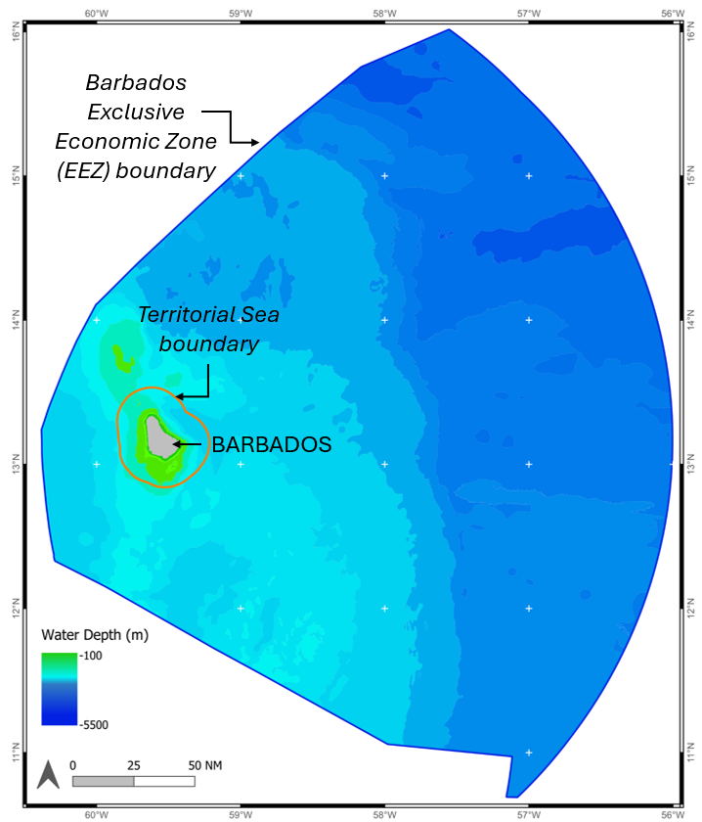
Figure 1. Barbados territorial sea (12nm) and exclusive economic zone (200nm) boundaries.
The MSP encompasses a holistic approach by considering ecological, economic, and social factors and integrating multiple uses and stakeholders (each with unique interests and responsibilities) for an inclusive decision-making that considers the needs and inputs of multiple parties. Effective MSP requires collaboration among these stakeholders to balance competing interests, promote sustainable use, protect marine ecosystems, and enhance livelihoods. Engaging all relevant parties early in the planning process ensure diverse perspectives are considered and actions to implement a marine spatial plan have greater support from the different ocean users. Table 1 describes Barbados proposed pivotal sectors (IADB, 2021).
Table 1. Barbados BE Action Plan/Roadmap essential sectors (IDB, 2021).
Sector | Description
Fisheries | Involves the harvesting, processing, and distribution of fish and other aquatic organisms for human consumption and other uses.
Tourism | All activities and services related to travel and hospitality.
Marine transportation | Involves the movement of goods and people over water using various types of vessels.
Energy | All activities related to production, distribution, and consumption of energy.
Marine technology | Relies on bioprospecting, market demand, R&D, as well as the availability of sustainable supplies of the resource that are confirmed by surveys and  inventories. It is also supported by the feasibility of harvesting biomaterials given the logistical considerations, environmental impacts, and profitability.
Marine services | These services include mapping and data collection, engineering, data management systems, maritime surveillance, compliance and safety inspections through monitoring and enforcement, risk management,  insurance, financial services, production of metocean data, and support services for offshore industries such as offshore oil and gas exploration and mining.
Maritime non-living resources | Includes marine aggregates, sands, and deep-sea minerals.

The Coastal Zone Management Unit (CZMU) is the leading agency responsible for the execution of the MSP. Its mission is to develop and implement a national risk resilient Integrated Coastal Zone Management policy and planning framework and, through acting as key advisors to government, support the provision and coordination of quality, timely and relevant information to those who require it. A Marine Spatial Plan Project Unit (within the CZMU) is undertaking the tasks and activities for the MSP process with the support of specialists and consultants. This unit will coordinate with the different BE pivotal sectors (Table 1).
This data gaps and needs assessment is being supported by the BE-CLME+ Project, which is a regional initiative aimed at promoting blue economy development in the Caribbean region through MSP and marine protected areas, ecosystem approaches to fisheries, development of climate-smart sustainable fisheries value chains, and knowledge management in six Caribbean countries —including Barbados.
This consultancy focuses on the Barbados fisheries sector. The BE action plan/roadmap specific objectives for the fisheries sector include building climate resilience, improving sustainability, and improving community access to high value capture fisheries (HVCF), as well as developing the value chains associated with HVCFs, extending the range of HVCFs, and exploring mariculture options (IADB, 2021). These objectives will require supporting data not only related to the fisheries (spatial and temporal distribution of the different fisheries) but also more and better data of commercially important fish species and the potential for the development of mariculture opportunities. Therefore, this consultancy worked with Barbados’ Fisheries Division on an assessment of needs, data availability and data gaps, specifically related to the fisheries sector, to contribute to the work currently being undertaken by the CZMU to inform the MSP process in Barbados.
The government of Barbados has developed the Barbados Fisheries Policy 2023—2033 as part of the ongoing BE agenda. “The policy provides for a set of principles and guidelines that will serve as an overall framework for guiding public action and related investments in the sector and support the forthcoming Sustainable Fisheries Management and Development Suite of Laws and an updated Fisheries Management Plan” (Fisheries Division, 2023). The integration of MSP into this policy is fundamental for achieving holistic management of the country's marine environments. Some synergies between this policy and MSP are:
- Sustainability goals: Both the fisheries policy and MSP aim to promote sustainable use of marine resources, ensuring that fishing practices do not deplete stocks or harm marine ecosystems.
- Ecosystem-based management: Both frameworks advocate ecosystem-based approaches, considering the interconnections between species, habitats, and human activities in marine environments.
- Data-driven decisions: Effective MSP relies on comprehensive data collection and analysis. Barbados' fisheries policy encourages the improvement of existing data collection system to support scientific research, economic analysis, and local knowledge to inform management decisions.
- Zoning: MSP provides a framework for spatially managing different marine activities, such as fishing, tourism, and conservation. Zoning can help reduce conflicts between sectors and protect critical habitats.
- Stakeholder engagement: The fisheries policy emphasizes the importance of involving fishers, local communities, and other stakeholders in decision-making processes. MSP facilitates this engagement by bringing various interests together.
- Capacity building: Both initiatives stress the importance of capacity building for fishers and communities, enhancing their ability to participate effectively in fisheries management and MSP processes.
- Monitoring and evaluation: Regular monitoring and evaluation of marine activities are essential components of both frameworks, helping to assess the effectiveness of management measures and adjust them as needed.
This holistic approach promotes collaboration, stakeholder engagement, and informed decision-making, ultimately benefiting both people and the environment.
The MSP process is typically divided into steps (Fig. 2), each critical for creating and implementing an effective marine spatial plan. An initial analysis can be performed with existing data to establish a baseline and to initiate stakeholder dialogue and participation (steps 1 to 4). However, as the process evolves, more reliable data should be secured (step 5 & 6) and/or use to improve results and adapt the spatial management process (steps 9 & 10). Stakeholders’ input is central throughout the different steps to ensure that results (and their implications) reflect true and acceptable conditions. The MSP process in Barbados is still in the early stages of development (step 3 and 5) and zones have yet to be determined.
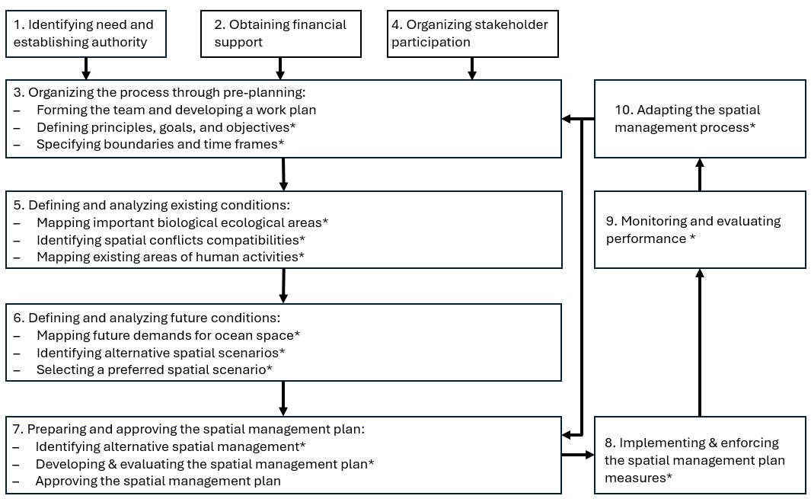
Figure 2. MSP steps (Ehler& Douvere, 2009). Asterisk (*) indicates stakeholder participation in step.
The MSP process should be guided by clear objectives. However, in terms of data needs, four broad categories have been identified in the literature (World Bank, 2022):
- Administrative boundaries: A limit or border of a geographic area under study or area of interest. Example of these layers are national, territorial, EEZ, protected areas, etc.
- Physical, chemical, and biological features and processes: This information provides details about the physical and chemical conditions and processes in the ocean (e.g., sea surface temperature, bathymetry, etc.). It also includes biological features and processes which include data on the distribution and/or condition/status of marine-related species (e.g., fish, birds, sea turtles, coral reefs, pollution, invasive species, etc.).
- Human activities and uses: these layers are used to identify temporal and spatial geographic areas where human activities of interest are taking place, for example, shipping channels or lanes, fishing effort, location of fish aggregating devices (FADs), underwater heritage sites, etc.
- Socio-economic: the inclusion of this information in MSP varies. This information is usually obtained through trade-offs and economic valuation studies.
The MSP process requires the collection of spatial data and information underpinning planning processes and collaborative decision-making. Data for MSP is intended to help characterize the spatial distribution of human activities within marine ecosystems, allowing for the prioritization of zones compatible for various human uses, zones that should be afforded some measure of environmental protection, and zones that are suitable for shared space opportunities. Data collected for MSP may also be relevant in evaluating future economic and climate scenarios.

Objective
The objective of this consultancy is to comprehensively assess data availability, data gaps and data needs - specifically related to the fisheries sector - to inform MSP in Barbados. Several countries in the Caribbean, including Barbados, have initiated MSP and Blue Economy development processes, and as such, the assessment is intended to complement ongoing BE processes in Barbados (Appendix 1).

Approach and Methodology
Our approach consisted of 3 interconnected activities: (1) a systematic literature review and on-line exploration for relevant spatial data (2) a participatory mapping exercise involving small-scale fishers to identify and map zones that are important to their fishing activities; and (3) an assessment of organizational capacity and needs through interviews with key stakeholders in the fisheries management sector.

Systematic literature review and spatial data exploration
An online literature review (activity 1) was conducted to identify publicly available information and spatially represented data (print or digital) relevant to the objective and activities of this consultancy. This review included scholarly works and gray literature developed by governments, international agencies, and NGO’s. The review included information pertinent to recommending data sources, acquisition costs (where applicable), and collection methods.
The main databases queried were Google Scholar (97 results 04/20/2024), CERMES technical reports (109 results 05/010/2024), and AquaDocs (35 results 05/08/2024). Terms used during online searches included “Barbados”, “fisheries.” Each result was scanned for spatial data (e.g., GPS information, maps, or geospatial file information). Furthermore, during the interviews (activity 3), participants were asked to provide any lead to known research or projects with spatial or geo-referenced data.
Spatial atlases and databases were also explored using the same search terms and through a snowball method (if a layer was found, other information shared by the author of that layer and his/her organization was investigated). Below is a description of the atlases and databases identified.
- ArcGIS Online is a cloud-based mapping and analysis platform. It is used to create maps and analyze spatial data which can be easily shared with other users. It requires the creation of an account.
- Mapping Ocean Wealth provides spatial information about the economic, social, and cultural values of coastal and marine habitats worldwide. Several topics are available in the mapping tool including the value of healthy ecosystems to the tourism industry, coastal protection benefits of coral reefs, and status of coral reef fisheries, among others.
- Resource Watch (World Resource Institute —WRI) features several data sets such as coral bleaching monitoring, water temperature and salinity, commercial shipping lanes, among others. Data can be visualized through their mapping platform, and it is also easily downloaded.
- Caribbean Science Atlas (The Nature Conservancy —TNC) provides a compilation of the TNC scientific resources. Data can be visualized and downloaded for further analysis. It also provides tools such as the Blue Carbon Explorer, Climate Mitigation, Coral Restoration, Climate Adaptation, and Marine Protection. Layers available through these tools can be requested by providing a brief description of how the layer will be used.
A complete inventory and description of spatial data references identified is provided in tables 2-7.

Participatory mapping exercise
The objectives of the mapping exercise were to: (1) map important areas related to the fisheries sector, drawing from participants’ local knowledge, and (2) facilitate the engagement of fisherfolks in the marine spatial planning process.
2.1. Pre-mapping exercise activities:
In coordination with the Fisheries Division, a SeaSketch project was created (Appendix 3) to facilitate two participatory mapping workshops with fishers (activity 2). SeaSketch is an online mapping platform that can be used to engage stakeholders and collect spatial information. The SeaSketch project developed for this activity consisted of an online map in which different spatial layers can be accessed by the data collector to guide discussions with fisherfolk (e.g., country boundaries, administrative divisions, location of fish landing sites, bathymetry, benthic habitats, vessel distribution, etc.). Layers used for the SeaSketch project were obtained through searches in mapping atlases (e.g., ArcGIS online, Caribbean Science Atlas, etc.). The SeaSketch application was used to guide discussions with fisherfolk to identify current fishing grounds, fish nursing areas, fish aggregation sites, localities of observed user conflict, and the location of any known FADs. Mapped information was connected to a set of questions to gather information about the participants being interviewed (e.g., age, fishing experience, gear used, etc.).
2.2. Participatory Mapping Sessions:
Two participatory mapping sessions organized by the BFD were held with fishers on May 6, 2024 (first session) and May 7, 2024 (second session). The first session, held at the Barbados Fisheries Division, was attended by 16 fishers (Fig. 3). The second session, attended by 12 fishers, took place at the Oistins Fisherfolk Cooperative. Small-scale, recreational, and commercial fishers participated in this mapping exercise (Appendix 4: list of participants). Participants were also asked to complete a voluntary participant profile survey (e.g., what sector do you represent, what is your gender, etc.) (Appendix 5).
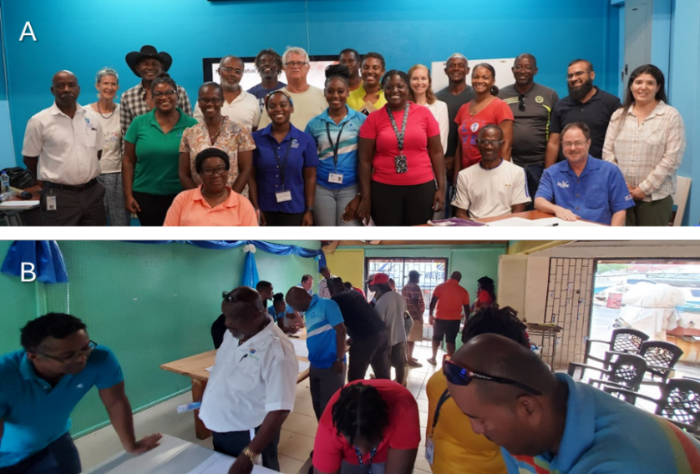
The consultants provided an overview of the mapping exercise and instructions to the participants to guide their discussions and demarcation of six key data layers where their input was needed (Appendix 6). Break out groups were organized into six stations allowing groups of fishers, discuss and map features characterizing:

Figure 3. Mapping exercise. A) Fisheries Division May 6, 2024. B) Oistins fisher cooperative May 7, 2024.
1. Current fishing grounds
2. Historical fishing grounds
3. Fish nursing grounds
4. Fish spawning aggregation areas
Figure SEQ Figure \* ARABIC 2. Poster maps (24x36 in) used during the exercise. A. Territorial sea (12nm). B. Exclusive Economic Zone.
5. Locations of known conflict
6. Locations of fish aggregation devices
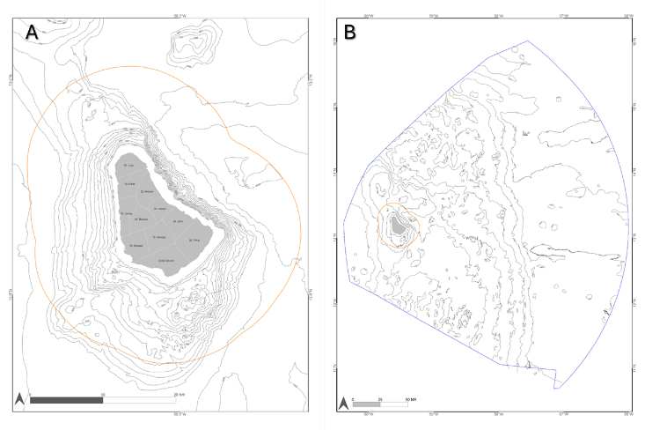
Discussion taking place at each station was facilitated by the consulting team, members from the BFD, CRFM, and CZMU, who were trained to complete specialized data forms corresponding to mapped features for each of the six topical areas. Two paper maps (24x36in) displaying the country’s administrative divisions and bathymetry were available per station (Fig. 4).

Figure 4. Poster maps (24x36 in) used during the exercise. A. Territorial Sea (12nm). B. Exclusive Economic Zone.
2.3 Mapping Exercise Follow-Up:
The Fisheries Division is currently in the process of acquiring the ArcGIS software and was interested in continuing their engagement with fisherfolk the MSP process using a digital data collection application that mimicked the mapping exercise sessions. A live demonstration of the form developed to continue data collection was conducted during a virtual meeting on May 23, 2024. The digital form was shared with the BFD data collectors to facilitate ongoing data collection. Step-by-step instructions on how to install the application and examples of how to use the application for data collection, online and offline, were presented to the fisheries division (Appendix 7).
Data obtained in the participatory mapping exercise was analyzed and summarized maps (when applicable) were created. The information provided by the fisherfolk was digitized as shapefiles (WGS84). A sampling grid (cells=0.5 x 0.5 km) was created to summarize polygon layers and to create density maps. Qualitative and quantitative methods were used to analyze the information obtained by the interviews and the mapping exercise.

Interviews with key stakeholders in the fisheries sector.
The target group was comprised of people that work/use fisheries spatial and temporal data. People invited to participate in the interviews were identified by the BFD (Appendix 8). Interviews were conducted via email, face to face, and via phone (WhatsApp). Solicited information included awareness of spatial layers related to the fisheries sector, data sharing protocols, and perception of needed spatial data to inform MSP, which was supported by a digital questionnaire designed and used to guide the interviews and ensure that relevant topics were discussed during the meetings (Appendix 9). The main topics discussed during the interviews were (1) the types of existing data and uses of that data, (2) data that is of interest but not being collected or represented spatially, (3) the technical capabilities and training needs/interests among staff to engage in marine spatial planning, and (4) the kinds of software and hardware that are now being utilized to fulfill data acquisition, storage, and analysis. The BFD and the CRFM reviewed the questionnaire and provided feedback.
A national validation workshop was conducted on August 20, 2024. During this activity participants had the opportunity to validate and provide feedback (Appendix 10). A list of participants was created in coordination with the BFD and the CZMU (Appendix 11). Invitations were distributed by the Fisheries Division (Appendix 12). Furthermore, to highlight the findings of this assessment, a brochure was designed in coordination with CRFM and BFD (Appendix 13).

Results and Discussion

Assessment of the status of MSP processes in Barbados
Barbados has been actively engaging in MSP to enhance its marine resource management and support sustainable development. The MSP efforts are closely aligned with Barbados’s Blue Economy strategy through planning and guiding documents such as:
- The Barbados Blue Economy Scoping Study (Stocktake, 2020): within the thematic area 1: enabling environments through the Area 1.1. integrated approaches to ocean governance, the document highlights the need for establishing a national marine spatial planning and zoning programme through MSP. And under Area 1.6. Research and marine information, the reports document the lack of information to inform MSP (especially at a national EEZ-scale).
- Implementation of an Integrated Blue Economy Policy Framework and Strategic Action Plan for Barbados (IADB, 2021): through its section on enabling strong blue growth, it emphasizes the need for integrated multisectoral data inventories (including the fisheries sector) and the importance of transitioning to an information governance framework (digital ocean).
The data gap and needs assessment conducted will complement the current MSP process being undertaken by the Government of Barbados (GOB). The development of this MSP is overseen by a cabinet-appointed MSP Project Steering Committee (PSC). This committee is comprised of representatives from the Ministry of Environment and National Beautification; the CZMU, the Blue Economy and Fisheries Divisions; the Policy Research Planning and Information Unit, the Planning and Development Department; the Ministry of Energy and Business; the Ministry of Tourism and International Transport (Tourism, Shipping Registry, and Barbados Coast Guard), the University of the West Indies (UWI) – Centre for Resource Management and Environmental Studies (CERMES), the Barbados Chamber of Commerce and Industry (BCCI), and the Nature Conservancy (TNC).
The MSP Project Steering Committee is currently developing the “MSP Design Guide” which will provide information on elements related to strategic direction, project management processes, and communications for use by the MSP planning team. The guide’s workplan includes actions to generate sector-specific analysis (including the fisheries sector) of existing and future conditions (as needed). It also includes actions to create and maintain a geospatial database with a web-based data viewer and planning tools.
The MSP Plan is currently under development under the leadership of the CZMU. Several milestones have been identified, including: 1) determine goals and objectives, 2) identify issues and collect appropriate information/forecast, 3) analyze information and generate options, 4) evaluate options, 5) prepare spatial plan, 6) examination of plan, 7) adopt plan, 8) implement and monitor and review. The MSP process in Barbados is currently working on milestone 2.

Data currently available that could be used to inform MSP
The following section characterizes the status of fisheries-related data deemed relevant to the MSP process based on existing literature and examples of MSP worldwide. MSP relies on various types of data (e.g., fisheries data, species distribution, habitat data, oceanographic data, etc.) to make informed decisions about the sustainable use of marine resources.

Fisheries Distribution
This category refers to spatial arrangement or movements of fishing activities. Incorporating fisheries data into MSP ultimately supports balanced and effective marine resource use, benefiting both ecosystems and human communities. In general, available spatial information related to the fisheries sector is limited. The available data was presented with different thematic approaches (e.g., distribution of fishing activities by gear or by target species), spatial data types (points, polygon, line data or raster format), with little to no details of how the data was collected, how the analysis was conducted, or how the resulting map was created (e.g., coordinate system, spatial tools used, etc.). Existing data are presented at different spatial resolutions and scales (study site, countrywide, etc.), and represent a static view (snapshot) of observed distributions. Below is a summary of these observations, with references provided in Table 2.
- Thematic approach: Ideally a map should have only one purpose or message so that the information it presents is clear and concise. Existing spatial information can be broken down into four thematic categories.
  - Location of fish landing sites: This includes estimates of the number of fishers per site. Data are represented as point features on land (Cecil, 1943; Bair, 1996; Prescod et al., 1996; Salas et al. 2011). This provides a general overview of where fisherfolk are launched from (as well as historical references), but it does not provide information about the location of different fishing activities on the water (e.g., how far from shore they are fishing, where their fishing grounds are located, fishing effort, etc.), limiting its use for MSP.
  - Distribution of fishing activities by gear: Some of the studies found are documenting the spatial distribution of longline fishing, seine fishing, or spear fishing, etc. (Rawlins et al. 2007; Walcott et al., 2009; Maraj et al., 2011; Blades et al., 2019; Gill et al., 2019).
  - Fishing grounds of specific target species: Other studies documented the distribution of fishing grounds or fishing activities based on target species such as flying fish, queen conch, sea urchin, lobster, etc. (Sobers 2010; Sheibling & Mladenov, 1987; McConney et al., 2003; Vermeer et al., 2005; Cox and McConney, 2012).
  - Vessel tracking data: this is the most spatially precise and provides the greatest amount of information, but it is also resource and capacity demanding. It involves the use of vessel tracking devices. This technology allows for the creation of maps showing fishing distribution by gear or by target species over time. It also requires higher levels of fisherfolk participation as they must agree to install the device on their vessel and provide information related to their catch. This data was collected through the project Digi-Fish a 1-year project funded by the Barbados Environmental Conservation Trust. Current data was collected in 2022 through a pilot test with 30 small-scale vessels (devices were installed in 12 landing sites, most of them in the west coast of Barbados).
- Data types: There are two data models used in GIS for mapping data: vector or raster. A vector model can be represented as points, polygons or lines features. A raster model (grid data) consists of a matrix of equally sized cells. Each cell represents a location and contains a numeric value with continuous or discrete data. Characterization suggests that existing data characterizing fisheries distribution is presented in different data types. Some of the studies conducted used point features (Mitchell, 1999; Rawlins et al. 2007; Oxenford et al., 2007; Walcott et al., 2008; Mahon et al., 2003), others used polygon features (Maraj et al., 2011; McConney et al., 2003 Blades et al., 2019), while others represent the data using a grid (raster) format (Gill et al., 2019; Zuecher et al., 2021; DigiFish, 2023). The multitude of different data types/formats for characterizing similar features suggests that comparison might require standardization and/or will be challenging. MSP involves combining multiple data layers. When all layers are in the same type, it facilitates easier integration and analysis, allowing planners to see relationships and patterns clearly. Furthermore, different software and tools used in MSP may require specific data formats. Having all layers in the same type increases compatibility across various platforms.
Furthermore, most current data is available in a PDF format which is not compatible with GIS software. Spatial layers will have to be requested to the authors. If the spatial data used to create the map of interest is no longer available, the PDF map(s) can be digitized and georeferenced. However, this will require extra effort and give rise to potential errors to the spatial layer diminishing the accuracy of the data being presented.
- Metadata: In GIS metadata describes how the data were created or obtained, what parameters were used, at what scale, etc. Because the metadata provides essential context and information about the data being used, it is important to have access to such data. Some of the data found did not have metadata (especially information found in PDF format) limiting and cautioning about its use.
- Data accuracy and spatial resolution: Data accuracy is a statement of how closely a spatially referenced feature reflects reality. Spatial resolution refers to the detail/precision with which a map depicts the location of geographic features. The data review indicated that there is a different level of accuracy based on how data was collected and analyzed. Basic studies (Sobers, 2010; Sheibling & Mladenow, 1987; Vermeer et.al., 2005) used simple methods (e.g., circles and/or marks) indicative of low accuracy and spatial resolution. Other studies used data generated through interviews to show the distribution of interest with simple unprocessed polygons (Maraj & Cox, 2011) or point features (Rawlins et al. 2007; Walcott et al., 2008; Blades et al., 2019). In other studies, more sophisticated methods (e.g., results were generated from modelling observed data and explanatory variables) were used (Gill et.al., 2019; Zuecher et.al., 2021). The latest approach includes the use of tracking technology (DigiFish, 2023), which increases data resolution and reduce errors and uncertainty commonly associated with other data collection methods. These sorts of applications will allow for the capture and generation of higher-resolution data for mapping and characterizing the spatial distribution of specific fisheries in Barbados.
- Spatial scale: Spatial scale involves grain, the size of pixels, and extent, the size of the study area. Most of the spatial information currently available and analyzed is described for land (Mitchell et al., 1999; Salas, et al., 2011;), and nearshore (Sheibling & Mladenov, 1987; McConney et al., 2003; Vermeer et al., 2005; Oxenford et al., 2007; Maraj et al., 2011; Cox and McConney, 2012; Gill et al., 2017; Zuecher et al., 2021). There are limited examples of fishing distribution outside Barbados territorial waters (Sobers, 2010; Rawlins et al., 2007; Walcott et al., 2009; Blades et al., 2019; DigFish, 2023).
- Explanatory and predictive capacity: Spatial information referenced in reports and scientific literature, in most cases, represented a single or limited snapshot of the distribution of the feature of interest. The snapshot approach has been used in MSP to provide baseline assessments and immediate decision-making support. In terms of fisheries distribution, the Mapping Ocean Wealth (Zuecher et al., 2021) provides the only example found in which a model was used to estimate cumulative fishing impacts (this was a regional model with estimates for Barbados among other countries). Models use observed data and explanatory variables (e.g., environmental or anthropogenic) to predict distributions or patterns. Models could be used to predict future scenarios and could also integrate various data sources. In this way, they would be useful for long-term planning.
In terms of mariculture, this assessment found the abstract of a preliminary report on the feasibility of farming dolphinfish (Coryphaea hippurus) on the northwest coast of Barbados (Prescod & Wayne, 1997). Unfortunately, the report did not have specific information about the location of the study.
Table 2. Current spatial information related to the fishing industry.
Reference | Name | Documented spatial data: | Spatial data
Distribution of fisheries activities based on landing sites.
Bair (1962) | The Barbados fishing industry. The development and economic importance of fishing industry in the tropics [#] | Fig. 10. Main areas from which fishing boats operate. Pag. 45A  Note: handmade map | 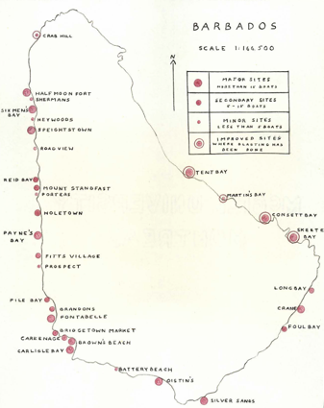
Cecil 1973 | Fishing in the Southeastern Caribbean | Fig. 7.4. Locations of permanent beaches sites. Pag. 145.  Description with maps of the coastline environment and distribution of fishing units. (Pag .138-147).  Distribution of beach marketing sites (Pag. 260).  Market facilities (Pag. 272).  Table Appendix H, fisheries units by site and level (Pag. 374). | 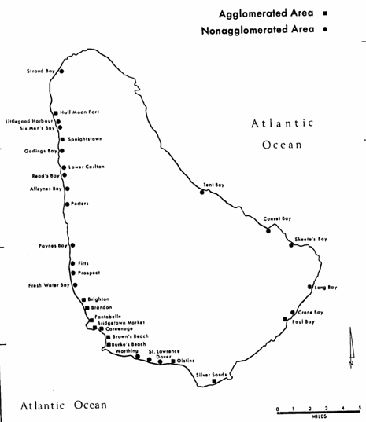
Prescod et al. 1996 | The snapper fishery of Barbados: present status and a preliminary assessment of the potential for expansion | Fig. 1. Fish landing sites around Barbados showing the location and number of boats involved in the snapper fishery. Pag. 161  Other information: Table 1 shows snapper fishing fleet by gear used based on Fig. 1. Pag. 163 | 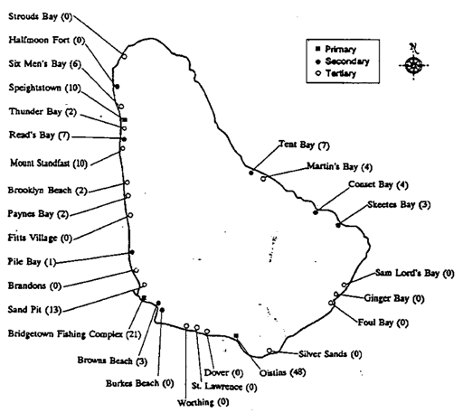
Mahon  et al.  2003 | Participatory methodology used for sea urchin co-management in Barbados | Fig. 1. The main sea egg fishing communities as identified by fishers and by the initial contact survey.  Communities enclosed in boxes are perceived by fisherfolk to be one community. Stars indicate  communities where meetings were held. | 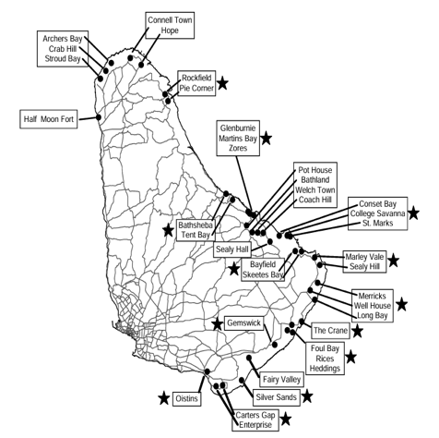
Salas et al. 2011 | Coastal fisheries of Latin America and the Caribbean | Fig. 5. Distribution of sea urchin harvesters. Pag. 66. | 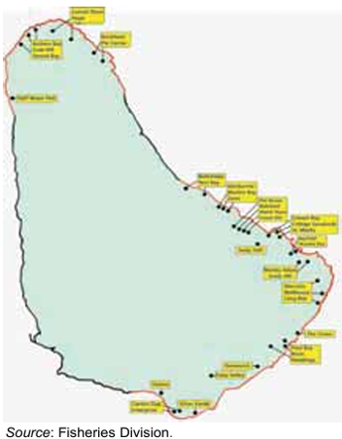
Salas et al. 2011 | Coastal fisheries of Latin America and the Caribbean | Fig. 6. Distribution of sea urchin resources. Pag. 66. | 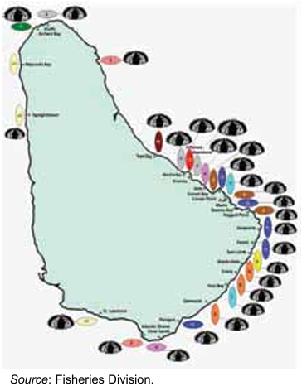
Distribution of fishing activities based on fishing gear
Maraj  et al.  2011 | The small-scale seine fishery of Barbados: Description and current contribution to the fishing industry | Fig. 1. Map of Barbados showing the location of the six seine nets, numbers of seine fishers and approximate areas fished by each net around the coastline. Pag. 3 | 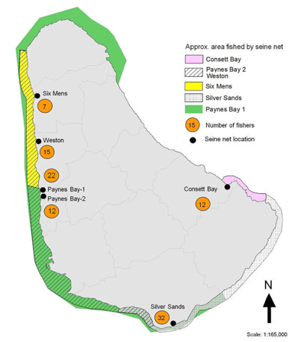
Rawlins  et al. 2007 | Preliminary Investigation of the Diets of Large Oceanic Pelagic Species of Importance to the Longline Fishery in Barbados | Fig. 2. Location of capture for each sampled fish (black dots) shown separately for each species. FYT – yellowfin tuna, BUM – Blue marlin, WHM – white marlin, ASAI – Atlantic sailfish. Pag. 245 | 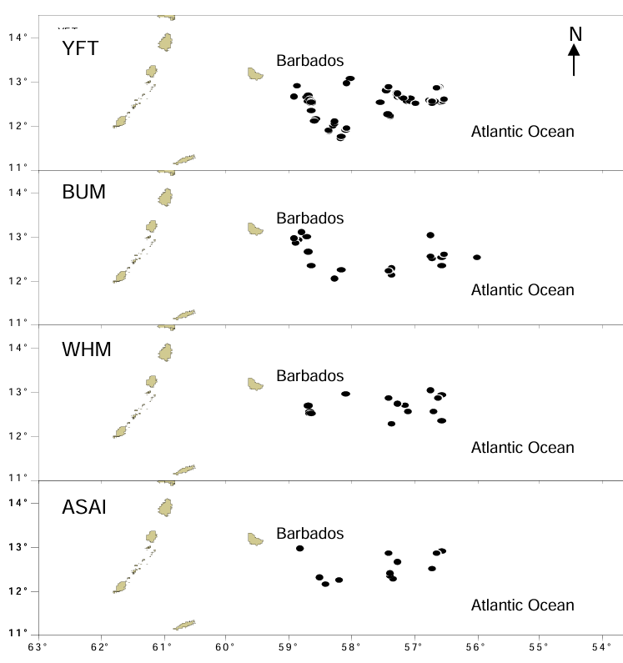
Walcott  et al. 2008 | Current Status of the Longline fishery in Barbados | Figure 4. GPS coordinates of fishing sets made by five Barbadian longline vessels between 2004 and 2006. Pag. 26 | 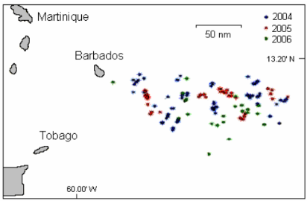
Blades  et al. 2019 | Leatherback bycatch in an eastern Caribbean artisanal longline fishery | Fig. 1. Areas fished by 5 Barbados longline vessels during different quarters of the year between April 2014 and December 2016, superimposed on (A) leatherback sea turtle density pixels estimated from satellite tracks (adapted from Fig. 1b in Fossette et al. 2014) and (B) areas of susceptibility to bycatch where high fishing pressure overlapped with leatherback habitat use (adapted from Fig. 2 in Fossette et al. 2014) | 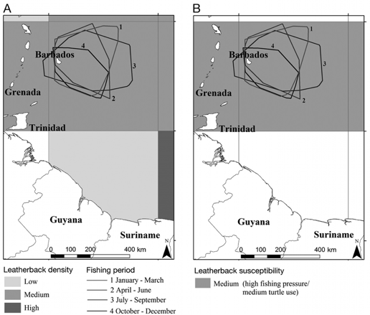
Gill  et al. 2017 | Making the most of data-poor fisheries: Low-cost mapping of small island fisheries to inform policy | Fig. 2. Variability in annual commercial fishing intensity (mt km−2 yr−1) for reef-associated species on the nearshore shallow shelf in Barbados.  Other information:  Fig. 4. Spatial variation in fishing intensity (mt km−2 yr−1) from (A) spear fishing, (B) trap fishing, (C) line fishing, and (D) seine fishing. | 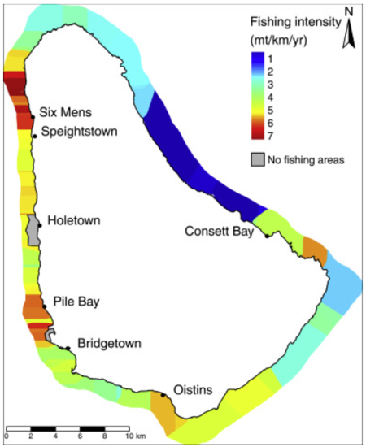
Fishing grounds by target species
Mitchell 1999 | Notes on the local fishery and import trade for spiny lobsters in Barbados | Fig. 1. Fishing areas and landing sites for lobster in Barbados. Pag. 123  Note: handmade map | 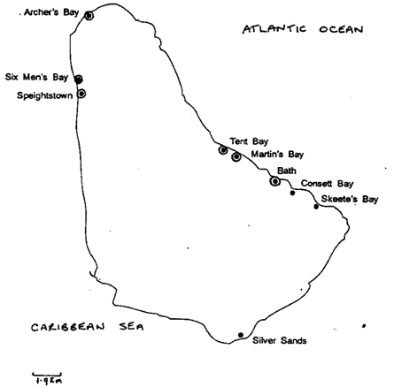
Oxenford et al.  2007 | Fishing and marketing of queen conch in Barbados | Fig. 3.1 Map of Barbados showing conch fishing grounds, landing sites and number of conch divers active on each coast. Deep fishing grounds are > 15 m, requiring SCUBA gear to access them. Pag. 14 | 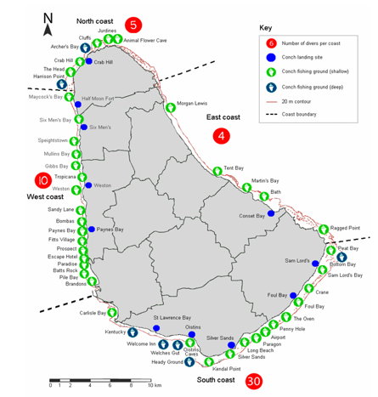
Sobers 2010 | Bioeconomic analysis of the flying fish fishery in Barbados | Fig 2. Barbadian fishing vessels traditional flying fish area. Pag. 7 | 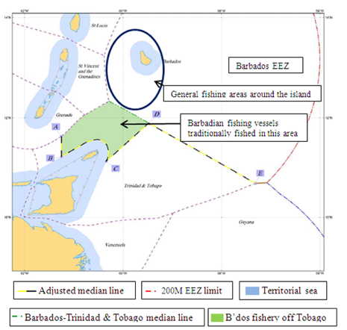
Sheibling & Mladenov 1987 | The Decline of the Sea Urchin, Tripneustes ventricosus, Fishery of Barbados: A Survey of Fishermen and Consumers | Fig. 1. Places and subareas (A, B, C, D) of sea urchin fishing grounds. Pag.63 | 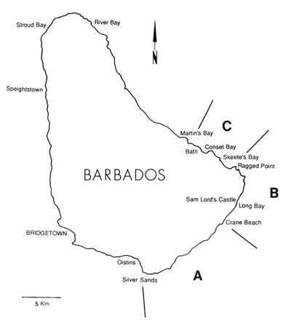
McConney et al.  2003 | Barbados case study: the sea egg fishery | Figure 5.3 The main sea egg fishing grounds of Barbados (gray shading). Pag. 11 | 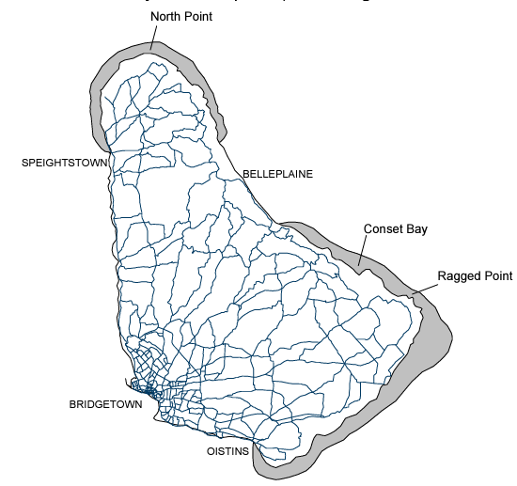
Vermeer et al.  2005 | An assessment of the potential for community-level management of the sea urchin fishery in Barbados | Fig. 1. Sea urchin fishing areas on the southeast and east coasts of Barbados. Pag. 81 | 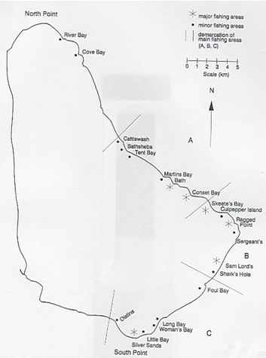
Cox and McConney  2012 | The Role Livelihood Outcomes and Strategies Play in the Adaptive Co-management of the Sea Urchin Fisheries in Barbados and St. Lucia | Location of the five communities under study in Barbados (2 communities). Pag. 337 | 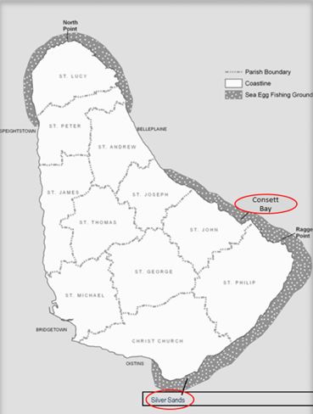
Distribution of fishing activities based on vessel tracking device
DigFish 2023 | DigiFish: Data Driven Solutions to Inform Decision Making | Fishing activity overview – by community | 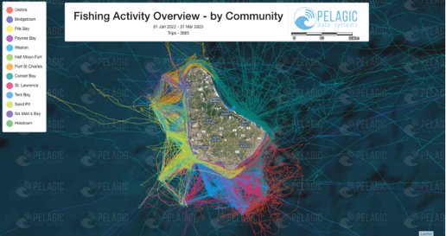
Digifish 2023 | DigiFish: Data Driven Solutions to Inform Decision Making | Fishing effort | 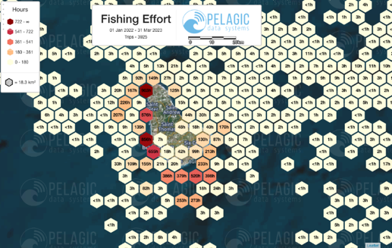
Distribution of fisheries activities based on a modeling approach
MOW  Zuecher et al.  2021 | Mapping Ocean Wealth | Estimate cumulative fishing impact (0–1).  Estimated cumulative fishing impact calculated based on parrotfish mean size. Values scaled from 0 (no fishing) to 1 (highest fishing). Impact values are relative to the fishing impact across the entire study region (Anguilla to Grenada). | 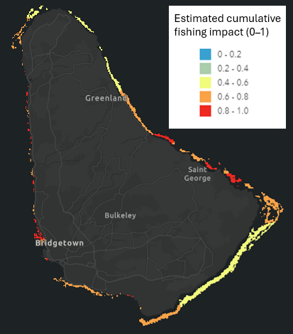

The Barbados fisheries division is also collecting fisheries related data including vessel and fisher registration, and estimated fish catches at landing sites. Data collected at landing sites is recorded using paper forms that are later digitized. However, the BFD has recently developed digital forms for documenting vessel and fisher registration. These forms provide details about Barbados fishing vessel fleet (e.g., size, types, abundance, etc.) as well as general characteristics of fisherfolk (e.g., parish of residence, age, etc.).

Participatory Mapping
One of the first steps in marine spatial planning is the identification or mapping of human activities (e.g., fishing grounds, shipping, tourism, suitable areas for economic activities, areas prone to conflict between users, vulnerable areas to climate change impacts, etc.), and ecologically significant areas (e.g., marine habitats, species distributions, spawning and nursery grounds, etc.). These activities benefit from stakeholder participation at different levels. To date, there are no similar mapping exercises documented for Barbados.
Fourteen participants completed the voluntary profile survey. Most of the respondents were male (86%); highly experienced (93% with more than 10 years fishing in Barbados), and 50 years old or older (79%). Almost 40% of respondents stated that more than 51% of their previous year’s income came from fishing activities (catching and selling the fish), and 57% are members of a fishing association and/or cooperative. The majority (57%) participate in commercial fishing while 21% participate in small-scale fishing and recreational fishing. Most respondents are using a day boat (36%) and longliner (22%). The preferred fishing gear is hand line or rod and reel (40%) followed by long line and gill nets (20%). Most of them are also using a GPS unit (60%) to locate their fishing areas/spots (Fig. 5).
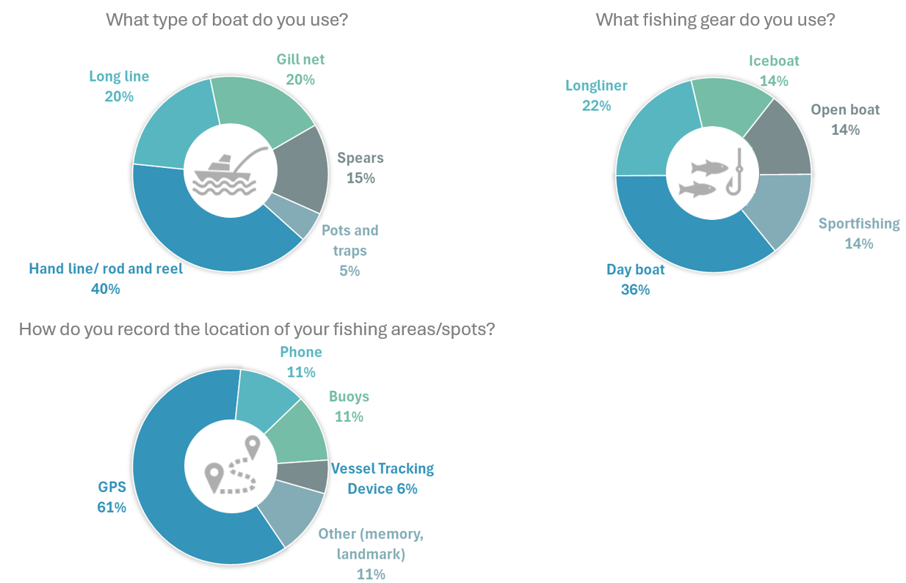
Figure 5. Participants boat, gear, and positioning system characteristics (n=14).

Mapping exercise participants were asked to provide information related to 6 themes:
- Current fishing grounds: this topic generated the greatest amount of feedback, with 41 polygons. Figure 6 shows participants’ feedback as a surface density layer (each grid summarizes the number of overlaying features). A greater number of reports occurred in the nearshore areas (within the territorial sea) in the south (depths 600m or less), and east of Barbados (depths between 450 – 1,000m). Some areas in the north also show a high number of reported fishing (depths up to 150m). Another bank with depths between 350m and 1000m was also reported as a current fishing ground. Areas with only one report were located farther from land. In the EEZ, participants reported fishing grounds between depths of 2,500 – 4,500m along the middle portion of the EEZ. They also reported fishing ground areas east of the Barbados mainland that cover most of the eastern section of the EEZ. The most reported species in the areas mapped include snappers, amberfish, barracuda, and tuna (Table 3).
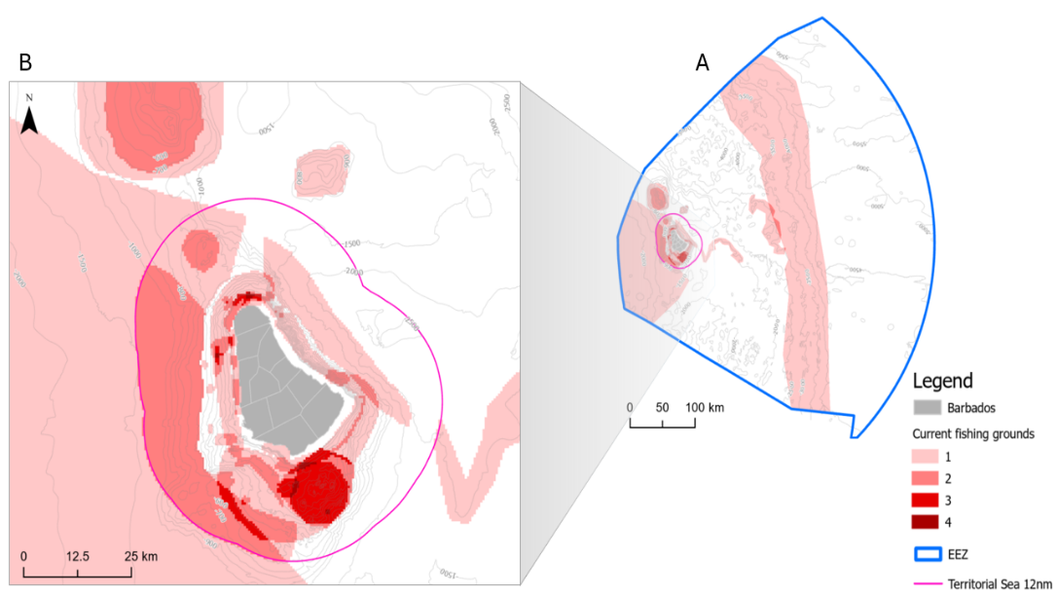

Figure 6. Current fishing grounds identified during the mapping exercise (n=41). A) Barbados Exclusive Economic Zone; B) Territorial Sea.

Table 3. Species identified for the current and historical fishing grounds and fish nursing grounds. *Species identified in all 3 fishing grounds.
Species | Current fishing grounds |  | Historical fishing grounds |  | Nursing grounds
Species | # of times reported | Percentage | # of times reported | Percentage | # of times reported | Percentage
Amberfish | 11 | 8% | 1 | 3% | 0 | 0%
Bait fish | 0 | 0% | 1 | 3% | 2 | 3%
Barracuda | 11 | 8% | 4 | 12% | 0 | 0%
Billfish | 2 | 1% | 1 | 3% | 0 | 0%
Blowgoat | 6 | 4% | 0 | 0% | 1 | 1%
Blue marlin | 1 | 1% | 0 | 0% | 0 | 0%
Bonita | 2 | 1% | 0 | 0% | 0 | 0%
Cavally* | 5 | 4% | 3 | 9% | 6 | 9%
Conch* | 5 | 4% | 1 | 3% | 6 | 9%
Dolphin fish | 8 | 6% | 1 | 3% | 0 | 0%
Flying fish | 0 | 0% | 0 | 0% | 0 | 0%
Grouper | 0 | 0% | 1 | 3% | 0 | 0%
Gunnit | 0 | 0% | 1 | 3% | 0 | 0%
Jacks* | 5 | 4% | 3 | 9% | 5 | 7%
Kingfish | 9 | 6% | 1 | 3% | 0 | 0%
Lionfish* | 8 | 6% | 1 | 3% | 5 | 7%
Lobster* | 5 | 4% | 1 | 3% | 7 | 10%
Mackerels* | 5 | 4% | 2 | 6% | 5 | 7%
Pot fish* | 7 | 5% | 2 | 6% | 3 | 4%
Sailfish | 2 | 1% | 0 | 0% | 4 | 6%
Sea Cat* | 5 | 4% | 2 | 6% | 3 | 4%
Sea eggs | 0 | 0% | 2 | 6% | 5 | 7%
Shark* | 4 | 3% | 2 | 6% | 6 | 9%
Silversides | 0 | 0% | 1 | 3% | 0 | 0%
Snapper* | 15 | 11% | 2 | 6% | 6 | 9%
Swordfish | 5 | 4% | 0 | 0% | 0 | 0%
Tuna* | 10 | 7% | 1 | 3% | 2 | 3%
Trumpet | 0 | 0% | 0 | 0% | 1 | 1%
Wahoo | 9 | 6% | 0 | 0% | 0 | 0%
Total | 140 |  | 34 |  | 67

- Historical fishing grounds: There were only 6 reports of areas where participants or their communities used to fish but no longer do. Figure 7 shows the unprocessed shapes (features are presented as collected and no analysis or summation was done). Most of the reports of historical fishing grounds were located nearshore (depths less than 100m) by the St. Philip parish and in the northern section of the Christ Church parish. The most reported species in those areas include barracuda, cavally, and jacks, followed by mackerel, pot fish, sea cat, sea eggs, and sharks (Table 3).

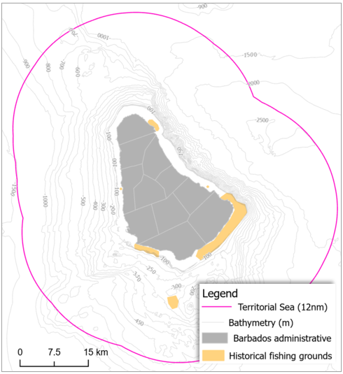

Figure 7. Historical fishing grounds identified during the mapping exercise (n=6).

- Fish nursing grounds: Seven polygons were created to identify areas where juvenile fish and other organisms grow. Figure 8 shows the unprocessed shapes. Several small areas were located nearshore (depths less than 100m) by the Christ Church parish. Some of the areas were linked to pipe structures. The northern bank with depths between 350m and 1000m was also reported as a fish nursing ground. The most reported species in those areas include cavally conch, lobsters, sharks, and snappers (Table 3).
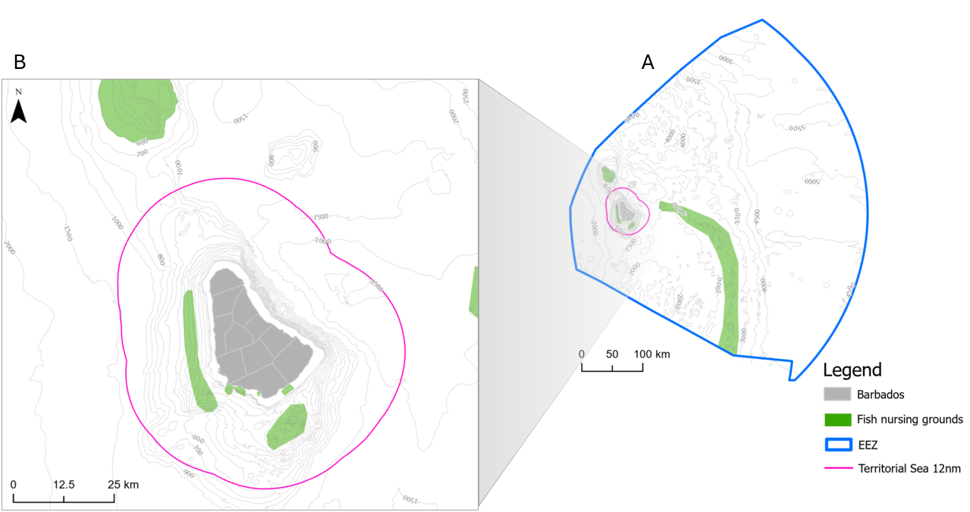

Figure 8. Fish nursing grounds identified during the mapping exercise (n=11). A) Barbados Exclusive Economic Zone; B) Territorial Sea.

- Fish spawning and aggregation areas: none of the participants were able to identify areas where fish gather to breed and rear their young. It should be noted that, generally, the participating fisherfolk were less knowledgeable about locating nursing grounds and fish spawning and aggregation areas than spatially delineating and characterizing the other fishery layers in question.

- Fish aggregating device’s (FADs) locations: Participants identified the location of 14 FADs. Most of them are located within the territorial sea in the eastern side of Barbados (Fig. 9). Two of the FADs were located beyond a depth of 1,500m very close to the EEZ east border. All the identified FADs were described as anchored structures with 79% of them identified as owned by the government.
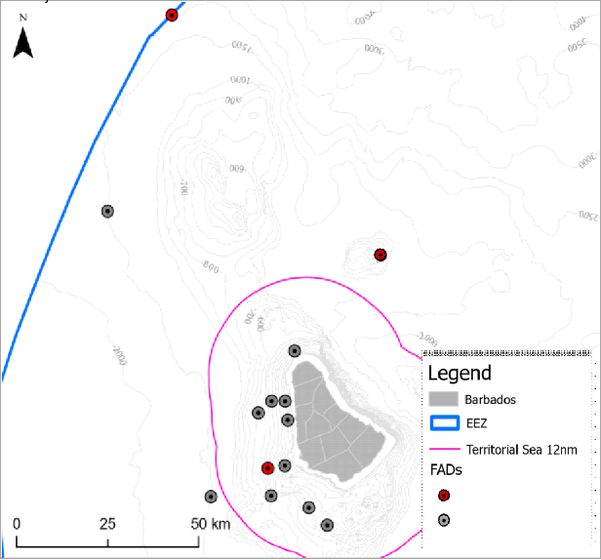
Figure 9. FADs locations identified during the mapping exercise (n=14).
6. Observed user conflict locations: There were 7 locations in which participants observed issues or conflict among users (Fig. 10). Most reported incidents involve issues between spear fisher and transiting vessels (e.g., recreational, commercial, and transportation vessels).
Figure SEQ Figure \* ARABIC 9. Observed user conflict locations identified during the mapping exercise (n=7). Coordinate system: WGS 84.
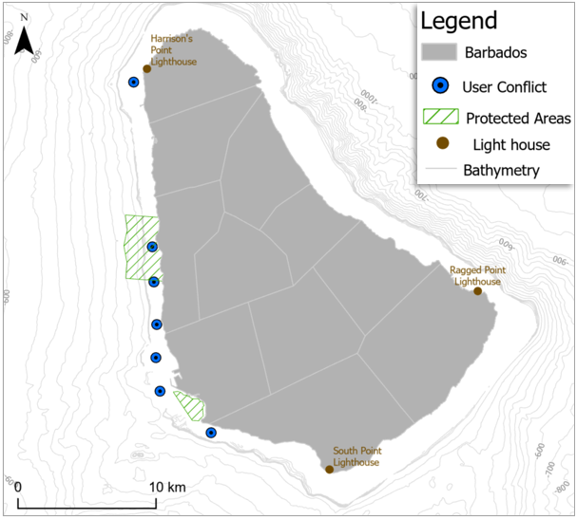

Figure 10. Observed user conflict locations identified during the mapping exercise (n=7).

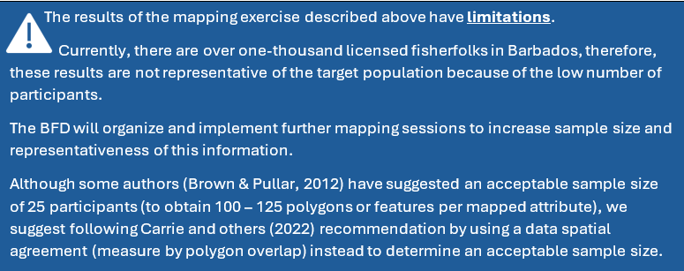

Marine Habitats
Two main sources of information for nearshore benthic habitats in Barbados were identified: Baldwin and others (2019) and Schill and others (2021). The datasets provided from both sources are available in geospatial format. There is no information about marine habitats in the Barbados EEZ area. However, the CZMU has spatial information about the deep-sea geomorphic features (e.g., sills, canyons, etc.) that could also be used as surrogates (an alternative) for some species until efforts to collect this information become available. Additionally, there are examples of small-scale studies related to specific habitats such as coral and seagrass (Horrocks, 1991; Rakitin & Kramer, 1996; Cowen et al., 2003; Maclean & Oxenford, 2016; Oxenford et al., 2020). Only one example was found that describes the location of a coral bleaching event (Oxenford et al., 2008).
Table 4. Current spatial information related to marine habitats.
Reference | Name | Documented spatial data: | Spatial data
Nearshore Benthic Habitat
Peterson et al.  2014 | Future of Reefs in a Changing Environment: an ecosystem approach to managing Caribbean coral reefs in the face of climate change Barbados Country Profile | Multiple layers. CZMU has the spatial layers produced by this project. | 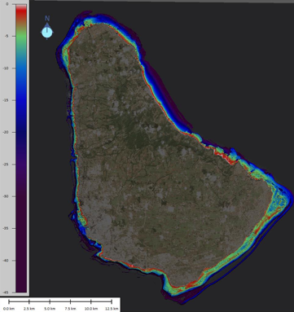
Baldwin  et al.  2019 | Developing a benthic habitat classification scheme and island-wide map for Barbados based on remote sensing and comprehensive ground-truthing | Figure 14. Map of the class (deep water) showing areas around the coastline where habitats were beyond the  resolution of remote sensing technology. Pag. 28 | 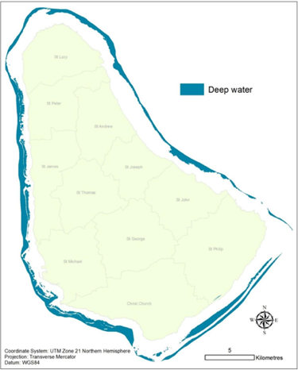
Baldwin  et al.  2019 | Developing a benthic habitat classification scheme and island-wide map for Barbados based on remote sensing and comprehensive ground-truthing | Fig.15. Final 12-class benthic habitat map of the coastal marine environment of Barbados. Pag. 29 | 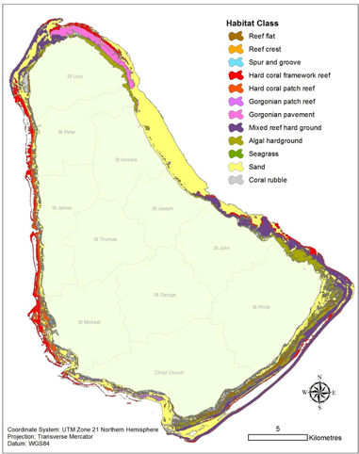
Baldwin  et al.  2019 | Developing a benthic habitat classification scheme and island-wide map for Barbados based on remote sensing and comprehensive ground-truthing | Fig. 16. Map of the shallow reefs (fringing reefs comprising reef flat, reef crest and spur and groove zones and other reef flats) around Barbados. Pag. 30 | 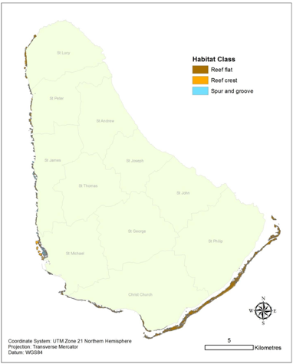
Baldwin  et al.  2019 | Developing a benthic habitat classification scheme and island-wide map for Barbados based on remote sensing and comprehensive ground-truthing | Fig. 17. Map of the hard coral framework reefs (bank reefs and other reef slopes) around Barbados. Pag. 31 | 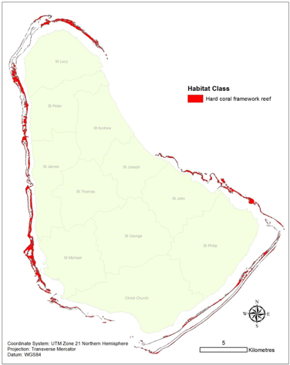
Baldwin  et al.  2019 | Developing a benthic habitat classification scheme and island-wide map for Barbados based on remote sensing and comprehensive ground-truthing | Fig.18. Map of the mixed reef hard ground and gorgonian pavements typical of the high wave energy coastal waters of Barbados. Pag. 32 | 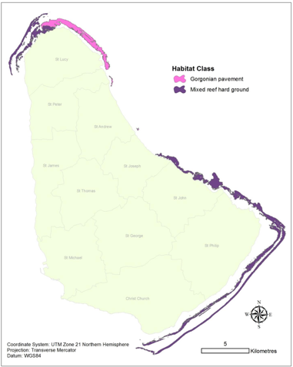
Baldwin  et al.  2019 | Developing a benthic habitat classification scheme and island-wide map for Barbados based on remote sensing and comprehensive ground-truthing | Fig. 19. Map of the hard coral and gorgonian patch reefs found along the more sheltered coastlines of Barbados. Pag. 33 | 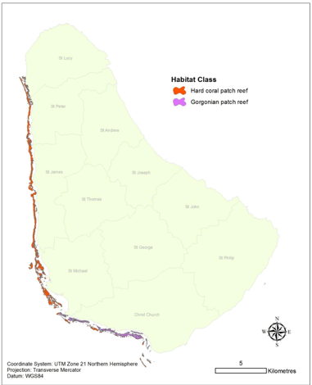
Caribbean Science Atlas | Caribbean Reef Explorer (Caribbean Science Atlas)  This site compiles TNC scientific resources for use by partners and stakeholders. | Benthic Habitats (4m resolution).  Source: Schill, et.al. 2021  Data is available upon request. | 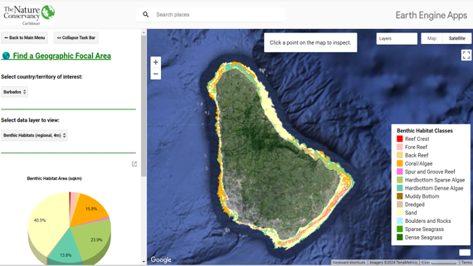
MOW | Ocean Wealth:  Mapping Ocean Wealth Explorer | Several data layers. For example: modeled coral reef fisheries catch | 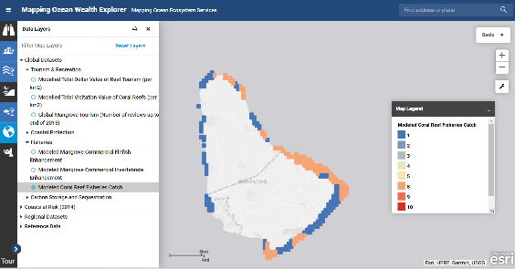
MOW | Ocean Wealth:  Mapping Ocean Wealth Explorer | Coastal protection: | 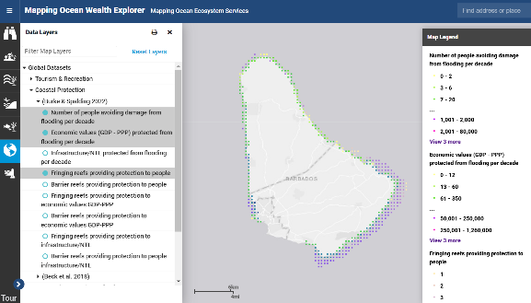
CSA | Caribbean Reef Explorer  (Caribbean Science Atlas) | Coral refugia ranking | 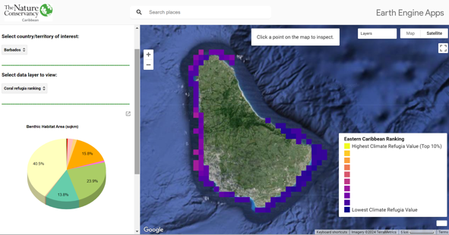
CZMU | Coastal Zone Management Unit | Status of Barbado’s coral reefs 2017.  The CZMU has available online form to report available to the public to stony coral tissue loss disease and coral bleaching. | 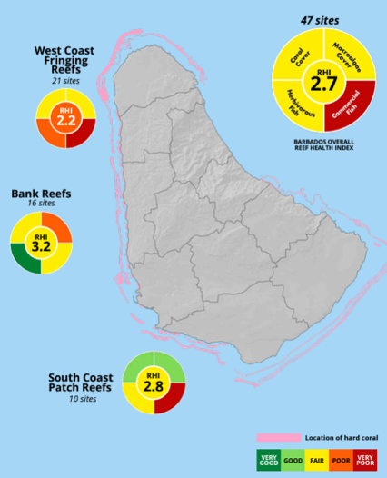
Small-scale habitat distribution studies
Horrocks 1991 | Sea Turtle Recovery Action Plan for Barbados | Map 2. Locations of sea grass and offshore bank coral reefs around Barbados, West Indies. Pag. 48. | 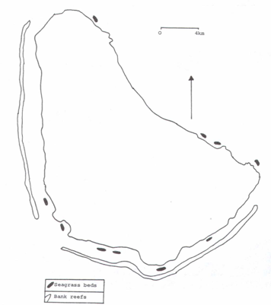
Rakitin & Kramer 1996 | Effect of a marine reserve on the distribution of coral reef fishes in Barbados | Fig. 2. Map of the study area…Left: the study area on the west coast of Barbados showing the location of the Barbados Marine Reserve (dashed lines) and the fringing reef (shaded). Reefs are numbered according to increasing distance from the center of the Reserve. | 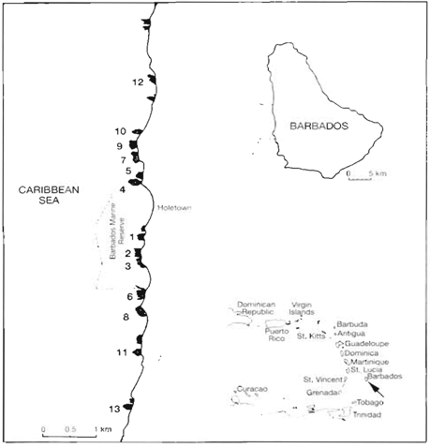
Maclean & Oxenford 2016 | Mapping the return of acroporid corals on fringing reefs along the west coast of Barbados | Figure 12. The overall spatial distribution of Acropora colonies found along the west coast of Barbados from June to August 2015. Pag. 19  Other figures showing the distribution of Acropora and benthic habitats, cluster and demarcation. Appendix 2 shows Lat/Lon of the 46 reefs surveyed. Pag. 55 | 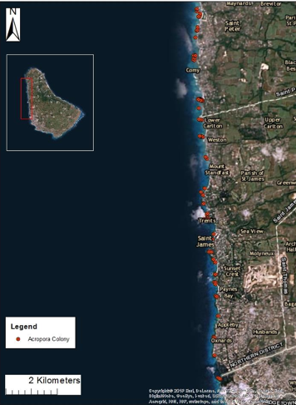
Oxenford et al.  2020 | Assisted recovery of elkhorn coral (Acropora palmata) on a fringing reef in Barbados: A pilot study 2016-2019 | Appendix 3. Report of elkhorn spawning at Mullins Field report of Acropora palmata (elkhorn coral) spawning observations at Mullins fringing reef, Barbados. Pag. 41. Other information: Appendix 4. Genetic samples database with GPS data. Pag. 45 | 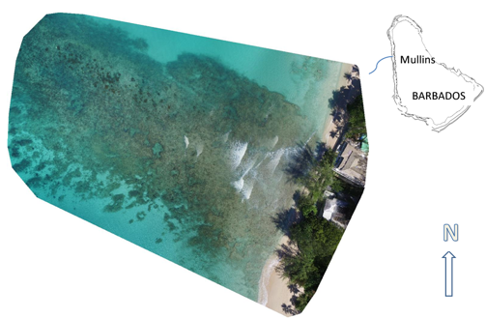
Cowen  et al.  2003 | Impact of North Brazil Current rings on local circulation and coral reef fish recruitment to Barbados, West Indies | Fig. 3. Maximum residence time (RT) on the western shore of Barbados  during the 1996 and 1997 experiments at the mean depth of center of mass for  Thalassoma bifasciatum (40-60 m) (a) before and (b) after low salinity intrusions. | 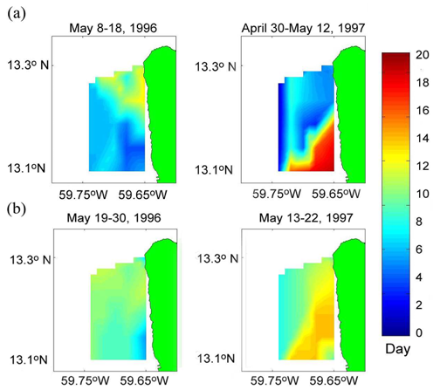
Oxenford et al.  2007 | Quantitative observations of a major coral bleaching event in Barbados, Southeastern Caribbean | Fig. 1. Map of Barbados showing extent of coral reefs and location of survey sites. Pag. 437. | 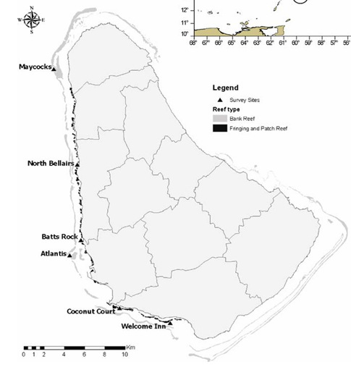
Geomorphic features
CZMU 2024 | Conservation Data Layers CZMU | Deep sea geomorphic features.  Sills  Fans  Canyons  Escarpments  Ridge  Rises  Plateaus | 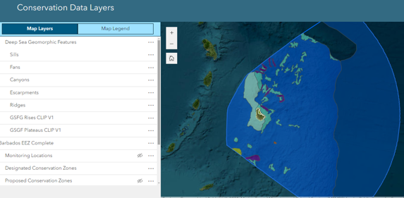

Species distribution
This section refers to information about the arrangement and location of different species. For Barbados, in general, information about relevant marine species is limited temporally and spatially. The Global Biodiversity Information Facility (GBIF) provides sightings information for different groups of species (e.g., birds, turtles, fishes) but the information is obtained through opportunistic encounter events and is not systematically collected. Only one study was found that documents the movement of fishes off the west coast of Barbados (Chapman & Kramer, 2000). The Mapping Ocean Wealth online platform has layers showing the estimated biomass for snappers/groupers and parrotfish which are located mainly in nearshore waters. Additionally, two studies documented the movements and home ranges of queen conch; however, these are small scale studies, which are limited (Bissada-Gooding & Oxenford 2010; Phillips et al. 2011).
Several studies that map the distribution of sea turtle nesting beaches were identified (Horrocks & Scott, 1991; Horrocks & Willoughby, 1991; Horrocks, 1992; Horrocks & Walcott, 2016; Dow et al., 2007), nearshore movements (Walcott et al., 2009; Walcott et al., 2012; Walcott et al., 2014), and international distribution tracking (Horrocks et al. 2001; Luke et al., 2004; Krueger et al., 2011; Browne et al., 2010). Some of these studies may provide useful baseline information for MSP. An option to consider is tapping the expertise of these researchers and scientists by developing a methodology that includes feedback from them (participatory mapping with experts) and encouraging their participation throughout the MSP process.
One reference mapped the distribution of marine mammals in Barbados (Basran et al., 2023). documenting that sighting of a humpback whale and her calf. Additionally, one reference provides the general location and estimates of lionfish and other marine invasive species in Barbados (Valles et al., 2023). Sargassum (an invasive floating seaweed) is monitored using satellite derived data through a seasonal bulletin managed by CERMES. There was also a report documenting a fish kill event (Willoughby et al., 2002). The limited number of studies and spatial information related to fish kills and invasive species is concerning because these occurrences constitute significant threats to marine biodiversity, ecosystems, and human activities. Mapping and risk assessment of these topics would be a valuable contribution to the MSP because it involves evaluating potential threats and uncertainties associated with human activities and natural processes in marine environments.
Table 5. Current spatial information related to species distribution.
Reference | Name | Documented spatial data: | Spatial data
Biodiversity
GBIF | The Global Biodiversity Information Facility (GBIF) | GBIF is an international network and research infrastructure funded by the world’s governments and aimed at providing anyone, anywhere, open access to data about all types of life on Earth.  There were 154,672 records found for the Barbados area. | 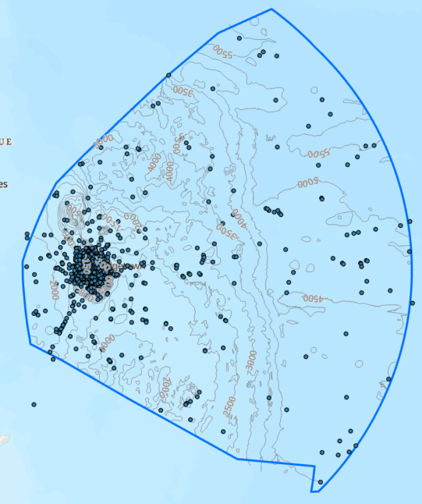
 | OBIS-SEAMAP | It is a spatially, temporally interactive online database for marine mammal, sea turtle, seabird and ray & shark data. Only 104 records found for Barbados area. | 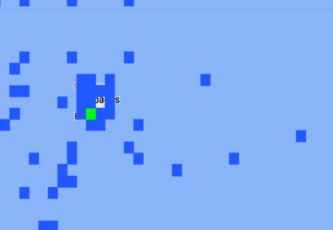
Fish distribution
MOW | Mapping Ocean Wealth | Coral reef fisheries: current biomass (snapper/grouper).  Predicted current total biomass of snapper-grouper complex, derived from models and originally informed by and documented by fisheries independent visual surveys. | 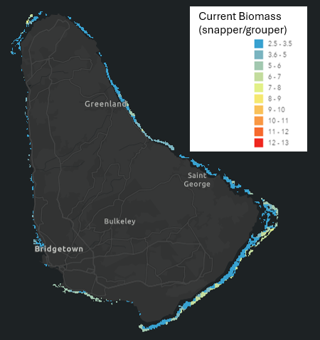
MOW | Mapping Ocean Wealth | Coral reef fisheries: current biomass (parrotfish).  Predicted current total biomass of parrotfish, derived from models and originally informed by and documented by fisheries independent visual surveys | 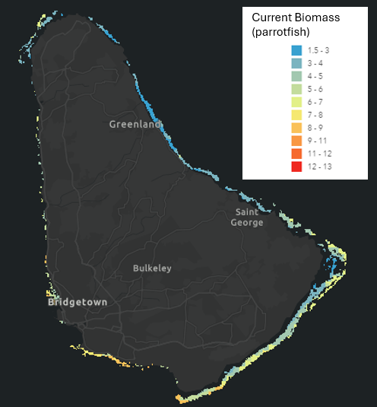
MOW | Mapping Ocean Wealth | Coral Reef Fisheries: Predicted Gain in Biomass (snapper/grouper).  The expected percent increase in snapper-grouper fish stocks if fishing were reduced to 0 in each 1 ha cell. This could be through a marine reserve or some other fisheries management measure. | 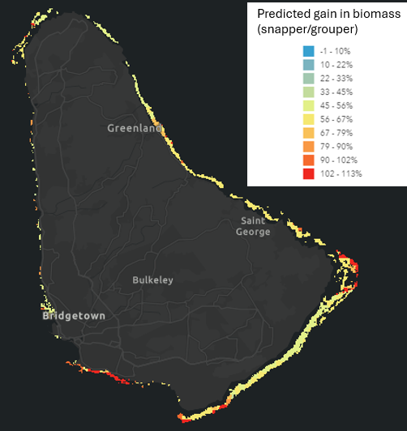
MOW | Mapping Ocean Wealth | Coral Reef Fisheries: Potential Biomass (snapper/grouper)  Predicted future biomass for snapper-grouper complex if fishing were to be reduced to zero. | 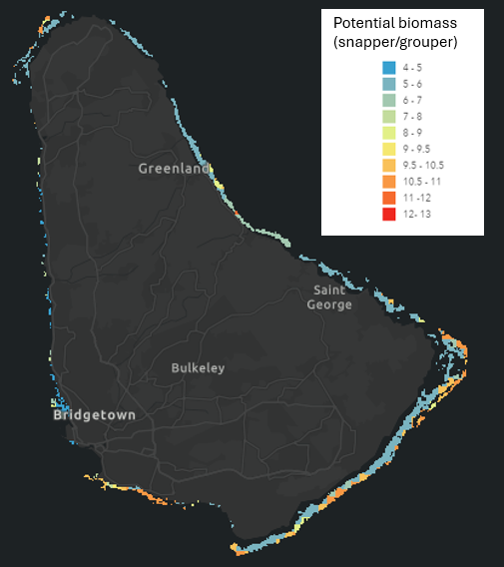
MOW | Mapping Ocean Wealth | Coral Reef Fisheries: Potential Biomass (parrotfish).  Predicted future biomass of parrotfish with a 25% increase in reef cover. | 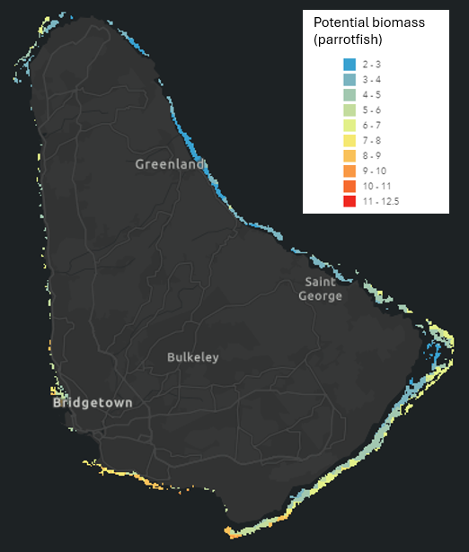
Arocha  et al. 2024 | Review of biological data, spatial distribution of the stocks and ecological connectivity between areas beyond national jurisdiction and exclusive economic zones in the Western Central Atlantic Fishery Commission Region | The report contains regional distribution maps for several commercially important fishes for example distribution of Caribbean spiny lobster, red grouper, Nassau grouper, red hind, grey snapper, among others. | Spiny lobster  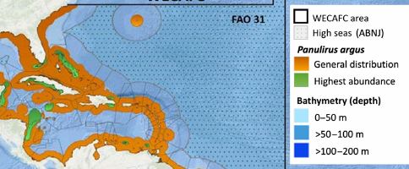  Red grouper  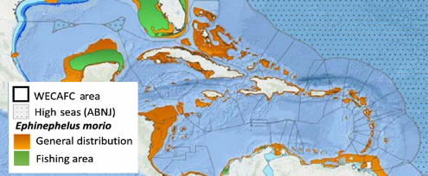  Nassau grouper  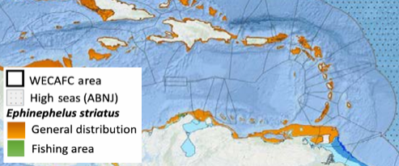
Chapman & Kramer 2000 | Movements of Fishes Within and Among Fringing Coral Reefs in Barbados | Fig. 1. Map of the west coast of Barbados showing the location of study reefs (stippled) and the 23 sites (squares) where fish were tagged and recaptured. The dashed line indicates the boundary between the Barbados Marine Reserve (BMR) and the non-reserve (NR).  They tagged 1443 individuals of 35 reef fish species. Most species were strongly site attached, with most recaptures and re-sightings occurring at the site of tagging. | 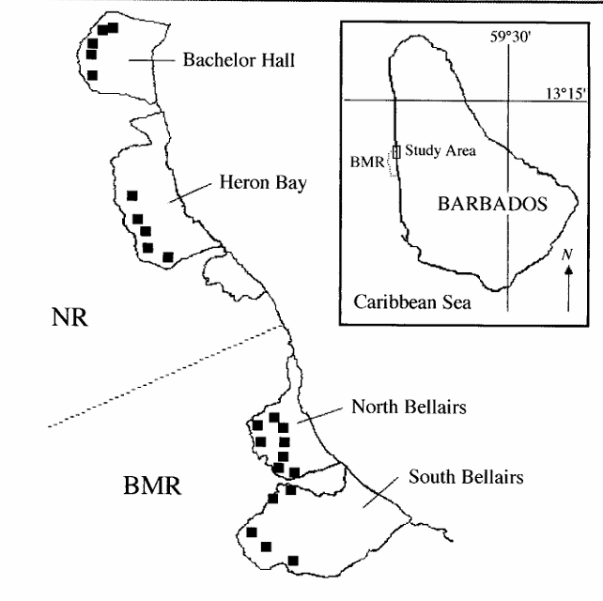
Queen Conch
Phillips  et al.  2011 | Preliminary Investigation of the Movements, Density, and Growth of Juvenile Queen Conch in a Nursery Area in Barbados | Fig. 5. Maps showing (a) minimum convex polygon home ranges and (b) kernel density estimation of home ranges for key informant juvenile conch (AC6 and AC7) in Carlisle Bay, Barbados over the summer (July 14 – Sept 23, 2010. Pag. 432.  Other information. Fig. 1. Study sites. Pag. 428. | 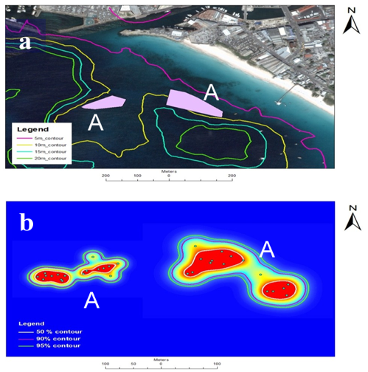
Bissada-Gooding & Oxenford 2010 | Estimating home range and density of a Queen Conch aggregation using acoustic telemetry and conventional tagging | Fig. 1 Map of Barbados showing the study site located on the west coast. Pag. 384.  Note: The study site is described as close to Bridgetown Port. They mapped the position of all conch but no info is provided in the document. They have home range estimates based on 3 tagged conchs. | 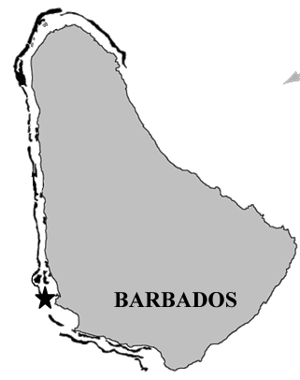
Sea turtle nesting
Horrocks & Scott 1991 | Nest site location and nest success in the hawksbill  turtle Eretmochelys imbricata in Barbados,  West Indies | Barbados, showing locations of hawksbill nests in 1987, 1988 and 1989. Pag. 2. | 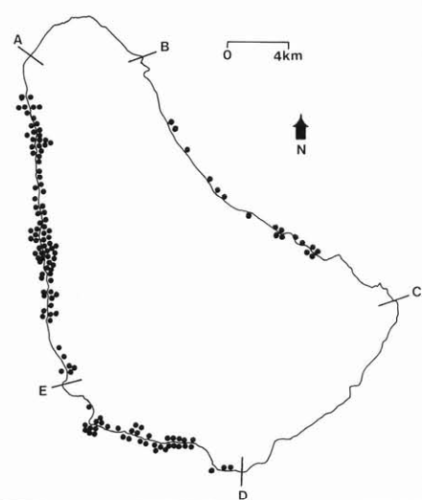
Horrocks & Willoughby 1991 | Reproduction, mortality and conservation of the hawksbill turtle (Eretmochelys imbricata) in Barbados | Fig. 1. Ma of Barbados showing potential nesting beaches and beaches where hawksbills nest.  Pag. 248  Note: poor quality image and hard to read the line features. | 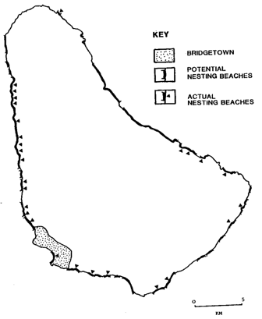
Horrocks 1992 | Sea Turtle Recovery Action Plan for Barbados | Map 3. Locations of potential nesting beaches and actual nests for the leatherback sea turtle (Dermochelys coriacea) in Barbados, West Indies, 1984-1991. Pag. 49. | 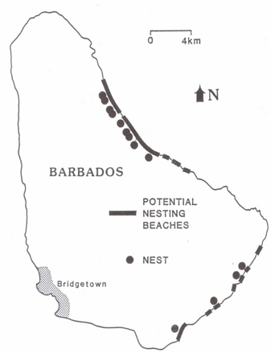
Horrocks 1992 | Sea Turtle Recovery Action Plan for Barbados | Map 4. Locations of hawksbill sea turtle (Eretmochelys imbricata) nests reported by the public in 1990 (stars) and 1991 (dots) in Barbados. Pag. 50. | 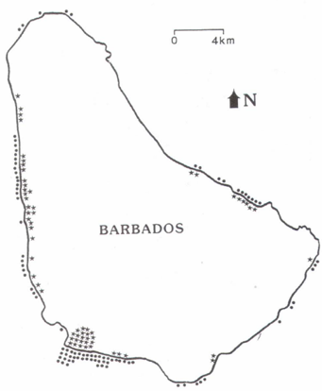
Dow  et al.  2007 | An Atlas of Sea Turtle Nesting Habitat for the Wider Caribbean Region | Sea turtle nesting habitat. Pag. 83. | 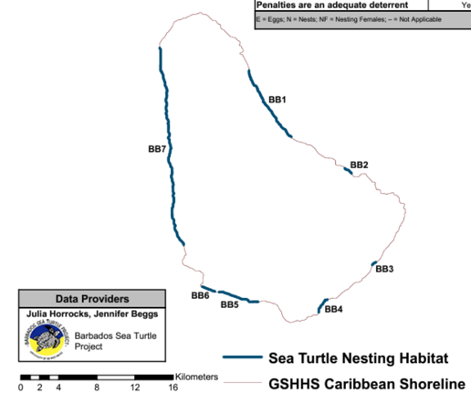
Dow  et al.  2007 | An Atlas of Sea Turtle Nesting Habitat for the Wider Caribbean Region | Nesting habitat. Pag. 84  Other information:  Tables with identified threats to sea turtles nesting areas and foraging/migrating  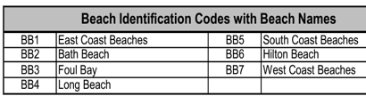 | 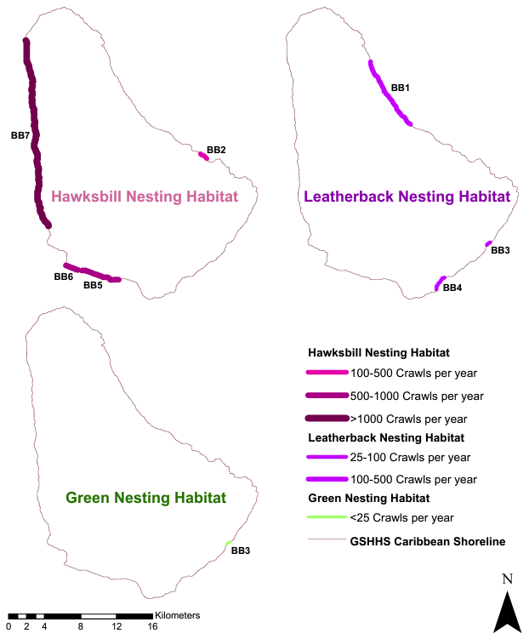
Horrocks & Walcott  2016 | Nesting by hawksbill sea turtles on the west coast of Barbados in relation to beach wide: with recommendations for conservation of critical nesting habitat. | Fig. 1. The Nineteen Sectors of West Coast Beaches in Barbados monitored by the Barbados Sea Turtle Project. | 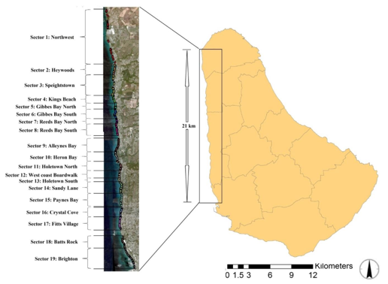
Horrocks & Walcott  2016 | Nesting by hawksbill sea turtles on the west coast of Barbados in relation to beach wide: with recommendations for conservation of critical nesting habitat. | Figure 5. Sector 3 Speightstown. A. Aerial photo showing the positions of Nesting Activities, color coded to show the average width of the Location where the Activities occurred; B. showing the % Nests, Attempts and False Crawls on stretches of different widths within the Sector. Place names are shown for orientation only.  Other areas are also shown in the report. | 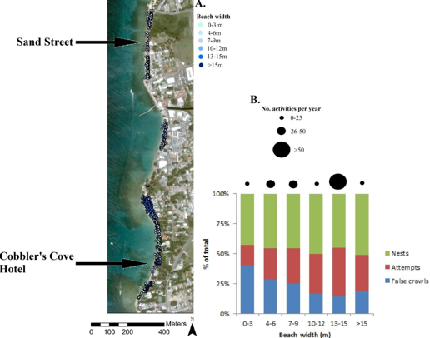
Fish et al.  2008 | Construction setback regulations and sea-level rise: mitigating sea turtle nesting beach loss. | Fig. Location of the study beaches around the island of Barbados. | 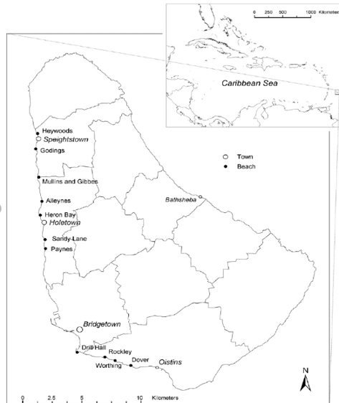
Sea turtle nearshore movement
Walcott  et al  2009 | Telemetric monitoring of inter-nesting behaviour and habitat use by hawksbill turtles (Eretmochelys imbricata) nesting at Needham’s Point, Barbados | Fig. 6. Movement patterns of three tracked females. Poster | 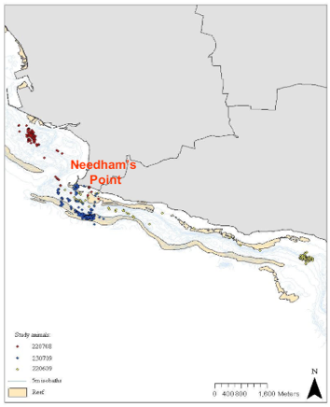
Walcott  et al.  2014 | Design of a protected area for inter-nesting hawksbills in Barbados: an evidence-based approach | TOP: Fig. 3. Portions of the coast and the marine environment that would need to be protected, according to the percentage of all Resident Areas (n = 17) afforded protection (25%–100%). The respective boundaries are indicated by colored lines). Pag. 975  Fig. 4. Tourism and local recreational use of (A) the waters adjacent to the south coast of Barbados and (B) the beachfront. Pag. 976.  BOTTOM: Fig. 5. Fishing related use of the south coast of Barbados and the waters adjacent to it. Primary landing sites represent sites where there is physical infrastructure present in the form of a market, while tertiary landing sites are those with no physical infrastructure present and simply represent beaches. Pag. 978 | 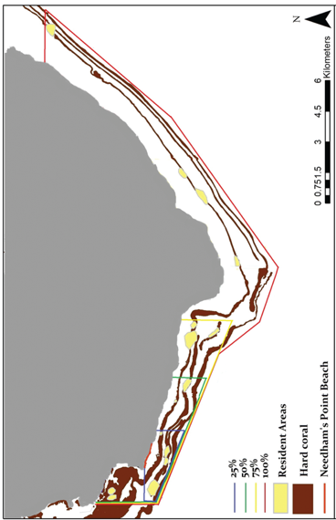  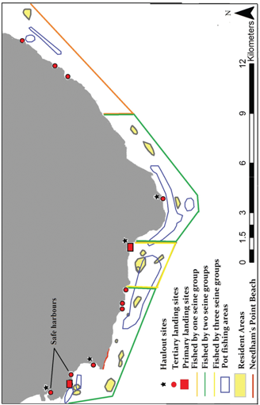
Walcott  et al.  2012 | Tracking hawksbill sea turtles (Eretmochelys imbricata) during inter-nesting intervals around Barbados | Fig.3 Inter-nesting resident areas (polygons) utilized by study animals. Pag. 933 | 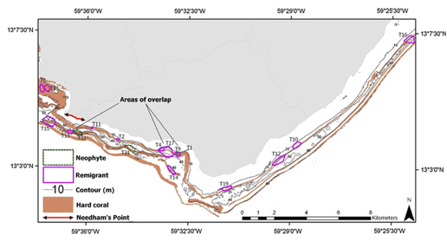
Walcott  et al.  2012 | Tracking hawksbill sea turtles (Eretmochelys imbricata) during inter-nesting intervals around Barbados | Fig. 5 Area of the Needham’s Point nesting beach utilized by females for both long-term (as inter-nesting resident areas, N=3) and short-term (23–65 h prior to a nesting emergence, N=8) residency. Pag. 935 | 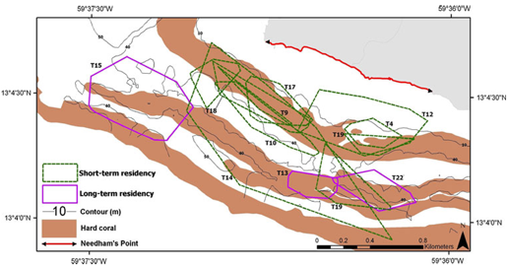
Walcott  et al.  2014 | Use of a towed camera system to investigate benthic habitat use by inter-nesting female hawksbill sea turtles | Fig. 1. Southern portion of Barbados, showing the nesting beach of hawksbill sea turtles Eretmochelys imbricata (Needham’s Point), the resident areas (RAs, colored polygons) utilized by study animals (n = 17) and the hard coral reef system. Yellow, blue and green polygons represent high-, medium- and low-quality RAs, respectively. The 4 regions indicating different distances from the nesting beach are also shown. Pag. 161. | 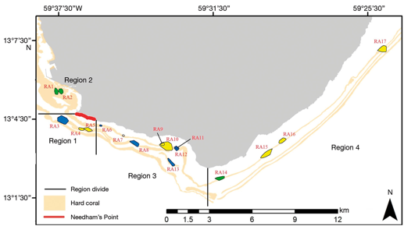
Sea turtle international movements
Luke et al. 2004 | Origins of green turtle (Chelonia mydas) feeding aggregations around  Barbados, West Indies | Fig. 1. Map of the Atlantic region showing green turtle (Chelonia mydas) rookeries (excluding Cyprus) relative to Barbados foraging population. Mean percentage contributions by the different nesting populations, as estimated by Markov chain Monte Carlo estimation, are indicated. Note: the pathways shown are not indicative of migratory corridors. Pag. 803 | 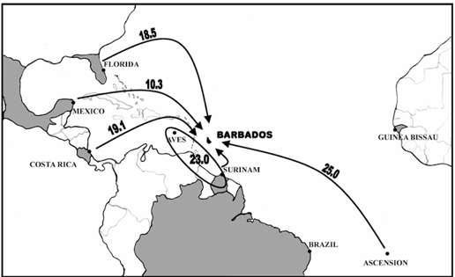
Luke  et al.  2004 | Origins of green turtle (Chelonia mydas) feeding aggregations around  Barbados, West Indies | Fig. 2. The major Atlantic currents affecting the Caribbean region. Pag. 804. | 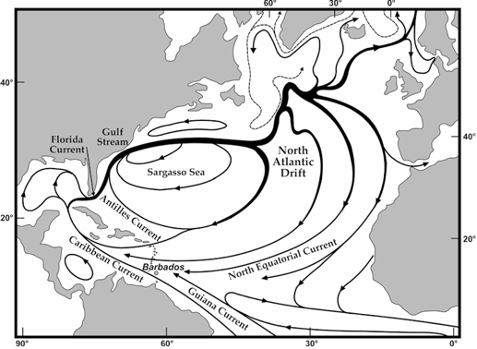
Browne  et al.  2010 | Population subdivision in hawksbill turtles nesting on Barbados, West Indies, determined from mitochondrial DNA control region sequences | Fig. 1 Sampling locations from the leeward (Speightstown to Dover)  and windward coast (Bath) nesting sites in Barbados, within the Caribbean region. The TCS parsimony network for the regional haplotypes is overlaid on the In the Barbados map inset, the haplotype diversities for the two coasts are indicated by black haplotypes within scaled down representations of the complete regional haplotype network. | 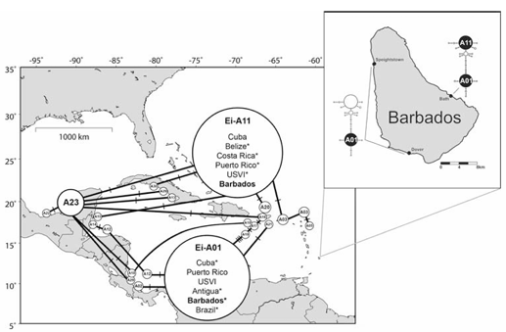
Krueger  et al.  2011 | International Movements of Adult Female Hawksbill Turtles (Eretmochelys imbricata): First Results from the Caribbean's Marine Turtle Tagging Centre | Figure 2. International tag returns for adult female hawksbill sea turtles (Eretmochelys imbricata) tagged in Barbados, as well as in Palm Island and Nevis (insert), using MTTC tags during the reporting period (January 2002 to June 2009). Arrows point to the location of recapture. Pag. 23.  Table 2. shows where turtles were tagged and then recaptured. Pag. 21 | 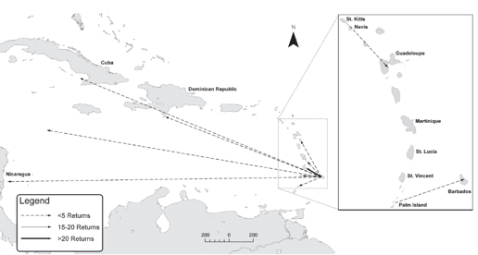
Horrocks et al.  2001 | Migration Routes and Destination Characteristics of Post-Nesting Hawksbill Turtles  Satellite-Tracked from Barbados, West Indies | Fig. 1. Post-nesting migration route (•--•--•) of hawksbill turtle 8179 between her nesting beach in Barbados and her foraging ground destination off Dominica (• location fixes of LC1-3; o location fixes LC < 1). Dates are provided for location fixes occurring at the same time of day on the date indicated. Geostrophic current directions are indicated by arrows, and strength of currents by the length of the arrow. Isobaths at 500 m intervals are indicated. | 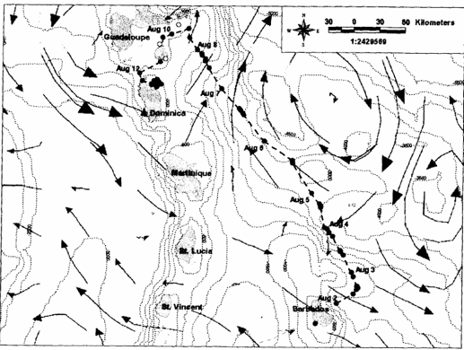
Horrocks et al.  2001 | Migration Routes and Destination Characteristics of Post-Nesting Hawksbill Turtles  Satellite-Tracked from Barbados, West Indies | Fig. 2. Post-nesting migration route (•--•--•) of hawksbill turtle 8180 between her nesting beach in Barbados and her foraging ground destination off Petite Martinique (Grenada) (•location fixes of LC1-3; o location fixes LC<1). Dates are provided for location fixes by the length of the arrow. | 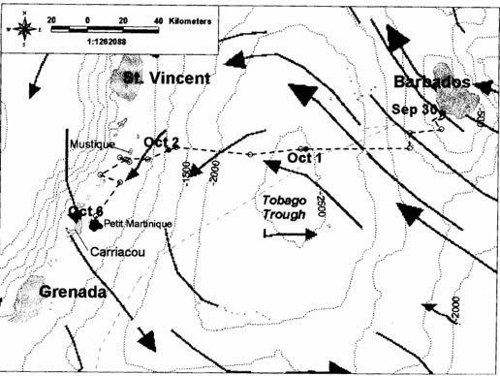
Horrocks et al.  2001 | Migration Routes and Destination Characteristics of Post-Nesting Hawksbill Turtles  Satellite-Tracked from Barbados, West Indies | Fig. 3. Post-nesting migration route of hawksbill turtle 8207 (•--•--•) between her nesting beach in Barbados and her foraging ground destination off Trinidad, and of hawksbill turtle 8208 (▪--▪--▪) between her nesting beach in Barbados and her foraging ground destination off Los Testigos (Venezuela) (• and ▪ indicate location of fixed LC1-3; o and ▫ location fixes LC<1). For each female, dates are provided for location fixes by the length of the arrow. | 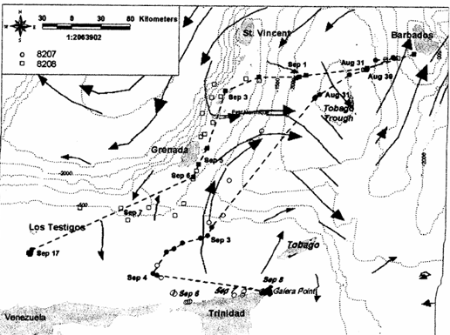
Marine mammal distribution
Basran  et al.  2023 | Short Communication: First documented migration of an Icelandic humpback whale mother and calf pair from the West Indies breeding grounds | Fig. 1. Map and photographs showing the sighting locations, dates and photographic evidence of ISMN0028and her calf. Dates in red text, denoted with *, indicate the within‐year migration of the mother‐calf pair between Barbados and Iceland. Pag. 207. | 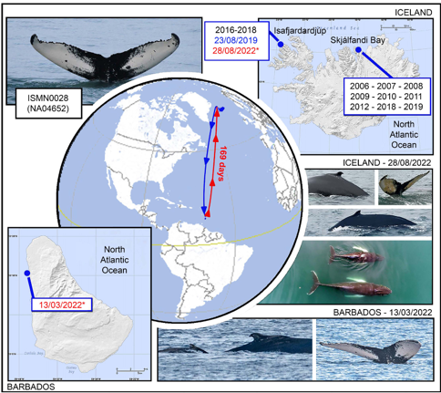
Invasive species distribution
Valles  et al.  2023 | Assessment and Management of Lionfish and Status of Other Marine Invasive Species of Threat to High Biodiversity-value Reef Ecosystems | Figure 2.2. Location of the ten coral reef sites on the west and south coast of Barbados used for the repeat surveys of native coral reef fish and lionfish. Black stars indicate the main reef fish landing sites where fisher surveys were conducted (see Section 2.2.2).  Appendix 2. GPS coordinates for fish survey sites. | 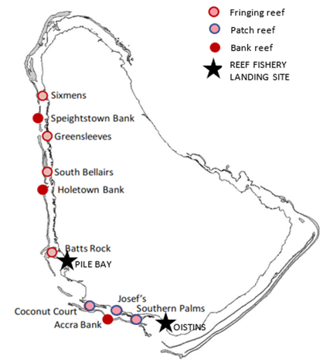
Fish kill
Willoughby et al. 2002 | Factors contributing to the 1999 mass mortality of reef-associated fish in Barbados | Fig. 2. Areas of Barbados where fish were beached during the 1999 fish kill. Pag. 28  Note: legend and symbology difficult to read. | 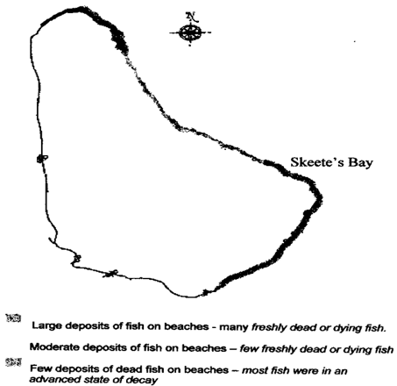
Sargassum
CERMES | Sargassum Sub-regional Outlook Bulletin | This bulletin is brought to you by the Sargassum Team at The Centre for Resource Management and Environmental Studies (CERMES).  The processed satellite image shows sargassum abundance over the 7-day period 26 May - 1 June 2024.  Source: USF Optical Oceanography Laboratory | 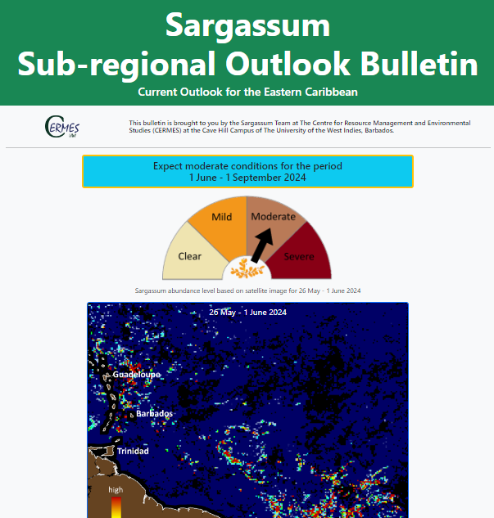
Reports of spiny coral tissue loss disease
AGRRA  2024 | Atlantic and Gulf Rapid Reef Assessment. Data Explorer | There are 34 reports for Barbados in the AGRRA database. | 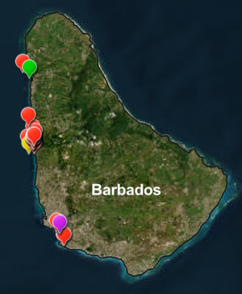

Oceanographic Data
The most available resources of oceanographic data are the CZMU and NOAA. The CZMU has several spatial layers related to oceanographic variables (e.g., bathymetry, water quality, etc.). Furthermore, international platforms such as NOAA, also provide satellite derived information (e.g., sea surface temperature, salinity, currents, etc.). The table below describes the sources and provides examples of the most oceanographic data identified.
Table 6. Current spatial information related to oceanographic variables.
Reference | Name | Documented spatial data: | Spatial data
GEBCO | General Bathymetric Chart of the Oceans GEBCO | GEBCO Bathymetry Contours (500m) 2021.  It doesn’t cover nearshore areas. | 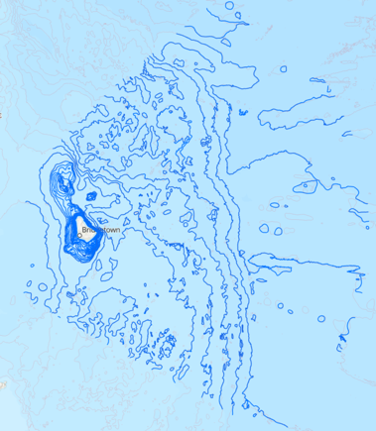
CZMU | Coastal Zone Management Unit.  Nearshore Bathymetry Contours (m). | The nearshore bathymetry layer was provided by the CZMU. | 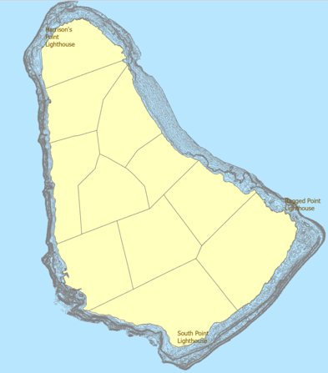
CZMU | Coastal Zone Management Unit. Oceanographic Monitoring Stations and Historical Data | CREWS – Coral Reef Early Warning System Buoy. Measures a range of hydrometeorological parameters  3 Metre Discus Buoy – Measures directional wave and current parameters (height, speed, period) as well as meteorological parameters (wind speed and direction, air temperature, barometric pressure)  Triaxys Wave Buoy – Measures directional wave and current data and water temperature  AWAC – Acoustic Wave and Current Profiler. Measure directional wave and current data and water temperature  AQUADOPP – Acoustic Doppler Current Profiler. Measure directional wave and current data. | 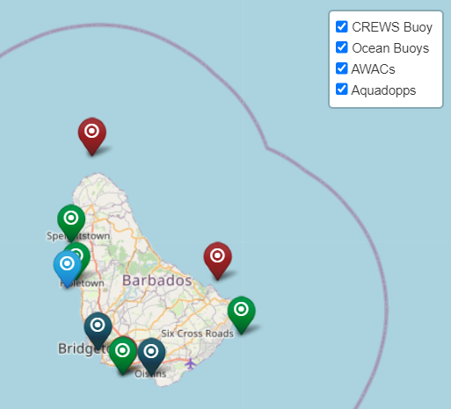
NOAA | National Oceanic and Atmospheric Administration (NOAA).  Global near-surface currents (annual mean) | A drifter-derived annual climatology of global near-surface currents. Satellite-tracked SVP drifting buoys provide observations of near-surface circulation at unprecedented resolution.  Description  http://www.aoml.noaa.gov/phod/dac/dac_meanvel.php | 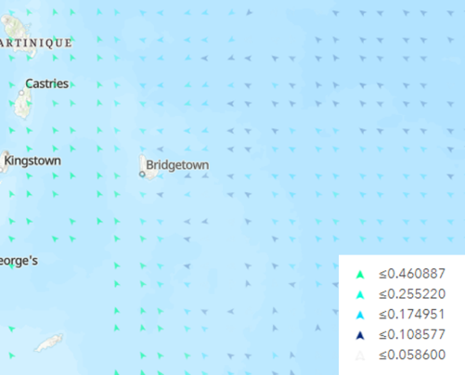
NOAA | National Oceanic and Atmospheric Administration (NOAA).  Sea Surface Temperature. | Ocean temperature measured at the surface by satellites. The SST scale ranges from -2 to 35 °C. Data are produced globally at 5km-resolution and are updated daily. | 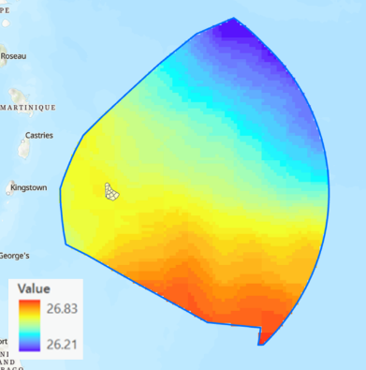
Salas  et al. 2011 | Coastal fisheries of Latin America and the Caribbean | Fig. 1. Barbados oceanographic features. Pag. 50. | 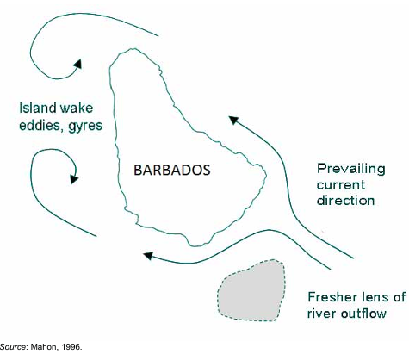

Other relevant layers for the fisheries sector
This grouping includes data on administrative boundaries, location of relevant features such as wetlands, scuba diving sites, land cover/use layers, distribution of shipping/cargo vessels and marine traffic, hazard risk assessments and hurricanes, and layers related to spatial distribution of tourism activities.
Country jurisdictional and administrative boundary layers (e.g., county boundaries, administrative divisions, roads, etc.) are available through online sources. Furthermore, the CZMU has access to these administrative layers including boundary layers for the territorial sea and the economic exclusive zone (EEZ).
There is a relatively new wetland inventory depicting the location of nationally important wetlands (Mahon & Mascia, 2023). In addition, the Barbados SCUBA Dive Site Association has made GPS locations of diving sites available through their website (Table 7).
Commercial vessels (shipping and cruise industries) represent main actors in the marine spatial environment. Due to their size these vessels are required to have an automatic identification system (AIS) that documents their location, speed, direction, among other attributes. There are several websites and tools that can be used to access real-time and historical data such as the Global Fish Watch and the Marine traffic tool (Table 7).
Table 7. Current spatial information related to other relevant layers.
Reference | Name | Documented spatial data: | Spatial data
Other relevant layers
Mahon & Mascia,  2023 | Barbados National Wetland Inventory | Figure 1. the location of nationally important wetlands. Pag. 11.  Detail spatial information of primary wetlands. | 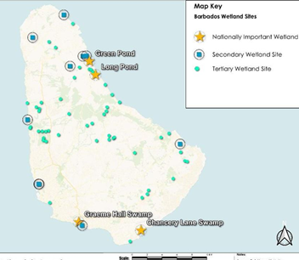
BSDS | Barbados SCUBA Dive Sites | Waypoints are available to download as KML. Map was published on Oct 13, 2023. | 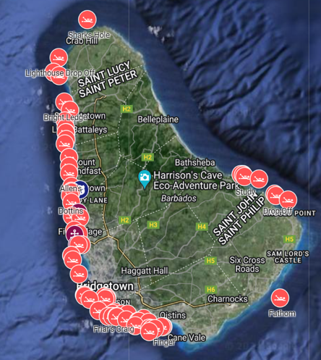
LULC
Gosine and Mahone 2015 | Mapping land-use, human activities and vegetation in the Conset Bay watershed, Barbados, to determine potential sources of coastal pollution | Several layers. For example, Fig. 8 Land-use map of Conset Bay Catchment area. Pag. 22 | 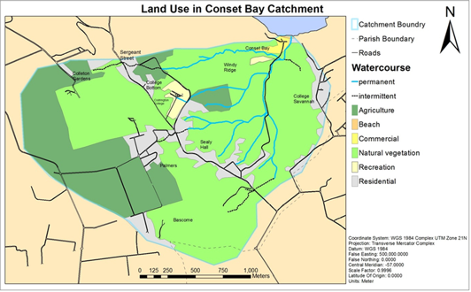
Shipping and transportation layers
GFW | Global Fish Watch | GFW is an open-access online platform for visualization and analysis of human activity at sea.  Vessel abundance | 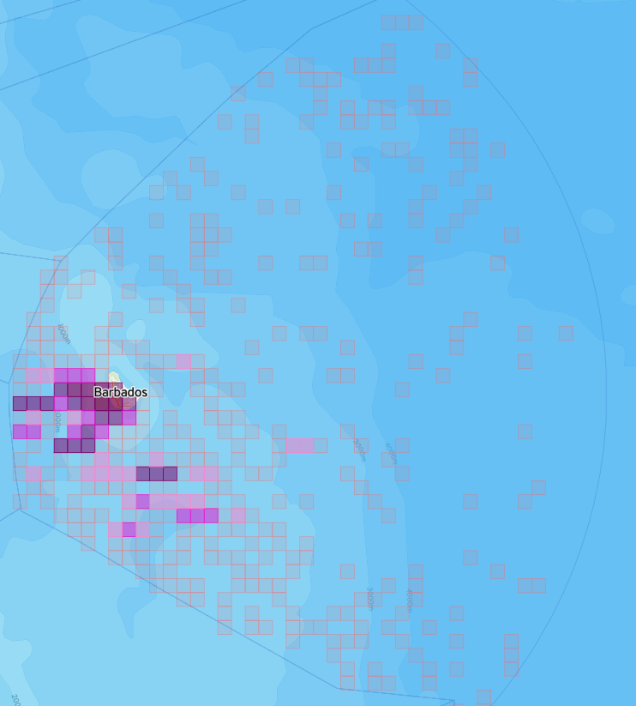
GFW | Global Fish Watch | Apparent fishing effort:  GFW uses data about a vessel’s identity, type, location, speed, direction and more that is broadcast using the Automatic Identification System (AIS) and collected via satellites and terrestrial receivers. GFW analyzes AIS data collected from vessels that their research has identified as known or possible commercial fishing vessels and applies a fishing presence algorithm to determine “apparent fishing activity” based on changes in vessel speed and direction. | 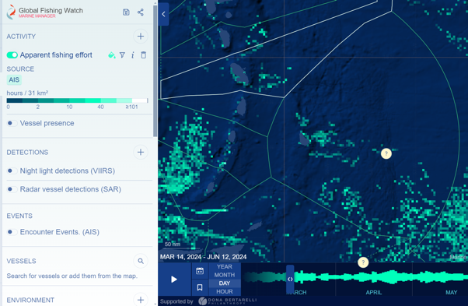
MT | Marine traffic | Smart ship tracking and maritime analytics.  This is a paid licensing tool that starts off with a 7-day free trial, subsequently, the cost is $19 USD per month for the standard plan or $69 USD per month for the professional plan. | 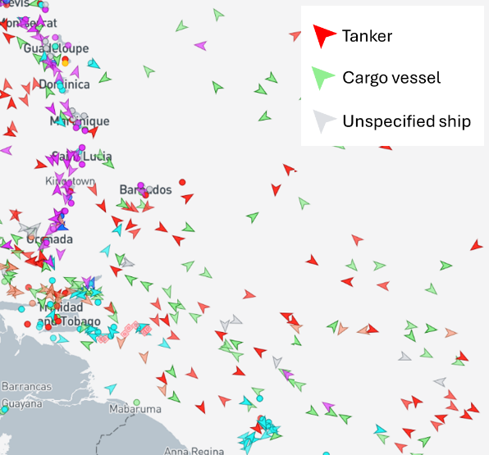
Small & Oxenford 2021 | Assessing anchoring impacts of cruise ships in Barbados during the COVID-19 pandemic of 2020 | Figure 3.7 Map showing the locations of 20 cruise ship anchoring events on the west coast of Barbados between 1 March and 1 September 2020. Pag. 21  Other information: Appendix 1 Time, date and position when cruise ships’ AIS status changed from to ‘At anchor’ for all 132 recorded anchor drops in Barbados between 1 March and 1 September 2020 | 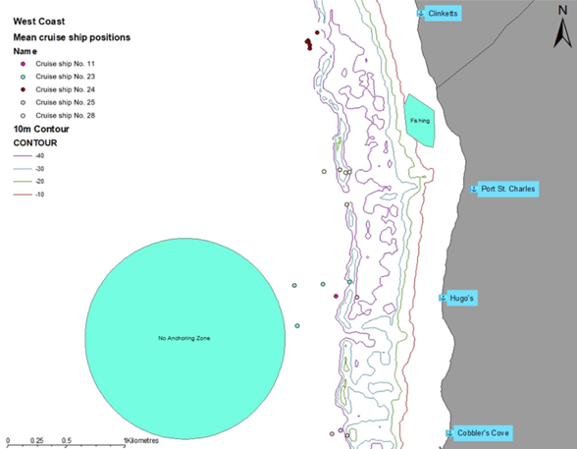
Hazard risk assessment
Alleyne-Greene 2016 | Assessing vulnerability to climate change and variability at Six Men’s Bay fishing community | Figure 15: Community-based hazard map of Six Men's Bay. Pag. 33  Other information: Figure 21: 1 in 100-year storm surge flood hazard map of Six Men's Bay. Pag. 38 | 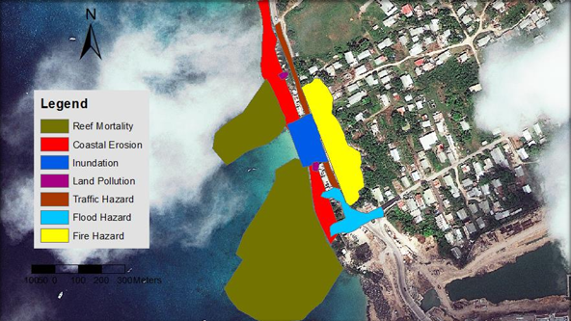
Alleyne 2019 | Assessing the vulnerability of Holetown, Barbados, to relative sea level rise and storm surge | Figure 16: Hazard map: relative sea level rise impact zone: 1.6 m; Critical infrastructure, land use and economic areas affected.  Pag. 30 | 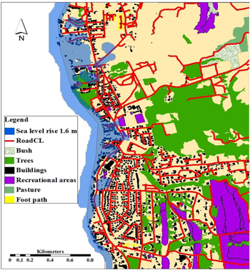
Mycoo et al. 2021 | Human Adaptation to Coastal Hazards in Greater Bridgetown, Barbados | Fig. 4. Flood hazard map of Bridgetown showing some of the key coastal assets (Coastal Zone Management Unit, Government of Barbados). Pag. 7. | 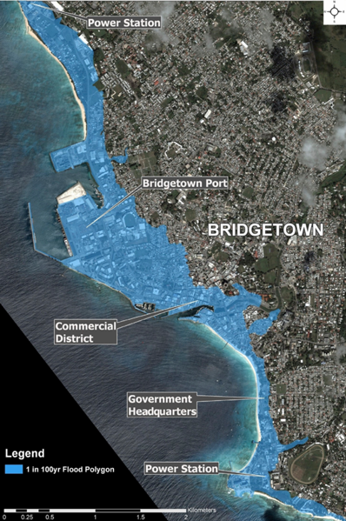
Degia et al. 2022 | Applying hazard risk assessment and spatial planning tools to sargassum inundations in the Eastern Caribbean Small Island Developing States as a basis for improving response | Fig. 10. Map of Barbados showing the level of sargassum inundations by the eight coastal sub-areas and at 31 exposed beaches. Pag. 21. | 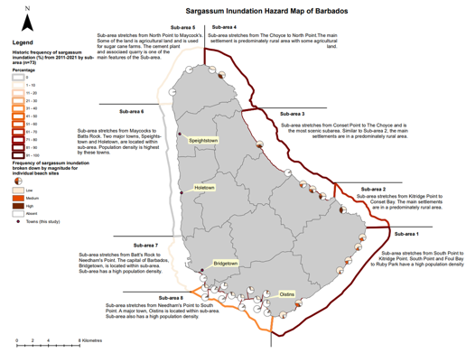
Degia et al. 2022 | Applying hazard risk assessment and spatial planning tools to sargassum inundations in the Eastern Caribbean Small Island Developing States as a basis for improving response | Fig. 11. Map of Barbados showing the exposure of coastal ecosystems to sargassum inundations.  Pag. 23. | 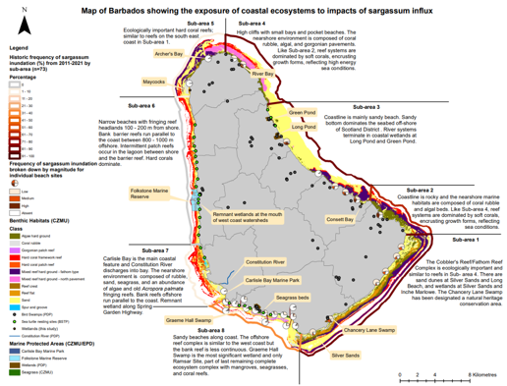
Degia et al. 2022 | Applying hazard risk assessment and spatial planning tools to sargassum inundations in the Eastern Caribbean Small Island Developing States as a basis for improving response | Fig. 12. Map of Barbados showing the exposure of tourism to sargassum inundation. Pag. 25. | 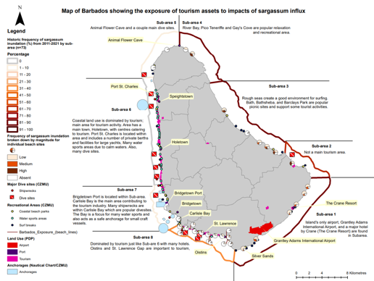
Degia et al. 2022 | Applying hazard risk assessment and spatial planning tools to sargassum inundations in the Eastern Caribbean Small Island Developing States as a basis for improving response | Figure 13 Map of Barbados showing the exposure of fisheries assets to sargassum inundations. Pag. 27. | 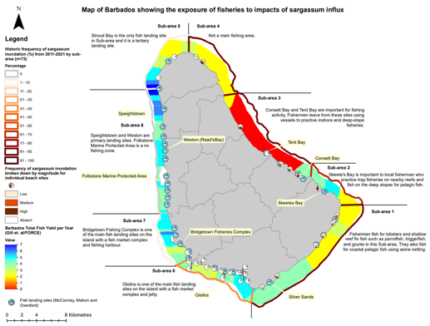
OW | Ocean Wealth:  Mapping Ocean Wealth Explorer | Flood protection Coral reefs:  People Protected (No.) | 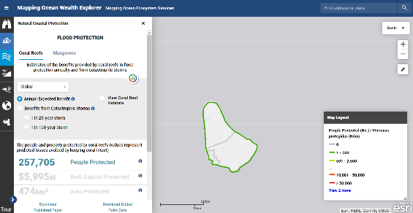
OW | Ocean Wealth:  Mapping Ocean Wealth Explorer | Population under 10m elevation (per sq km) | 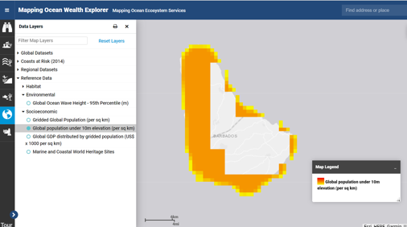
MOW | Mapping Ocean Wealth | Natural Coastal Flood Protection: Number of people avoiding damage from flooding per decade. | 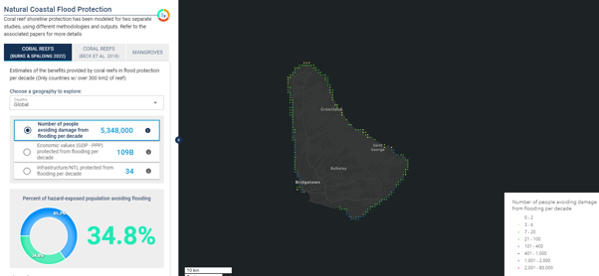
MOW | Mapping Ocean Wealth | InVEST Wind and Wave Hazards.  A model of wind and wave hazards was built using the wind and wave indicators from InVEST [1,2]. These data are derived from peak (top 10 %) historic wind and wave records over the period 1997–2007. | 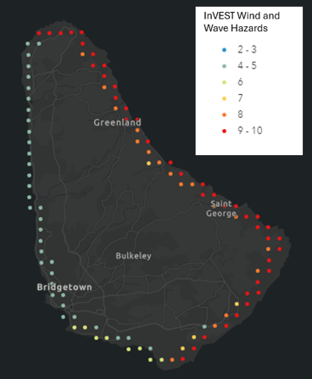
MOW | Mapping Ocean Wealth | Fringing reef providing protection to infrastructure/NTL  The relative importance of fringing reefs in defending adjacent coastal infrastructure from flooding. | 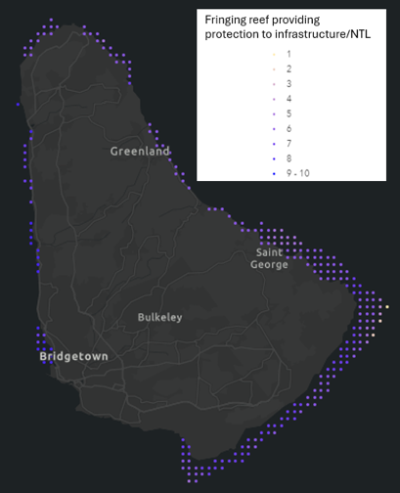
Hurricanes
CGP | The Caribbean GeoPortal | Contains several spatial layers and tools for hurricanes and cyclones, land use/land cover from 2017-2021, and sargassum worldwide or regional distribution. No specific layers for Barbados (5/29/2024). | 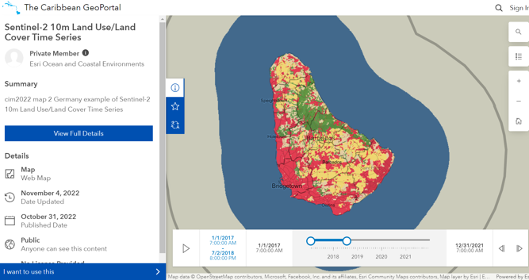
Tourism
Ricker et al. 2013 | Tourism and environmental change in Barbados: gathering citizen perspectives with volunteered geographic information (VGI) | They used map-based online tools (google maps, Geoweb) to facilitate citizen participation in discussing the impacts of tourism.  Figure 3. Google My Map interface and results. (A color version of this figure can be found in the  online version at www.tandfonline.com/JOST.) The map is no longer available 06/8/2024 | 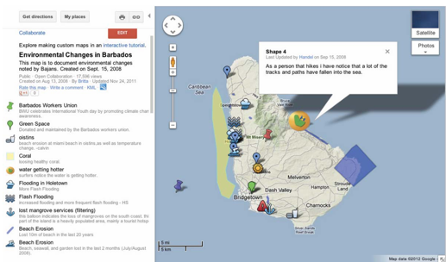
CSA | Caribbean Reef Explorer  (Caribbean Science Atlas) | Tourism value (on reef) | 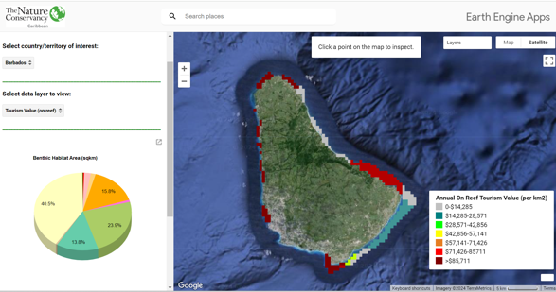
CSA | Caribbean Reef Explorer  (Caribbean Science Atlas) | Tourism value (reef adjacent) | 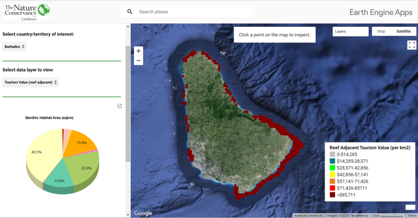
OW | Ocean Wealth:  Mapping Ocean Wealth Explorer | Modelled total dollar value of reef tourism (per km2) | 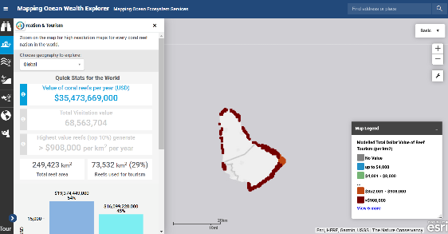
MOW | Mapping Ocean Wealth | Recreation and tourism | 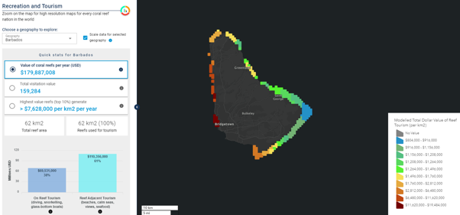

Fisheries related data gaps
Effective MSP often faces challenges due to missing or incomplete data about a particular topic. Because the MSP embraces a holistic approach, in which several sectors should be included, addressing data gaps is essential for an effective planning process. Some of the strategies to mitigate data gaps often require enhanced monitoring programs, improved data sharing practices, and collaboration between different stakeholders (e.g., governmental, NGO’s, private sector, academic, etc.). In terms of data gaps related to the fisheries sector, the assessment identified the following data gaps:

Human activities — fisheries sector:
- There is incomplete and/or outdated information on the distribution of fisheries activities (e.g., longline, seine, etc.). Except for the information provided by the DigiFish project, other existing information related to the distribution of fishing activities and fishing grounds is incomplete in terms of its spatial and temporal coverage. Furthermore, fisheries statistics data should also be reviewed and improved to better serve the needs of the MSP process based on clear objectives that have not yet been defined for Barbados.

- There is a lack of information related to conflict between the different fishing activities and between other sectors (e.g. spearfishing and cruising vessels).
- There is no information related to the use and impact of FADs.
- Limited information on the fishing community vulnerability and risk assessment to climate change and sea level rise.
- Through the BE, there is a great interest in promoting and developing the aquaculture/mariculture industry. However, there is no information regarding potential areas, species, and cost for aquaculture/mariculture endeavors.

Biological data:
- Although there is data on the distribution and status of benthic habitats, this data requires periodical reports and updates usually through the establishment of monitoring systems. For example, although there is information about the status of coral reefs in Barbados in 2017, the information is now 7 years old. Furthermore, there is no information about the status of other habitats such as seagrass and mangrove habitats. There is no information about deep-sea habitats.
- There is a gap in information related to the distribution of most of the commercially important fish species. Including information about their nursing, spawning and mating grounds. Although, in some cases it is possible to use surrogate data (such as habitat type, seafloor morphology, etc.) specific information about their seasonal distribution throughout the whole EEZ should be a priority.
- The assessment identified several reports on the distribution of other species such as sea turtles. This information combined with expert advice could be used during initial assessments. Although the Global Biodiversity Information Facility (GBIF) provides location information of opportunistic sightings of different species through Barbado’s EEZ, there is not a study that documents/describes/analyses this data for Barbados.
- Information about invasive species and their effect on the marine environment is unknown.
- There is missing information related to the distribution of marine mammals and sea birds especially for migratory species.

Environmental Data:
- There is inadequate/missing information on sources and levels of pollution, including plastic debris, chemical contaminants, and nutrient runoff and their effects on marine ecosystems, species and the economy.
- Further research on sargassum is needed to inform on its impact on Barbados environmental and socio-economic aspects.
- There is a data gap related to the effects of artificial light on sea turtles and nearshore fishes’ populations.

Socioeconomic Data:
- Insufficient data on the distribution and economic value of the fisheries industry.
- Data to support profitability and production analysis to determine how profitable and productive different fishing gears operating in different locations are, including new fisheries sub- sectors areas such as mariculture and aquaculture.
- Lack of detailed information on how marine activities impact (e.g., overfishing, pollution, habitat degradation, etc.) coastal communities and their livelihoods.
- There is a lack of data that help to define and measure the standard of living of Barbados small-scale fishing Communities.

Fisheries related data needs to inform MSP
The MSP process is typically divided into steps, each critical for creating and implementing an effective marine spatial plan. An initial analysis can be performed with existing data to establish a baseline and to initiate stakeholder dialogue and participation. However, as the process evolves, more reliable data should be secured and/or used to improve the results. Stakeholders’ input is central throughout the different steps to ensure that results (and their implications) reflect true and acceptable conditions.
The MSP process should be guided by clear objectives, which in turn, will also help determine the data needed during the different phases of the MSP process. Typical, data categories used for MSP process include administrative boundary layers (e.g., country boundaries, EEZ, protected areas, etc.), physical, chemical and biological layers that includes oceanographic data (e.g., bathymetry, sea surface temperature, ocean acidification, nutrients, etc.), species distribution and/or biological layers (e.g., benthic habitats, fishes, birds, sea turtles distribution, nursing, spawning and/or mating habitats, etc.), human spatial and temporal distribution (e.g., fisheries, transportation, energy, tourism and recreation), and socio-economic information which can be use as indicator variables and or combined but specific analysis to be included in the spatial analysis (e.g., fishing value, tourism value, livelihood information, etc.). Other categories include specific objectives, such as the inclusion of mariculture activities into current or already developed zoning, pollution layers, impact of climate change and sea level rise, among others.
At the very least, data should be objective, reliable, spatially and temporally relevant. Any data limitations should be clearly disclaimed, so they are considered by stakeholders.
Table 8 shows a list of data related to the fisheries sector considered useful to guide an initial MSP assessment. The table also includes suggested methodologies that could improve existing data for further phases of the MSP process. Integrating these types of data into a comprehensive spatial planning/analytical framework will allow managers and stakeholders to collaboratively assess options for balancing the use and conservation of Barbados’ marine habitats and resources.
It should be noted that the effort to document existing data needs and capacity gaps for the fisheries sector to inform MSP is being complemented by similar efforts led by the CZMU to obtain information for other relevant sectors including maritime transportation, tourism, energy production (renewable & non-renewable), and mining (sand and gravel), among others. It is fundamental that MSP focuses on managing marine environments in a way that considers the complex interactions between ecological systems and human activities (holistic approach).
Table 8. Suggested data inputs for the early stages¹ of the Barbados MSP related to the fisheries sector. Additionally, descriptions of methods for data collection during the implementation phase² (improve current data) are included in the methods column.
Spatial data | Priority for collecting data | Current availability | Method for obtaining/collecting data | Partners for improving data catalog
HUMAN ACTIVITIES — FISHERY SECTOR
Small-scale fishing distribution | High | Some data; mainly nearshore | ¹Participatory mapping  (low resolution, medium cost, EEZ coverage)  ¹Vessel tracking system (through the DigiFish project or similar)  (high resolution, high cost, EEZ coverage)  ²Human activity distribution models  (medium resolution, medium cost, EEZ coverage) | BFD  CZMU  Fishers/Fisheries organizations  CERMES
Recreational and charter-for-hire distribution | High | Some data; mainly nearshore
Commercial fishing distribution | High | Data poor
Areas where users’ conflicts have been reported | High | Some data; mainly nearshore
Distribution of fisheries activities by gear (e.g., longline, seine, spearfishing, etc.) | High | Some data; mainly nearshore
Fishing grounds (historical & current) —subsistence/commercial | High | Data poor
FAD locations | High | Data poor
Landing sites | High | Some data | ¹Use satellite data to estimate location of features  (low resolution, low cost, land and nearshore coverage)  ²Ground truthing locations estimated with satellite data  (high resolution, medium cost, land and nearshore coverage) | BFD  CZMU  Fishers/Fisheries organizations  Barbados divers’ association (BADASS’n)
Anchorages/mooring areas | Low | Some data
Diving sites | High | Good  BADASS’n
Other fisheries related land base facilities (e.g., boat yards, marinas, lighthouses, etc.) | Low | Some data
Offshore aquaculture/mariculture (potential) | High | Data poor | ¹Implement suitability study  (high resolution, high cost, mix coverage) | BFD  CERMES
Fisheries socio-economic data (e.g. fish caught by landing site, number of vessels and fisherfolk register, etc.) | High | Some data | ¹Continue using current fisheries socio-economic data.  ^{1,2}Evaluate and improve current data collection of fisheries socio-economic data. | BFD  Fishers/Fisheries organizations  Barbados Statistical Service
BIOLOGICAL — Habitats
Coral reefs distribution | Medium | Baldwin et al., 2019 & Schill et al., 2021 | ¹Continue using information from current sources  (mix resolution, low cost, nearshore coverage)  ²Enhance current monitoring system to update current habitat information  (medium resolution, high cost, nearshore coverage) | CZMU  TNC  MENB  Barbados diving association
Seagrass distribution | Medium | Baldwin et al., 2019 & Schill et al., 2021
Benthic habitats distribution | Medium | Baldwin et al., 2019 & Schill et al., 2021
Mangrove distribution | Medium | Some data
Degraded habitats distribution due to climate events (e.g., coral bleach, seagrass loss, etc.) | High | Data poor | ¹Implement specific studies  (mix resolution, high cost, nearshore coverage)  ²Implement a reporting and monitoring system (citizen science — mechanism for people to report events) | CZMU  BFD  MENB  TNC  Fishers/Fisheries organizatons  CERMES  Barbados diving association
Population and demographic data | Low | National statistical data | ² Analyze ecosystem services provided by marine habitats based on population and demographic data | CZMU  BFD  CERMES  TNC
BIOLOGICAL — Species Distribution
Nursing areas | High | Data poor | ¹Participatory mapping  (low resolution, medium cost, mix coverage)  ^{1,2}Distribution models  (low-medium resolution, medium cost, mix coverage)  ^{1,2}Tracking studies  (high resolution, high cost, mix coverage) | BFD  Fishers/Fisheries organizations  CZMU  MENB  CERMES  CRFM  Barbados diving association
Spawning aggregation sites | High | Data poor
Fish distribution | High | Data poor
Lobster distribution | High | Data poor
Conch distribution | High | Data poor
Sea urchin distribution (sea egg) | High | Data poor
Sea turtle distribution | High | Data poor
Marine mammal distribution | Low | Some data
Algae distribution | Medium | Data poor
Sargassum distribution | Low | Data poor
Invasive species (Lionfish) distribution | Low | Satellite data
OCEANOGRAPHIC CONDITIONS
Bathymetry (contour lines or satellite imagery) | Low | Nearshore (CZMU, 2015)  EEZ (GEBCO, 2023) | ¹Continue using global digital elevation models (DEM) (e.g., GEBCO, Seabed 2030)  (medium resolution, low cost, EEZ coverage)  ²Update lidar data  (high resolution, very high cost, nearshore coverage) | CZMU  BFD  MENB
Chlorophyll a concentration | Low | Satellite data | ¹Continue using satellite data (medium resolution, low cost)  ²Deploy oceanographic buoys  (high resolution, high cost, usually nearshore coverage) | CZMU  BFD
Nutrients (e.g., nitrates, phosphates, etc.) | Low | Satellite data |  | CZMU  BFD
Ocean currents (direction and speed) | Low | Satellite data |  | CZMU  BFD
Prevailing winds (direction and speed) | Low | Satellite data |  | CZMU  BFD
Salinity | Low | Satellite data |  | CZMU  BFD
Sea surface temperature | Low | Satellite data |  | CZMU  BFD
Hydrometeorological parameters | Medium | CZMU Buoy | ¹Continue using information provided by current deployed oceanographic buoys (nearshore)  (high resolution, high cost, usually nearshore coverage)  ^{1,2}Deploy oceanographic buoys in other areas (farther offshore).  (high resolution, high cost, usually nearshore coverage) | CZMU  BFD
Directional wave | Medium | CZMU Buoy |  | CZMU  BFD
Water temperature | Medium | CZMU Buoy |  | CZMU  BFD
Meteorological parameters such as wind speed and direction, air temperature, barometric pressure | Medium | CZMU Buoy |  | CZMU  BFD
Current wave parameters (height, speed, period) | Medium | CZMU Buoy |  | CZMU  BFD
OTHER RELATED DATA
Land cover/land use | Low | Some data | ¹Continue using available data  (mix resolution, low cost, land nearshore coverage)  ^{1,2}Implement specific studies  (mix resolution, high cost, land and nearshore coverage) | MENB  CERMES
Wetlands | Low | MENB, 2023 |  | MENB  CERMES
Watersheds | Medium | Some data |  | MENB  CERMES
Pollution (e.g., trash, sewage, etc.) | Medium | Data poor |  | MENB  CERMES
Hazard risk coastal areas | Medium | Data poor |  | MENB  CERMES
Flooding | Medium | Data poor |  | MENB  CERMES
Hurricanes | Low | Some data | ^{1,2}Implement specific studies  (mix resolution, high cost, nearshore coverage) | CZMU  MENB  CERMES
Sea level rise | Low | Data poor |  | CZMU  MENB  CERMES
Ocean acidification | Low | Some regional data |  | CZMU  MENB  CERMES
Changes in sea surface temperature | Low | Satellite data |  | CZMU  MENB  CERMES
Changes in tides and waves | Low | Satellite data |  | CZMU  MENB  CERMES
¹ Early phases of the MSP; ² MSP Implementation phase

Data access
Data accessibility refers to the ease with which users can find, retrieve, understand, and use the data. During this assessment of data access in Barbados several limitations for accessing data were found and are described below. These limitations can significantly impact the effectiveness of MSP planning and management efforts.
- Data integration: Existing data must be integrated into a project to allow for its incorporation and usage in analytical tools. This could be a challenge because existing data from different sources have varying formats (e.g., shapefile, geotiff, geoJSON, KML, jpg, png, PDF, etc.), temporal and spatial scales (e.g., collected locally, nationwide, nearshore, regionally, etc.), and quality (which is highly dependent on data collection methodologies and equipment). Most of the current available data in Barbados is in PDF format. Thus, the information will have to be requested from the source. If the map/layer is not in a usable format (usually a spatial format) then further procedures will have to be completed (e.g., digitalization, georeferencing, etc.) so the data can be combined into a cohesive and usable format.
- Data quality: This can be measured based on several characteristics such as completeness (presence or absence of features and/or their attribute information), spatial (related to the position of features in relation to Earth), and thematic (related with the attributes within features) accuracy. Existing data for Barbados was collected with specific objectives and methodologies which can affect its quality and accuracy. For instance, the spatial accuracy of a layer created using a GPS unit (higher accuracy) is different than a layer created using aerial imagery (lower accuracy). The layer’s metadata is usually used to evaluate its quality. GIS metadata refers to essential information about a layer or dataset, including its source, quality, content, and other characteristics. Exploring and understanding the quality of a layer is an important step in any GIS/spatial dependent project.
- Locating data: Finding relevant data can be challenging due to the plethora of platforms to publish data (e.g., reports, scientific publications, organization servers and/or websites, atlas and portals, etc.). To mitigate this limitation a national data access and sharing platform will have to develop and coordinate, so data from all the pivotal sectors can be included there. The CZMU could lead the development of this MSP platform or mechanism (index) in which authors can share a description of their research and/or project with a section for describing and sharing their spatial data.
- Unwillingness to share information: There are several reasons for people or an organization’s indisposition to share information. Data may be sensitive (e.g., precise location of endemic species) or proprietary (e.g., fishing spots). There could be legal or regulatory constraints, or in some cases it could be because there is a lack of trust. Several strategies can be used to mitigate this limitation. For instance, trust can be enhanced by fostering open communication and building relationships with stakeholders and data holders, by establishing clear procedures and protocols that provide details regarding how data will be used, shared, and protected, by creating different data sharing privileges so sensitive data might only be shared with relevant stakeholders, among others.
Clear guidance documents and procedures should mitigate the effect of these limitations during the implementation phase of the MSP process. At the very least, this should include:
Data sharing agreements: They are formal contracts that outline the terms and conditions for sharing data. Their purpose is to ensure that all parties understand their rights and responsibilities concerning data use, access, and protection. In most cases, data related to the fisheries sector is shared through informal agreements. Usually, a request is made to the source of information (e.g., Fisheries Division Chief officer, professor or principal investigator, etc.) and data sharing is decided on a case-by-case basis. Usually involving the acknowledgment of the source of the requested information. The development of a MSP sharing platform or mechanism should include a data sharing agreement. The Caribbean Science Atlas sharing agreement is a good example of such practices, in which users are required to complete and sign the agreement before they can download information available through this atlas.
Data sharing protocols: they contain practical guidelines for technical and operational aspects of data exchange (who should share, what to share, what format, etc.). For instance, once the MSP data sharing platform is operational it should allow stakeholders to upload and share their data. The data sharing protocols will then provide the necessary information to ensure that new data meets established data quality standards, and it is provided in a format that allows for seamless integration with current data (as possible).

Technological and human resources
Effective Marine Spatial Planning (MSP) relies on both technological and human resources to ensure that data is accurately and effectively collected, analyzed, and utilized for decision-making.

Technological resources
For this assessment technology resources consist of hardware and software required for developing and implementing a MSP process.
Hardware
Running GIS analysis, models and simulations, as well as managing large datasets can be computationally demanding. Typical computer needs include multi-core processors, minimum 8GB of memory/RAM (recommended ≥32GB), a dedicated graphic card, and preferable solid-state drivers for faster data access. Furthermore, other important resources include stable internet connectivity (for accessing online GIS data sources, cloud-based GIS services, and software updates), backup systems and protocols (hardware and cloud-based), and up-to-date antivirus software.
Both the CZMU and the BFD meet the minimum hardware requirements for installing and working with GIS software. They also have backup systems and antivirus software. However, the current internet connectivity (speed and reliability) could be improved. During the interview process with stakeholders, it was rated by staff that were interviewed as intermediate —3 out of 5).
As the MSP leading agency, the CZMU will have to increase their technological resources (e.g., servers, data storage, clearinghouse data, etc.) to accommodate the national data sharing mechanism able to manage complex and large datasets expected from combining information from multiple agencies and organizations (e.g., shipping sector, tourism, environmental, fisheries, etc.).
Software
Geographic Information System (GIS) software is essential in MSP because it provides tools for collecting, managing, analyzing, visualizing, and sharing marine and coastal data and results. There are several software options currently available for developing, curating and analyzing spatial data. This assessment focused on the most popular software for MSP, which can be divided into three main categories based on their capacity: a) acquiring, exploring and preparing data; b) analyzing data; and c) sharing and interacting with data results.

Software for acquiring, exploring, and preparing data
Once the objectives of the MSP are determined, the focus can turn to acquiring the information needed. In the case of Barbados, some of the information is readily available (e.g., country boundary, fisheries statistics, etc.). Some information might require further processing or manipulation (e.g., clipping to study areas, coordinate system, etc.) to standardize all the spatial layers (usually from different sources) for further analysis. In some instances, spatial information must be collected and therefore, ideally, the software should provide tools or extensions to aid in data collection (paper and digital forms).
ArcGIS Pro and QGIS are leading software packages used to create, manage, analyze and visualize spatial data (Table 9). In general, ArcGIS software is very reliable, user-friendly, with advanced spatial analysis tools and easy integration with other features for data visualization (e.g., interactive maps, story maps, dashboard, etc.). However, it is also expensive and requires a yearly license per user. QGIS is also a powerful software, with several standard GIS functionalities but customization depends on its community for more specialized tools. Although the license for QGIS is open source (no cost), other features, training, and customization might require a fee. Furthermore, although features for publishing and visualizing data can be accessed, they might be available through other companies (e.g., Mapbox) which can increase effort and cost.

Table 9. Comparison between ArcGIS and QGIS software.
Characteristic | ArcGIS (ESRI products) | QGIS
Cost | Paid license (3 levels). The cost of the GIS professional advance licensing in the US is USD $4,150/year for 1 computer/user. Additionally, the cost of the software extensions bundle is USD $1,950/year*. | Open-source and free to use. There might be costs associated with training, support, and customization.
User interface | User-friendly with comprehensive documentation and support tools (e.g., websites, forums, blogs, tutorials, and training –some at no extra cost). | Steeper learning curve for beginners. It offers extensive customization options. Community-driven support (e.g., forums, video tutorials, and developers).
Functionality | Wide array of advanced spatial analysis tools and integration with other services (R software, satellite data) | Broad range of GIS functionalities, including spatial analysis, map design, geoprocessing, and plugins for additional capabilities. It depends on its community for more specialized tools.
Customization | Through scripting and coding (mainly Python language). | Through plugins and scripts (Python language and others). Community-driven plugin repository that allows users to access and contribute plugins.
Features for data visualization | It offers cloud-based solutions such as ArcGIS Online, interactive maps, dashboards, story maps, among others. Because the different solutions are integrated, a map created in ArcGIS Pro is easily shared among the different apps. | Interactive maps are shared through plugins but require other platforms (e.g., OpenLayer, Leaflet, MapBox) to make it available online.
System compatibility | ArcGIS is a Windows-only application. It can be run on Mac systems using a natively on a Windows partition. Support and troubleshooting are limited. | It runs on Windows, macOS, Linux, and BSD.
* Pricing was estimated for the United States (2024) and it might differ based on the country, organization, number of users, software credits, etc. Please contact your local ESRI provider for accurate cost estimates.
R software is another option, not requiring a license, for working with GIS data. However, R is mainly used as statistical software with capabilities for performing GIS analysis. It is not as user-friendly, with a steep learning curve (requiring dedicated time and effort) that includes R syntax (programming), data structure, and the use of multiple packages (collections of functions, documentation, and data that expand R).
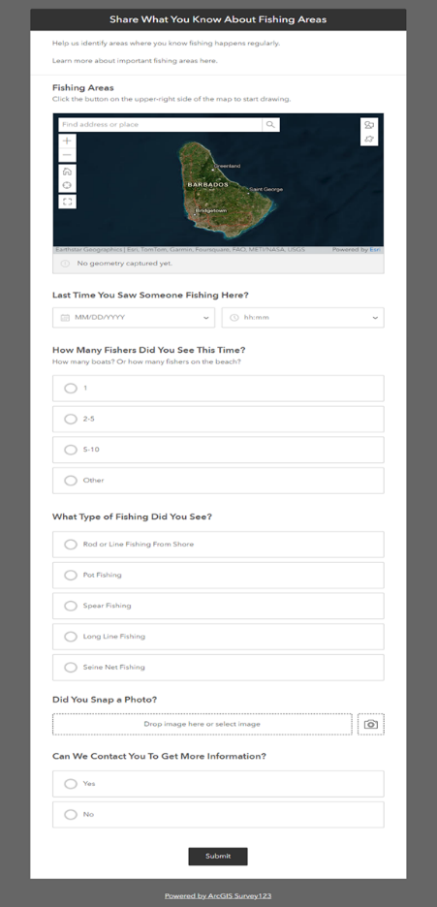
The CZMU is currently utilizing the ArcGIS software. Their personnel skills level with the software ranges from intermediate to advanced. The CZMU marine spatial planning website provides a glance of some of the spatial data (interactive maps created using ESRI products). Furthermore, the CZMU has developed a data collection form to gather fisherfolk input related to fishing areas (Fig. 11) using Survey123.

Figure 11. CZMU Fishing areas survey (Survey123).
The BFD is currently securing funds to obtain one ArcGIS license. They have one technician designated to support MSP, but the level of GIS expertise is basic. Furthermore, the BFD recently developed a digital form in Kobo Toolbox for registering fishing licenses and vessel inspections. Kobo Toolbox provides data collection tools starting with a community license for free. However, some of the comments related to the use of this software expressed issues mainly while collecting data offline.
Both the BFD and CZMU agencies have basic expertise in working with QGIS. They know about the software and have used it sporadically for simple mapping applications.
ArcGIS and QGIS are continually developing and providing access to new associated products and tools. Therefore, there are opportunities for further capacity and technical training on the use of both software for MSP.

Analyzing MSP process data
There are several software packages with specific tools, extensions and plugins designed to help decision makers to interpret results and find solutions for complex issues during the MSP process. Table 10 shows a comparison of the main software packages currently available. Marxan and SeaSketch are platforms specifically created to support planning processes, requiring basic knowledge in GIS, while ArcGIS and QGIS are software packages developed to work with spatial data (not specific for planning) but with the capacity to perform spatial and scenario modeling analysis. However, ArcGIS and QGIS require technicians with intermediate to advanced knowledge in GIS, spatial analysis, and in operating the software itself.

A comprehensive list and description of other specialist MSP software was published in 2022 by the World Bank through its MSP Blue Economy Data and Tools report. The list includes:
Software and application tools:  - Adaptation Design Tool: Corals and Climate Adaptation Planning  - ARIES  - Capturing Coral Reef & Related Ecosystem Services (CCRES) project tools  - Changing tides. Climate Adaptation Methodology for Protected Areas (CAMPA): coastal and marine  - Climate Adaptation Toolkit for Marine and Coastal Protected Areas  - Coastal Climate Adaptation Decision Support  - Decision Support Tool for Blue Economy in Marine Protected Areas  - DEVOTES  - Earth Blox  - EcoImpact Mapper  - Ecopath with Ecosim (EwE)  - EO4SD Marine and Coastal Resources Portfolio  - ExtendSIM  - Guide for Planners and Managers to Design Resilient Marine Protected Area Networks in Changing Climate  - iMarine  - Living Standards Measurement Study (LSMS)  - Marxan  - Natural Capital Project  - ODEMM  - Reef Resilience Toolkit  - The Marine Spatial Planning Challenge  - Tools4MSP | Online GIS mapping tools and portals:  - ArcGIS Online  - ARIES for SEEA Explorer  - Caribbean Marine Atlas  - Climate Engine  - Coastal Resilience  - Earth Map  - European Atlas of the Sea  - Google Earth Engine  - IPCC WGI Interactive Atlas  - Marine Protection Atlas  - MESH Seabed Habitat Maps (EMODnet)  - Ocean+ Habitats  - Ocean Wealth Explorer  - PEDDR Opportunity Mapping Tool  - SeaSketch  - Spatial Agent  - Tools4MSP Geoplatform  - The World Bank Maps  - AI Tools for Rapid Natural Capital Accounting  - Ocean Accounts Diagnostic Tool  - System of Environmental Economic Accounting  - Symphony  - Wealth Accounting and the Valuation of Ecosystem Services (WAVES)  - Bayesian Belief Networks  - Leaflet  - TerraGo Toolbar

Table 10. Comparison among selected MSP software.
Software | Marxan | SeaSketch | ArcGIS | QGIS
Description | It applies an algorithm (procedure) to find one or more solutions to a well-defined problem. | Participatory mapping software. | GIS software for creating, modifying, analyzing, and reporting spatial information. | GIS software for creating, modifying, analyzing, and reporting spatial information.
Basic software cost | Free | Free | $$ | Free
Advance software cost (customization) | Free | Baseline $3K. Group project $15-$20K. Large projects $30-80K | Basic $2K. Advanced $5K per user/year | $
Project setup | Moderate | Easy | Moderate | Moderate
Support | Though its community is free  Specialized training $$ | Though its community is free  Specialized training $$ | Basic is included  Specialized training $$ | Though its community is free Specialized training $$
Level of GIS expertise | Moderate | Basic | High | High
Guided workflows | Yes | Yes | No | No
MSP tools | Reserve design, with zones, with connectivity y With probability | Zoning but it can be customized | Several such as suitability modeler | Several plugins
Scenarios capacity | Yes | Yes | Yes | Yes
Data collection forms setup | No | Easy | Moderate | Moderate
Online data collection | No | Projects & surveys | FieldMaps, Survey123 | QField
Offline data collection | No | $$ | Included | $$
Layer preparation | No | No | Yes | Yes
Sharing results, stakeholder collaboration | Marxan web | SeaSketch Projects | Interactive maps, story maps, dashboards | Plugins to other companies

Cost/Effort

Sharing and interacting with data and results
MSP should be a participatory and collaborative process that benefits from software and tools with integrated data sharing capabilities. From the selected software in Table 11, ArcGIS has the greatest level GIS. ESRI has a series of other completely integrated products such as ArcGIS Hub, dashboards, story maps, interactive maps, digital data collection (Field Maps and Survey123), among others. QGIS is also a powerful GIS software able to complete all the steps of the GIS. However, some of its products are not fully integrated and require access to extra software (offered by different companies). MSP requires that personnel using ArcGIS and QGIS to also have intermediate to advanced GIS skills.
Marxan and SeaSketch provide web-based sharing platforms of data and results. However, data acquisition, exploration and manipulation cannot be performed using either of these packages. These applications are, however, relatively easy to use, require personnel with basic GIS skills, and are well adapted as MSP digital data collection platforms.

Human resources
For this assessment, human resources refer to core team personnel in charge of overseeing the day-to-day activities involved in developing and implementing a MSP process.
Several people interviewed from BFD and the CZMU are yearly contracted personnel, which could create an unstable environment and a greater personnel turnover. One of the reasons to justify this arrangement is that official permanent positions within the government are difficult to create and might require a lengthy process. Furthermore, some of these personnel are hired with budget from projects that require a determined budget time execution.
The composition of an MSP team typically includes a multi-disciplinary range of experts, including a project manager, GIS professionals, communication and outreach specialist, policy and legal expert, an ecologist or marine biologist, an economist, an information technology specialist, and technicians to support data collection effort. Currently, the CZMU team is comprised of 11 people with a wide range of expertise and capable of handling the development and implementation of a national MSP process.
In terms of the fisheries sector, the BFD has some personnel limitations. Currently, there is only 1 data analyst with basic knowledge in GIS, and whose duties and effort are divided among multiple projects and activities. The BFD has several data collectors and/or field observers; however, it is anticipated that a great amount of effort is necessary to support fisheries data collection, analysis, and reporting, which may require more than 1 dedicated data analyst — at least at the early stages of the MSP process.
Capacity building
MSP requires a combination of technical capacities and skills. At the very least, technicians should have a basic to intermediate knowledge and skills in GIS including acquiring reliable and relevant data, managing and processing individual layers as well as integrating the diverse layers and datasets, usually from multiple sources (including non-spatial data) and with different formats, into one project for further analysis.
Several software products and tools used for MSP consist of underlying models (e.g., reserve design in Marxan, suitability model in ArcGIS, etc.) to provide insight into the question of interest. MSP technicians should have at least basic knowledge of mathematical and statistical modeling techniques to maximize the use and interpretation of “canned” (standard or already developed) models (e.g., reserve design with zones, suitability analysis, etc.). As the MSP progresses, technical capacities should also grow expanding on standard tool applications and developing customized models to support the long-term goals of the MSP (complex simulations to help predict the impacts of different planning scenarios).
It is anticipated that the MSP team (within the CZMU) will oversee the implementation of core MSP analysis. The MSP team has capacity for working with spatial (e.g., shapefile, raster, etc.) and non-spatial data (e.g., socio-economic data, surveys, etc.). They also have access to the ESRI products and support. However, they might benefit from training related to advanced spatial analysis and modeling techniques. GIS technology is usually improving, and it is important to participate in conferences and specialized training to make use of the most advanced techniques and tools.
In contrast, the BFD does not have a technician exclusively working on supporting MSP activities, personnel level of expertise in GIS is basic, and they are currently securing funding for the ESRI license. However, once this software is acquired the expectation is that it will aid in/contribute to fisheries related data collection efforts by the BFD, while the MSP team from CZMU will handle the robust analysis and data sharing efforts. Nevertheless, it is important to build capacity among the different governmental agencies, and therefore it is suggested that the BFD technicians and personnel focus their training on digital data collection —designing surveys and stakeholder engagement.
The area of stakeholder engagement is an opportunity for BFD and CZMU collaboration. Therefore, training in communication, outreach, writing, design of presentation, and facilitation skills should also be considered.
Capacity building programs should consider multiple training strategies to account for potential personnel turnover. For example, in-person training could be complemented with online, at learners’ pace, training modules. Table 11 presents several recommended trainings to improve current technical capacity to support the MSP process, which are applicable not only to the fisheries sector but also to other relevant agencies for developing and improving MSP in Barbados.
Table 11. Suggested trainings for technicians supporting Barbados MSP process.
Trainings | Main topics
Introductory training in GIS | Acquiring data  Managing spatial data  Basic analysis based on already established tools (e.g., analyst tools)
Digital data collection | Participatory mapping surveys  Direct data collection through tracking data.  Monitoring systems (e.g., acoustic monitoring, drones and remotely operated vehicles)
Facilitation skills | Methods for participatory planning and stakeholder engagement
Remote sensing | Acquiring satellite data  Creating and working with derived data (data created as a product of previous analysis)
Introduction to modeling and simulations | Basic knowledge  MSP software and tools (in deep exploration of current leading platforms to understand their strengths and limitations)
Models and simulations (intermediate training) | Understanding of ecological and environmental modeling concepts  Creating and modifying models  Modeling software (e.g., MATLAB, Python, R software, etc.)  Spatial statistics (e.g., cluster analysis, hot spot analysis, etc.)  Advance simulations
Economic analysis | Cost-benefit analysis of different scenarios  Trade-off evaluation among competitive uses  Assessment of economic development opportunities
Legal and policy | Introduction to national and international laws, regulations, and policy framework related to MSP  National and international data sharing protocols
Cloud-based platforms for sharing data | Exploration of current platforms (strength and weakness based on national need)  Design and implementation of online platforms and tools (e.g., website, interactive maps, dashboards, mapping surveys, discussion forums, etc.) for sharing data and results to support stakeholder engagement  Mobile apps (design and implementation for data and results sharing)

Incorporating fishermen (e.g., small-scale, commercial, and recreational fisheries) into the MSP process not only supports sustainable resource management but also promotes social equity and resilience in coastal communities. Their involvement is essential for creating comprehensive and effective marine management strategies. Therefore, it is important to provide training opportunities and outreach activities for this group that include:
- Marine Spatial Planning training that describes:
  - what it is,
  - how it is done,
  - how they can actively participate in this process,
  - how the information they provide is used and shared and
  - the importance of accurate, up-to-date information for an effective MSP process.

- Training in the use of technology to collect, share, analyze and visualize data that might be useful for MSP and their fishing operations (e.g., GPS to locate fishing spots, cargo ships distribution, sea surface temperature, interactive maps, etc.).

Recommendations
Barbados government is committed to promote and develop its Blue Economy, in part by developing and implementing a MSP process. Based on this assessment the following recommendations are proposed:
Data collection
Although the DigiFish dataset (vessel tracking project) has its limitations (e.g., there is a need to increase its sample size), it provides the best information related to the temporal and spatial movements of fishing vessels. It also allows for further analysis based on time spent in the water (effort), vessel and fisherfolk characteristics, etc. It is recommended that efforts should be allocated to secure funding to extend this project and increase its sample size, so the data is more representative of the fishing community.
There is some basic data that can be used during the early stages of the MSP process (e.g., scientific reports, governmental data, etc.). However, it is recommended that the results of the analysis performed using this available data should be interpreted carefully due to the limitations inherited by this data (e.g., data was collected using different methodologies, timeframes, purposes, etc.).
Because there are temporal and spatial gaps in information related to the distribution of fishing activities and commercially important species, the MSP team should prioritize data collection on these topics. A timely and effective option is the use of surveys and participatory mapping that can be applied to collect initial data (through consultations with fisherfolk, managers, and researchers). Participatory mapping will not only provide basic information but will also facilitate necessary stakeholder engagement at early stages of the MSP process. These methodologies can be timely, and they don’t require a vast number of resources. Nevertheless, because they rely on recollection of information rather than direct observations, participatory mapping has its limitations which should be recognized during the results interpretation and reporting. Some spatial layers obtained with these methodologies include fishing grounds, nesting, nursing and spawning areas (e.g., commercially important fishes, sea turtles, marine mammal, invasive species, etc.), areas where conflict has been experienced, on-the-water areas used for tourists (e.g., swimming, diving, snorkeling, jet ski, yacht cruising, etc.), livelihood and gender related data, among others.
Although the BFD is still collecting data using paper forms, they are also trying to transition into digital data collection with mixed results. Therefore, there is an opportunity to develop these digital data collection tools using integrated software. As well as sharing related expertise among agencies.
It is also recommended partnering with other relevant institutions such as TNC, academic centers in the Caribbean region, and other NGOs to collect specific data that will improve the baseline assessment performed with current available data. As the MSP process progresses, reliance on current available data should decrease in favor of data collected through established protocols. For instance, efforts and funding should be allocated to collect data through tracking devices such as the Digifish project. This will provide more accurate and higher resolution estimates of fishing grounds (by gear, by target species, fishing effort, etc.) and important species. Furthermore, there are some important topics such as potential areas, species and cost evaluations for the mariculture industry on which there is no current available data. Therefore, specific studies will have to be implemented with support from the different partners.
MSP Analysis
The government of Barbados has not negotiated a multiagency ESRI license. Therefore, each agency must secure funding and negotiate their individual license with an authorized distributor or use alternative software (such as QGIS and Kobo Toolbox, etc.). It is recommended that all relevant sectors (and agencies) use the same software for data collection, management and sharing. Therefore, a decision must be made and actions to secure access to all relevant actors should be implemented. This will facilitate integrating data from multiple sources into a unified MSP platform or system. Capacity building can also be tailored to the use of the chosen software and tools.
It is also recommended to use other MSP specialized software such as Marxan. It is powerful software capable of handling complex solutions (e.g., connectivity, zoning, etc.) for defined objectives. It provides the ability to evaluate the impact of different scenarios to support the planning process. Its use and capabilities can be complemented by other relevant spatial analysis performed in GIS software (ArcGIS Pro and QGIS).

Required human and technological resources
The CZMU has technological resources such as computer equipment, operating software, antivirus, and backup systems to perform all the necessary analysis and reporting. Internet resources could be improved because some of the tools for data collection, managing information and interactive sharing of data and results rely on a stable internet connection. CZMU will have to increase their technological resources to accommodate the MSP data sharing platform. It is expected that the platform should be able to handle large and complex datasets. As well as providing diverse tools for sharing data and interactive results to promote stakeholder engagement.
In terms of human resources, the MSP process requires a dedicated multidisciplinary team, each contributing critical knowledge and skills to the planning process to ensure that spatial plans are scientifically sound, legally compliant, and socially equitable. The CZMU MSP team consists of and relies on multidisciplinary professionals to provide support related to planning, data collection, stakeholder engagement, marine ecology, fisheries, communication, policy and legal expertise, among others. In addition, the MSP Project Steering Committee (a multi-sectoral technical advisory committee) provides guidance to the CZMU MSP team. It is recommended that Barbados continue embracing a multidisciplinary team to implement and guide its MSP process. However, some of the personnel are on a contractual basis of employment which can generate gaps and instability as people seek other employment opportunities and/or their contract is renewed. Usually, long-term contracts in governmental institutions must have secure funding, and require a lengthy recruitment process. The team leading the MSP in Barbados, should develop strategies and protocols to mitigate any disruptions or gaps generated due to personnel turnover.
The MSP team should seek training opportunities to continue their skills and capacity development as the MSP process progresses. It is also recommended that the MSP team participate in regional and international opportunities to share their experiences and lessons learned during the development of the Barbados MSP process. Furthermore, training and outreach opportunities for key stakeholders (e.g., fisherfolks) and the public in general should also be provided. This will help to implement more effective, equitable, and sustainable marine management strategies that balance ecological health with human needs and values.
Information sharing
The MSP process depends on an effective and comprehensive mechanism that allows not only sharing data (spatial and non-spatial) with different access privileges levels (for sensitive data), but the share of preliminary results for discussion and enrichment through stakeholders’ feedback. Such a data sharing mechanism as well as data sharing agreements and protocols should be developed and implemented by the CZMU during the early steps of the MSP process.

Conclusions
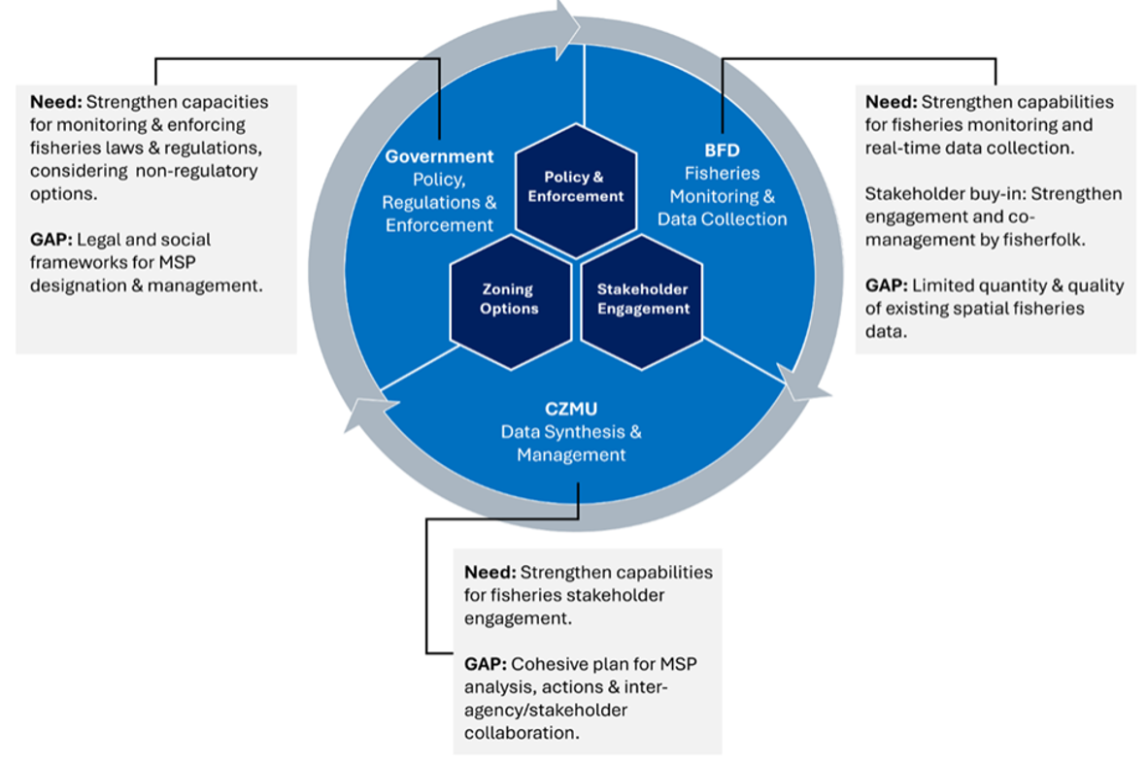
The MSP needs and data gaps assessment conducted is intended to characterize existing data, technology, and human capacities and identify any needs and gaps that may be relevant to the MSP process. Accordingly, this assessment is framed around the desire to develop a collaborative framework for recognizing and integrating fisheries contributions into the entire MSP process for Barbados (Figure 10).

Figure 12. A collaborative framework for integrating fisheries interest into the MSP process
This framework concentrates on the interrelationships between two principal governmental entities that will play an important role in the monitoring and collection of relevant fisheries data (the BFD) and in data synthesis, management, sharing and reporting (the CZMU). Key collaborative activities to be undertaken include stakeholder engagement and the spatial modeling framework that will map zoning options for human uses and marine ecological/habitat conservation. These activities should synchronize and support government decision-making to establish policies, promulgate regulations and engage in enforcement actions.

References
AGGRA. (2023). Stony coral tissue loss disease outbreak reports for Barbados. Data explorer. Retrieved from https://agrra-data-explorer-oref.hub.arcgis.com/ in August 2024.
Arocha, F., Narvaez, M., & Mendoza, J. (2024). Review of biological data, spatial distribution of the stocks and ecological connectivity between areas beyond national jurisdiction and the exclusive economic zones in the Western Central Atlantic Fishery Commission region. Food & Agriculture Org.
Alleyne-Greene, C. K. (2016). Assessing vulnerability to climate change and variability at Six Men’s Bay fishing community. Centre for Resource Management and Environmental Studies (CERMES) Faculty of Science and Technology, The University of the West Indies, Cave Hill Campus, Barbados. CERMES Technical Report No. 83.
Alleyne, M. (2l19). Assessing the vulnerability of Holetown, Barbados, to relative sea level rise and storm surge. 10.13140/RG.2.2.33875.53282.
Bair, R. (1962). The Barbados fishing industry. The development and economic importance of the fishing industry in the tropics. Master’s Degree Thesis. McGill University, Montreal, Quebec. 111 pp.
Baldwin, K., Oxenford, H. A., Purkis, S., & Knowles, L. (2019). Developing a benthic habitat classification scheme and island-wide map for Barbados based on remote sensing and comprehensive ground-truthing. Center for Resource Management and Environmental Stuies (CERMES) Faculty of Science of Technology. The University of the West Indies, Cave Hill Campus, Barbados, 1-53.
Baldwin, K., McConney, P., & Sandoval, R. (2021). An introduction to using drones for participatory mapping of climate, poverty and fisheries information in Caribbean coastal communities. Centre for Resource Management and Environmental Studies, University of the West Indies, Barbados. CERMES Technical Report No. 104. 36 pp.
Basran, C., Chosson, V., Williams, A., Simpson, N., Long, S. A., Dodds, F., & Horrocks, J. A. (2023). First documented migration of an Icelandic humpback whale mother and calf pair from the West Indies breeding grounds. J. Cetacean Res. Manage., 24, 205-208.
Beggs, J. A., Horrocks, J. A., & Krueger, B. H. (2007). Increase in hawksbill sea turtle Eretmochelys imbricata nesting in Barbados, West Indies. Endangered Species Research, 3(2), 159-168.
Bissada-Gooding, C., & Oxenford, H. A. (2010). Estimating home range and density of a queen conch aggregation using acoustic telemetry and conventional tagging. Proceedings of the 62nd. Gulf and Caribbean Fisheries Institute Conference.
Blades, D. C., Walcott, J., & Horrocks, J. A. (2019). Leatherback bycatch in an eastern Caribbean artisanal longline fishery. Endangered Species Research, 40, 329-335.
Browne, D. C., Horrocks, J. A., & Abreu-Grobois, F. A. (2010). Population subdivision in hawksbill turtles nesting on Barbados, West Indies, determined from mitochondrial DNA control region sequences. Conservation Genetics, 11, 1541-1546.
Cecil, R. G. (1973). Geographical characteristics of fisheries in selected southeastern Caribbean Islands. Doctoral Dissertation. McGill University, Montreal, Quebec.
Chapman, M. R., & Kramer, D. L. (2000). Movements of fishes within and among fringing coral reefs in Barbados. Environmental Biology of Fishes, 57, 11-24.
Charlemagne, R. M., Mahon, R., & Marshall, N. R. (2006). A geographical information system for the proposed conservation area at Long Pond, St. Andrew, Barbados. Center for Resource Management and Environmental Studies (CERMES), University of the West Indies, Cave Hill Campus, 1-47.
Cowen, R. K., Sponaugle, S., Paris, C. B., Fortuna, J. L., Lwiza, K. M. M., & Dorsey, S. (2003). Impact of North Brazil Current rings on local circulation and coral reef fish recruitment to Barbados, West Indies. In Elsevier Oceanography Series (Vol. 68, pp. 443-462). Elsevier.
Cox, S. A., & McConney, P. (2012). The role livelihood outcomes and strategies play in the adaptive co-management of the sea urchin fisheries in Barbados and St. Lucia. Proceedings of the 64th Gulf and Caribbean Fisheries Institute October 31 - November 5, 2011, Puerto Morelos, Mexico.
CZMU & CERMES. (2018). Barbados 2020 status of coral reefs. Coral reef report card. Coastal Zone Management Unit and Centre for Resource Management and Environmental Studies.
Degia, A. K., Small, M., & Oxenford, H. A. (2022). Applying hazard risk assessment and spatial planning tools to sargassum inundations in the Eastern Caribbean Small Island Developing States as a basis for improving response.
Douvere, F., & Ehler, C. N. (2009). New perspectives on sea use management: initial findings from European experience with marine spatial planning. Journal of environmental management, 90(1), 77-88.
Dow, W., Eckert, K., Palmer, M., & Kramer, P. (2007). An atlas of sea turtle nesting habitat for the wider Caribbean region. The Wider Caribbean Sea Turtle Conservation Network and The Nature Conservancy, Beaufort, North Carolina, 267.
Ehler, C. & Douvere, F. (2009). Marine Spatial Planning: a step-by-step approach toward ecosystem-based management. intergovernmental Oceanographic Commission and Man and the Biosphere Programme. iOC Manual and Guides no. 53, iCaM Dossier no. 6. Paris: UneSCO.
Fish, M. R., Cote, I. M., Horrocks, J. A., Mulligan, B., Watkinson, A. R., & Jones, A. P. (2008). Construction setback regulations and sea-level rise: mitigating sea turtle nesting beach loss. Ocean & Coastal Management, 51(4), 330-341.
Fisheries Division. 2023. Barbados Fisheries Policy. Ministry of the Environment and National Beautification, Green and Blue Economy. Bridgetown: Barbados. 27 pp.
Global Biodiversity Information Facility. (2023). https://www.gbif.org/en/country/BB/summary
Global Fishing Watch. (2023). https://globalfishingwatch.org/map/index?start=2024-03-27T00%3A00%3A00.000Z&end=2024-06-27T00%3A00%3A00.000Z&zoom=1.5&latitude=19&longitude=26
Gosine, T., & Mahon, R. (2015). Mapping land-use, human activities and vegetation in the Conset Bay watershed, Barbados, to determine potential sources of coastal pollution. Centre for Resource Management and Environmental Studies (CERMES) Faculty of Science and Technology, The University of the West Indies, Cave Hill Campus, Barbados. CERMES Technical Report No. 75.
Government of Barbados. (2019). Sixth National Report to the Convention on Biological Diversity, Barbados. 78 pp.
Government of Barbados (2021). Integrated Coastal Zone Management: The Barbados CZM Plan (2020 to 2030).
Government of Barbados (2023). Barbados Marine Spatial Planning Design Guide (draft March 2023).
Gill, D. A., Oxenford, H. A., Turner, R. A., & Schuhmann, P. W. (2019). Making the most of data-poor fisheries: low-cost mapping of small island fisheries to inform policy. Marine Policy, 101, 198-207.
Horrocks, J. A., & Scott, N. M. (1991). Nest site location and nest success in the hawksbill turtle Eretmochelys imbricata in Barbados, West Indies. Marine Ecology Progress Series, 1-8.
Horrocks, J. A., Oxenford, H. A., & Willoughby, S. A. (1991). Reproduction, mortality and conservation of the hawksbill turtle (Eretmochelys imbricata) in Barbados. Proceedings of the 40th. Gulf and Caribbean Fisheries Institute Conference.
Horrocks, J.A. (1992). WIDECAST Sea Turtle Recovery Action Plan for Barbados. (Eckert, K.L., editor). CEP Technical Report No. 12. UNEP Caribbean Environment Programme, Kingston, Jamaica. 61 pp.
Horrocks, J.A., Vermeer, L.A., Krueger, B., Coyne, M., Schroeder, B. A., & Balazs, G. H. (2001). Migration Routes and Destination Characteristics of Post-Nesting Hawksbill Turtles Satellite-Tracked from Barbados, West Indies Chelonian Conservation and Biology, 4(1-2001).
Horrocks, J. A., Krueger, B. H., Fastigi, M., Pemberton, E. L., & Eckert, K. L. (2011). International movements of adult female hawksbill turtles (Eretmochelys imbricata): first results from the Caribbean's marine turtle tagging centre. Chelonian Conservation and Biology, 10(1), 18-25.
Horrocks, J., & Wallcott, J. (2016). Nesting by hawksbill sea turtles on the west coast of Barbados in relation to beach width: with recommendations for conservation of critical nesting habitat. Barbados Sea Turtle Project, University of West Indies, Cave Hill Campus, Barbados. 49 pp.
Horrocks, J. A., Stapleton, S., Guada, H., Lloyd, C., Harris, E., Fastigi, M., & Eckert, K. L. (2016). International movements of adult female leatherback turtles in the Caribbean: results from tag recovery data (2002-2013). Endangered Species Research, 29(3), 279-287.
IADB (2021). Implementation of an Integrated Blue Economy Policy Framework and Strategic Action Plan for Barbados. Project #: ATN/CO-17589-BA. Inter-American Development Bank.
Irvine, J.A., Oxenford, H.A., & Suckoo, R. (2021). A coral report card for Barbados: Development, design and metadata. Centre for Resource Management and Environmental Studies (CERMES) Faculty of Science and Technology, The University of the West Indies, Cave Hill Campus, Barbados. CERMES Technical Report No. 98.
Krueger, B. H., Chaloupka, M. Y., Leighton, P. A., Dunn, J. A., & Horrocks, J. A. (2011). Somatic growth rates for a hawksbill turtle population in coral reef habitat around Barbados. Marine Ecology Progress Series, 432, 269-276.
Luke, K., Horrocks, J. A., LeRoux, R. A., & Dutton, P. H. (2004). Origins of green turtle (Chelonia mydas) feeding aggregations around Barbados, West Indies. Marine Biology, 144, 799-805.
Maclean, R., & Oxenford, H.A. (2016). Mapping the return of acroporid corals on fringing reefs along the west coast of Barbados. Centre for Resource Management and Environmental Studies (CERMES) Faculty of Science and Technology, The University of the West Indies, Cave Hill Campus, Barbados. CERMES Technical Report No. 80.
Mahon, R., & Mascia, M. B. (2003). The Barbados (Alias Folkestone) Marine Reserve, Barbados: A Late Bloomer? Gulf and Caribbean Research, 14(2), 171-180.
Mahon, R., Almerigi, S., McConney, P., Parker, C., & Brewster, L. (2003). Participatory methodology used for sea urchin co-management in Barbados. Ocean & Coastal Management, 46(1-2), 1-25.
Mahon, R., Warren, S., Wood, J., & Jarde, T. (2023). Barbados National Wetland Inventory. 152 pp.
Mahon, R., & Mascia, M. B. (2003). The Barbados (Alias Folkestone) Marine Reserve, Barbados: A Late Bloomer? Gulf and Caribbean Research, 14(2), 171-180.
Maraj, V., Cox, S. A., & Oxenford, H. A. (2011). The small-scale seine fishery of Barbados: Description and current contribution to the fishing industry. Centre for Resource Management and Environmental Studies (CERMES), UWI, Cave Hill Campus, Barbados.
Marine Traffic. (2023). https://www.marinetraffic.com/en/ais/home/centerx:-56.4/centery:12.4/zoom:6
McConney, P., Mahon, R., & Parker, C. (2003). Barbados case study: the sea egg fishery. Caribbean Coastal Co-management Guidelines Project. Caribbean Conservation Association, Barbados.
Mitchell, A. (1999). Notes on the local fishery and import trade for spiny lobsters in Barbados. Proceedings of the Gulf and Caribbean Fisheries Institute, 46.
Mycoo, M., Robinson, S. A., Nguyen, C., Nisbet, C., & Tonkel III, R. (2021). Human adaptation to coastal hazards in Greater Bridgetown, Barbados. Frontiers in Environmental Science, 9, 647788.
Oxenford, H. A., Fields, A., Taylor, C., & Catlyn, D. (2007). Fishing and marketing of queen conch (Strombus gigas) in Barbados. Centre for Resource Management and Environmental Studies (CERMES), University of the West Indies, Barbados.
Oxenford, H. A., Roach, R., Brathwaite, A., Nurse, L., Goodridge, R., Hinds, F., & Finney, C. (2008). Quantitative observations of a major coral bleaching event in Barbados, Southeastern Caribbean. Climatic Change, 87(3), 435-449.
Oxenford, H. A., Suckoo, R.B., Cox, A.M., & Cox, A.J. (2020). Assisted recovery of elkhorn coral (Acropora palmata) on a fringing reef in Barbados: A pilot study 2016-2019. Centre for Resource Management and Environmental Studies (CERMES) Faculty of Science and Technology, The University of the West Indies, Cave Hill Campus, Barbados. CERMES Technical Report No. 109.
Peterson, Angelie & Turner, Rachel & Gill, David & Forster, Johanna & Fitzsimmons, Clare & Mahon, Robin & Oxenford, Hazel & Stead, Selina. (2014). Future of reefs in a changing environment: an ecosystem approach to managing Caribbean coral reefs in the face of climate change.
Phillips, M. A., Bissada-Gooding, C. E., & Oxenford, H. A. (2011). Preliminary investigation of the movements, density, and growth of juvenile queen conch in a nursery area in Barbados. Proceedings of the 63rd Gulf and Caribbean Fisheries Institute
Prescod, S. D., Oxenford, H. A., & Taylor, C. (1996). The snapper fishery of Barbados: present status and a preliminary assessment of the potential for expansion. Proceedings of the 44th. Conference of the Gulf and Caribbean Fisheries Institute.
Prescod, S., & Hunte, W. (1997). A Preliminary report on the feasibility of farming Dolphinfish (Coryphaena hippurus) on the northwest coast of Barbados, WI. Proceedings of the Gulf and Caribbean Fisheries Institute, 49.
Rakitin, A., & Kramer, D. L. (1996). Effect of a marine reserve on the distribution of coral reef fishes in Barbados. Marine Ecology Progress Series, 131, 97-113.
Rawlins, M., Oxenford, H. A., & Fanning, P. (2007). Preliminary investigation of the diets of large oceanic pelagic species of importance to the longline fishery in Barbados. Proceedings of the 58th. Conference of the Gulf and Caribbean Fisheries Institute.
Reed, E. T., Kardynal, K. J., Horrocks, J. A., & Hobson, K. A. (2018). Shorebird hunting in Barbados: Using stable isotopes to link the harvest at a migratory stopover site with sources of production. The Condor: Ornithological Applications, 120(2), 357-370.
Reimer, J. M., Devillers, R., Zuercher, R., Groulx, P., Ban, N. C., & Claudet, J. (2023). The Marine Spatial Planning Index: a tool to guide and assess marine spatial planning. Ocean Sustainability, 2(1),15.
Ricker, B. A., Johnson, P. A., & Sieber, R. E. (2013). Tourism and environmental change in Barbados: gathering citizen perspectives with volunteered geographic information (VGI). Journal of Sustainable Tourism, 21(2), 212-228.
Salas, S., Chuenpagdee, R., Charles, A. T., & Seijo, J. C. (Eds.). (2011). Coastal fisheries of Latin America and the Caribbean (Vol. 544). FAO Fisheries ana Aquaculture Technical Paper No. 544. Rome: FAO. 430p.
Scheibling, R. E., & Mladenov, P. V. (1987). The decline of the sea urchin, Tripneustes ventricosus, fishery of Barbados: a survey of fishermen and consumers. Marine fisheries review, 49(3), 62-69.
Schill, S. R., Asner, G. P., McNulty, V. P., Pollock, F. J., Croquer, A., Vaughn, N. R., ... & Shaver, E. (2021). Site selection for coral reef restoration using airborne imaging spectroscopy. Frontiers in Marine Science, 8, 698004.
Singh-Renton, S. 2024. Barbados Blue Economy Roadmap Fisheries Sector Strategy and Implementation Plan. BE:CLME+ project, CAF, FAO, GEF, and CRFM.
Small, M., & Oxenford, H. A. (2021). Assessing Anchoring Impacts of Cruise Ships in Barbados during the COVID-19 Pandemic of 2020 (pp. 1-69). Centre for Resource Management and Environmental Studies, The University of the West Indies, Cave Hill Campus, Barbados. CERMES Technical Report 101.
Sobers, R. H. (2010). Bioeconomic analysis of the flyingfish fishery in Barbados. The United Nations Fisheries Training Programme, Reykjavik, Iceland.
Vallès, H., Walcott, J., & Oxenford, H. A. (2023). Assessment and Management of Lionfish and Status of Other Marine Invasive Species of Threat to High Biodiversity-value Reef Ecosystems. Final Report. Preventing Costs of Invasive Alien Species (IAS) in Barbados and Countries of the OECS Project. CERMES, UWI, Cave Hill, Barbados, 53pp.
Vermeer, L. A., Hunte, W., & Oxenford, H. A. (2005). An assessment of the potential for community-level management of the sea urchin fishery in Barbados.
Walcott, J., Oxenford, H. A., & Schuhmann, P. (2009). Current status of the longline fishery in Barbados. Sixty-First Annual Gulf and Caribbean Fisheries Institute. Gosier, Guadeloupe. Volume: 61
Walcott, J., Eckert, S., & Horrocks, J. (2009). Telemetric monitoring of inter-nesting behaviour and habitat use by hawksbill turtles (Eretmochelys imbricata) nesting at Needham’s Point, Barbados. 62nd Gulf and Caribbean Fisheries Institute Conference.
Walcott, J., Eckert, S., & Horrocks, J. A. (2012). Tracking hawksbill sea turtles (Eretmochelys imbricata) during inter-nesting intervals around Barbados. Marine Biology, 159, 927-938.
Walcott, J., Eckert, S., & Horrocks, J. A. (2013). Diving behaviour of hawksbill turtles during the inter-nesting interval: Strategies to conserve energy. Journal of experimental marine biology and ecology, 448, 171-178.
Walcott, J., Eckert, S., Oxenford, H. A., & Horrocks, J. A. (2014). Use of a towed camera system to investigate benthic habitat use by inter-nesting female hawksbill sea turtles. Endangered Species Research, 24(2), 159-170.
Walcott, J., & Horrocks, J. A. (2014). Design of a protected area for inter-nesting hawksbills in Barbados: an evidence-based approach. Bulletin of Marine Science, 90(4), 969-987.
Willoughby, S., Parker, C., Hunte, W., St John, V. S., Roach, C. J., & Ferguson, H. (2002). Factors contributing to the 1999 mass mortality of reef-associated fish in Barbados. Proceedings of the Gulf and Caribbean Fisheries Institute, 53.
Zuercher, R., Esch, M., Harborne, A.R. (2021). Coral Reef Fish and Fisheries in the Eastern Caribbean. Produced by Florida International University for the Organization of Eastern Caribbean States and The Nature Conservancy under the Caribbean Regional Oceanscape Project

Appendix

Appendix 1: Terms of Reference (TOR)
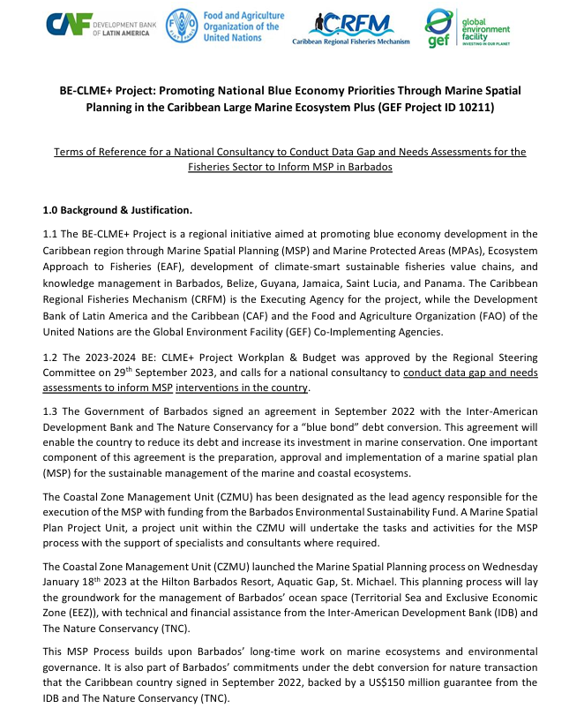

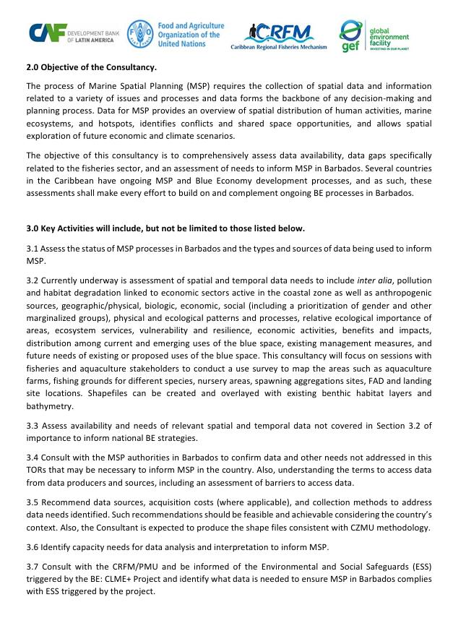
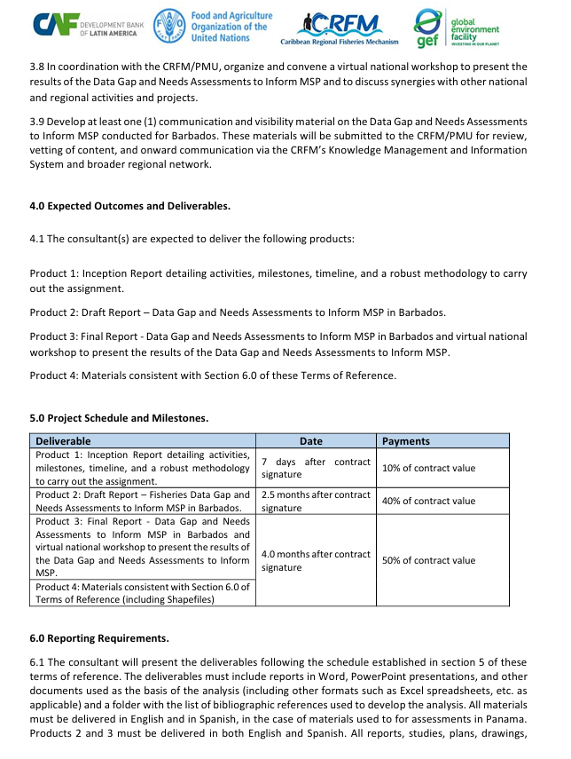
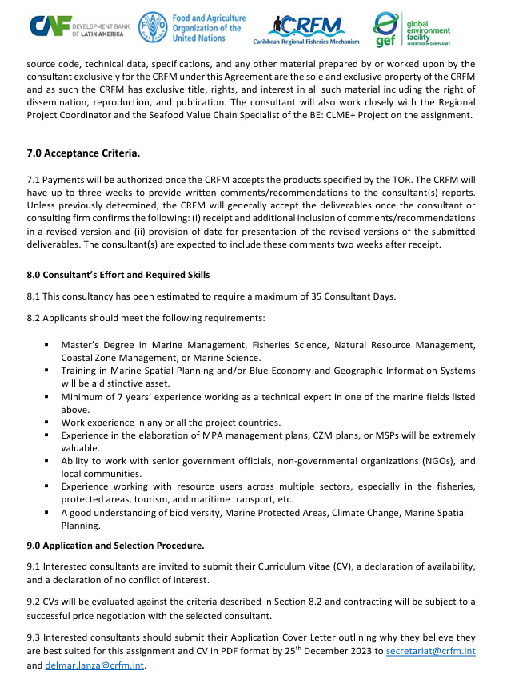

Appendix 2: Inception Meeting
This meeting took place virtually on April 4, 2024, at 10:00 AM (Barbados time). Below is the meeting agenda:
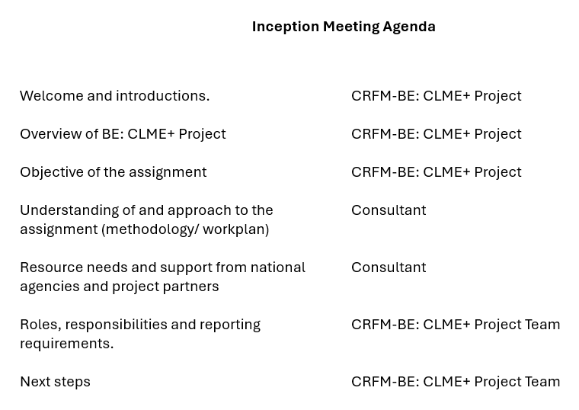
Meeting participants:
- Barbados Fisheries Division: Dr. Shelly-Ann Cox and Christopher Parker
- CRFM: Allena Joseph and Keegan Slinger
- Data gap and needs consultants: Dr. Nancy Montes and Dr. Charles Sidman
- BE Roadmap consultant: Dr. Susan Singh-Renton

Appendix 3. SeaSketch project
A map with different layers created.
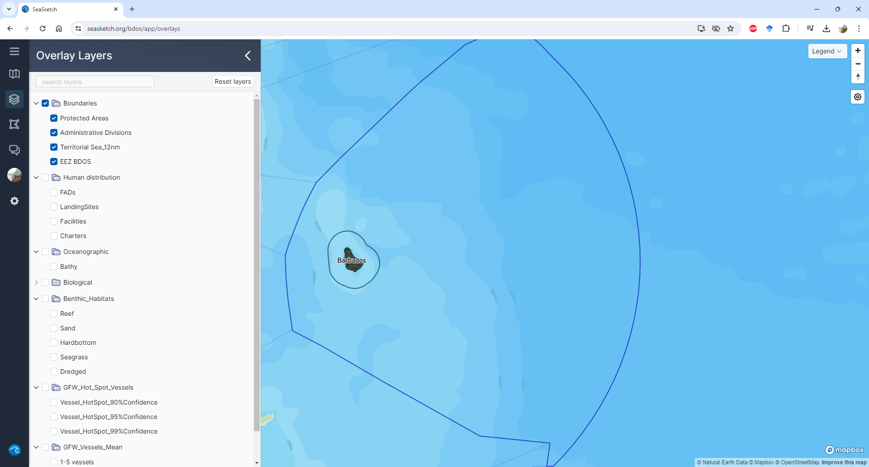
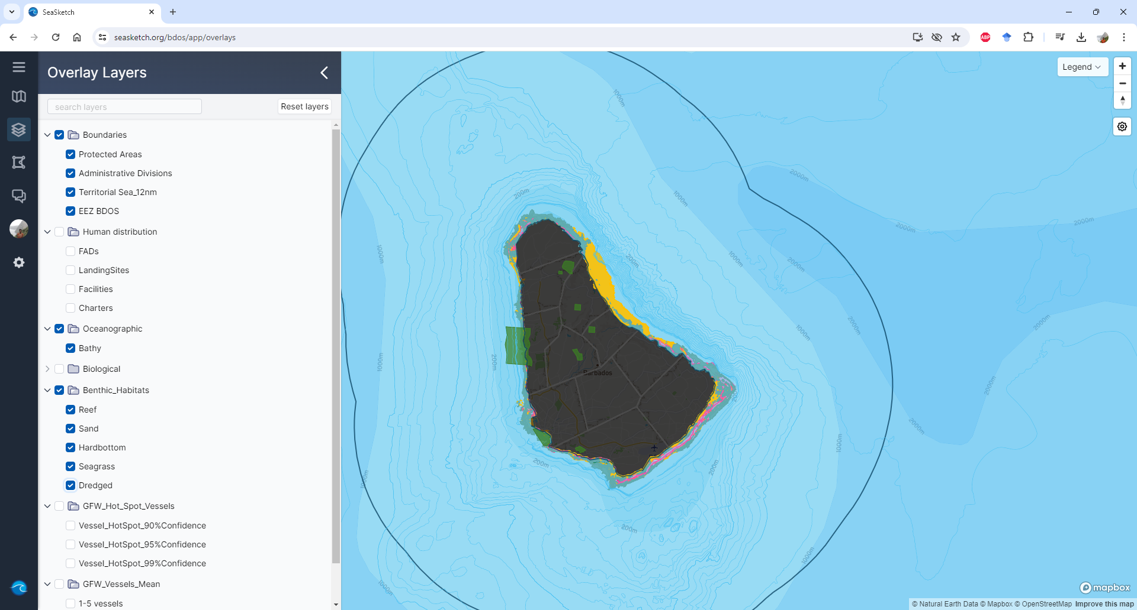
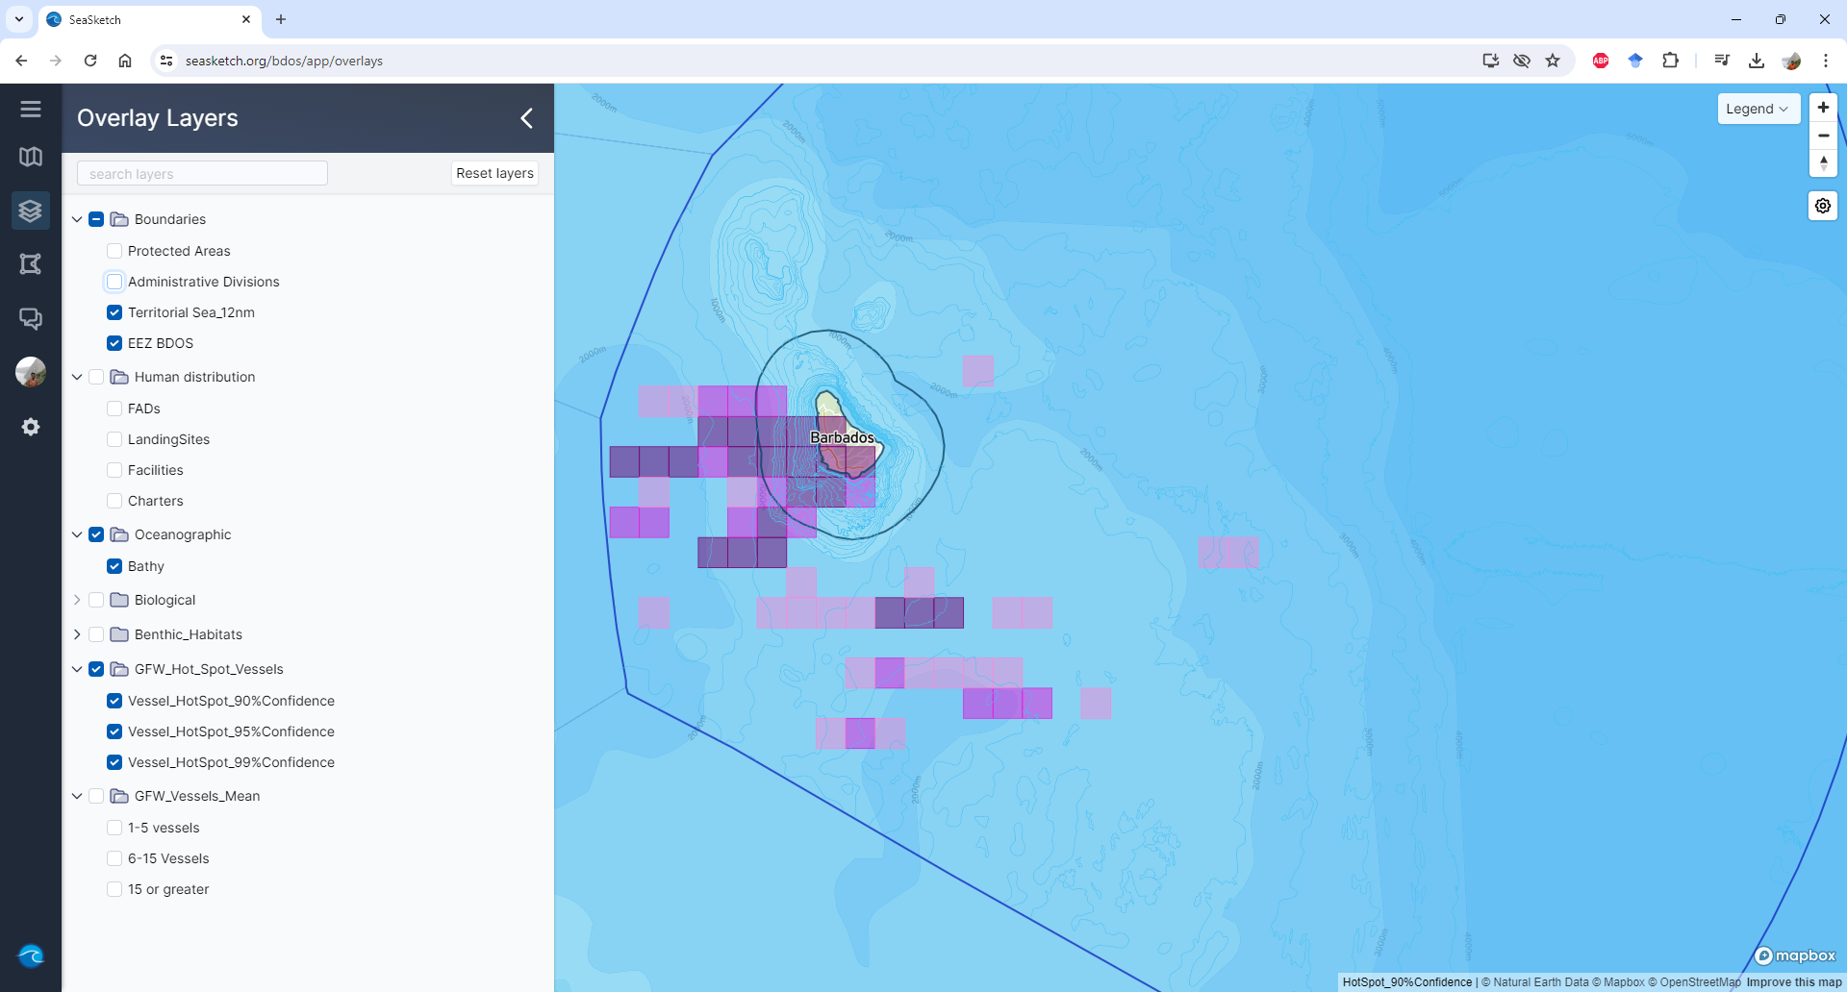
A survey project was also created:
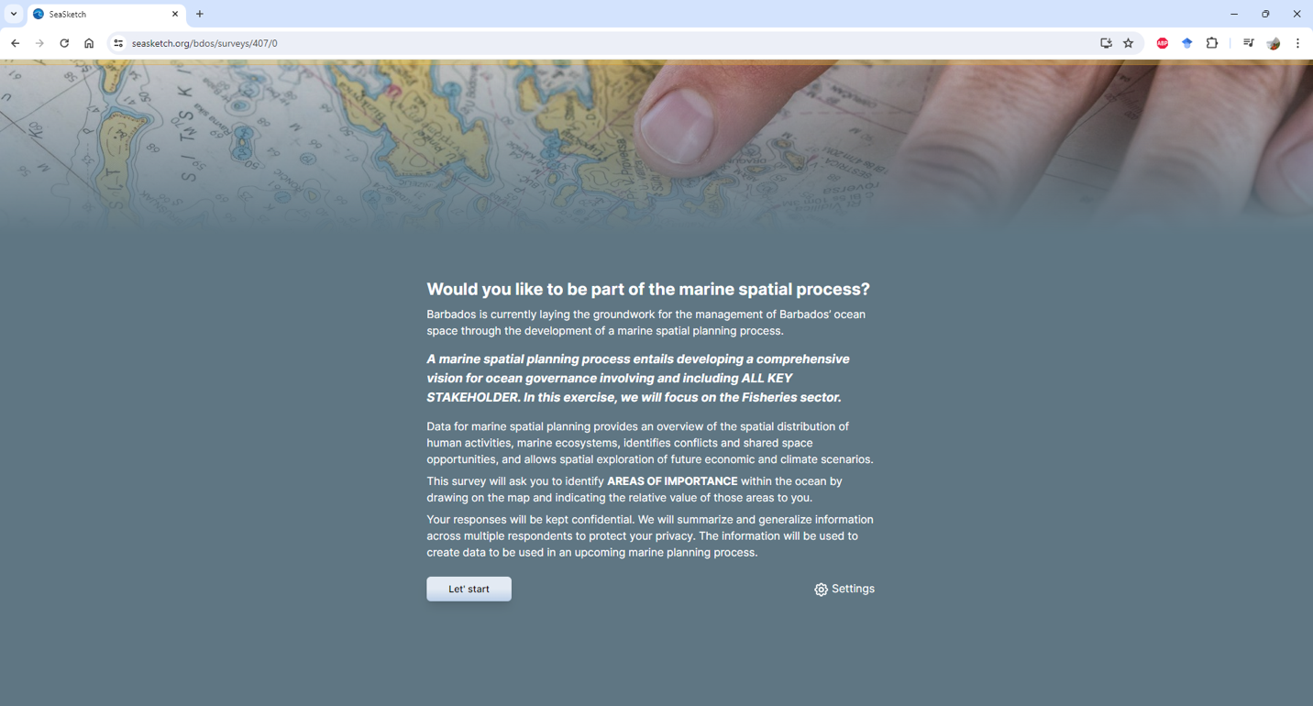
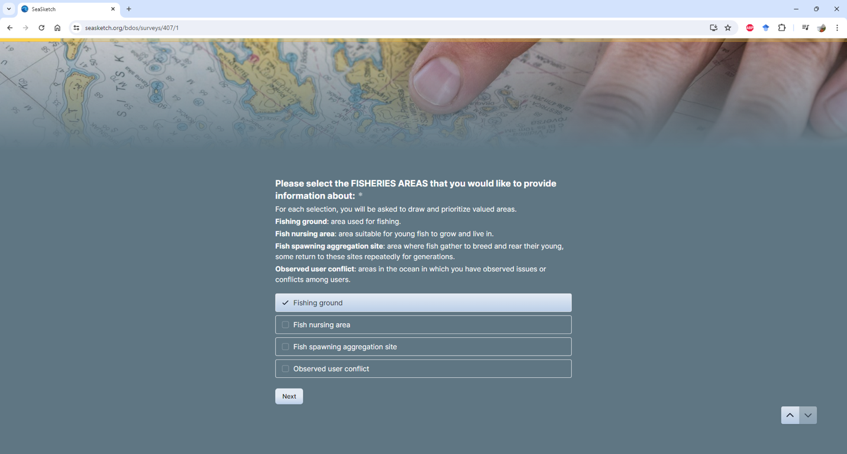
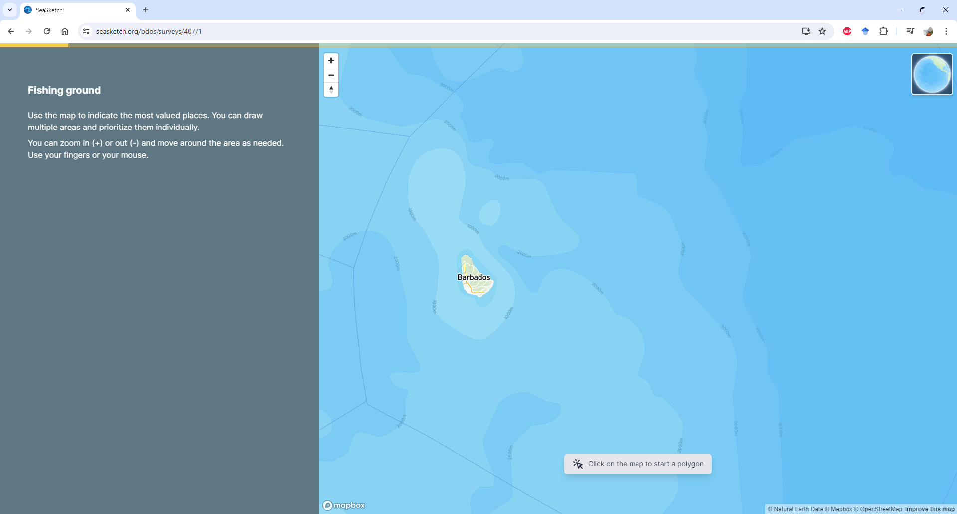
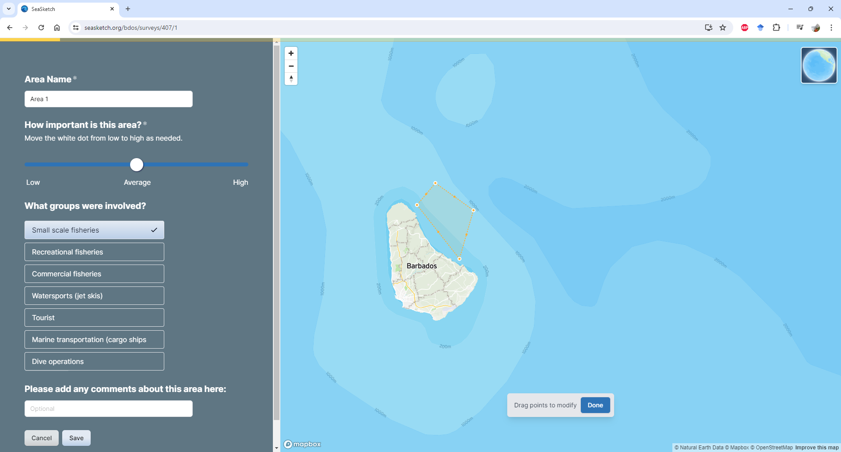
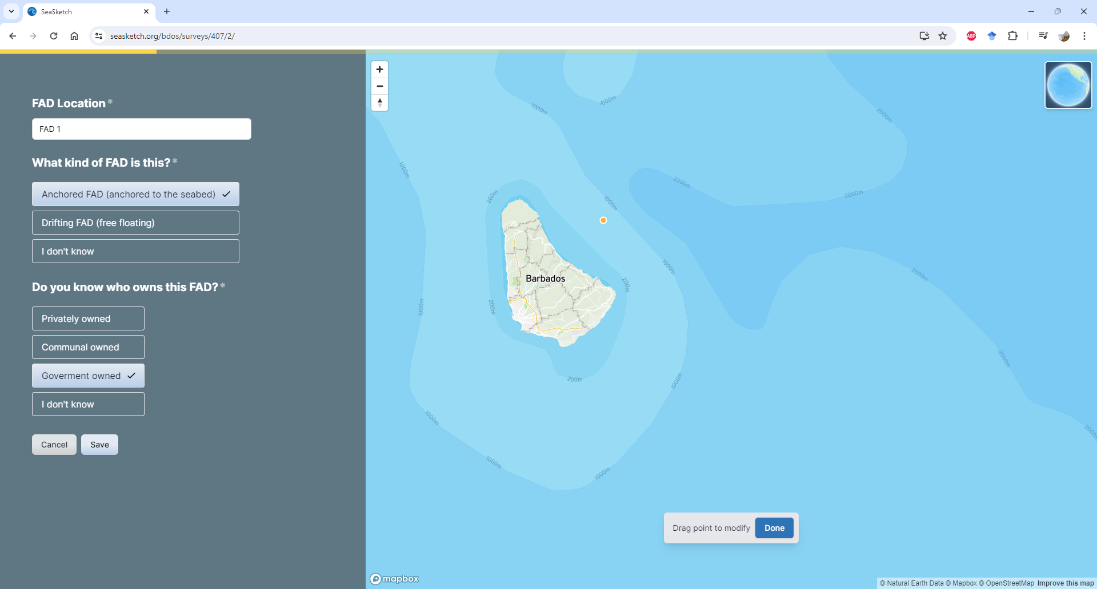
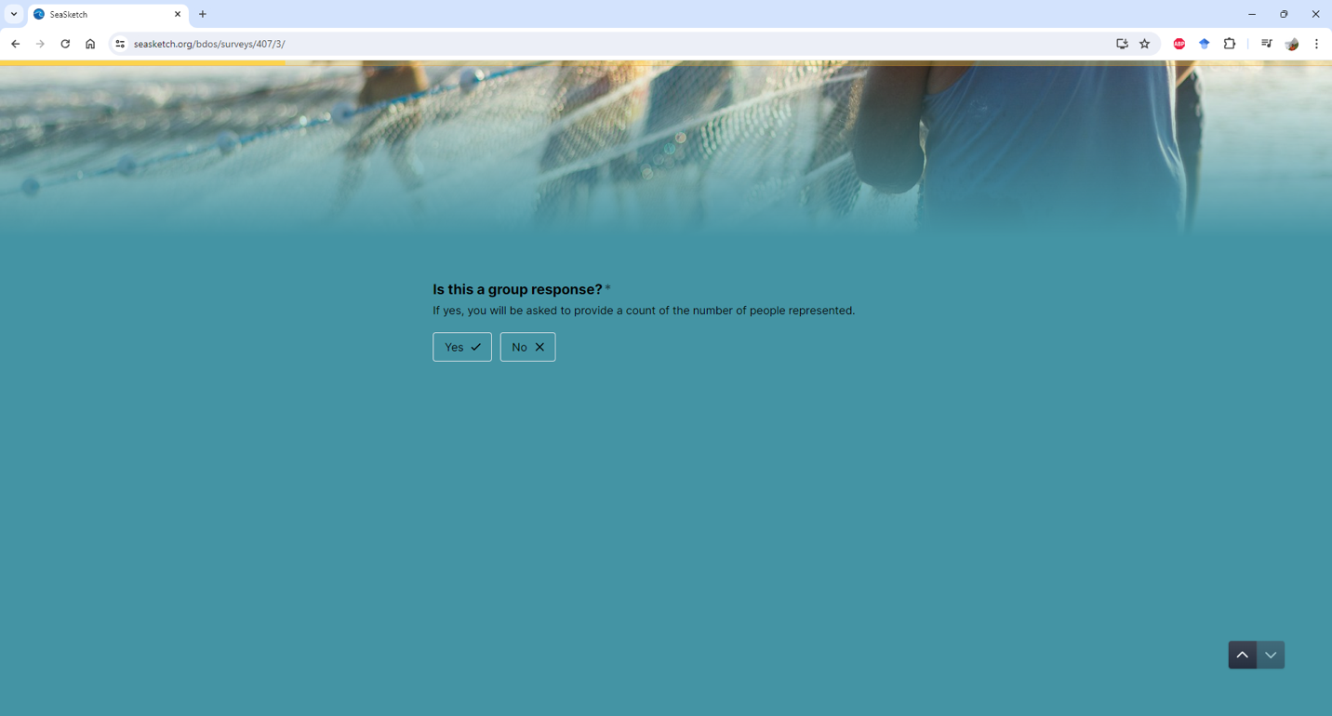
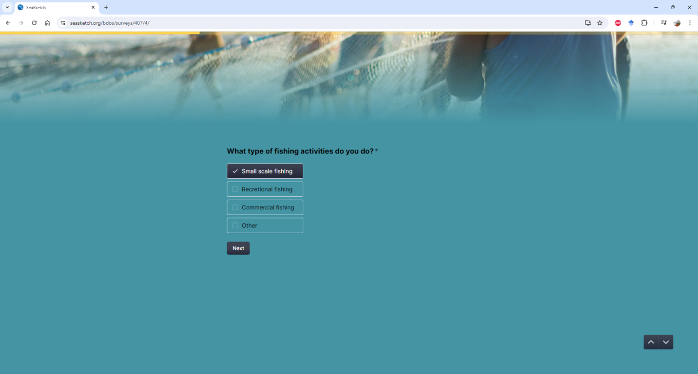
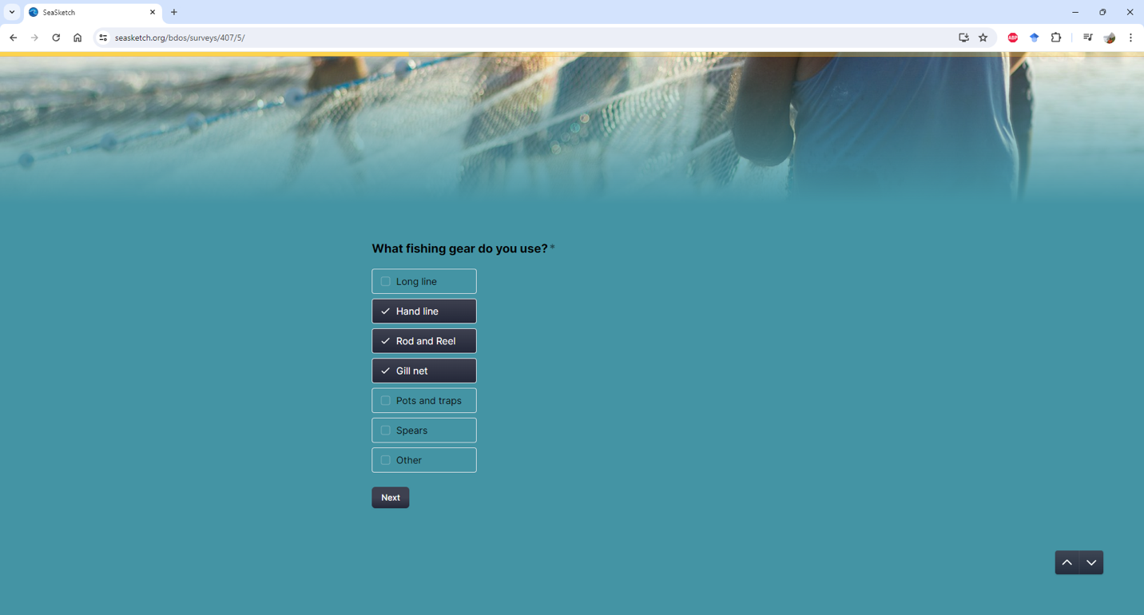
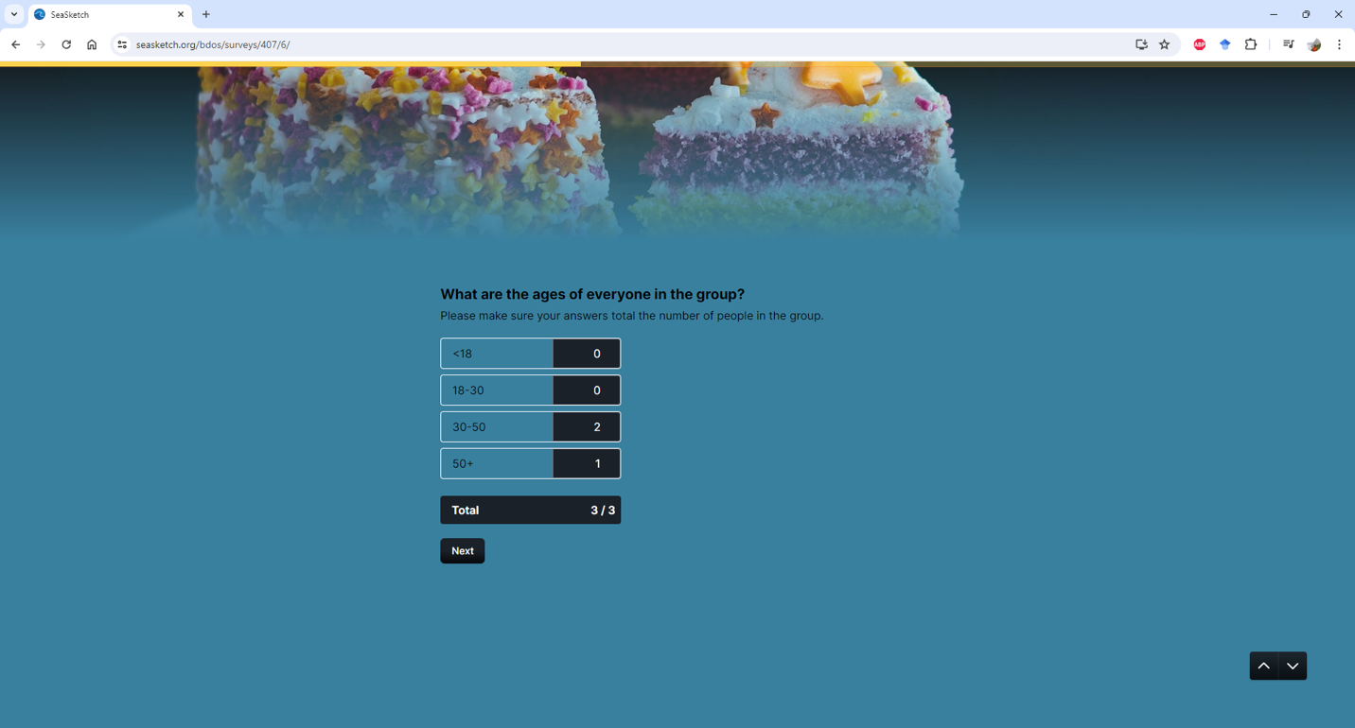
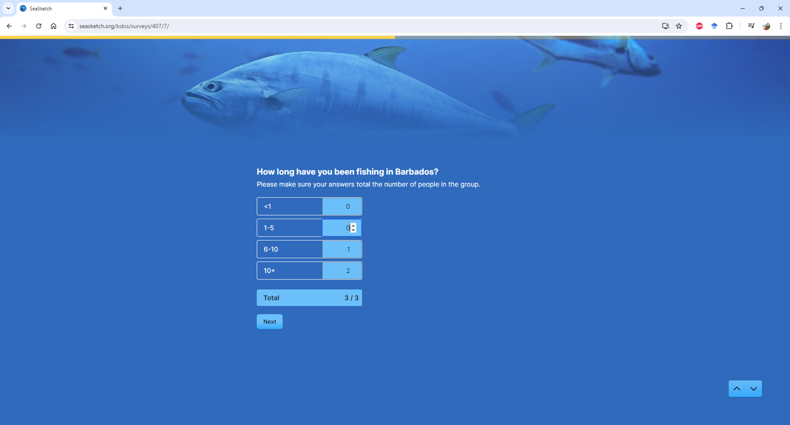
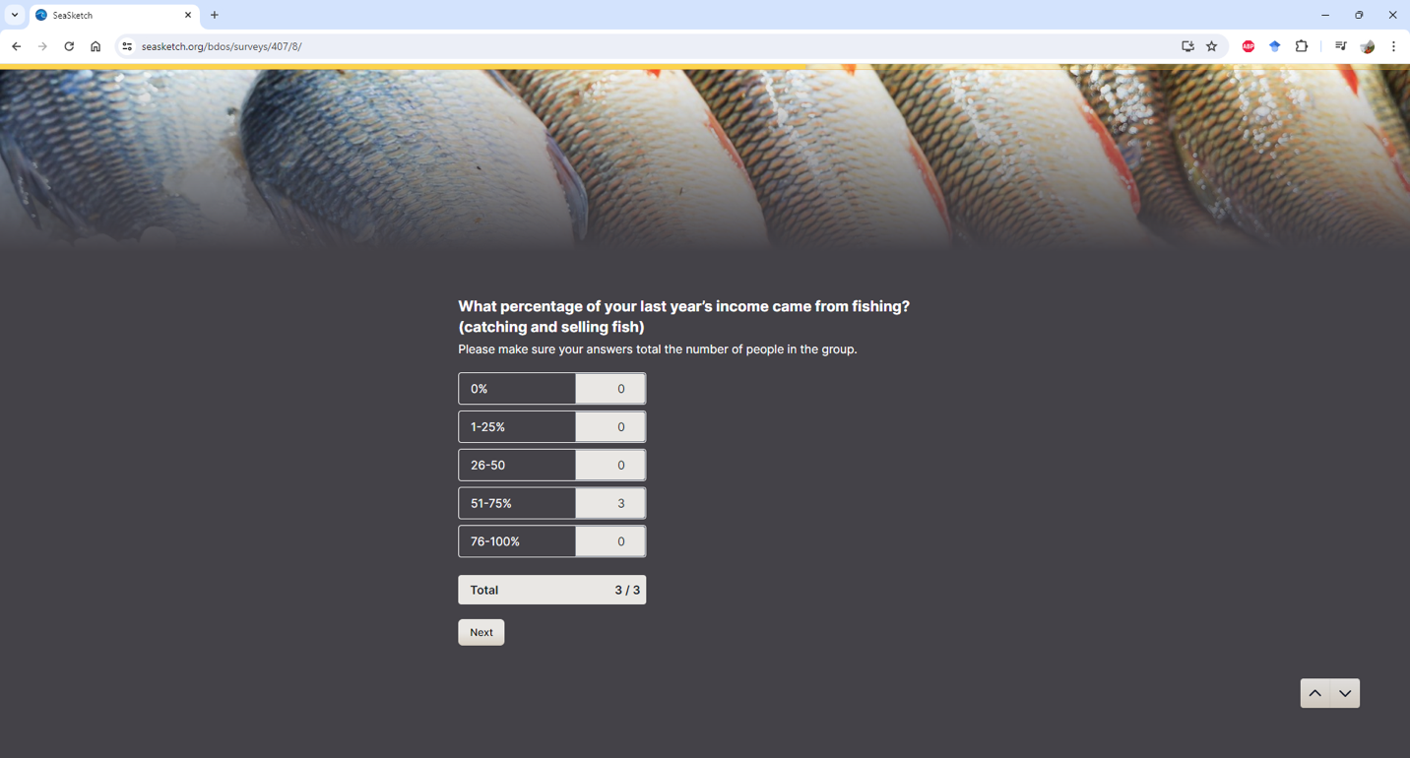
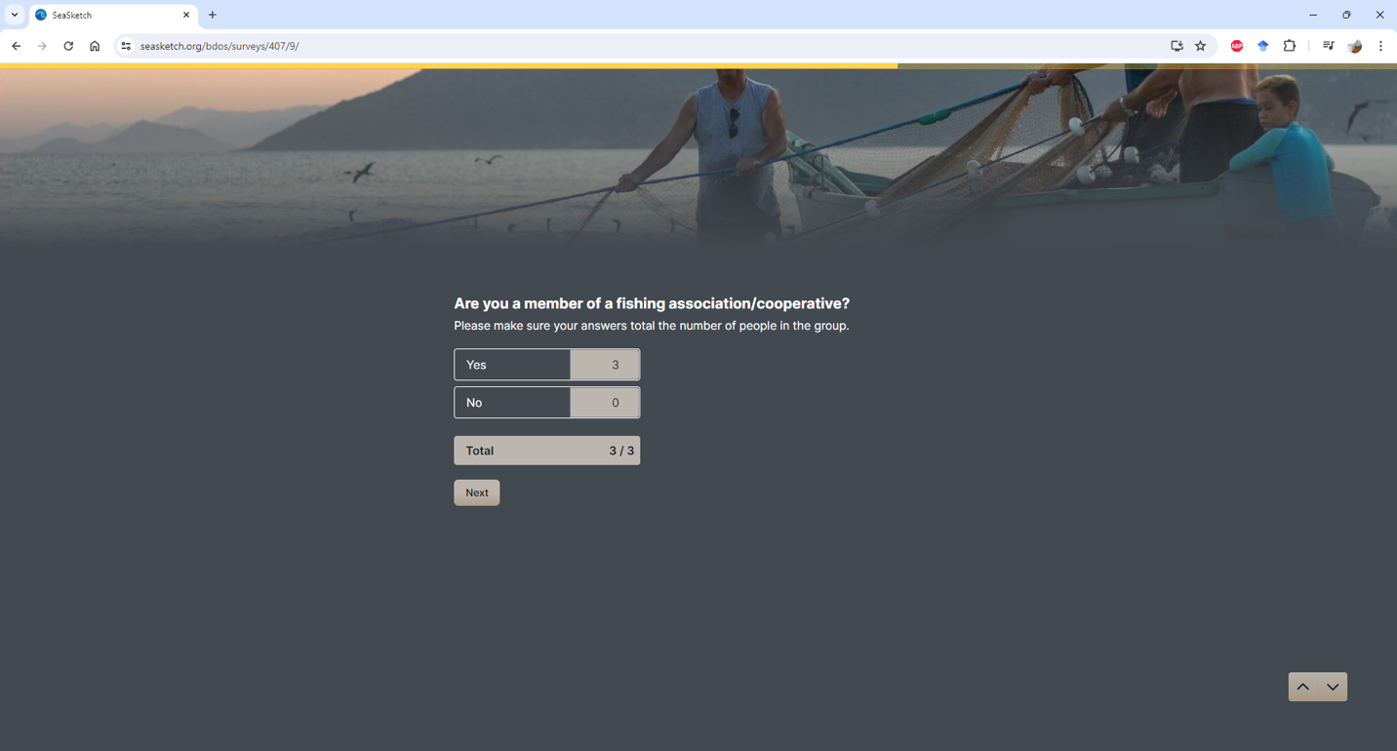
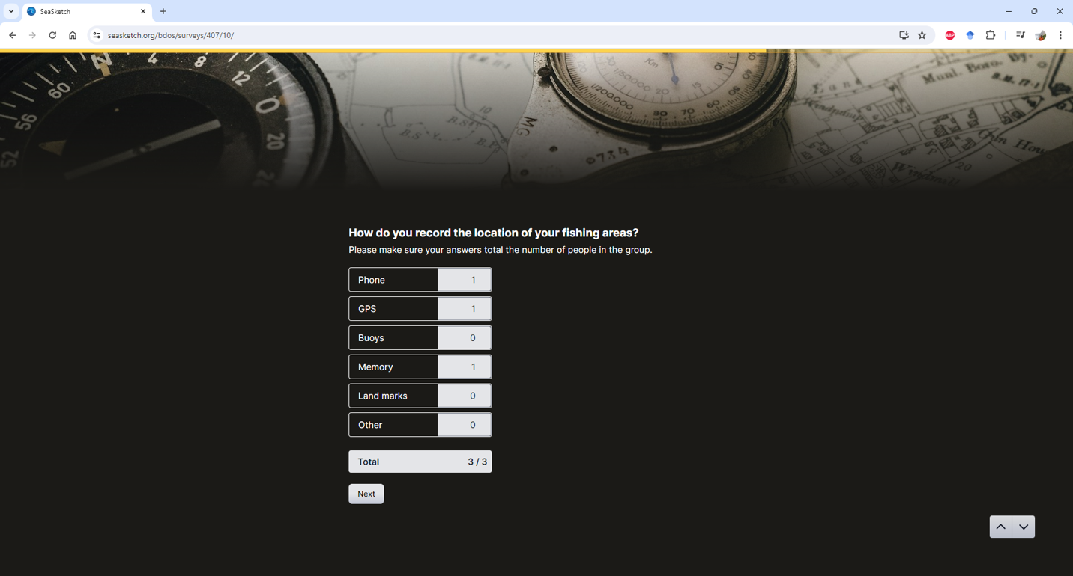
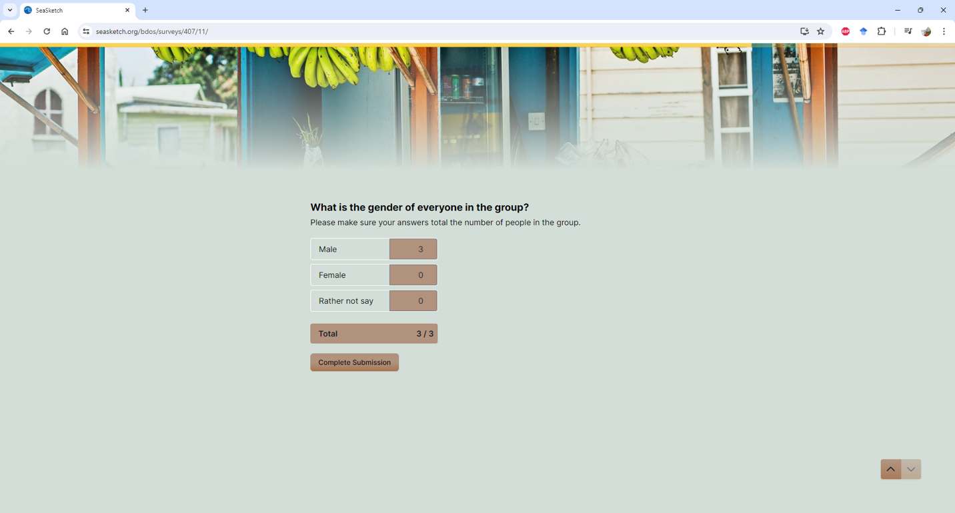
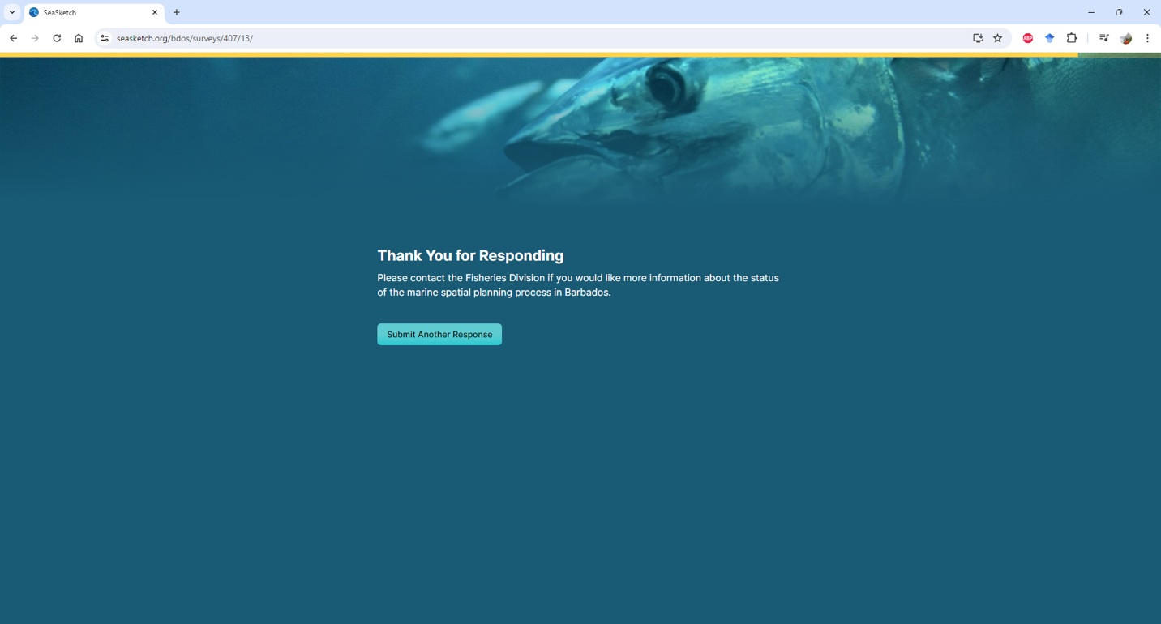

Appendix 4. List of participants of the mapping exercices
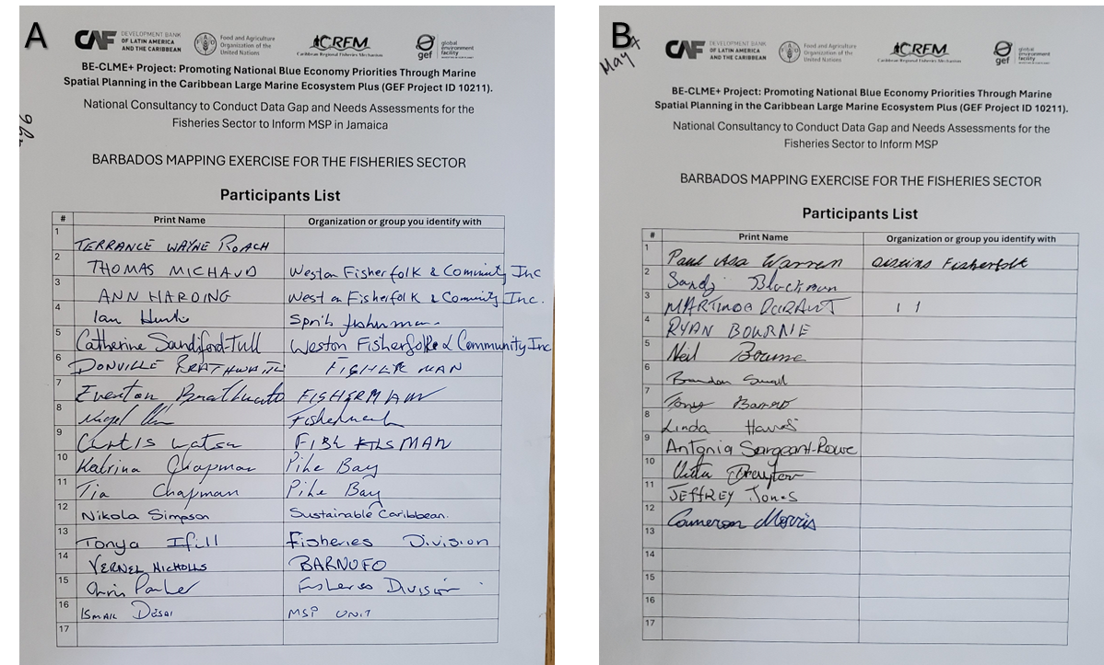

Appendix 5. Participant’s profile survey

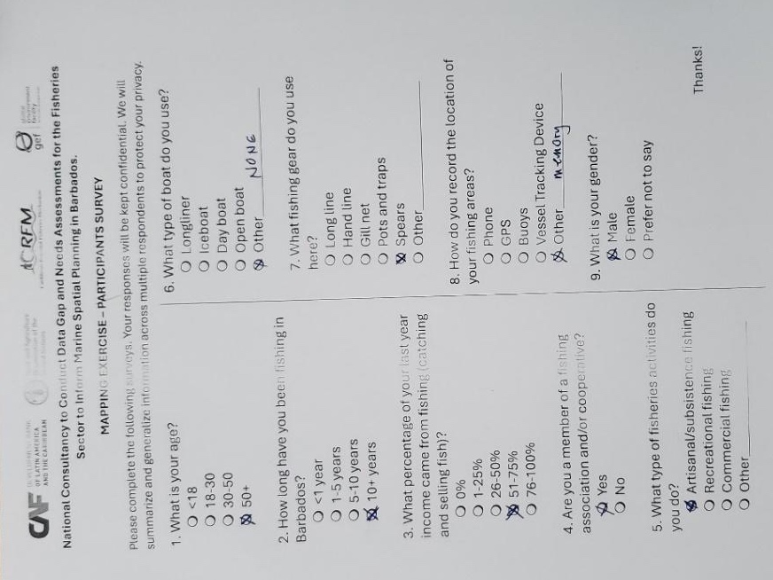

Appendix 6. Mapping exercise instructions for each station
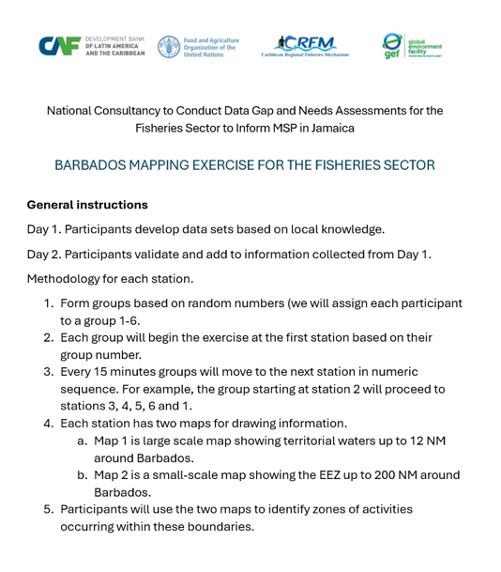 | 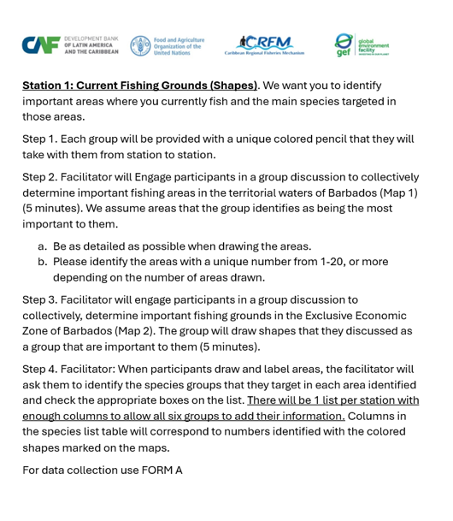
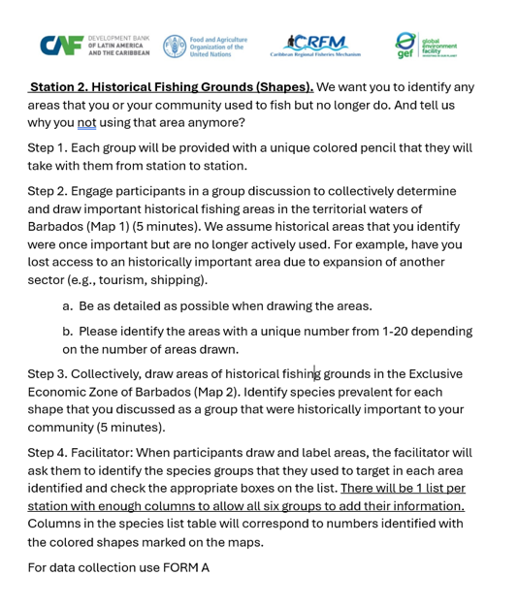 | 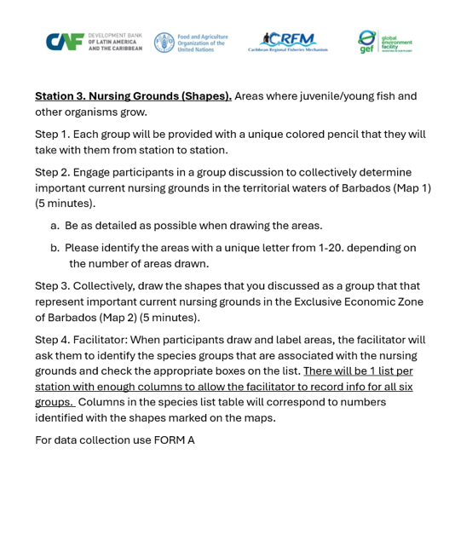
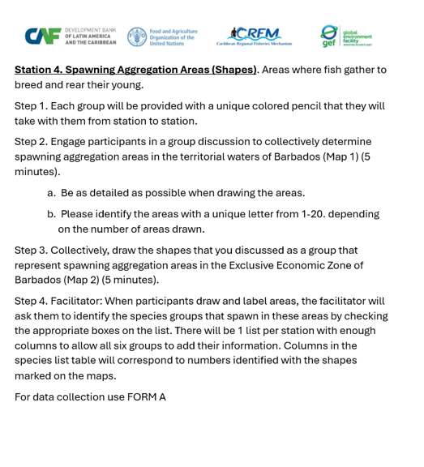 | 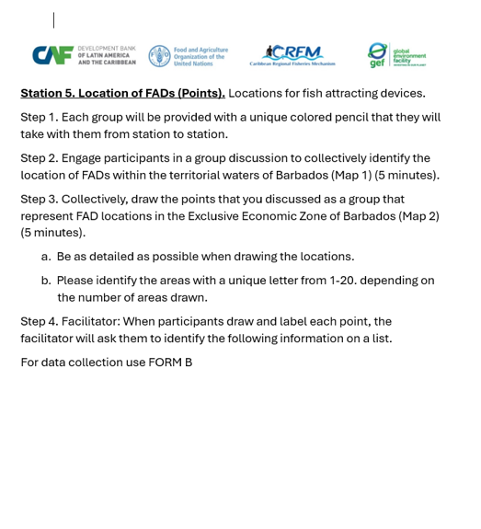
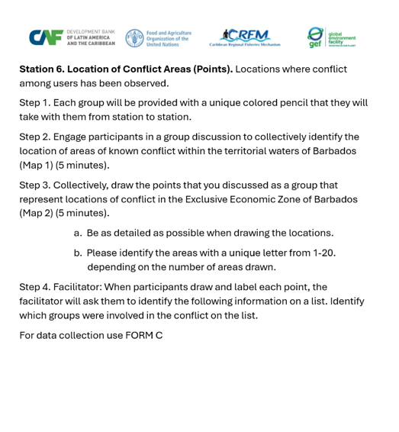 | Form A  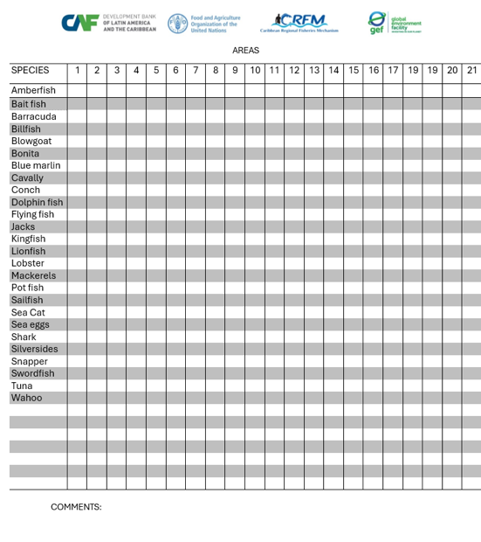
Form B (FADs) 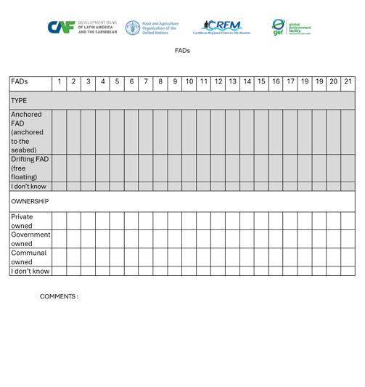 | Form C (User Conflicts)  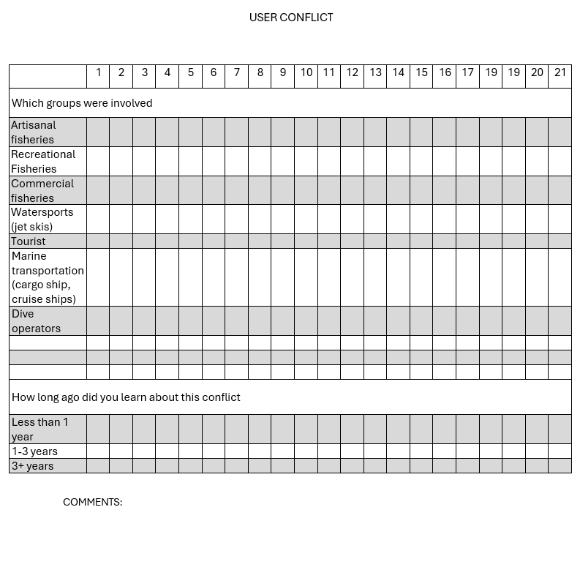

Appendix 7. Digital data collection instructions
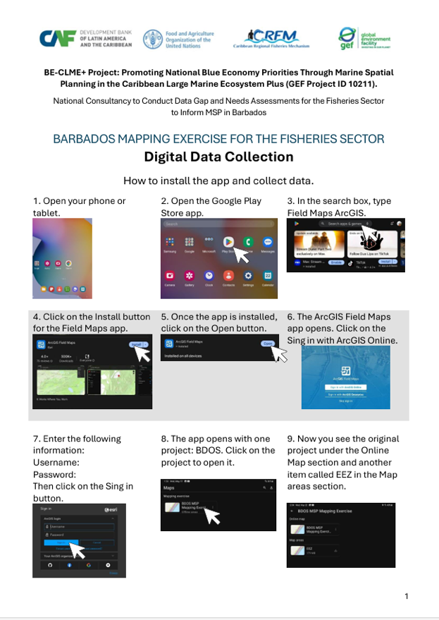 | 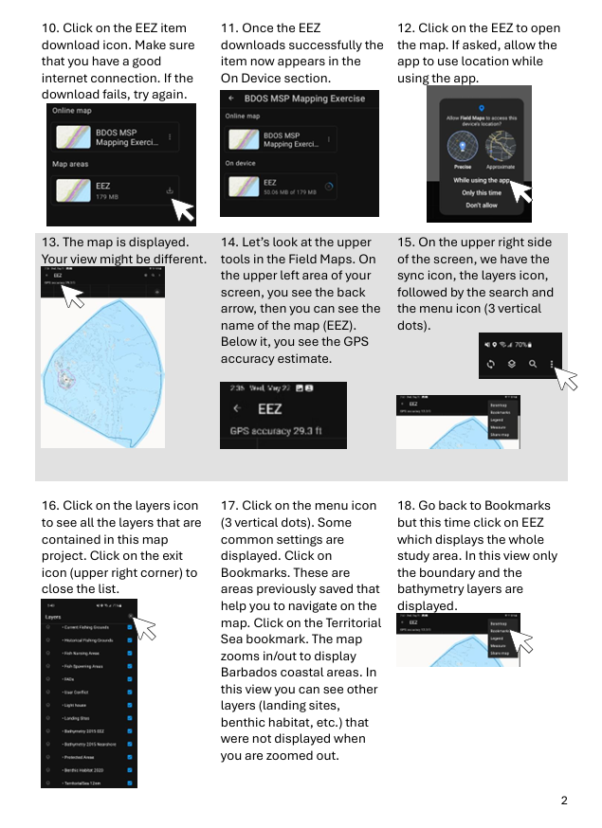
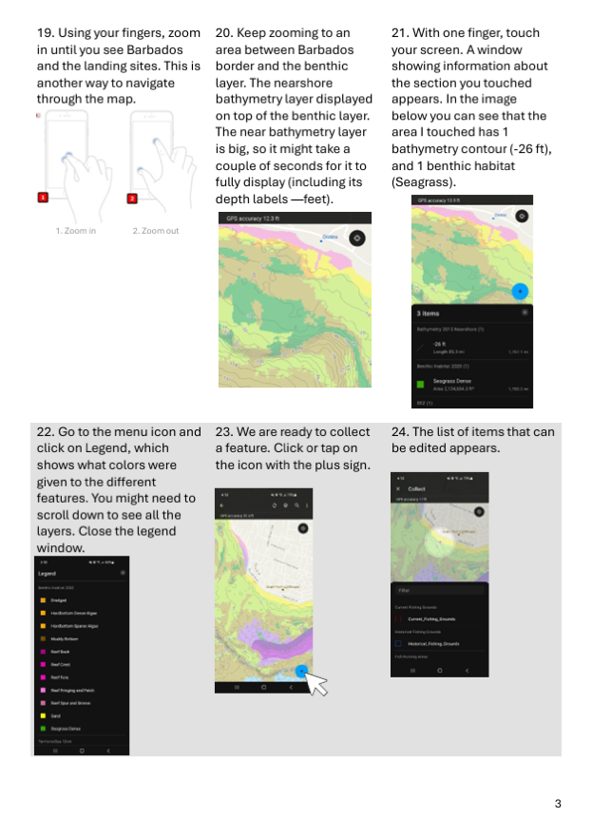 | 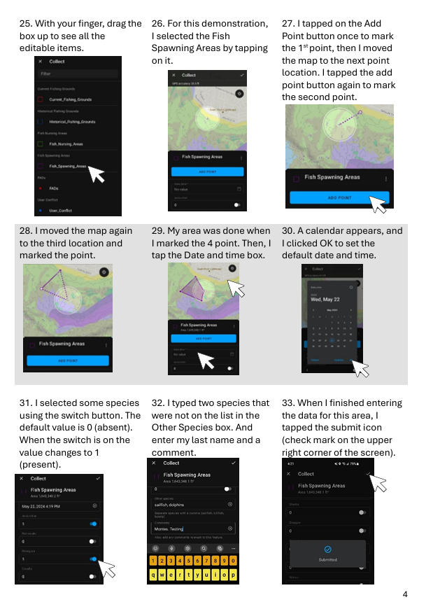
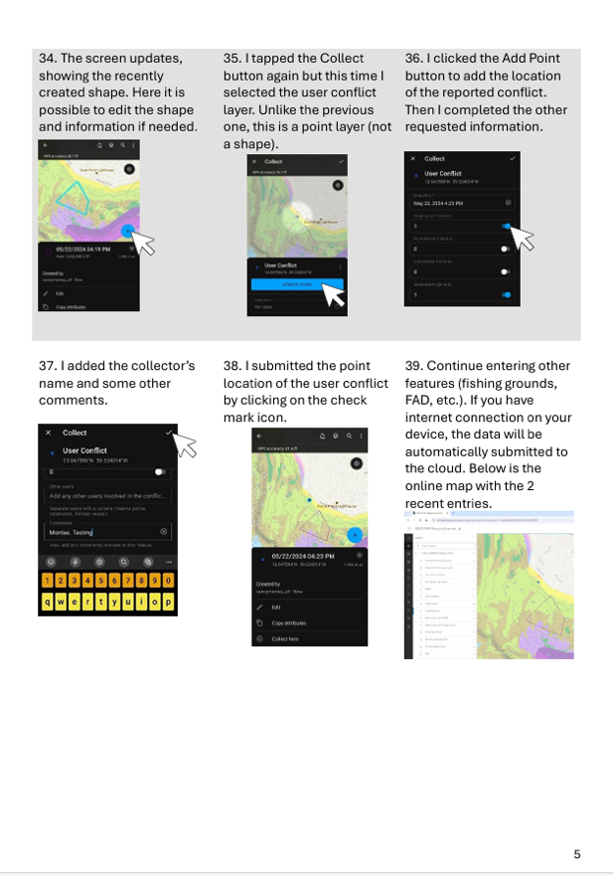 | 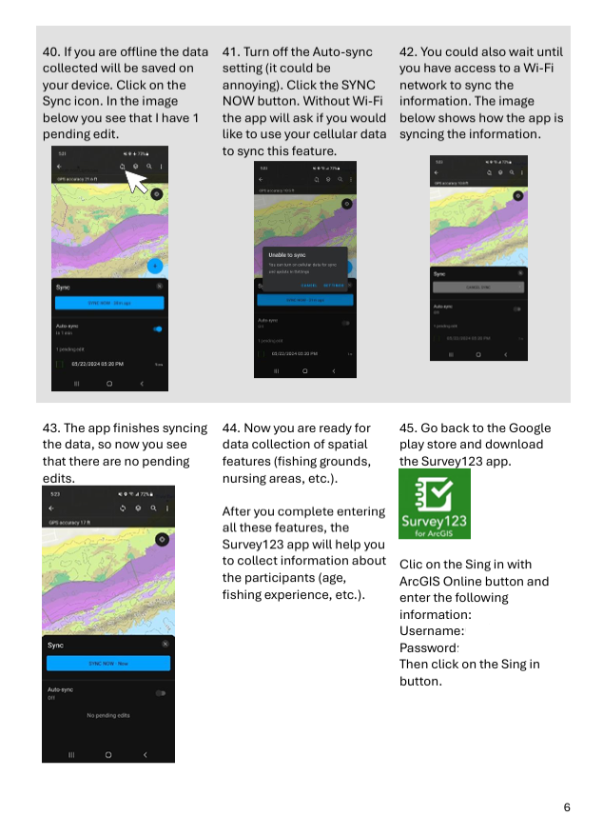
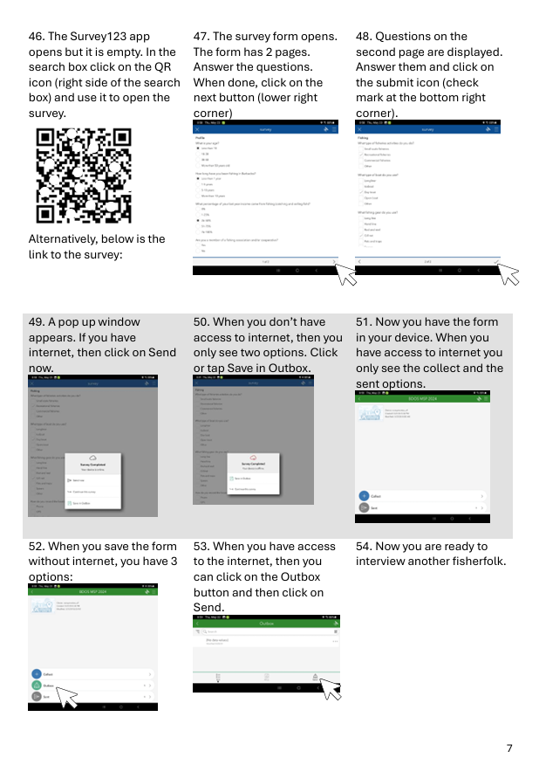

Appendix 8. The contact list used to request input through interviews, emails, and during the participatory mapping exercise.
NAME | ORGANISATION | Method | Gender*
Shelly Cox | BFD | In-person interview | F
Colvin Taylor | BFD | In-person interview | M
Adriel Jackman | BFD | In-person interview | M
Jalisa King | BFD | In-person interview | F
Christopher Parker | BFD | In-person interview | M
Richard Suckoo | CZMU | In-person interview | M
Allison Wiggins | CZMU | Not available
Jehroum Wood | CZMU | In-person interview | M
Ismail Desai | CZMU | In-person interview | M
Ramon Roach | CZMU | In-person interview | M
Fabian Hunte | CZMU | In-person interview | M
Aaron Gaskin | CZMU | In-person interview | M
Shonee Howell | CZMU | In-person interview | F
Derrick Brathwaite | Barbados Coast Guard | MSP Project Steering Committee | M
Leo Brewster | CZMU | MSP Committee | M
Jacqueline Pollard | Tourism Ministry | MSP Project Steering Committee | M
Jamar White | Energy Ministry | MSP Project Steering Committee | M
Maria Pena | CERMES | MSP Project Steering Committee | M
Lt Andrew Walcott | Barbados Coast Guard | Email unanswered
Paul Hamel-Smith | Barbados Game Fishing Association | Email unanswered
Susan Mahon | CORALL - Coral Reef Restoration Alliance | Email unanswered
Debbie Roach | CORALL - Coral Reef Restoration Alliance | Email unanswered
Tom Fountain | Barbados Divers Association | Email answered | M
Meike Joseph | WIRRED - Water Institute for Regenerative Research, Education, and Design | Email unanswered
Ann-Marie Eversley | EPD, Marine Pollution Officer | Email unanswered
Kim Baldwin | Marine Spatial Information Solutions | Email unanswered
David Yawson | CERMES | Email unanswered
Hazel Oxenford | CERMES | Email unanswered
Patrick McConney | CERMES | Email answered | M
Julia Horrocks | CERMES | Email answered | F
Julian Walcott | CERMES | Email answered | M
Robin Mahon | Fisheries and Environmental Consulting | Email unanswered
*Gender is provided only for people that participated in the interviews and/or answered email request for information.

Appendix 9. Questionnaire used to guide interviews
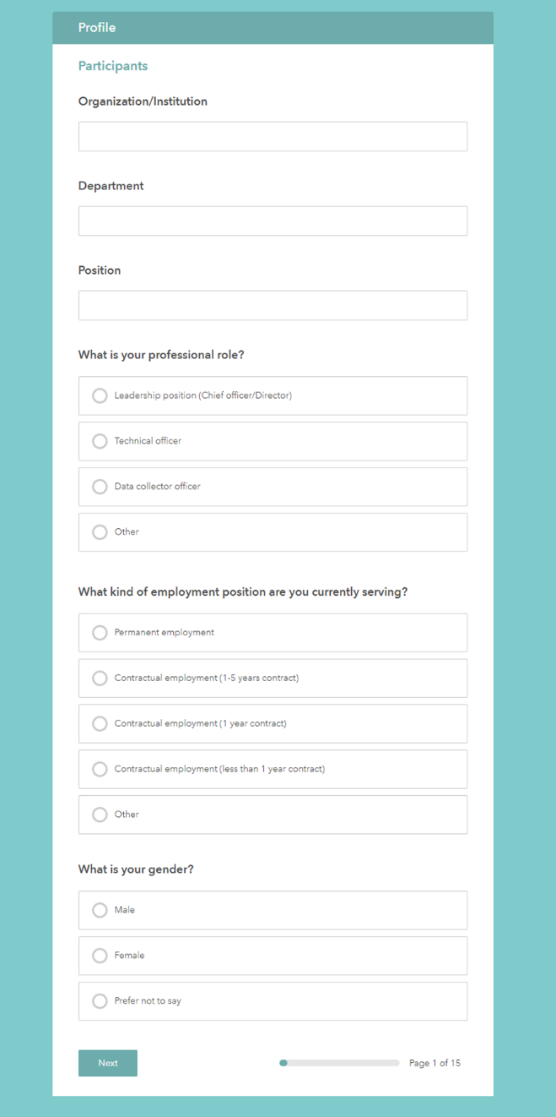 | 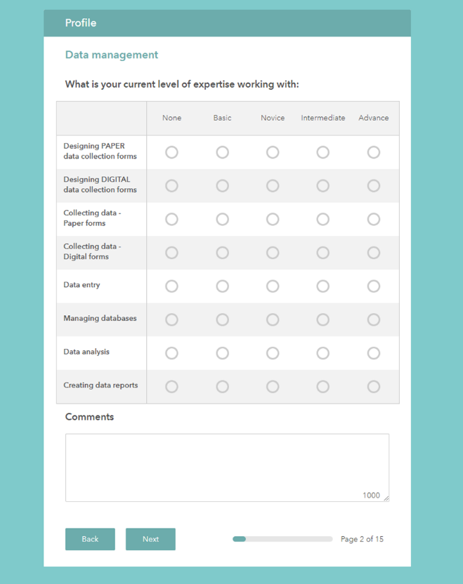
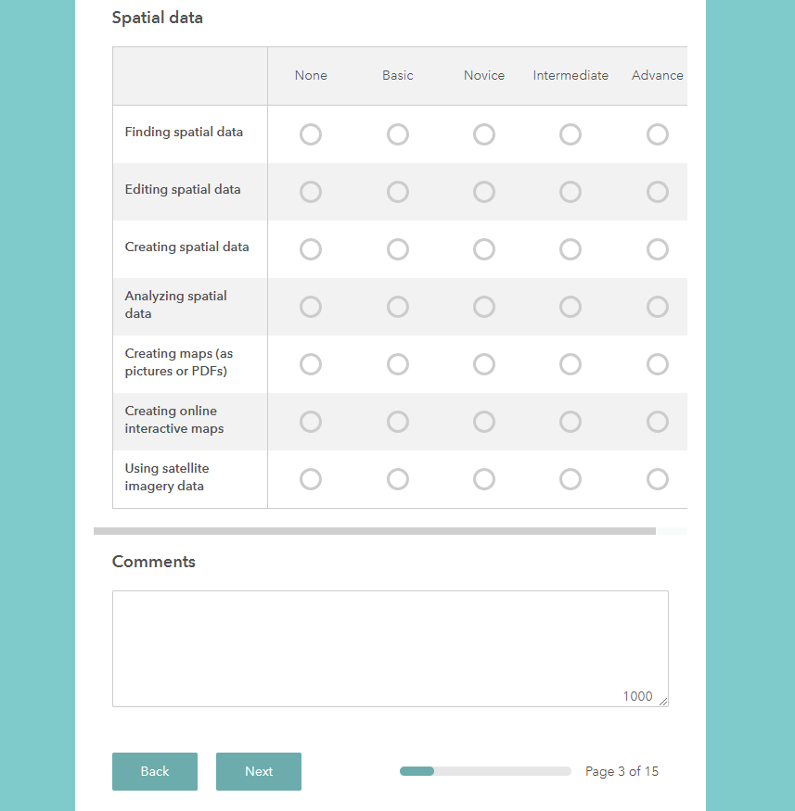 | 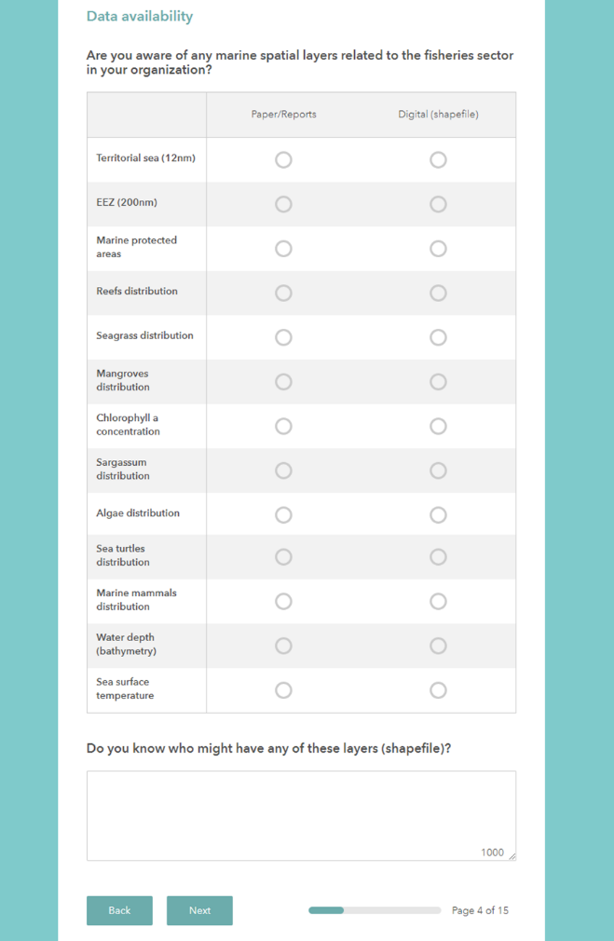
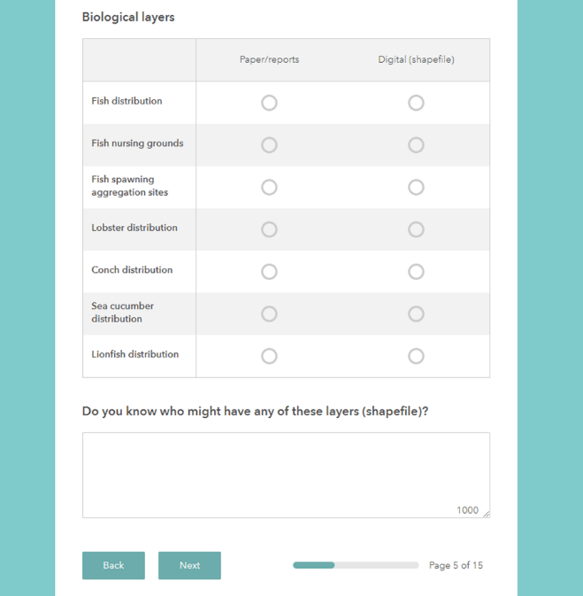 | 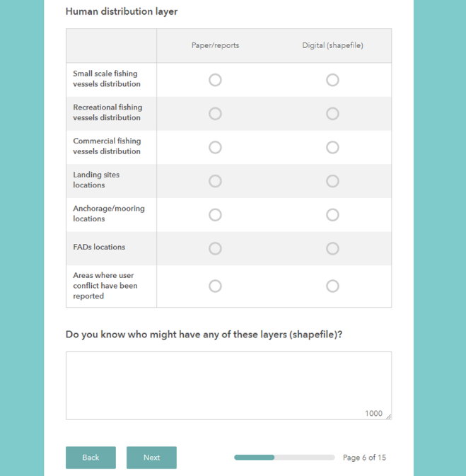
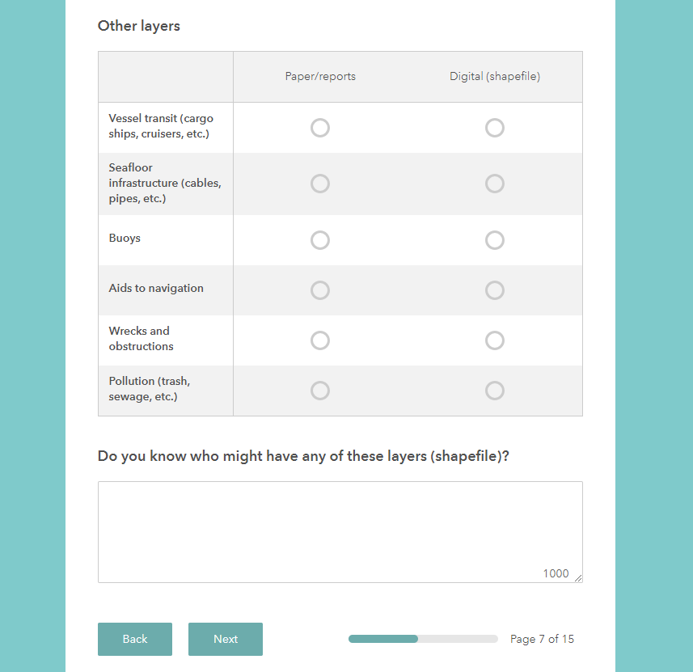 | 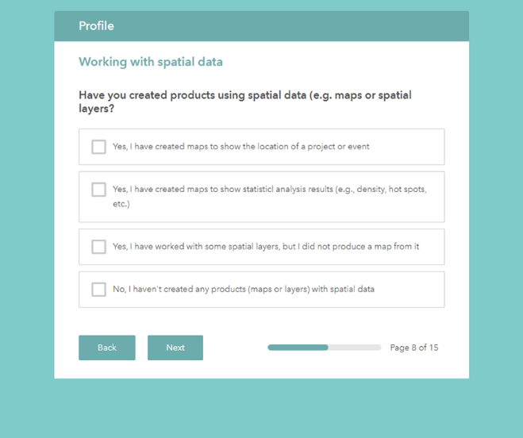
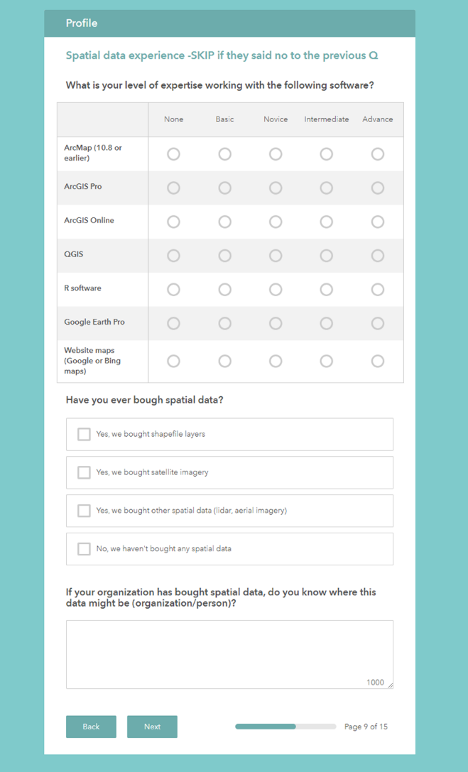 | 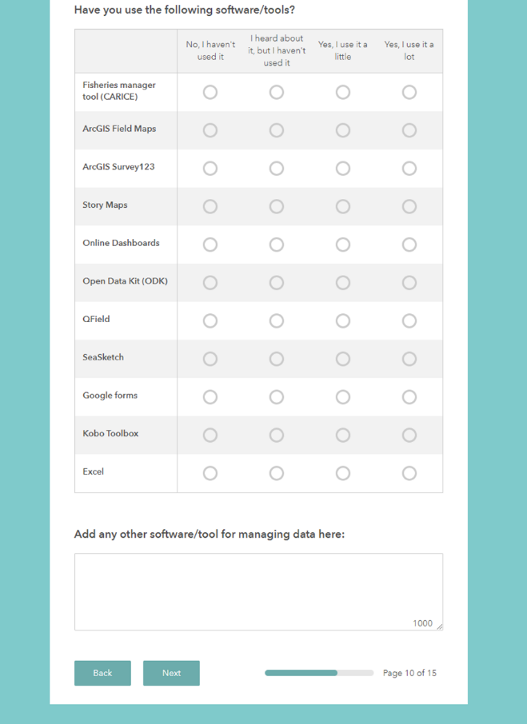
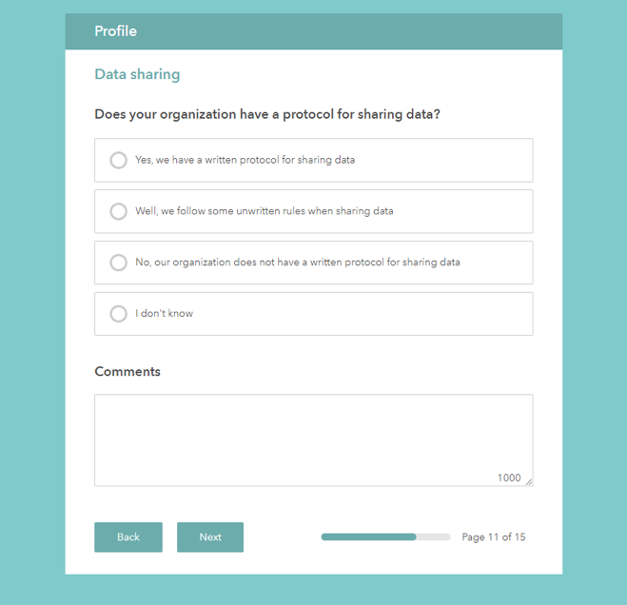 | 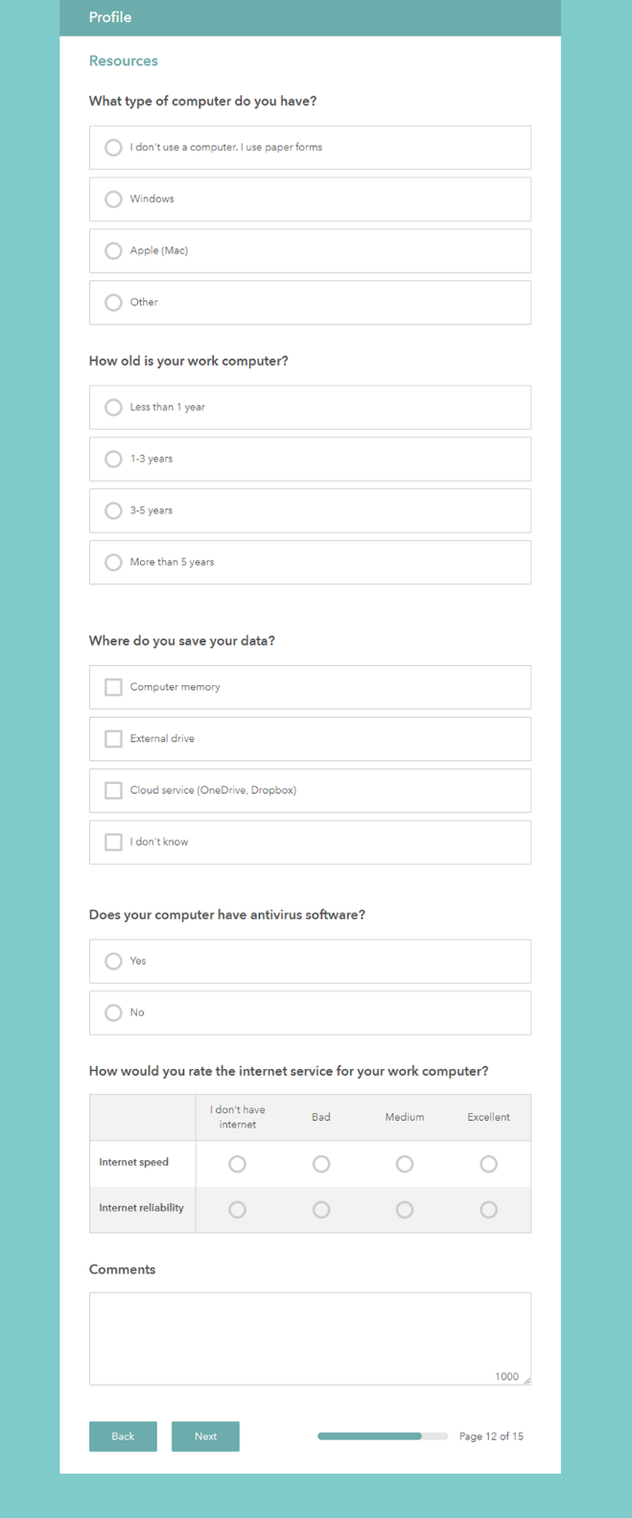
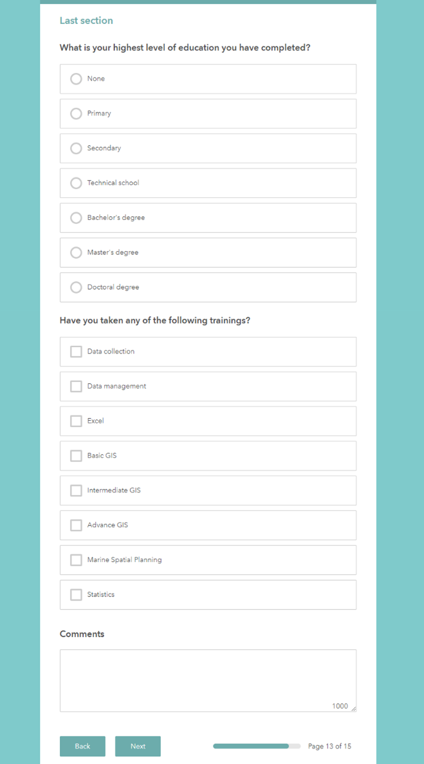 | 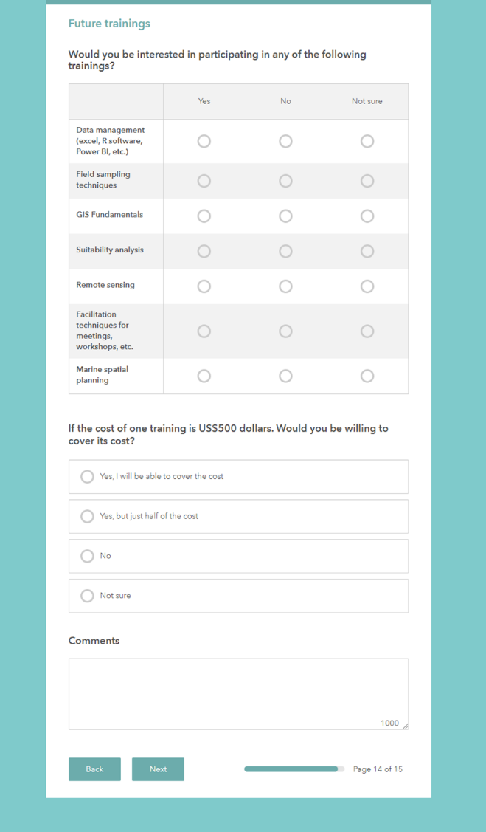
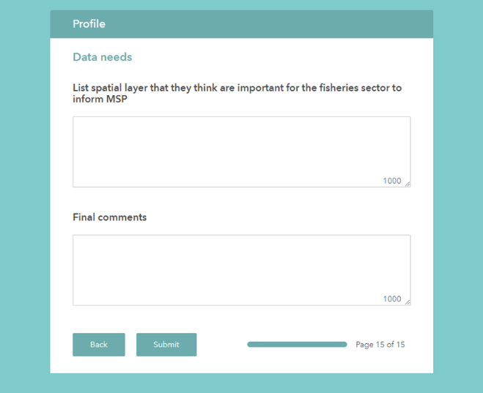

Appendix 10. Working agenda of the national validation workshop
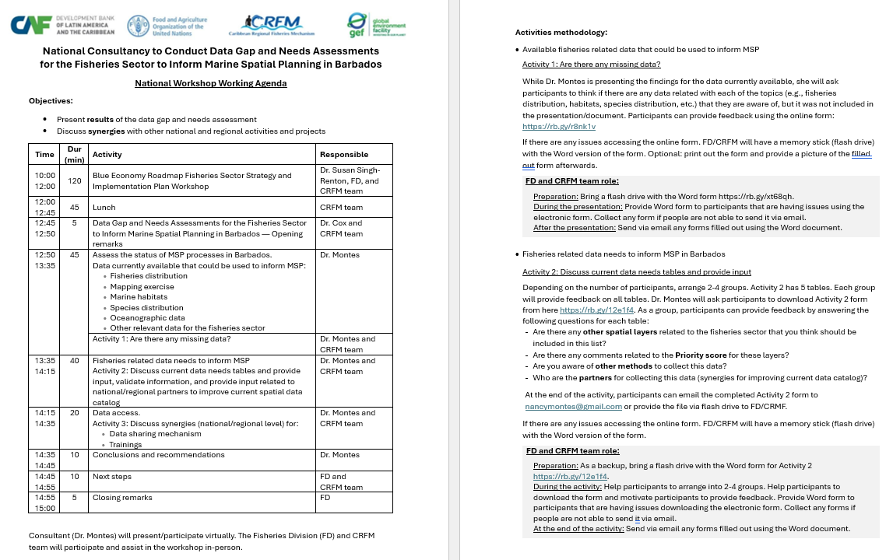
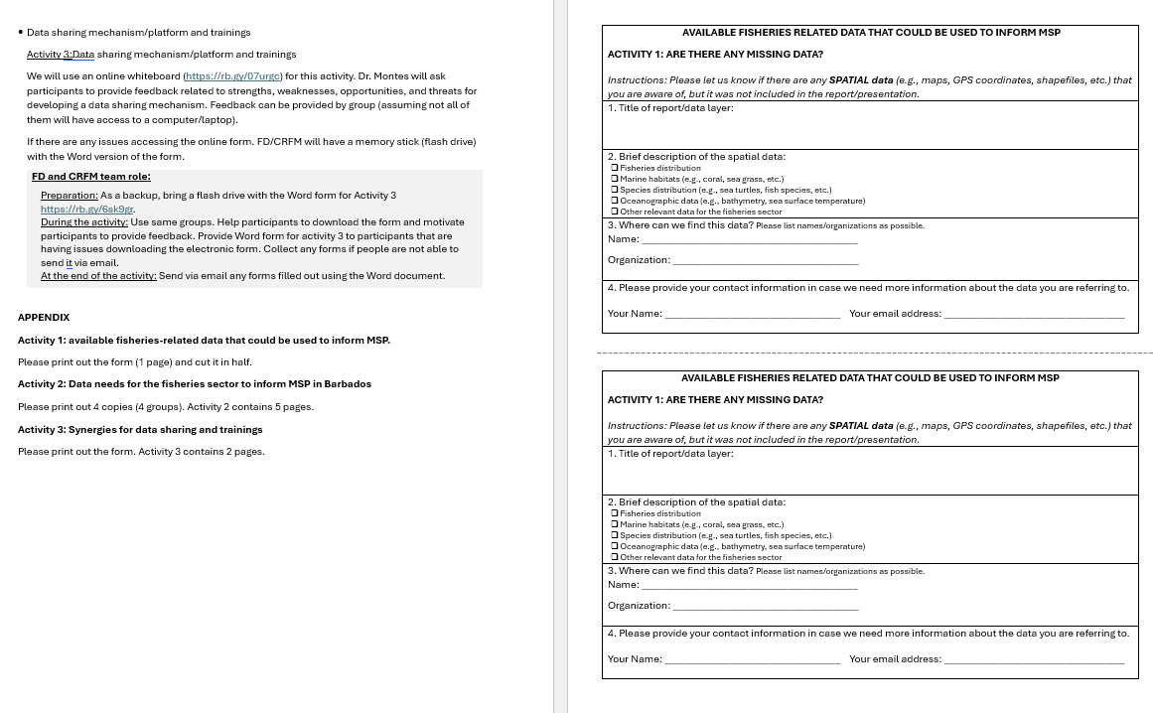

Appendix 11. National validation workshop invitation (communication product)
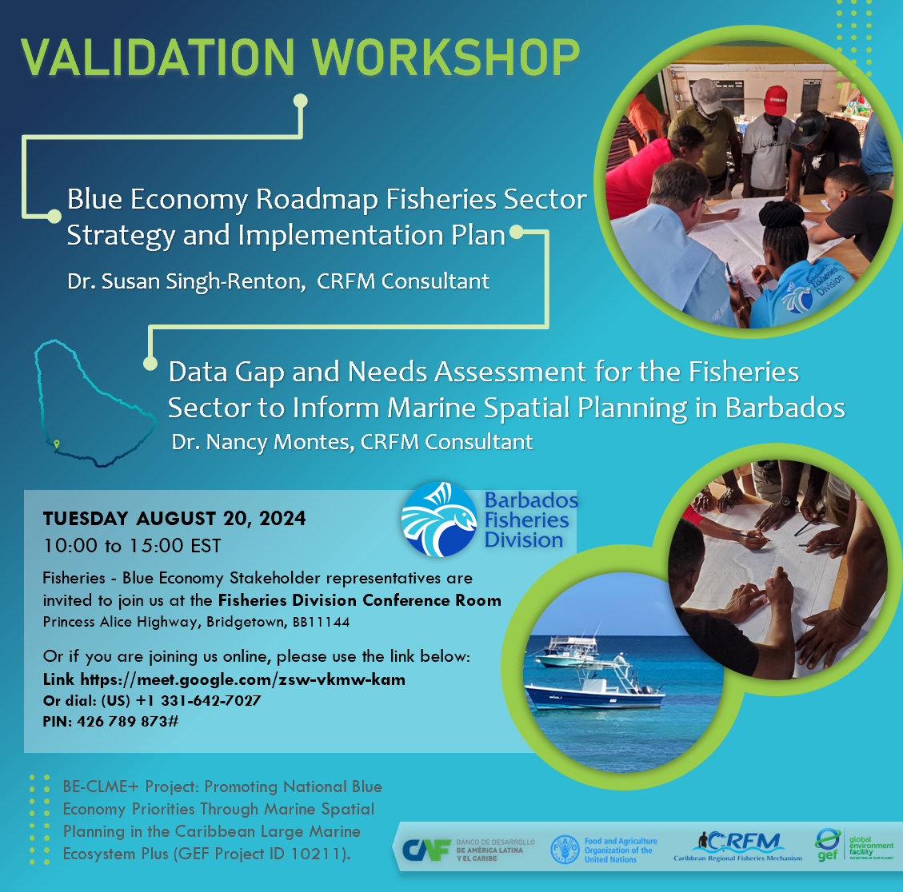

Appendix 12. National validation workshop list of participants.
Name | Job Title | Name of Organization
Ann-Marie Eversley | Senior Marine Pollution Officer | Environmental Protection Department
Ronnie Griffith | Chief Economist | Ministry of Economic Affairs and Investment
Susan Mahon | President | Coral Reef Restoration Alliance
Jacqueline Pollard | Senior Tourism Officer | Ministry of Tourism and International Transport
Mitch Hartman | Economist | Economist
Chemora Mc Knee | Climate Finance Access Network (CFAN) Advisor | Climate Finance Access Network
Ricardo Marshall | Director | Roofs to Reefs Unit, Prime Minister’s Office
Henri Valles | Senior Lecturer | BCS-UWI
Mechelle Lynch | Admin/Assistant-Office Manager | Barbados Environmental Sustainability Fund
Shoneé Howell | Water Quality Technician | Coastal Zone Management Unit

Appendix 13. MSP brochure (communication product)
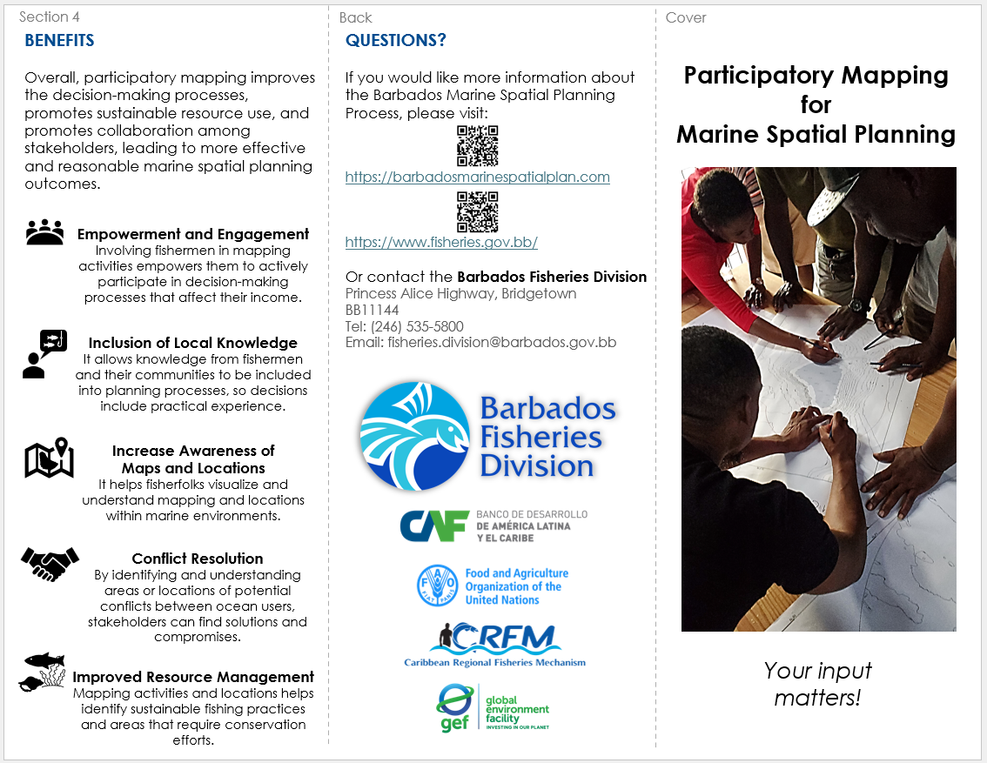

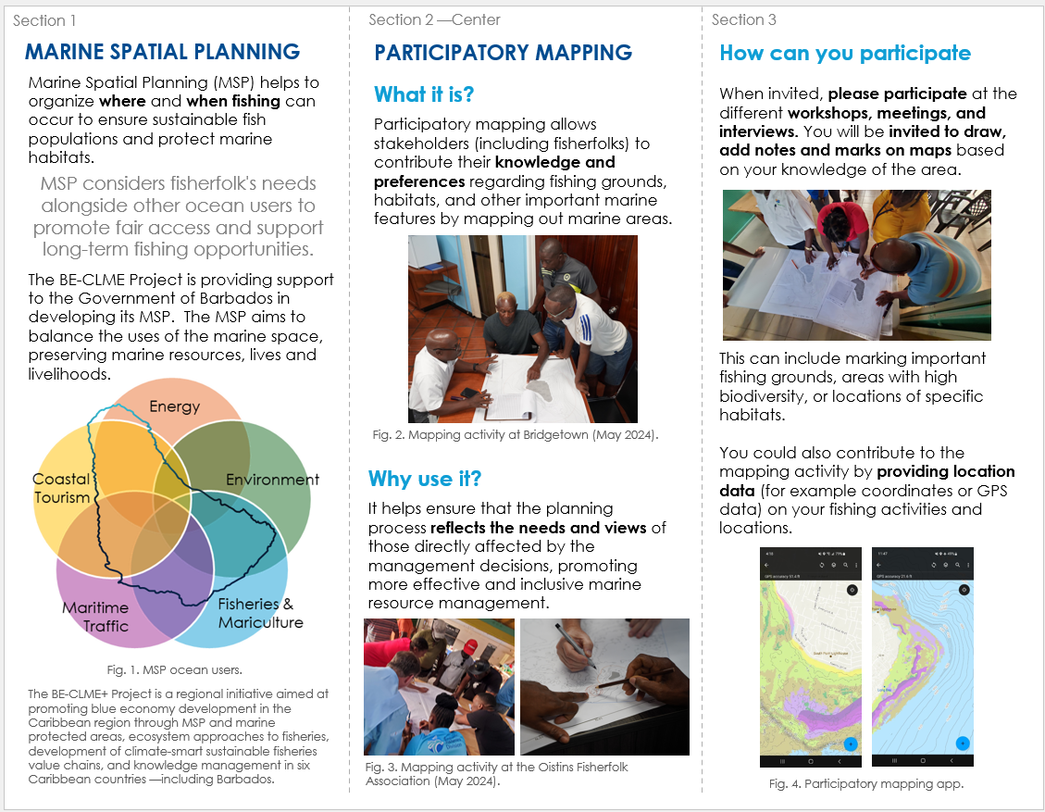

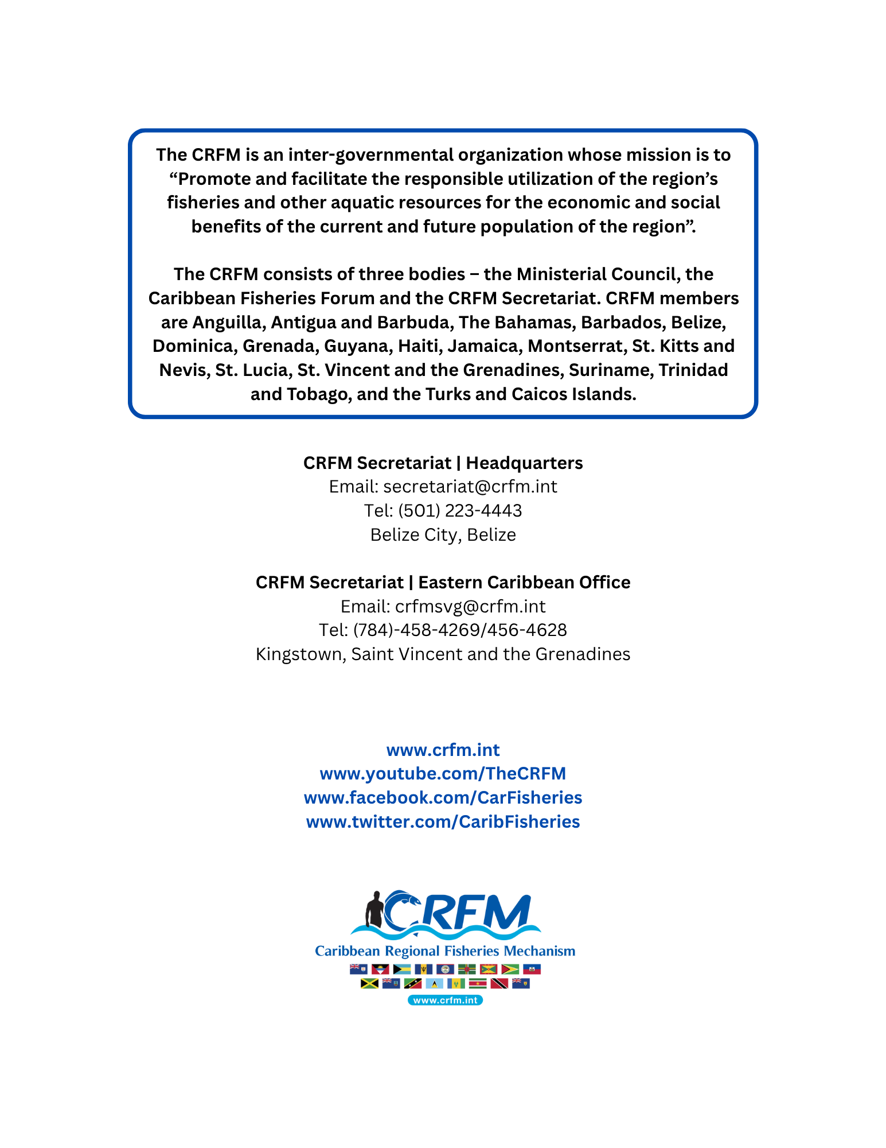

The Environmental Systems Research Institute, Inc. (ESRI) is one of the world's leading supplier of GIS software, web GIS and geodatabase management applications. Esri’s GIS technology enhances the effectiveness and efficiency of MSP initiatives by providing several interconnected products useful for data collection and integration, visualization, collaboration, analysis tools and real-time or near-real-time data.

