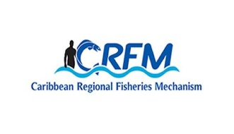




ISSN: 1995-1132

CRFM Technical & Advisory Document
No. 2025 / 14

FINAL REPORT

Data Gap and Needs Assessments to Inform MSP Implementation in Jamaica

CRFM Secretariat
Belize
2025

CRFM Technical & Advisory Document -
Number 2025 / 14

Data Gap and Needs Assessments to Inform MSP Implementation in Jamaica

Prepared by: Nancy Montes
Consultant
Geographic Information System and Human Dimensions Specialist.

This publication has been made possible through funding by BE-CLME+ Project: Promoting National Blue Economy Priorities Through Marine Spatial Planning in the Caribbean Large Marine Ecosystem Plus - GEF Project ID 10211

CRFM Secretariat
Belize
2025

CRFM Technical & Advisory Document Number 2025/ 14

Data Gap and Needs Assessments to Inform MSP Implementation in Jamaica

© CRFM 2025
All rights reserved.
Reproduction, dissemination and use of material in this publication for educational or non-commercial purposes are authorised without prior written permission of the CRFM, provided the source is fully acknowledged. No part of this publication may be reproduced, disseminated or used for any commercial purposes or resold without the prior written permission of the CRFM.

Correct Citation:
CRFM, 2025. Data Gap and Needs Assessments to Inform MSP Implementation in Jamaica. CRFM Technical & Advisory Report No. 2025 / 14. 99p.

ISSN: 1995-1132
ISBN: 978-976-8368-01-0

Published by the Caribbean Regional Fisheries Mechanism Secretariat
Belize and St. Vincent and the Grenadines

Executive Summary
The Government of Jamaica is currently developing its Blue Economy (BE) plan to promote the sustainable use of ocean resources for economic growth, improved livelihoods, and jobs while preserving the health of ocean ecosystem. The BE promotes the ecosystem-based approach in which both the economy and ecosystems thrive (World Bank, 2017). Marine Spatial Planning (MSP) is a tool used to implement the Blue Economy. MSP is a process that guides where and when human activities (including offshore energy, shipping, fishing, aquaculture, tourism, and mining) occur in the marine environment. It seeks to optimize the use of marine space and resources while minimizing conflicts and impacts on the marine ecosystem.
In 2023, with funding from the World Bank, recommendations for a Blue Economy Roadmap for Jamaica were developed in coordination with the Planning Institute of Jamaica (PIOJ) and a multi-agency Technical Review Committee. Within its strengthening fundamental pillar, the Blue Economy Roadmap highlights the need to increase and improve current data collection protocols, as well as data management, analysis and reporting by taking advantage of new technologies. Data collection plays a crucial role in MSP because it allows planners to make informed decisions, helps to monitor the health and status of marine ecosystems, and identifies any current or potential conflicts among marine uses.
Regional initiatives are also aiding this process. The Nature Conservancy (TNC) has been working in the region facilitating the Blue Bond Agreement being implemented in countries such as Belize and Barbados. Further support is being provided through, this consultancy to conduct a data gap and needs assessment which is being supported by the BE-CLME+ Project: Promoting National Blue Economy Priorities Through Marine Spatial Planning in the Caribbean Large Marine Ecosystem Plus (GEF Project ID 10211).
The Jamaica National MSP process is in its early stages (the government has yet to define the MSP goals and objectives). However, there are a couple of previous projects that conducted multisectoral spatial planning in Jamaica. For instance, the Jamaica Ecoregional Planning project provided recommendations for both terrestrial and marine spatial portfolio and spatial analysis for the whole country through a consultative process with stakeholders. This project aimed to provide a scientific basis and methodology for island-wide conservation planning. More specifically, the project provided information to assist in the design of a network of conservation areas to support the diversity of species, communities and ecosystems in Jamaica (John et al., 2006). More recently, the Pedro Bank MSP, which included a multi-use zoning design, was also developed (Baldwin, 2015). In both cases, relevant governmental agencies were involved in these efforts and the information produced by these projects was used to support the development of specific management plans.
Through this consultancy a comprehensive assessment of data gaps and needs was conducted through (1) systematic literature and (2) structured interviews with key stakeholders. It is expected that the findings of this assessment would inform ongoing MSP efforts in Jamaica.
In terms of available data to inform MSP, although some data is currently available (e.g., queen conch fishing grounds, etc.), its use for MSP may be limited and it will require a dedicated unit to bring it into a single GIS project. During the data gaps assessment, the following general observations were made: the current information is (1) decentralized, (2) most of the information is outdated, (3) it was created for different purposes at different scales and resolutions, and (4) it was collected and analyzed using different spatial data models (e.g., points, polygons, and grid cells). Although some data were in spatial file format (e.g., shapefile, geotiff, etc.) other data were only found contained within reports (as images). Most of the current data represents a single or limited snapshot of the distribution of the feature of interest and is located nearshore with a limited amount covering other areas of the Jamaica EEZ. Further analysis (e.g., scenario modeling) and systems to collect and analyze longitudinal data will be required to better support the MSP process in Jamaica.
A MSP for Jamaica will require information about the location of fishing grounds and other fishing areas (such as fish aggregating devices), commercially important fish nursing and spawning aggregating areas, benthic habitats, oceanographic variables (e.g., bathymetry, sea surface temperature, etc.), mariculture, other marine species of interest (e.g., sea turtles), identification of important areas (current and potential) for other sectors like tourism, energy, shipping and transportation, among others both nearshore and in the entire exclusive economic zone.
There is also a need to develop and maintain processes by which information is continually enriched and improved through a combination of more reliable data collection and stakeholder input. The government of Jamaica has already invested in the Spatial Planning Information Technology (NSPIT) to improve decision making in planning and national development by providing stakeholders (e.g., government agencies, academic centers, private sector) access to reliable spatial data. Because this platform is still under development, there is an opportunity to develop specific tools for MSP that promotes long-term stakeholder participation and consensus building. Which ultimately would enhance collaboration, improve decision-making, increase efficiency, and enhance transparency.
An assessment of the technological and human capacities of Government institutions in Jamaica revealed the access to the ESRI software and products. ESRI provides the world’s leading GIS software. Current GIS technicians (including NEPA and NFA) might require intermediate to advanced training in specific topics and software (e.g., apps for data collection, interactive dashboard and online mapping for data sharing, etc.) In contrast, other relevant actors (e.g., data collectors, sanctuary biologists, etc.) might require more basic GIS training to allow them to understand and feel comfortable in collecting and analyzing data, supporting the MSP process. To effectively engage stakeholders, mitigate conflicts, and foster collaboration it is also important to provide training to improve personnel facilitation, communication and outreach skills.
Finally, MSP presents an opportunity to promote collaboration and synergy among government agencies, non-profit organizations, and academic institutions to collectively assist in capacity development and the refinement of processes for data collection, meta-data, storage, and analysis to underpin MSP policy, stakeholder engagement and buy-in, and enforcement.
Table of Contents

Executive Summary 1
Introduction 1
Objective 2
Approach and Methodology 2
Systematic literature review and spatial data exploration 2
Interviews with key stakeholders. 3
Validation workshop 3
Results and Discussion 3
Current available data 4
Previous MSP initiatives in Jamaica 4
Online Atlas and Portals 8
National Data Sharing Portals 14
Spatial layers in reports/peer-reviewed literature 16
Summary of available data 31
Data gaps 39
Data needs to inform MSP 42
Data access 54
Software 58
Technical and human resources 61
Recommendations 64
Conclusions 66
References 67
Appendix 72
Appendix 1: Terms of Reference 72
Appendix 2: Inception meeting agenda and participants: 77
Appendix 3. List of people who participated in the interviews 78
Appendix 4. Questionnaire used to guide interviews 80
Appendix 5. Working agenda of the virtual national workshop 85
Appendix 7. Communication product —Virtual validation workshop invitation 87
Appendix 8. Virtual validation workshop participants 87

List of Figures

Figure 1. Jamaica Ecoregional Planning. Recommended marine conservation portfolio………………………………………………………………………………………………………………………… | 5
Figure 2. The marine multi-use zoning design developed for the Pedro Bank MSP extent. …………………………………………………………………………………………………………………………………..… | 8
Figure 3. The Caribbean Science Atlas tools. ………………………………………………………….…………… | 9
Figure 4. Mapping Ocean Wealth specialized apps………………………………………………….……………. | 10
Figure 5. Ocean Watch dashboard………………………………………………………………………….………….. | 11
Figure 6. ESRI ArcGIS Online…………………………………………………………………………………….……….. | 11
Figure 7. Global Biodiversity Information Facility……………………………………………………….…………. | 12
Figure 8. Global Fishing Watch platform………………………………………………………………….………….. | 12
Figure 9. Marine Traffic platform. Live map……………………………………………………………….…………. | 13
Figure 10. Skylight platform……………………………………………………………………………………...................................………… | 14
Figure 11. The NSPIT viewer interface…………………………………………………..………………………………………………………………………… | 15
Figure 12. Examples of data used worldwide for MSP………………………………………………………………… | 45
Figure 13. Evolution of data analysis in MSP…………………………………………………………………………….. | 46
Figure 14. Example of a layer’s metadata in NSPIT……………………………………………………………………. | 56
Figure 15. Caribbean Science Atlas data sharing agreement….………………………………………………..… | 57
Figure 16. Examples of GIS layers shared by Jamaica governmental agencies using ESRI products. …………………………………………………………………………………………………………………………………………. | 58

List of Tables

Table 1. Major data sources for the mapping of Jamaica Ecoregional Planning marine conservation targets………………………………………………………………………………………………………………………………….……… | 6
Table 2. Pedro Bank MSP geodatabase……………………………………………………………………………………. | 7
Table 3. Available data with its source…………………………………………………………………………………….. | 31
Table 4. Summary of current data and data gaps…………………………………………………………..………….. | 39
Table 5. MSP data categories (with examples) identified by  the World Bank (2022) ………………………………………………………………………………………………. | 43
Table 6. Data needs to inform MSP …………………………….………………………………………………………….. | 47
Table 7. Current limitations for accessing data encountered………………………………………………………. | 53
Table 8. Suggested training for technicians supporting Jamaica’s MSP process…………………………………………………………………………………………………………………………….. | 61

LIST OF ACRONYMS AND ABBREVIATIONS

BE | Blue Economy
CAF | Development Bank of Latin America and the Caribbean
CERMES | Centre for Resource Management and Environmental Studies
ESRI | Environmental Systems Research Institute, Inc.
FAO | Food and Agriculture Organization of the United Nations
GEF | Global Environmental Facility
GIS | Geographic Information Systems
GOJ | Government of Jamaica
CLME | Caribbean Large Marine Ecosystem
CRFM | Caribbean Region Fisheries Mechanism
ESS | Environmental and Social Safeguards
FADs | Fish Aggregating Devices
MEGJC | Ministry of Economic Growth and Job Creation
MSP | Marine Spatial Planning
NCOCZM | National Council on Ocean and Coastal Zone Management
NEPA | National Environment and Planning Agency
NGO | Non-Governmental Organization
NSPIT | Spatial Planning Information Technology
PIOJ | Planning Institute of Jamaica
PMU | Project Management Unit
POC | Point of Contact
TNC | The Nature Conservancy
TOR | Terms of Reference

Introduction
The Government of Jamaica is currently developing its Blue Economy (BE) plan to promote the sustainable use of ocean resources for economic growth, improved livelihoods, and jobs while preserving the health of ocean ecosystem. The BE promotes the ecosystem-based approach in which both the economy and ecosystems thrive (World Bank, 2017). Marine Spatial Planning (MSP) is a tool used to implement the Blue Economy. MSP is an adaptative process to analyze and provide guidelines related to the spatial and temporal distribution of human activities in marine and coastal environment (including fishing, aquaculture, shipping and transportation, tourism, offshore energy and mining. It seeks to optimize the use of marine space and resources while minimizing conflicts and impacts on the marine ecosystem (Douvere & Ehler, 2009; World Bank, 2017).
The MSP process involves several key components. It starts by defining goals and objectives and identifying key stakeholders. This is then followed by a baseline assessment of the current state of the marine ecosystem, and the performance of spatial analysis and mapping to illustrate the distribution of key features (e.g., marine habitats, human activities, etc.) based on multiple management options. A plan is then drafted and validated by stakeholders to outline spatial allocations, management measures, any zoning regulations, and communication and education strategies. Once a plan has been approved by the relevant authorities, an action plan will guide its implementation by highlighting roles, responsibilities, and timelines. At a late component, the monitoring and evaluation is undertaken throughout MSP implementation, which provides information and identifies the resources needed to adjust or adapt the plan and address new challenges or changing conditions (adaptative management).
In 2023, with funding from the World Bank, the Government of Jamaica adopted recommendations for a Blue Economy Roadmap for Jamaica. The recommendations were developed in coordination with the Planning Institute of Jamaica (PIOJ) and a multi-agency Technical Review Committee. Within its strengthening fundamental pillar, the Blue Economy Roadmap highlights the need to increase and improve current data collection protocols, as well as data management, analysis and reporting by taking advantage of new technologies. Data collection plays a crucial role in MSP because it allows planners to make informed decisions, it helps monitor the health and status of marine ecosystems and identifies any current or potential conflicts among marine uses.
In terms of data, analysis and dissemination of the data, the recommendations from the Blue Economy Roadmap for Jamaica concluded that there is a strong government capacity, prestigious academic institutions, and a range of specific publications and data releases of direct relevance to the BE. However, they also identified challenges such as data collection gaps in key areas, limited use of new technologies to collect data (especially geospatial) and limited use of data to support policy making (World Bank, 2023).
This consultancy is supported by the BE-CLME+ Project, which is a regional initiative aimed at promoting blue economy development in the Caribbean region through MSP and marine protected areas, an ecosystem approach to fisheries, the development of climate-smart sustainable fisheries value chains, and knowledge management in six Caribbean countries —including Jamaica. This consultancy worked closely with the Jamaica NFA on an assessment of needs, data availability and data gaps to inform MSP in Jamaica.

Objective
The objective of this consultancy is to comprehensively assess data availability, data gaps and data needs to inform MSP in Jamaica. Several countries in the Caribbean, including Jamaica, have initiated MSP and Blue Economy development processes, and as such, the assessment is intended to complement ongoing BE processes in Jamaica (Appendix 1 & 2).

Approach and Methodology
The approach to this assignment, as defined by the TOR, consisted of three interconnected activities: (1) a systematic literature review and on-line exploration for relevant spatial data; (2) an assessment of organizational capacity and needs through interviews with key stakeholders representing sectors that have a stake in utilizing and managing marine resources (e.g., fisheries, transportation, conservation and natural resources, energy, tourism, security, etc.); and (3) validation workshop.

Systematic literature review and spatial data exploration
An online literature review (activity 1) was conducted to identify publicly available information and spatially represented data (print or digital) relevant to the objective and activities of this consultancy. This review included scholarly work and gray literature developed by governments, international agencies, and NGO’s. The review also included information pertinent to recommending data sources, acquisition costs (where applicable), and collection methods.
The main web search engine queried was Google Scholar (204 results). Terms used during online searches included “Jamaica”, “fisheries”, “GIS.” Most relevant results were scanned for spatial data (e.g., GPS information, maps, or geospatial file information). Additionally, during the interviews (activity 2), participants were asked to provide any lead-to known research or projects with spatial or geo-referenced data. Relevant government agencies’ official websites (e.g., NEPA, NFA, PIOJ, etc.) were also explored.
Spatial atlases and databases were also searched using the term “Jamaica” and through a snowball method (if a layer was found, other information shared by the author of that layer and his/her organization was investigated). Only atlas and databases from known and reliable organizations were explored. However, because these are international sources usually the spatial information is generated through GIS models at a regional scale and with inherent levels of uncertainty.

Interviews with key stakeholders.
A contact list of key stakeholders was created using the outline of the ministries and their agencies related to the development of a blue economy documented in the recommendations for a Blue Economy Roadmap for Jamaica (World Bank 2023). The NFA reviewed and provided contact information of relevant actors. They also arranged and scheduled interviews with key stakeholders (Appendix 3).
A digital questionnaire was designed and used to guide the interviews and ensure that relevant topics were discussed during the meetings. The NFA and the CRFM reviewed the questionnaire and provided feedback (Appendix 4). The main topics discussed during the interviews were (1) the types of existing data and uses of that data, (2) data that is of interest but not being collected or represented spatially, (3) the technical capabilities and training needs/interests among staff to engage in the marine spatial planning process, and (4) the kinds of software and hardware that are now being utilized to fulfill data acquisition, storage, and analysis. During the interviews, consent was requested only when individual pictures were taken.

Validation workshop
Findings, recommendations and conclusions were presented in a virtual national validation workshop conducted on August 13, 2024 (Appendix 5). NFA distributed personalized invitations to key stakeholders (contact list previously developed for interviews) that included a fact sheet describing BE and its relation to the MSP in Jamaica (Appendix 6). A broader invitation was also distributed by NFA (Appendix 7). Thirty-seven people participated in the validation workshop (Appendix 8) and provided valuable feedback that was included in the final report.

Results and Discussion
In 2023, a document titled “Recommendations for A Blue Economy Roadmap for Jamaica” was published with funding from the World Bank and the support of several national and international agencies. Based on this document, Jamaica’s blue economy coordinating structure is led by the Ministry of Economic Growth and Job Creation (MEGJC), the National Council on Ocean and Coastal Zone Management (NCOCZM), and the Planning Institute of Jamaica (PIOJ). Other key institutions driving the activities and recommendations of the roadmap include:

- The National Environmental and Planning Agency (NEPA),
- the National Fisheries Authority (NFA),
- the Ministry of Finance Public Services (MOFPS),
- the Jamaica Promotions Corporation (JAMPRO),
- the Ministry of Science, Energy, and Technology (MSET),
- the Ministry of Tourism (MOT), the National Solid Waste Management Authority (NWSMA), the Port Authority of Jamaica (PAJ),
- the Maritime Authority of Jamaica (MAJ),
- the Water Resources Authority (WRA),
- the Ministry of Agriculture and Fisheries (MOAF),
- the Ministry of Education and Youth (MOEY),
- the Ministry of Labour and Social Security (MLSS), and
- academia (Universities and Colleges).
The Recommendations for a Blue Economy Roadmap was validated at a workshop and published in May 2023. The document is currently available through the PIOJ website. Its implementation plan has yet to be developed. Furthermore, there is a need to develop a MSP plan that will include the country’s vision, objectives, roles, and timelines for implementing this process. Together they should drive the development of Jamaica’s marine spatial management plan and provide implementation guidance to support Jamaica’s blue economy.
In terms of currently available data that could be used to inform Jamaica’s MSP, overall, data has been collected as part of projects being implemented and does not follow any national programmatic data collection process of a particular agency (e.g., NEPA, NFA, PIOJ, CERMES, etc.). Therefore, spatial data is limited, decentralized, and in several cases outdated (more than 10 years old). Existing data are presented at different spatial resolutions and scales (e.g., study site, countrywide, regionally, etc.). Given that existing data is generated from different sources, features are presented using different spatial data types (i.e., point, polygons, grid cells, and raster). In addition, the data are not updated temporally, so in most cases it represents a static view (snapshot) of observed distributions. Moreover, the wealth of the currently available data represents nearshore features with a limited amount characterizing the broader area of the Jamaica’s EEZ. Below is a summary of these observations, with references to specific spatial layers provided in Table 3.

Current available data

Previous MSP initiatives in Jamaica
Jamaica Ecoregional Planning (JERP)
The Nature Conservancy published the Jamaica Ecoregional Planning (JERP) report (2006), outlining conservation areas and strategies for the sustainable use of freshwater, marine and terrestrial biodiversity. This 3-year initiative was supported by a multidisciplinary group of local and international scientists, technicians and conservation practitioners. The report includes draft recommendations for marine conservation areas based on a set of pre-defined goals (Fig. 1).
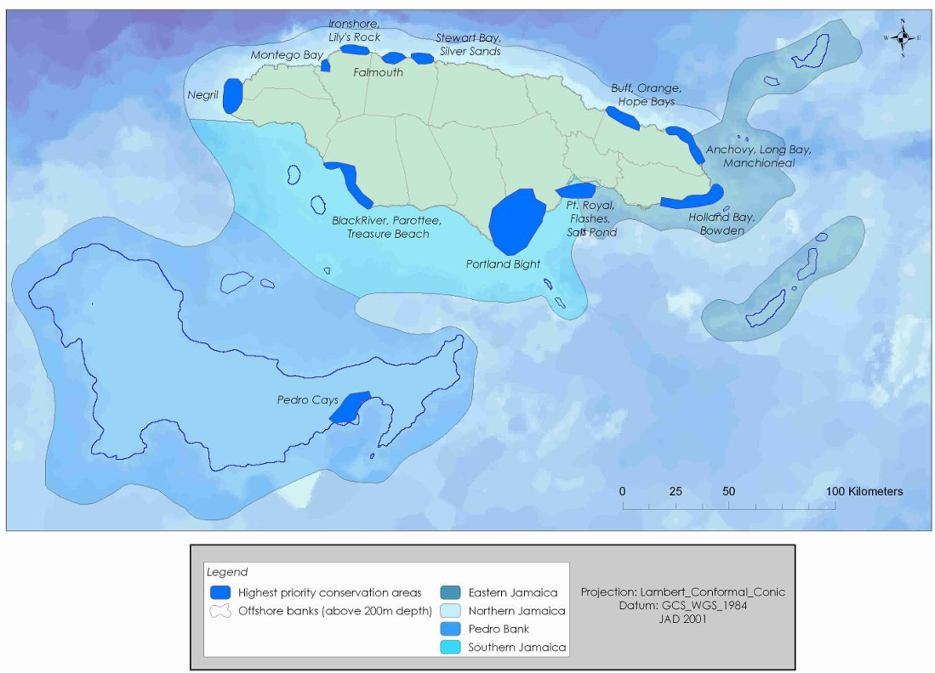
Figure 1. Jamaica Ecoregional Planning. Recommended marine conservation portfolio with goals met. Source: John et al., 2006.
The analysis was guided by expert advice and a GIS database which was developed using existing data (Table 1). Although the project provided a link to access the GIS database, the link is no longer functioning. This spatial information, if available could be useful as reference data, however, due to the changing marine environment, more recent layers should be considered for performing analysis in a future MSP process initiative. The results and recommendations are based on analyses performed using GIS-based modelling, Marxan software and a priority-setting tool.
The JERP was further reviewed and discussed by a team of local experts along with refined GIS analysis, and eventually the information generated for this effort supported the national ecological gap assessment that was used to develop the Jamaica’s Protected Area System Master Plan (Donna Blake, personal communication, August 2024).
Table 1. Major data sources for the mapping of Jamaica Ecoregional Planning marine conservation targets. Source: John et al., 2006.
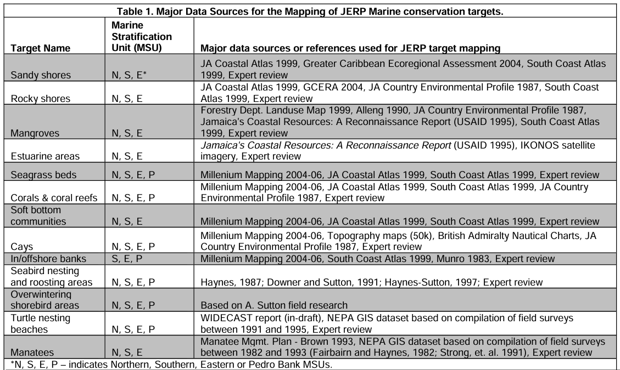
Pedro Bank MSP
The Government of Jamaica with support from The Nature Conservancy undertook a one-year participatory MSP process to plan for the management of Pedro Bank’s marine resources (Baldwin, 2015). The objective of this MSP process included the drafting of a marine multi-use zoning for the Pedro Bank, and demarcating priority conservation areas within the Pedro Bank system. Analyses were conducted using spatial information obtained from scientific data, local knowledge (participatory mapping), and associated socio-economic information contained in national reports (Table 2). As part of the deliverables of the Pedro Bank MSP process an online GIS database of mapped habitat, resources and space-use features was created using Dropbox. However, the link to the data no longer functions. If available, this data could be used as a reference to evaluate the current state of the proposed zoning and update the recommendations of this initiative as needed (adaptative management).
Table 2. Pedro Bank MSP geodatabase (02/17/2015). Source: Baldwin, 2015.
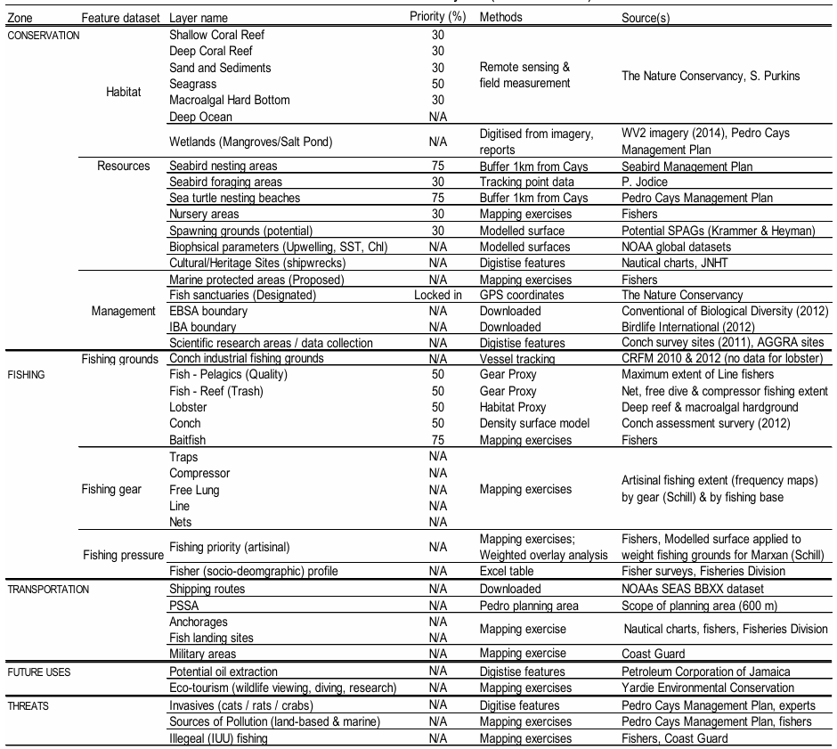
The multi-use zoning design that includes a conservation zone, fishing zone, transportation zone, future development zone, and research zone was developed using Marxan software and it was validated through stakeholders’ consultations (Figure 2).
The Pedro Bank MSP was accepted by the NEPA. The management plan was updated and this, along with the MSP, has been used to bring focus to areas in need of conservation on the Bank. As a result, the NEPA is planning to declare three marine protected areas identified by these efforts (Blake, 2024).

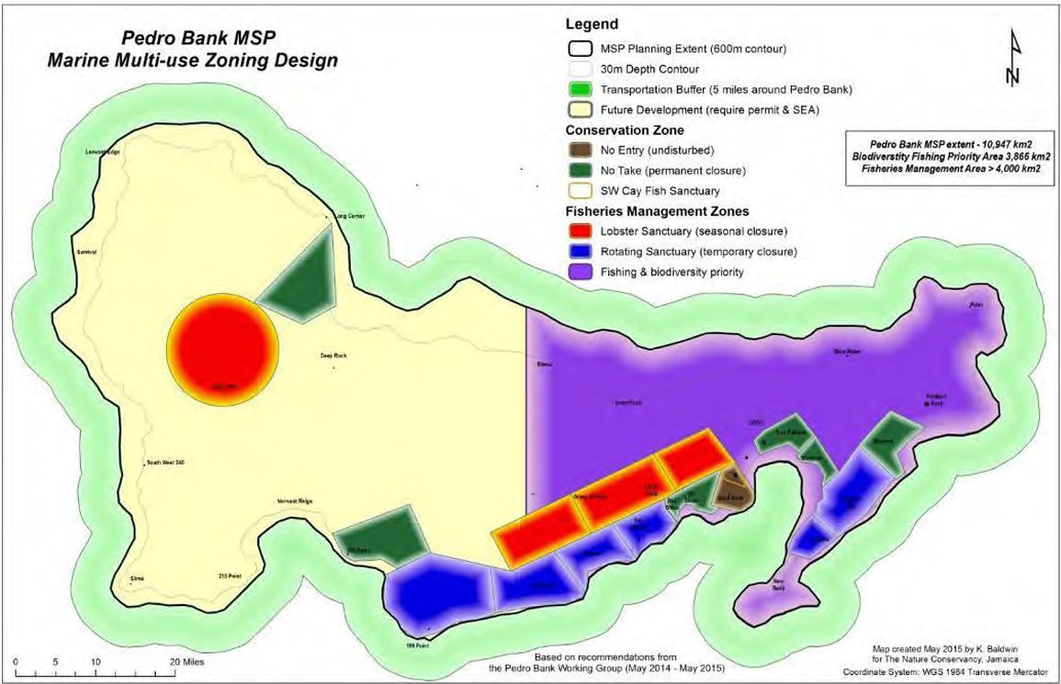
Figure 2. The marine multi-use zoning design developed for the Pedro Bank MSP extent. Source: Baldwin, 2015.

Online Atlas and Portals
There are several atlas and portals developed by international organizations that provide not only the spatial layers but also interactive tools and dashboards to easily visualize available data and, in some cases, provide quick statistics based on a customizable area.
The information provided by these atlas and portals might be the only data currently available during the planning phase of the MSP process, though these data are not without their limitations. For example, much of the data was created on a worldwide or regional scale and it might be available only at a coarse spatial resolution. Furthermore, data is contributed by several organizations and was created using different methods and at different timeframes. Nevertheless, the platforms offer a rudimentary approach to access metadata not currently available at the national or local level.
A description of the most important atlas and portals is presented below. Identified layers are listed in Table 3.

The Caribbean Science Atlas
Provides scientific and geospatial data in the Caribbean region. Spatial datasets can be accessed through a formal request function built into the tool. The layers are searchable, but they can also be accessed through four topic tools (July 2024):
1. Climate Mitigation
2. Coral Restoration
3. Climate Adaptation
4. Marine Protection

Figure 3 shows a general description of each tool.
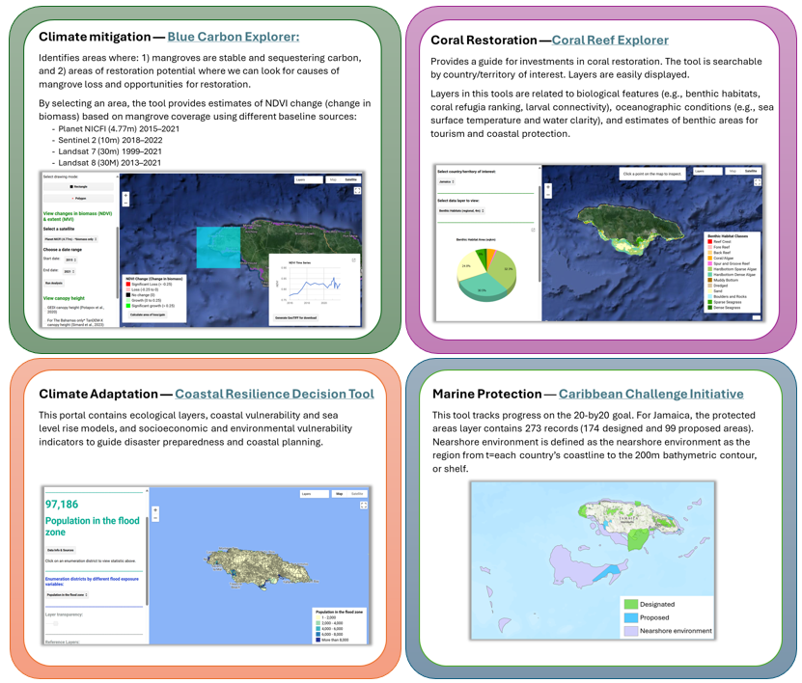
Figure 3. The Caribbean Science Atlas tools.

Mapping Ocean Wealth (MOW)
The MOW application provides access to a collection of datasets and tools for sharing and understanding the value of marine and coastal ecosystems (Fig. 4). Data can be accessed through the interactive and customizable resource platform or by using specialized features that provide not only a view of the spatial layer, but also quick stats by country. Current specialized applications include (July 2024):
- Recreation & Tourism: it explores the value of coral reef tourism worldwide in terms of tourism expenditure and visitor numbers.
- Natural Coastal Protection: provides global models to explore the value of coral reefs (data for Jamaica) and mangrove forest in defending people and coastal assets from the impacts of flooding.
- Blue Carbon: provides data on the carbon held in mangrove forest. However, currently there is no data for Jamaica.
- Coral Reef Fisheries: currently there is no data for Jamaica.
- Mangrove Restoration: extent of restorable mangrove forest worldwide.
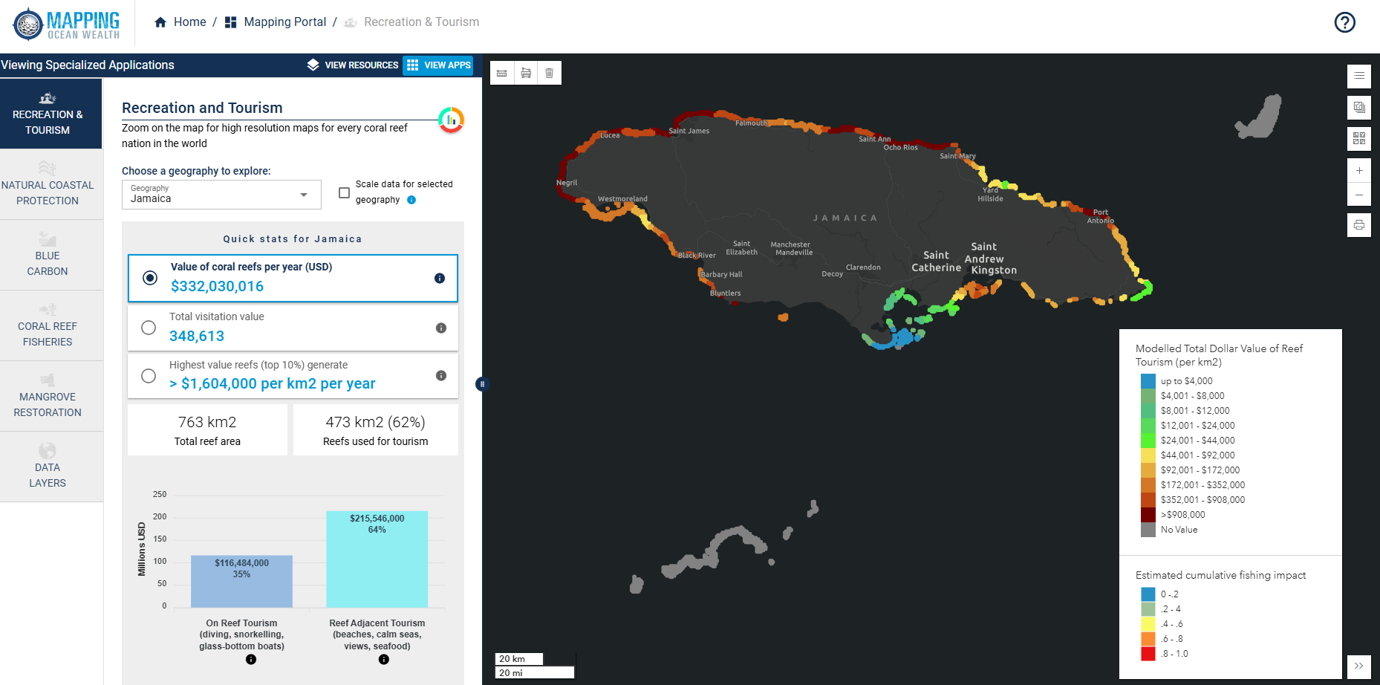
Figure 4. Mapping Ocean Wealth specialized apps.

Ocean Watch
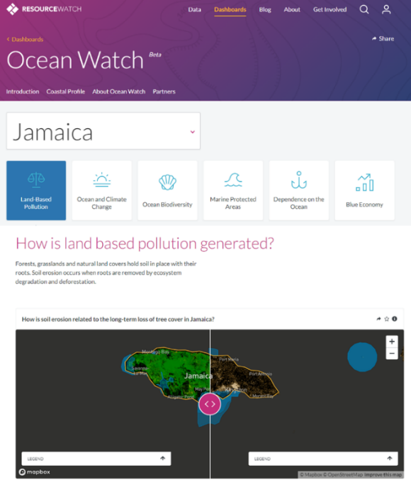
Ocean Watch is a dynamic platform that provides access to visualization tools and 360 datasets.

Figure 5. Ocean Watch dashboard.
Data can be explored individually or in combination and the application does include some near real-time datasets.
Data are organized based on topics through specialized dashboards, which can be customized by country (Fig. 5). The following topics are currently available:
- Ocean Watch  - Climate  - Forest  - Food | - Society  - Cities  - Water  - Energy
Environmental Systems Research Institute (ESRI)
ESRI GIS mapping products offer the most powerful mapping and spatial analytics technology currently commercially available (closed access). Through several of its online products (e.g., ArcGIS Online, ArcGIS Hub, ArcGIS Living Atlas) it offers a platform for sharing spatial data. A query for “Jamaica” within the mapped area conforming to Jamaica’s EEZ produced 739 public items. This included benthic habitats, country administrative boundaries, location of beaches and tourism features, flood prone areas, among others (Fig. 6). Items from official sources deemed to be relevant for MSP are listed in Table 3.
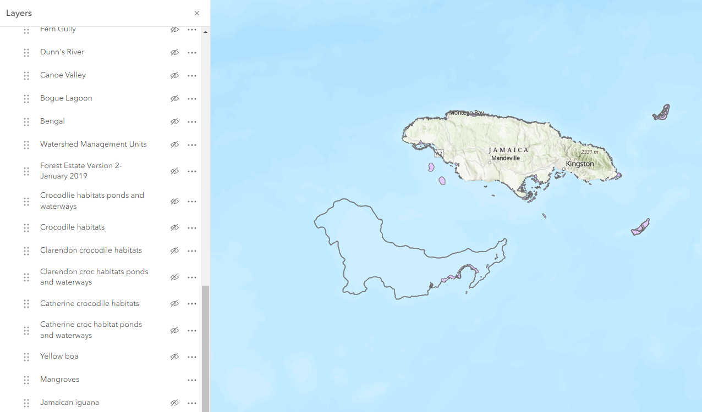
Figure 6. ESRI ArcGIS Online displaying some publicly available layers shared by the NEPA.

Global Biodiversity Information Facility (GBIF)
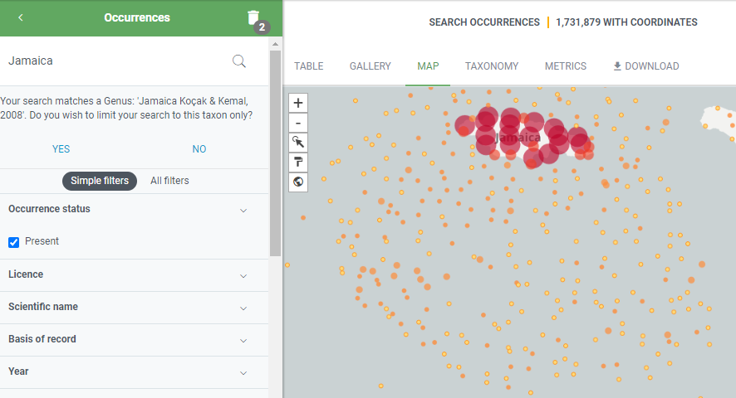
The GBIF represents an open-access international network aimed at providing biodiversity data. The GBIF network facilitates data sharing by providing an online platform in which diverse data sources can be queried and accessed. A query using the word “Jamaica” produced almost 2-million records with spatial information (latitude and longitude) that can be used as a starting point to document the presence of species of interest (e.g., birds, fish, invertebrates, plants, etc.).
Figure SEQ Figure \* ARABIC 7. Global Biodiversity Information Facility species occurrence datasets for Jamaica (Retrieved on June15, 2024).

Figure 7. The Global Biodiversity Information Facility.
Global Fishing Watch
Global Fish Watch is an open-access interactive online platform that provides spatial information related to human activities at sea. The platform provides tools for visualizing and analyzing vessel-based activity (Fig. 8), such as:
- Apparent fishing effort: Location of vessels are recorded using the automatic identification system (AIS). An AIS algorithm determines “apparent fishing effort” based on vessel speed and direction, which is visualized through a grid-based heat map.
- Radar vessel detections (SAR): Information about objects on the water (e.g., size, texture) are mapped using a radar imaging system.
- Vessel tracks and events: The platform also allows for the visualization of precise, high-resolution data that maps vessel tracks. Vessels are also searchable by name, source, flags, and dates active.
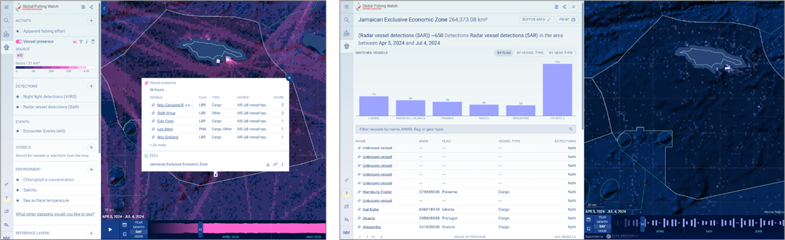
Figure 8. Global Fishing Watch platform. (On left) Heat map of vessel presence in Jamaica’s EEZ. (On right) Vessel detections based on Radar Imaging System for Jamaica’s EEZ.
Data in this application can also be analyzed and summarized based on a set layer (e.g., EEZ). Figure 8 shows a heat map of vessel presence in Jamaica based on AIS, but it has the capability to utilize other sources (e.g., radar imaging system) to detect and map the presence of vessels.
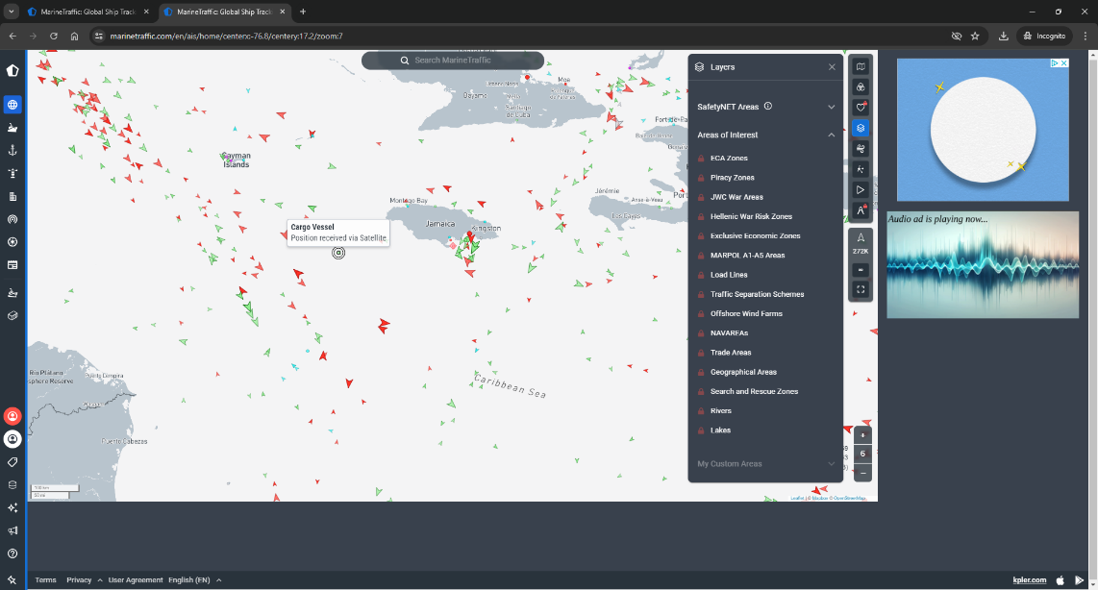
There are several commercial platforms for visualizing AIS vessel data. For example, Marine Traffic offers free visualization of near real-time vessel locations using their live map. However, ship details, tracking and maritime analytics are licensed and can only be accessed through one of their plans (monthly standard plan starts at $29 USD).

Figure 9. Marine Traffic viewer.
Figure 9. Marine Traffic platform. Live map.
Skylight
Skylight is an AI-driven program that provides tools to combat illegal fishing by providing visualization and analysis of vessel behaviors. Access to the software is controlled, but government, regional, and nongovernmental organizations can request free licensing. Some of the features of the software are:
- Vessel heatmap visualization
- Vessel detections (visualization and analysis) using different sources (i.e., satellite radar, optical imagery, and night lights). Provide information to identify fishing fleets and/or vessels potentially conducting abnormal or suspicious activity (AIS off).
- Standard rendezvous: potential transshipments and bunkering
- Vessel details
- Entry events: when a vessel’s AIS transmission is detected inside a user-defined area
- Fishing events: is generated when fishing behaviour (trawling, longlining, purse seining, and squid jigging) is detected in the tracks of an AIS vessel using an algorithm to produce the alerts.
- Speed range events: it monitors AIS vessels who meet certain speed parameters set the programmer
- In progress events
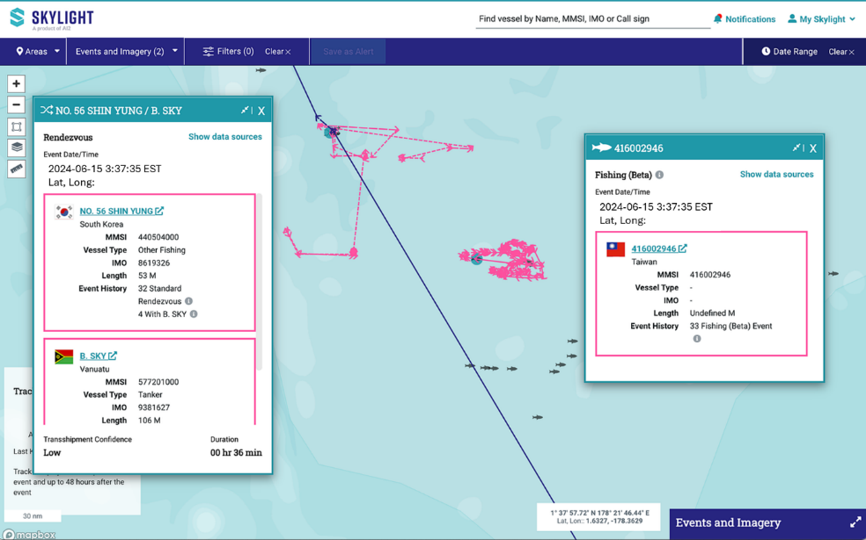

Figure 10. Skylight platform. Example of a rendezvous and fishing events detected by the program.

National Data Sharing Portals
National spatial data infrastructure (NSDI)
Jamaica’s government has a specific division mandated to provide and maintain GIS data as well as an online mechanism for data sharing —The Spatial Data Management Division.
“The Spatial Data Management Division has the responsibility for coordinating, implementing and managing national GIS programmes and projects. A part of its mandate is to establish a national spatial data infrastructure (NSDI) to improve access sharing and use of place-based data. A fundamental component of the NSDI is a mechanism that provides an electronic facility to search, view, transfer, order, advertise, and preserve geospatial data from numerous sources (government, the private and non- profit sectors and academia) through the internet. The efficient operation of the recently established geospatial and metadata portals are therefore important to the sustainability of the NSDI.”
However, the NSDI portal mentioned above was not found online. Searches included the terms “NSDI”, “Jamaica national spatial infrastructure”, so there is no evidence that this platform is currently available.
National Spatial Planning Information Technology (NSPIT) Platform
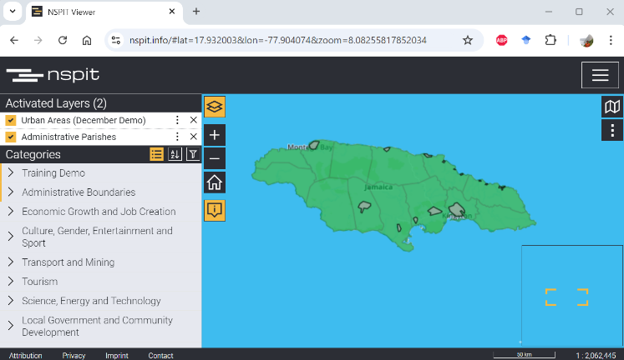
The Ministry of Housing, Urban Renewal Environment and Climate Change launched in 2021 the National Spatial Planning Information Technology (NSPIT) platform. Its objective is to function as Jamaica's spatial data infrastructure to improve decision making. It includes a viewer (http://nspit.licj.org.jm/) and a data portal (http://data.nspit.licj.org.jm/) interface.

Figure 11. The NSPIT viewer interface.
Although the platform was launched in 2021, it is currently (August 2024) only available as a demo and testing site. The exploration of the site in early June 2024 shows several issues with the platform. For instance, the NSPIT viewer was not working properly (the map area was not displaying any of the selected layers), although multiple categories were displayed, there was only a limited number of layers that were repeated through the categories, and although in their description the layer says that the data is downloadable, we couldn’t find a link to do so.

Nevertheless, this platform is still under development, and it is currently available at a limited capacity, but technicians are currently working on improving the site and once fully operational it will be an asset for spatial data sharing and the MSP process in Jamaica.

The Jamaica Clearinghouse Mechanism (JA CHM)
The Natural History Museum of Jamaica has developed and maintains the Jamaica Clearing House Mechanism (JA CHM). The site collates, distributes and exchanges data and information on biodiversity and its conservation in Jamaica. It was created to support national and international information that supports the United Nations Convention on Biological Diversity (CBD).
The current site was developed as a website application, and it does not contain tools for accessing spatial data. Furthermore, a disclaimer states that because the localities of endemic and endangered species are considered sensitive data, the site will not share that kind of information.
The site provides access to reports and documents, especially species presence lists in general (with no location data). Some tools and services offered by the site are still under development. Their data sharing agreement has been developed and easily accessed on the site.

Spatial layers in reports/peer-reviewed literature
A review of pertinent literature uncovered several references to spatial layers that might be useful for the MSP process in Jamaica. However, they were only available as images in reports and articles. These data are grouped based on topic (fishing grounds, nursing grounds, aquaculture, biological, and climate/hazard) and are described below:
FISHING GROUNDS —GENERAL
Status of the Jamaica Reef fishery and proposals for its management
Aiken & Haughton, 1987
“The physical characteristics of the island shelves affect the fishable resources. The north shelf of Jamaica is very narrow and nowhere exceeds 1.4 km in width before plunging vertically to deep (>100m) waters. This restricts the size of coral reefs and importantly, makes these smaller norther reefs very accessible due to their proximity to shore. The south shelf, on the other hand, measures about 24km at its widest point and provides considerably more fishable area. Pag. 470.”
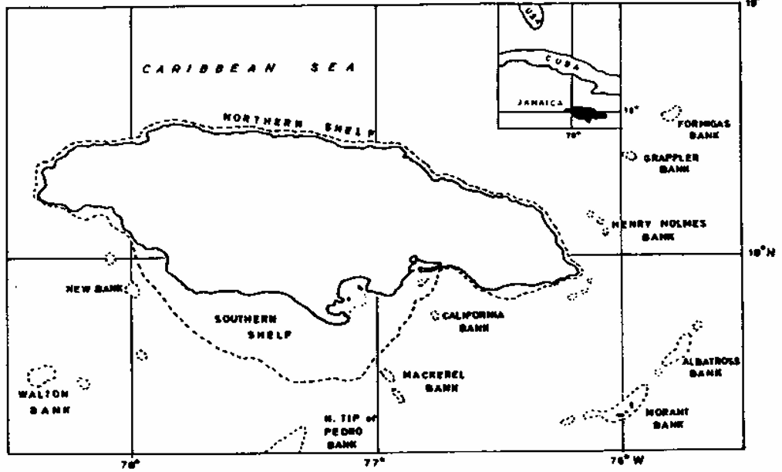  Fig. 1. Fishing areas of Jamaica and 200= isobath. | 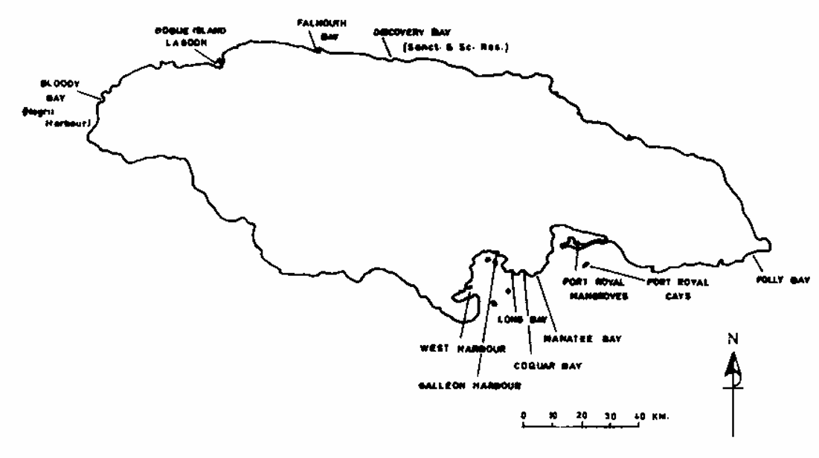  Fig. 7. Proposed fish sanctuaries and scientific reserves.

Economic production from the artisanal fisheries of Jamaica
Gustavson, 2002
Jamaican fisheries can be broadly classified into two sectors, the inshore fishery and the offshore fishery, operating within four distinct geographical regions —the north shelf, south self, small proximal banks, and the offshore banks (i.e., Pedro and Morant Banks.
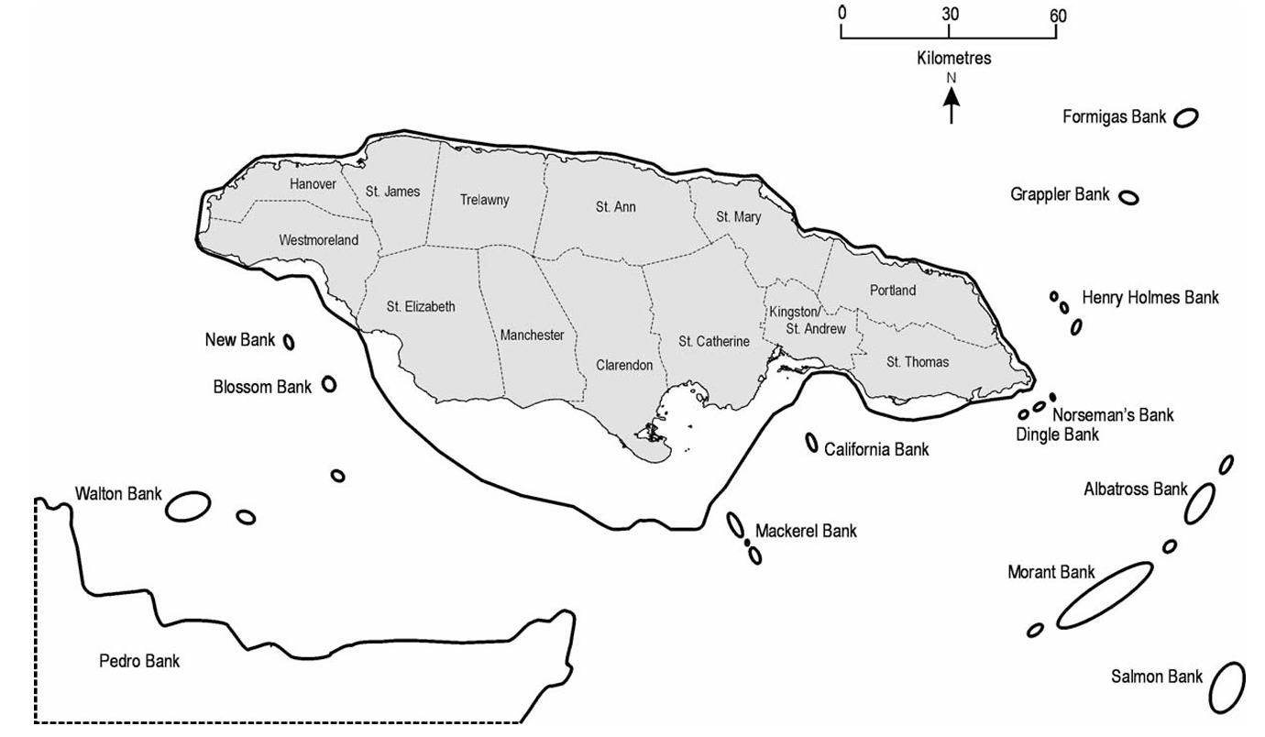  Fig. 1. Shel and banks, including the northern tip of the Pedro Bank, associated with the fisheries of Jamaica (adapted from Haughton, 1988; Espeut, 1992). | 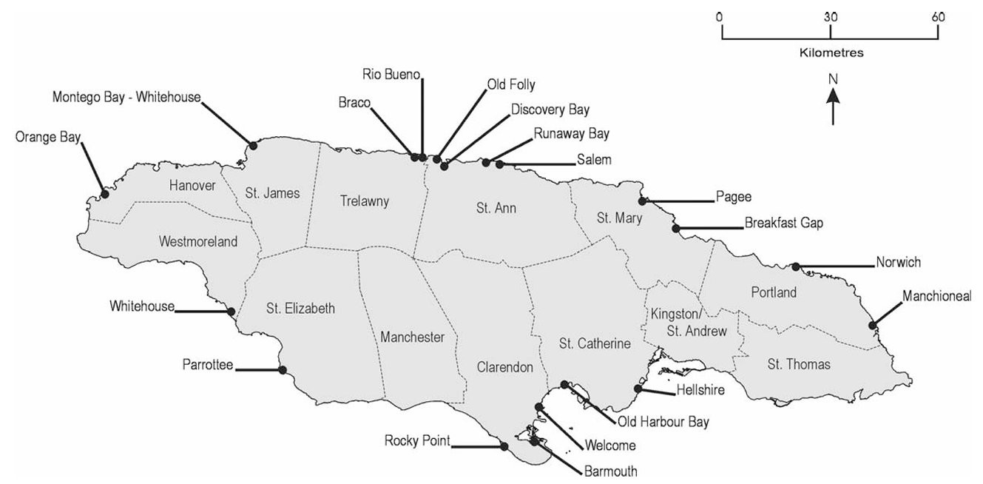  Fig. 2. Locations of landing sites surveyed for 1996 and/or 1997 catch and effort data collection program as conducted by the Fisheries Division, Government of Jamaica.

Technical summary of the Jamaica ecoregional planning (JERP) marine analysis  John et al., 2006  “The cost surface is analogous to a human footprint on Jamaica’s coastal and marine resources, indicating areas where we ‘tread’ lightly or more heavily…  …the higher the cost to the conservation target’s condition is, and therefore the higher the cost of doing environmental conservation and management in that area”.  Fig. 4. JERP Marine cost surface  including fishing pressure | 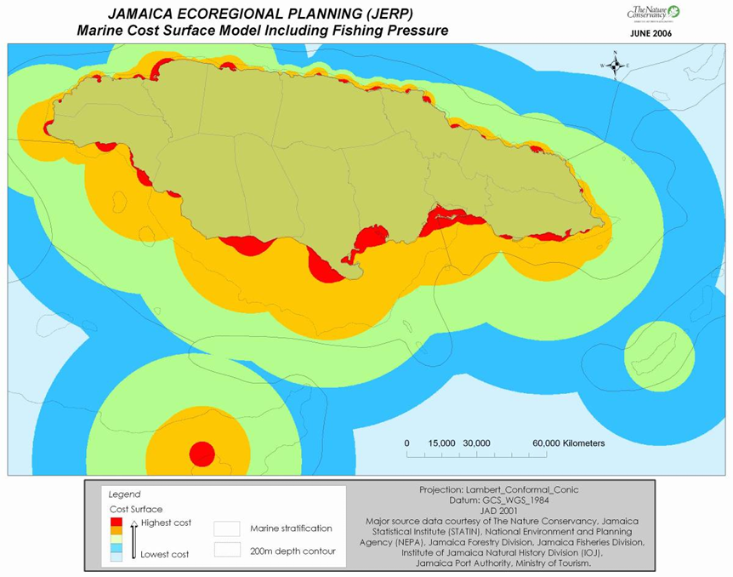

Marine Fisheries of Jamaica: total reconstructed catch 1950-2010.  Lingard et al., 2012  The study provides a description of fish species by region (north, south, and outer banks).  Fig. 1. Map of Jamaica and its EEZ.  Outer fishing banks are shown with dashes lines. | 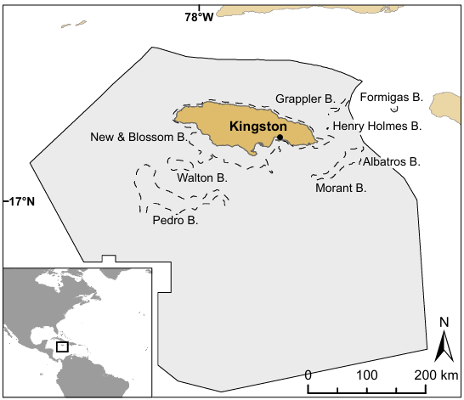

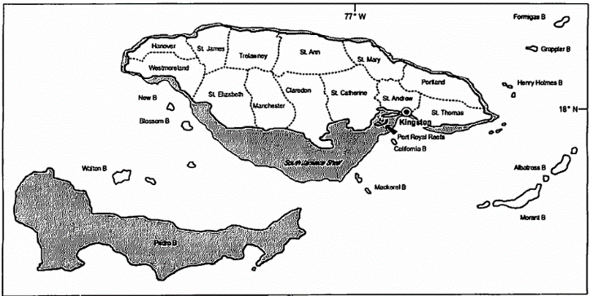
The marine fisheries of Jamaica
Aiken & Kong, 2000

General description of fish landings and characteristics of fishing areas.
“These vessels fished 300m deep baited longlines fitted with chemical lights, Pag. 32.”

Fig. 1. Main fishing ground around Jamaica.

Condition of reef fish on Jamaica's north coast signals late stages of overexploitation  Klomp et al., 2003  “Saba Bank, although regulated at the time of the survey in 1999, has experienced heavy fishing pressure from foreign fishing fleets in recent decades. Pag. 594.”  Fig. 7. Location of sites where the fleshy macroalgae index, herbivorous fish densities, and Diadema densities exceed mean values by more than 30%. | 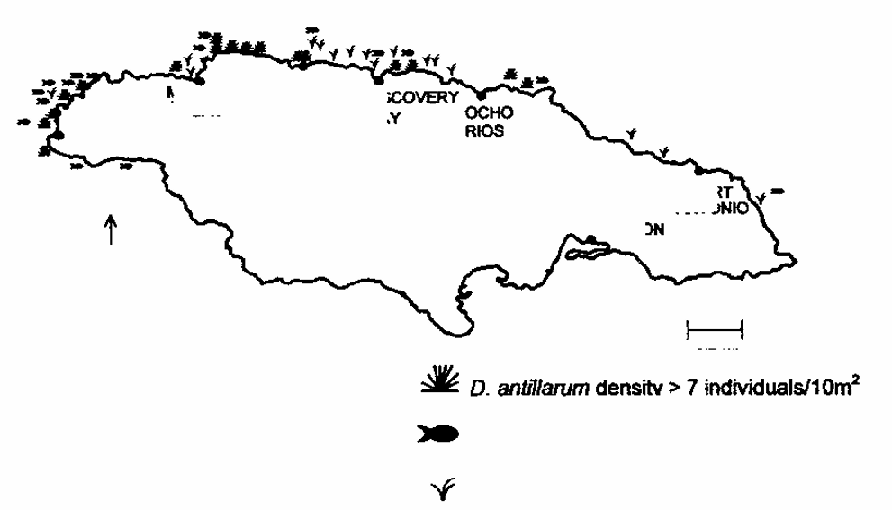

Status of the Morant Cays fishery; Jamaica's second largest offshore artisanal reef fishery  Pears & Zary 1987  “It is believed that the marine life of the banks are relatively little disturbed by human activities, and thus the area is considered important as a potential marine conservation site…  …The marine habitats of the Morant Cays provide an important refuge for many marine plants and animals that are increasingly threatened elsewhere in the region. Pag. 220.”  “The Morant Cays trap fishery appears to be very productive. Pag. 233.”  Fig. 1. Map of Morant Bank indicating fishing ground referred to in the text. Adapted from Admiralty Chart 255. 1979. | 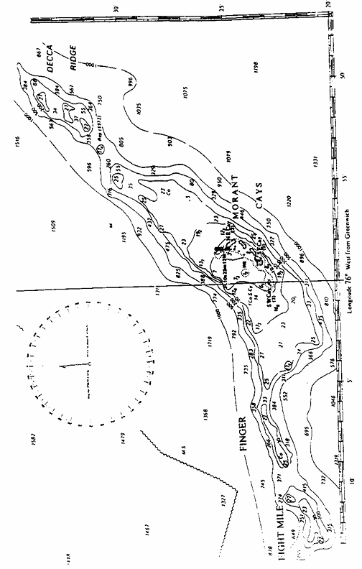

Introducing the 1998 marine fisheries census of Jamaica  Grant et al., 2003  Fig. 1. The distribution of mooring sites  for fishing vessels in Jamaica. | 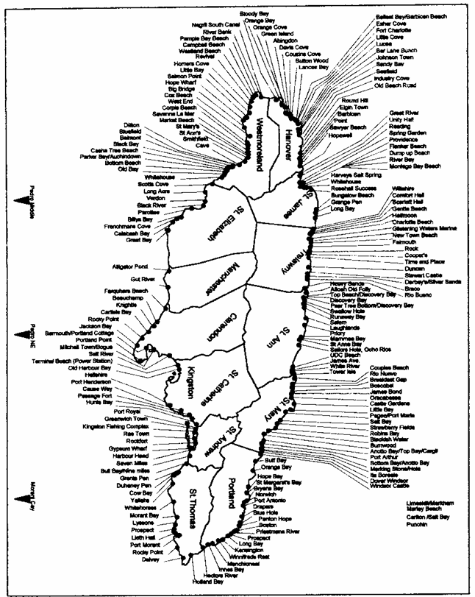

Artisanal fishing in Jamaica today: a study of a large fishing site
Murray & Aiken, 2006
Study describes landing sites at the Whitehouse fishing beach (700 fishers with 150 fishing vessels). It provides a general description of fishing areas.

“The main fishing areas are on the island shelf and on the nine small oceanic banks. Pedro bank is a larger oceanic bank that is 5,500 km2 in area and is to the southwest of Kingston. It is accessible to all larger south coast canoes, and many undertake the perilous, but profitable journey. On the eastern fringe of Pedro bank are three small sandy cays on which fishers reside, fishing and shipping their sorted catches mainly to Kingston, at regular intervals for most
of the year. Pag. 218.”
“Nearly 60% of all fishers operate on the south coast…
…Offshore, the major activities center on Pedro Bank… Pag. 219.”

Species composition, abundance and catch rates of fish caught on the Formigas Bank, Jamaica  Grant 2001  Species composition, abundance and catch rates by gear on the Formigas Bank.  Fig. 1. Map of Jamaica showing extent of shelf areas and position of proximal oceanic bank (Source Munro, 1983). | 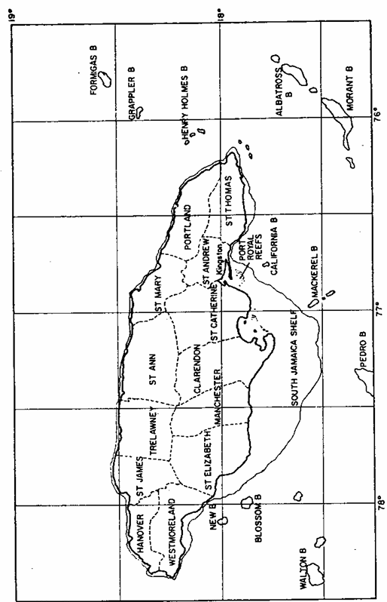

Spearfishing as a potential threat to fishery sustainability in Jamaica: a survey of 23 fishing beaches  Ennis & Aiken, 2014  “The largest banks that are utilized as fishing grounds are Pedro Bank and Morant Bank. Pag. 141.”  Fig. 1. Major fishing areas of Jamaica. The island shelf consisting of the very narrow northern and much wider southern portions, small nearshore banks, and offshore areas including Pedro Bank (bottom left) and Morant Bank (center right). | 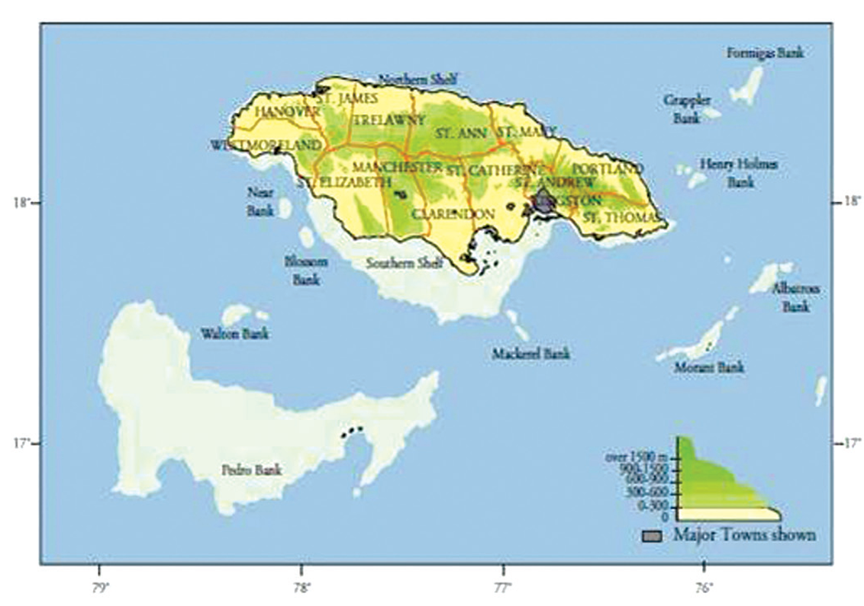

Consulting services for the assessment of the potential for and development of management plan for artisanal longline fishing for offshore pelagics. Pelagic Fisheries Management Plan
Pearce et al.
“Based on the surface longline catches from all available sources as well as known artisanal pelagic fishers the most productive fishing areas known at present are:
• Morant Bank waters (offshore)
• Southern Pedro Bank (offshore)
• Deep water near to Montego Bay, St. James, (north coast)
• Waters off Pagee (near Port Maria), St. Mary (north coast)
• Areas near several small offshore banks off St. Elizabeth (southwest coast)
• Waters near small offshore banks off Westmoreland (southwest coast) and
• Waters off Manchioneal, Portland (north-eastern Jamaica).”

FISHING GROUNDS —SPINY LOBSTER
A bioeconomic analysis of the Jamaican industrial Spiny lobster (Panulirus argus) fishery.
Morris et al., 2010
“The Jamaican spiny lobster stock is concentrated mainly on the offshore banks and to a lesser extent on the island shelf; commercially viable quantities can be found particularly on the Pedro Bank, Morant Bank and Formingas Bank (Haughton and King 1992).”

FISHING GROUNDS —CONCH
The status of the conch fishery on the shelf and banks off the south coast of Jamaica  Mahon et al., 1999  “Most of the conch currently exported from Jamaica appears to be harvested from Pedro Bank (Pag. 956)”  Fig. 1. (a) Offshore banks in the area of Jamaica.  (b) The south self; (c) Pedro Bank (Munro, 1983). | 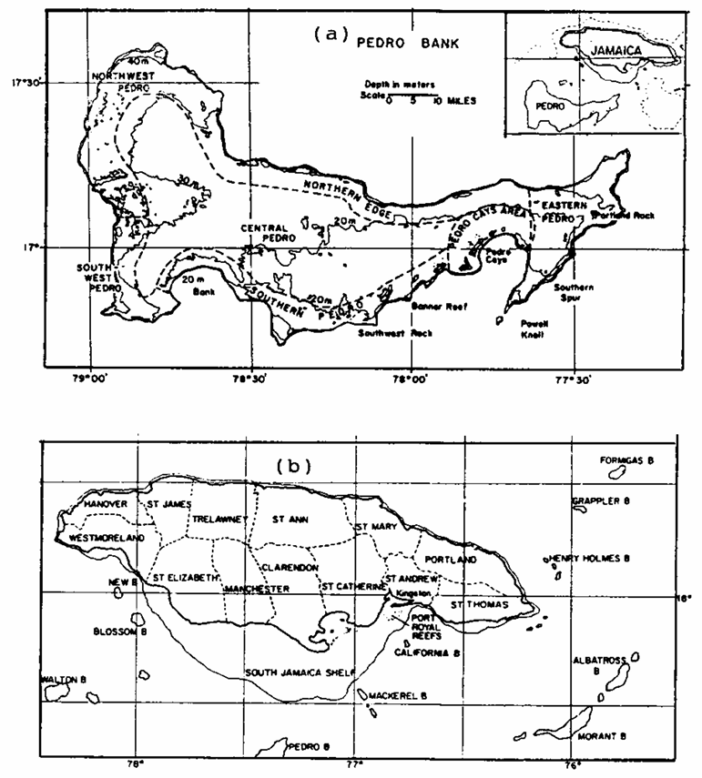

Managing Jamaica's queen conch resources  Aiken et al., 2006  “The main problems are overfishing by licensed fishers who take more than permitted, and serious poaching by industrial vessels mainly from Honduras, which exploit poor high seas enforcement by Jamaican authorities.”  Fig. 1. Map of Jamaica showing insular shelf to 200 m, proximal bank and the major conch fishing ground, Pedro Bank, to southwest. | 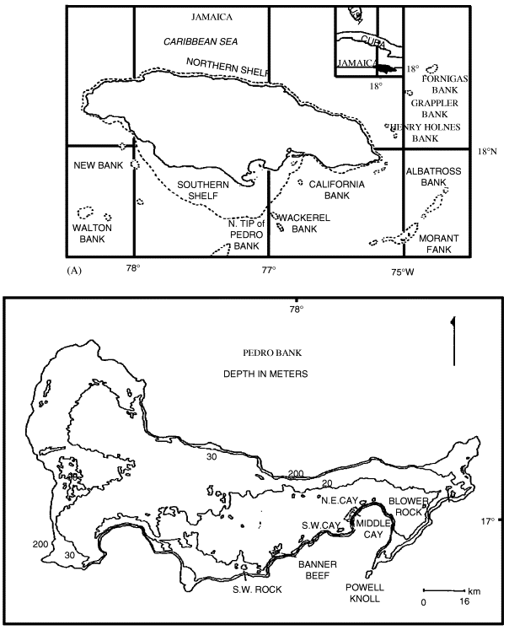

NURSING GROUNDS
Preliminary assessment of nearshore fishable resources of Jamaica's largest bay, Portland Bight, Jamaica  Aiken et al., 2002  General description, Sampling areas Portland bight and Old Harbour Bay.  "Despite limited sampling, it was apparent that some areas functioned as critical nursery areas for many species and that the entire area as a whole, appeared to function as a giant nursery for many useful species".  Fig. 1. A. Map of Jamaica showing 100m depth contour and proximal oceanic bands; B. Portland Bight and Old Harbour Bay sampling sites. | 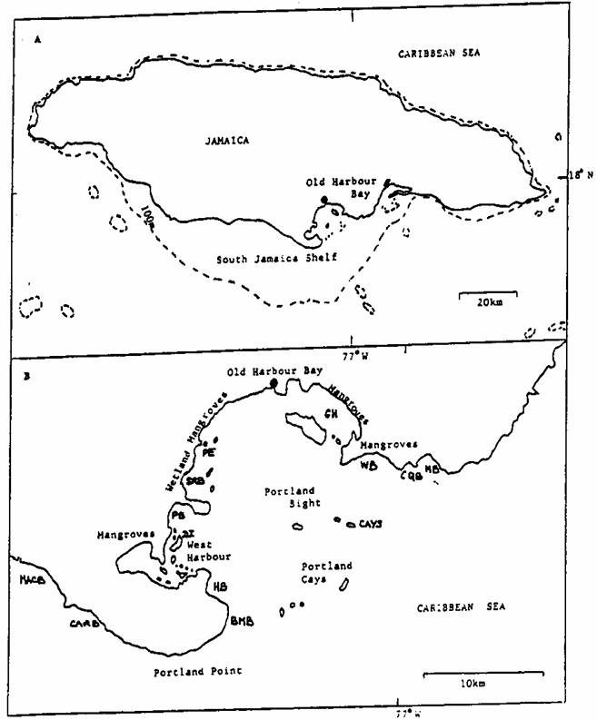

Out mitigation and movement of tagged coral reef fish in a Marine Fishery Reserve in Jamaica  Munro 2000  “The Discovery Bay Fishery Reserve serves principally as a nursery habitat for coral reef fish. Pag. 557.”  Fig. 1. Discovery Bay, Jamaica, showing the  location of the Discovery Bay Fishery Reserve. | 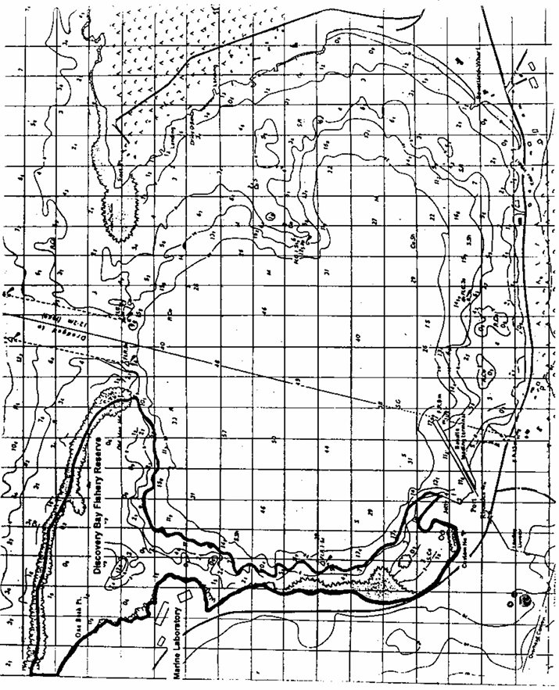

Biological evidence of diminished nursery capability in Discovery Bay, Jamaica  Quinn & Kojis, 2004  The study identified Discovery Bay as a nursery ground for many important fisheries species —diminished nursery capability.  Fig. Map of Jamaica and sampling sites around Discovery Bay. | 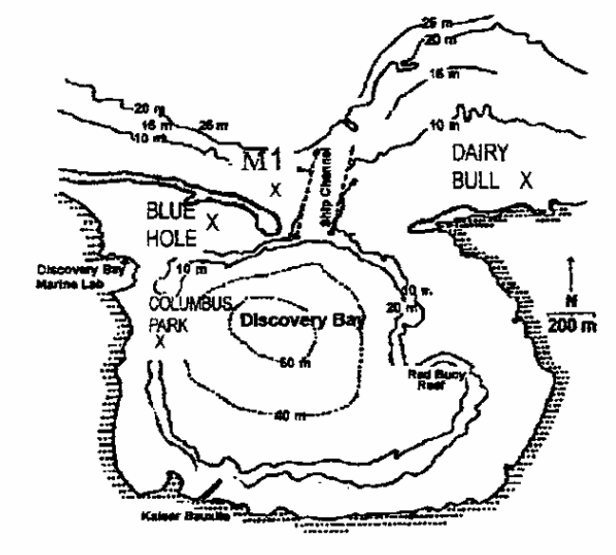

Nursery grounds for fishable species in Kingston Harbour, Jamaica: do they still exist?  Aiken et al., 2009  “All of the six stations sampled functioned as nurseries for all of the 21 fish species identified, based on their small (juvenile) size distribution and repeated presence over the two-year duration of the study. Slightly higher species diversity was found at the two stations nearest the harbor mouth. Notably, all six stations also functioned as refugia for invertebrates such as crabs, and urchins, suggesting that they are important in sustaining the stability and health of the food chains in the harbor near Port Royal at the very least, and possibly for the entire harbor. Pag. 358.” | 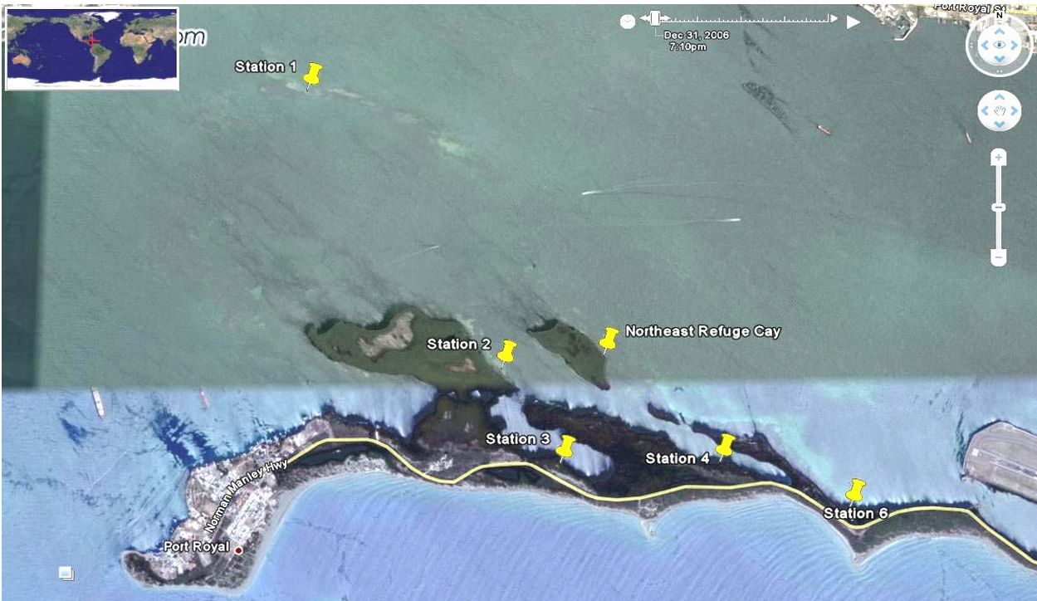  Fig. 2. Satellite image of the location of the six sample stations (yellow pins) used in the present study showing Kingston Harbour, with Port Royal left and tip of Manley International airport runway at bottom far right. Northeast refuge Cay in centre, is Station 5.

AQUACULTURE
Subtidal culture of the mangrove Oyster, Crassostrea rhizophorae, in Jamaica  Richards, 1992  “The number of bays suitable to oyster culture is limited by freshwater inflows and pollution. At Bowden in Port Morant, St. Thomas ideal conditions were identified (Pag. 363).”  Fig. 1. Map of Jamaica and site of oyster cultivation. | 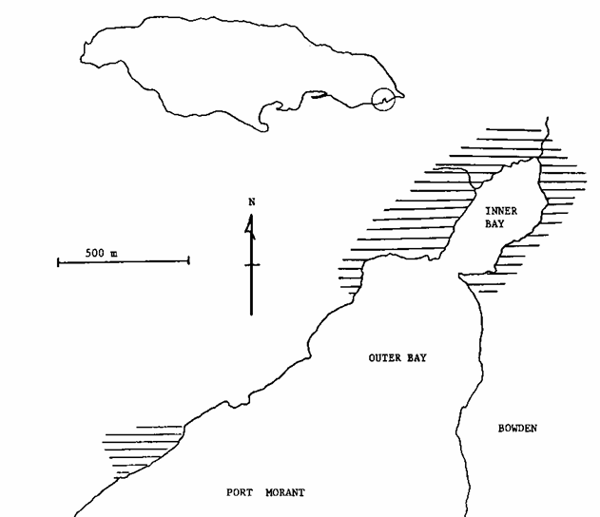

Tilapia farming in Jamaica  Chakalall & Noriega, 1992  Distribution (parish resolution) and surface area is provided in table 2.  Table 2. Distribution and surface area of fishponds by parish (1986). The information of this table can be used to produce a map of fishponds by parish. | 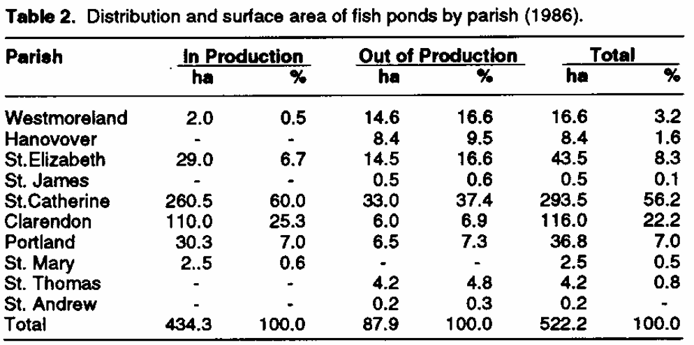

Potential for mariculture in Jamaica
Haughton & King, 1992
“The prospects for mariculture in Jamaica look good. There are several shallow, sheltered, bays and inlets along the coast that appear to be suitable for mariculture…the shallow coastal waters of the south coast, which has many sheltered bays and inlets, and suitable climatological and hydrological features provide the most suitable sites for mariculture. Pag. 436-437.”
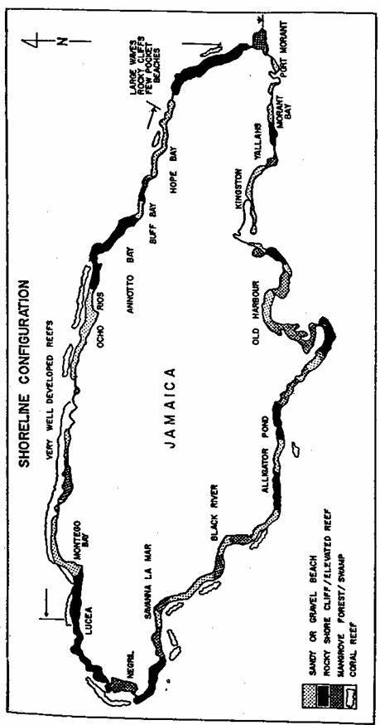
Fig. 2. Jamaica’s shoreline configuration 1987

Mariculture draft policy and regulations  Natural resources Conservation Authority and Coastal Zone Management Division, 1998  Appendix 2 listed potential sites for mariculture development for oyster culture, cage finfish culture and seamoss culture. | 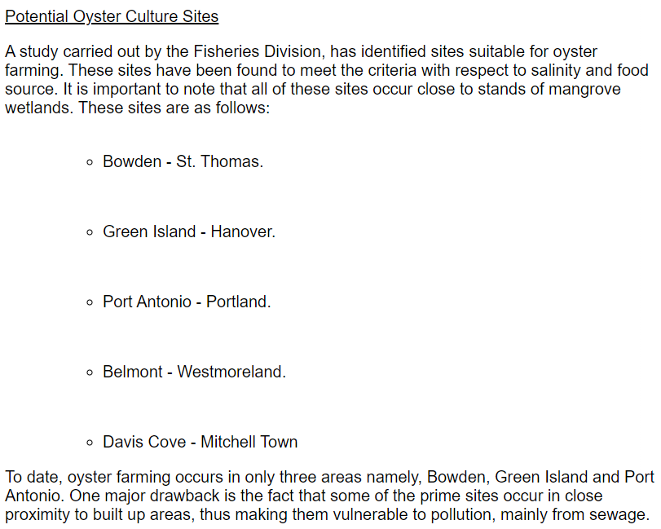

BIOLOGICAL
Coral reef health status report for Jamaica 2020  NEPA  The coral reef health index scores are grouped using coarse spatial details (e.g., parish, park, conservation areas). The report does not contain any maps and there is no spatial information for the reef assessment sites (GPS coordinates).  Table 1. CRHI for 2020 by reef assessment sites and locations | 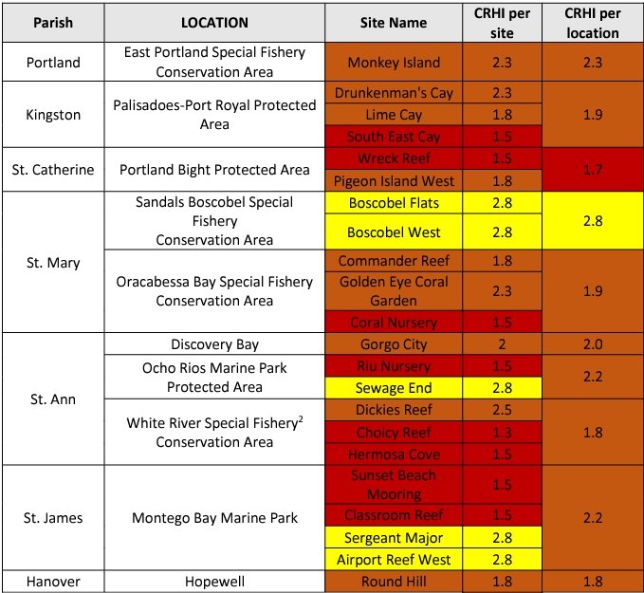

Rapid ecological assessment of the Montego Bay Marine Park, Jamaica: evaluation of marine parks as marine fisheries reserves  Sullivan et al., 1999  The study describes benthic habitat based on five areas.  Fig. 1. Map of Montego Bay, Jamaica. The Rapid Ecological Assessment of the Park divided the bay into five areas:  1)North Airport, 2) Core reefs and beaches, 3) Seawind island, 4) Bogue sound and 5) Western reefs. | 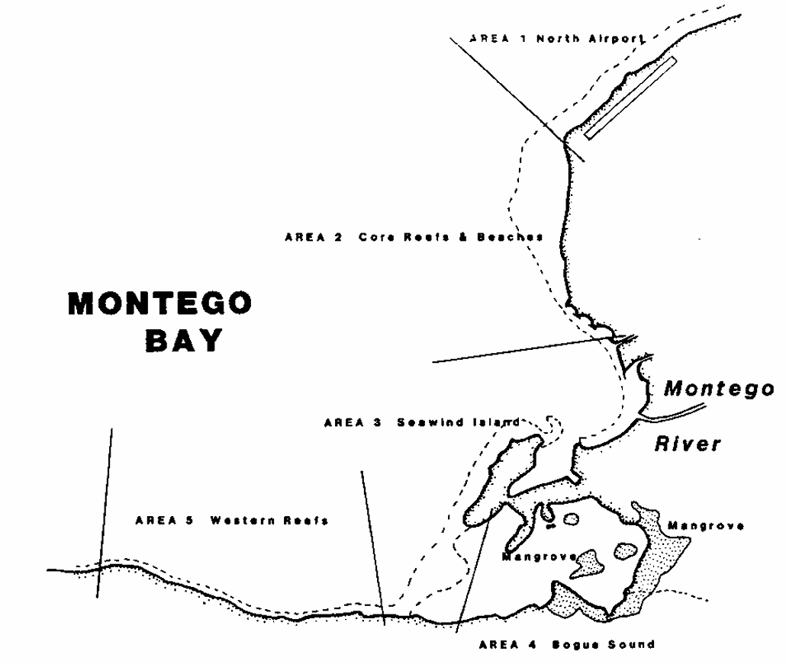

Benthic mapping of the Bluefields Bay fish sanctuary, Jamaica
McIntyre 2015
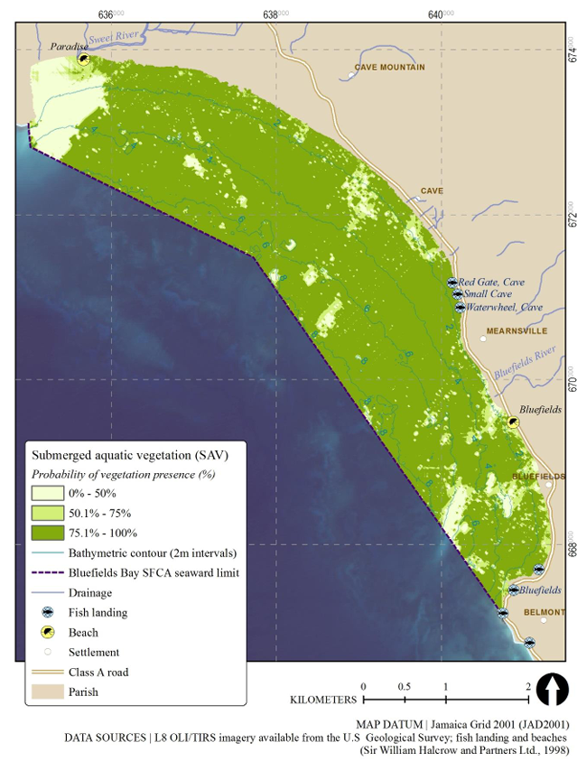  Fig. 26. Probability of SAV presence across the BBSFCA | 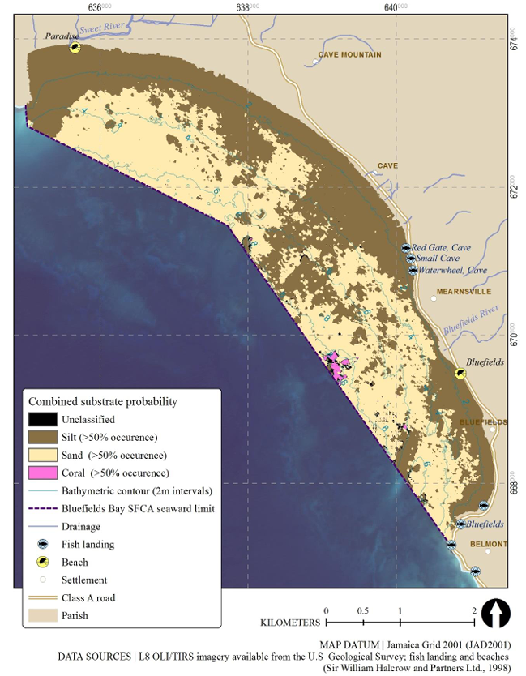  Fig. 30. Combined probability of bottom substrates across the BBSFCA. Unclassified accounts for areas having <50% occurrence of silt, sand or coral, or areas having >50% probability of two or more substrate classes.

Genetic composition of queen conch (Lobatus  gigas) population on Pedro Bank, Jamaica and  its use in fisheries management  Blythe-Mallett et al., 2021  Fig. 1. Map of Pedro Bank. (a.) Highlighting location approximately 80 km SW of mainland Jamaica with major contour lines demarcating Artisanal zone (0–10 m) and Industrial Fishing zone (11–20 m).  (b.) VSD Monitoring zones 1–5 established across the bank for management purposes and straddling the depth zones 0–10 m in yellow (artisanal zone), 11–20 m in blue (industrial zone) and the 21–30 m zone in red. (c.) Sampling locations within monitoring zones. Three sets of samples were located in zone 1 as differentiated by shades of green triangles. Diamond shapes were representative of samples in zone 3 while zones 2, 4 and 5 were grouped into one sample set (star shapes). (a) Adapted from Appeldoom (1995) while (b and c) were produced using ArcGIS ver. 10.3.1. | 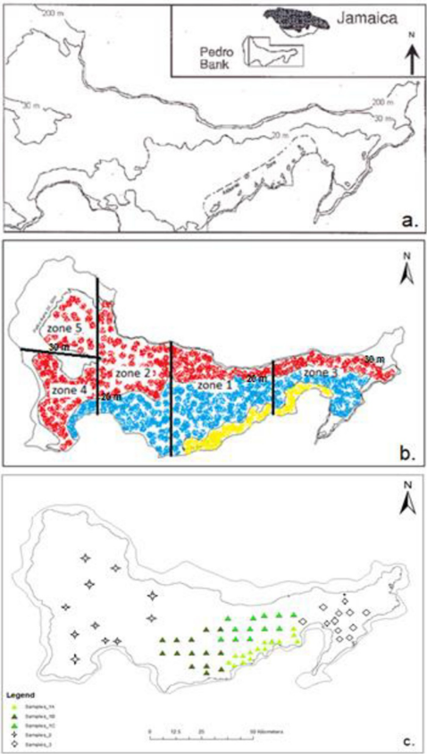

Modelling the spatial population structure and distribution of the queen conch, Aliger gigas, on the Pedro Bank, Jamaica
Morris et al., 2022
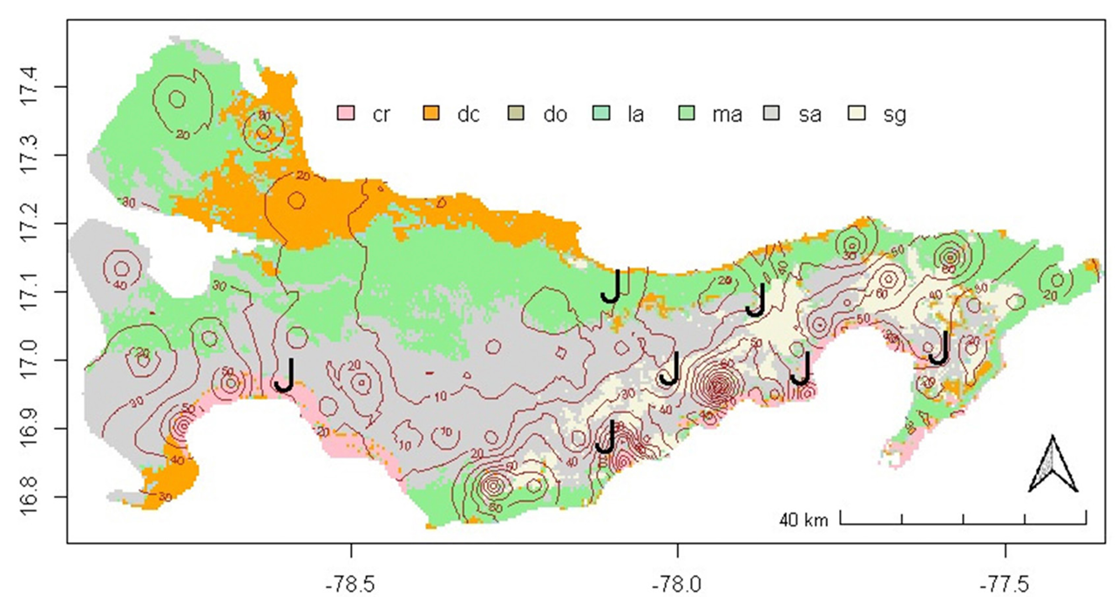
Fig. 6. Habitat map of the Pedro Bank based on Baldwin (2015) overlaid with predicted adult abundance distribution 2015 (isolines) and the relative location of high-density juvenile patches (“J”). Abundance isolines units are in the number of conches per pixel. cr, coral reef; dc, deep coral; do, deep ocean; la, land; ma, macroalgae hardground; sa, sand and sediment; sg, seagrass.

The egg trace method of identifying diamondback squid fishing grounds in Jamaican waters  Aiken et al., 2007  “Possible fishing areas for this squid would be somewhere along the red line. Pag. 268.”  Fig. 1. Map of fishing ground where fishing  took place in the first phase of exploratory survey. | 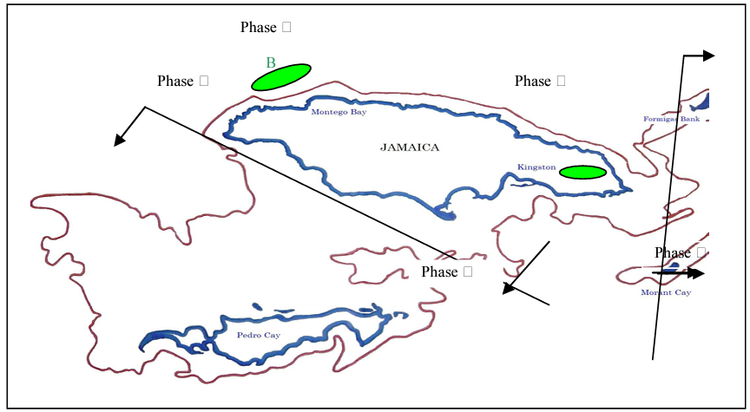
Habitat Preference in the Invasive Lionfish (Pterois volitans/miles) in Discovery Bay, Jamaica: Use of GIS in Management Strategies  Lee et al., 2011  Map. Lionfish refuges around the island of Jamaica. |  | 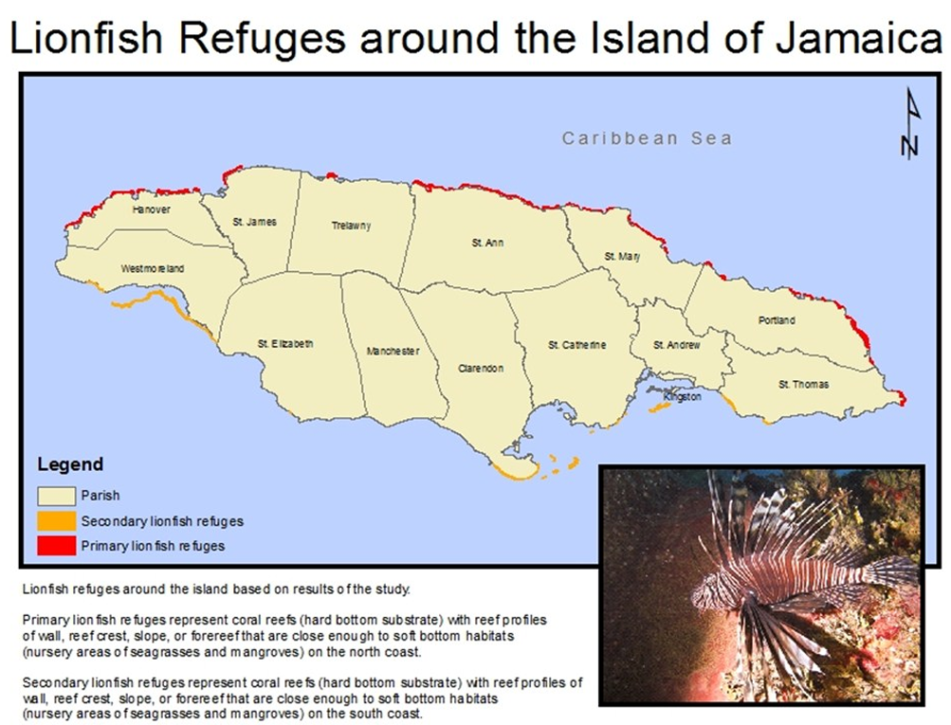

Review of biological data, spatial distribution of the stocks and ecological connectivity between areas beyond national jurisdiction and exclusive economic zones in the Western Central Atlantic Fishery Commission Region
Arocha et al., 2024
The document contains maps of the distribution of several commercially important fishes in the region, including Jamaica. It is a recent publication, and there is potential for requesting these spatial layers. Some examples are:
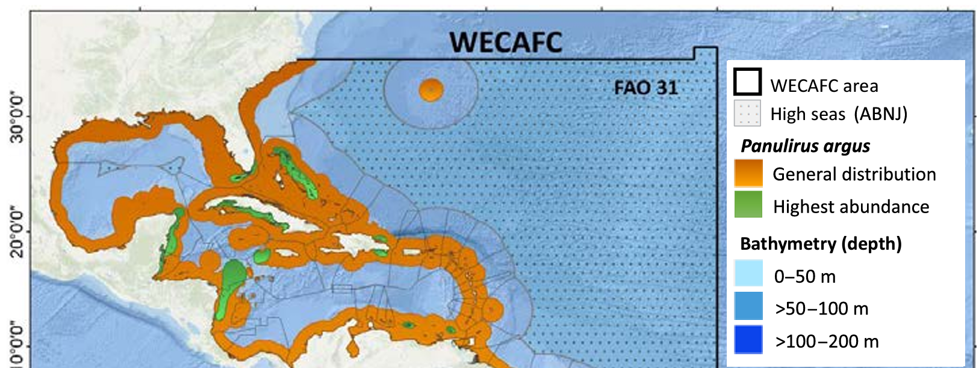 | 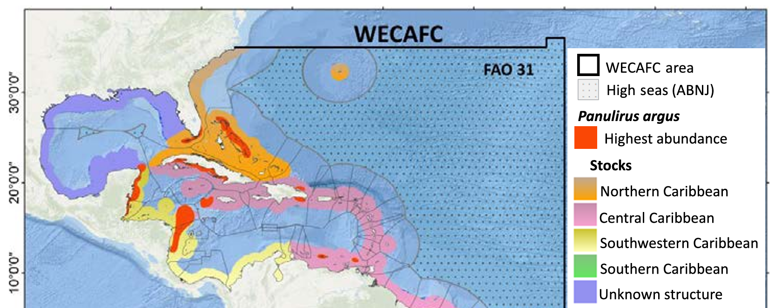
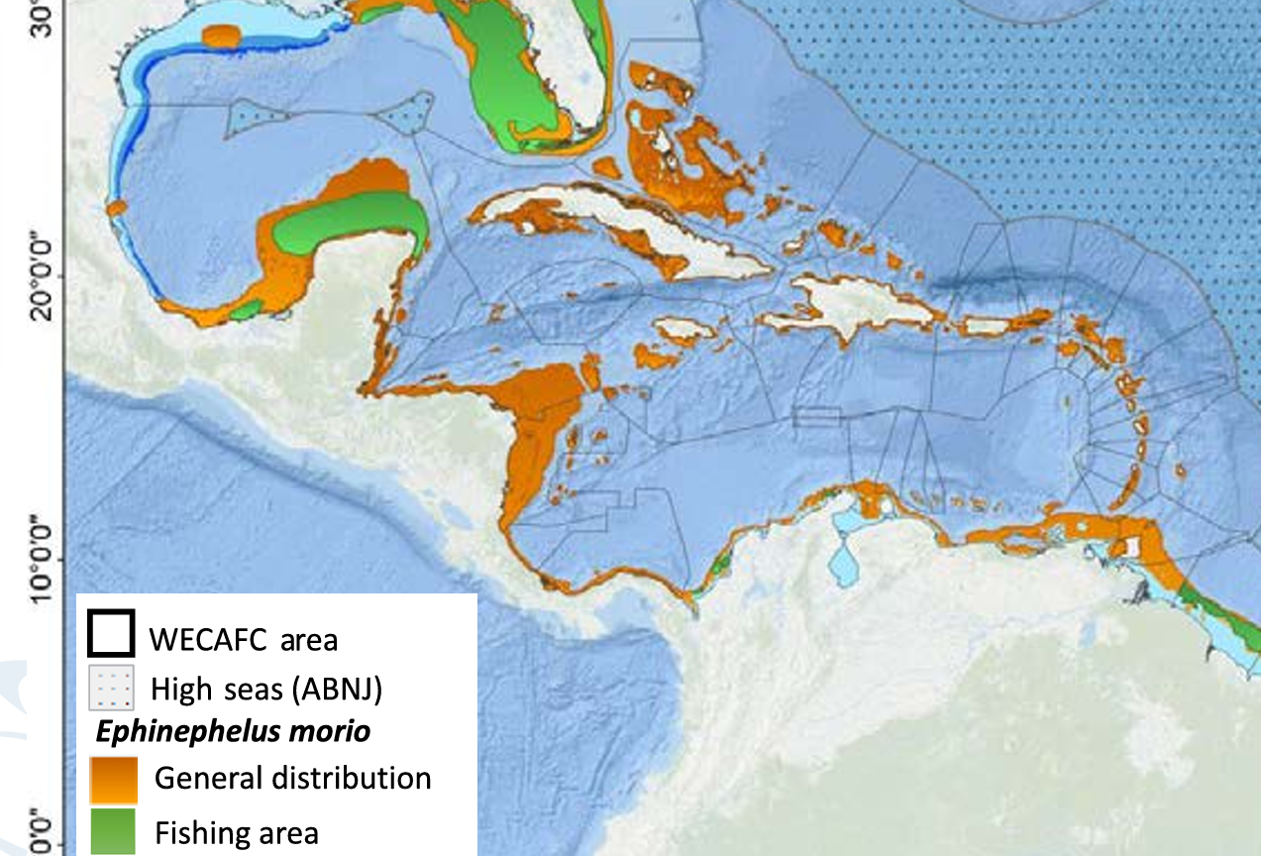 | 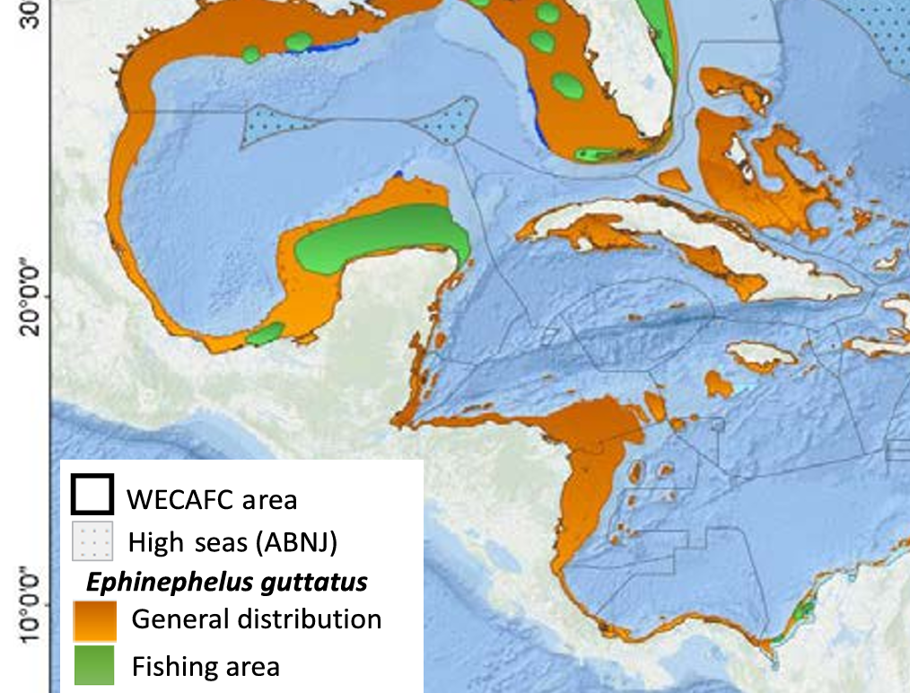

Sea turtle nesting in the Wider Caribbean region—Jamaica sea turtle habitat
Eckert & Eckert 2019
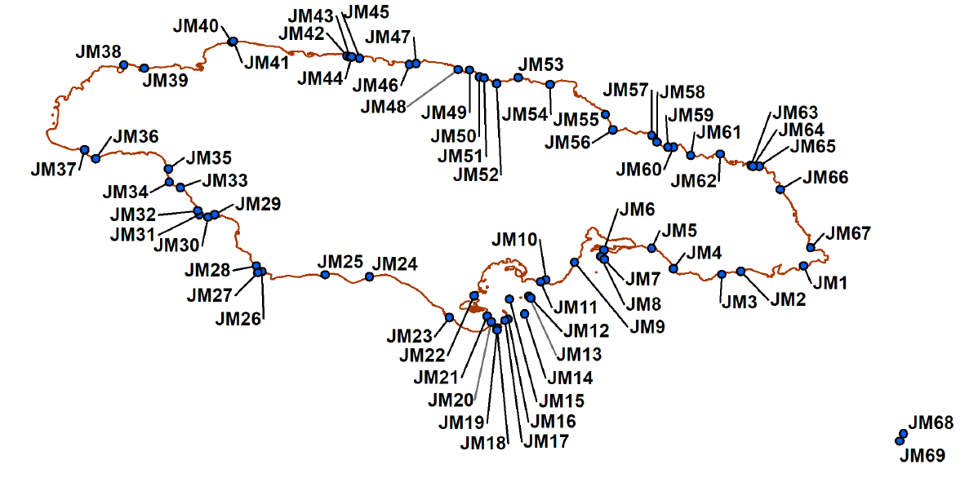  Sea turtle nesting habitat (source: NEPA) | 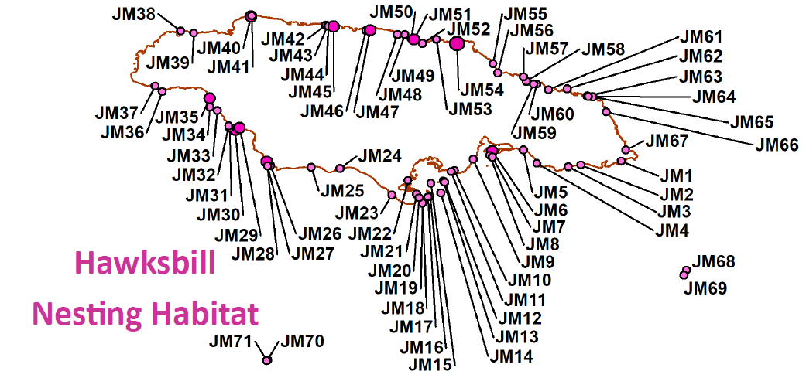
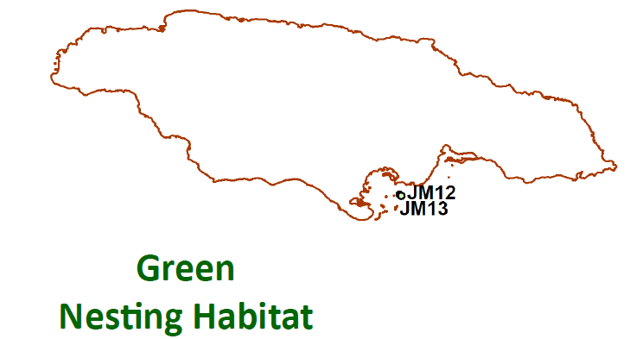 | 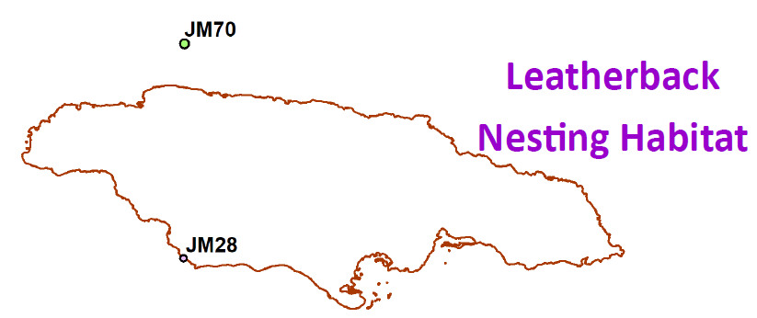

Distributions of the Hawksbill Sea Turtle (Eretmochelys imbricata) in the Western Atlantic Inferred from Satellite Telemetry
Maurer & Eckert, 2024
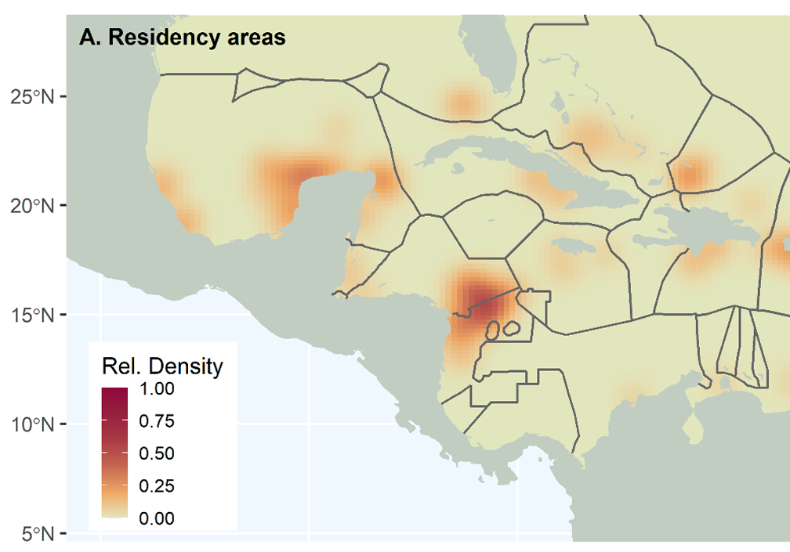 | 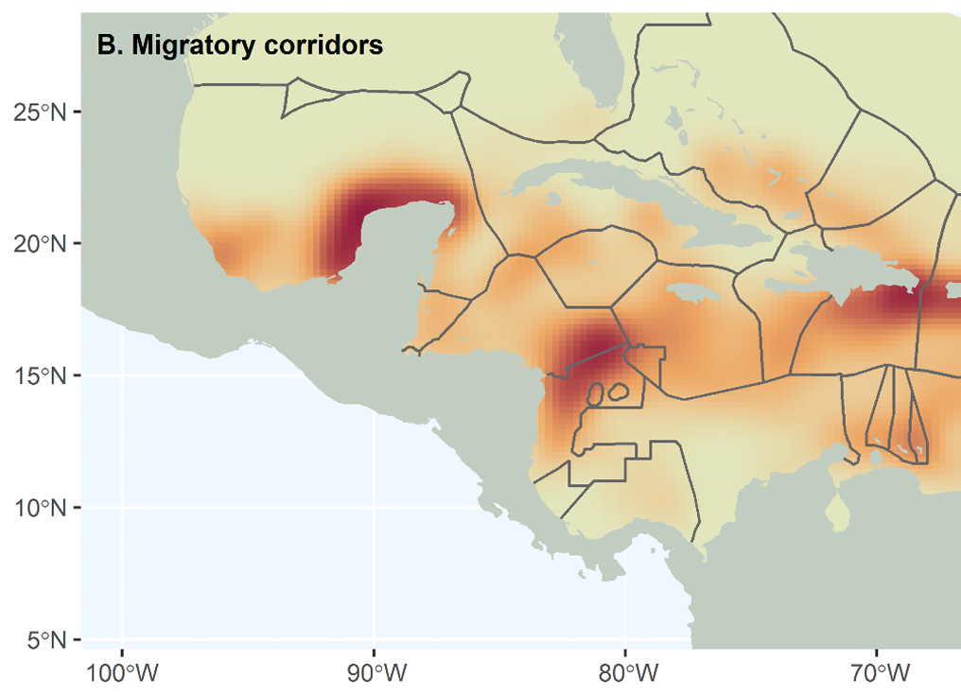
Fig. 10. The distribution of residency (putative foraging) (A) and migratory corridor densities (B) for hawksbill sea turtles (Eretmochelys imbricata) in the Wider Caribbean Region in relation to maritime boundaries. Gray lines show EEZ.

CLIMATE/HAZARD
A coastal and social vulnerability assessment to climate hazards in Jamaica.
Palmer 2017
Table 5. Vulnerable coastal towns.  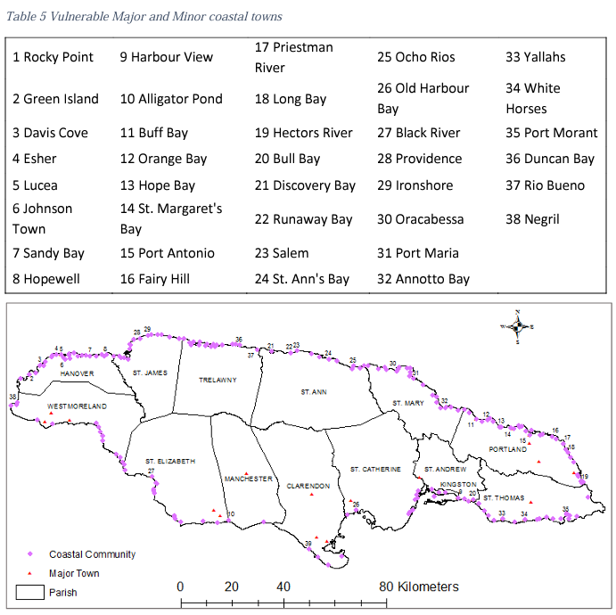  Fig. 6. Location of major coastal towns. | 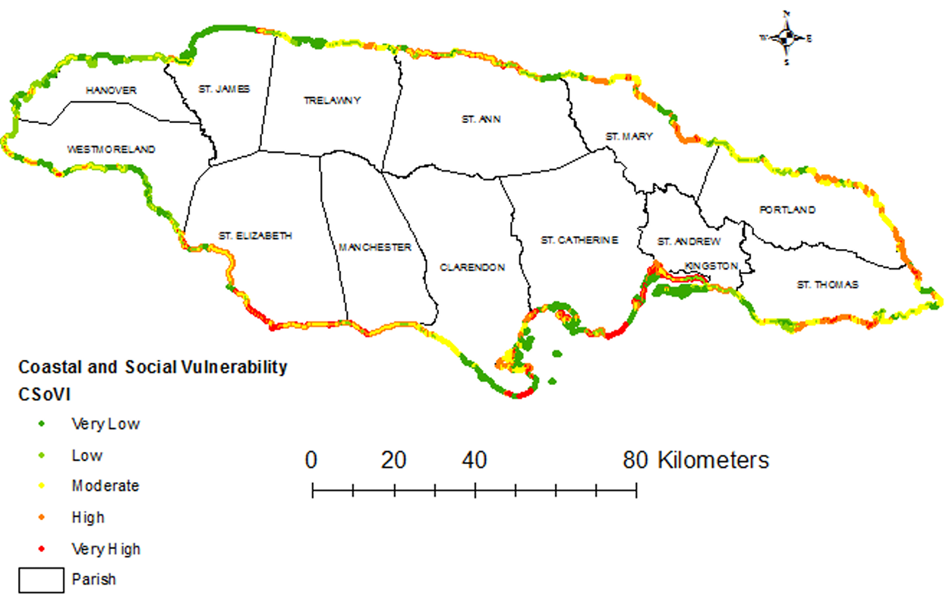  Fig. 12. Overall vulnerability (CSoVI).

Shoreline Solutions: Guiding Efficient Data Selection for Coastal Risk Modeling and the Design of Adaptation Interventions —Case study: Old harbour Bay, Jamaica
Acosta-Morel et al., 2021
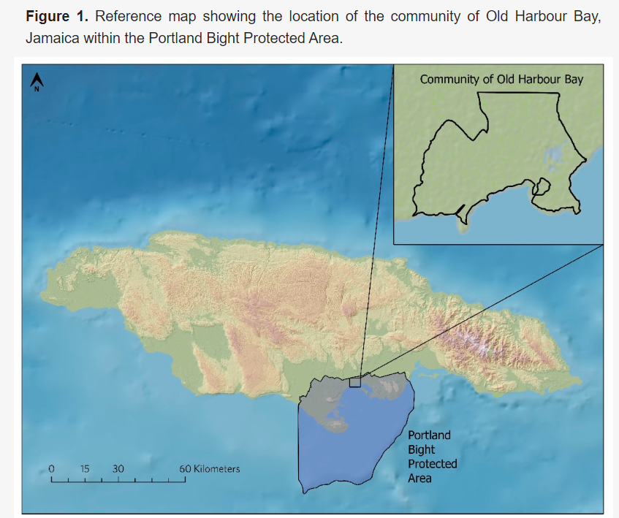  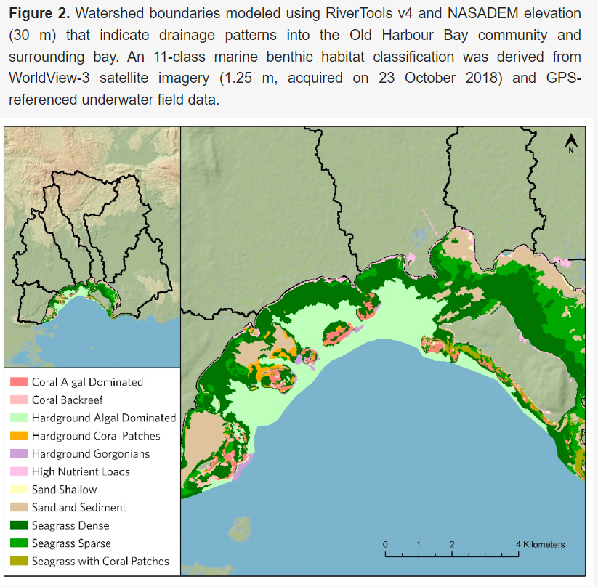 | 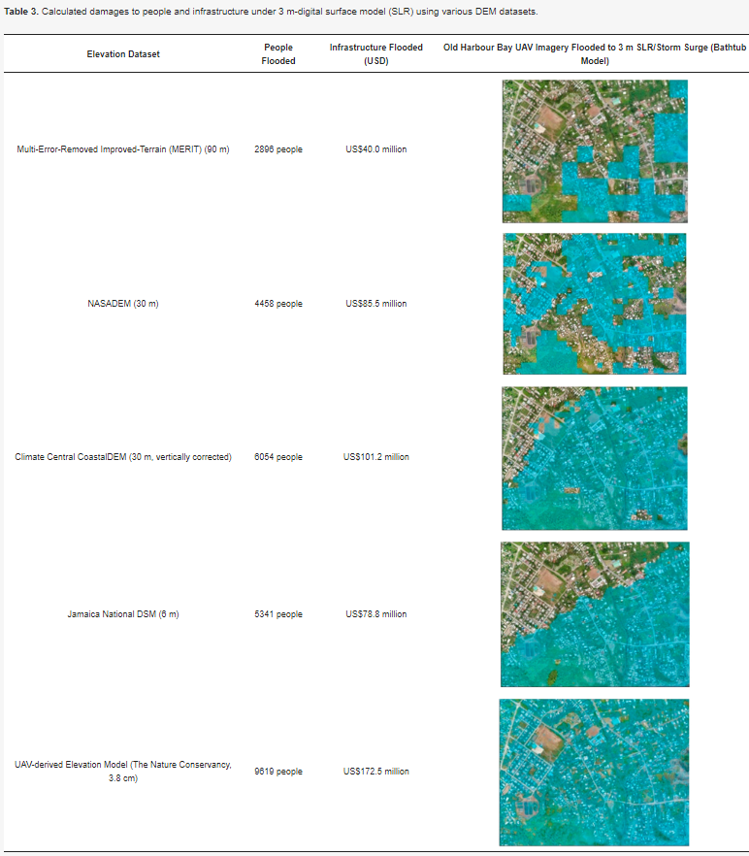

Coastal Capital: Jamaica  The economic contribution of Jamaica’s coral reefs  World Resources Institute  Map 2. Relative shoreline protection  from coral reefs in Jamaica. | 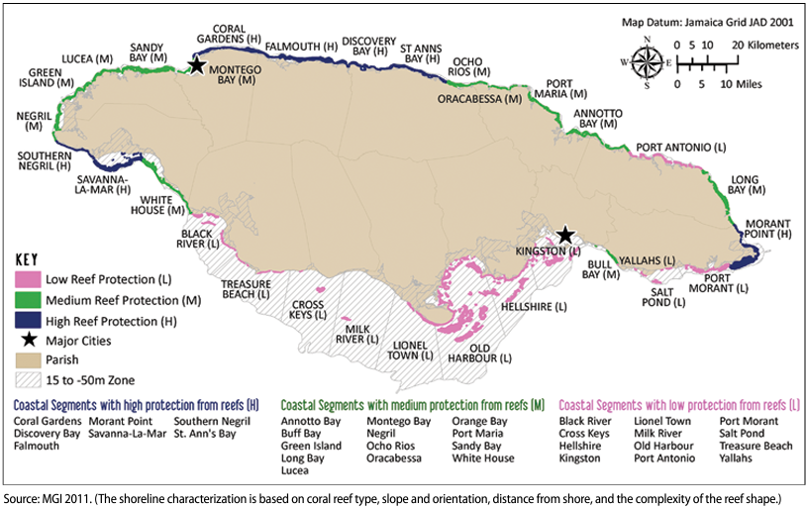

The Caribbean Pilot Programme for Climate Resilience (PPCR) Programme — Regional Track System  MEGJC  Main objectives:  - To improve regional processes to acquire, store, analyze access and disseminate climate relevant data  - To pilot and scale up innovative climate resilient initiatives in the region | 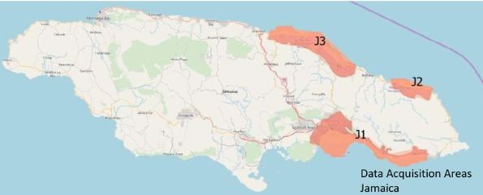Map. Lidar and aerial imagery for coastal zones: Kingston-Moran Bay, Port Antonio-Fairy Hills, and Ocho Rios-Annoto Bay.

Summary of available data
Based on the sources previously described, Table 3 lists the different layers found grouped by relevant MSP themes and with reference to where each layer was found (its source). Where possible, a link to an online source is included.
Table 3. Available data with its source. Unless mark as PDF, data is available in spatial format (e.g., shapefile, geotiff, etc.).
DATA | Source
Boundaries
Country | NFA; ArcGIS Online
Administrative divisions (parish) | NFA; ArcGIS Online
Territorial Sea | NFA; ArcGIS Online
EEZ | NFA
MPAs (Knowles et al., 2015) | The Caribbean Science Atlas
Protected Areas (Land Information Council of Jamaica) | NFA
Protected/Managed areas (TNC, 2022) | The Caribbean Science Atlas
Special Fishery Conservation Area (SFCA) | NFA
MPA —Designated, proposed, and nearshore environment | The Caribbean Science Atlas
Watershed Management Units (NEPA) | NEPA; ArcGIS Online
Watershed (Land Information Council of Jamaica) | NFA
Fisheries
Coral reef fisheries relative catch (2014) | Resource Watch
Ocean areas expected to have high impact from human (2018) —areas of the oceans predicted to be most- impacted by human stressors. | Resource Watch
Coral Reef Fisheries: Modeled Fish Catch from the World's Coral Reefs | Mapping Ocean Wealth
Potential mariculture sites for oyster, cage finfish, and seamoss (PDF) | NEPA
Tilapia ponds | NFA
General fishing grounds (PDF) | Aiken & Haughton, 1987; Gustavson, 2002; Lingard et al., 2012; Aiken & Kong, 2000; Klomp et al., 2003; Pears & Zary 1987; Murray & Aiken, 2006; Ennis & Aiken, 2014
Fishing grounds spiny lobster (PDF) | Morris et al., 2010
Fishing grounds conch (PDF) | Mahon et al., 1999; Aiken et al., 2006
Landing sites | NFA
Landing sites (PDF) | Gustavson, 2002; Grant et al., 2003
Nursing grounds (PDF) | Aiken et al., 2002; Munro 2000; Quinn & Kojis, 2004; Aiken et al., 2009
Aquaculture (PDF) | Richards, 1992; Chakalall & Noriega, 1992; Haughton & King, 1992
Fishing events (based on AIS, SAR) | Skylight
Marine cost surface including fishing pressure (PDF) | Jamaica Ecoregional Planning
Fishing vessel characteristics (# of registered vessels by year/fishing category/parish) (PDF) | NFA Jamaica Fisheries Quarterly Statistics reports
Fisher licenses (by year, parish) (PDF) | NFA Jamaica Fisheries Quarterly Statistics reports
Estimated marine fish production (based on landing sites and individual beaches) for artisanal finfish, sea cucumber, industrial conch and industrial spiny lobster (weight and value) (PDF) | NFA Jamaica Fisheries Quarterly Statistics reports
Aquaculture production (tilapia). Information is estimated based on registered producer. (PDF) | NFA Jamaica Fisheries Quarterly Statistics reports
Fisheries socio-economic data (fishers age and gender) (PDF) | NFA Jamaica Fisheries Quarterly Statistics reports
Biological
Benthic habitat (regional, 4m) (Schill et al., 2021) | The Caribbean Science Atlas
Benthic habitat – Pedro Bank (TNC, 2014) | ArcGIS Online
Benthic habitat – Portland (TNC, Alligator Head Foundation, 2019) | ArcGIS Online
Benthic habitats (PDF) | Sullivan et al., 1999; McIntyre 2015
Oracabessa Fish Sanctuary (TNC, 2017) | ArcGIS Online
Coral reefs (NEPA) | NEPA; ArcGIS Online
Coral reef health index 2011-2020 (PIOJ) | ArcGIS Online
Coral refugia ranking (Chollett et al., 2022) | The Caribbean Science Atlas
Larval connectivity (Schill et al., 2015) | The Caribbean Science Atlas
Tidal Marsh Distribution (Global tidal marshes, 2020) | Mapping Ocean Wealth
Mangroves (Schill et al., 2023) | The Caribbean Science Atlas
Mangroves (NEPA) | NEPA; NFA; ArcGIS Online
Mangrove area (Spalding et al., 2012) | The Caribbean Science Atlas
Mangrove change 2013–2018 —NVDI analysis on Landsat 8 data | The Caribbean Science Atlas
Mangrove 2019-2021 (TNC) | ArcGIS Online
Mangrove Blue Carbon —Aboveground (Simard et al. 2019) | Mapping Ocean Wealth
Mangrove Blue Carbon: Soil Organic Carbon (Sanderman et al., 2018) | Mapping Ocean Wealth
Aboveground mangrove biomass density (2014) | Resource Watch
Seagrass (points & polygons) (2018) | Resource Watch
Seagrass points and polygons | Resource Watch
Seagrass area (CLME, 2013; UN, 2003) | The Caribbean Science Atlas
Seagrass (MacDonald 2017) | ArcGIS Online
Wetlands (2004) | Resource Watch
Ramsar Sites (wetlands) (PIOJ) | ArcGIS Online
Reef area (CLME, 2013; WRI, 2011) | The Caribbean Science Atlas
Coral reefs (NEPA, TNC) | NEPA; NFA
Global coral reef habitat (Spalding et al., 2001) | Mapping Ocean Wealth
Coral reef locations | Resource Watch
Coral reef connectivity (2011) | Resource Watch
Weekly bleaching alert (7-day maximum) (2024) | Resource Watch
Onset of 10x per decade severe coral bleaching conditions | Resource Watch
Global observations of coral disease (1970-2010) and coral bleaching (1963-2012) | Resource Watch
Historical coral bleaching stress frequency 1958-2018 | Resource Watch
Projection for future global coral reef bleaching events during the decades 2030 and 2050 | Resource Watch
Local threats to coral reefs. Estimated threat to coral reefs from combined local activities such as development, pollution and fishing | Resource Watch
Endangered species critical habitats (2019) – Alliance for Zero Extinction | Resource Watch
Crocodile habitats | NEPA; NFA; ArcGIS Online
Crocodile habitats and waterways | NEPA; NFA; ArcGIS Online
Conch distribution Pedro Bank (PDF) | Blythe-Mallett et al., 2021; Morris et al., 2022
Diamondback squid (PDF) | Aiken et al., 2007
Lionfish distribution (PDF) | Lee et al., 2011
Fish distribution (PDF) | Arocha et al., 2024
Fish occurrence | Global Biodiversity Information Facility
Sea turtles (PDF) | Eckert & Eckert 2019;Maurer & Eckert, 2024
Birds’ occurrence | Global Biodiversity Information Facility
Mammals’ occurrence | Global Biodiversity Information Facility
Manatee sightings (PDF) | Jamaica Ecoregional Planning
Seabird nesting and roosting areas (PDF) | Jamaica Ecoregional Planning
Overwintering shorebird areas (PDF) | Jamaica Ecoregional Planning
Oceanographic
Chlorophyll-a concentration (1/4 degree) (updated weekly) | Global Fishing Watch
Salinity (1/12 degree) (updated daily) | Global Fishing Watch
Chlorophyll-a concentration (2024) | Resource Watch
Bathymetry (2019) | Resource Watch
Bathymetry | NFA
Significant wave height (2021) | Resource Watch
Sea surface temperature (Callejas et al., 2022) | The Caribbean Science Atlas
Sea surface temperature (1/20 degree) (updated daily) | Global Fishing Watch
Sea surface temperature —27 SST monitoring sites (PDF) | NEPA
Water clarity (Callejas et al., 2022) | The Caribbean Science Atlas
Global tidal range (Aviso+) | ArcGIS Online
Bay coves | NFA
Land
The biodiversity intactness map (2005) shows global estimates of how land use pressures have affected the numbers of species and individuals found in an area. | Resource Watch
Sentinel-2 (10m) Land use/land cover time series 2017–2021 | The Caribbean GeoPortal
Land spatial planning (NEPA) | ArcGIS Online
The Protected Areas System Master Plan 2013-2017 (NEPA, NRCA, GOJ) | ArcGIS Online
Species (Jamaican hutia, iguana, yellow boa, crocodiles, swallowtail kite) (NEPA) | ArcGIS Online
Climate adaptation/Hazards
Beach erosion sites | NFA
Beach erosion (2017) | NEPA
Shoreline changes (monitored in 5 main beaches) | NEPA
Major flood prone communities | NFA
Landslide historical events 1895 to 2009 | NFA
Landslide vulnerability | NFA
Hazard multi variable model | NFA
Coastal protection (Beck et al., 2022) | The Caribbean Science Atlas
Coastal inundation (TNC) | ArcGIS Online
Ecosystem services and natural resources valuation (report includes seagrass beds, coral reefs, and mangrove values) (PDF) | ECONEXUS 2020
Relative value of coral reef shoreline protection (2014) | Resource Watch
Landslide hazard alerts (2024) | Resource Watch
Peatlands (2018) | Resource Watch
Predicted soil erosion prevalence (2020) | Resource Watch
Historical cyclone intensity (1970-2009) | Resource Watch
Projected ocean acidification | Resource Watch
Cumulative climate impacts on marine ecosystems (2017) | Resource Watch
Projected sea level rise 2100 (2013) | Resource Watch
Flood extent (2007 projections + 3m sea level rise) | The Caribbean Science Atlas
Number of people avoiding damage from flooding per decade (Burke and Spalding, 2022) | Mapping Ocean Wealth
Economic values (GDP - PPP) protected from flooding per decade (Burke and Spalding, 2022) | Mapping Ocean Wealth
Infrastructure/NTL protected from flooding per decade | Mapping Ocean Wealth
Fringing reefs providing protection to people (Burke and Spalding, 2022) | Mapping Ocean Wealth
Fringing reefs providing protection to economic values GDP-PPP | Mapping Ocean Wealth
Fringing reefs providing protection to infrastructure/NTL (Burke and Spalding, 2022) | Mapping Ocean Wealth
Coral Reef Coastal Protection Annual Expected Benefit to People (No.) | Mapping Ocean Wealth
InVEST Hazards – Wind and Wave Index | Mapping Ocean Wealth
Flood portal (several years, locations) (GOJ) | ArcGIS Online
Beach erosion sites (NEPA) | ArcGIS Online
Coastal and social vulnerability (PDF) | Palmer 2017
Coastal risk modelling Old Harbour Bay (PDF) | Acosta-Morel et al., 2021
Relative shoreline protection from coral reefs (PDF) | World Resources Institute
Lidar and aerial imagery for coastal zones: Kingston-Moran Bay, Port Antonio-Fairy Hills, and Ocho Rios-Annoto Bay (PDF) | The Caribbean Regional Track of the PPCR Programme
Transportation
Commercial shipping lanes | Resource Watch
Cruise ports | Resource Watch
Major ports | Resource Watch
Heatmap of vessel presence (based on AIS) (near real-time) | Global Fishing Watch
Heatmap of vessel detections (based on SAR) (near real-time) | Global Fishing Watch
Vessel tracks and events (near real-time) | Global Fishing Watch
Mooring sites (NEPA) | NEPA; NFA; ArcGIS Online
Shipping activities at Jamaica’s Ports (total vessel visits by major facility and port of call, cargo and miscellaneous vessel visits to the major ports, cruise ship, passenger and crew by port of call, total cargo handled at Jamaica) (PDF) | The Port Authority of Jamaica (monthly statistical reports)
Tourism
Dive snorkel sites | NFA
Value of coral reef tourism (2012) | Resource Watch
Coral Reef Tourism Value (Total) (Spalding et al., 2017) | Mapping Ocean Wealth
Coral Reef Tourism Visitation Value (Total) (Spalding et al., 2017) | Mapping Ocean Wealth
Mangrove Tourism (Spalding and Parrett, 2019) | Mapping Ocean Wealth
Coral reef tourism value (on reef) (Spalding et al., 2017) | Mapping Ocean Wealth
Coral reef tourism value (reef-adjacent) (Spalding et al., 2017) | Mapping Ocean Wealth
Tourism value (Spalding et al., 2017) | The Caribbean Science Atlas
Total stop over arrivals by country of residence 2018–2022 (PIOJ) | ArcGIS Online
Jamaica travel guide (Owner:s1093359_ZGIS) | ArcGIS Online
Ports of entry (Owner:s1093359_ZGIS) | ArcGIS Online
Beach locations (GOJ, 2022) | ArcGIS Online
Beach locations 2019 (NEPA) | NEPA; ArcGIS Online
Beach locations | NFA
Tourism statistics (passengers by airport, purpose of trip, expenditure, cruise visitors) (PDF) | Tourism Analytics &  Jamaica Tourist Board
Visitor by resort region and accommodation type (PDF) | Jamaica Tourist Board
Energy
Global power plants by fuel type and capacity. Includes coal, oil, gas, hydro, nuclear, solar, waste, wind, geothermal, and biomass. | Resource Watch
Surface geology –Caribbean region (French & Schenk, 2011) | ArcGIS Online
Geology | NFA
Security/enforcement
Vessel detections —based on AIS, SAR (identification of fishing fleets and/or vessels potentially conducting abnormal or suspicious activity) | Skylight
Rendezvous events (potential transshipments and bunkering) | Skylight
Entry events (when a vessel’s AIS transmission is detected inside a user-defined area) | Skylight
Speed range events (it monitors AIS vessels who meet certain speed parameters set the programmer) | Skylight
Police stations (GOJ) | NFA; ArcGIS Online
Compliance statistics based on inspections at fishing beaches, marinas, restaurants, tournaments, seafood stores, rivers, fish farms, supermarkets, and wholesales. (PDF) | NFA Jamaica Fisheries Quarterly Statistics reports
Pollution
Hazardous waste material | NFA
Hazardous waste facilities (NEPA) | NEPA; ArcGIS Online
Global estimate of river plastic discharge into the world’s oceans for 2010 | Resource Watch
Suspended matter concentration (2024). Concentration of inorganic particulate matter in seawater, which is a measure of turbidity, i.e. nontransparency | Resource Watch
Pourpoints transporting nitrogen from wastewater to coastal ocean (2015) | Resource Watch
Wastewater plumes in coastal areas (2015) | Resource Watch
Surface concentration of nitrate in seawater —monthly average (2024) | Resource Watch
Surface concentration of phosphate in seawater —monthly average (2024) | Resource Watch
Surface concentration of dissolved oxygen —monthly average (2024) | Resource Watch
Pollutant release and transfer register 2018 (NEPA) | ArcGIS Online
Other
Estimated residential population (2020) | Resource Watch
Residential settlements | NFA
Jamaica average household size (2022) | The Caribbean GeoPortal
Population (WoldPop, 2016) | The Caribbean Science Atlas
Urban areas industrial | NFA
Cattle density (2010) | Resource Watch
Critical facilities — water/waste treatment, cell towers, electric, airport etc. (Open Street Map and TNC, 2019) | The Caribbean Science Atlas
Community facilities —religious, hotel, tourism, heritage (TNC, 2006) | The Caribbean Science Atlas
Minor water supplies 2022 (Owner:ddaley_GOJ) | ArcGIS Online
Elevation (GOJ, 2013) | ArcGIS Online
Public schools (GOJ) | NFA; ArcGIS Online
Illiteracy (Statistical Institute of Jamaica) | The Caribbean Science Atlas
Major towns roads (GOJ) | NFA; ArcGIS Online
Roads (Open Street Map, 2019) | The Caribbean Science Atlas
Major river network 2016 (NEPA) | NEPA; ArcGIS Online
River network (National Land Agency) | NFA
Hospitals (GOJ) | NFA; ArcGIS Online
Endemic turtles and fish freshwater (NEPA) | NEPA; NFA; ArcGIS Online
Hydrostratigraphy 2018 (NEPA) | ArcGIS Online
Hydrobasins (NEPA) | ArcGIS Online
Stream gauge stations | ArcGIS Online
Water quality (NEPA) | ArcGIS Online
Airport aerodrome | NFA
Post office | NFA
Emergency facilities — medical, shelter, fire, police, etc. (Planning institute of Jamaica, Ministry of Health and Mona GeoInformatics Institute, and Jamaica Fire Brigade). | The Caribbean Science Atlas
Health facilities | NFA
Health centers | NFA
Fire stations | NFA
Political constituencies | NFA
Waterbodies | NFA
Faults | NFA
Drains gullies | NFA
Wells | NFA
Geology | NFA
Soil | NFA
Forest reserves | NFA
Forest estates | NFA

Data gaps
Although there is information for most of the relevant topics to develop a limited baseline assessment, there are also some gaps or weaknesses in current data that could be improved. Table 4 shows a summary of current data by category with suggestions related to data gaps.
Table 4. Summary of current data and data gaps.
Category | Status | Data gap
Boundaries:  Marine protected areas and sanctuaries | There are up-to-date spatial layers delimiting current marine protected areas and sanctuaries.  There are overall policies in place, however only some sanctuaries have management plans. There are individual reports of the effectiveness of MPA’s and sanctuaries. | Integrated system and indicators to share information of the effectiveness and status of the MPAs and sanctuaries system.
Physical and oceanographic data | There is bathymetry data from regional sources that covers the EEZ. There are also some nearshore areas with lidar information.  NEPA monitors shoreline changes in 5 main beaches in Jamaica.  There are coarse satellite/modelled layers for several physical variables such as salinity, temperature, oceanic currents, etc. | Refine scale data for physical variables throughout Jamaica’s EEZ.  There is some information related to water quality but there is a need to update this data.
Biological data: Marine habitats | There is information on the distribution and types of nearshore marine habitats.  Several layers produced regionally (coarse scale). | Consider updating current marine habitat layers.  Develop national marine habitat mapping to measure presence and status of features (finer scale).  Continue monitoring and reporting coral reef health index.
Biological data:  Species distribution | Although there is information related to the location and abundance of some marine species, this is dispersed, outdated, atemporal, site-specific in some cases, and in others it was produced at a regional scale (coarse scale).  There are a few studies documenting site-specific nursing grounds. | There is no data at country level (EEZ) for most commercially harvested species. Queen conch, lobster and sea cucumber are currently the only species accounted for.  Consider updating current sea turtle data to include all the habitats (e.g., nesting, foraging, and breeding areas, migratory routes, etc.), temporal data that cover the whole EEZ.  There is no data related to important areas for fish nursing and spawning grounds, birds, invasive species, and marine mammals.
Biological data:  Ecosystem health | There are some site-specific efforts to document water quality.  There is some regional data related to inorganic particulate matter, nitrogen, and phosphate in seawater. | There is a data gap in terms of current and temporal national level information on water quality, nutrient levels, and pollution sources at a national level (EEZ).
Biological data:  Ecosystem services valuation and assessment | There is some regional and site-specific data related to flood and storm protection and erosion control. | Continue monitoring and updating current estimates of the ecosystem service and natural resource valuation.
Human activities:  Fisheries | There is information specially linked to landing sites (fish caught, weight, species), number and types of vessels and fishers by parish.  There are general details of nearshore fishing grounds (mainly surrogate data to banks and certain water depths). Pedro Bank has better data than other areas.  NFA is interested in promoting the use of fish aggregating devices (FADs). | There is no temporal data at country level (EEZ) for most fishing grounds either by gear (e.g., longline, spear fishing, traps and nets, etc.) or by species of interest.  If promoted, FAD fisheries data should also be collected and analyzed.  There is a gap in information related to cultural/community fishing grounds and routes.
Human activities:  Aquaculture | There are some outdated site-specific reports of mariculture.  The Mariculture draft policy and regulation document (1998) identifies current and/or potential sites for oyster culture, cage culture of finfish, and seamoss culture.  Identification of sites is only textually described, and no maps and/or spatial coordinates of these sites were included.  Inshore, there is information related to aquaculture permits (mainly for tilapia). | The Mariculture draft policy and regulation (1998) needs to be updated and finalized.
Human activities:  Renewable energy | The National Renewable Energy Policy 2009 – 2030 considers the utilization of renewable energy options in Jamaica’s EEZ. | Feasibility studies for offshore renewable energy (e.g., offshore wind, tidal, floating solar and ocean thermal energy conversion.
Human activities:  Transportation | Routes and shipping areas are documented timely using the AIS.  There is information related to the location of transportation infrastructures (ports, buoys, etc.).  There are statistics related to shipping activities at Jamaica’s Ports.  Port authorities will be training on systems to detect oil/gas spills using satellite technology.  Although currently there are no ferries, there are several discussions about potential routes and permits.  NEPA has information about dredging operations through their permits.  NEPA is currently working on oil spill risk maps for major port areas. | There is no location information for vessels that are not required to have a AIS.  Monitoring system to document oil spills.
Human activities:  Tourism and recreation | There is some spatial information related to the relationship between coral reef and tourism.  There are tourism related statistics (e.g., number of air/cruise visitors, purpose of trip, expenditure, visits by resort region, accommodations, etc.). | There is no spatial data related to the on-the-water distribution of tourism and recreation activities (e.g., diving, snorkeling, jet skis and other water sport activities).
Human activities: Military, coastal defense, and maritime law enforcement | Further internal communication between agencies should provide information related to military operations and infrastructure as allowed by the national security policies. | The marine police are assisting the NFA but neither organization records any precise location data (only at parish scale).  The Jamaica Defense Force Coast Guard also records data on security operations.
Human activities:  Mining | The Recommendations for a BE Roadmap does not include mining activities.  However, the Government of Jamaica joined other 15 member states by signing the International Seabed Authority call for action related to deep-sea mining in August of 2024. | Feasibility and environmental impact of studies for deep-sea mining.
Human activities:  Conflict reports | During the interviews, some anecdotical reports about trap/pots fisheries and cruising ships were documented. However, there is no specific information on the location of these reports (only at parish level). | There is no data related to the location of conflict reports within and among human activities.
Climate change, hazards and disasters | There are site specific layers for risk to flooding and sea level rise.  There are coarse satellite/modelled layers for ocean acidification, sea surface temperature, and waves height. | Refine scale data for physical variables throughout Jamaica’s EEZ.
Socio-economic data | National population and demographic statistics exist (e.g., employment by sector, population by parish, gender, age, etc.) | Gender related studies (e.g., role of women in fisheries, vulnerability to climate change, etc.).

Data needs to inform MSP
Marine ecosystems are dynamic, complex and subject to various changes and uncertainties (e.g., natural variability, human activities, and climate change, etc.). The MSP process should apply an adaptative approach to allow for flexibility and responsiveness in managing marine resources and environments. The MSP process should be guided by clear objectives, which in term, could also help determine which data are needed to inform the MSP process. An adaptive approach involves:
Baseline assessment: to evaluate the current state of the marine environment which provides a baseline for monitoring changes.
Setting objectives: the planning process is guided by clear objectives for established areas.
Implementing management measures: strategies (e.g., zoning, regulations, conservation initiatives, etc.) are put in place to achieve the set objectives.
Monitoring and evaluation: the effectiveness of management measures is tracked by continuous monitoring (e.g., environment indicators, social impacts, and economic outcomes).
Review and adaptation: management strategies are reviewed and adapted based on the monitoring results and new information.
The World Bank through its MSP Blue Economy Data and Tools report (2022) identifies four broad categories of MSP data: (1) boundaries, (2) physical/chemical/biological, (3) activities and uses, and (4) socio-economic and cultural data). Some examples of the layers grouped in each category are presented in table 5.
Table 5. MSP categories (with examples) identified by World Bank (2022).
Categories | Example of layers in this category
Boundaries | Administrative boundaries, territorial sea, exclusive economic zone, marine management areas, globally recognized areas such as Ramsar sites, etc.
Physical/ chemical/ biological | Physical: Seabed relief and bathymetry, salinity, land cover, shoreline change.  Climate change: sea level rise, ocean acidification, wave and tidal changes.  Hazards & disasters: vulnerability assessments, flooding, storm activity.  Biological: habitat presence and status, sea birds, species distribution.  Pressures and impacts: dredging activities, extraction activities, pollution, invasive species distribution, land use, waste management mapping.
Activities and uses | Fisheries: Fishing areas, fishing effort, cultural, and aquaculture.  Renewable energy: location, infrastructure  Installation & infrastructure: energy, transportation, benthic structures.  Maritime transport routes & traffic flows: routes and shipping areas, global shipping traffic density, ports’ locations, ports socio-economic data (employment, goods handled, etc.).  Military: locations  Raw material extraction: active extraction site (e.g., gravel, oil, etc.), and storage.  Scientific research: locations  Submarine cables & pipeline routes: infrastructure  Tourism and recreation: zones, sites, distribution of tourists, and heritage sites.  Coastal defense: zones, coastal engineering.  Socio-economic: employment, gross added value, and economic importance.
Socio-economic and cultural | Social: conflict resolution, population and demographics, vulnerable groups.  Cultural: important sites  Economics: valuations, analysis (cost-benefit, impact evaluation), ocean accounting.

The World Bank (2022) also recognized that the inclusion for each of potential data and/or categories varies across marine spatial plans. For illustration purposes, Figure 12 shows examples of data used for MSP which is determined by the specific objective of the analysis and data availability. Main categories applied for these MSP initiatives were:
Boundaries:
- Study area boundary
- Marine protected or managed areas: Only Pataki and Kitsiou (2022) and Roy et.al. (2022) use MPA and/or fish sanctuary.
Physical/chemical/biological:
- Benthic habitats: Except for Roy et.al. (2022), all the examples used at least one layer that mapped the distribution of benthic or seabed habitats.
- Species distribution layers: three out of five MSP initiatives used layers related to the distribution of important species (e.g., commercially important fishes, fish nursery grounds, sea turtles, cetaceans, etc.).
- Wastewater disposal: Only one study included a layer related to water pollution.
- Bathymetry: Only one study included this layer related to physical features.
Activities and uses:
- Fisheries distribution layers: four out of five examples used spatial layers representing this feature. However, its approach varies. For example, Pataki and Kitsiou (2022) and Roy et. al. (2022) used fishing distribution by gear (e.g., trawling, seining, longline, etc.) while Agostine et. al. (2015) and Flower et.al. (2020) use instead a measure of fishing value (e.g., bait fishing value, lobster fishing value, fishing value, etc.).
- Anchorages/mooring areas: Except for one example, these layers were included in the analysis.
- Transportation: Except for Vernier et.al. (2021), all the other examples used shipping, sea, or cruise lanes in their analysis.
- Tourism and recreation layers: Only Agustine et.al. (2015) used explicit layers related to recreational activities in the water (e.g., surfing, jet skis, etc.). Although Pataki and Kitsiou (2022) used a layer related to bathing waters.
- Energy layers: Only Roy et.al. (2022) utilized layers related to the energy sector (e.g., extraction of energy resources, and proposed offshore wind farm).
- Other layers: Some layers were only used by 1 or 2 studies. For example: underwater archeological sites, submarine communications cable and pipes, marinas, military bases, dredging sites, wreck & underwater obstructions, sand mining, geothermal vent, aquaculture profitability and suitability.
Socio-economic and cultural data:
- Conflict: Only one study used a layer to document the number of uses in conflicts with aquaculture.
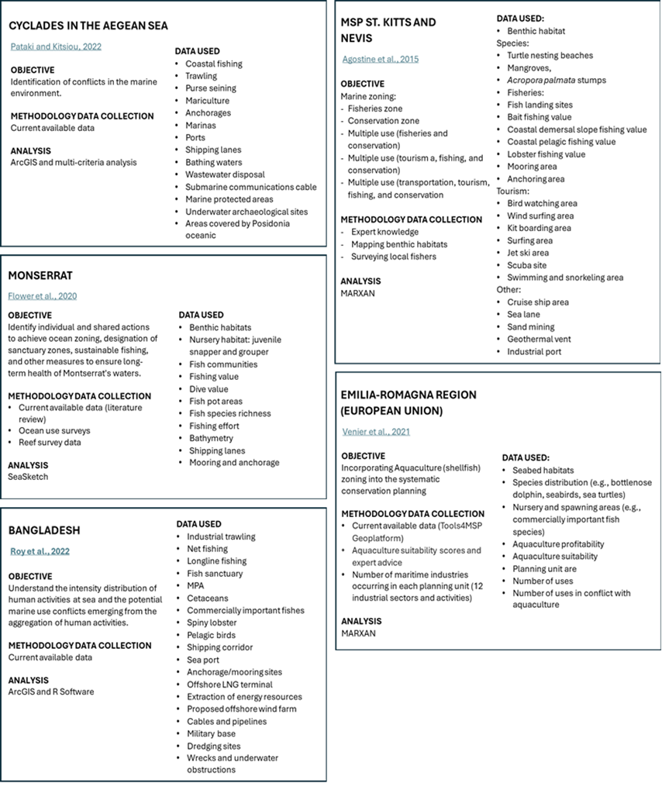

Figure 12. Examples of data used for MSP worldwide.

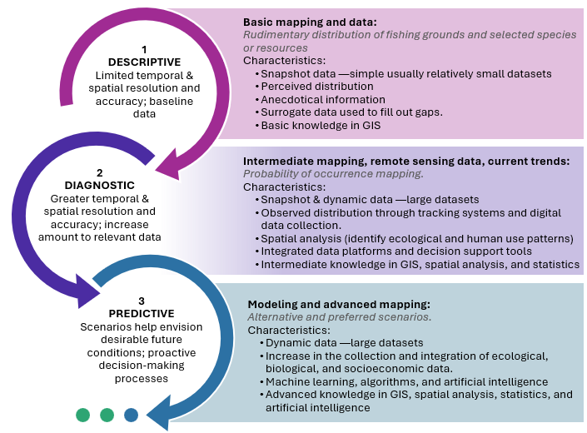
MSP is a dynamic and adaptive process. It is expected that as the process progresses new data needs will be identified not only in terms of the topic of the data but also in terms of its quality. Figure 13 illustrates a stakeholder driven analytical process for conducting MSP assessments that are conducted along a continuum of descriptive, explanatory, and predictive analysis. In this example, initially, the MSP utilizes descriptive analysis which are produced with limited temporal (usually snapshot data), low spatial resolution and accuracy for example general distribution of fishing grounds and species from previous studies, consultations with scientist, experts and anecdotal references from users. As the MSP progresses, refined monitoring and data collection generates an increase in the amount and quality of available spatial data, with greater spatial and temporal resolution and accuracy for example distribution of fishing grounds and species based on direct observations, latitude/longitude data, which allows more robust analyses (such as current trends, probability of occurrence mapping, etc.) relevant to more immediate decision-making. As the MSP process matures, the development of systems to handle dynamic data (such as data from vessel tracking systems for small vessels, automatic identification system for maritime transportation, satellite data, etc.) allows the use of alternative or future scenarios that integrate relevant data sources and provide useful long-term planning guidance (e.g., how marine environments and human activities might change over time).

Figure 13. Evolution of data analysis in MSP.

At the very least, data should be objective, reliable, and spatially and temporally relevant. Generally, several key types of information are essential. A list of data deemed useful to guide MSP is also presented in Table 6. Layers and prioritization were determined based on information provided during the interviews with key actors, qualitative analysis of current available data and feedback during the national validation workshop.

Table 6. Data needs to inform MSP.
FISHERY SECTOR
Spatial data | Priority score for collecting data | Method for obtaining/collecting data | Partners for improving spatial data catalog
Small-scale fishing distribution | High | ¹Participatory mapping  (low resolution, medium cost, EEZ coverage)  ²Human distribution models  (medium resolution, medium cost, EEZ coverage)  ²Vessel tracking system  (high resolution, high cost, EEZ coverage) | MSP Unit (TBD)  NFA  Fishers/Fisheries organizations  National Spatial Data Management Unit  University of the West Indies
Recreational and charter-for-hire distribution | High
Commercial fishing distribution | High
User conflict areas (multisectoral) | High
FAD locations (potential) | High
Diving sites (spearfishing) | High
Landing site’s locations with estimates of fish landings | High | ¹Use satellite data to estimate location of features  (low resolution, low cost, land and nearshore coverage)  ²Ground truthing locations estimated with satellite data. (high resolution, medium cost, land and nearshore coverage) | MSP Unit (TBD)  NFA  Fishers/Fisheries organizations  National Spatial Data Management Unit
Anchorages/mooring areas/locations | High
Marina’s location | Low
Aquaculture: current fishpond farms | Medium
Law enforcement reports (locations) | High
Mariculture (potential) | High | Implement suitability study  (high resolution, high cost, mix coverage) | MSP Unit (TBD)  NFA  University of the West Indies
Fishing vessel characteristics (# of registered vessels by year/fishing category/parish) | Low | ¹National fisheries statistical reports  ²As the MSP process progresses there might be needed to coordinate with the NFA to obtain other fisheries related data/variables. | NFA
Fisher licenses (by year, parish) | Low |  | NFA
Estimated marine fish production for artisanal finfish, sea cucumber, industrial conch and industrial spiny lobster (weight and value) | Low |  | NFA
Aquaculture production (tilapia). | Low |  | NFA
Fisheries socio-economic data (fishers age and gender) | Low |  | NFA
BIOLOGICAL DATA
Coral reefs distribution | High | ¹Continue using information from current sources (e.g., TNC). (mix resolution, low cost, nearshore coverage).  ²Monitoring system to update and expand data collection of current habitat information (e.g., coral reef health score). (medium resolution, high cost, nearshore coverage) | MSP Unit (TBD)  NFA  NEPA  Protected areas and sanctuaries  Fisheries Associations  National Spatial Data Management Unit  The Nature Conservancy  University of the West Indies
Seagrass distribution | High
Benthic habitats distribution | High
Mangrove distribution | Medium
Degraded habitats distribution due to climate events (coral bleach, seagrass loss, etc.) | High | ²Implement specific studies. (mix resolution, high cost, nearshore coverage)
Fish distribution | High | ^{1&2}Implement specific studies. (mix resolution, high cost, nearshore coverage) | MSP Unit (TBD)  NFA  NEPA  Sanctuaries  Fisheries Associations  National Spatial Data Management Unit  The Nature Conservancy  University of the West Indies
Areas of high biodiversity | High
Nursing areas | High
Spawning aggregation sites | High
Lobster distribution | High
Conch distribution | Medium
Sea turtle distribution | Medium
Marine mammal distribution | Medium
Invasive species (e.g., lionfish, sargassum) distribution | High
OCEANOGRAPHIC DATA
Bathymetry (contour lines or satellite imagery) | Low | ¹Continue using global digital elevation models (DEM) (e.g., GEBCO, Seabed 2030)  (medium resolution, low cost, EEZ coverage)  ²Obtain lidar data  (high resolution, very high cost, nearshore coverage) | National Spatial Data Management Unit  MSP Unit (TBD)  National Land Agency
Chlorophyll a concentration | Low | ¹Continue using satellite data (medium resolution, low cost)  ¹There is some information from nearshore monitoring for pH, dissolved oxygen, and ocean acidification.  ²Deploy oceanographic buoys  (high resolution, high cost, usually nearshore coverage) | National Spatial Data Management Unit  MSP Unit (TBD)  Meteorological Department  NEPA  The Nature Conservancy  Protected Areas  Water Resource Authority
Nutrients (Nitrates / Phosphates / Silicates) | Low
Ocean currents (direction and speed) | Low
Prevailing winds (direction and speed) | Low
Salinity | Low
Sea surface temperature | Low
pH | Medium
Dissolve oxygen | Medium
Ocean acidification | Medium
TRANSPORTATION SECTOR
Cargo/tankers ships distribution (AIS) | Low | ^{1 & 2} Vessel tracking system —Automatic Identification System (AIS)  (high resolution, high cost, EEZ coverage) | Ministry of Transport and Mining  National Spatial Data Management Unit  MSP Unit (TBD)
Cruise ships distribution (AIS) | Low
Port locations | Low | ¹Use satellite/nautical charts data to estimate location of features  (low resolution, low cost, land and nearshore coverage)  ²Ground truthing locations estimated with satellite data (high resolution, medium cost, land and nearshore coverage) | Ministry of Transport and Mining  National Spatial Data Management Unit  MSP Unit (TBD)  Port Authority of Jamaica  NEPA
Dredging operations | Low
Aids to navigation | Low
Obstacles and wrecks | Low
Oil/gas spills | Medium
Gas and pump-out station locations | Low
Shipping activities at Jamaica’s Ports (total vessel visits by major facility and port of call, cargo and miscellaneous vessel visits to the major ports, cruise ship, passenger and crew by port of call, total cargo handled at Jamaica) | Low | ^{1 & 2} National monthly shipping activities statistics | The Port Authority of Jamaica
TOURISM AND RECREATION SECTOR
Distribution of tourist | High | ¹Participatory mapping  (low resolution, medium cost, EEZ coverage)  ²Human distribution models  (medium resolution, medium cost, EEZ coverage)  ²Vessel tracking system  (high resolution, high cost, EEZ coverage) | Ministry of Tourism  National Spatial Data Management Unit  MSP Unit (TBD)  University of the West Indies
Visitors by resort region accommodations | Low
Recreational vessels (sightseeing/cruising) | High
Watersports areas | High
Diving and snorkeling areas | High
Destination sites (on the water) | High
Tourism statistics (passengers by airport, purpose of trip, expenditure, cruise visitors) | Low | National yearly tourism and recreation statistics | Jamaica Tourist Board
Visitor by resort region and accommodation type | Low | National yearly tourism and recreation statistics | Jamaica Tourist Board
ENERGY/MINING SECTOR
Submarine cables, pipelines, transmission lines and infrastructure | Low | ¹Continue using current information  (mix resolution, low cost, nearshore coverage). | Ministry of Science, Energy and Technology  National Spatial Data Management Unit  MSP Unit (TBD)
Sand and gravel | Medium
Offshore oil and gas exploration | Medium
Renewable energy (wind farms, wave, tidal, etc.) potential | Medium | ^{1&2}Implement suitability study  (high resolution, high cost, mix coverage)
OTHER DATA
Algae distribution | High | ¹Continue using available data  (mix resolution, low cost, land nearshore coverage)  ²Implement specific studies  (mix resolution, high cost, land and nearshore coverage) | National Spatial Data Management Unit  MSP Unit (TBD)  National Solid Waste Manag. Authority  NEPA  University of the West Indies
Pollution (agricultural discharge, plastic and solid waste) | High
Hazard risk coastal areas (vulnerability assessments) | High
Ocean acidification | high
Changes in sea surface temperature | Low
Changes in tides and waves | Low
Military operations (offshore) | Medium | ¹Consult with Ministry of National Security | Ministry of National Security
Cultural heritage sites (underwater) | Low | ¹Current database. Sites are used for research in archeological studies. | Jamaica National Heritage Trust  University of the West Indies
¹ Descriptive phase of MSP process (baseline assessment); ² Diagnostic and predictive phases.

Data access
Data accessibility refers to the ease with which users can find, retrieve, understand, and use data within an organization. MSP requires integrating diverse types and sources of data to support decision-making processes. Data collection in the marine environment can be expensive and time consuming thus it is a common practice to use already available data as much as possible, especially during early stages of the MSP process (descriptive phase). Nevertheless, accessing and integrating this data comes with its challenges (Table 7). Overall, in terms of data access to inform the MSP in Jamaica, there is a good amount of spatial data already available in spatial format that is published by reliable sources (e.g., governmental agencies, NGO’s, etc.), but some of the data is outdated and it is hard to find/filter/manage because although there are effort to create a data sharing mechanism, this platform is still in development. More specifically, some of the limitations regarding accessing currently available data encountered during this assessment are:
Table 7. Current limitations for accessing data encountered.
Description | Objective | Required actions
Data format
Some of the current available data is in PDF format which limits its use for spatial analysis. The information will have to be requested to the authors who may or may not have the information in spatial format (e.g., shapefile, geoJSON, geotiff, etc.). | Convert data into compatible formats and ensure consistent units and scales. | Request spatial data from authors.  If the spatial layer is no longer available, it is possible to geo-reference its image with permission from the author.
Outdated data
The marine environment is very dynamic and some of the current available data for some species are from 5–10-year-old reports.  However, CPUE reports for queen conch are done annually. | Update data to reflect current conditions. | Develop and implement a research portfolio in coordination with NGOs and academic organizations.  Participatory mapping with stakeholders:  - Sessions with scientists, experts and managers.  - Sessions with fisherfolk (small-scale, recreational, and commercial fisheries).  - Cross-sectional mapping sessions.
License or closed data source
In several cases, the reference found is in a peer-reviewed publication that requires a fee to access the information (USD$20 to $40). | Ensure that data can be accessed independently of its cost. | Some organizations will waive or reduce the cost of accessing specific articles upon official request.  Another option is to request the reference and/or spatial information directly from the main author.  During the planning phase, include some funding to access these references.
Data original purpose
Most of the current data was collected with specific objectives and methodologies which can affect or limit its use to inform MSP.  Nevertheless, a lack of standard protocols across different agencies or studies can result in incompatible data sets. | Understand the limitations of the data used in the analyses. | Evaluate and report the limitations of the use of current data which can increase uncertainty during decision making processes.
Data management
Data management is the practice of collecting, keeping, and using data securely, efficiently, and cost-effectively. It could be expensive, and it requires specialized technical knowledge (e.g., Oracle, SQL, etc.). | Develop a data management system. | Implement robust data management systems to handle storage, access, and integration efficiently.
Data quality
The Internet is a great platform to access information, but it is important to review the source of such information as a first filter to access quality data (meet acceptable standards, description of how data was collected, analyzed, etc.). During our assessment we focused on well-known reputable references/sources (e.g., TNC, NEPA, etc.).  Nevertheless, variability in methodologies and instruments can affect data accuracy, leading to inconsistencies. | Ensure the use of the best available data. | Review data quality of any potential layer that will be included in any MSP analysis.  Understand the limitations for decision-making of the use of results generated with the best available data (even if the only available data is deemed to have low quality).
Decentralize
With the plethora of sources (e.g., websites, journal articles, clearinghouse, online databases, etc.) there is a need for a platform or mechanism (index) in which authors can share a description of their research and/or project with a section for describing their spatial data. The NSDI/NSPIT once operational could be used to mitigate this limitation. | Centralized databases to simplify the process of searching and accessing data (rather than navigating multiple sources). | Continue developing the NSDI and NSPIT.  Once operational, promote the benefits of using the NSDI and/or NSPIT for centralizing data.  Expand publishing privileges to include curated data from other relevant sources (e.g., research institutions, NGO’s, private sector, etc.).
National data integration mechanism or portal not currently operational
Current data is presented in different temporal and spatial resolutions and formats.  Previous MSP process projects in Jamaica shared the data using online platform but after the project ends so does the access to this spatial data.  Jamaica’s government is currently working on developing the NSDI and/or the NSPIT as platforms that will integrate and share diverse datasets (e.g., biological, ecological, human activities, socioeconomic datasets, etc.). | Unified Access through a platform that integrates diverse data types from various sources, ensuring that all stakeholders work with the same curated information. | Continue developing the NSDI and NSPIT.  Once operational, promote the benefits of using the NSDI and/or NSPIT for centralizing data.  Defining standardized formats and metadata requirements to ensure consistency and interoperability among different datasets.  Expand the platform capacities to provide interactive dashboards to speed the data sharing process (near real-time data) among different organizations.

Data sharing agreements
Another important aspect regarding data accessibility is related to data sharing agreements. Data sharing agreements between organizations to address issues such as data ownership, responsibilities, and liability. Their objective is to outline how data will be shared, used, and managed.
During the assessment, it was found that at the national level there are no approved and/or official data sharing agreements for data sharing and access in many governmental units. Information is shared among the participating organizations using unwritten rules: a request is made to the author (source) of the information (e.g., chief officer, unit director, professor or principal investigator, main peer-reviewed article, etc.) and data sharing is decided on a case-by-case basis. Usually involving the acknowledgment of the source of the requested information.
Usually, a data sharing agreement are formal and official documents that include details regarding its purpose and scope, data ownership and rights, data access and security, data usage and responsibilities, confidentiality, data quality and accuracy, compliance and legal considerations. By clearly defining the terms and conditions, these agreements help ensure that data sharing is conducted effectively and responsibly, protecting the interests of all parties involved.
At a national level, the Jamaica Clearing House Mechanism offers an example of a data sharing agreement which includes details regarding who they are, what types of data and information is available in the site (current and potential), and intellectual property rights. The site also has defined guidelines for submitting information to the site and their data validation process.
To ensure consistency and compatibility, data should follow standardized formats and protocols. In GIS, a common protocol for describing geographic information about the identification, the extent, the quality, currency, spatial reference, and legal limitations of data is the ISO 19115. This information is then shared with the spatial layer through its metadata. The National Spatial Planning Information Technology (NSPIT) platform is also following this industry standard (Figure 15). This geospatial portal is also used as a central hub to download data that is available in the NSPIT Viewer (not available in the current demo version). Downloads are made available by data transfer through the WFS standard. If download capabilities have been enabled for a specific dataset, the data page’s NSPIT tab will display a WFS Data URI.
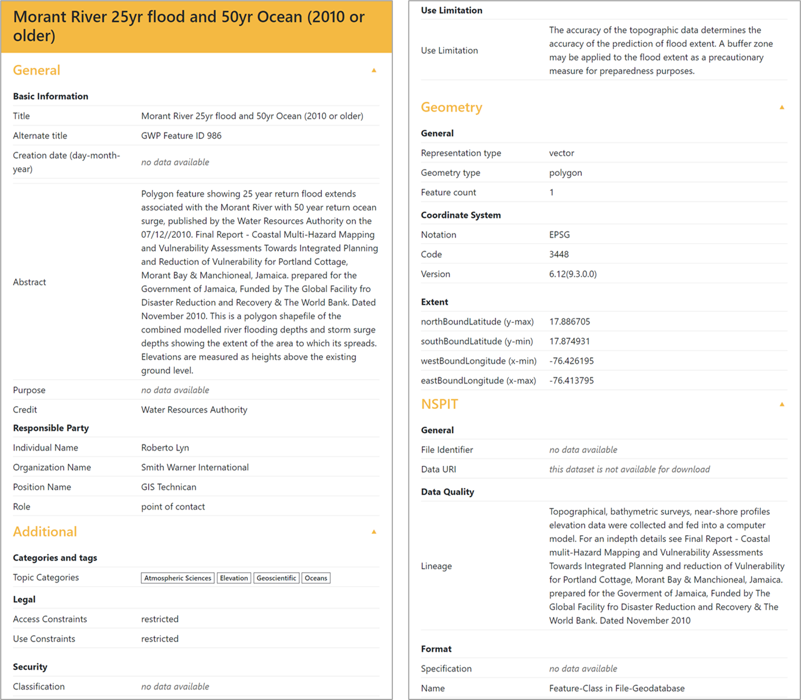
Figure 14. Example of a layer’s metadata in NSPIT.

International organizations such as Caribbean Science Atlas and Resource Watch, among others, provide mechanisms to access the spatial data as well as guidelines of how to cite or reference the source of the information. For other more general sources (such as ArcGIS Online), sharing protocols and description of the data (metadata) although encouraged, is not always available and depends on the person publishing/using the data. For illustrative purposes, Figure 15 shows the online data sharing agreement that users must fill out while requesting data.
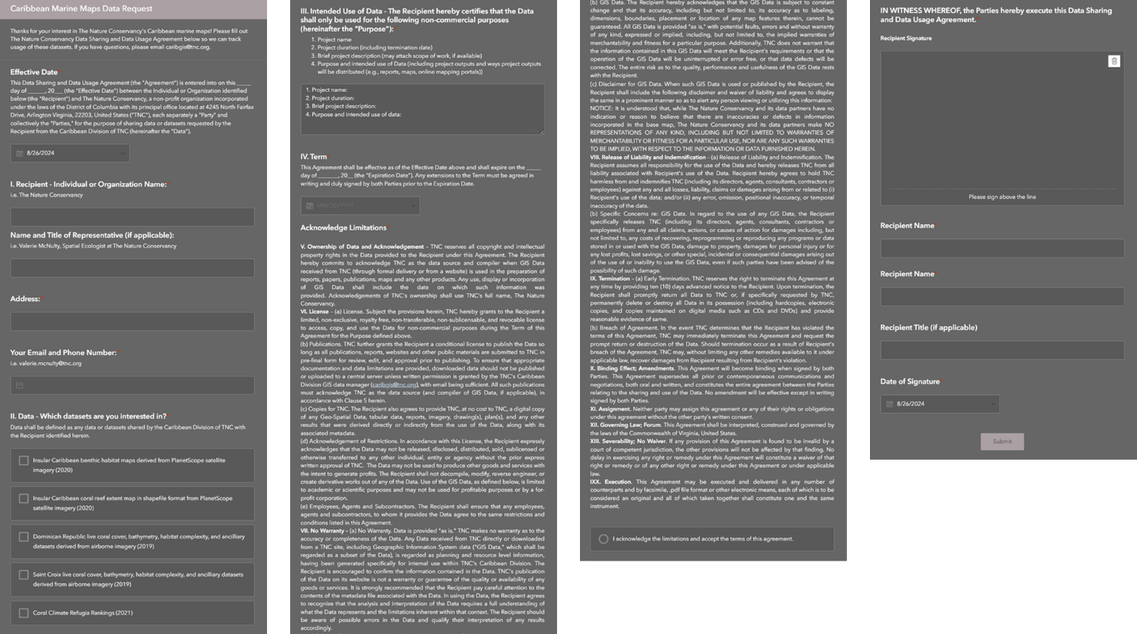
Figure 15. Caribbean Science Atlas data sharing agreement. The agreement is available from https://survey123.arcgis.com/share/6c882b425ada435a86940824c6af83e5

Software
Jamaica’s government has already secured the ESRI ArcGIS license, making it available to all their divisions and agencies. ESRI is the leading GIS company in the world. Based on information from the interviews, it is expected that the MSP process in Jamaica will then be carried out using this GIS company and the several products that it offers (e.g., ArcGIS Pro, ArcGIS Online, Dashboards, Story Maps, etc.).
In general, ESRI software and products are reliable, user-friendly, with advanced spatial analysis tools and easy integration with other features for data sharing and visualization (e.g., interactive maps, story maps, dashboard, etc.). There are several examples of the current use of this software throughout different governmental agencies in Jamaica (Figure 16).
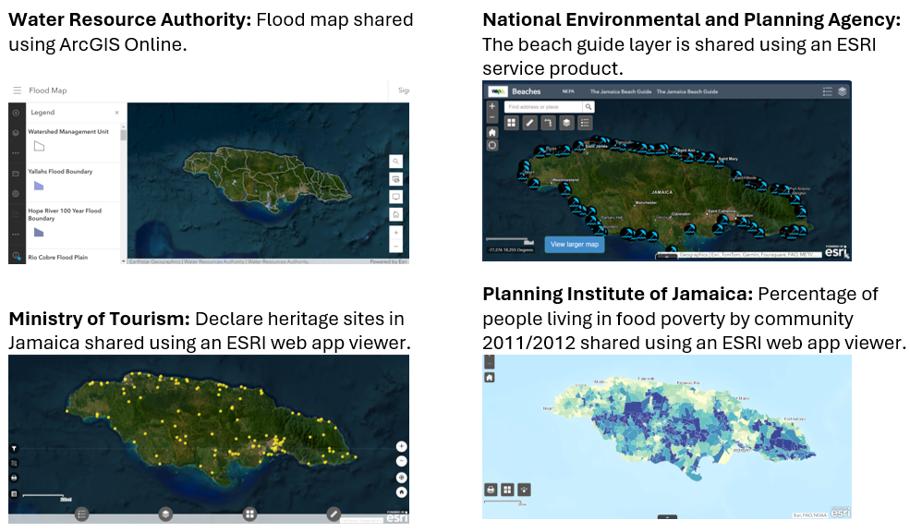
Figure 16. Examples of GIS layers shared by Jamaica governmental agencies using ESRI products.
Some of the personnel from NFA are also using QGIS software to create, manage, perform spatial analysis and produce static maps (e.g., images, PDF, etc.) for presentations and reports (e.g., temporal conch distribution in Pedro Bank). QGIS is also a powerful open-source software, with several standard GIS functionalities. However, the software depends on its community of users and independent developers to access specialized tools — called “plugins and extensions”. Furthermore, QGIS is not as user-friendly as ArcGIS Pro, there is a steeper learning curve for beginners, in some cases requiring basic programming skills. Interactive maps created with QGIS are shared through plugins but require other platforms (e.g., OpenLayer, Leaflet, MapBox) to make them available online that might require a fee.
QGIS software could be an alternative to ArcGIS Pro mainly for non-governmental organizations. Although ESRI software is the most versatile and user-friendly GIS software, it is expensive, and each user is required to have a yearly license. Therefore, institutions with limited resources and budget should make use of open-source software and tools such as QGIS.
Another important aspect of MSP is data collection. In the case of fisheries related data collection, the NFA is currently using a customized portal called “IrieFINS” for registering fishers and vessels. However, fisheries and biological data is still mainly collected on paper forms which increases the time to process, analyze, and deliver results. Some recent efforts to document landing sites utilized a digital form developed using Kobo Toolbox which provides data collection tools starting with a community license for free. However, some of the comments related to the use of this software expressed issues while collecting data offline and unexplained errors in the latitude/longitude variables.
The degree to which other agencies are collecting data digitally varies. NEPA is currently collecting data using paper base materials but also digital technology and tablets (e.g., Survey123, FieldMaps). The common paper customs form is also outdated by a digital form (https://enterjamaica.gov.jm/). This form provides important visitor information for the Jamaica’s Ministry of Tourism. On the other hand, the marine police are still depending on paper forms which increase the processing and reporting time.
MSP software
There are several software packages with specific tools, extensions and plugins designed to facilitate MSP. Previous MSP initiatives in Jamaica had used the Marxan software (open source). Marxan is a specialized software that applies optimization algorithms to identify solutions that balance conservation goals with cost to a well-defined problem. Its current version can incorporate complex analyses that consider connectivity, probabilities and multiple zones. The software can handle various types of data (spatial and non-spatial data) and allows users to incorporate multiple objectives, as well as to assess potential outcomes of different conservation strategies using scenarios. However, the software requires specialized training because it can be complex to set up, use, and interpret. It can be computationally intensive, especially for large datasets or complex scenarios. It is highly sensitive to parameters set by users (e.g., conservation targets, cost, etc.) which should be well-defined and realistic. It is advisable to use Marxan with other tools or methods for comprehensive conservation planning. Furthermore, spatial data must be already prepared (e.g., clipped to study area, same coordinate system, etc.) to be added to the software. This is usually done using GIS software such as ArcGIS and QGIS.
GIS software such as ArcGIS and/or QGIS offer several tools and functionalities to support MSP initiatives. Their basic/common tools allow users to obtain, manage and integrate different data formats into one GIS project to be analyzed using specialized tools (e.g., suitability analysis, habitat analysis, risk assessment, etc.). Unique or customized MSP requirements can be included through custom scripting (e.g., Python language) and workflows (the steps and processes used to complete a GIS project). Although GIS software requires significant time and training to become proficient, Jamaica already has GIS technicians allocated in different governmental agencies. They might require only to complement their skills with specialized training in tools and procedures specifically applied to MSP analyses.

Technical and human resources
Technical resources
In terms of technical resources (e.g., computers, software, etc.), running GIS analysis, models and simulations, as well as managing large datasets can be computationally demanding. Typical computer needs include multi-core processors, minimum 8GB of memory/RAM (recommended ≥32GB), a dedicated graphic card, and preferable solid-state drivers for faster data access. Furthermore, other important resources include stable internet connectivity (for accessing online GIS data sources, cloud-based GIS services, and software updates), backup systems and protocols (hardware and cloud-based), and up-to-date antivirus software.
Both the NEPA and the NFA possess the minimum hardware requirements for installing and working with GIS software. These organizations also have backup systems and antivirus software. However, the current internet connectivity (speed and reliability) could be improved (it was rated by staff that were interviewed as intermediate —3 out of 5). Furthermore, as more data becomes available (large datasets), there may be a need for improving backup and storage capacity.
Human resources
In terms of human resources, although, qualified personnel exist at the different governmental agencies in Jamaica, they are already exercising duties related to the work of their specific agencies. For example, there is only one GIS technician at the NFA, and his effort is already divided among different projects and activities. Therefore, due to the amount of effort necessary to support the different aspects of a MSP initiative, consideration should be given to hired a MSP team force that could them coordinate with personnel at the different agencies and other related stakeholders (e.g., TNC, University of West Indies, etc.).
Suggested team members are a project manager, GIS specialist, ecologist (marine scientist), communications specialist, policy and legal expert, information technology specialist, economist, and field technicians or data collectors.
Training and capacity building
Data collection, curation and analysis in support of MSP requires a combination of technical capacities and skills. At the very least, technicians should have basic to intermediate knowledge and skills in GIS including acquiring reliable and relevant data, managing and processing individual layers as well as integrating the diverse layers and datasets (usually from multiple sources and with different formats) into one project for deeper analysis.
Several software products and tools used for MSP consist of underlying models (e.g., reserve design in Marxan, suitability model in ArcGIS, etc.) that can provide insight into the question(s) of interest. MSP technicians should have at least basic knowledge of mathematical and statistical modeling techniques to maximize the use and interpretation of “canned” models (e.g., reserve design with zones, suitability analysis, etc.). As the MSP progresses, technical capacities should also grow expanding on “canned” tool applications to developing customized models to support long-term MSP goals and objectives (complex simulations to help predict the impacts of different planning scenarios).
The NEPA and the NFA have access to the ESRI software and products and technical capabilities to implement MSP analysis utilizing geospatial data. Current GIS technicians might require intermediate to advanced training in specific topics and software (table 8). In contrast, other relevant actors (e.g., data collectors, sanctuary biologists, etc.) might require more basic GIS training to allow them to understand and feel comfortable in collecting and analyzing data, supporting the MSP process.
Stakeholder engagement is crucial for the MSP process. Therefore, it is important that the team leading the initiative has access to a communications specialist to support the development of outreach and communication materials tailored to the different stakeholders (e.g., fisherfolk, policy makers, researchers, and public). Furthermore, training in facilitation and communication skills can enhance the team capabilities.
Capacity building programs should consider multiple training strategies to account for personnel turnover. For example, in-person training could be complemented with online, at the learners’ pace, training modules. Table 8 presents several recommended trainings to improve current technical capacity to support the MSP process in Jamaica.
Table 8. Suggested trainings for technicians supporting Jamaica’s MSP process.
Trainings | Main topics
Introductory training in GIS | - Acquiring data  - Managing spatial data  - Basic analysis based on already established tools (e.g., analyst tools)
Digital data collection | - Participatory mapping surveys  - Design and implementation of digital forms for data collection  - Direct data collection through tracking data.  - Monitoring systems (e.g., acoustic monitoring, drones and remotely operated vehicles)
Facilitation skills | - Methods for participatory planning and stakeholder engagement.  - Negotiation, conflict resolution.
Communication skills | - Technical writing to create clear and precise written documents, reports, etc.  - Public speaking to build confidence and improve delivery at public forums, workshops, and meetings.  - Effective presentations that deliver information in a compelling and engaging manner using several formats
Remote sensing | - Acquiring satellite data  - Creating and working with derived data (new data created by combining and processing existing raw data)
Introduction to modeling and simulations | - Basic knowledge  - MSP software and tools (in deep exploration of current leading platforms to understand their strengths and limitations)
Models and simulations (intermediate training) | - Understanding of ecological and environmental modeling concepts  - Creating and modifying models  - Modeling software (e.g., MATLAB, Python, R software, etc.)  - Spatial statistics (e.g., cluster analysis, hot spot analysis, etc.)  - Advance simulations
Economic analysis | - Cost-benefit analysis of different scenarios  - Trade-off evaluation among competitive uses  - Assessment of economic development opportunities
Legal and policy | - Introduction to national and international laws, regulations, and policy framework related with MSP  - National and international data sharing protocols
Cloud-based platforms for sharing data | - Exploration of current platforms (strength and weakness based on national need)  - Design and implementation of online platforms and tools (e.g., website, interactive maps, dashboards, mapping surveys, discussion forums, etc.) for sharing data and results to support stakeholder engagement  - Mobile apps (design and implementation for data and results sharing)

Recommendations
The government of Jamaica is committed to the development of its blue economy through a holistic (ecosystem based) approach that emphasize the role and responsibilities of multiple sectors. However, the procedures and funding necessary to develop and implement a MSP process in Jamaica have not yet been established. Nevertheless, based on our assessment the following recommendations are proposed:
Data collection
There is some basic data that can be used during the early stages of the MSP process (e.g., scientific reports, international and regional atlas, local knowledge, etc.). However, it is recommended that the result of the analysis performed using this available data should be interpreted carefully due to the limitations inherited by this data (e.g., data was collected using different methodologies, timeframes, purposes, etc.).
There are temporal and coverage gaps of information in most of the data categories, especially those related to human activities and biological data. Most data do not cover the whole EEZ, and it was not collected periodically (at different point in time). In these cases, there are some methodologies such as surveys and participatory mapping that can be applied to collect initial data (through consultations with fisherfolk, managers, and researchers). Participatory mapping will not only provide basic information but will also facilitate necessary stakeholder engagement at early stages of the MSP process. These methodologies can be timely, and they don’t require vast resources. Nevertheless, because they rely on recollection of information rather than direct observations, they come with their own set of limitations that should be emphasized during the results interpretation and reporting. Some spatial layers obtained with these methodologies include fishing grounds, nesting, nursing and spawning areas (e.g., commercially important fishes, sea turtles, marine mammal, invasive species, etc.), areas where conflict has been experienced, on-the-water areas used for tourist (e.g., swimming, diving, snorkeling, jet ski, yacht cruising, etc.), livelihood and gender related data, among others.
Although some governmental agencies are still collecting data using paper forms, they are also trying to transition into digital data collection. For example, NEPA is using Survey123 and Field Maps apps for data collection because, in part, the seamless integration with other software such as ArcGIS Pro, ArcGIS Online, dashboards. It is recommended that the different governmental agencies adopt the use of ESRI products for data collection (similarly to NEPA) to reduce data processing time (digitize data) and data collection errors (missing data and inconsistent entries).
It is also recommended partnering with other relevant institutions such as TNC, academic centers in the Caribbean region, and other NGOs to collect specific data that will improve the baseline assessment performed with current available data. As the MSP process progresses, reliance on current available data should decrease in favor of data collected through stablished protocols. For instance, efforts and funding should be allocated to collect data through tracking devices. This will provide more accurate and higher resolution estimates of fishing grounds (by gear, by target species, fishing effort, etc.) and important species. Furthermore, there are some important topics such as potential areas for mariculture on which there is limited up-to-date data. Therefore, specific studies will have to be implemented.
MSP Analysis
The government of Jamaica is facilitating access to the ESRI license, and several governmental agencies are already using several of its products. It is recommended that a national MSP process continue with the adoption of ESRI products to create, collect, manage, analyze, report, and share the results. ArcGIS Pro has several tools that can be used to analyze different aspects of the MSP process based on defined objectives (e.g., suitability analysis, hot spot analysis, data modeling, etc.). It is integrated with data collection tools (survey123 and Field Maps) which allows for real-time updates, and increased access to the data to relevant actors. It has multiple interactive products for data sharing (e.g., ArcGIS Online, ArcGIS Hub, interactive maps, story maps, dashboards, etc.) which can be used to support collaboration and enhance the ability to communicate complex spatial information and scenarios to stakeholders and decision-makers.
It is also recommended to use other MSP specialized software such as Marxan. This software has been used worldwide as well as in two previous MSP initiatives in Jamaica. It is powerful software capable of handling complex solutions (e.g., connectivity, zoning, etc.) for defined objectives. It provides the ability to evaluate the impact of different scenarios to support the planning process. Its use and capabilities can be complemented by other relevant spatial analysis performed in GIS software (ArcGIS Pro and QGIS).
Required human and technological resources
The Blue Economy is still in its developing/planning phase and guidelines and action plans to oversees and the marine spatial planning in Jamaica are yet to be developed and adopted.
There is at least basic GIS expertise through the different government agencies identified in the Recommendation for a Blue Economy Roadmap (World Bank, 2023). Some agencies (e.g., NEPA, WRA, NFA, etc.) there is at least one GIS technician with intermediate to advance skills. Furthermore, governmental agencies have capable technical resources such as computer equipment, operating software, antivirus, and backup systems to perform all the necessary analysis and reporting. However, internet resources could be improved because some of the tools for data collection, managing information and interactive sharing of data and results rely on a stable internet connection.
In terms of human resources, the MSP process requires a dedicated multidisciplinary team, each contributing critical knowledge and skills to the planning process to ensure that spatial plans are scientifically sound, legally compliant, and socially equitable. Suggested team members are a project manager, GIS specialist, ecologist (marine scientist), communications specialist, policy and legal expert, information technology specialist, economist, and field technicians or data collectors. Experts from the different government agencies can provide support to these units related to planning, data collection, stakeholder engagement, marine ecology, fisheries, renewable energy, transportation and tourism and recreation, among others. In addition, the MSP process should be designed and implemented with the support of a multi-sectoral technical advisory committee.
Information sharing
The MSP process depends on an effective and comprehensive mechanism that allows not only sharing data (spatial and non-spatial) with different access privileges levels (for sensitive data), but also it allows to share preliminary results for discussion and enrichment through stakeholders’ feedback. The government of Jamaica has already invested US$50 million to develop the National Spatial Planning Information Technology (NSPIT) Platform whose objective is to function as Jamaica's spatial data infrastructure to improve decision making in planning and national development, providing government agencies, educational institutions, the private sector, and citizens access to Jamaica's spatial data. Currently the development of the NSPIT platform is not yet completed and there is an opportunity to work collaboratively with the NSPIT team to design and implement specific MSP tools within the platform and to promote its use for a national MSP initiative.

Conclusions
The MSP needs and data gaps assessment conducted characterize existing data, technology, and human capacities and identify any needs and gaps that may be relevant to the MSP process.
This framework concentrated on the interrelationships among governmental entities that will play an important role in the monitoring and collection of relevant data to aid the MSP process in Jamaica. Key collaborative activities to be undertaken include stakeholder engagement and the spatial modeling framework that will map zoning options for human uses and marine ecological/habitat conservation to mitigate conflict. These activities should synchronize and support government decision-making to establish policies, promulgate regulations and engage in enforcement actions.
This assessment found that there is some basic spatial information exists for use during the baseline assessment for MSP process in Jamaica. Thanks to the efforts of multiple governmental agencies (e.g., NEPA, WRA, etc.) and NGOs (e.g., TNC, Global Fish Watch, etc.) several data is already in a geospatial format (e.g., shapefile, geotiff, etc.). However, data found in reports and publications will have to be requested and in some cases digitized, so that it can be included in a GIS project for further analysis. Careful consideration should also be given to the inclusion of some data that might be deemed outdated. The marine environment is very dynamic, and conditions are always changing, so although there might be information regarding a specific topic, the information might no longer be relevant. Nevertheless, analysis, interpretation, and reporting should all consider the limitations of the use of this currently available data.
Efforts should be made to collect missing data. Especially related to temporal and spatial coverage issues. The wealth of the currently available data represents nearshore features with a limited amount characterizing the broader area of the Jamaica EEZ. Also, the spatial resolution and characterization of certain species or topics is limited. Data collection protocols will also need to be developed and implemented to fill gaps in data, extent and quality. The participatory mapping methodology could aid in timely data collection of some important information (e.g., fishing grounds, user conflict areas, etc.). Furthermore, this method allows for the inclusion and engagement of stakeholders (e.g., scientists, experts, managers, users, etc.) in early phases of the MSP. This approach is consistent with other literature and previous MSP national efforts (John et al., 2006; Baldwin, 2015).
A cornerstone for the MSP process is a national platform that supports the planning process by integrating, managing, and sharing data, and providing tools for results interpretation and discussion forums to promote stakeholder engagement. Formal and official data sharing agreements should also be developed to ensure that data sharing is done responsibly, ethically, and legally. The government of Jamaica has already invested in the creation of the National Spatial Planning Information Technology (NSPIT) and efforts should be made to utilize and build on this platform for the MSP in Jamaica.

References
Acosta-Morel, M., McNulty, V. P., Lummen, N., Schill, S. R., & Beck, M. W. (2021). Shoreline solutions: guiding efficient data selection for coastal risk modeling and the design of adaptation interventions. Water, 13(6), 875.
Aiken, K. A., & Haughton, M. (1987). Status of the Jamaica reef fishery and proposals for its management. Retrieved from AquaDocs https://aquadocs.org/handle/1834/29712.
Aiken, K., & Kong, G. A. (2000). The marine fisheries of Jamaica. Naga, The ICLARM Quarterly (Vol. 23 No. 1).
Aiken, K. A., Hay, B., & Montemuro, S. (2002). Preliminary assessment of nearshore fishable resources of Jamaica's largest bay, Portland Bight, Jamaica.
Aiken, K., Kong, A., Smikle, S., Appeldoorn, R., & Warner, G. (2006). Managing Jamaica's queen conch resources. Ocean & coastal management, 49(5-6), 332-341.
Aiken, K. A., Kumagai, N., Yasuda, T., & Jones, I. (2007). The egg trace method of identifying diamondback squid fishing grounds in Jamaican waters. Proceedings of the 59th Gulf and Caribbean Fisheries Institute.
Aiken, K. A., Pal, A. R., & Perry, G. A. (2009). Nursery grounds for fishable species in Kingston Harbour, Jamaica: do they still exist? Proceedings of the 61st Gulf and Caribbean Fisheries Institute.
Aiken, K., Squire, O., Kong, A. & Smilke, S. (2012). Creating a fish sanctuaries network in Jamaica, West Indies. Proceedings of the 64th Gulf and Caribbean Fisheries Institute.
Arocha, F., Narvaez, M., & Mendoza, J. (2024). Review of biological data, spatial distribution of the stocks and ecological connectivity between areas beyond national jurisdiction and the exclusive economic zones in the Western Central Atlantic Fishery Commission region. Food & Agriculture Org.
Baldwin, K., Schill, S., Zenny, N., & Blake, D. (2014). Developing ecosystem-based information for marine spatial planning on the Pedro Bank, Jamaica.
Baldwin, K. (2015). Marine spatial planning for the Pedro Bank, Jamaica. Strengthening the Operational and Financial Sustainability of the National Protected Areas System (NPAS) Project. For the Nature Conservancy, Kingston, Jamaica. 108 pp.
Blake, D. (2023). Marine Spatial Planning. Jamaica —Pedro Bank. Retrieved in August 2023 from https://marineplanning.org/projects/caribbean/jamaica-pedro-bank/
Blythe-Mallett, A., Aiken, K. A., Segura-Garcia, I., Truelove, N. K., Webber, M. K., Roye, M. E., & Box, S. J. (2021). Genetic composition of queen conch (Lobatus gigas) population on Pedro Bank, Jamaica and its use in fisheries management. Plos one, 16(4), e0245703.
Chakalall, B. & Noriega-Curtis, P. (1992). Tilapia farming in Jamaica. Proceedings of the 41st Gulf and Caribbean Fisheries Institute.
Douvere, F., & Ehler, C. N. (2009). New perspectives on sea use management: initial findings from European experience with marine spatial planning. Journal of environmental management, 90(1), 77-88.
Eckert, K. L., & Eckert, A. E. (2019). An atlas of sea turtle nesting habitat for the wider Caribbean region. Revised Edition (No. 19). WIDECAST Technical Report.
ECONEXUS. (2020). Ecosystem services and natural resources valuation assessment. ECONEXUS Consulting Group. https://www.nepa.gov.jm/sites/default/files/2020-12/nrv_and__ecoservices_princess_hotel__final_feb_7_2020.pdf
Global Biodiversity Information Facility. (2023). https://www.gbif.org/en/country/BB/summary
Global Fishing Watch. (2023). Retrieved in June 2023 from https://globalfishingwatch.org/map/index?start=2024-03-27T00%3A00%3A00.000Z&end=2024-06-27T00%3A00%3A00.000Z&zoom=1.5&latitude=19&longitude=26
Grant, S., Brown, M., Edmondson, D., & Mahon, R. (2003). Introducing the 1998 marine fisheries census of Jamaica. Proceedings of the 54th Gulf and Caribbean Fisheries Institute.
Grant, S. (2001). Species composition, abundance and catch rates of fish caught on the Formigas Bank, Jamaica. Proceedings of the 52nd Gulf and Caribbean Fisheries Institute.
Haughton, M. O., & King, D. P. (1992). Potential for mariculture in Jamaica. Proceedings of the 42nd Gulf and Caribbean Fisheries Institute.
Jamaica Tourism Board. (Multiple years). Annual travel statistics. https://www.jtbonline.org/report-and-statistics/
John, K., Sutton, & A., Zenny, N. (2006). Jamaica Ecoregional Plan. Technical Summary. The Nature Conservancy.
Klomp, K. D., Clarke, K., Marks, K., & Miller, M. (2003). Condition of reef fish on Jamaica's north coast signals late stages of overexploitation. Proceedings of the 54th Gulf and Caribbean Fisheries Institute.
Lee, S., Buddo, D. S., & Aiken, K. A. (2011). Habitat preference in the invasive lionfish (Pterois volitans/miles) in Discovery Bay, Jamaica: use of GIS in management strategies. Proceedings of the 64th Gulf and Caribbean Fisheries Institute.
Lingard, S., Harper, S., Aiken, C., Hado, N., Smikle, S., & Zeller, D. (2012). Marine fisheries of Jamaica: total reconstructed catch 1950-2010. In Fisheries catch reconstructions: Islands, Part III (pp. 47-59). University of British Columbia.
Mahon, R. O. B. I. N. (1991). Developing fishery data collection systems for Eastern Caribbean Islands. Proceedings of the 40th Gulf and Caribbean Fisheries Institute.
Mahon, R., Kong, G. A., & Aiken, K. A. (1999). The status of the conch fishery on the shelf and banks off the south coast of Jamaica. Proceedings of the 45th Gulf and Caribbean Fisheries Institute.
Maurer, A. S., & Eckert, K. L. Distributions of the Hawksbill Sea Turtle (Eretmochelys imbricata) in the Western Atlantic Inferred from Satellite Telemetry. UNEP Caribbean Environment Programme, Specially Protected Areas and Wildlife Regional Activity Centre (SPAW RAC). WIDECAST Technical Report No. 23. Godfrey, Illinois. 35 pp.
Marine Traffic. (2023). Retrieved in June 2023 from https://www.marinetraffic.com/en/ais/home/centerx:-56.4/centery:12.4/zoom:6
McIntyre, K. (2015). Benthic mapping of the Bluefields Bay fish sanctuary, Jamaica. LUMA-GIS Thesis.
Miller, M., Bartley, E., Grant, D., Hanson, C., Kelly, R., Masters, J., & McConney, P. (2007). Towards a Fisheries Management Plan for the Negril Marine Park, Jamaica. Proceedings of the 58th Gulf and Caribbean Fisheries Institute.
Ministry of Energy and Mining. (2010). National renewable energy policy 2009-2030. https://www.mset.gov.jm/wp-content/uploads/2019/07/Draft-Renewable-Energy-Policy_0.pdf
Morris, R. A., Kingston, J., & Arnason, R. (2010). A bioeconomic analysis of the Jamaican industrial Spiny lobster (panulirus argus) fishery. Final project report, Fisheries Training Programme, United Nations University, Reykjavik, Iceland.
Morris, R. A., Hernández-Flores, A., & Cuevas-Jimenez, A. (2022). Modelling the spatial population structure and distribution of the queen conch, Aliger gigas, on the Pedro Bank, Jamaica. Scientia Marina, 86(3), e040-e040.
Munro, J. L. (2000). Outmigration and movement of tagged coral reef fish in a marine fishery reserve in Jamaica. Proceedings of the 51st Gulf and Caribbean Fisheries Institute.
Murray, A., & Aiken, K. (2006). Artisanal fishing in Jamaica today: a study of a large fishing site. Proceedings of the 57th Gulf and Caribbean Fisheries Institute.
National Fisheries Authority. (Multiple years). Jamaica Fisheries: Quarterly statistics report. https://www.fisheries.gov.jm/general-reports/
Natural Resources Conservation Authority and Coastal Zone Management Division. 1998. Mariculture draft policy and regulation. Retrieved from https://websitearchive2020.nepa.gov.jm/policies/draft/mariculture.htm.
Palmer, T. (2017). A Coastal and Social Vulnerability Assessment to Climatic Hazards in Jamaica. NOVA IMS & Universitat Jaume Thesis.
Pears, R. J., & Sary, Z. (1997). Status of the Morant Cays fishery; Jamaica's second largest offshore artisanal reef fishery. Proceedings of the 49th Gulf and Caribbean Fisheries Institute.
Pearce, J., Richardson, H., Howarth, P., Medley, P., Aiken, K., Kitson, D., Pollard, I., Collinson, K., & Mangi Chai, S. Consulting services for the assessment of the potential for and development of management plan for artisanal longline fishing for offshore pelagics. Pelagic Fisheries Management Plan. MRAG & LUMIN Consulting. https://www.fisheries.gov.jm/wp-content/uploads/2024/02/JM2736_Pelagic_Fisheries_Management_Plan_Final_V3.pdf
Quinn, N. J., & Kojis, B. L. (2004). Biological evidence of diminished nursery capability in Discovery Bay, Jamaica. Proceedings of the 55th Gulf and Caribbean Fisheries Institute.
Richards, K. (1992). Subtidal culture of the mangrove Oyster, Crassostrea rhizophorae, in Jamaica. Proceedings of the 42nd Gulf and Caribbean Fisheries Institute.
Sullivan, K. M., Chiappone, M., Littau, J., Miller, M., Rath, T., Soto, M., ... & Wilson-Kelly, P. (1999). Rapid ecological assessment of the Montego Bay Marine Park, Jamaica: evaluation of marine parks as marine fisheries reserves. Proceedings of the 45th Gulf and Caribbean Fisheries Institute.
The National Environmental and Planning Agency (NEPA). (2019). State of the Environment Report 2017. Jamaica. The National Environmental and Planning Agency. Kingston, Jamaica. https://www.nepa.gov.jm/sites/default/files/2022-03/State-of-the-Environment-Report-Jamaica-2017_0.pdf
The National Environmental and Planning Agency (NEPA). (2021). Coral reef health status report for Jamaica 2020. The National Environmental and Planning Agency. Kingston, Jamaica. https://www.nepa.gov.jm/sites/default/files/2022-12/2020-Status-of-Coral-Reef-Report-020-FINAL-March-2021.pdf
The Port Authority. (Multiple reports). Monthly statistical publication. Covers shipping activities in Jamaica’s ports. https://www.portjam.com/index.php/statistical-report.
The World Bank. (2017). The potential for the Blue Economy. Increasing long-term benefits of the sustainable use of marine resources for small island developing states and coastal least developed countries. Bank for Reconstruction and Development / The World Bank. Retrieved on May 15, 2023 from https://openknowledge.worldbank.org/server/api/core/bitstreams/cee24b6c-2e2f-5579-b1a4-457011419425/content
The World Bank. (2022). Blue Economy Data and Tools. https://documents1.worldbank.org/curated/en/099610006152282116/pdf/P1750970004c390c60b64707db29cb15a4c.pdf
The World Bank. (2023). Recommendations for a Blue Economy Roadmap for Jamaica. International Bank for Reconstruction and Development / The World Bank. Retrieved on May 15, 2023, from https://www.pioj.gov.jm/product/recommendations-for-a-blue-economy-roadmap-for-jamaica/
Tourism Analytics. (Multiple years). Jamaica Tourism Statistics. https://tourismanalytics.com/jamaica-statistics.html

Appendix

Appendix 1: Terms of Reference
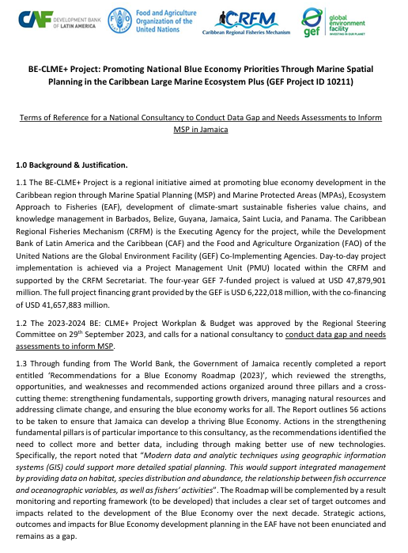
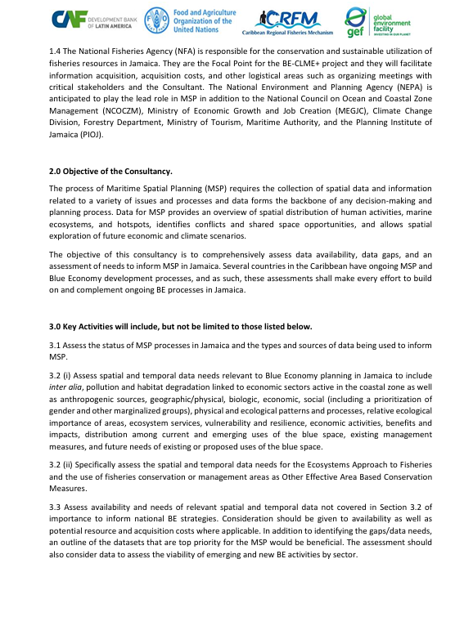
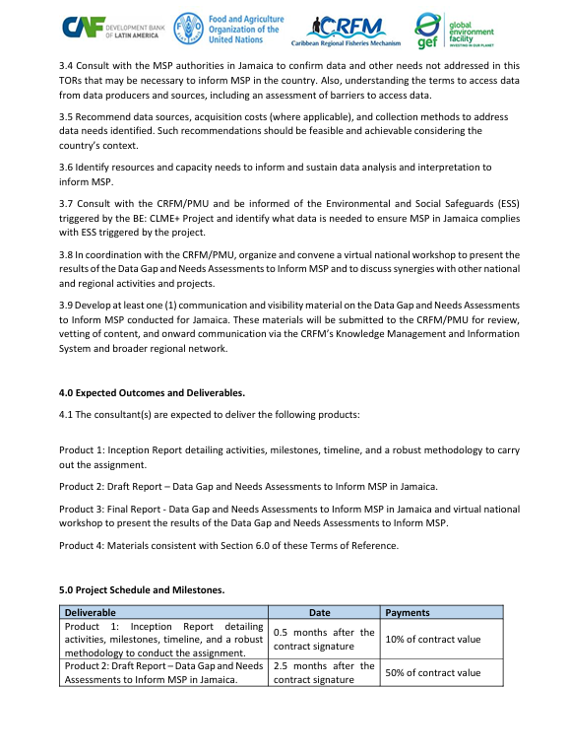
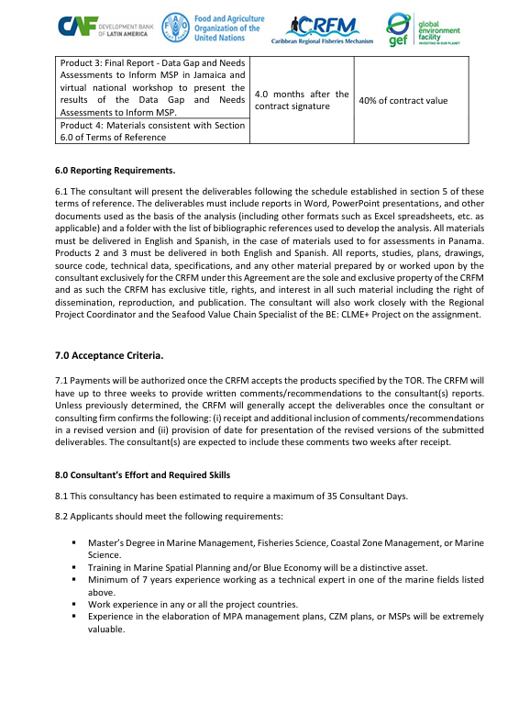
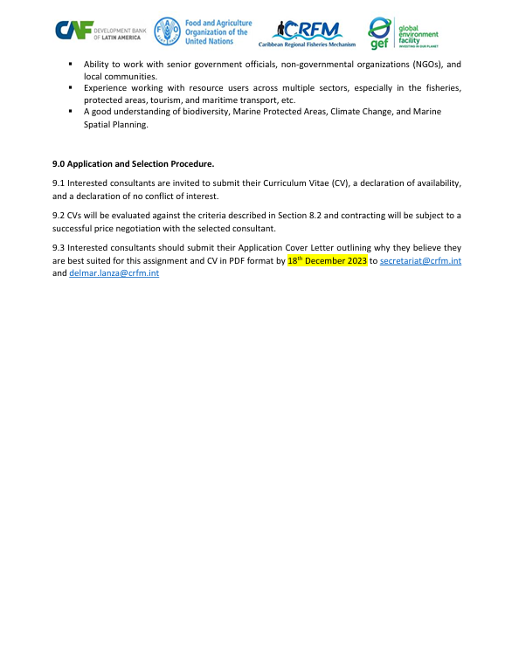

Appendix 2: Inception meeting agenda and participants:
This meeting took place virtually on April 9, 2024, at 2:00 PM (Jamaica time). Below is the meeting agenda:
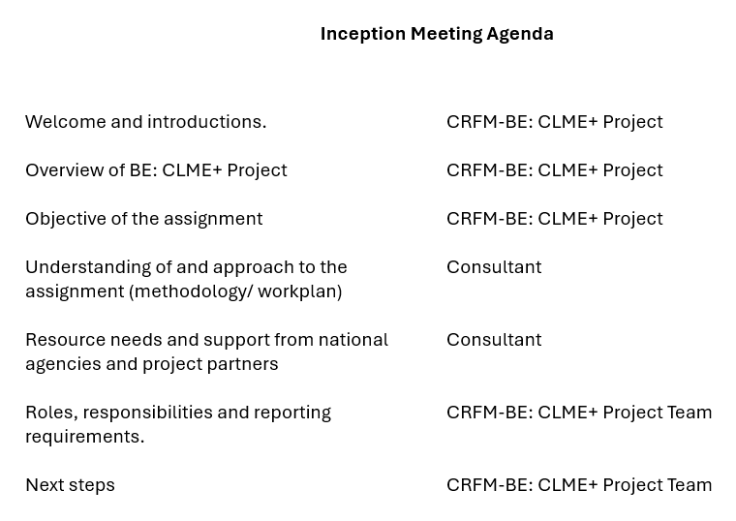
Meeting Participants:
- National Fisheries Agency: Stephen Smikle and Dr. Azra Blythe-Mallett
- CRFM: Allena Joseph and Keegan Slinger
- Data gap and needs consultants: Nancy Montes and Charles Sidman

Appendix 3. List of people who participated in the interviews
NAME | ORGANIZATION
Gavin Bellamy | NFA
Stephen Smikle | NFA
Avery Smikle | NFA
Zahra Oliphant | NFA
Azra Blythe-Mallett | NFA
Anginette Murray | NFA
Jevaune Gordon | NFA
Andre Bingham | NEPA
Carla Gordon | NEPA
Monique Curtis | NEPA
Stephanie Linton | NEPA
Gillian Guthrie | Ministry of Economic Growth and Job Creation
Courtney Cole | Ministry of Agriculture, Fisheries & Mining
Dahlia Kildare Fletcher | Ministry of Agriculture, Fisheries & Mining
Ashley Codner | Planning Institute of Jamaica
Bertran Smith | Maritime Authority of Jamaica
Commander Aceion Prescott | Jamaica Defense Force
Eron Samuels | Marine Police
Andre Clarke | Marine Police
Evan Thompson | Meteorological Office
Shawn Taylor | Jamaican Fisheries COOP Union
Roderick Francis | Industrial Fishers, Conch Cluster of Jamaica
Stephen Rhoden | Caribbean Maritime University
Ingrid Parchment | Caribbean Coastal Area Management Foundation
Donovan Brandon Hay | Caribbean Coastal Area Management Foundation
Inilek Wilmot | Oracabessa Bay Fish Sanctuary
Reanne McKenzie | Negril Environmental Protection Trust
Nickie Myers | Jamaican Alligator Head Foundation
Dannielle Haye | The Forestry Department
Nakhle Hado | Food for the Poor

Appendix 4. Questionnaire used to guide interviews
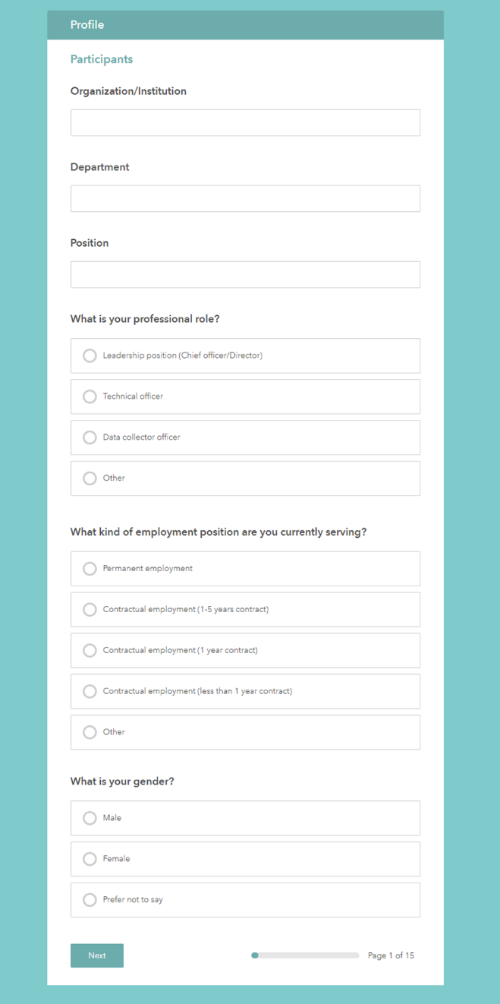 | 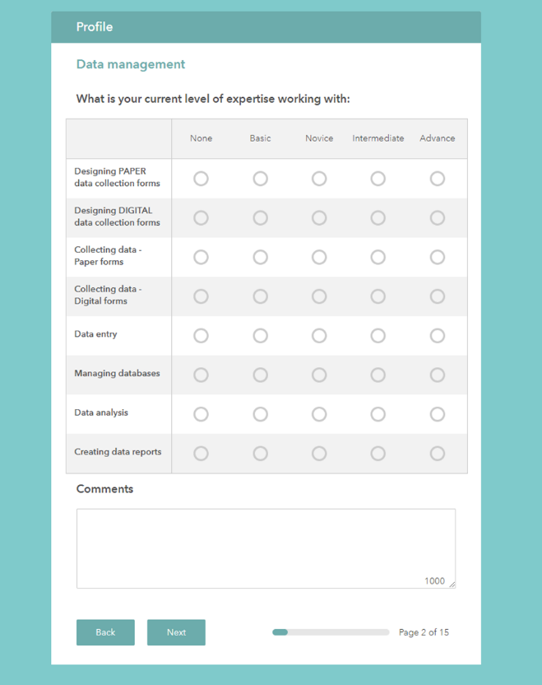
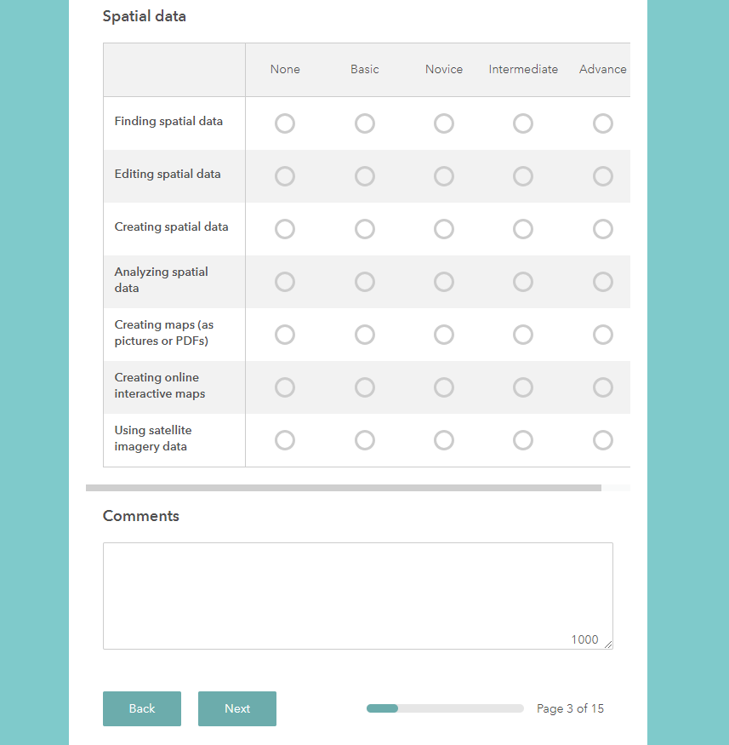 | 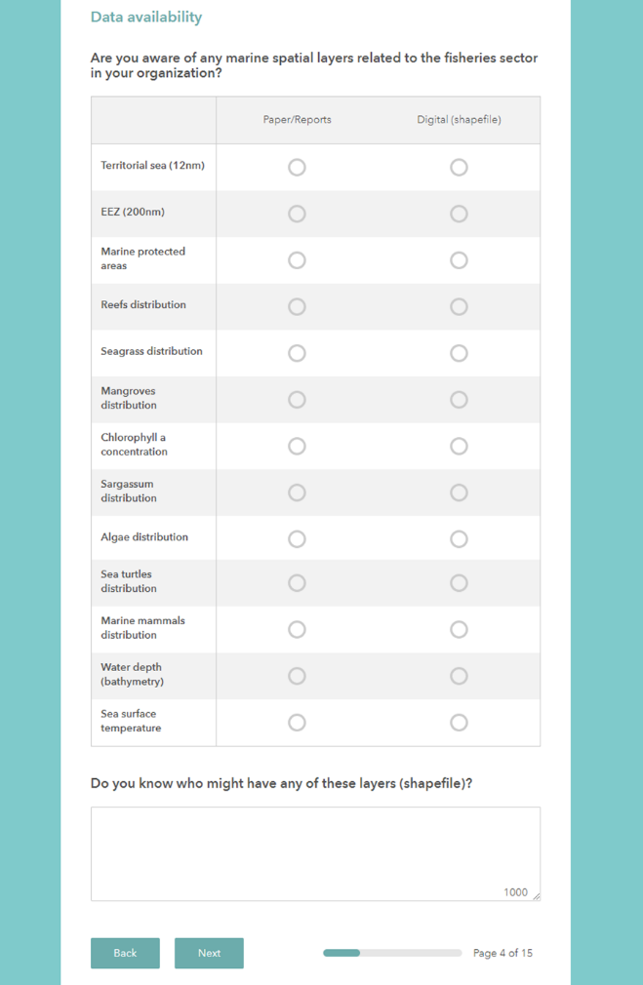
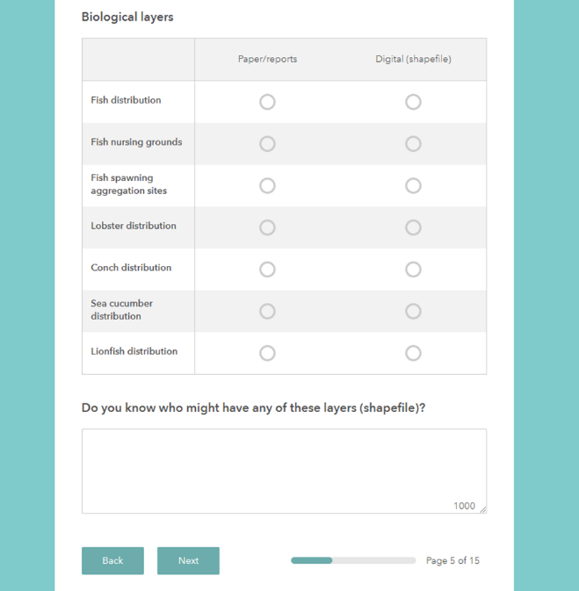 | 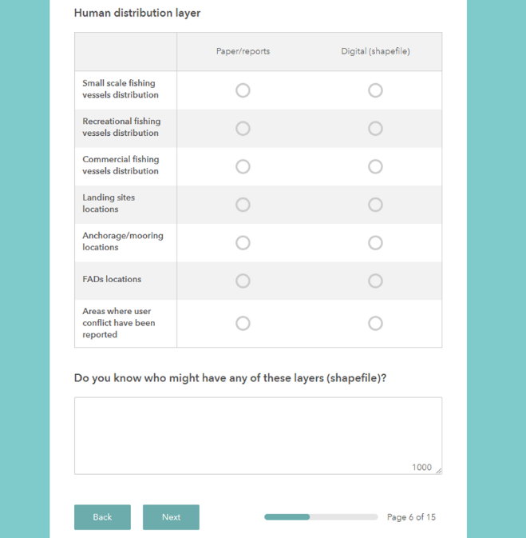
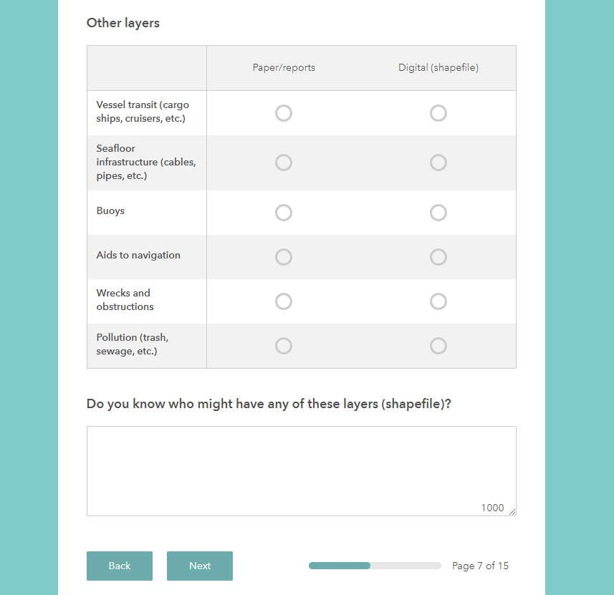 | 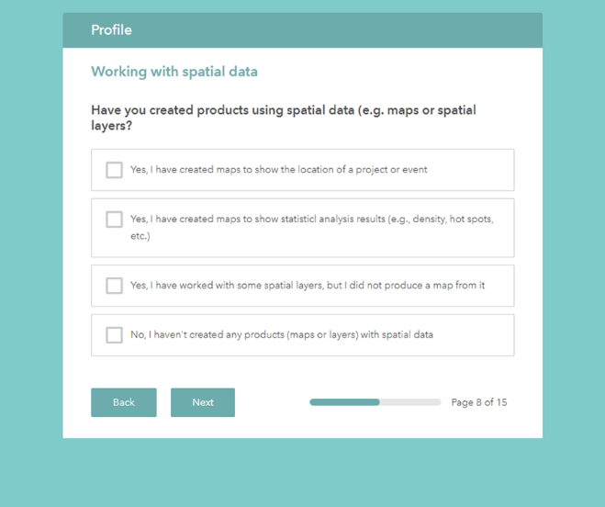
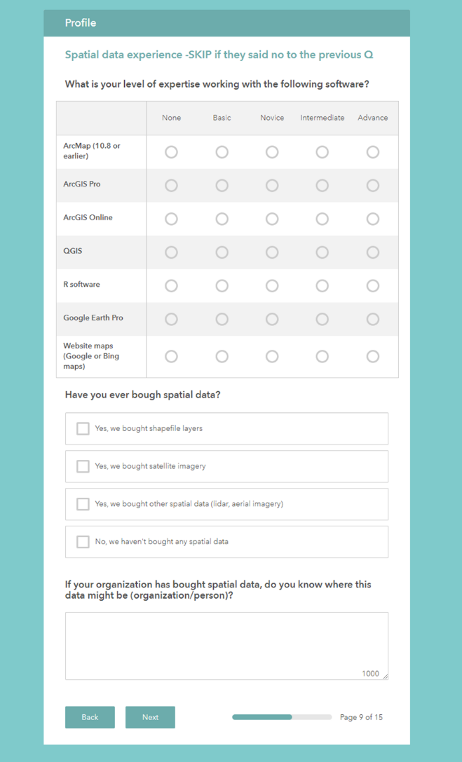 | 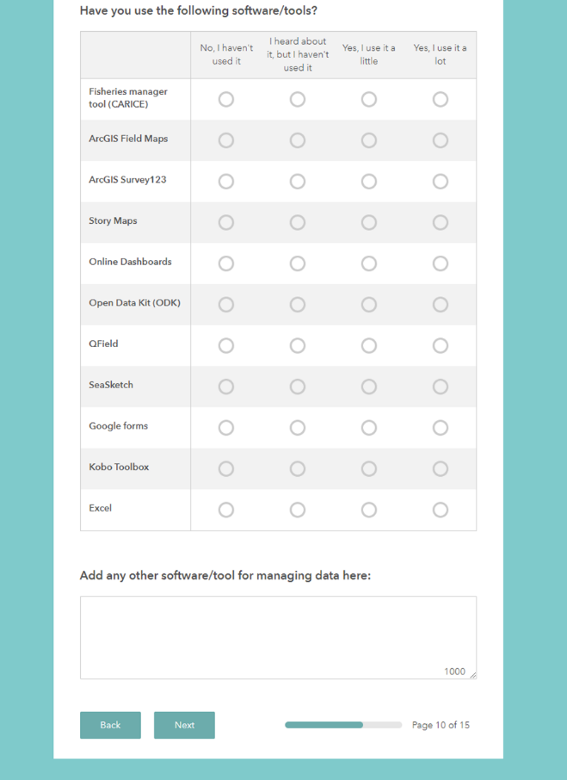
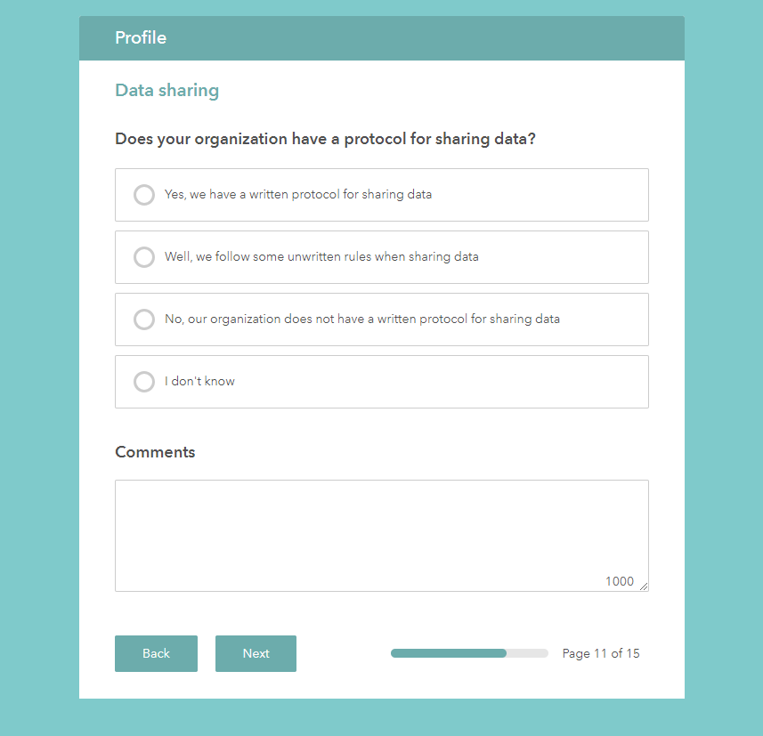 | 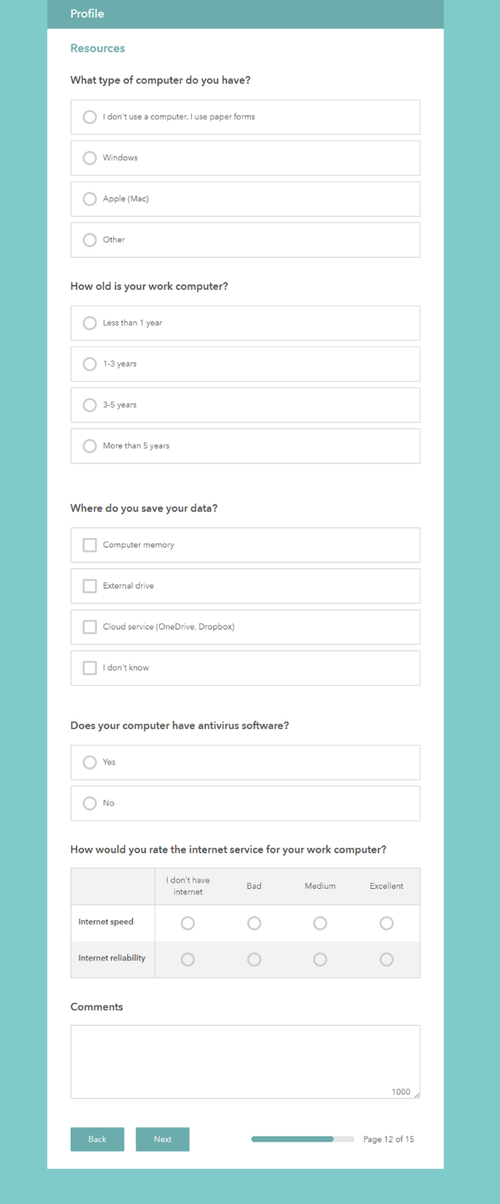
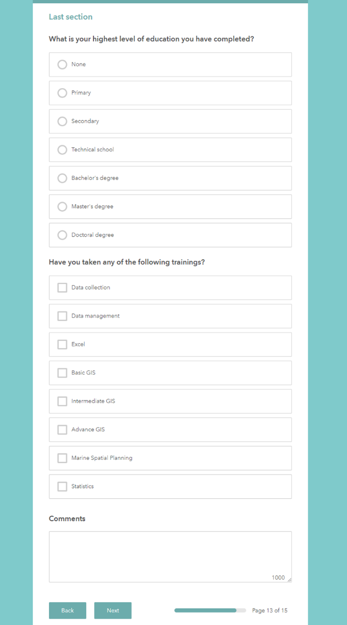 | 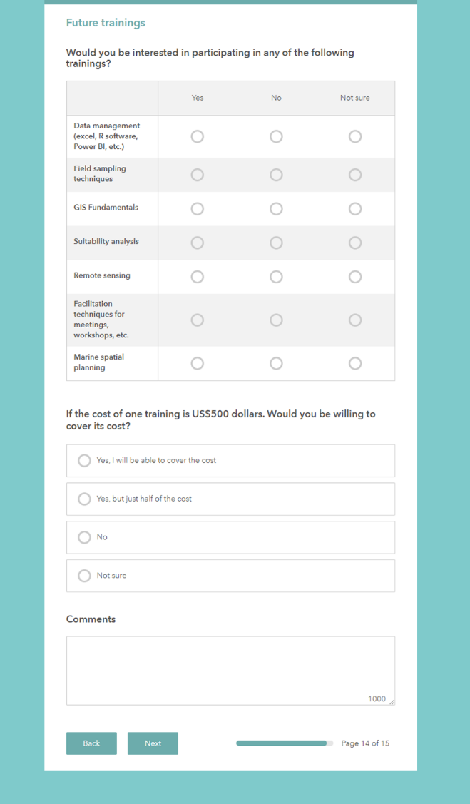
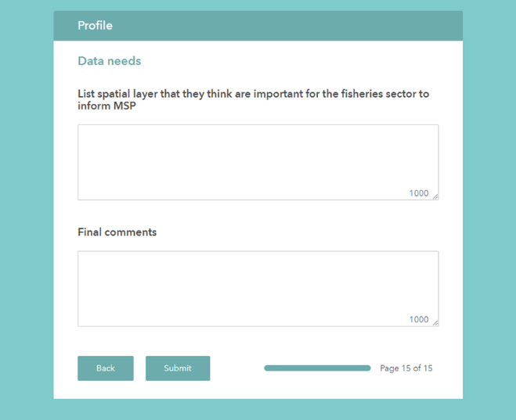

Appendix 5. Working agenda of the virtual national workshop
1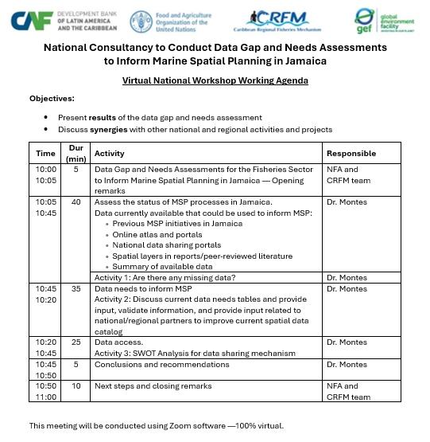 | 2  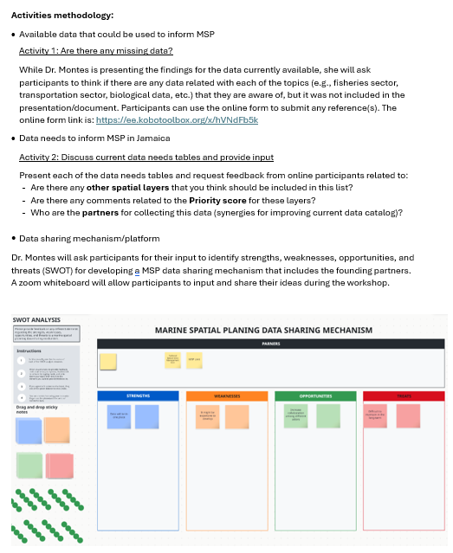

Appendix 6. DRAFT Communication product — Promoting Jamaica’s Blue Economy through Marine Spatial Planning.
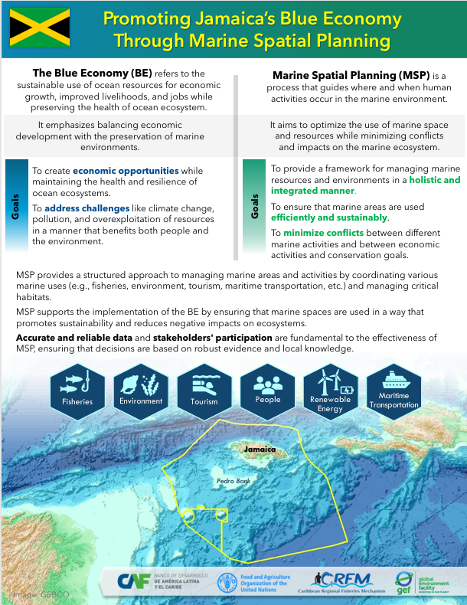

Appendix 7. Communication product —Virtual validation workshop invitation
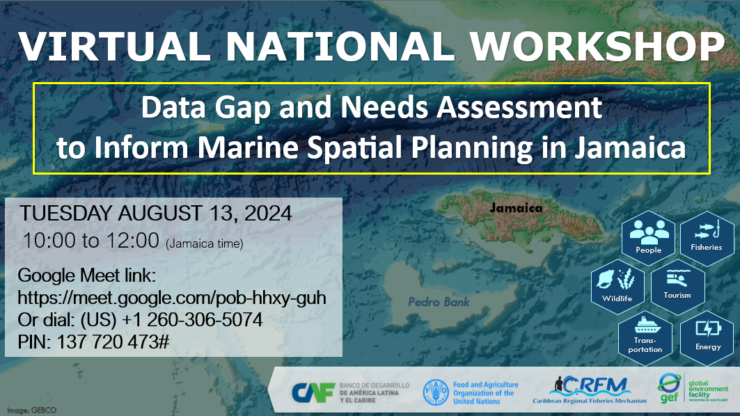

Appendix 8. Virtual validation workshop participants
# | Participants | Organization
1 | Ingrid Parchment | Caribbean Coastal Area Management Foundation
2 | Alex Simpson | Caribbean Coastal Area Management Foundation
3 | Donovan Hay | Caribbean Coastal Area Management Foundation
4 | Keegan Slinger | Caribbean Regional Fisheries Mechanism
5 | Nakhle Hado | Food for the Poor
6 | Jumaine Remikie | Forest Resources Information Management
7 | Sara Simpson | Natural Resource Management & Environment Planning, Urban Development Corporation
8 | Sydney Innis | Jamaica Defense Force
9 | Michelle Topping | Jamaica National Heritage Trust
10 | Mark Alleyne | Ministry of Agriculture, Fisheries & Mining
11 | Zavier Gray | Ministry of Agriculture, Fisheries & Mining
12 | Brittany Bygrave | Ministry of Agriculture, Fisheries & Mining
13 | A. Edwards | National Environment and Planning Agency
14 | Andre Bingham | National Environment and Planning Agency
15 | Chanel Raynor | National Environment and Planning Agency
16 | Ranya Reid | National Environment and Planning Agency
17 | Avery Smikle | National Fisheries Authority
18 | Azra Blythe-Mallett | National Fisheries Authority
19 | Jevaune Gordon | National Fisheries Authority
20 | NFA DataCollectors | National Fisheries Authority
21 | Rachel Feddis | National Fisheries Authority
22 | Selena Ledgister | National Fisheries Authority
23 | Shellene Berry | National Fisheries Authority
24 | Ashley Codner | Planning Institute of Jamaica
25 | Pcole | Planning Institute of Jamaica
26 | Shane Robinson | Caribbean Maritime University
27 | Anna Ebanks-Chin | The Nature Conservancy
28 | Donna Blake | The Nature Conservancy
29 | Chauntelle Green | University of the West Indies
30 | Madeka Henry | University of the West Indies
31 | Mona Webber | University of the West Indies
32 | Nasya Jones | University of the West Indies
33 | Camille Campbell
34 | Hugh Small
35 | Jodi-Ann
36 | Orange River
37 | Sean Townsend | Land Information Council of Jamaica

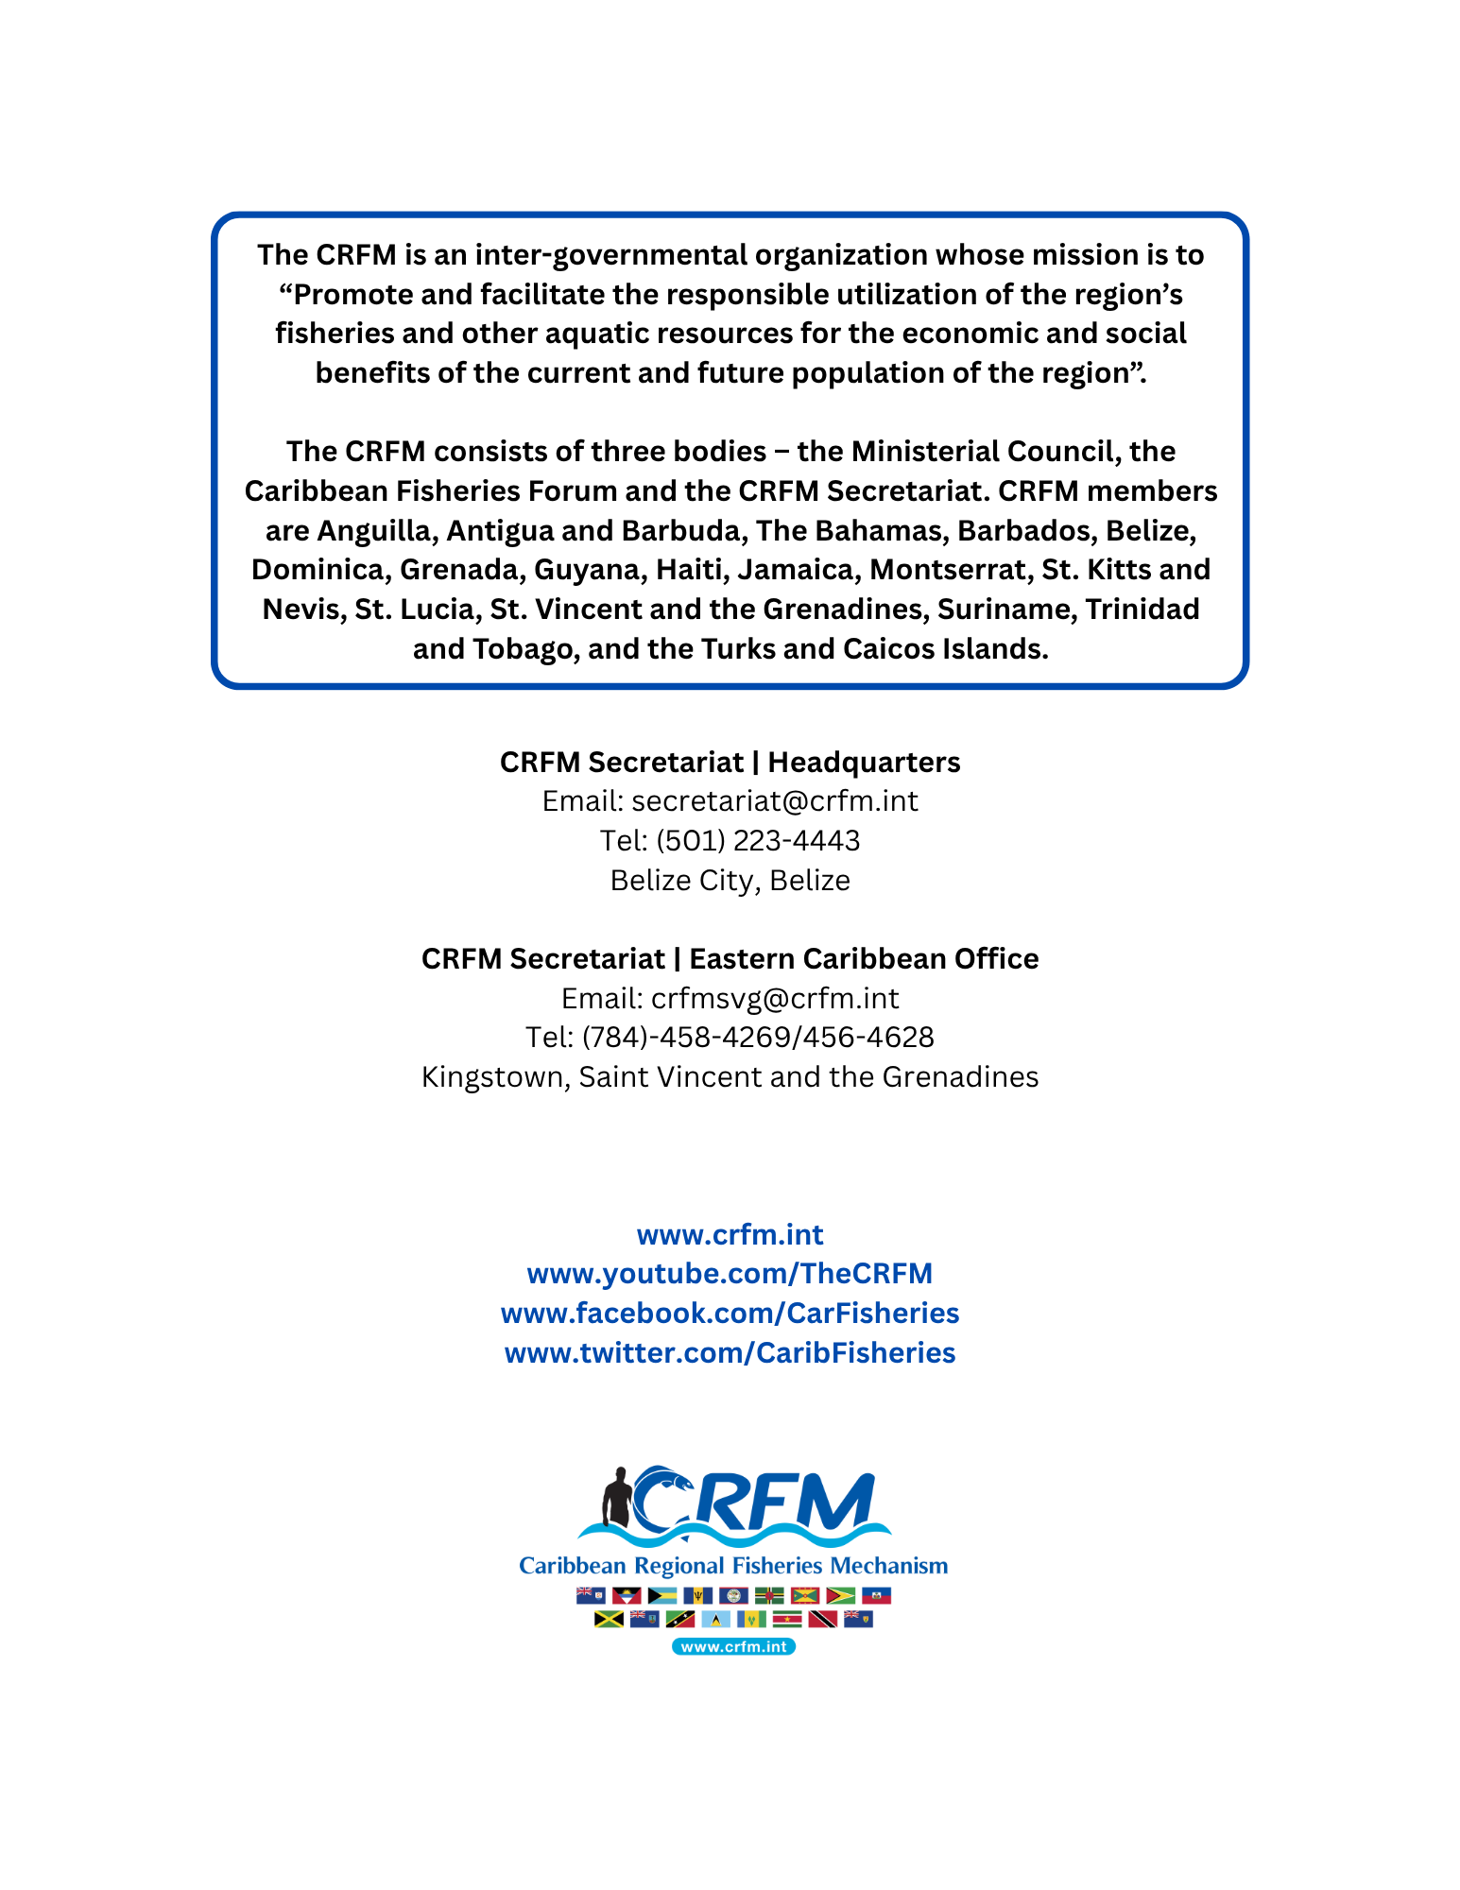

In data management, dynamic data is information that is periodically updated.

