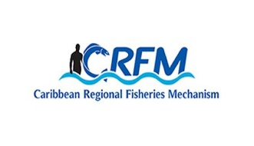
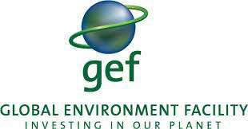
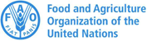


ISSN: 1995-1132

CRFM Technical & Advisory Document
No. 2025 / 10

SAINT LUCIA
MARINE SPATIAL PLANNING PROFILE

CRFM Secretariat
Belize

CRFM Technical & Advisory Document –
Number 2025 /10

Saint Lucia Marine Spatial Planning Profile

Prepared by:

Claire Hedley, Principal Consultant, Howell Marine Consulting
Email: claire@howellmarine.co.uk

Joseph Onwona Ansong, Senior Consultant, Howell Marine Consulting
Email: kofi@howellmarine.co.uk

CRFM Secretariat
Belize
2025

CRFM Technical & Advisory Document Number 2025/10

Saint Lucia Marine Spatial Planning Profile

© CRFM 2025
All rights reserved.
Reproduction, dissemination and use of material in this publication for educational or non-commercial purposes are authorised without prior written permission of the CRFM, provided the source is fully acknowledged. No part of this publication may be reproduced, disseminated or used for any commercial purposes or resold without the prior written permission of the CRFM.

Correct Citation:
CRFM, 2025. Saint Lucia Marine Spatial Planning Profile. CRFM Technical & Advisory Report No. 2025 / 10. 29p.

ISSN: 1995-1132
ISBN: 978-976-8293-98-5

Published by the Caribbean Regional Fisheries Mechanism Secretariat
Belize and St. Vincent and the Grenadines

EXECUTIVE SUMMARY
The Caribbean Large Marine Ecosystem Plus (BE-CLME+) Project aims to promote and further progress a blue economy in the Caribbean Region through MSP and Marine Protected Areas (MPAs) in Barbados, Belize, Guyana, Jamaica, Saint Lucia, and Panama. Under the BE-CLME+ Project, the Caribbean Regional Fisheries Mechanism (CRFM) Secretariat have developed a Caribbean Regional Marine Spatial Planning (MSP) Step-by-Step Guide and Protocol. This Saint Lucia Marine Spatial Planning Profile was produced, following desk-based research and stakeholder feedback, to assess the current status, challenges and opportunities for marine spatial planning in Saint Lucia, in order to inform the development of the Guide and Protocol.
Saint Lucia covers a land area of 616 km² and an Exclusive Economic Zone (EEZ) of approximately 16,000 km² in the eastern Caribbean. The island’s economy is highly reliant on tourism, financial services, and agriculture, with the marine environment playing a crucial role in supporting local livelihoods and natural heritage—highlighted by the Pitons Management Area, a UNESCO World Heritage Site. The island faces environmental challenges including marine pollution, overfishing, habitat loss, and increasing climate change impacts such as sea-level rise and extreme weather events.
Saint Lucia’s marine spatial planning (MSP) is an evolving process aimed at sustainably managing the island’s limited but vital marine and coastal resources to balance economic growth, environmental conservation, and climate resilience. The development of MSP is grounded in a legacy of integrated coastal zone management efforts beginning in the 1990s, including early projects like the North West Coastal Conservation Project and the establishment of the Coastal Zone Management Unit in 2005.
The National Ocean Policy (NOP), adopted in 2020, provides the overarching framework for integrated ocean governance over a 15-year horizon (2020–2035). The NOP establishes high-level goals to optimise benefits from the blue economy, ensure resilience to climate impacts, and protect marine ecosystems and natural capital. Aligned with the NOP is the Saint Lucia Coastal Master and Marine Spatial Plan (CM&MSP), which is now in its implementation phase following formal approval in 2024. The CM&MSP operationalises this vision by defining spatial zones, management measures, and investment opportunities that promote sustainable blue growth, ecosystem-based management, and social inclusivity.
The MSP process follows a comprehensive and participatory approach. Key institutional roles are fulfilled by the National Ocean Governance Committee (NOGC), which coordinates the implementation of the NOP and CM&MSP, bringing together multiple government ministries and agencies including Fisheries, Sustainable Development, Tourism, Ports, and Foreign Affairs. This committee ensures multi-sectoral collaboration, stakeholder engagement, and alignment with regional frameworks.
Stakeholder participation has been integral throughout the MSP development. Engagement activities have included national and community consultations, participatory 3D mapping exercises, training sessions on marine governance and GIS tools, and hybrid workshops validating data assessments and planning priorities. These efforts have sought to integrate the voices of local fishers, indigenous groups, NGOs, private sector stakeholders, and government.
Data collection and management remain foundational to MSP success. A major data gap and needs assessment identified available spatial datasets related to habitats, socio-economic activities, infrastructure, and cultural resources, as well as numerous critical gaps, including fisheries data, water quality metrics, and renewable energy project mapping. A National Spatial Data Infrastructure (NSDI) with the GEOServices platform has been established to centralise geospatial data, though challenges persist around data standardisation and accessibility.
Transboundary cooperation is a guiding principle in Saint Lucia’s MSP, with established maritime boundary agreements with Barbados, Martinique (France), and Saint Vincent and the Grenadines facilitating joint resource management. Regional integration is strengthened through membership in the Organisation of Eastern Caribbean States (OECS) and the Caribbean Community (CARICOM), benefiting from technical and financial support via projects such as the Caribbean Regional Oceanscape Project (CROP), the BE-CLME+ Project, and ProCaribe+. These programs promote shared governance, capacity building, and harmonised policies throughout the region.
Financial mechanisms for MSP are diverse but rely heavily on external funding sources including the Global Environment Facility (GEF), World Bank, and various international climate finance programs. Saint Lucia has developed a Blue Bond Framework aimed at mobilising capital for sustainable marine and coastal management aligned with Sustainable Development Goals (SDGs).
Key challenges remain, including data gaps, limited institutional capacities, fragmented governance, financial sustainability, and environmental pressures from pollution, overuse, and climate change. However, notable successes include the formal adoption of key policy documents, establishment of coordinating bodies, substantial data compilation, and targeted training programs.
Recommendations for advancing MSP in Saint Lucia focus on addressing data and capacity gaps, strengthening legal and governance frameworks, improving financing models, and enhancing public awareness and stakeholder engagement. Continued regional cooperation and integration into global ocean governance frameworks are critical for sustained progress.

Table of Contents
EXECUTIVE SUMMARY i
1 INTRODUCTION 1
1.1 Scope 1
1.2 Context 1
2 MSP OVERVIEW 3
3 MSP PROCESS REVIEW 7
3.1 MSP Vision and Objectives 7
3.2 Role of Institutions and Agencies 10
3.3 Stakeholder Engagement 11
3.4 Data and Evidence 12
3.5 Transboundary Cooperation 13
3.6 Funding MSP Processes 15
4 MSP CHALLENGES 16
5 MSP BEST PRACTICES AND SUCCESSES 18
6 RECOMMENDATIONS 19
REFERENCES 21

INTRODUCTION

Scope
The Caribbean Regional Fisheries Mechanism (CRFM) Secretariat is preparing a Caribbean Regional Marine Spatial Planning Step-by-Step Guide and Protocol under the BE-CLME+ Project, to be delivered by the end of 2025. The Guide and Protocol will align with international best practice for developing and implementing MSP but it will be tailored to the specific challenges and opportunities of the countries participating in BE-CLME+: Barbados, Belize, Guyana, Jamaica, Panama and Saint Lucia.
Consultations took place in each country through July and August 2025 to understand how the Guide and Protocol can best take account of their individual circumstances. The profile provides a detailed overview of the current status of Marine Spatial Planning (MSP), its underpinning drivers and political support, and challenges and recommendations specific to Saint Lucia. This profile was originally prepared in July 2025 in advance of those consultations based on desk-based research using available documents relevant to MSP in Saint Lucia to provide an initial baseline of information. The information was tested and refined through consultation with MSP stakeholders in Saint Lucia, to identify the issues most relevant to the development of the Guide and Protocol.
The recommendations contained in Section 6 reflect recommendations contained in the various evidence sourced reviewed for how Saint Lucia can further progress MSP. They indicate potential future direction of travel for MSP in Saint Lucia and will be used to understand how the Regional Guide and Protocol can support addressing them.

Context
Located north/northeast of the island of Saint Vincent, northwest of Barbados and south of Martinique, Saint Lucia forms part of the Lesser Antilles. It covers a land area of 616 km², has an Exclusive Economic Zone (EEZ) of 16,000 km² (Figure 1) and has an estimated population of around 180,000. Saint Lucia’s economy focuses on tourism, financial services, agriculture and small-scale manufacturing, the former providing our main source of jobs and income. St Lucia’s marine and coastal environment is very important, and the Pitons Management Area was designated as a UNESCO World Heritage Site in 2009.
In addition to climate change, which is seen as a significant threat, local environmental issues include marine pollution, overfishing and the pressures from increased tourism. Drivers of environmental degradation include land clearing, poor construction practices, the release of toxic and hazardous wastes from industrial, commercial and domestic sources, clearing of mangrove systems, near shore development, reduced and polluted river flows, smothering of coral reefs, inappropriate disposal of solid waste and extreme weather events (OECS, 2019).
Saint Lucia’s MSP efforts are rooted in a legacy of coastal zone management projects beginning in the 1990s, progressing through the establishment of regulatory frameworks, institutional units, and participatory marine protected area initiatives. These efforts reflect the island’s growing recognition of the need to balance economic development, environmental conservation, and climate resilience in its sensitive coastal zones.
In 1994, the Government of Saint Lucia launched the North West Coastal Conservation Project (NWCCP), one of the earliest efforts aiming to address coastal and marine resource degradation. This pilot project developed an integrated coastal zone management framework for a priority region on the island, leading to further studies and recommendations on contaminant assessments and watershed interactions.​
Subsequently, recognising the need for a formal institutional framework, Saint Lucia established a Coastal Zone Management Unit (CZMU) within the public sector in 2005, along with a Coastal Zone Management Working Group (CZMWG) involving multiple government agencies. This institutional structure was tasked with implementing the Coastal Zone Management (CZM) policy and guidelines adopted in 2004 by the Cabinet.​ The CZM policy defined the coastal zone spatially and provided strategic guidance for sustainable management, focusing on improving data collection, promoting stakeholder engagement, and facilitating effective inter-agency coordination.
MSP efforts are closely linked with these earlier coastal management foundations but have expanded into a wider ocean governance framework, including the implementation of the National Ocean Policy (NOP).
A notable zoning initiative is the Soufriere Marine Management Area (SMMA), a well-known community-based marine protected area established through participatory approaches involving fishers, local communities, and government stakeholders. The SMMA serves as a model for co-management and zoning-based marine conservation in Saint Lucia. Efforts continue to digitally and physically delineate the SMMA boundaries, strengthen management through by-laws, and explore sustainable financing mechanisms supported by partners like GIZ and MPAConnect.​
This foundation supports ongoing efforts to implement a broader, integrated MSP system that combines zoning, ecosystem-based management, and stakeholder collaboration. The MSP process continues to mature with support from regional and international partners while addressing challenges such as data gaps, institutional coordination, and sustainable financing.
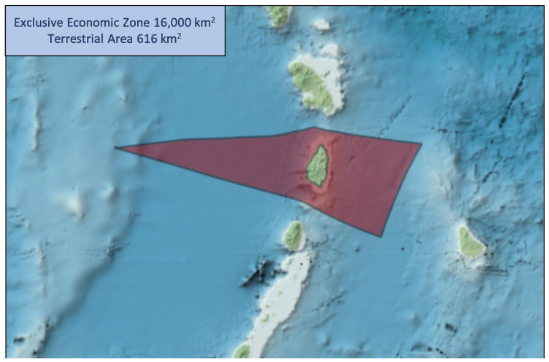
Figure 1. The EEZ of Saint Lucia (Source: www.marineregions.org)

MSP OVERVIEW
This section provides an overview of the status of the Saint Lucia MSP, including underpinning legislation and policy, lead authority, the status of MSP, planning approach and scope.
Table 1. MSP overview
Criteria | Overview
MSP Legislation and Policies | Saint Lucia adopted its National Ocean Policy (NOP) and Strategic Action Plan (SAP) in 2019. The NOP establishes a framework for integrated marine planning and management of Saint Lucia’s marine space and the activities that occur within it from 2020 until 2035. All relevant planning, authorisation or enforcement decisions, or development of government policy, are to take account of the NOP and the supporting SAP.  Saint Lucia’s Coastal Master and Marine Spatial Plan (2020–2035) was developed as a product of the NOP. It serves as the primary spatial planning document for Saint Lucia’s marine and coastal areas. It outlines spatial zones, management measures, and supports the country’s transition to a blue economy.  Saint Lucia’s Strategic Action Plan (SAP) is embedded within the Coastal Master and Marine Spatial Plan. It identifies specific goals, outcomes, and actions aligned with MSP, marine managed areas and marine protected areas (MMAs/MPAs), skills development, and sustainable finance.  Saint Lucia's Sectoral Adaptation Strategy and Action Plan for the Fisheries Sector (Fisheries SASAP, 2018) is primarily focused on climate adaptation, but references MSP as an emerging concept and highlights its relevance for fisheries and coastal adaptation.  Physical Planning and Development Act (2001): Enabling planning and regulation of development on land as well as Saint Lucia’s territorial seas as well as the designation of Environmental Protection Areas.  National Conservation Authority Act (1999): Enabling the designation of protected areas on land or water, including marine protected areas.  Beach Protection Act (1967): Providing for the protection and control of activities on beaches and the seashore.  Fisheries Act (1984): Enabling the management of fisheries and the establishment and protection of Marine Reserves.  Fisheries (Amendment) Act (2023): Amends the Fisheries Act (1984) by inserting two new sections, 22A and 22B. These amendments introduce the concept of a Marine Management Authority, which can be a designated local authority, cooperative, or association within a marine reserve.  Maritime Areas Act (1984): Establishes and defines Saint Lucia's maritime zones, including its territorial sea, internal waters, contiguous zone, and exclusive economic zone (EEZ), enabling national authority over the protection, planning and control of development across the EEZ.  Minerals Vesting Act (1989): Enabling control by the Crown of all minerals within Saint Lucia’s jurisdiction.
Lead MSP Authority | The National Ocean Governance Committee (NOGC), comprising multiple ministries and agencies, has been established to coordinate, monitor, and evaluate the implementation of the NOP, CM&MSP, and the Eastern Caribbean Regional Ocean Policy. This committee provides direct advice to the government and leads MSP implementation efforts.
Stage of MSP | The Saint Lucia’s Coastal Master and Marine Spatial Plan (2020–2035) was endorsed and approved in June 2024 (CRFM, 2024) and they are therefore in the plan implementation phase.
Plan Name/MSP Initiative(s) | Saint Lucia’s Coastal Master and Marine Spatial Plan (2020–2035)  (Hereafter referred to as the CM&MSP)
Plan Scale | The spatial boundary of the MSP (Figure 2) is defined as the combined extent of the territorial seas and EEZ of Saint Lucia, beginning at the baseline coastal boundary (i.e., the shoreline) and extending out to the outer boundary of the EEZ.
Plan Scope | Saint Lucia’s MSP is designed to integrate with land planning through policy alignment, shared data and analysis tools (such as GIS), and a focus on cross-sectoral ecosystem management. This integrated approach is evident in national strategies and policy frameworks, though practical implementation is an ongoing process.  The 2007 National Land Policy explicitly promotes the integration of land use, management, and development considerations with other relevant sectors, including coastal zone management, fisheries, and tourism. The 2009 Protected Areas Systems Plan also promoted the idea that protected areas are part of an integrated land use management system, further supporting cross-sectoral planning. While the CM&MSP’s primary focus is marine and coastal areas, it is designed to complement and align with existing land and coastal management strategies, reflecting a recognition of the interconnectedness of land and sea.
Planning Approach | Saint Lucia’s MSP approach is comprehensive, participatory, and adaptive, aiming to harmonise sustainable economic growth with marine conservation and climate resilience, underpinned by robust policy frameworks and active stakeholder engagement. It uses a combined approach by integrating both a comprehensive policy framework and detailed zoning.
Political Commitment to MSP | Political commitment is high, characterised by both policy development and institutional action:  National ocean policy and strategic plans: The government has developed and adopted the NOP and SAP, and CM&MSP as key mechanisms for transitioning to a blue economy. These documents have been developed with broad stakeholder engagement and are aligned with regional initiatives such as the Caribbean Regional Oceanscape Project (CROP) and the Eastern Caribbean Regional Ocean Policy (ECROP).  Cabinet endorsement and ministerial support: Saint Lucia adopted its NOP in 2020, establishing a 15-year (2020-2035) integrated framework for managing marine resources. The NOP and associated plans are expected to be endorsed at the Cabinet level. The Minister for Sustainable Development has publicly advocated for the ocean governance programme and supports MSP as a means to capitalise on sustainable marine opportunities.  Governance: The National Ocean Governance Committee (NOGC), comprising multiple ministries and agencies, has been established to coordinate, monitor, and evaluate the implementation of the NOP and CM&MSP.  Ongoing legislative and management actions: There are ongoing efforts to establish new MMAs, draft cabinet memos for new marine reserves, and strengthen existing management frameworks, indicating active government involvement and follow-through on MSP commitments.  Regional and international alignment: Saint Lucia’s MSP efforts are supported by international organisations and initiatives providing essential technical, financial, and policy support for integrated ocean governance and sustainable marine management Initiatives include the Caribbean Regional Oceanscape Project (CROP), funded by the GEF and implemented through OECS and the World Bank, which focuses on strengthening ocean governance and MSP capacity. The BE-CLME+ Project, an EU-supported initiative led by the CRFM, promotes participatory MSP and blue economy development across the Eastern Caribbean. Additionally, Saint Lucia benefits from ProCaribe+, which advances MSP in Caribbean sub-regions, and global support through GEF financing, the UNFCCC National Adaptation Plan integration, and UNESCO biosphere reserve programs.

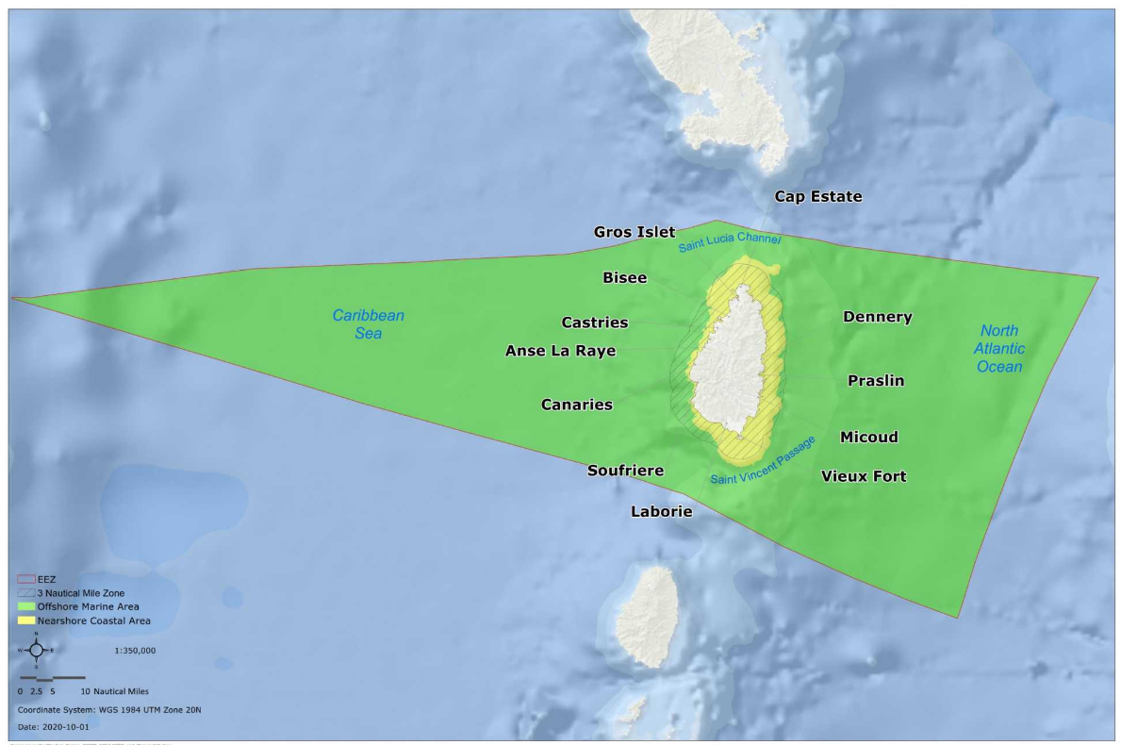
Figure 2. Map of the Saint Lucia MSP areas

MSP PROCESS REVIEW
The following steps (Figure 3) were taken to develop Saint Lucia’s CM&MSP (2020–2035):
- Collection and review of existing background information and data
- Identification and analysis of key stakeholders and vulnerable populations
- Completion of policy, legal and institutional assessment
- Integrated analysis using EBM-DPSER conceptual model
- Definition of marine spatial zoning
- Identification of blue economy investment opportunities
- Evaluation and selection of priority blue economy project profiles
- Preparation of CM&MSP
- Preparation of the implementation and monitoring framework

Stakeholder engagement activities formed a core component throughout the planning process. The approach to stakeholder engagement is described in Section 3.3 of this document.
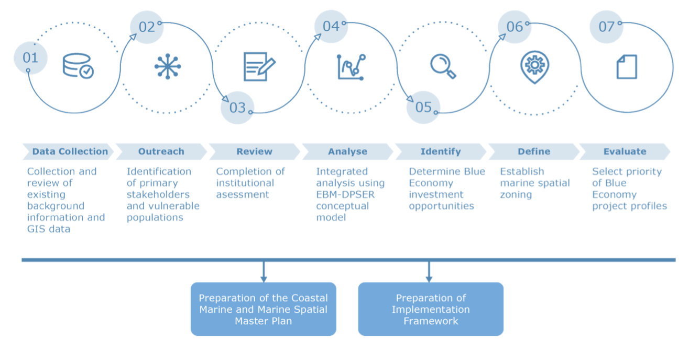

Figure 3. Process to develop the Coastal Master and Marine Spatial Plan (Source: CM&MSP)

MSP Vision and Objectives
The CM&MSP is guided by a vision, 12 core principles, and strategic objectives set out in the NOP (Government of Saint Lucia, 2020).
Actions and measures to achieve the strategic objectives are to be consistent with sector-specific guidance given in the NOP.

NOP Vision
Our coastal and marine resources are sustainably managed to optimise the benefits of the Blue Economy, ensure resilience to climate impacts, protect and restore Saint Lucia’s natural capital and valuable marine ecosystems, and nurture our natural and cultural heritage for the benefit of current and future generations.

NOP Twelve Core Principles
The principles collectively aim to build resilience against economic disruptions, promote environmental stewardship, and ensure social equity, driving Saint Lucia's blue economy initiatives. The effective implementation of MSP also relies heavily on continuous data collection, gap assessment, and extensive stakeholder engagement.
  - Island Systems Management (ISM): This involves a multidisciplinary, integrated approach using adaptive management to address conflicts in resource use and control human intervention impacts. It recognises the unique characteristics of islands and the need for a coordinated framework across land and sea.
  - Ecosystem Based Management (EBM): An integrated resource planning approach that considers the connections between land, air, water, and all living things, including people, aiming to balance conservation, sustainable use, and equitable sharing of common resources.
  - Environmental stewardship: Actions taken by individuals, groups, or institutions to protect, care for, and responsibly use the natural environment, vital for conserving and enhancing biodiversity.
  - Sustainable development: Responsible use and management of ocean resources to support economic growth, environmental health, and social well-being, ensuring long-term benefits without depleting marine ecosystems.
  - Public and private participation: Full involvement from the public, private sector, and non-governmental organisations (NGOs) is essential for credible rules, co-management, and empowering stakeholders in ocean governance.
  - Use of best available evidence, sound science and best practice: Planning and management decisions should be based on the best available information, integrating natural, social, economic, scientific, and traditional knowledge for sustainable resource use.
  - Precautionary approach: Applying risk-based management with precautionary measures when there is a risk to human health or the environment, particularly under scientific uncertainty.
  - Access and benefit sharing: This principle is listed in the NOP's table of contents.
  - Environmental liability: Ensuring fair pricing for access to ocean resources for private profit, with liable parties understanding and acting responsibly on their obligations.
  - Trans-boundary cooperation: Considering the impact of marine spatial plans and activities on neighbouring islands and nations, encouraging cooperative management.
  - Good governance: Public bodies must exercise prudence, responsibility, and accountability, ensuring decisions are proportionate, consistent, and targeted.
  - Gender equality and inclusivity: Promoting equal access to resources, opportunities, and decision-making for all, including marginalised and disadvantaged groups, ensuring their views are considered.
NOP Strategic Objectives
  - Expanded fisheries: Saint Lucia’s fisheries industry is currently artisanal in nature and there is desire to expand the capacity of the sector to harness the opportunities presented from ridge to EEZ, as well as aquaculture and mariculture.
  - Self-sufficiency: Saint Lucia is highly reliant on imported fuel, food, and other products and there are opportunities to increase the self-sufficiency of the island to be more resilient to the impacts of climate change and global market fluctuations.
  - Healthy ecosystems: The availability and health of island’s ecosystems and natural resources are critical to the livelihoods of Saint Lucians. The ability to protect ecosystem health on land and in the ocean is dependent on a unified regulatory framework and effective collaboration between departments.
  - Diverse economy: The economy is highly dependent on the tourism sector and there is a need to diversify the employment base with sustainable blue growth livelihood opportunities and support for local entrepreneurship to reduce unemployment and poverty.
  - Responsible tourism: The tourism industry will continue to be an important economic sector for Saint Lucia and the expansion of this industry should focus on harnessing blue economy benefits sustainably, as the degradation of coastal/marine resources that attract visitors can also be far-reaching and affect other economic sectors.

NOP Priority Sectors
Marine fisheries are important to Saint Lucia and current government policy is to sustainably expand and diversify, to modernise the fisheries sector and increase its contribution to income, employment and foreign exchange earnings.
Marine aquaculture makes a growing contribution to food security and livelihoods, and Saint Lucia is committed to developing the embryonic aquaculture sector.
Marine environment and biodiversity protection supports cultural and social well-being and plays a significant role in the Saint Lucian economy; maintaining and restoring the health and biodiversity of coastal and marine ecosystems is fundamental for environmentally sustainable development.
Surface water management and wastewater treatment and disposal is a concern in Saint Lucia and should be improved for the health of the public and the environment.
Maritime transport and supporting infrastructure such as ports and harbours are vital to the economic growth of the country, which is heavily reliant on sea import/export and cruise ship tourism, and small vessel traffic related to fisheries, local ferry/boating services, and other tourism.
Tourism and recreation are important for the economy and there is a growing interest in eco-tourism and wildlife experiences, which will be enhanced by a well-managed, healthy and safe marine environment with clean recreational waters and healthy ecosystems such as beaches, coral reefs and mangroves.
Coastal developments are particularly vulnerable to the effects of climate change and important actions are necessary to adapt to and reduce the impacts of climate change.
Submarine cables and pipelines are an important part of the infrastructure network for power, information and international telecommunications, and there is an increasing need in the region for electricity interconnectors between islands.

In the context of the NOP vision and principles, the CM&MSP focuses on the following elements:
- Sustainable management of valued ecosystem services
- Integrated and equitable frameworks for managing coastal and marine resources
- Resilience to natural hazards, climate change and climate variability
- Management and sharing of critical data
- Investment opportunities in the marine and coastal zones

Table 2. Priority sectors and national strategic objective alignment (Source: CM&MSP)

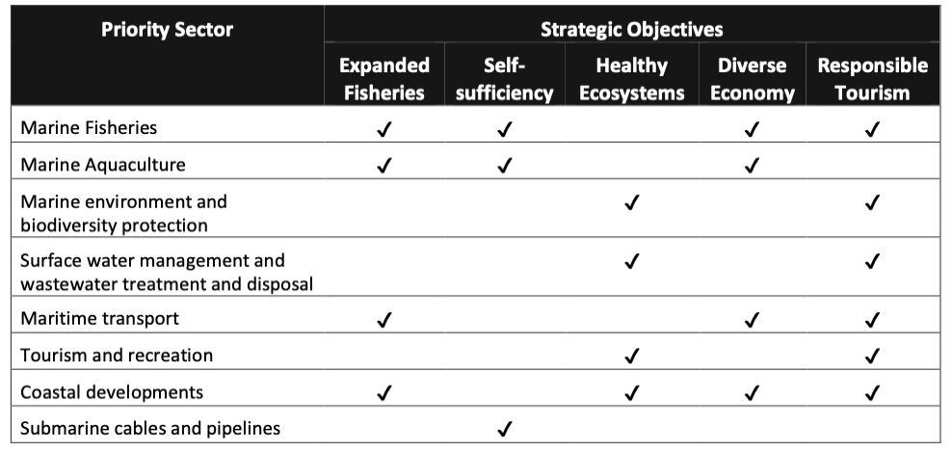

Role of Institutions and Agencies
The roles of MSP institutions and agencies in Saint Lucia are organised through a collaborative, multi-agency approach to ensure coordinated data collection, stakeholder engagement, policy development, enforcement, and sustainable management of Saint Lucia’s marine and coastal spaces. MSP efforts are led by the National Ocean Governance Committee (NOGC) with no apparent single agency taking the ‘lead’ to develop or implement MSP.
National Ocean Governance Committee (NOGC): is responsible for coordinating, monitoring, and evaluating the implementation of the National Ocean Policy, which includes activities relevant to MSP. The committee advises the Government on marine space management. The committee works closely with the relevant ministries and departments responsible for sustainable development, ocean governance, and coastal zone management. The NOGC is composed of representatives from:
- Department of Fisheries (DoF): promotes sustainable fisheries development and participatory management and assists with on-the-ground MSP implementation and data collection. Serves as the focal point for the regional BE-CLME+ Project.
- Sustainable Development and Environmental Division / Coastal Zone Management Unit (CZMU): oversees coastal and marine ecosystem management and integrates climate adaptation and biodiversity conservation into MSP.
- Saint Lucia Air and Sea Ports Authority (SLASPA): manages port operations and maritime safety, contributing data and expertise for MSP.
- Department of Tourism (DoT): represents tourism interests and ensures sustainable use of marine resources in tourism development.
- Ministry of Foreign Affairs: supports international maritime boundaries and agreements relevant to MSP.
- Cross-cutting agencies (Customs, Immigration, Legal, Police Marine Unit, Finance/Economic Development): support regulatory enforcement, legal frameworks, and financial planning for MSP.
- Other supporting agencies: Department of Environmental Health, Water Resources Management Agency, Division of Forest and Lands Resources: Provide expertise and data on environmental health, water, and terrestrial-marine interface management.

Stakeholder Engagement
The stakeholder engagement approach for MSP in Saint Lucia is designed to be inclusive, participative, and interactive, aiming to ensure that the diverse needs and priorities of various groups, from government agencies to local communities, were considered. Key aspects of the stakeholder engagement process are detailed below.
Overarching policy and principles
The NOP emphasises public and private participation as a core principle, advocating for full awareness and participation of the general public, the private sector, and non-governmental organisations (NGOs) to foster credible and accepted rules, co-management, and empowerment in ocean governance and decision-making. The NOP also states that Saint Lucian people will be more involved in their marine area, engaging in planning and decision-making for marine sectors. MSP itself is understood as a public process.
Coordinating bodies
The NOGC plays a central role, tasked with establishing processes to identify and integrate local communities and local industries in developing policies and management strategies for ocean resources. It also works to stimulate participation from public and private institutions, governmental and non-governmental organisations, and civil society.
Stakeholder identification and engagement
As MSP has progressed in Saint Lucia via a range of separate and incremental projects and initiatives, several stakeholder engagement activities have been conducted, primarily under regional projects such as the Caribbean Regional Oceanscape Project (CROP) and the BE-CLME+ Project. Key activities include:
- National and community consultations, workshops, and validation forums for the Coastal and Marine Spatial Plans, involving fishers, private sector actors, government agencies, NGOs, and local communities. (CROP)​.
- Participatory 3D mapping and focus group discussions to capture local knowledge, particularly integrating indigenous and vulnerable communities' perspectives. (BE-CLME+)​.
- Stakeholder capacity-building sessions on marine governance, economic valuation of ecosystem services, and spatial planning tools such as GIS and SeaSketch. (CROP and related initiatives)​.
- A hybrid national workshop was held on 22 August 2024 to validate the findings of data gap and needs assessments for MSP implementation. (BE-CLME+).
- formulation of the National Adaptation Plan (NAP) and its Sectoral Adaptation Strategies and Action Plans (SASAPs), which underpin the MSP, involved extensive consultations and focus group sessions with a "multitude of actors".
- Communication and awareness campaigns to foster environmental stewardship and sustainable marine resource use among coastal communities (Various projects).
Despite robust efforts, participatory stakeholder mapping and engagement for the Caribbean Regional Oceanscape Project (CROP) plans were disrupted due to the COVID-19 pandemic and associated restrictions on in-person meetings. Additionally,, Saint Lucia still faces challenges related to capacity building needs for effective MSP, including limitations in specialised software and equipment, which can impact data collection and analysis efforts that rely on stakeholder input.

Data and Evidence
A data gap and needs assessments to inform MSP implementation in Saint Lucia (CRFM, 2024) found that the Government of Saint Lucia, MSP partners and stakeholders have already generated a substantial amount of MSP data through their on-going work programmes as well as externally-funded projects. The OECS Caribbean Regional Oceanscape Project (CROP) explored various MSP scenarios for Saint Lucia’s EEZ to develop the Master Coastal and Marine Spatial Plan 2020-2030.
Through extensive stakeholder consultation, the assessment (CRFM, 2024a) identified 83 spatial datasets related to the marine environment, categorised into eight broad data types crucial for effective MSP and sustainable resource use. There are 34 datasets associated with the coastal and marine habitat data type in addition to 32 socio-economic datasets and 11 datasets related to protected area and international designations. These datasets are primarily stored in shapefile format, though some are available as maps in PDF project reports, posing a challenge for spatial analysis. Table 3 lists the data available.
Table 3. Available data types identified through the data gaps and needs assessment (CRFM, 2024a)
Theme | Data
Protected areas and international designations | This includes critical conservation areas like marine parks, Ramsar sites, Important Bird Areas (IBAs), and Key Biodiversity Areas (KBAs), ensuring alignment with protection goals and international agreements.
Coastal and marine habitat | Data on ecosystem health and function, such as habitat maps, distribution of nearshore marine habitats, coral reefs, seagrass beds, mangroves, and information on pollution and water quality.
Socioeconomic | Reflecting human dimensions, this includes data on economic activities, social structures, distribution and intensity of fisheries (e.g., fishing grounds, landing sites, mariculture/aquaculture sites), and local community demographics.
Maritime zonation | Information on EEZ, territorial waters, and shoreline boundaries.
Tourism | Datasets on recreational marine use, dive and snorkel sites, recreational beach use, sports fishing areas, and coastal tourism developments.
Cultural | Data on cultural and historical significance, such as shipwreck locations and culturally important coastal landmarks.
Coastal and marine infrastructure | Physical structures supporting marine activities, including ports, harbours, marinas, reverse osmosis plants, and wastewater treatment plants.
Shipping | Logistics of transport and trade routes, including navigation areas, shipping lanes, and vessel tracking data.

Data Gaps
Several key datasets were identified (CRFM, 2024) as either missing or requiring updating but being necessary to support MSP implementation.
Data gaps identified during stakeholder consultations:
- Connectivity between landfill sites and the marine environment (pollution)
- Locations of future renewable energy project/s
- Spatial data on the boundaries of ponds, mariculture areas and fisheries facilities
- Fishing grounds
- Beach and marine use and carrying capacity
- Deepwater benthic contours and habitats
- Desalination plants and brine discharge outflow pipes
- Water quality in coastal areas including within marinas
- Microplastics dispersal and content
- (Demarcation of) MMAs, including Laborie MMA, Micoud (East Coast MMA), and other sites
- identified within the marine protected area and marine management area systems plan
- Stakeholders’ perceptions and ecological knowledge
Previously collected data in need of updating:
- Biodiversity- and environmental-related datasets (including expanding on priority species
- distributions and benthic habitat mapping)
- Navigational charts to be updated regularly with any additional MSP-related datasets

Transboundary Cooperation
Saint Lucia’s NOP includes transboundary cooperation as a guiding principle, ensuring MSP considers impacts on neighbouring countries and promotes joint management of shared resources. Fisheries management, maritime boundary delimitation agreements with Barbados, Martinique (France) and Saint Vincent and the Grenadines, and shared infrastructure projects all require cross-border collaboration. Climate change impacts and ecosystem connectivity, such as migratory species and marine protected area networks, further underscore the need for regional cooperation.
Maritime boundary agreements
Saint Lucia has signed maritime boundary delimitation agreements with both Barbados and Saint Vincent and the Grenadines, which include provisions for cooperation on the protection and preservation of the marine environment and conservation of living resources in the adjoining areas (Government of Saint Lucia, 2020). The agreement with Saint Vincent and the Grenadines further provides for technical consultations and joint management of resources (such as oil, gas, or minerals) straddle the boundary (ref).
Regional policy and governance frameworks
Saint Lucia is a full member of the Organisation of Eastern Caribbean States (OECS), which drives integration and cooperation on environmental and marine issues among its members. The OECS Commission has played a pivotal role in advancing MSP in the region, recognising member states as “large ocean states” due to their extensive EEZs.
CARICOM, the Caribbean Community, is a regional organisation that promotes economic integration, coordination of policies, and cooperation among its member states in the Caribbean. In the context of marine spatial planning (MSP), CARICOM plays a vital role in advancing regional harmonisation of ocean governance, sustainable management of marine resources, and blue economy development. Saint Lucia, as a CARICOM member state, benefits from this regional framework by aligning its MSP efforts with CARICOM-led initiatives. CARICOM supports MSP through regional projects such as the BE-CLME+ Project, which promotes MSP and marine protected areas across Caribbean countries including Saint Lucia. CARICOM also works with partners like the UK government to strengthen ocean governance frameworks and build capacity among member states. This relationship helps Saint Lucia integrate regional protocols, data sharing, fisheries management policies (like the Caribbean Community Common Fisheries Policy – see below), and coordinated environmental strategies into its national MSP development process. Overall, CARICOM strengthens Saint Lucia’s capacity to engage in effective, cooperative transboundary marine spatial planning by coordinating regional projects, ensuring alignment of national MSP efforts with regional priorities, and facilitating dialogue and shared governance across maritime boundaries. It supports development of a Regional Marine Spatial Planning Framework that enables cooperation on transboundary marine issues among OECS Member States, including Saint Lucia, fostering harmonised policies and joint planning for ecosystem resilience and economic sustainability.​ It also provides platforms for knowledge exchange, stakeholder engagement, and integration of international conventions and policies relevant to transboundary MSP under CARICOM-led or affiliated initiatives like ProCaribe+ (see Regional projects below).
Saint Lucia is a party to the Caribbean Community Common Fisheries Policy (CCCFP), which mandates regional cooperation in sustainable fisheries management, food security, and combating illegal, unregulated and unreported (IUU) fishing. The Regional Security System (RSS) provides mutual assistance in maritime policing, fishery protection, and pollution control. Adherence to the UN Convention on the Law of the Sea (UNCLOS), multilateral environmental agreements (MEAs), and International Maritime Organisation (IMO) conventions ensures Saint Lucia’s policies are consistent with global standards.
Regional project initiatives
Saint Lucia actively participates in numerous regional projects that foster transboundary cooperation. The BE-CLME+ Project, involving several Caribbean nations, promotes blue economy development through MSP and marine protected areas. The Caribbean Regional Oceanscape Project (CROP), funded by the World Bank and implemented by the OECS, was instrumental in developing Saint Lucia’s CM&MSP, enhancing coherence in marine planning across the region. The PROCARIBE+ Project, which advances MSP initiatives throughout the Caribbean and Mesoamerican Reef sub-region, provides technical assistance and knowledge exchange.​ Regional training programs and forums such as the MSPforum Latin America and the Caribbean, organised by UNESCO-IOC and partners, develops capacity for implementing MSP and fostering transboundary cooperation.
Data sharing and capacity building
Transboundary cooperation extends to data sharing, coordinated research, and capacity development. Regional entities like the OECS and Caribbean Regional Fisheries Mechanism (CRFM) facilitate joint data collection and knowledge exchange, although challenges remain with data-sharing protocols. Saint Lucia collaborates with regional and international organisations to access expertise and resources and is developing its hydrographic services and marine research strategy to align with regional priorities.

Funding MSP Processes
MSP in Saint Lucia is primarily funded through a combination of external funding mechanisms and international partnerships, with a clear recognition of the need to develop sustainable national financing strategies for long-term implementation (Government of Saint Lucia, 2018; CRFM, 2024).
Key sources of funding and financial initiatives include:
The Global Environment Facility (GEF) is a significant funder, often working through co-implementing agencies like the Development Bank of Latin America and the Caribbean (CAF) and the Food and Agriculture Organization (FAO) of the United Nations for projects such as the BE-CLME+ Project, which promotes blue economy development through MSP.
The World Bank has also provided substantial funding, notably for Saint Lucia's NOP and the CM&MSP under the GEF-6 CROP Programme.
The United States In-Country National Adaptation Plan (NAP) Support Programme (NAP-SP), implemented by the International Institute for Sustainable Development (IISD), has supported the development of Sectoral Adaptation Strategies and Action Plans (SASAPs), including those relevant to marine planning like the Fisheries SASAP (Government of Saint Lucia, 2018) and the Resilient Ecosystems Adaptation Strategy and Action Plan (REASAP) (Government of Saint Lucia, 2020).
Other international donors and partners involved in funding various projects that support MSP, either directly or indirectly through marine and coastal management, include the German Federal Ministry for the Environment, The Nature Conservancy, Building and Nuclear Safety (BMUB) for the Eastern Caribbean Marine Managed Areas Network (ECMMAN) Project, the Inter-American Development Bank (IDB) for the Fisheries Early Warning Emergency Response (FEWER) project, and the Darwin Initiative for projects like "Developing Sustainable Sea Moss Farming Methods".
The Green Climate Fund (GCF) and Adaptation Fund were identified in the SASAPs (Government of Saint Lucia, 2018 and 2020) as potential future sources of climate finance for MSP-related activities.
National contribution
While external funding has been crucial for collecting baseline data and establishing frameworks, it is acknowledged that additional national funding will be necessary for the sustained implementation, monitoring, and evaluation of the MSP and blue economy initiatives.
The NOP aims to be fully costed and aligned with Government sectoral budgets, demonstrating a commitment to integrating ocean governance into national financial planning.
Innovative and emerging long-term sustainable financing mechanisms
Saint Lucia does not yet have an active blue bond in the market, but it has developed and launched a Blue Bond Framework and is preparing for issuance in the near future. According to official statements by Prime Minister Philip J. Pierre in the 2024–2025 budget address (Government of Saint Lucia, 2024) and at COP28, Saint Lucia’s Blue Bond Framework (Government of Saint Lucia, 2023) was introduced to the international finance community in December 2023. This framework is designed to enable the country to issue blue bonds that will fund projects aligned with Sustainable Development Goals (SDGs), particularly SDG 6 (Clean Water and Sanitation) and SDG 14 (Life Below Water).
The framework outlines how blue bond proceeds would be used for environmental, social, and economic benefits, including key projects such as a wastewater treatment plant for the Castries Basin. The government has emphasised that the bond will support Saint Lucia’s National Adaptation Plan, Nationally Determined Contributions, and broader sustainable development priorities.
In addition, there are ongoing collaborations with international partners, such as The Nature Conservancy, to structure debt-for-nature swaps and other sustainable financing mechanisms for marine and coastal conservation. However, as of July 2025, the blue bond has not yet been issued, but all preparatory steps and frameworks are in place to facilitate its imminent launch.

MSP CHALLENGES
Based on the sources reviewed, Saint Lucia's MSP implementation faces several significant and interconnected challenges, stemming from data limitations, capacity constraints, governance issues, and financial dependencies (Commonwealth Secretariat 2018; OECS, 2019; OECS, 2021; Mahadeo, 2022; CRFM, 2024a).

Data limitations and management
- A lack of comprehensive environmental and biological data is a constraint, particularly for offshore areas, which has resulted in less detailed zoning in plans for these regions.
- There is an urgent need for modern data and updated nautical charts to ensure safe navigation and inform coastal development and environmental management decisions.
- Despite the existence of a centralised system, the GEOServices platform remains underused and underpopulated, creating challenges for data sharing. Stakeholders note that data is often not in an easily shareable format (CRFM, 2024a).
- Issues persist with data collection standards and the need for guiding methodologies.
- Specific data gaps identified include information on sector-level socio-economic data, future renewable energy projects, boundaries of mariculture areas and fisheries facilities, deepwater benthic contours, and updated biodiversity and environmental datasets. Climate change modelling, a key decision-support tool, is also limited by data resolution issues.
- Data collected through external projects are not always shared in usable formats, and it is often unclear what data exists and who holds it.

Capacity constraints
- A significant human resource deficit exists across the region, particularly in maritime law, hindering legislative progress for MSP.
- There is a lack of current capacity within national agencies to undertake seabed mapping to modern standards.
- Stakeholders have identified a broad need for training and capacity building in areas such as GIS, data management software applications, remote data collection (including drones and satellite imagery), spatial data analysis, statistical analysis, and qualitative data collection for local ecological knowledge.
- Many agencies lack the necessary capital, technology-forward equipment, and specialised software required for effective MSP data collection and analysis.
- Reliance on external consultants for technical planning due to internal capacity gaps poses a problem for the long-term institutionalisation of MSP in the region.

Governance and legislative gaps
- The NOGC, while central, has no legal responsibilities and cannot compel the Government to act on its recommendations.
- Most MSP plans are non-legislated, placing MSP in a precarious position as legislation is crucial for achieving goals and ensuring enforcement.
- There is ambiguity surrounding who has the authority or mandate for planning at the national level, partly due to the unique regional project arrangements.
- Responsibilities for protected area management are fragmented across various agencies, indicating a need for a single coordinating mechanism.

Financial sustainability
- MSP processes have primarily relied on external funding, which creates uncertainty regarding the continuity of the planning cycle beyond initial project phases.
- There is a lack of dedicated budget allocation for MSP within national government structures.
- Sustainable financing mechanisms are essential for long-term implementation, monitoring, and management of the marine space, including reinvesting revenue from blue economy initiatives.

Implementation and awareness
- Moving beyond the planning phase to actual implementation remains a challenge for all processes.
- The lack of training provided to stakeholders before and during the planning process means they are often ill-equipped to effectively carry out their roles in plan implementation.
- A limited awareness and understanding of MSP and the blue economy among stakeholders and the public can hinder support and buy-in. This highlights the need for continuous dialogue and communication efforts [conversation history].
- The disruption caused by the COVID-19 pandemic impacted participatory stakeholder mapping and engagement, forcing greater reliance on external consultants [conversation history].

Environmental and sectoral pressures
- Saint Lucia faces significant environmental degradation from marine pollution, overfishing, and tourism pressures.
- The intensification of human activities in marine areas can lead to greater user conflicts and increased pressure on fragile ecosystems, with demand potentially exceeding sustainable capacity.
- There are concerns about climate change impacts, such as rising sea levels, increased storm frequency, ocean acidification, and their effects on marine ecosystems and livelihoods. The cost of inaction on climate change is projected to be a significant percentage of GDP.
- The risk of ad hoc, piecemeal development in unplanned offshore areas by investors is a concern.
- Existing plans provide limited information on how cumulative impacts will be assessed.

MSP BEST PRACTICES AND SUCCESSES
Saint Lucia has made significant strides in MSP with best practices and successes in MSP development and implementation. These achievements are rooted in a combination of strong policy frameworks, dedicated data management, and collaborative partnerships.
Examples of best practice include:
Integrated policy frameworks: a comprehensive and fully endorsed NOP and Strategic Action Plan that serves as a high-level planning document guiding operational decisions for marine space management. Complementing this is the CM&MSP which is designed as a "living document" that will adapt with new data and evolving conditions.
Ecosystem-Based Management (EBM) and Island Systems Management (ISM): the NOP explicitly embeds EBM and ISM principles, encouraging integrated management across land and sea and aiming to balance conservation with sustainable resource use.
Evidence-based decision-making: a core principle of Saint Lucia’s MSP is the reliance on best available evidence, sound science and best practice. MSP itself is inherently a data-driven approach that uses scientific and geospatial information to inform decisions on marine resource use and management.
Inclusive stakeholder participation: the NOP champions public and private participation, ensuring government bodies, non-governmental organisations (NGOs), private sector entities, and local communities are actively involved in the planning, decision-making, and implementation processes of ocean governance. Consultations with a broad range of stakeholders were integral to developing policies like the Fisheries and Resilient Ecosystems Sectoral Adaptation Strategies and Action Plans (SASAPs).
Strategic capacity building and training: there is a recognised need and ongoing effort to build capacity across various agencies. The NOP’s Strategic Action Plan includes developing a Blue Economy skills strategy, and implementing training programs in critical areas such as GIS, data management, remote data collection, and ocean governance to ensure long-term MSP success.
Innovative financing mechanisms: Saint Lucia’s Blue Bond Framework aims to restructure sovereign debt to channel funds directly into marine and coastal conservation efforts, setting a progressive example for long-term financial sustainability of MSP.
Integration with climate change adaptation: the development of SASAPs for sectors like fisheries and resilient ecosystems demonstrates a commitment to building climate resilience and addressing climate risks within marine planning.

Key successes include:
Formal policy and plan adoption: successful development and formal endorsement of the NOP and the CM&MSP in June 2024 are significant achievements, providing the overarching framework for integrated marine management.
Substantial data collection and availability: Saint Lucia has gathered a substantial amount of MSP data through ongoing national work and externally funded projects.
Establishment of centralised data infrastructure: the GEOServices platform as part of Saint Lucia’s National Spatial Data Infrastructure (NSDI), a collaborative effort with the World Bank, marks a success in centralising, standardising, and promoting the sharing of geospatial data according to FAIR Data principles.
Implementation of supportive projects: Numerous projects since 1995 have contributed directly and indirectly to MSP, yielding valuable data and frameworks. Examples include the Caribbean Regional Oceanscape Project (CROP) which explored MSP scenarios and produced the CM&MSP, and the Eastern Caribbean Marine Managed Areas Network (ECMMAN) Project, which strengthened existing and established new marine management areas.
Developed institutional structures: establishment of the NOGC to coordinate, monitor, and evaluate the implementation of the NOP, acting as a crucial focal point for MSP initiatives.
Public awareness materials: communications materials on MSP have been developed to enhance public understanding and support for the project, covering key aspects of Saint Lucia's blue economy and MSP priorities.

RECOMMENDATIONS
The recommendations below reflect recommendations set out in the evidence sources reviewed when developing this profile and some of these may have already been implemented. The list also includes some suggestions based on challenges and limitations identified in the evidence sources. They indicate the potential direction of travel for Saint Lucia MSP, and they will be tested and developed further through consultation with MSP stakeholders in Saint Lucia to understand the feasibility and practicality of actioning them, which will inform the Guide and Protocol.
To effectively progress its MSP, Saint Lucia should focus on several key areas, including reviewing and prioritising actions and recommendations already set out in existing documents, such as the NOP, CM&MSP, and the data gaps and needs assessment.
Data collection and management
- Address specific data gaps, including spatial information on coastal wetlands, mariculture areas, fisheries facilities, future renewable energy projects, fishing grounds, deepwater benthic contours and habitats, water quality (especially in marinas), and microplastics dispersal.
- Improve data governance, storage, and management to ensure data is well-managed, complete, accurate, and accessible.
- Leverage the existing GEOServices platform, part of Saint Lucia's National Spatial Data Infrastructure (NSDI), as a centralised system to reduce redundancy and enhance efficiency.
- Strengthen legislation and protocols for data sharing among agencies and with external consultants and convert existing datasets into spatially compatible standardised formats.
Targeted capacity building and training
- Prioritise training in qualitative data collection, remote data collection (drones, satellite imagery), data management software (Excel, GIS), spatial data analysis (GIS software), and statistical data analysis and modelling (e.g., fish stocks, vessel monitoring systems).
- Develop a long-term capacity development plan to transfer knowledge and skills to local personnel, thereby reducing reliance on external experts.
- Address the current institutional capacity limitations caused by fragmented data management and limited resources through enhanced training and infrastructure.
Technology and Equipment
- Procure essential equipment such as aerial and underwater drones, in-field data collection tools (tablets, GPS units), water quality monitoring equipment, and high-performance laptops.
- Acquire specialised software and subscriptions, including GIS software licenses and fisheries data collection software.
- Expand the Vessel Monitoring System (VMS) program for enhanced fishing data.
Governance and legal frameworks
- Develop and implement national systems of coastal and MSP, alongside appropriate policy, regulatory, and voluntary mechanisms for coordinated decision-making.
- Formalise the annual interim review of the NOP by the NOGC to ensure continuous performance and relevance.
- Review and revise national hydrographic and maritime boundary baselines and implement domestic legislation.
- Develop a National Maritime Transport Policy in alignment with International Maritime Organization (IMO) requirements.
- Develop and enforce regulatory systems for human activity management, a marine pollution strategy, and an Invasive Alien Species (IAS) Bill.
- Ensure the seamless integration of the NOP with climate change adaptation policies, and mainstream sustainable use of marine resources within national policies.
- Coordinate monitoring and research activities to produce a comprehensive National Ocean Status report.
Sustainable financing mechanisms
- Explore diverse funding mechanisms such as private-public partnerships, blue/green carbon credits, and conservation trust funds.
- Ensure the NOP and the CM&MSP are fully costed and aligned with government sectoral budgets, with clear finance and co-financing mechanisms identified.
Enhanced public awareness and stakeholder engagement
- Develop effective communication materials for MSP to increase public understanding of the ocean's importance.
- Actively involve civil society and local communities in planning and decision-making processes.
- Ensure citizens have access to information regarding marine management and spatial planning through digital tools.

REFERENCES
BIOPMA (2017). Legal Analysis of the Saint Lucia Legislative and Governance Framework for Protected Areas.
https://www.cbd.int/doc/c/8ba4/74e5/338b76537a4522dd68bf0f34/mcb-em-2018-01-saintlucia-submission5-en.pdf

UK Government Commonwealth Secretariat. (2018). Enabling safe and sustainable marine economies across Commonwealth Small Island Developing States. Saint Lucia Country Review. Commonwealth Marine Economies Programme.

CRFM. (2024). Caribbean Community Common Fisheries Policy. CRFM Special Publication, No. 26.ISSN-1995-4875.

CRFM. (2024a). Data Gap and Needs Assessments to Inform MSP Implementation in Saint Lucia. CRFM Fishery Report, GEF Project ID 10211.

Government of Saint Lucia. (2007). National Land Policy. https://archive.stlucia.gov.lc/docs/NationalLandPolicy.pdf

Government of Saint Lucia. (2018). Saint Lucia’s Sectoral Adaptation Strategy and Action Plan for the Fisheries Sector (Fisheries SASAP) 2018-2028.
https://www4.unfccc.int/sites/NAPC/Documents/Parties/SLU-Fisheries-SASAP-May-2018.pdf

Government of Saint Lucia. (2020). Saint Lucia’s Resilient Ecosystems Adaptation Strategy and Action Plan (REASAP) 2020–2028.

Government of Saint Lucia. (2023) Saint Lucia Blue Bond Framework. https://www.govt.lc/media.govt.lc/www/resources/publications/saint-lucia-blue-bond-framework-final-29nov0.pdf

Government of Saint Lucia. (2024). Building our Infrastructure for a Resilient Economy. Prime Minister Philip J. Pierre Budget Address 2024-2025. https://www.govt.lc/media.govt.lc/www/pressroom/news/attachments/prime-minister-philip-j.-pierre-budget-address-2024-2025--2-.pdf

International Maritime Organization (IMO). (2017). Maritime Boundary Treaty between Saint Lucia and Saint Vincent and the Grenadines. https://www.un.org/depts/los/LEGISLATIONANDTREATIES/PDFFILES/TREATIES/SaintLuciaStVincentTreaty.pdf

Mahadeo, S., (2022). Marine spatial planning in the Eastern Caribbean: Trends and progress. Marine Policy 145 (2022) 105277.

Organisation of Eastern Caribbean States (OECS0. (2009). A Systems Plan for Protected Areas in Saint Lucia. OECS Protected Areas and Associated Livelihoods Project Report.
https://rris.biopama.org/sites/default/files/2021-03/St.%20Lucia%20Protected%20Areas%20System%20Plan%20(2009).pdf

Organisation of Eastern Caribbean States (OECS). (2019). Saint Lucia National Ocean Policy. OECS Commission.
https://oecs.int/en/our-work/knowledge/library/ocean-governance/saint-lucia-national-ocean-policy

Organisation of Eastern Caribbean States (OECS). (2021). Saint Lucia Coastal Master and Marine Spatial Plan. OECS Commission.
https://oecs.int/en/our-work/knowledge/library/ocean-governance/saint-lucia-coastal-master-and-marine-spatial-plan

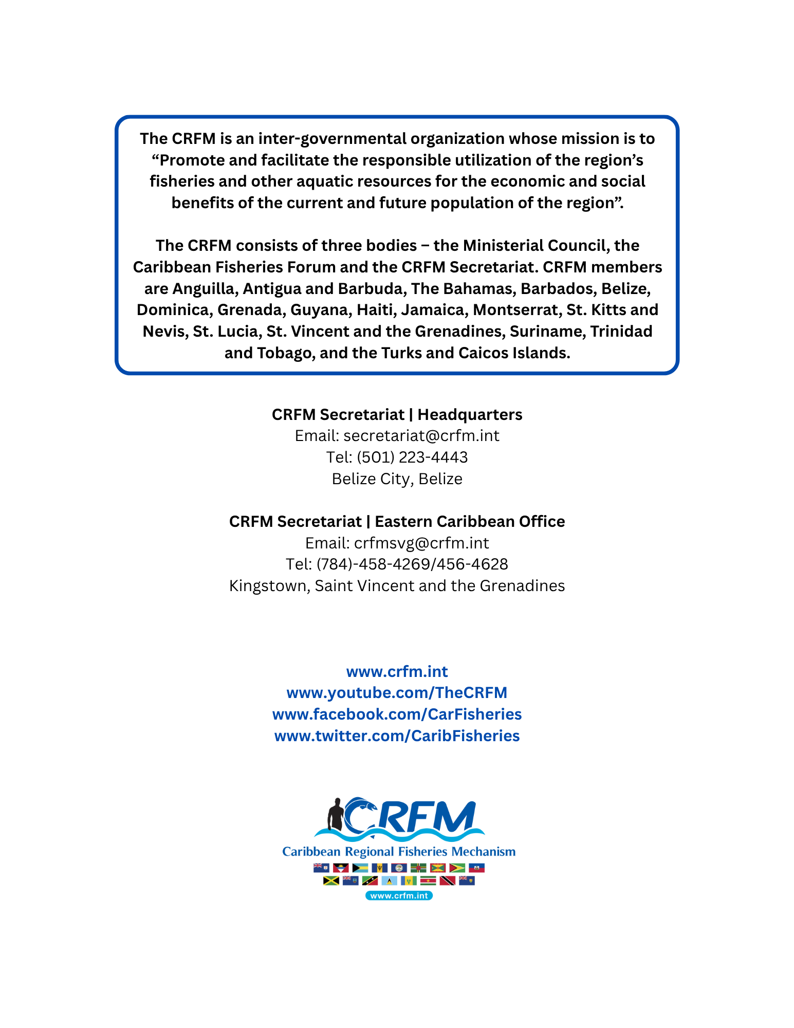

https://www.worldometers.info/world-population/saint-lucia-population/. Accessed 2 October 2025.

