Data Gap and Needs Assessment to Inform MSP in Belize

Communication and Visibility Material
Prepared for: Caribbean Regional Fisheries Mechanism

Submitted by: Science for Sustainability Ltd (SSL).

August 12, 2024
communication and visibility material on the Data Gaps and Needs Assessment to inform MSP, intended as informational content for dissemination among BSOP stakeholders and the general public in Belize and for sharing with the CRFM’s Knowledge Management and Information System and the broader regional network.

CONTENT MATERIAL (in PDF format) FOR:

- A webpage to be hosted on CZMAI’s website presenting information on the data gaps and needs assessment to inform MSP, intended for technical and general audience;
- Social media trivia content delivering questions and answers on the data gaps and needs assessment to inform MSP, intended for a general audience.

- Content for a webpage to be hosted on CZMAI’s website presenting information on the data gaps and needs assessment to inform MSP, intended for technical and general audience.

Data Gap and Needs Assessment to Inform MSP in Belize

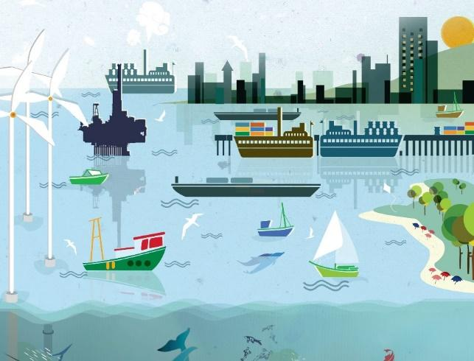
WHAT IS MARINE SPATIAL PLANNING?
Marine Spatial Planning (MSP) is a public process of analyzing the spatial and temporal distribution of human activities, habitats and natural resources in marine areas in order to designate specific use zones to achieve ecological, economic and social objectives that have been specified through a political process.

MSP is a practical way to create and establish a more rational use of Belize’s marine space and the interactions among users, to balance demands for development with the need to protect the environment, and to deliver social and economic outcomes in an open and planned way. This is done through the development of a Marine Spatial Plan.

[Photo of community engagement with stakeholders from ocean space]

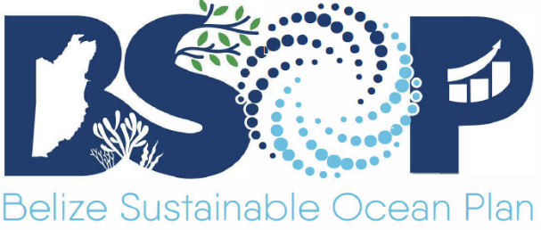
WHO IS INVOLVED IN THE PROCESS?

As part of its commitments under the Blue Loan Agreement, Belize is obligated to produce a Marine Spatial Plan that brings together multiple users of the sea – including energy, industry, government, conservation and recreation – to make informed and coordinated decisions about how to use marine resources sustainably. The Coastal Zone Management Authority and Institute has been designated the MSP lead coordinating agency. Belize’s MSP is known as the Belize Sustainable Ocean Plan (BSOP).

HOW IS THE MARINE SPATIAL PLAN OR BSOP DEVELOPED?
MSP uses spatial data to prepare maps that show a more comprehensive picture of the marine area – identifying where and how an ocean area is being used and what natural resources and habitats exist but that also depict zones or areas for managed use and planned or future uses. MSP involves a variety of steps which include:

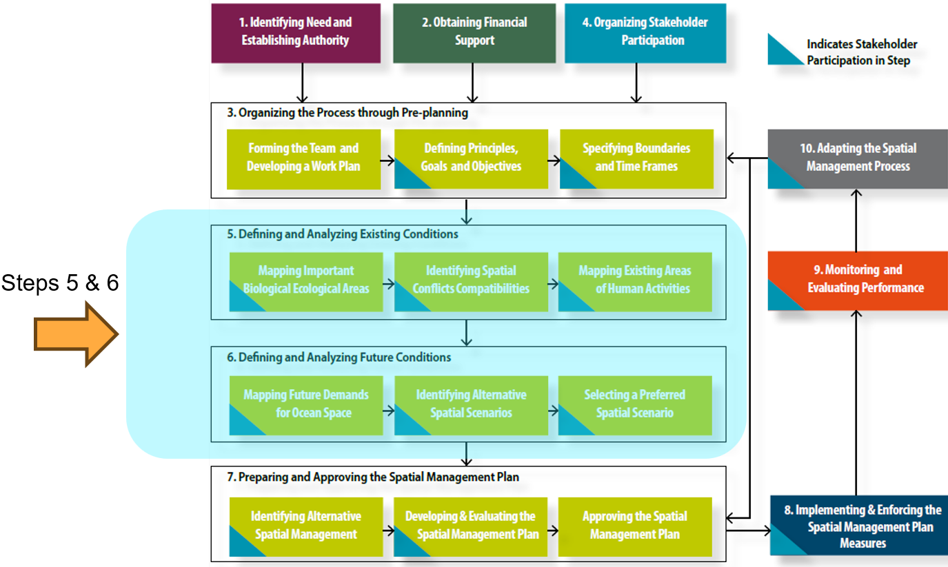

Steps in the MSP process, highlighting the steps where spatial data is needed (From Ehler and Douvere, 2009).


WHY IS DATA IMPORTANT TO MSP?

To develop a marine spatial plan, it is important to first define and analyze existing conditions and then define and analyze future conditions. This involves assessing the status of the coastal and marine environment and collecting a wide range of baseline data. It should also consider trends and developments in uses and pressures.

Data should be up-to-date, objective, reliable, relevant and include biological and ecological features, distribution of human activities along with oceanographic and other physical environmental features.

The general expected outputs of data analysis include inventories and maps of important biological and ecological areas, current and future human activities and pressures, new demands on ocean space, identifying possible alternative future scenarios, and identification of possible conflicts and compatibilities between existing and future human uses and the environment.

The data needed for MSP must take into consideration what data is already available to meet MSP objectives so that gaps may be identified and filled in time to meet planning objectives.


METHODOLOGICAL APPROACH

To provide a comprehensive assessment of where Belize is currently in terms of data availability and data gaps, AND technical capacity needed for data collection, storage and analysis for MSP, the following stakeholder-driven consultative and analytical approach was followed.

A list of essential data needed for MSP was compiled based on MSP best practices, by reviewing BSOP related documents, and by reviewing the data needs identification process used in similar countries' MSP.

A hierarchy of data categories was developed based on Lightsom et al (2015) and using the BSOP categories. This allowed for all categories to be examined for data availability and gaps. The list of data needed for MSP from step 1, was aligned to these categories.

Information on MSP data and capacity gaps, and priority data and capacity needs in Belize, was collected from key stakeholders using online surveys, one-on-one meetings, examination of local data centres, focus group discussions and a validation workshop.

A Microsoft Excel data catalog for marine and coastal data was developed with relevant metadata (e.g. spatial and temporal extent) for each dataset and analyzed to examine gaps and priorities for MSP. The data catalog is available for download (here) as a separate file.

[Can insert a picture here from the validation workshop with the caption: “Stakeholders validating the data catalog at workshop in CZMAI’s conference room on 9 August 2024”]


MAIN FINDINGS

Data Needs and Gaps: Belize has considerable data on various marine ecosystems and human activities. A total of 229 datasets were identified as relevant for Marine Spatial Planning (MSP) in Belize. These datasets span multiple categories, including governance, infrastructure, living resources, non-living resources, and ocean uses.

Out of the 229 identified datasets, 137 datasets (or 60%) are already available. These datasets cover areas such as fisheries, marine biodiversity, and habitat mapping. The remaining 92 datasets (40%) were identified as gaps, meaning that these datasets are currently unavailable or incomplete. These gaps are particularly prominent in emerging sectors like deep-sea minerals, offshore renewable energy, and biopharmaceuticals. Data availability by category was as follows:
Governance: 5 out of 7 datasets available.
Infrastructure: 10 out of 14 datasets available.
Living Resources: 47 out of 75 datasets available.
Non-living Resources: 12 out of 29 datasets available.
Ocean Uses: 63 out of 104 datasets available.

While progress has been made in collecting data for traditional sectors, significant gaps remain in newer and emerging sectors to support comprehensive marine spatial planning in Belize.
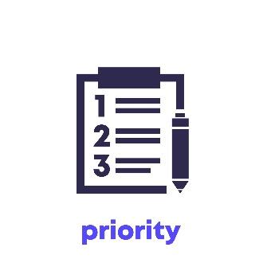
Priority Data Gaps: As highlighted by stakeholders, these data gaps include essential datasets on biodiversity, land tenure, hydrography, and coastal geomorphology. For emerging sectors, there is an urgent need for baseline data to support future development, such as in marine renewable energy and biopharmaceutical exploration.


Significance of Data Gaps: Data gaps could delay Belize's progress toward achieving its conservation and development goals, particularly the country’s target of effectively conserving and managing 30% of its marine territory as marine protected areas (MPAs) by 2026. Without a complete picture of marine biodiversity and the impact of human activities on habitats and species, Belize may have difficulty to create effective protection zones that fulfill its obligations under the BLA.

One of the key challenges lies in Belize's limited technological capacity and human resources to manage and analyze the data. Furthermore, the high cost of acquiring the remaining data represents a significant barrier to comprehensive planning.


Resources and Strategies needed to Close Gaps: The Belize Marine Spatial Planning (MSP) Data Gaps and Needs Assessment provides key recommendations for addressing the data needs and gaps identified throughout the assessment. It offers strategic approaches in four main areas: (i) institutional arrangements, (ii) capacity building, (iii) data sources and collection methods and (iv) collaboration to ensure Belize can effectively implement MSP:

Institutional Arrangements: The report emphasizes the need for an Interagency Information Management System or Data Hub for MSP. This centralized system would organize, store, and provide access to all data required for MSP. The Coastal Zone Management Authority and Institute (CZMAI) is recommended as the lead agency to manage the MSP Data Hub, given its experience in data collection and collaboration with various stakeholders. However, institutional strengthening, especially in human and technical capacity, is necessary for the CZMAI to fully manage the system.




Capacity Building: The report stresses the importance of investing in human capacity for managing spatial data, especially in areas such as metadata standards, data integrity, and online data portals. There is also a need for technical expertise in data analysis, particularly for specialized subject areas such as species population dynamics and habitat coverage.


Data Sources and Collection Methods: The report outlines recommendations for improving data collection methodologies and filling priority data gaps. This includes developing data-sharing protocols to ensure that stakeholders can access the data they need, without bureaucratic hurdles. Creating a master list of definitions for all datasets relevant to MSP will also help in the assimilation of new data into the system.

Collaboration: Collaboration between government agencies, non-governmental organizations, and international partners will be essential to gather missing data and share technical expertise. The report suggests that international cooperation will be critical in closing data gaps and improving technical capacity. Partnerships with regional and international organizations, such as The Nature Conservancy (TNC) and the Caribbean Regional Fisheries Mechanism (CRFM), have already provided valuable support in data collection and planning. Extending these collaborations could help Belize access additional resources and expertise for overcoming the technological and financial challenges it faces. This includes access to new technologies, such as satellite imagery and high-precision hydrographic surveys, as well as collaborations partners to gain access to advanced data management tools and expertise.



- Content for social media trivia content delivering questions and answers on the data gaps and needs assessment to inform MSP, intended for a general audience.

Title: What is Marine Spatial Planning and why is data so important?

Question 1. What is Marine Spatial Planning (MSP)?

Answer: MSP is a public process of analyzing the distribution of human activities, habitats and natural resources in marine areas, across space and time, to establish specific use zones for achieving ecological, economic and social objectives in an open and planned way.

Question 2. How many steps are there in the MSP process?

Answer: 10 Steps

1. Identifying Need and
Establishing Authority
2. Obtaining Financial
Support
4. Organizing Stakeholder
Participation
7. Preparing and Approving the Spatial Management Plan
3. Organizing the Process through Pre-planning
5. Defining and Analyzing Existing Conditions
6. Defining and Analyzing Future Conditions
10. Adapting the Spatial Management Process

9. Monitoring and Evaluating Performance

8. Implementing & Enforcing the Spatial Management Plan Measures

Question 3. What two steps of the MSP process depend on analyzing data to inform decision making regarding use of the blue space?

Answer:

Step 5 – Defining and Analyzing Existing Conditions

AND

Step 6 – Defining and Analyzing Future Conditions.

Question 4: What are two types of data outputs obtained in step 5?

Answer:
- Inventory and maps of important biological and ecological areas
- Inventory and maps of existing human activities and pressures
- Maps of possible conflicts and compatibilities among existing human uses
- Maps of possible conflicts and compatibilities between human uses and nature

Question 5: List and describe two data gaps for Belize that can affect the MSP process?

Answer:

Coastal Geomorphology

The landforms that develop and persist along the coastline of Belize and their influence on the development and evolution of the coast, littoral zone, beaches, nearshore and offshore environments is an area lacking in suitable data.

Hydrography

Complete bathymetric data showing underwater features sfor the entire extent of Belize’s seas and exclusive economic zone is an outstanding need and priority for planning and development of the maritime area.

Land Tenure

An updated land tenure dataset, including leasehold, freehold and public lands, is necessary to properly plan for multiple and future uses of Belize’s coastal space.

Biodiversity Hotspots
A good understanding of biodiversity resources (species richness and abundance) as well as biodiversity status (threatened or otherwise) is needed across ALL Belize’s habitats and ecosystems in the blue space, but especially deep reef and pelagic ecosystems of the EEZ.

Future Scenario Projections

Best practice guidelines from the Inter-governmental Oceanographic Commission of UNESCO recommends looking to future scenarios to decide present day use of the ocean. Priority future uses for Belize’s blue space include mariculture, biopharmaceuticals and offshore renewable energy.

Long-term Research Data

MSP requires a long-term commitment to data collection, management and analysis. But long-term data, over many decades, needed to understand the significance of human impacts, are frequently not available when MSP is initiated. Establishment of long-term research data to inform implementation of the BSOP is crucial.

