
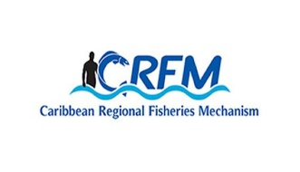
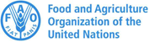
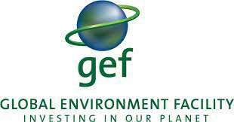

ISSN: 1995-1132

CRFM Technical & Advisory Document
No. 2025 / 07

GUYANA
MARINE SPATIAL PLANNING PROFILE

CRFM Secretariat
Belize
CRFM Technical & Advisory Document -
Number 2025 / 07

Guyana Marine Spatial Planning Profile

Prepared by:
Joseph Onwona Ansong, Senior Consultant, Howell Marine Consulting
Email: kofi@howellmarine.co.uk
Claire Hedley, Principal Consultant, Howell Marine Consulting
Email: claire@howellmarine.co.uk

This publication has been made possible through funding by BE-CLME+ Project: Promoting National Blue Economy Priorities Through Marine Spatial Planning in the Caribbean Large Marine Ecosystem Plus - GEF Project ID 10211

CRFM Secretariat
Belize
2025

CRFM Technical & Advisory Document Number 2025/ 05

Guyana Marine Spatial Planning Profile

© CRFM 2025
All rights reserved.
Reproduction, dissemination and use of material in this publication for educational or non-commercial purposes are authorised without prior written permission of the CRFM, provided the source is fully acknowledged. No part of this publication may be reproduced, disseminated or used for any commercial purposes or resold without the prior written permission of the CRFM.

Correct Citation:
CRFM, 2025. Guyana Marine Spatial Planning Profile. CRFM Technical & Advisory Report No. 2025 / 07. 29p.

ISSN: 1995-1132
ISBN: 978-976-8293-97-8

Published by the Caribbean Regional Fisheries Mechanism Secretariat
Belize and St. Vincent and the Grenadines

EXECUTIVE SUMMARY
The Caribbean Large Marine Ecosystem Plus (BE-CLME+) Project aims to promote and further progress a blue economy in the Caribbean Region through MSP and Marine Protected Areas (MPAs) in Barbados, Belize, Guyana, Jamaica, Saint Lucia, and Panama. Under the BE-CLME+ Project, the Caribbean Regional Fisheries Mechanism (CRFM) Secretariat have developed a Caribbean Regional Marine Spatial Planning (MSP) Step-by-Step Guide and Protocol. This Guyana Marine Spatial Planning Profile was produced, following desk-based research and stakeholder feedback, to assess the current status, challenges and opportunities for marine spatial planning in Guyana, in order to inform the development of the Guide and Protocol.
Guyana’s marine environment holds immense economic, ecological, and social significance. Covering an Exclusive Economic Zone (EEZ) of approximately 138,240 km², it is home to diverse ecosystems that support a wide array of sectors including fisheries, tourism, and the burgeoning oil and gas industry. Recognizing the importance of sustainable management, Guyana is actively progressing towards establishing a comprehensive marine spatial planning (MSP) framework to balance economic growth with environmental conservation and climate resilience.
The development of Guyana’s MSP foundations began early, building on previous initiatives such as the EU-funded "Promoting Integrated and Participatory Ocean Governance in Guyana and Suriname" (2017–2020). This project laid the groundwork for participatory governance, stakeholder engagement, and data collection, establishing a foundation for future policies like the National Ocean Policy (NOP) and the Marine Spatial Plan (MSP). The draft NOP scoping paper was submitted to cabinet in 2022, marking a significant step towards formalizing ocean governance.
Guyana’s legal framework for marine spatial planning comprises several statutes, including the Maritime Zones Act 2010, which aligns with UNCLOS, allowing for the designation of marine protected areas (MPAs), reserves, and special use zones. The Protected Areas Act 2011 supports national biodiversity goals, with Shell Beach designated as Guyana’s only marine protected area. A suite of other legislation, such as the Fisheries Act 2002 and Environmental Protection Act 1996, underpins sustainable resource use.
The MSP process in Guyana is currently in its preparatory phase, with ongoing efforts to formulate a national policy, establish relevant institutions, and build capacity. The Actively developing framework adopts an ecosystem-based approach, aiming to integrate diverse sectors—including fisheries, oil, tourism, and conservation—and address climate change impacts such as sea-level rise and extreme weather events. This involves a multi-scale geographic scope, covering the entire EEZ, territorial sea, and coastal zone, with detailed plans for nearshore and offshore zones.
The vision for Guyana’s MSP aligns with the LCDS 2030 and emphasizes the development of a “Blue Economy”—a sustainable, inclusive, and resilient marine economy supporting job creation, food security, climate adaptation, and biodiversity conservation. Key objectives include protecting marine ecosystems, promoting sustainable fishing, advancing offshore renewable energy, modernizing port infrastructure, and managing oil and gas development responsibly.
Guyana’s ocean governance landscape is fragmented by sector, with numerous agencies sharing overlapping responsibilities. This includes the Ministry of Foreign Affairs and International Cooperation (MFAIC), the Environmental Protection Agency (EPA), the Guyana Lands and Surveys Commission (GLSC), and the Maritime Administration Department (MARAD). To improve coordination, a suggested approach is to establish a central ocean authority, possibly revitalizing the Coastal and Marine Management Committee or creating a dedicated Ocean Affairs Authority.
Stakeholder engagement remains central to Guyana’s MSP approach. Inclusive participation involves government agencies, private sector entities, NGOs, academic institutions, and indigenous communities. The use of participatory tools like 3D modelling (P3DM) enhances local community involvement. Despite progress, challenges persist, including data gaps—particularly hydrographic, socio-economic, and biodiversity data—and limited institutional capacity. Efforts are underway to strengthen data management through initiatives like the National Spatial Data Infrastructure (NSDI) and Ocean Data Repository.
Funding remains a critical concern, with resources derived from the Natural Resources Fund, international grants, and innovative instruments like blue bonds and carbon credits. Capacity-building activities focus on technical skills, legal reform, stakeholder facilitation, and enforcement to address illegal, unreported, and unregulated fishing and pollution.
Transboundary cooperation with neighbouring countries and regional bodies is vital given the shared nature of marine ecosystems. The collaboration with Suriname under the Eastern Gate project exemplifies the regional approach to MSP. Geopolitical issues, such as border disputes with Venezuela, pose challenges but also underline the need for strong regional and international partnerships.

Table of Contents
EXECUTIVE SUMMARY i
1 INTRODUCTION 1
1.1 Scope 1
1.2 Context 1
2 MSP OVERVIEW 3
3 MSP PROCESS REVIEW 6
3.1 MSP Vision and Objectives 7
3.2 Role of Institutions and Agencies 9
3.3 Stakeholder Engagement 10
3.4 Data and Evidence Gaps 11
3.5 Transboundary Cooperation 13
3.6 Funding MSP Processes 14
3.7 Capacity Building and Needs 15
3.8 MSP Monitoring and Implementation 15
4 MSP CHALLENGES 16
5 MSP BEST PRACTICES AND SUCCESSES 17
6 RECOMMENDATIONS 20
REFERENCES 22

INTRODUCTION

Scope
The Caribbean Regional Fisheries Mechanism (CRFM) Secretariat is preparing a Caribbean Regional Marine Spatial Planning Step-by-Step Guide and Protocol under the BE-CLME+ Project, to be delivered by the end of 2025. The Guide and Protocol will align with international best practice for developing and implementing MSP but it will be tailored to the specific challenges and opportunities of the countries participating in BE-CLME+: Barbados, Belize, Guyana, Jamaica, Panama and Saint Lucia.
Consultations took place in each country through July and August 2025 to understand how the Guide and Protocol can best take account of their individual circumstances. The profile provides a detailed overview of the current status of Marine Spatial Planning (MSP), its underpinning drivers and political support, and challenges and recommendations specific to Guyana. This profile was originally prepared in July 2025 in advance of those consultations based on desk-based research using available documents relevant to MSP in Guyana to provide an initial baseline of information. The information was tested and refined through consultation with MSP stakeholders in Guyana, to identify the issues most relevant to the development of the Guide and Protocol.
The recommendations contained in Section 6 reflect recommendations contained in the various evidence sources reviewed for how Guyana can further progress MSP. They indicate the potential future direction of travel for Guyana, and will be used to understand how the Regional Guide and Protocol can support addressing them.

Context
Guyana, located on the northern coast of South America, maintains strong historical and social ties to the Caribbean. The country's marine area, which includes an Exclusive Economic Zone (EEZ) covering approximately 138,240 km² (Figure 1), accounts for more than half of its terrestrial area. Renowned for its abundant natural resources, Guyana's coastal zone is home to approximately 90% of its population and infrastructure, despite accounting for only about 7% of the total land area. Much of this critical coastal region, including parts of the capital city, Georgetown, lies below sea level. Guyana's dynamic coastline is also significantly shaped by three large rivers originating from the northern Amazon basin, which deposit substantial amounts of sediment into the Caribbean Sea, leading to a highly changeable seabed.
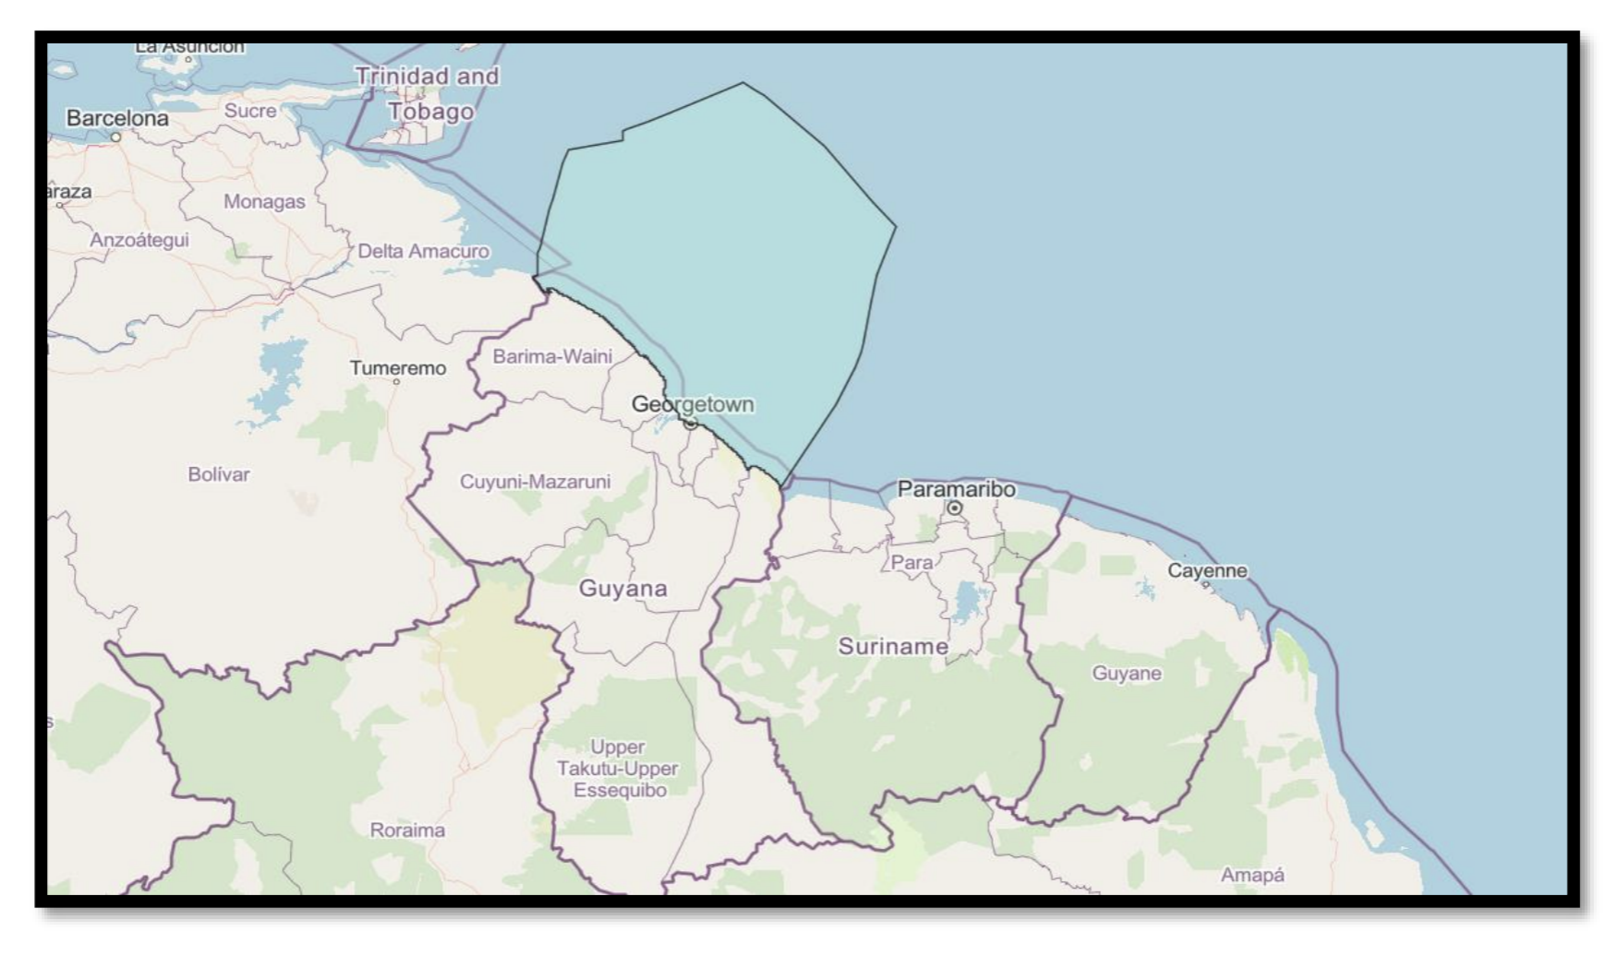
Figure 1. Map of Guyana's EEZ. (Source: draft National Ocean Plan scoping paper)

The marine and coastal environment of Guyana is central to the nation's economy and the wellbeing of its people. Key economic sectors reliant on this space include a well-established fisheries industry crucial for livelihoods and food security, a growing tourism sector, particularly eco-tourism, and a rapidly expanding oil and gas industry that is projected to become the country's largest sector (Low Carbon Development Strategy). Beyond economic activities, marine ecosystems, especially mangroves, provide vital services such as coastal protection against storm surges, flooding, and erosion, and play a significant role in carbon sequestration, often referred to as 'blue carbon'.
MSP is critical for Guyana due to the dynamic nature of its marine environment, the accelerating impacts of climate change (including sea levels rising at five times the global average, increased storm surges, and extreme rainfall events and the growing demands from diverse marine sectors).
Guyana is currently in the early stages of developing its ocean governance framework, which presents a strategic opportunity to integrate human and social factors, particularly the needs of Indigenous peoples and vulnerable communities and dependent on coastal and ocean resources. Key ongoing initiatives include the EU-funded project "Promoting Integrated and Participatory Ocean Governance in Guyana and Suriname: the Eastern Gate to the Caribbean," launched in 2017 (2017-2020). This project aimed to enhance governance, protection of marine and coastal resources, and capacity among stakeholders, contributing to the achievement of Aichi biodiversity targets under the Convention on Biological Diversity (CBD). The project was a foundational milestone for integrated and participatory marine spatial planning in Guyana, increasing policy momentum, capacity, and stakeholder readiness for the development of a national marine spatial plan. Building on the efforts, Guyana is now developing a National Ocean Policy (NOP) and a Marine Spatial Plan (MSP), with a draft NOP Scoping Paper submitted for Cabinet review in 2022. Presently, the NOP remains in the drafting and consultative phase, actively aligning with CARICOM and international best practices, but is yet to be finalised or adopted as law. The MSP is actively under development, informed by strategic assessments and stakeholder-driven approaches, but the finalised document and regulatory framework are not yet in force.
Efforts are also underway to improve hydrographic surveying and charting, with support from the Commonwealth Marine Economies (CME) Programme and the UK Hydrographic Office, which has provided new navigational charts and capacity building to the Guyana Maritime Administration Department (MARAD). Despite significant data gaps identified, particularly in newer and emerging sectors and concerning gender breakdown of ocean use, efforts are being made to centralise data and improve accessibility for decision-makers. While Guyana has not yet established formal marine protected areas, the Protected Areas Commission (PAC) is working towards a goal of designating up to 30% of its ocean area for biodiversity protection by 2030, in line with international biodiversity targets.
Guyana has also developed a Maritime Economy Plan (MEP), which aligns with Guyana's broader Low Carbon Development Strategy (LCDS), sharing principles of low carbon, resource efficiency, and social inclusion, and focusing specifically on the marine area. The primary goal is to transition towards a sustainable 'Blue Economy' or 'Sustainable Ocean Based Economy’ (SOBE), which will enable Guyana to better understand and manage its marine resources for sustained economic growth, job creation, poverty reduction, and resilience against natural forces.

MSP OVERVIEW
This section provides an overview of the status of MSP in Guyana including policies, lead MSP authority, the status of MSP, planning approach and scope.
Table 1. MSP overview
Criteria | Overview
MSP Legislation and Policies | Guyana’s MSP framework is currently in early stages of development, building on previous work undertaken through the "Promoting Integrated and Participatory Ocean Governance in Guyana and Suriname: the Eastern Gate to the Caribbean” project (2017-2020). Efforts are focused on establishing a comprehensive and integrated approach to ocean governance with the long term goal of developing an integrated NOP.  Various statutory instruments and acts are in place that contribute to the establishment of use zones, conservation measures, and overall marine management:  The Maritime Zones Act 2010 incorporates provisions of the UN Convention on the Law of the Sea (UNCLOS) and allows for the designation of areas within the EEZ for special purposes, including natural resources and marine environmental protection. It also provides for the creation of marine parks, reserves, and mariculture operations, requiring permits and ensuring no negative impact on marine species.  The Protected Areas Act 2011 establishes a national network of protected areas (NPAS) and aims to protect marine ecosystems. Shell Beach Protected Area is specifically noted as Guyana's only marine protected area situated on the coast. The Act also aligns with the Aichi Biodiversity Target 11, which calls for 10% of coastal and marine areas to be protected.  The Fisheries Act 2002 regulates fishing activities within Guyana's waters, including the EEZ, and empowers the Minister to issue regulations concerning the discharge of harmful substances. Notably, the seabob fishery implements enforced 'closed-seasons' to allow stocks to recover, with patrols conducted within the EEZ to ensure compliance.  The Environmental Protection Act 1996, Sea Defence Act 1988, and Wildlife Conservation and Management Act 2016 also offer protection of both marine and forest environments and the sustainable use of natural resources.  In addition, several strategic development plans have been established that are aligned with MSP principles:  The Low Carbon Development Strategy (LCDS) 2030, building on previous versions from 2009 and 2013, sets a vision for inclusive, sustainable development. It explicitly expands its focus to include the Ocean/Blue Economy as a new frontier for sustainable development, aiming to integrate marine resources with broader goals of valuing ecosystem services, clean energy, and climate/biodiversity protection.  The Maritime Economy Plan (MEP) 2021, developed in partnership with the UK Government, serves as a strategic overview of Guyana’s marine economic potential. It is aligned with the LCDS and supports economic growth, livelihoods, and resilience against natural hazards and climate change by addressing both traditional and emerging maritime sectors.  The Integrated Coastal Zone Management (ICZM) Action Plan 2010, formulated by the Environmental Protection Agency (EPA), promotes the wise use, development, and protection of coastal and marine resources through inter-agency collaboration.  The Climate Resilience Strategy and Action Plan (CRSAP) 2015 outlines key strategic actions to enhance Guyana's resilience to climate change impacts.  In line with the concept of a "Blue Economy", Guyana is actively pursuing the sustainable development of its marine resources. The Maritime Economy Plan (MEP) explicitly incorporates and supports the principles of a blue economy, treating marine/maritime economy and blue economy as synonymous, emphasising sustainability, resource efficiency, and social inclusion. The MEP is designed to support the achievement of the UN Sustainable Development Goals (SDGs), and explores the potential of innovative financial instruments such as blue bonds to fund marine conservation and sustainable development initiatives. Furthermore, the establishment of a NOP is seen as a foundational step to comprehensively define Guyana's marine space and align with government commitments.
Lead MSP Authority | Guyana does not have a single, formally designated lead MSP authority. The Ministry of Foreign Affairs and International Cooperation (MFAIC) has jurisdiction over the marine area, and produced the draft NOP scoping paper. This NOP will eventually incorporate MSP and comprehensively define Guyana’s marine space.  However, several other existing government ministries and agencies hold overlapping jurisdictions and responsibilities relating to marine and coastal management:  The Environmental Protection Agency (EPA) drafted the Integrated Coastal Zone Management (ICZM) Action Plan in 2010 and has established a Coastal and Marine Management Committee (CMMC), which is focused on addressing issues within Guyana’s coastal and marine environment. The EPA is also a key partner in the EU-funded "Promoting Integrated and Participatory Ocean Governance in Guyana and Suriname" MSP project.
Stage of MSP | Guyana began developing its MSP framework in 2017 under the "Promoting Integrated and Participatory Ocean Governance in Guyana and Suriname: the Eastern Gate to the Caribbean” with the aim of enhancing marine governance and protection through stakeholder-driven marine spatial planning (MSP) and improved decision-making frameworks in both countries. It has built on the foundations of this project and is now developing its NOP.  The proposed process for developing a NOP (detailed within the draft NOP scoping paper) involves a preparatory stage, formulation stage, and implementation stage.  Overall, Guyana is in the preparatory and formulation stages of MSP, focusing on establishing the necessary policy, legal, data, and institutional frameworks, and building human capacity, before moving into full implementation of a national MSP. The current stage involves filling critical information gaps in marine and coastal data and building capacity of key stakeholders.
Plan Name/MSP Initiative(s) | The primary MSP initiatives within Guyana are the NOP and the 2017-2020 “Promoting Integrated and Participatory Ocean Governance in Guyana and Suriname”.  The coastal zone is managed under the Guyana Integrated Coastal Zone Management (ICZM) Action Plan 2010.
Plan Scale | Guyana's marine planning is designed to cover a multi-scale geographical approach. This includes:  - the entirety of its EEZ, which spans approximately 138,240 km², extending 200 nautical miles from the coast;  - the Territorial Sea (extending 12 nautical miles); and,  - the broader coastal zone, a low-lying area about 430 km long and 26-77 km wide, where most of the population and economic activity are concentrated.  The marine environment itself is considered to begin around 22 km from the coastline, extending offshore (anything before this part is considered the coastal zone and inshore waters).  Discussions have also explored the potential for developing distinct nearshore and offshore marine plans, indicating a detailed approach to spatial management. Geographical areas explicitly considered for planning include river mouths, mangrove areas, Shell Beach (Guyana's only formally designated marine protected area), the continental shelf, and high seas.
Plan Scope | The functional scope of MSP in Guyana is broad and aims for integrated, comprehensive ocean governance and protection of marine and coastal resources. This involves addressing a wide range of existing and emerging economic sectors and environmental objectives. Key areas include the rapidly expanding oil and gas industry, fisheries and mariculture (both artisanal and industrial), shipping and ports, and tourism, particularly eco-tourism and potential for cruise/yachting. Environmental priorities are central, focusing on biodiversity conservation and protection, ecosystem services (especially mangroves for coastal protection and carbon sequestration), and combating climate change impacts like sea-level rise. The MSP process also aims to improve marine scientific research and data collection, enhance maritime security, surveillance, and enforcement, and address land-based pollution.
Planning Approach | Guyana’s MSP framework is currently in the early stages of development, and being established with the goal to support a comprehensive and integrated approach to ocean governance, to support the development of a blue economy.  Guyana’s MSP will be built on a spatial zoning approach (identifying and regulating use areas), while also requiring supporting policy measures and legal reforms. The spatial framework is the main operational tool, but policy change is recognised as necessary to ensure integrated, ecosystem-based ocean governance  The MSP framework follows an ecosystem-based approach, aiming to balance environmental protection with economic development. To ensure inclusive and informed decision-making, the MSP is being developed through a participatory process that actively engages stakeholders, with specific effort to engage Indigenous peoples (see section 3.3 below).  The MSP process includes the development of a NOP and a comprehensive MSP. It is designed to be iterative, with ongoing monitoring, updates, and improvement based on new data, evolving priorities, and stakeholder feedback.
Political Commitment to MSP | Guyana's commitments to marine planning are rooted in a combination of legally binding international agreements and national legislation, further guided by strategic national policies and plans that articulate the country's vision for sustainable ocean governance.  At the national level, Guyana's commitment is enshrined in domestic legislation, which is legally binding within its jurisdiction.  In addition, while not inherently legally binding in the same way as ratified treaties or national laws, Guyana's strategic documents provide the framework and political will for its marine planning efforts.

MSP PROCESS REVIEW
The Government of Guyana is currently in the preparatory stage of MSP: it has not yet established a dedicated MSP but has begun to develop plans and policies that will support MSP development, including a NOP and MEP. The MEP provides a foundation for building a MSP process within Guyana. This includes considerations of the different types of marine plan, and how they relate to each other, and each of Guyana’s sea areas (Figure 2).
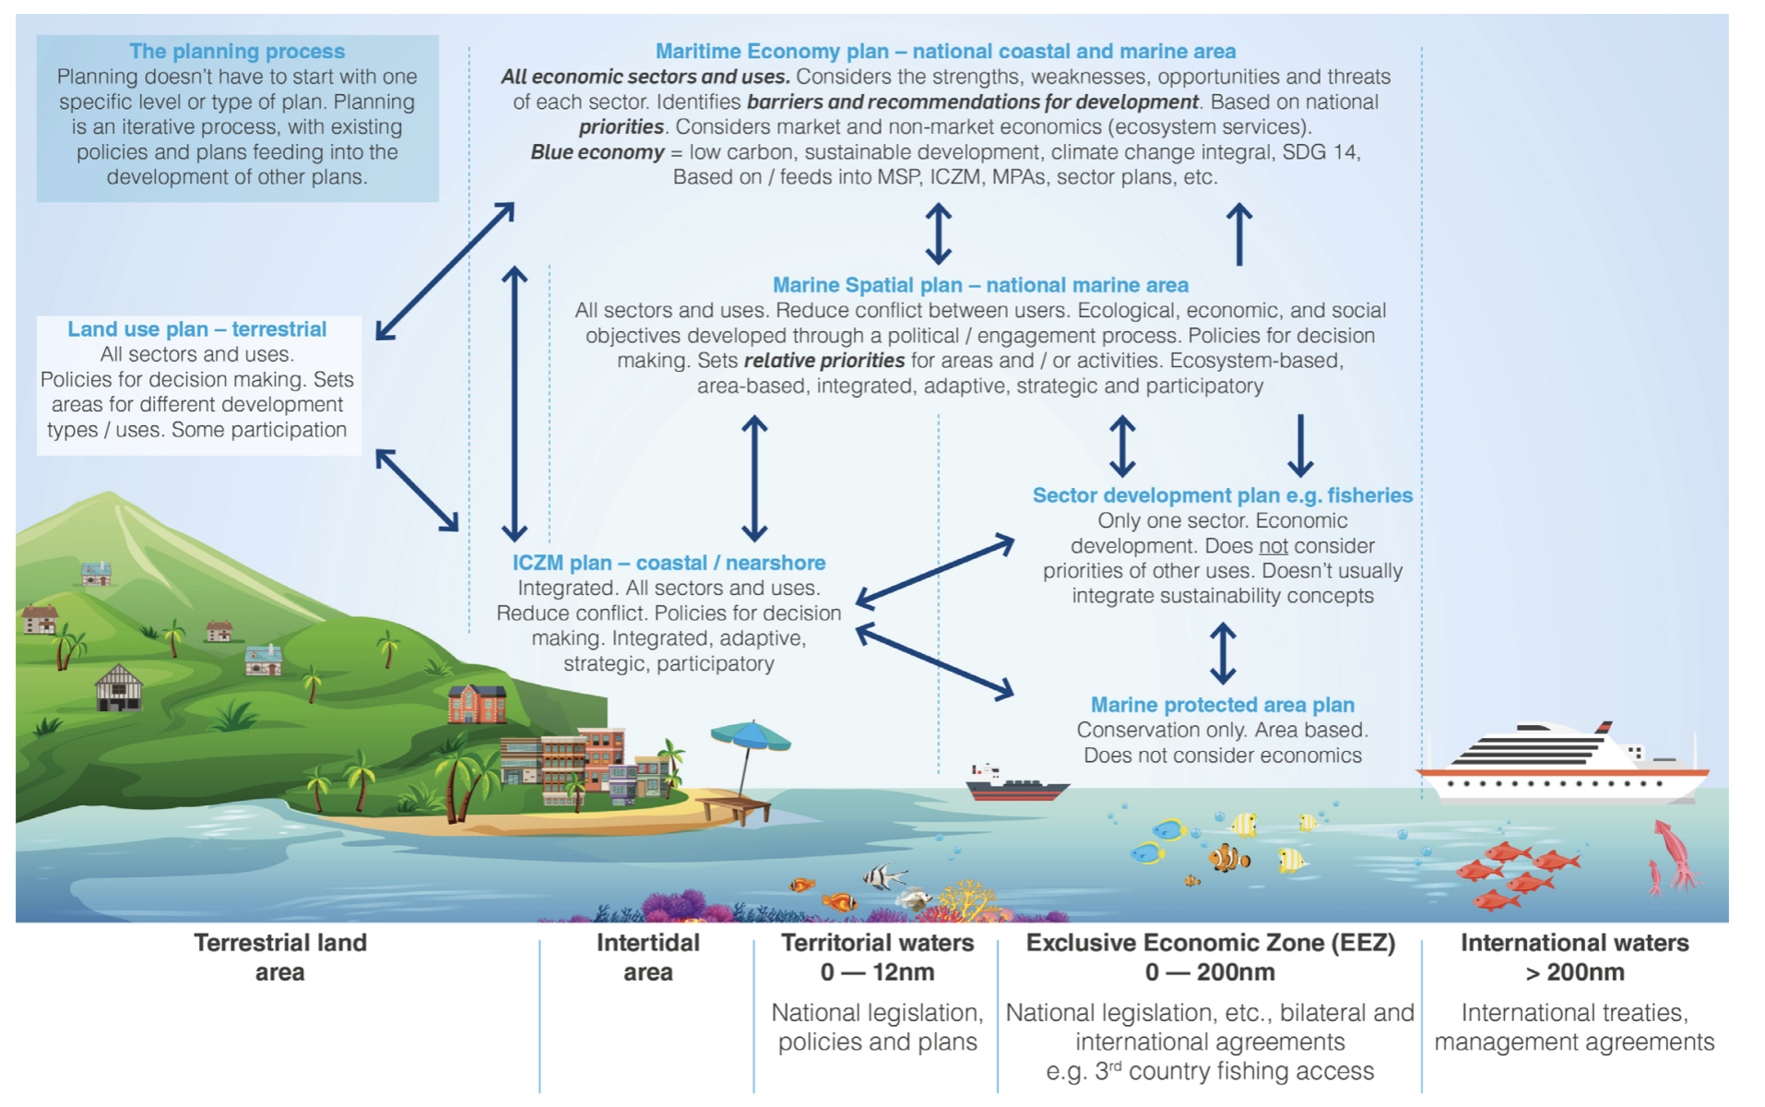
Figure 2. Figure showing different types of marine plan and how they relate to each other in Guyana. (Source: Guyana's MEP)

MSP Vision and Objectives
The overarching vision for MSP in Guyana, in alignment with the LCDS 2030, is to achieve integrated and sustainable management of its coastal and marine resources and to nurture a "Blue or Ocean Economy". This vision encompasses ensuring that human activities are managed in a way that protects the natural environment for present and future generations, applying an ecosystem-based approach. Guyana’s vision for a Blue Economy Framework is demonstrated in Figure 3 taken from the MEP.

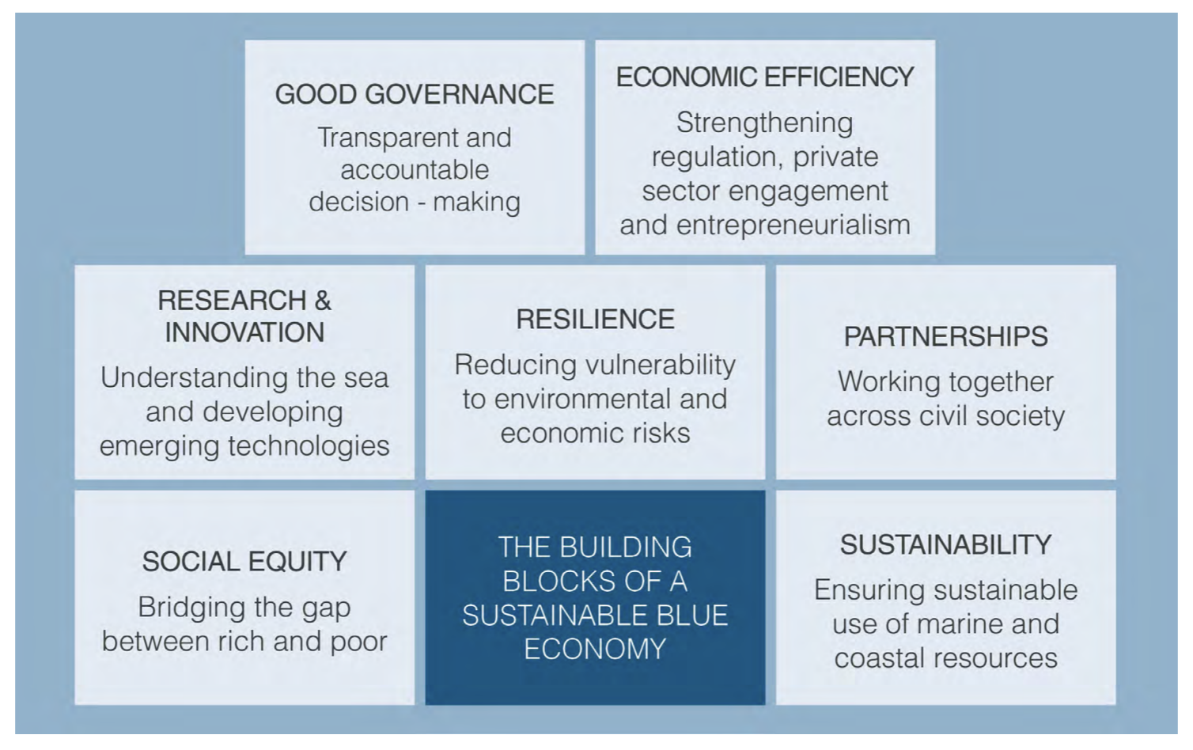
Figure 3. Figure showing Guyana's basis for building a Blue Economy. (Source: Guyana's MEP)

Specific objectives and goals articulated through the MSP process and related strategic documents include:
- Promoting the sustainable use of marine resources.
- Protecting marine biodiversity and safeguarding vulnerable species and ecosystems.
- Addressing the impacts of climate change, particularly through resilience and adaptation strategies for coastal and marine environments.
- Fostering sustainable economic growth and socio-economic development, creating jobs in low-carbon sectors, and supporting livelihoods.
- Ensuring the implementation of a legally enforceable Marine Spatial Plan.
- Developing and implementing mechanisms, processes, and procedures for an effective and functional MSP process.
- Strengthening the marine protected area network and designating areas for conservation, with a commitment to expand protected areas to 17% and progressively to 30% by 2030, including terrestrial and marine protection.
- Supporting the sustainable growth and development of Belize’s blue economy in alignment with legislation, policy, and planning frameworks.
- Identifying and evaluating ocean spaces for their functional suitability to support projected sustainable expansion and management of traditional, existing, and emerging economic uses.
- Reducing land-based pollution and improving waste management.
- Promoting sustainable fisheries, including, for example, implementing closed seasons as needed or appropriate, and strengthening management plans.
- Achieving a "resilient ocean where there are sustainable use and management of natural resources and people can live in harmony with nature" by 2030.

Role of Institutions and Agencies
Ocean governance in Guyana has traditionally been sectoral, with numerous institutions sharing responsibilities, often leading to fragmentation and uncoordinated efforts, and a lack of clear leadership. There are calls for improved coordination and harmonisation of laws.
Key governmental and non-governmental actors involved in or relevant to MSP include:
- Ministry of Foreign Affairs and International Cooperation (MFAIC): Responsible for the Maritime Zones Act (MZA) 2010, international boundaries, and maritime conventions. The Minister can designate marine park operations or temporary marine protected areas. This Ministry is developing a Draft National Ocean Policy Scoping Paper.
- Protected Areas Commission (PAC): Established in 2011, oversees Guyana’s National Protected Areas System (NPAS) and is a key partner in the EU-funded MSP project. The PAC is engaged in a marine spatial mapping project to provide updated information on the marine environment, including the EEZ. It is the only government agency currently reported to be consistently engaging and consulting with Indigenous villages within existing protected areas for management decisions.
- Environmental Protection Agency (EPA): Manages environmental protection, including pollution control, environmental impact assessments (EIAs), and coordinates the Coastal and Marine Management Committee (CMMC). The EPA is the focal point for the LBS Protocol under the Cartagena Convention. The agency started reviewing the Environmental Protection Act in 2020 to update and amend it. The EPA also possesses control to select areas for protection, including marine and aquatic areas.
- Guyana Lands and Surveys Commission (GLSC): Holds jurisdiction over maritime areas for surveys, mapping, and land use planning, serving as the custodian of public lands, rivers, and creeks. The GLSC is leading the development of the MEP with support from the British High Commissioner. It is establishing the National Spatial Data Infrastructure (NSDI) and geospatial platform. The National Hydrographic Committee (NHC) was established under the GLSC to coordinate the sustainable management of sea and river resources.
- Maritime Administration Department (MARAD): Responsible for shipping administration, search and rescue, pollution prevention, monitoring offshore operations, pilotage, and hydrographic surveying. MARAD serves as the focal point for engagement on the Maritime Economy Plan and provides modern navigational charts and hydrographic services.
- Ministry of Natural Resources (MNR): Oversees natural resource sectors, including oil and gas. The Ministry has plans to upgrade the upstream oil and gas policy.
- Fisheries Department (Ministry of Agriculture): Manages fisheries, enforces regulations, collects data, and issues licenses. They are working to strengthen the seabob sector through a 10-year plan.
- Civil Defence Commission (CDC): Involved in national oil spill contingency planning and disaster risk management.
- Ministry of Public Works (MPW): Responsible for sea and river defence systems, and includes MARAD and the Ports and Harbours Division.
- Guyana Energy Agency (GEA): Manages and advises on energy matters, including oil, gas, and renewables.
- University of Guyana (UG): Offers information, training, and expert knowledge on conservation, protection, and management of biodiversity.
- Guyana Marine Conservation Society (GMCS): Monitors data on coastal dynamics and biodiversity, and supports initiatives like Northwest Organics.
- World Wildlife Fund (WWF)-Guianas: A significant NGO involved in promoting integrated ocean governance, marine biodiversity, and conservation projects.
- Private Sector: Includes fishing companies, shipping companies, oil and gas operators, and tourism entities. The private sector's engagement with vulnerable groups is relatively limited, often occurring through functioning cooperatives.
Overlapping mandates and a lack of clear leadership are critical issues, with recommendations for strengthening coordination (e.g., through a revived CMMC or a new Ocean Affairs Authority) and harmonising laws suggested within the draft NOP scoping report, and a recent gap analysis and legislative review. Stakeholder engagement activities (SeaSketch workshop) have suggested that MSP in Guyana should be led by an assemblage of existing agencies, with the EPA, Ministry of Agriculture, and MARAD identified as potential coordinating bodies.

Stakeholder Engagement
Meaningful and inclusive stakeholder participation is a critical and recurring theme within Guyana's MSP process. The approach aims to consider all users and values, involving a diverse array of stakeholders, including government, the private sector, NGOs, civil society, academic institutions, and importantly, Indigenous and local communities. This participatory approach to MSP within Guyana is detailed within the MEP and summarised in Figure 4.
For example, the LCDS 2030 was developed through extensive national consultations, including community-based sessions in every region, engaging over 200 Indigenous Villages and forest-based communities. This consultative process is intended to continue as the LCDS moves into implementation.
Indigenous peoples have been directly engaged in the marine spatial planning (MSP) process through the “Promoting Integrated and Participatory Ocean Governance in Guyana and Suriname: the Eastern Gate to the Caribbean” project and subsequent national MSP initiatives.​
A major feature of Guyana's MSP engagement has been the use of participatory three-dimensional modelling (P3DM), which allows Indigenous and local communities to contribute spatial knowledge by collaboratively mapping their customary marine and coastal use areas, environmental values, and related threats.​
Stakeholder mapping, capacity-building workshops, and open consultations involved indigenous representatives from early stages, ensuring their perspectives were considered in setting priorities for marine resource management.​

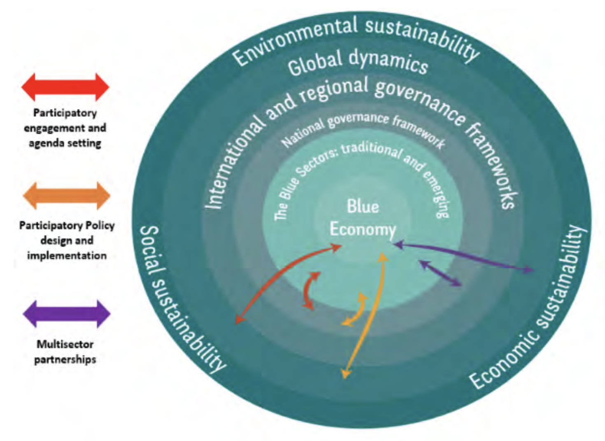
Figure 4. Guyana's framework for delivering a Blue Economy. (Source: Guyana's MEP)

An “Equivalence-Gap Analysis” was completed to specifically assess and address gaps in participation, equity, and integration of indigenous and gender considerations, supporting meaningful inclusion in decision-making. It highlighted that Indigenous peoples and women often perceive their role in decision-making as weak. Only 11% of survey respondents felt that community inputs informed project resource allocation and budgeting. There are calls for ongoing robust and comprehensive consultations with these vulnerable groups to understand their aspirations and needs, ensuring opportunities are tailored to them.
​Continued challenges include ensuring that engagement remains substantive and is not tokenistic, building long-term capacity, and embedding explicit recognition of indigenous rights and knowledge systems into formal MSP regulations and the forthcoming national ocean policy.​
The Protected Areas Act, 2011, explicitly outlines the participation and engagement of Indigenous Peoples, emphasising their role in the decision-making process for identifying and adopting protected areas. The Amerindian Act also provides for the recognition and protection of collective rights of Indigenous Peoples, Villages, and Communities in Guyana, promoting good governance.

Data and Evidence Gaps
A significant lack of marine data, assessments, and trained personnel continues to pose a major challenge to the sustainable management of coastal and marine environments. Existing data is often fragmented, inconsistent, or not easily accessible to decision-makers, which limits its usefulness for effective planning and governance.
Among the most pressing gaps is the need for updated hydrographic data. Modern navigational charts are lacking, and the seabed requires comprehensive surveying to ensure safe navigation. Although the Guyana MARAD has some mapping capacity, its efforts are constrained by inadequate survey platforms and equipment.
Understanding seabed resources and ocean dynamics is also limited. With recent oil discoveries within Guyana's EEZ, there is an urgent need to improve knowledge of natural seabed resources. However, the country faces a shortage of relevant data, technical assessments, and skilled staff to carry out ocean modelling and sea-level monitoring.
In the fisheries sector, key data gaps include socio-economic information, detailed stock assessments, and guidance to prevent overfishing. Similarly, while spatial datasets on various marine ecosystems exist, biodiversity and ecosystem data remain incomplete, especially concerning land tenure and coastal geomorphology.
Data is also lacking in emerging industries such as deep-sea mining and offshore renewable energy, and there is no consolidated or published valuation of ecosystem services for Guyana.
Efforts are underway to address many of these gaps. The EU-funded “Promoting Integrated and Participatory Ocean Governance in Guyana and Suriname" project (2017-2020) sought to fill critical information voids in coastal and marine data. Complementing this, work is in progress to develop a Marine GIS Atlas and an Ocean Data Repository that will integrate various types of data, ranging from local knowledge to hydrographic and biodiversity datasets.
Under the Guyana Lands and Surveys Commission (GLSC), a National Spatial Data Infrastructure (NSDI) and geospatial platform is being developed to house all of Guyana's satellite and lidar imagery. This aims to minimise duplication of effort and improve data accessibility for uses such as geological mapping, oil spill monitoring, tracking deforestation and mangrove change, supporting sea defences, and contributing to REDD+ programmes.
The SeaSketch platform, introduced during MSP training undertaken in 2020, provides an intuitive interface for visualising maps, contributing spatial data, and collaborating on marine zoning scenarios. Human ocean-use patterns are also being mapped through tools like the Ocean Use Survey, based on models such as those used in Belize, to help identify overlapping interests and complementary uses.
Other ongoing initiatives include visual shoreline assessments by Coastal Rangers from the Sea and River Defence Department (SRDD), who track erosion, accretion, and foreshore conditions. The Guyana Forestry Commission (GFC) also maintains a GIS database with 5-meter resolution RapidEye imagery (2012–2016) for the entire coastline. Additionally, Environmental Impact Assessments (EIAs) carried out through the EPA provide a valuable source of data related to living resources.
Data Storage and Data Standards
There is a critical need to strengthen and consolidate existing databases and biodiversity information systems. More systematic approaches to collecting, storing, analysing, and sharing data are essential, as the current system suffers from fragmentation, inconsistency, and limited accessibility.
Several recommendations and ongoing initiatives have been identified through Guyana’s developing MSP process. One key proposal is the creation of a centralised data repository, enabling all relevant stakeholders to access high-quality, up-to-date information. This must be supported by the standardisation of data collection and analysis methods, as well as standardise sharing protocols, which would reduce duplication and improve the efficiency of future data gathering and data accessibility.
The establishment of an Interagency Information Management System or central Data Hub dedicated to MSP is also recommended to streamline information sharing across institutions. In parallel, the NSDI and geospatial platform, led by the GLSC, will help centralise satellite and lidar imagery to support sustainable land and marine management.
There is a need to improve regulation of third-party data, particularly that generated by commercial or independent research activities, to ensure proper governance of data ownership and intellectual property. Guyana manages third-party data through structured MOUs, collaborative databases, monitoring programs, and emerging policy guidance designed to enhance data integration, accessibility, and regulatory oversight for MSP delivery, for example through regional protocols introduced by CRFM.
Finally, a dedicated Ocean Data Repository is being developed to manage information related to coastal and marine environments and to meet long-term data needs across sectors.

Transboundary Cooperation
Guyana's MSP efforts are conducted within a complex web of regional and international collaborations and obligations, reflecting the transboundary nature of marine ecosystems and activities. For example, the EU-funded project: "Promoting Integrated and Participatory Ocean Governance in Guyana and Suriname: The Eastern Gate to the Caribbean" directly supports MSP development in both Guyana and Suriname by enhancing marine governance and protection through stakeholder-driven MSP and improved decision-making frameworks in both countries. The project supports transboundary cooperation by transboundary cooperation between Guyana and Suriname through a collaborative marine spatial planning (MSP) process that involves shared governance, joint stakeholder engagement, and coordinated data gathering across their contiguous coastal and marine areas.
The Ministry of Foreign Affairs' Frontiers Department manages relations with Venezuela and Suriname, particularly concerning the preservation of territorial integrity and maritime spaces. Ongoing border issues with Venezuela have been noted as potential challenges to the MSP process.
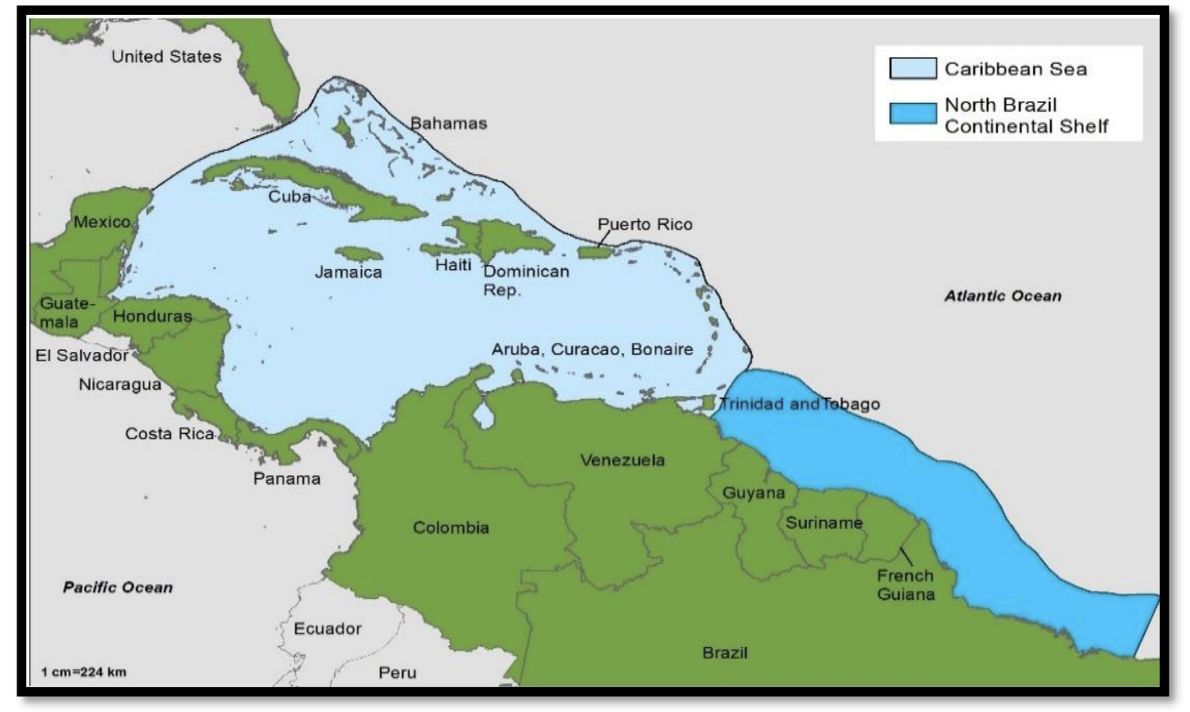
Figure 5. Map showing the shared marine space between Guyana and surrounding countries. Taken from the draft NOP scoping report.

Funding MSP Processes
Securing adequate financial resources remains one of the most significant challenges to the successful implementation of MSP in Guyana, and a number of funding mechanisms are either in place or under development to support the process. For example, the LCDS 2030 offers a foundational framework, guiding the investment of revenues generated into broader low-carbon development goals. This includes fostering a sustainable ocean economy.
In addition, the Natural Resources Fund may be utilised to finance key activities identified in the MEP. Complementing this, carbon market revenues, particularly from the sale of ART-TREES (Architecture for REDD+ Transactions) carbon credits, present new opportunities. A notable allocation is the commitment of 15% of these revenues to community-led programmes for Indigenous Peoples and Local Communities (IPLCs), which will be implemented through Village Sustainability Plans (VSPs).
Guyana is also exploring novel financial instruments to support environmental goals. These may include payments for ecosystem services and other innovative tools aimed at protecting habitats and species, offering promising avenues for long-term, sustainable MSP funding.

Capacity Building and Needs
To ensure effective implementation of integrated ocean governance, Guyana requires a significant strengthening of awareness, skills, and knowledge across all levels—individual, organisational, and societal. A comprehensive, strategic approach to capacity building is therefore essential.
From a technical standpoint, there is a pressing need for training in areas such as hydrographic governance, marine scientific research, data collection, and ocean modelling. Proficiency in GIS and participatory mapping—particularly through platforms like SeaSketch—is increasingly important, as is the ability to conduct robust Environmental Impact Assessments (EIAs).
Sector-specific training is also crucial, especially for fisheries monitoring, enforcement, and the management of new and emerging marine sectors. Parallel to this is the need for enhanced skills in policy development, legal interpretation, and a deeper understanding of Guyana’s international commitments related to marine governance.
Effective stakeholder engagement remains a cornerstone of the MSP process. As such, there is a recognised need for training in facilitation techniques, inclusive dialogue, and conflict resolution to support participatory approaches. On the administrative side, strengthening general and project management capabilities will help ensure MSP initiatives are implemented efficiently.
Finally, digital literacy is an ongoing need, particularly in hinterland and remote coastal communities, where enhanced communication and computer skills can significantly improve participation. Promoting ecosystem-based management principles across all training efforts will also help integrate environmental sustainability into marine and coastal decision-making at every level.

MSP Monitoring and Implementation
Guyana's MSP process is still in its formative stages, necessitating a robust framework for monitoring and implementation to ensure its success and adaptability. The process is designed as an iterative cycle of public discourse, analysis, re-analysis, and implementation, with continuous monitoring, revision, and adjustment being key components.
The development of a NOP and an integrated MSP is a critical next step. A draft NOP scoping report was published in 2022, however the finalisation of a NOP is still under development. Defining administrative and analytical boundaries for the MSP area is a key preparatory activity as part of this development. The use of tools like SeaSketch facilitates the sketching and evaluation of zoning scenarios, including marine protected areas, fishing priority areas, and energy priority zones.
Guyana has committed to designating a series of MPAs in its EEZ, aiming to expand protected areas to 17% and progressively to 30% by 2030, in line with international biodiversity targets like the Aichi Biodiversity Targets. However, these targets include both terrestrial and marine protected areas.
Developing a clear results-based framework that aligns the MEP and LCDS is essential to communicate needs and priorities to international donor agencies and to effectively track progress and impact. The LCDS Investment Plan is intended to be reviewed every three years for updates and to track financing against Key Performance Indicators (KPIs).
Similarly, monitoring compliance with international and national environmental requirements is crucial. For instance, the effectiveness of the Fisheries Management Plan and the Vessel Monitoring System (VMS) needs continuous monitoring. There is a recognised need for strengthened enforcement to combat illegal activities like overfishing and pollution.
The success of the MSP process in Guyana depends on continuous engagement of all Guyanese and the leadership of a central coordinating body or a National Ocean Council. The transition to a Blue Economy requires an integrated, systemic, dynamic, inclusive, participatory, and ecosystem-based approach, minimising sectoral barriers at both participant and governance levels.

MSP CHALLENGES
Guyana faces several significant challenges in its MSP and broader ocean governance initiatives, stemming from a combination of institutional, technical, and socio-economic factors. These challenges hinder the effective and integrated management of its vast marine resources and the transition towards a sustainable "Blue Economy".
Key MSP challenges for Guyana include:
- Significant data gaps and insufficient information management: A pervasive challenge is the lack of up-to-date, modern, and comprehensive marine data. This includes critical hydrographic data (seabed surveys, modern navigational charts), socio-economic information in fisheries, detailed stock assessments, and complete biodiversity and ecosystem data. Data is also lacking for emerging industries like deep-sea mining and offshore renewable energy, and there is no consolidated valuation of ecosystem services. Furthermore, existing data is often fragmented, inconsistent, not easily accessible, or not subject to standardised collection and analysis frameworks, limiting its usefulness for planning and decision-making.
- Capacity and technical constraints: Guyana faces significant human capacity and technical gaps across various levels. This includes a shortage of trained staff for ocean modelling, sea-level monitoring, hydrographic governance, marine scientific research, data collection, GIS, and participatory mapping. There is also a need for sector-specific training in areas like fisheries monitoring and enforcement. High workforce turnover can further weaken institutional capacity.
- Challenges in stakeholder engagement and participation: While stakeholder participation is recognised as critical, achieving meaningful and broad engagement, especially from marginalised groups like Indigenous Peoples, women, and local fisher-folk, remains a hurdle. There is a need for more transparent and structured mechanisms for participation, and a lack of trust in the government among some communities. The difficulty in involving diverse sectors and getting them to collaborate is also a major obstacle.
- Inadequate and fragmented legislative frameworks: Many of Guyana's existing environmental and petroleum laws are developed sectorally and require amendment to align with international agreements and modern policy documents. There are overlaps in jurisdiction and responsibilities among various government ministries and agencies, leading to conflicts of competence and hindering effective coordination and harmonisation of laws. Specific legal ambiguities, such as the Protected Areas Act's application to marine protected areas in the EEZ, also exist.
- Financial and resource constraints: Securing adequate financial resources is a significant challenge for the successful implementation and long-term sustainability of MSP activities. Funding for research is a major limiting factor, with most quality research relying on external organisations.
- Geopolitical and transboundary issues: Ongoing border issues with neighbouring countries like Venezuela and Suriname pose potential challenges to the MSP process. The transboundary nature of marine ecosystems and pollution also necessitates greater regional cooperation.
- Impacts of rapid oil and gas sector expansion: While the burgeoning oil and gas industry offers significant economic opportunities, it also presents risks of environmental damage and potential conflicts with traditional sectors like fisheries for marine space. Managing these risks and ensuring that the revenue benefits the country holistically, including investment in renewable energy and other sustainable sectors, is a considerable challenge.
- Vulnerability to climate change and natural disasters: Guyana's low-lying coastal zone, where 90% of the population resides, is highly vulnerable to sea-level rise, ocean acidification, and extreme weather events. Protecting coastal infrastructure and marine environments, and building resilience, are ongoing challenges.
Overall, the effective implementation of MSP in Guyana requires a concerted effort to address these multifaceted challenges, necessitating robust political will, enhanced national and regional collaboration, targeted capacity building, improved data management, and the harmonisation of legal and policy frameworks.

MSP BEST PRACTICES AND SUCCESSES
Despite facing significant challenges, Guyana has demonstrated several key best practices and successes in its journey towards effective MSP and comprehensive ocean governance. These achievements highlight a proactive approach to managing its marine resources and fostering a sustainable "Blue Economy":
- Building a policy and planning framework: A draft NOP is under development; once finalised it will work alongside the 2021 MEP to set the foundation for integrated marine governance aligned with the LCDS.
- Improved hydrographic capabilities: With support from the UK Hydrographic Office and CME Programme, MARAD now independently conducts seabed surveys and updates nautical charts, improving navigation safety and port efficiency.
- Sustainable fisheries management: The Seabob shrimp fishery gained MSC certification in 2019, boosting exports, sustainability, and industry-government collaboration. Enforcement measures like seasonal closures and onboard monitoring have seen success.
- Conservation progress: Shell Beach remains Guyana’s only formally designated marine protected area, but there is an ambitious goal to protect 30% of marine space by 2030. Mangroves are also protected and actively restored.
- Data systems and planning tools: A Marine GIS Atlas and Ocean Data Repository are in development. Guyana’s Lands and Surveys Commission is establishing a National Spatial Data Infrastructure (NSDI) to centralise geospatial data. Tools like SeaSketch are used in stakeholder workshops for spatial scenario planning.
- Stakeholder training and engagement: Inclusive MSP training workshops (using platforms like SeaSketch) promote collaboration and empower local voices. Indigenous and civil society involvement is gradually improving.
- Oil spill preparedness and revenue management: A National Oil Spill Plan and dedicated Oil Spill Committee are in place. The Natural Resources Fund helps channel oil revenues towards broader development, including marine sectors.
- International collaboration: Guyana partners in regional and global initiatives (e.g. CME, EU ocean governance programmes), benefiting from technical support, funding, and shared learning.
Case Studies
The Commonwealth Marine Economies (CME) Programme, funded by the UK Government, aimed to support sustainable marine economies, drive economic growth, reduce poverty, and ensure food security in Commonwealth Small Island Developing States (SIDS), including Guyana. Within this framework, two key case studies demonstrate best practices and successes in MSP within Guyana: the seabob fishery certification and the updating of shipping routes and waterway maps.
Case Study 1: Marine Stewardship Council (MSC) Certification of the Seabob Fishery
Before this programme, Guyana possessed limited capacity to monitor the health and sustainability of its fishing stocks, including seabob shrimp, and assess the broader impact of its fishing industry on marine habitats. Efforts by the Guyana Association of Trawler Owners and Seafood Processors to achieve MSC certification had stalled due to a lack of technical guidance (Commonwealth Secretariat, 2022).
CME Programme provided crucial support for the MSC accreditation process. This was primarily delivered through training and capacity building provided by the UK's Centre for Environment, Fisheries, & Aquaculture Science (Cefas). Guyanese fishing industry representatives received bespoke training in the UK, and Cefas experts conducted in-country capacity building and training sessions.
Demonstration of good MSP process:
- Data-Driven management and monitoring: The certification process necessitated improved monitoring of fishing stocks and environmental impacts. It led to the implementation of rigorous enforcement mechanisms, including on-board monitoring systems and routine spot checks conducted jointly by the MSC and the Guyana Ministry of Agriculture's Fisheries Department. This ensures compliance with new regulations such as annual enforced 'closed-seasons' and regulated depth standards for trawlers, which are designed to avoid catching juvenile shrimp. Such measures exemplify adaptive management based on collected data.
- Capacity building for self-sufficiency: A key benefit was enabling local staff to become self-reliant in managing the accreditation process and the ongoing monitoring required to retain certification. This strengthened the skills and knowledge within the Fisheries Department.
- Sustainable resource utilisation: The MSC certification directly aligns with sustainable fisheries development, a core output of the CME Programme. The initiative resulted in tangible environmental gains, including improved stock management and reduced impact on marine habitats.
- Effective stakeholder engagement: A significant outcome was a positive shift in the attitudes and practices of boat captains and fishermen, fostering greater awareness of their impact on fish stocks and protected species like turtles and rays. This demonstrates how meaningful engagement can lead to improved resource stewardship. The accreditation process also strengthened the relationship and future collaboration between the industry association and the Fisheries Department.
The MSC certification facilitated access to new international markets where accreditation is a prerequisite and led to an increase in the market price of Guyana's seabob products. This contributes to economic growth and livelihoods, aligning with the broader goals of the CME Programme.
Case Study 2: Updating Shipping Routes and Waterway Maps
Guyana faced significant challenges due to outdated navigational charts and a lack of modern surveying data for its seabed (Commonwealth Secretariat, 2022a). This directly impacted the efficiency of cargo shipping for key exports like bauxite and timber, and limited tourist access by cruise ships due to safety concerns and higher insurance costs.
The CME Programme, in partnership with the UK Hydrographic Office (UKHO), provided crucial support. This involved enabling high-quality hydrographic data collection to produce new, modern navigational charts. Furthermore, the programme supplied the Government of Guyana with modern seabed mapping equipment.
Demonstration of good MSP process:
- Addressing data gaps and modernisation: The provision of equipment and training empowered Guyana's Maritime Administration Department (MARAD) to undertake seabed mapping and update charts independently, without relying on external assistance. This directly addresses the critical need for comprehensive and accessible marine data for effective spatial planning. MARAD has already surveyed key areas, such as the entrance channels to the Demerara and Essequibo Rivers.
- Capacity building and governance: The initiative focused on building local capacity to ensure these benefits could be sustained long-term in Guyana's dynamic marine environments. This included efforts to develop local hydrographic governance and establish a National Hydrographic Committee, aiming for compliance with International Hydrographic Organization (IHO) standards, which in turn reduces barriers to international trade.
- Enhancing safety and economic efficiency: The primary benefit has been a significant improvement in overall safety of navigation, thereby reducing risks to lives and the marine environment. This enhanced confidence allows cargo ships to reduce their under-keel clearance, leading to reduced costs and increased profits. The British High Commissioner to Guyana noted that insurance costs for shipping appeared to have fallen, and shipping agencies felt more confident using larger vessels. This also serves to encourage cruise ship visits.
- Foundation for future planning: Accurate and up-to-date hydrographic data is a foundational element for broader MSP, particularly for supporting the development of a burgeoning oil and gas industry and future deep-water ports.
The programme successfully provided Guyana with the tools and expertise to modernise its navigational infrastructure, leading to tangible economic advantages for its shipping and tourism sectors, alongside enhanced safety.
These two case studies collectively demonstrate how the CME Programme, through targeted support, has enabled Guyana to implement key MSP best practices. These include robust data collection and management, significant capacity building for long-term self-sufficiency, effective stakeholder engagement leading to positive behavioural changes, and the promotion of sustainable resource use that yields both environmental protection and economic benefits. These efforts contribute directly to Guyana's broader goals of integrated marine management and the development of a sustainable "Blue Economy".

RECOMMENDATIONS
The recommendations below primarily reflect recommendations set out in the evidence sources reviewed when developing this profile and include some suggestions by HMC based on challenges and limitations identified in the evidence sources. They indicate the potential direction of travel for Guyana MSP, and they will be tested and developed further through consultation with Guyana stakeholders to understand the feasibility and practicality of actioning them, which will inform the Guide and Protocol.
Key recommendations for Guyana to progress its MSP include:
- Finalise and implement core policies: A key factor to Guyana progressing MSP is to finalise and implement a comprehensive, integrated NOP, which will include a MSP. These documents should be aligned with Guyana’s LCDS and the MEP.
- Legal and regulatory reform: Review and harmonise existing legislation related to natural resource management, marine activities, and ocean governance to address overlaps, clarify responsibilities, and ensure alignment with national policies and international agreements. This may involve amending current legislation, or enacting new regulations for MPS and area-based protection, considering enforcement and monitoring.
- Address data gaps and modernise information systems: There is a need to address significant data gaps in marine, coastal, and seabed resources, including hydrographic data, socio-economic information including but not limited to nuances/gaps with vulnerable groups including youth , women, persons with disabilities, ocean dynamics, and sea-level monitoring. It is also recommended to centralise marine data by establishing a national data repository, supported by the standardisation of data collection and analysis methods
- Strengthen capacity and human resources: Improve coordination and cross-sectoral cooperation among government ministries and agencies involved in ocean and marine governance. Meaningful, inclusive, and continuous stakeholder participation throughout the MSP process is fundamental. Such engagement should engage diverse groups including government, private sector, NGOs, academic institutions, and critically, indigenous and local communities.
- Promote sustainable fisheries: Promote and support sustainable fisheries development, including continued support for MSC accreditation process (e.g. seabob fishery) and improving management regimes. The red snapper longline fishery and deep-sea fisheries represent opportunities to grow the fisheries sector. MSP will be critical to help identify and protect important fisheries areas to prevent conflicts with other sectors, such as the expanding oil and gas industry.
- Promote sustainable mariculture: As one of the emerging sectors identified in the MEP, mariculture represents a potential opportunity but there is a need to assess the options for nearshore and offshore mariculture. As with fisheries areas, MSP will be critical for safeguarding potential areas for mariculture.
- Modernise port infrastructure: Develop modern, deep-water terminal facilities and ensure adequate dredging capacity to meet the increasing demands driven by economic growth, especially from the oil and gas sector.
- Develop offshore renewable energy: Invest in and develop offshore renewable energy sources to reduce the country’s dependency on imported fossil fuels and advance low carbon development plans, including reducing dependency on oil and gas.
- Effective oil and gas management: Manage oil and gas development effectively by ensuring environmental safety and minimising pollution risks through robust regulatory systems, improved EIA screening processes, and comprehensive training and equipment for enforcement, monitoring, and emergency response. Reduced dependence and a transition to oil and gas might also be beneficial.
- Strategic funding: Secure adequate financial resources for MSP implementation, potentially leveraging Guyana’s Natural Resources Fund and coordinating with bilateral and multilateral funding partners.
- Grievance redress mechanism: using best practice from other projects with grievance redress mechanisms, ensure MSP has similar processes in place.

REFERENCES

Commonwealth Secretariat. (2018). Enabling safe and sustainable marine economies across Commonwealth Small Island Developing States. Guyana Country Review. Commonwealth Marine Economies Programme. UK Government.

Commonwealth Secretariat. (2022). Putting sustainability at the heart of Guyana’s shrimp industry. Commonwealth Marine Economies programme case study. UK Government.

Commonwealth Secretariat. (2022a). Updating shipping routes and waterway maps helps boost the Guyanese economy. Commonwealth Marine Economies programme case study. UK Government.

Elias-Roberts, A. (2020) Legislative Review of the Environmental Laws of Guyana in relation to the 2020 CBD targets. World Wildlife Fund (WWF) Report.

Government of Guyana (2021) Maritime Economy Plan Guyana.

Government of Guyana (2022) Guyana’s Low Carbon Development Strategy 2030.

Liverpool, E., Rampertab, S. and David, D. (c. 2019) Ocean Repository (Coastal and Marine Environment and Resources) Data and Data Needs. EU- MSP Funded Project: Promoting Integrated and Participatory Ocean Governance in Guyana.

Ministry of Foreign Affairs and International Cooperation (Guyana) (2022) Towards the Development of an Integrated National Ocean Policy Framework for Guyana. Government of Guyana.

Osborne, A. (2017) LAUNCH WORKSHOP FOR THE PROJECT: “Promoting Integrated and Participatory Ocean Governance in Guyana and Suriname: the Eastern Gate to the Caribbean” REPORT. European Union.

Osborne, A., Hurtado, J.L. and Chin, C. (c. 2021) Indigenous Peoples, Gender & Marginalized or Minority Groups: A cursory look at their engagement and participation in marine and coastal or ocean and coastal resources planning and implementation processes in Guyana. An Equivalence Gap Analysis Report. WWF-Guianas and Protected Areas Commission (PAC).

Protected Areas Act 2011, No. 14 of 2011 (Guyana).

Scherer, M.E.G., Diederichsen, S., Calado, H., Sanabria, J.G., Barrientos, C., McClintock, W.J., de Souza, V. and Coelho, R. (2020) Report on the MSP Training and SeaSketch Workshop for Guyana. Promoting Integrated and Participatory Ocean Governance in Guyana.

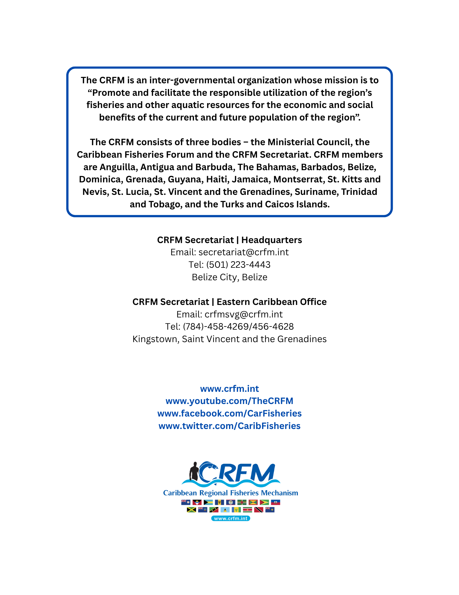

TREES is a standard for verifying greenhouse gas emission reductions from forest conservation (REDD+) at national and subnational scales, enabling countries to generate verified carbon credits aligned with Paris Agreement goals.

